Victoria’s pandemic management framework
Process flowchart for Public Health and Wellbeing Act 2008, Part 8A
OFFICIAL

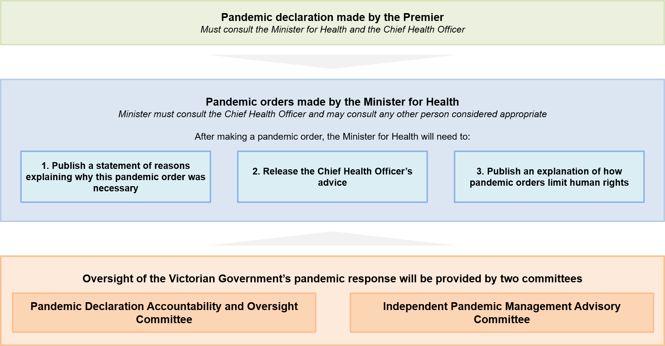

Process
The process for Victoria’s pandemic management framework is as follows:
- A pandemic declaration is made by the Premier
- The Premier must consult the Minister for Health and the Chief Health Officer
- Pandemic orders are made by the Minister for Health
- The Minister must consult the Chief Health Officer and may consult any other person considered appropriate
- After making a pandemic order, the Minister for Health will need to:
- Publish a statement of reasons explaining why this pandemic order was necessary
- Release the Chief Health Officer’s advice
- Publish an explanation of how pandemic orders limit human rights

Oversight
Oversight of the Victorian Government’s pandemic response will be provided by two committees
- Pandemic Declaration Accountability and Oversight Committee
- Independent Pandemic Management Advisory Committee

To receive this document in another format, phone 1300 651 160, using the National Relay Service 13 36 77 if required, or email the Department of Health <covid-19@dhhs.vic.gov.au>.
Authorised and published by the Victorian Government, 1 Treasury Place, Melbourne.
© State of Victoria, Australia, Department of Health, December 2021.

Available at <https://www.health.vic.gov.au/covid-19/victorias-pandemic-management-framework>

