Ban on smoking and vaping at public hospitals and registered community health centres
Factsheet for occupiers

By law, smoking and the use of e-cigarettes (vaping) is banned within four metres of an entrance to public hospitals and registered community health centres in Victoria.

Where does the ban apply?
Smoking and vaping is banned within four metres of entrances (pedestrian access points) to public hospitals and registered community health centres.
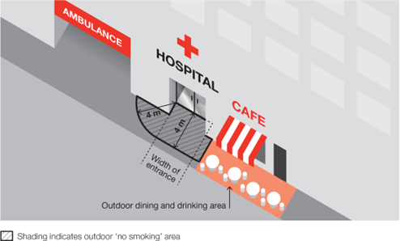
The diagrams below show examples of where the smoking and vaping ban applies at a hospital.
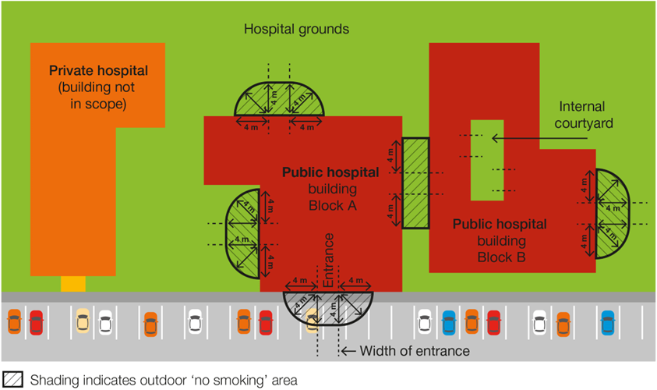
Public hospitals or registered community health centres may also have policies in place which further limit smoking and vaping in outdoor areas. Such a policy would apply in addition to the legislative ban.

Why does the ban exist?
The purpose of the smoking and vaping ban is to:
- protect the community from exposure to second-hand tobacco smoke and the aerosol from e-cigarettes
- further de-normalise smoking and vaping in the community. The more people see smoking and vaping in public places the more they will tend to think it is okay, rather than harmful
- support people who have quit or are trying to quit smoking and vaping.

What is a public hospital and a registered community health centre?
‘Public hospital’ is used broadly to refer to any of the following entities within the meaning of the Health Services Act 1988:
- denominational hospitals
- multi-purpose services
- the privately-operated hospital (Mildura Base Hospital)
- public health services
- public hospitals.
A registered community health centre is an independent community health centre that is registered by the Department of Health.

What is a pedestrian access point?
A pedestrian access point means a door or gate by which a person can enter or exit the premises.
It does not include an emergency exit that is locked to entry.
It does include shared doors or gates. For example, where a building is occupied by a registered community health centre as well as other organisations, such as private businesses, any shared entrances that are used to access both areas of the building would be subject to the smoking ban.
Any entrances which lead only to premises not included in the smoking ban, such as the private offices, would not be subject to the smoking ban.

Where does the ban not apply?
The ban does not apply:
- to an entrance to a private hospital, unless the entrance also provides access to a public hospital
- to an emergency exit that is locked to entry
- to a person walking through the smoke-free and vape-free area
- to a person in a motor vehicle that is driving or being driven through the smoke-free and vape-free area
- to a person in an area that is separated from the smoke-free and vape-free area by a road
- to a person in an outdoor drinking area located within the smoke-free and vape-free area
- to a person at a residential premises (at privately owned homes and land).

What if we are already smoke-free and vape-free?
The smoking and vaping ban is intended to complement and provide legislative support to any existing smoke-free and vape-free policies at public hospitals and registered community health centres.
If a public hospital or registered community health centre has its own smoking and vaping ban in place, the state-wide ban will act as a minimum standard, with any further requirements put in place by the premises applying in addition to the legislative ban.
For example, if your hospital has a smoke-free and vape-free policy for the entire premises, both your hospital’s policy and the state-wide ban will apply. However, inspectors authorised under the Tobacco Act 1987 can only take action to enforce the legislative ban.

How will people know about the ban?
You are required to display ‘No Smoking’ signs in the smoke-free and vape-free area (see below). Use of the ‘No Smoking or Vaping’ signage is voluntary.

Am I or my staff expected to enforce the ban?
No. Occupiers are not expected to enforce the ban and are not empowered to do so.
Compliance with the ban is expected to occur through public education and changed community expectations.
Consultation undertaken by the Department of Health shows strong community support for banning smoking and vaping at public places.
These factors are likely to result in high levels of voluntary compliance with the smoking and vaping ban.

How will the ban be enforced?
There is strong community support for banning smoking and vaping at public places. This means most people will voluntarily comply with the smoking and vaping ban and expect others to do so.
Inspectors authorised under the Tobacco Act 1987 may provide information about and, when necessary, enforce the ban. The first, priority of the inspector is to make sure smokers and vapers understand the ban.
Inspectors may not be available to respond to every complaint but, where circumstances allow, may attend in response.
You and your staff can assist to raise awareness of the ban by providing staff and visitors access to promotional resources.

What penalties might apply?
The maximum penalty for someone breaking this law is five penalty units, with an infringement penalty of one penalty unit.

What resources are available to promote the ban?

Signage
Occupiers are required by law to install acceptable ‘No smoking’ signs at entrances (pedestrian access points) to their premises. Signs are available to order free-of-charge from tobacco reforms website <www.health.vic.gov.au/public-health/tobacco-reforms>
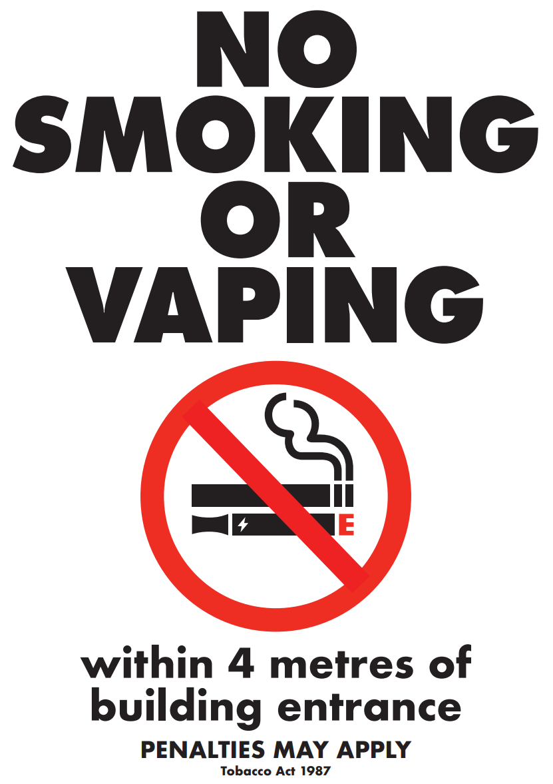
Electronic versions of the signs can also be downloaded and printed from the website above.

Posters
Occupiers can request posters to help educate and inform staff, visitors, and the general public of the new ban. Posters are available to order free-of-charge from the tobacco reforms website <www.health.vic.gov.au/public-health/tobacco-reforms>

Definitions of ‘occupier’
Under the Tobacco Act 1987, an occupier in relation to an area or premises, means:
- a person who appears to be of or over the age of 16 years and who is or appears to be in control of the area or premises, whether or not, the person is present in the area or on the premises; or
- a body corporate that is or appears to be in control of the area or premises.

How can I find out more?
For more information:
- visit the tobacco reforms website <www.health.vic.gov.au/public-health/tobacco-reforms>
- call the Tobacco Information Line on 1300 136 775

To view the legislation visit the Victorian Government’s legislation website <www.legislation.vic.gov.au> and search Tobacco Act 1987.

DISCLAIMER: Please note that any advice contained in this factsheet is for general guidance only. The Department of Health does not accept any liability for any loss or damage suffered as a result of reliance on the advice contained in this factsheet. Nothing in this factsheet should replace seeking appropriate legal advice.
To receive this document in another format, phone 1300 136 775, using the National Relay Service 13 36 77 if required, or email tobacco.policy@health.vic.gov.au
Authorised and published by the Victorian Government, 1 Treasury Place, Melbourne.
© State of Victoria, Australia, Department of Health, November 2023.
Except where otherwise indicated, the images in this document show models and illustrative settings only, and do not necessarily depict actual services, facilities or recipients of services.
ISBN 978-1-76131-438-4 (pdf/online/MS word) Available at tobacco reforms website <www.health.vic.gov.au/public-health/tobacco-reforms>

For current penalty unit values, visit the Department of Treasury and Finance website <www.dtf.vic.gov.au/financial-management-government/indexation-fees-and-penalties>

