Smoking and vaping restrictions in outdoor drinking areas
Factsheet for businesses

This factsheet provides general guidance on the smoking and use of e-cigarettes (vaping) restrictions in outdoor drinking areas and their interaction with smoke-free and vape-free outdoor dining areas.
Further detailed information is available in the Smoking and vaping restrictions in outdoor drinking areas guide available on the tobacco reforms website <www.health.vic.gov.au/public-health/tobacco-reforms>.

Outdoor drinking and outdoor dining areas
Changes to the Tobacco Act 1987 mean that smoking and vaping is banned in all commercial outdoor dining areas in Victoria.
The introduction of smoke-free and vape-free outdoor dining now means there are two types of outdoor areas for dining and drinking activities.
An outdoor area can be either:
- an outdoor dining area, or
- an outdoor drinking area.

Outdoor drinking areas
Outdoor drinking areas include the following places if predominantly used for the consumption of drinks:
- a balcony or veranda
- a courtyard
- a rooftop
- a marquee
- a street or footpath
- any similar outdoor area.
Drinks can include both alcoholic and non-alcoholic drinks such as coffee.

Existing smoking and vaping restrictions continue to apply
Smoking and vaping in outdoor drinking areas are banned when:
- an area has a roof in place, and
  - the total actual area of wall surfaces exceeds 75 per cent of the total notional wall area.

Outdoor drinking areas within 4 metres of outdoor dining areas
To support smoke-free and vape-free outdoor dining, smoking and vaping banned in an outdoor drinking area if any part of that area is within 4 metres of an outdoor dining area, unless separated by a wall of at least 2.1 metres high.
This means that if any part of an outdoor drinking area is within 4 metres of an outdoor dining area at the same or neighbouring venue, the business owner or manager of an outdoor drinking area will need to:
- ensure the outdoor drinking area is smoke-free and vape-free, or
- separate the two areas by:
a 4-metre buffer zone, or
a wall of at least 2.1 metres high.
A neighbouring venue is a different venue that is located immediately next to your venue.

Snacks can be eaten in outdoor drinking areas
Customers can eat only snacks in outdoor drinking areas.
A snack is a pre-packaged shelf-stable food that:
- is sealed in the container or package in which the manufacturer intended it to be sold, and
  - does not require any preparation prior to serving.
Shelf-stable food means food that can be stored safely for long periods (months) at room temperature.
Snacks also include uncut and unpeeled fruit.
Examples of snacks include pre-packaged potato crisps, nuts and chocolate bars. Pre-packaged sandwiches and hot chips are not snacks.

Complying with the new law
The following is general guidance about how to comply with the law.

Same venue
Figure 1: Separation by a 4-metre buffer zone
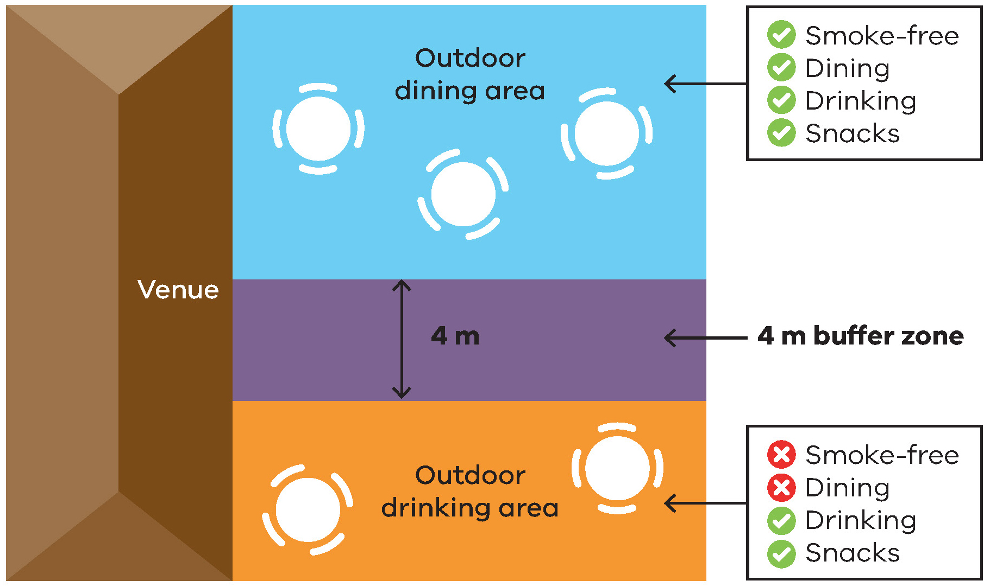
Figure 2: Separation by a wall of at least 2.1 metres high
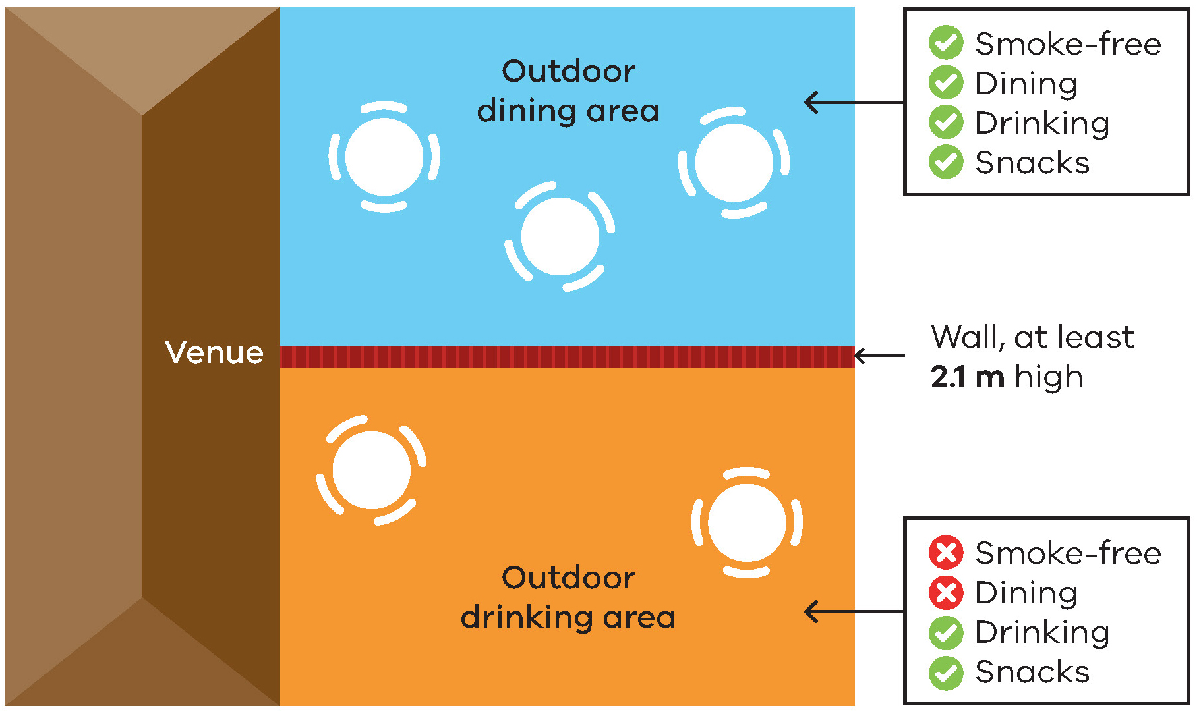
*A wall is a structure or device that prevents or significantly impedes lateral airflow, such as a water-resistant café blind.

Neighbouring venues
Figure 3: Separation by a 4-metre buffer zone (neighbouring venues on a footpath)
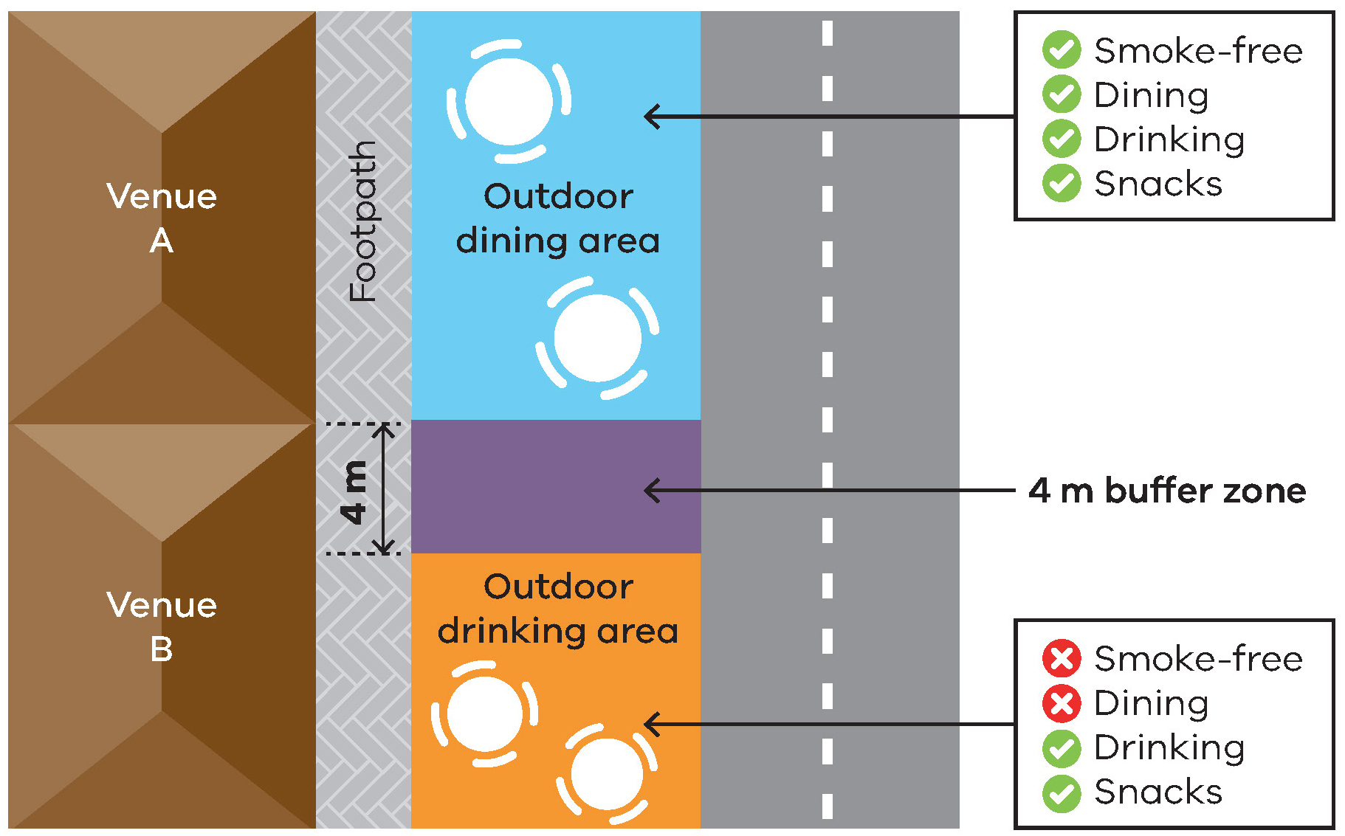
Figure 4: Separation by a wall at least 2.1 metres high (neighbouring venues on a footpath)
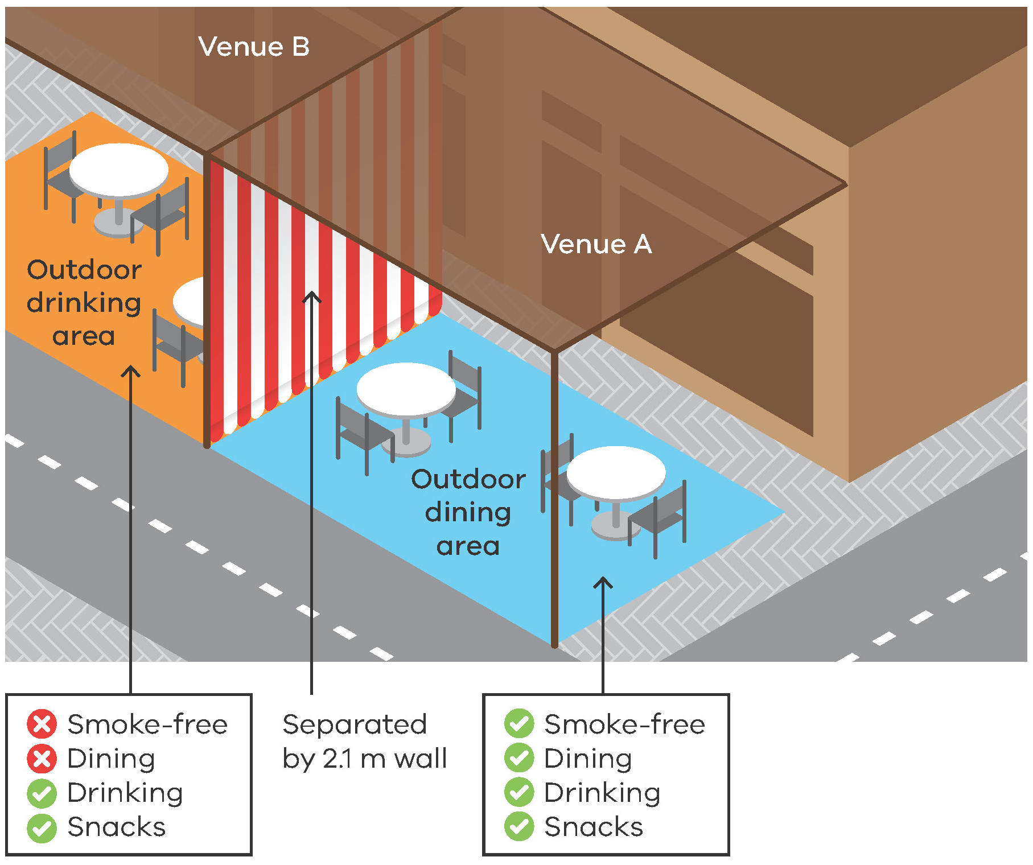

Go totally smoke-free and vape-free
You can make your venue totally smoke-free and vape-free. This will reduce the risk of non-compliance with the law and is the most effective way to protect customers and staff from smoke-drift and the aerosol from e-cigarettes that may drift.
Signage required
Venues must display acceptable ‘No smoking’ signage to indicate smoke-free and vape-free areas. The signs must be displayed so customers can see a sign when entering, or within, the outdoor drinking area. Use of the ‘No Smoking or Vaping’ signage is voluntary.
Signs can be ordered free of charge from the tobacco reforms website <www.health.vic.gov.au/public-health/tobacco-reforms>.

Further information and resources
For more information:
- visit the tobacco reforms website <www.health.vic.gov.au/public-health/tobacco-reforms>
  - call the Tobacco Information Line on 1300 136 775.
To view the exact wording of the law, visit the Victorian Government’s legislation website <www.legislation.vic.gov.au> and search Tobacco Act 1987.
To receive this document in another format, phone 1300 136 775, using the National Relay Service 13 36 77 if required, or email tobacco.policy@health.vic.gov.au
Authorised and published by the Victorian Government, 1 Treasury Place, Melbourne.
© State of Victoria, Australia, Department of Health, November 2023.
Except where otherwise indicated, the images in this document show models and illustrative settings only, and do not necessarily depict actual services, facilities or recipients of services.
Please note that any advice contained in this publication is for general guidance only. The Department of Health does not accept any liability for any loss or damage suffered as a result of reliance on the advice contained in this publication. Nothing in this publication should replace seeking appropriate legal advice.
ISBN 978-1-76131-104-8 (pdf/online/MS word)
Available at the tobacco reforms website <www.health.vic.gov.au/public-health/tobacco-reforms>.

The total notional wall area is the area of the wall surface if the walls were at the perimeter of the roofed area and continuous and of a uniform height equal to the lowest height of the roof.

