CDIS counselling and recommended contact processes
Victorian Maternal and Child Health (MCH) Child Development Information System (CDIS)
December 2020

Contents
Defining counselling, referral and recommended contacts 1
Recording counselling in client (child) history 1
Recording recommended contacts in client (child) history 4

Defining counselling, referral and recommended contacts

Counselling
Note: Counselling is counted for reporting purposes from the child history.
- A counselling session is recorded when additional guidance is provided specific to an identified health concern:
- this is outside the range of information or in more specific depth than that expected to be provided at the KAS consultation
- usually an ‘Additional Consultation’ will also require counselling to be included around that particular concern.

Referral
Note: Referral reasons are counted for reporting purposes from the child history
A referral is only recorded when communication is made to the referral agency with the consent of the primary caregiver. This includes a written letter or phone call to the referral agency, or a recording made in the parent-held child health record
The exception is in the case of mandatory reporting when primary caregiver consent is not required
A referral implies that counselling has also occurred at the time of consultation.
Record referral and counselling.

Recommended contacts
A recommended contact is when a person is given the option of contacting a external agency, but the formal referral procedure is not used.
Contact details of the external agency may be given, but communication to the agency has not been specifically made by the MCH Nurse.
Record recommended contacts and counselling.

Recording counselling in client (child) history
All counselling is recorded from the child history.
Counselling is counted for reporting purposes from the child history.
If the counselling is relevant to mother or family:
- Enter counselling in child history
- Document in Comments/Notes: ‘see [relevant client’s] history’
- Ensure that the relevant client is open (such as mother, father or caregiver)
- Document in the notes of that relevant client history:
- child consultation at which recommended contact was made
- relevant counselling notes
- Follow-up as required per clinical judgement.

CDIS process
- In Client History, open the Clinical activity menu, select Consultations
Figure 1: Clinical activity menu
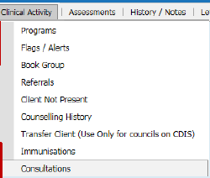
- Select and start appropriate consultation
- Complete consultation as appropriate
- Go to Counselling
- Select Child Reason or Mother/Family Reason from look-up list and enter comments or notes
Note: When delivering “Integrated Consultations” such as ‘Enhanced MCH’ and ‘Sleep and settling – outreach’, the consultation record will apply to multiple family members. For these consultations, be sure to specify the relevant family members in the Comments/Notes, so that it is clear which child(ren) or carer(s) the counselling applies to.
Figure 2: Counselling section
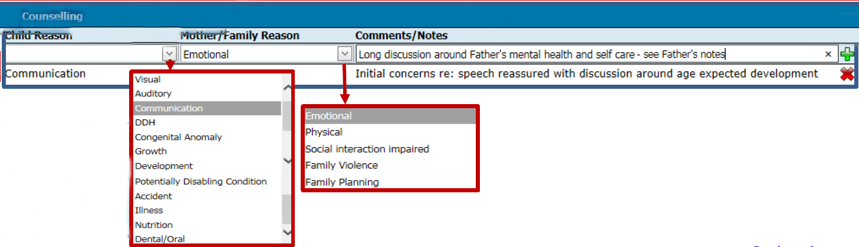
- Select the green plus icon to Add
- Repeat if required
- Select the red X icon to delete entry
Figure 3: Add and delete
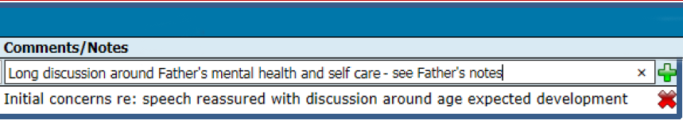

Example of completed recording of counselling in client (child) history
Figure 4: Notes with counselling recorded
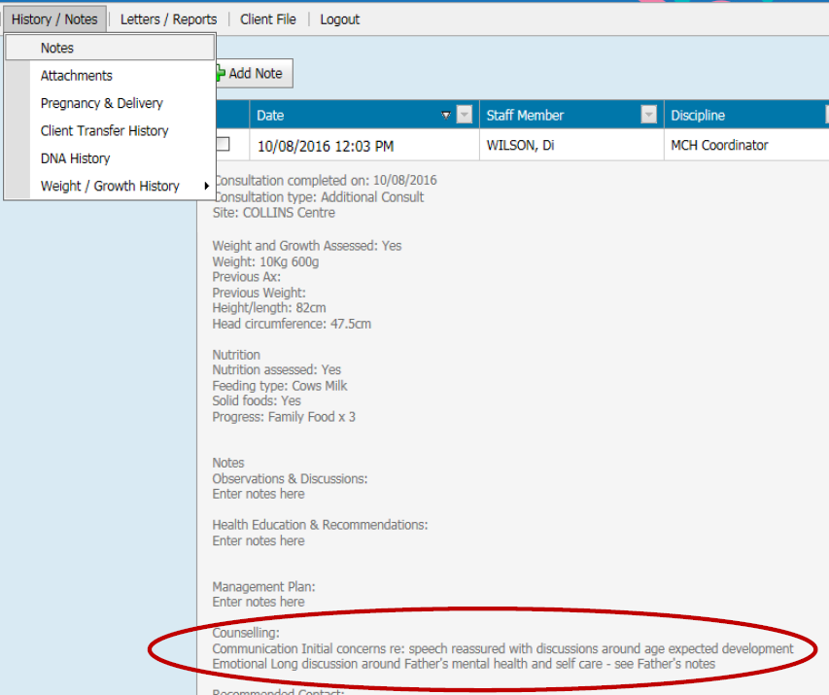

Recording recommended contacts in client (child) history
Recommended contact to be recorded from the child history.
If the recommended contact is relevant to the mother or family:
- Enter recommended contact in child history. Document in ‘Comments/Notes’ field ‘see [relevant client’s] history’
- Ensure that the relevant client (such as mother, father or caregiver) is open
- Document in the notes of that relevant client history:
    - child consultation at which recommended contact was made
    - recommended contact notes
- Follow up as required per clinical judgement

CDIS process
- In Client History, open the Clinical activity menu, select Consultations
Figure 5: Clinical activity menu
- Select and start appropriate consultation
- Complete consultation as appropriate
- Go to Recommended contact
- Select Agency from look-up list and enter comments in ‘Comments/Notes’ field
Figure 6: Recommended contact section
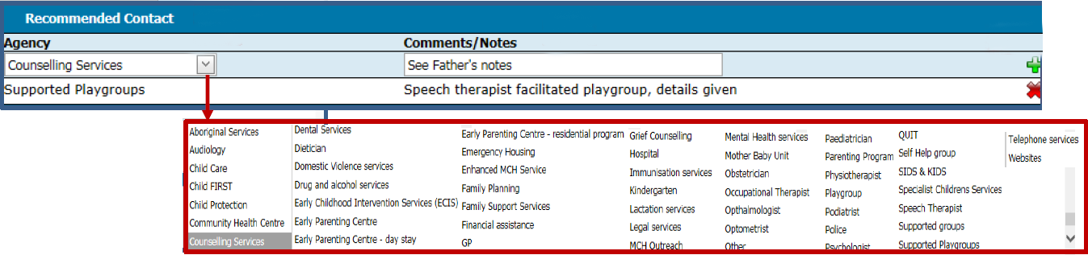
- Select green plus icon to add
- Repeat if needed
- Select red X icon to delete entry.

Example of completed recording recommended contact in client (child) history
Figure 7: Notes with recommended contact recorded
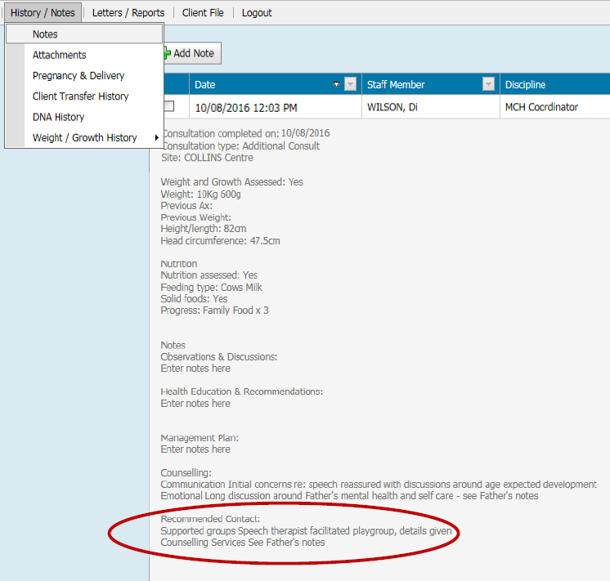

To receive this publication in an accessible format phone 1300 650 172, using the National Relay Service 13 36 77 if required, or email Commissioning Performance and Improvement Aged and Community Based Health Care and Cancer Services <mch@dhhs.vic.gov.au>
Authorised and published by the Victorian Government, 1 Treasury Place, Melbourne.
© State of Victoria, Australia, Department of Health and Human Services June 2020.
ISBN 978-1-76096-019-3 (pdf/online/MS word)
Available at health.vic – Child Development Information System <https://www2.health.vic.gov.au/primary-and-community-health/maternal-child-health/child-development-information-system>

