CDIS Additional assessment tools

Victorian Maternal and Child Health (MCH) Child Development Information System (CDIS)
December 2020
Contents
Overview 1
Sleep and Settling assessment tools available within CDIS 1
How to access the new tools 1
Tool access from client records 3
Assessment Tools 3
Parent and carers psychosocial assessment 3
Parent-child interaction scale – Infant and toddler (Brigance III) 4
Sleep pathways assessment form 5
Reporting 7

Overview
The Department of Health and Human Services (the department) has introduced changes to CDIS to support the MCH Workforce and Service Providers to accurately and flexibly record assessments within the CDIS system, replacing online forms where practical to do so.

Sleep and Settling assessment tools available within CDIS
Three new assessment tools have been added to CDIS.
- Parent and carers psychosocial assessment
- Parent-child interactions scale - Infant and toddler (Brigance III)
- Sleep Pathways Assessment form*
* This tool replaces the infant sleeping tool.

How to access the new tools

Accessing the tools from the Assessments Menu
All new online Assessment Tools are available from the Assessments Menu > Assessments /Interventions
The three new Assessment Tools can be accessed the same way as all Assessment Tools are accessed.
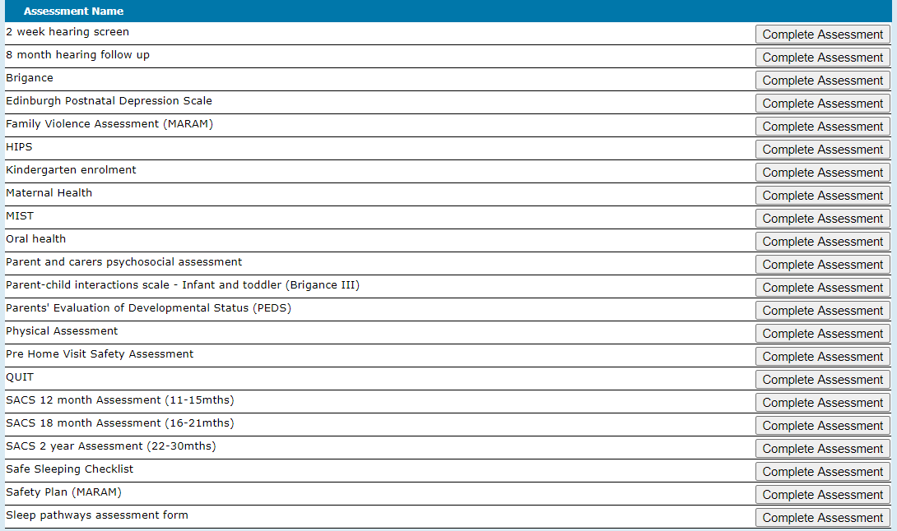

Accessing the tools from within consultations
Consultation types with direct access to the new Assessment Tools
Consultation type | Parent and carers psychosocial assessment | Parent-child interactions scale - Infant and toddler (Brigance III) | Sleep Pathways Assessment Form
Home Visit | ü | ü
2-week | ü | ü
4-week | ü | ü
8-week | ü | ü
4-month | ü | ü
8-month | ü | ü | ü
12-month | ü | ü | ü
18-month | ü | ü
2 year | ü | ü
3.5 year | ü | ü
Additional Consult | ü | ü | ü
Family Consultation | ü | ü
Enhanced MCH | ü | ü | ü
Sleep and Settling - Outreach | ü | ü | ü

Select assessment tools from the Assessment dropdown box in the Assessments / Interventions section of the consultation screen, as per existing practice.
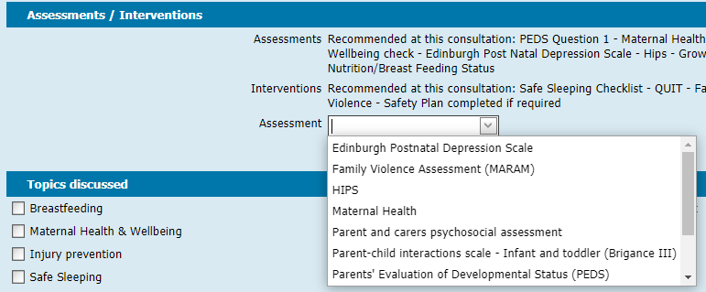

Tool access from client records
Access to new tools from client records may differ depending on the program you are delivering
Universal MCH Program | The new tools are accessed from the client record of the child who is being assessed. The assessment will be then be saved against that child’s record.  Note: To be consistent with consultation process:  All clients have the same type of client file to ensure you are in the correct client file before entering any data.  All universal consultations are counted for reporting purposes against the child record  All consultations are to be recorded from the child record – only in extenuating circumstances should a ‘consultation’ be recorded from the mother’s record.
Enhanced MCH Program | Refer to CDIS Enhanced MCH Guide
Sleep and Settling Outreach Program | Refer to CDIS Sleep and settling outreach guide

Assessment Tools

Parent and carers psychosocial assessment
At the top of the screen you are asked to select the parent/carer who is present. A parent/carer present must be selected when using this tool. This information will be recorded as part of the assessment information in the child’s client record.
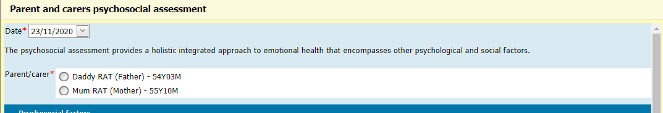
Complete the form in accordance with the principles included in Perinatal mental health and psychosocial assessment: Practice resource manual for Victorian maternal and child health nurses, then click Save
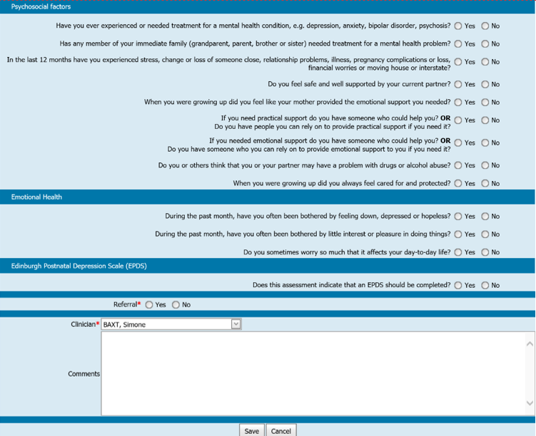

Parent-child interaction scale – Infant and toddler (Brigance III)
At the top of the screen you are asked to select the parent/carer who is present. A parent/carer present must be selected when using this tool. This information will be recorded as part of the assessment information in the child’s client record.
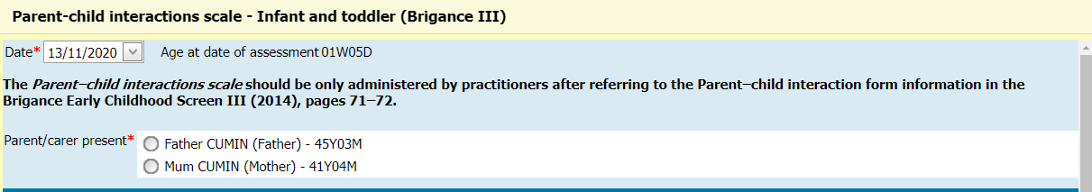
Complete the form and click save.
Note: The Parent–child interactions scale should be only administered by practitioners after referring to the Parent–child interaction form information in the Brigance Early Childhood Screen III (2014), pages 71–72.

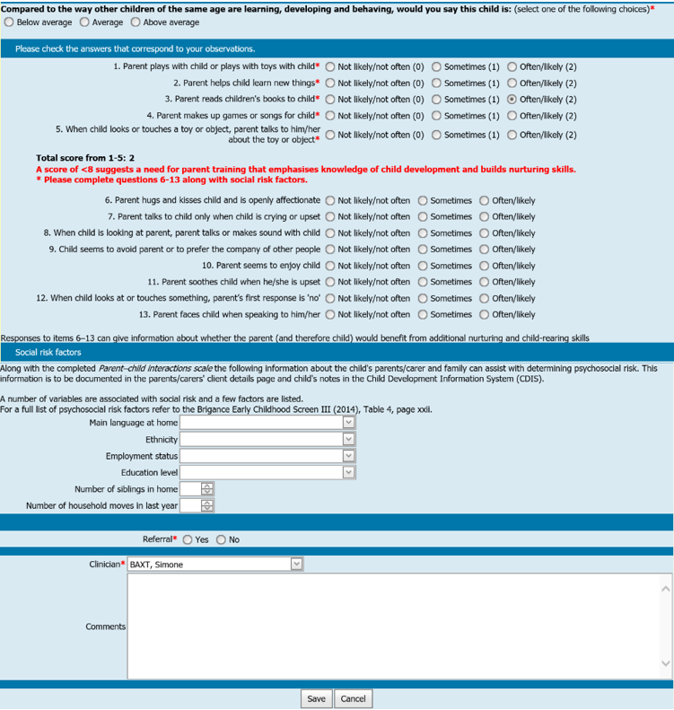

Sleep pathways assessment form
At the top of the screen you are asked to select the parent/carer who is present. A parent/carer present must be selected when using this tool. This information will be recorded as part of the assessment information in the child’s client record.
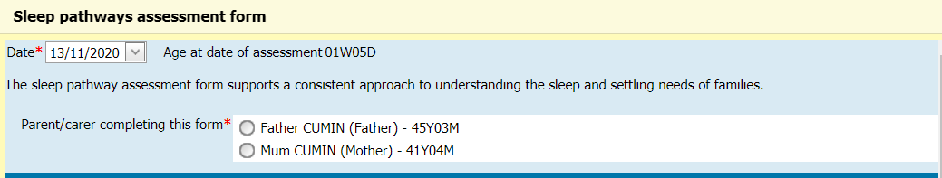
Complete the assessment in accordance with Sleep and settling model of care, then click Save
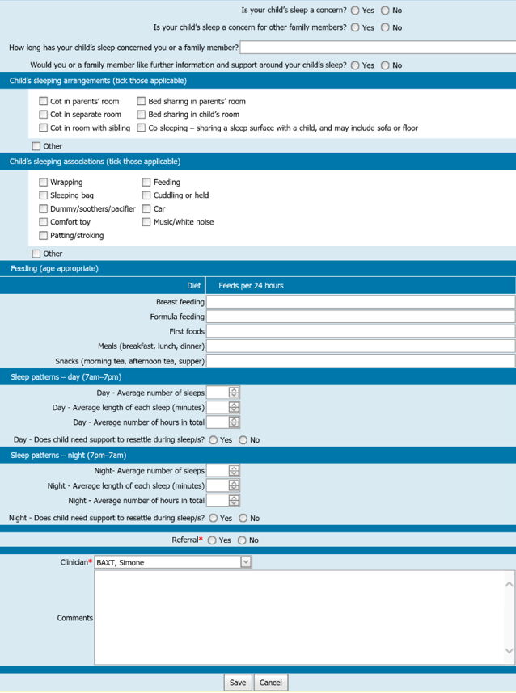

Reporting
The current MCH KAS Report built into CDIS includes a “Sleep Intervention” count for the 8-month KAS consultation. This count will no longer be accurate, as it does not count uses of the new “Sleep Pathways Assessment Form”. There will be a new report developed to provide accurate counts of assessment tool usage.

To receive this publication in an accessible format phone 1300 650 172, using the National Relay Service 13 36 77 if required, or email Commissioning Performance and Improvement Aged and Community Based Health Care and Cancer Services <mch@dhhs.vic.gov.au>
Authorised and published by the Victorian Government, 1 Treasury Place, Melbourne.
© State of Victoria, Australia, Department of Health and Human Services June 2020.
Except where otherwise indicated, the images in this publication show models and illustrative settings only, and do not necessarily depict actual services, facilities or recipients of services. This publication may contain images of deceased Aboriginal and Torres Strait Islander peoples.
In this document, ‘Aboriginal’ refers to both Aboriginal and Torres Strait Islander people. ‘Indigenous’ or ‘Koori/Koorie’ is retained when part of the title of a report, program or quotation.
ISBN 978-1-76096-240-1 (pdf/online/MS word)
Available at health.vic – Child Development Information System <https://www2.health.vic.gov.au/primary-and-community-health/maternal-child-health/child-development-information-system>

