CDIS Delivered hours guide
Victorian Maternal and Child Health (MCH) Child Development Information System (CDIS)
Contents
Collecting time data 1
Overview 1
How to complete 1

Collecting time data

Overview
On all Consultation and Client Not Present screens, CDIS mandates the collection of time data, to record the amount of time that each activity has taken to deliver.
Time is collected across three different categories:
- Direct – defined as time spent with client, either face-to-face or over-the-phone
- Indirect – defined as documentation and any other non-client time related directly to the client
- Travel – defined as travel time to-and-from an appointment
Users are obligated to complete these fields with as much accuracy as possible. Please do not simply enter the standard time allocation for the consultation you are delivering. Accurate data will improve understanding of the real time and cost of MCH service delivery.

How to complete
On Consultation screens the Time section appears towards the bottom of the screen, below the Notes section.
On Client Not Present screens the Time section appears towards the bottom of the screen, below the Client Not Present section.
There are six fields that can be completed:
It is mandatory to complete at least one of the first four fields (Direct hours, Direct minutes, Indirect hours, Indirect minutes)
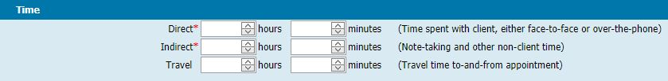
Figure 1: Time section on Consultation and Client Not Present screens

To receive this publication in an accessible format phone 1300 650 172, using the National Relay Service 13 36 77 if required, or email Commissioning Performance and Improvement Aged and Community Based Health Care and Cancer Services <mch@dhhs.vic.gov.au>
Authorised and published by the Victorian Government, 1 Treasury Place, Melbourne.
© State of Victoria, Australia, Department of Health and Human Services December 2020.
Except where otherwise indicated, the images in this publication show models and illustrative settings only, and do not necessarily depict actual services, facilities or recipients of services. This publication may contain images of deceased Aboriginal and Torres Strait Islander peoples.
In this document, ‘Aboriginal’ refers to both Aboriginal and Torres Strait Islander people. ‘Indigenous’ or ‘Koori/Koorie’ is retained when part of the title of a report, program or quotation.
ISBN 978-1-76096-239-5 (pdf/online/MS word)
Available at health.vic – Child Development Information System <https://www2.health.vic.gov.au/primary-and-community-health/maternal-child-health/child-development-information-system>

