CDIS Enhanced MCH migration guide
Victorian Maternal and Child Health (MCH) Child Development Information System (CDIS)
December 2020
Contents
1. Overview 1
2. Reporting: CDIS and IRIS 2
3. Program names: Old Enhanced MCH and (new) Enhanced MCH 2
4. When and how to start using the (new) Enhanced MCH program 3
5. How to enrol a new case 3
6. How to migrate an active enrolment from Old Enhanced MCH to (new) Enhanced MCH 4
6.1 Add ‘migration time’ to IRIS 4
6.2 Collect data from IRIS and from the Child and Family Action Plan 4
6.3 Create a new Enhanced MCH case in CDIS 4
6.4 Add existing case time into CDIS 5
6.5 Update the Case Summary Screen 6
6.6 Update any scheduled appointments 7
6.7 Assign case to practitioner 8
6.8 Close case in Old Enhanced Program 9
7 Migrating pending referrals 9

Overview
As of December 2020, CDIS has been enabled with a range of additional capabilities to support the Enhanced MCH Program. It is recommended that you first familiarise yourself with the CDIS Enhanced MCH guide which explains how these capabilities work, before continuing with this document.
This document describes the processes for migrating clients from the existing program and methods of managing and recording Enhanced MCH program delivery, to the new methods, including:
- Enhanced MCH reporting requirements (CDIS and IRIS)
- Program name changes in CDIS
- Migrating active cases into the new Enhanced MCH Program
- Managing pending referrals on the Programs Active List

Reporting: CDIS and IRIS
The introduction of these new capabilities in CDIS is an important step forward towards being able to stop entering data into IRIS. However, in the short term, users will need to continue entering data into IRIS as per current practice.

Program names: Old Enhanced MCH and (new) Enhanced MCH
The existing Enhanced MCH Program has been renamed Old Enhanced MCH. It still contains all your active Enhanced MCH clients and can continue to be used under its new name.
The new Enhanced MCH capabilities have been added to a new program which is called Enhanced MCH. Upon launch (December 2020), there are no active cases in this program. Existing Old Enhanced MCH cases can be migrated across to the Enhanced MCH program, and new cases can be created in the Enhanced MCH program.
 | Old Enhanced MCH Program | (new) Enhanced MCH Program
Was called | Enhanced MCH | N/A
Now called | Old Enhanced MCH | Enhanced MCH
Clients enrolled | Has existing clients prior to Dec 2020 | No existing clients prior to Dec 2020
Type of program functionality | Regular | Integrated
Who can be enrolled in a case? | One client (usually a child client) | A family, including parent/carers and children.  The case must be led by a parent/carer.
Has case management functionality? | No | Yes (Case Summary Screen)
Will be used to generate reports on program usage and delivery? | Limited reports available | Yes, with future CDIS enhancements

When and how to start using the (new) Enhanced MCH program
There is no need to immediately start using the (new) Enhanced MCH program on day one. The Old Enhanced MCH program will remain active for a number of months, to allow for a gradual transition.
By 1 April 2021, all active cases in the Old Enhanced MCH program should have been completed and closed, or migrated across to the (new) Enhanced MCH program.
This table shows the recommended schedule for migration, however providers can arrange their own approach.
When | Action
Mid Dec 2020 | - Keeping managing active cases using Old Enhanced MCH  - Keep enrolling new cases into Old Enhanced MCH
After training  (Jan 2021) | - Start enrolling all new cases into (new) Enhanced MCH  - Start migrating active cases from Old Enhanced MCH to (new) Enhanced MCH
Feb / Mar 2021 | - Identify all remaining cases in Old Enhanced MCH and migrate them

How to enrol a new case
Refer to the CDIS Enhanced MCH guide for detailed instructions.

How to migrate an active enrolment from Old Enhanced MCH to (new) Enhanced MCH
You should be familiar with the CDIS Enhanced MCH guide before migrating an active enrolment using the below instructions.

Add ‘migration time’ to IRIS

This process of migration will take time, and it is important that this time is accurately captured.

Access the case in IRIS.

Add a new service entry to the case in IRIS, to reflect the time you are about to spend migrating this case from the Old Enhanced Program in CDIS to the (new) Enhanced Program in CDIS.
- For ‘Service Type’, select ‘Indirect service’ > ‘Other’
- For ‘Date’, use today’s date
- For ‘Duration’, enter your best estimate for how long it will take you to complete this migration. For your first couple of case migrations, it is reasonable to presume 30 minutes of time to complete the migration. After that, you can improve your estimate for how long it will take you to migrate each case.

Collect data from IRIS and from the Child and Family Action Plan

Access the case in IRIS and also refer to the current Child and Family Action Plan for the case.

Make note of:
  - IRIS case reference number
  - Date the case commenced
  - All family members involved in the case (This should be at least one parent/carer and one child under 3)
  - Total hours used so far in the case, broken down by Duration and Travel
 | Case time in IRIS
Total Duration | 4.30 (4 hrs 30 mins)
Total Travel | 1.00 (1 hr 0 mins)
Total | 5.30 (5 hrs 30 mins)
  - Summaries of the current Issues and Goals for the case.

Do not close the case in IRIS. The case must remain open in IRIS until the case is completed.

Create a new Enhanced MCH case in CDIS

In CDIS, access the client records of all the family members involved in the case. Ensure that:
- There are CDIS client records for all the family members
- There are relationships between the lead client (This will be the IRIS client, usually the mother) and all other family members (including between the lead client and any other adults)
- The lead client is marked as primary carer or carer of all the children

Access the client record of the lead client. Open the Add Program screen (Clinical Activity > Programs > + Add Program)

Select ‘Enhanced MCH’ from the Program dropdown.

The Add Program screen will now have an extra section, called “Family included as part of this enrolment”. This section will list the lead client, and then all related clients. Click the checkboxes next to the names of the family members to be included as part of this case.

Select a Start Date for the case, being the date that the case first commenced in IRIS.

Click Save. A warning screen will popup, warning you that if you proceed, no referral will be recorded for this case.
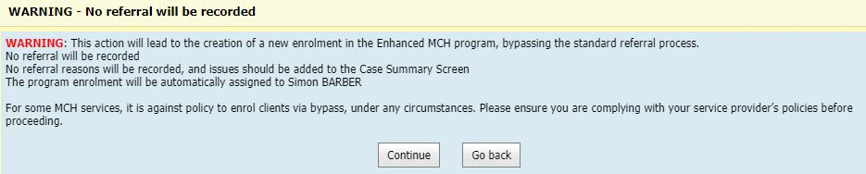

Ordinarily you would only commence a case via referral. However as this is a migration of an existing case, you can proceed. Click Continue. This case is now active and has been automatically assigned to you (current user).

Add existing case time into CDIS
In order for the new case to accurately reflect the hours of service delivery already expended, a special Client Not Present must be recorded.

Access the client record of the lead client. Open the Client Not Present screen (Clinical Activity > Client Not Present)

For “Service Date” enter today’s date

For “Start time” enter the current time

For “Program” select Enhanced MCH

For “Service type*” select “Migration – EMCH”

In “Notes” enter the IRIS case number

In the Time section, enter the time spent on the case so far.
- Use your clinical judgement to split the Total Duration (as recorded in IRIS) between the Direct and Indirect time categories. The Total Duration (as recorded in IRIS) already includes the migration time you added into IRIS at step 6.1.
- Add the Total Travel (as recorded in IRIS) to the Travel time
Case time in IRIS | Transfer à |  | Case time in CDIS
Duration (2 hrs 30 mins) | Use clinical judgement to divide into these categories | à | Direct time (1 hr 40 mins) Indirect time (50 mins)
Travel time (40 mins) | à |  | Travel time (40 mins)

Click Save.

Update the Case Summary Screen

Access the client record of the lead client. Open the client Summary Page (Client Details > Summary Page) and scroll down to the Programs section. Identify the Enhanced MCH case in the list, and click the View link on the right side of the screen.
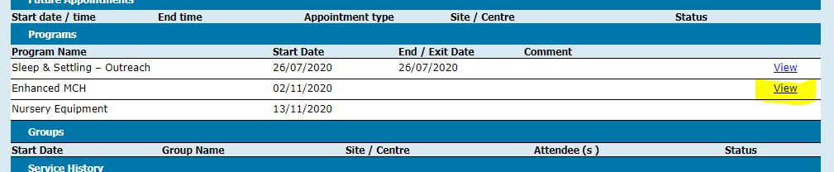

You are now on the Case Summary Screen for this case. Using information gathered at step 6.2, complete the “Issues” and “Goals” sections as appropriate (refer to the CDIS Enhanced MCH guide). It is not required to transpose all historical information from IRIS, as you will still have access to IRIS as needed.
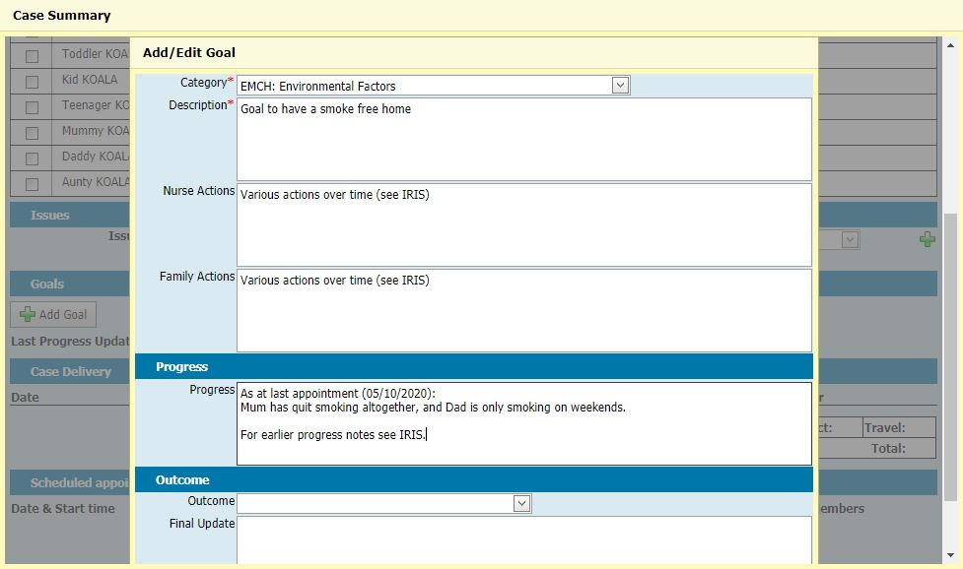

Review the “Case Delivery” section of the Case Summary Screen. It should list the Client Not Present entry you just added and should show accurate total case time for the case so far (matching what is in IRIS).
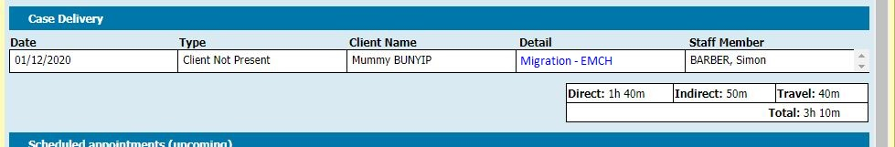

Update any scheduled appointments

Still on the Case Summary Screen, review the Scheduled appointments (upcoming) section. It will show all upcoming scheduled appointments for all family members involved in the case.
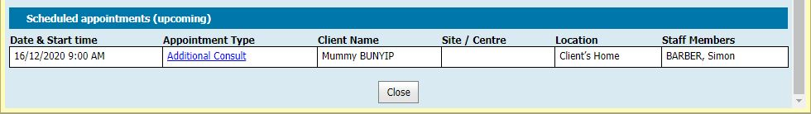

Identify any upcoming “Additional Consult” appointments that have been made for this Enhanced MCH case.

IF the scheduled appointment is in the name of the lead client, you can edit this appointment to change it from an “Additional Consult” appointment type to an “Enhanced MCH” appointment type:
  - Click on the “Additional Consult” link in the Appointment Type column. This will open the Edit Appointment screen.
  - Change the Appointment type from “Additional Consult” to “Enhanced MCH”.
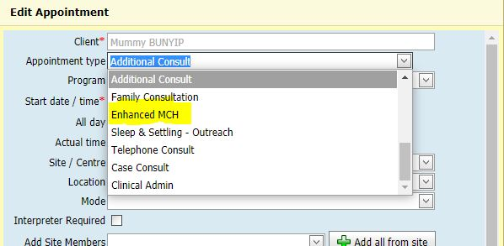
  - Select “Data Entry Error” as the reason for the edit of the appointment.
  - Click Save.
In the Scheduled appointments (upcoming) section, this appointment will now appear as an “Enhanced MCH” appointment.

IF the scheduled appointment is NOT in the name of the lead client but is instead in the name of the child, you will not be able to edit this appointment type, but you can create a parallel Enhanced MCH appointment:
  - Click on the “Additional Consult” link in the Appointment Type column. This will open the Edit Appointment screen.
  - Change the Appointment type from “Additional Consult” to “Enhanced MCH”.
Because the child is not eligible to lead an Enhanced MCH Case, you will be redirected to a screen offering alternative actions.
  - Under the name of the lead client, perform the action to “Schedule a Enhanced MCH consultation against LEAD CLIENT’s record for LEAD CLIENT and CHILD CLIENT”.
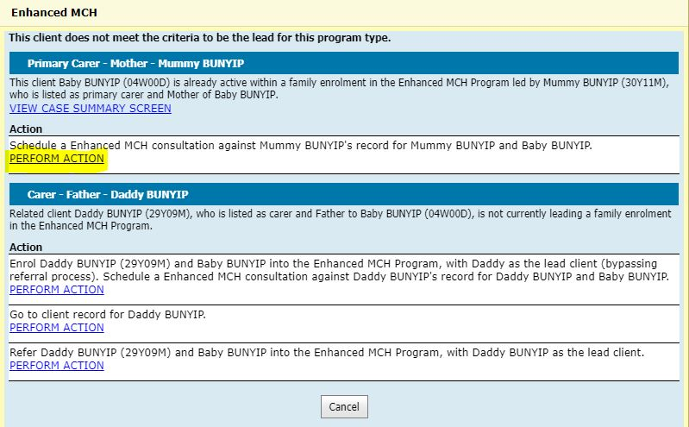
This will take you to a new Schedule appointment screen, which will be pre-set for the same date and time as the original Additional Consult appointment.
  - Add any required details to the appointment screen, and then click Save.
A popup warning box may appear, alerting you to the fact that your appointment conflicts with an existing appointment. If so, click “Yes” to continue.
In the Scheduled appointments (upcoming) section, you will now see:
- The original Additional Consult appointment in the child’s name
- A new Enhanced MCH appointment in the lead client’s name, at the same date and time
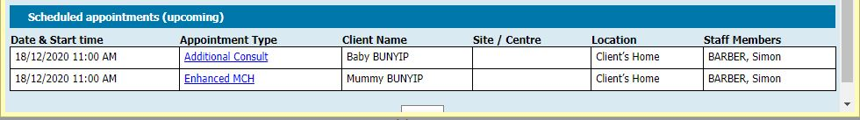
  - You may now choose to cancel the original Additional Consult appointment.

Assign case to practitioner
When you created the case at step 6.3, the case was automatically assigned to you. If you are the lead practitioner on this case, then you can skip this step.
If you are not the lead practitioner on this case (i.e. you are an administrator or a coordinator) then you should assign this case to the lead practitioner.

Access the Programs Active List (General > Programs Active List)

Filter the screen by:
- selecting “Enhanced MCH” in the Program dropdown
- selecting your username in the Clinician dropdown
- selecting “Assign Clinician” as the Action

The screen will now show all Enhanced MCH cases currently assigned to you.
- In the “Clinician” dropdown, select the name of the lead practitioner for this case.
- Click the checkbox on the left of the case you are migrating.
- Click the “Assign Clinician” button at the bottom of the screen.
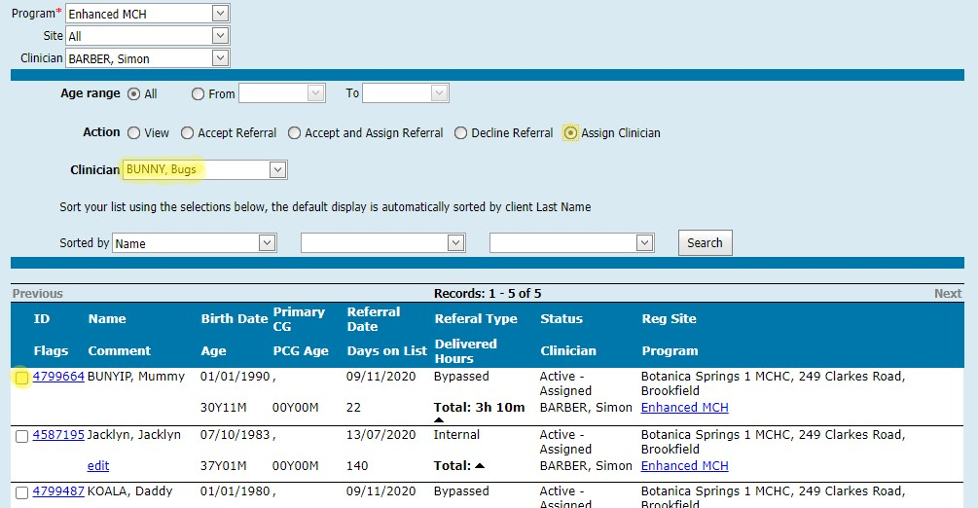

A popup box will ask you to confirm the action. Click Ok.
The case has now been reassigned.

Close case in Old Enhanced Program
Now that the case has been added to the (new) Enhanced MCH Program, it needs to be closed in the Old Enhanced MCH Program.

Access the client record of the lead client. Open the Programs screen (Clinical Activity > Programs)

Click the “Edit” button on the right of the “Old Enhanced MCH” program.
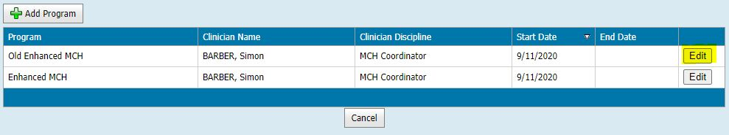

You will now be on the Edit Program screen.
- Enter today’s date into the “End / Exit Date” field.
- Click Save.

Migrating pending referrals
If a family has been referred into the Old Enhanced MCH Program but the referral is still pending, the easiest way to migrate is to reject the referral and submit a new internal referral into the (new) Enhanced MCH Program.

To receive this publication in an accessible format phone 1300 650 172, using the National Relay Service 13 36 77 if required, or email Commissioning Performance and Improvement Aged and Community Based Health Care and Cancer Services <mch@dhhs.vic.gov.au>
Authorised and published by the Victorian Government, 1 Treasury Place, Melbourne.
© State of Victoria, Australia, Department of Health and Human Services June 2020.
Except where otherwise indicated, the images in this publication show models and illustrative settings only, and do not necessarily depict actual services, facilities or recipients of services. This publication may contain images of deceased Aboriginal and Torres Strait Islander peoples.
In this document, ‘Aboriginal’ refers to both Aboriginal and Torres Strait Islander people. ‘Indigenous’ or ‘Koori/Koorie’ is retained when part of the title of a report, program or quotation.
ISBN 978-1-76096-246-3 (pdf/online/MS word)
Available at health.vic – Child Development Information System <https://www2.health.vic.gov.au/primary-and-community-health/maternal-child-health/child-development-information-system>

