Kilojoule labelling scheme Victoria
Sampling, verification and menu board surveillance
2018 / 2019

To receive this publication in an accessible format phone <1300 364 352>, using the National Relay Service 13 36 77 if required, or email <foodsafety@health.vic.go.au>
Authorised and published by the Victorian Government, 1 Treasury Place, Melbourne.
© State of Victoria, Department of Health and Human Services October 2020.
Available from the Food Safety Unit, Department of Health and Human Services

Contents
1. Background on the kilojoule labelling scheme 4
2. Introduction 4
3. Objectives of the kilojoule labelling scheme 5
4. Businesses that must comply with the scheme 5
5. Kilojoule Sampling and Menu Surveillance Programs 6
5.1 Kilojoule Menu Board Surveillance Program 6
Key points – kJ content on premises menus 9
Key points – 8700 kJ reference statement in premises 12
Online menu compliance checks 12
Key points – online menu compliance checks 15
5.2 Kilojoule Sampling and Verification Program 16
6. Results 17
6.1 Analysis of testing results 17
6.2 Analysis of kilojoule results and key findings 18
7. Conclusions 19

1. Background on the kilojoule labelling scheme
The kilojoule labelling scheme came into effect on 1 May 2018 following changes to the Victorian Food Act 1984 (the Act). These new legislative requirements are in Part ІІA of the Act - kilojoule labelling scheme (the scheme).
The Victorian Government introduced these new requirements into the Act to empower Victorian consumers to improve their health and enable them to compare the kilojoule (kJ) content of meals within, and between, large chain food outlets and to monitor and adjust their overall daily energy intake. The legislation relies heavily on the evidence and evaluation of the NSW kJ scheme. The NSW kJ labelling scheme was introduced in 2011.

2. Introduction
Kilojoule labelling is a cost effective and practical health scheme that complements a range of Victorian Government initiatives to combat preventable chronic diseases such as obesity, heart disease, diabetes, thrombosis, cholesterol, high blood pressure and some cancers. Contributing to this disease burden are increased consumption of energy-dense foods (high kJ) and reduced physical activity.
Approximately two-thirds of Victorians are either obese or overweight. Obesity is estimated to cost Victoria $14.4 billion a year when economic and social factors are considered. The scheme will assist in addressing this significant public health issue in Victoria and will be a significant addition to the efforts underway through the Victorian Healthy Choices initiative <https://www2.health.vic.gov.au/public-health/preventive-health/nutrition/healthy-choices-for-retail-outlets-vending-machines-catering>.
Kilojoule labelling aims to promote healthy food and drink options in places where people tend to spend their time. Many people are unaware that a single fast-food meal may contain most of an adult’s recommended daily kJ intake.
Implementation of the scheme has resulted in approximately 3000 Victorian chain food businesses, in addition to approximately 570 supermarkets, being captured by the scheme and required to display kJ information.
Proprietors of food premises are responsible for determining whether their business is subject to the scheme, and if any of their food products require kJ labelling.
The scheme requires large chain food outlets/restaurants and large chain supermarkets to display:
- the average kJ content of standardised, ready-to-eat food and non-alcoholic drinks on menus, menu boards, posters, food labels and price tags
  - the statement ‘The average adult daily energy intake is 8,700kJ’ on menus, menu boards and display cabinets where food is displayed for sale.
The definition of a ‘standardised food item’ is ‘a food item standardised for size and content across two or more outlets in the chain and sold at more than one outlet in the chain’. A standard food item must be prepared from a standard recipe and sold in standard serve sizes.

3. Objectives of the kilojoule labelling scheme
The following are the key objectives of the scheme:
- provide consumers with consistent and transparent kilojoule information about food and drinks at point of sale in qualifying chain food outlets
- allow consumers to compare relative kilojoule content of food and drinks for sale in qualifying chain food service outlets and between qualifying outlets
  - improve consumers’ general awareness about the recommended daily kilojoule intake and how this contributes to maintaining a healthy weight.

4. Businesses that must comply with the scheme
The scheme only applies to large ‘chain food premises’ and ‘large chain supermarkets’ that have at least 20 registered outlets in Victoria or 50 outlets nationally with at least one outlet in Victoria.
These are chain food businesses and large chain supermarkets operating under:
- franchise arrangements with a parent business
- the same trading name, brand or trademark
  - common ownership or control.
In addition to the above, supermarket chains must have a floor area greater than 1,000 square metres.
Under Section 18 of the Act, the following categories of businesses are exempt from the scheme:
- any supermarket with a floor area of 1,000 square metres or less
- cinema candy bars
- food catering services
- temporary food businesses
- mobile food businesses
- service stations selling fuel for motor vehicles
  - not-for-profit home delivery services, such as ‘meals on wheels’ services.
The following food items/categories are specifically excluded from displaying kJ information under sub-section 18C (2) of the Act:
- nuts in the shell, or raw fruit and vegetables that are usually washed, peeled or hulled by the consumer
- alcoholic beverages
- food that is available in a package on which there is a nutrition information panel within the meaning of the Australia New Zealand Food Standards Code (the Code)
  - trial or promotional food items that are available for sale for 60 days or less, available only at five or less outlets, and which have not been offered previously.

5. Kilojoule Sampling and Menu Surveillance Programs
The Department of Health and Human Services (the department) is responsible for enforcing the scheme together with local councils.
The department ran two surveillance programs in parallel over the period of 2018 to 2019. These were the Kilojoule Sampling and Verification Program and the Kilojoule Menu Board Surveillance Program. Both of these programs are explained in detail below.

5.1 Kilojoule Menu Board Surveillance Program
The Kilojoule Menu Labelling Surveillance Program (the surveillance program) undertook an evaluation of the scheme in May and June 2018. This involved conducting surveillance at food businesses captured by the scheme, in addition to other businesses that display kJ information voluntarily. The evaluation was to determine a baseline level of compliance with the scheme since its implementation on 1 May 2018.
Further surveillance was conducted one year after the inception of the scheme to evaluate the compliance rate against the baseline data collected in the first year. Surveillance took place over the period between March and May 2019.
The surveillance program included checking that the kJ content for standard food items was being displayed correctly and checking that the statement; ‘The average adult daily energy intake is 8,700 kJ’ was also being displayed correctly in the premises.

How does the average kJ content for a standard food item need to be displayed?
kJ information must be:
- expressed as kJ per item (but supermarkets can choose to display it as either per serve/item or per 100g)
- clearly legible
- displayed adjacent to, or in close proximity, to the name or price of the item
  - displayed in at least the same font size as the price, or if no price is displayed, then as the name of the food item.

How must the 8,700 kJ reference statement be displayed?
The reference statement must be:
- clearly legible
  - in at least the same font size as the name of the standard food item with the largest font, or if no name is displayed, as the price of the item.
The displayed reference statement must be:
- at least once in a prominent place on each menu that lists the standard food items
- for standard food items labelled and displayed in a cabinet, stand or area, in a prominent place, at least once, in or on that cabinet, stand or display area, so as to be clearly associated with the item(s).
Assessments were conducted at food premises by officers of the department’s Surveillance Program (a part of the Food Safety Unit) and included checking menu boards, printed menus, food tags, food labels, posters, leaflets, price tickets within the store and take away menus. The surveillance program assessed the level of compliance with the scheme and identified whether there were any particular issues.
Officers visited 32 different food business chains or franchises captured by the scheme over the 2018/2019 period. Businesses displaying kJ information voluntarily were not assessed and are therefore not within the scope of this report.
- In the period between May and June 2018, a total of 48 food premises were visited for kJ labelling assessment.
- In the period between March and May 2019, a total of 62 food premises were visited for kJ labelling assessment.
The following tables include the compliance rates for displaying the kJ content for standard food items in food premises captured by the scheme.

Menu – kJ content in premises
Table 1: Menu board – percentage complied
Year | Displayed | Legible | Numerals & kJ | Font size
2018 | 82.1 | 100.0 | 100.0 | 74.0
2019 | 100.0 | 95.2 | 90.5 | 76.2
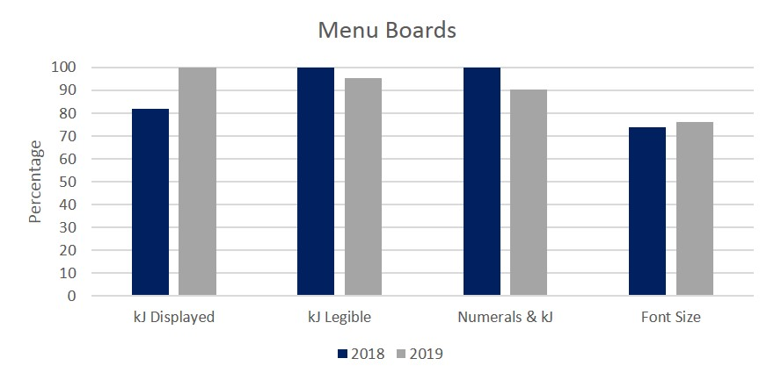
Table 2: Menu printed – percentage complied
Year | Displayed | Legible | Numerals & kJ | Font size
2018 | 75.0 | 100.0 | 100.0 | 100.0
2019 | 100.0 | 100.0 | 100.0 | 100.0
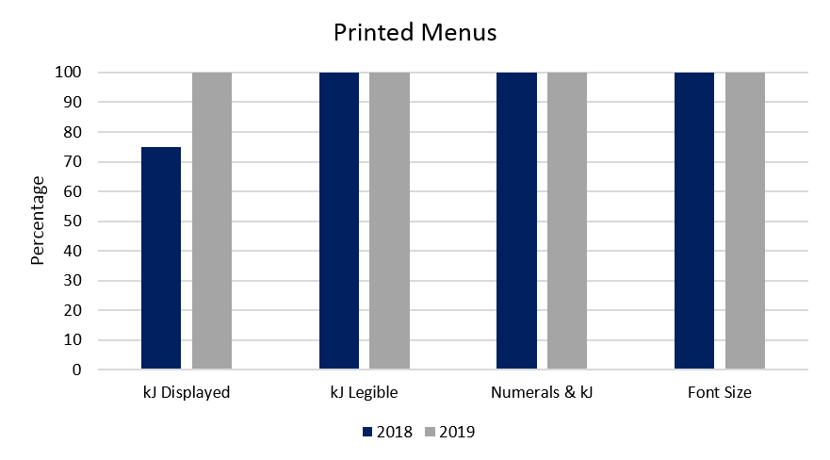
Table 3: Menu poster – percentage complied
Year | Displayed | Legible | Numerals & kJ | Font size
2018 | 75.0 | 100.0 | 100.0 | 100.0
2019 | 100.0 | 100.0 | 100.0 | 100.0

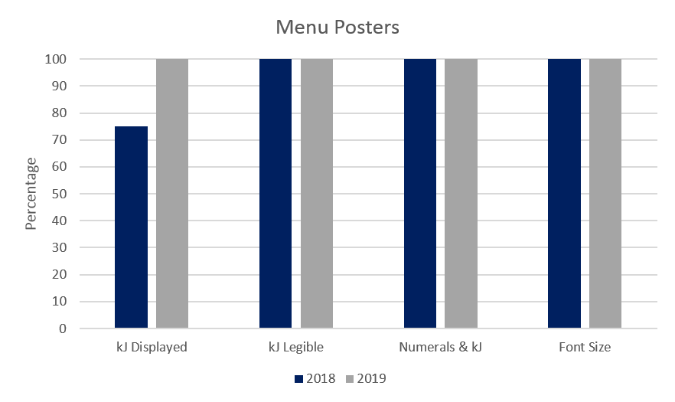

Table 4: Food tags – percentage complied 2018
Year | Displayed | Legible | Numerals & kJ | Font size
2018 | 76.2 | 100.0 | 100.0 | 93.8
2019 | 72.7 | 100.0 | 100.0 | 87.5

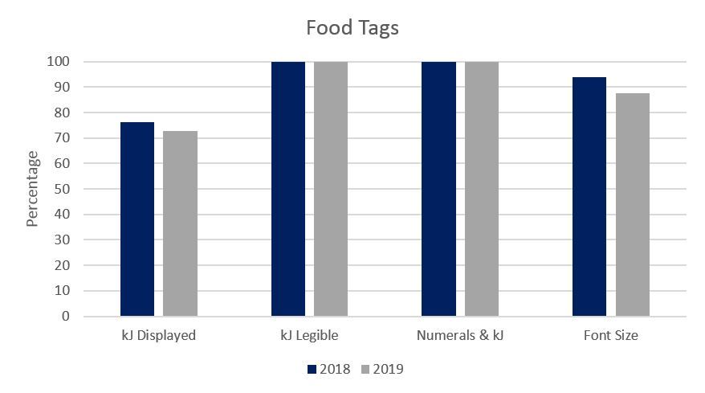

Key points – kJ content on premises menus
- There was an increase in the kJ content for standard food items being displayed on menu boards in premises that were checked for compliance. This increased from 82.1 per cent kJ content displayed in 2018 to 100.0 per cent kJ content displayed in 2019
- kJ content displayed on printed menus increased from 75.0 per cent kJ content displayed in 2018 to 100.0 per cent kJ content displayed in 2019
- kJ content displayed on menu posters also increased from 75.0 per cent kJ content displayed in 2018 to 100.0 per cent kJ content displayed in 2019
- the increase in the number of food premises displaying kJ content on their menu boards, printed menus and menu posters is a very satisfactory result
  - there was a slight decrease in food tags or labels displaying the kJ content; down from 76.2 per cent kJ content displayed in 2018 to 72.7 per cent kJ content displayed in 2019. This variability could possibly be due to food tags and labels being changed more frequently than menu boards and printed menus.
The following tables include the compliance rates for displaying the ‘8,700 kJ reference statement’ in food premises that are captured by the scheme.

Menu – 8,700 kJ reference statement in premises
Table 5: Menu board – percentage complied 2018
Year | Displayed | Legible | Prominent | Font size
2018 | 65.4 | 100.0 | 100.0 | 82.4
2019 | 100.0 | 83.3 | 94.4 | 55.6
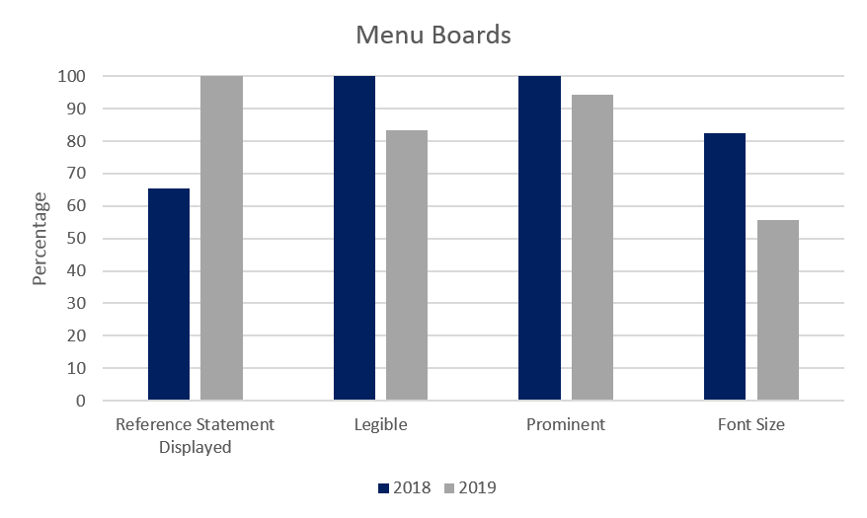
Table 6: Menu printed – percentage complied 2018
Year | Displayed | Legible | Prominent | Font size
2018 | 75.0 | 100.0 | 66.7 | 100.0
2019 | 100.0 | 100.0 | 100.0 | 50.0
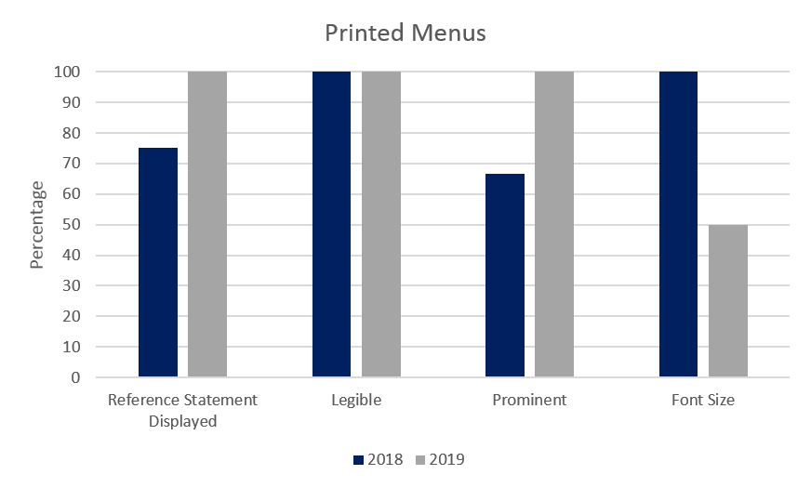
Table 7: Menu poster – percentage complied 2018
Year | Displayed | Legible | Prominent | Font size
2018 | 75.0 | 100.0 | 100.0 | 100.0
2019 | 100.0 | 100.0 | 100.0 | 100.0
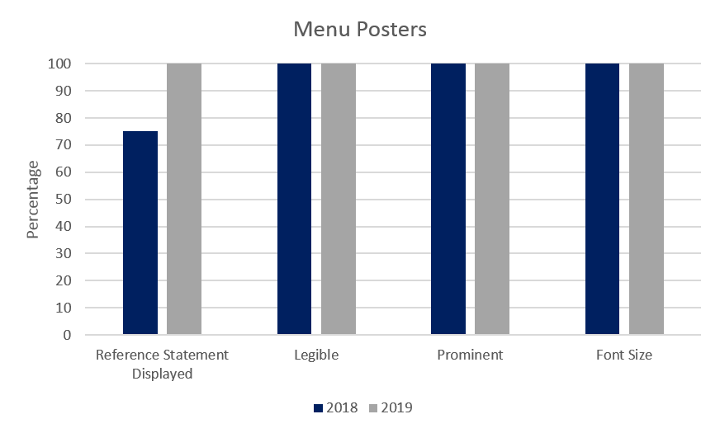

Table 8: Display cabinet – percentage complied 2018
Year | Displayed | Legible | Prominent | Font size
2018 | 45.5 | 100.0 | 100.0 | 100.0
2019 | 58.3 | 100.0 | 100.0 | 100.0

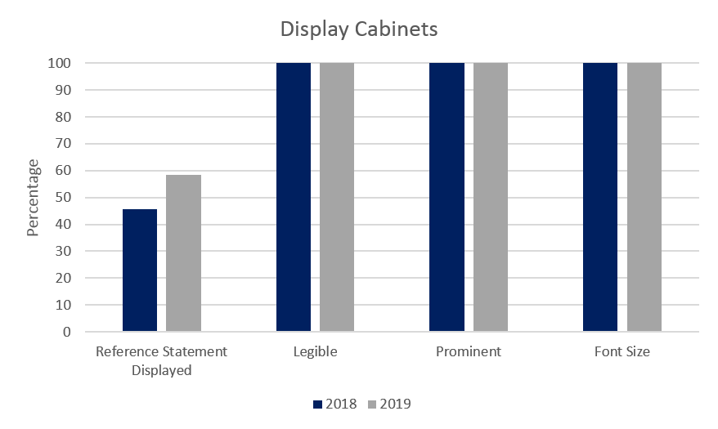

Key points – 8700 kJ reference statement in premises
- The presence of the ‘8,700 kJ reference statement’ on menu boards in food premises attended increased from 65.4 per cent of premises in 2018 to 100.0 per cent of premises in 2019 which is an excellent result
- The presence of the ‘8,700 kJ reference statement’ increased from 75.0 per cent compliance in 2018 to 100.0 per cent compliance in 2019 for both printed menus and posters
- The increase in the occurrence in the number of food premises displaying the ‘8,700 kJ reference statement’ on their menu boards, printed menus and menu posters is a very satisfactory result
- There was a slight increase in the presence of the ‘8,700 kJ reference statement’ on display cabinets; up from 45.5 per cent in 2018 to 58.3 per cent in 2019. It must be noted that in most food premises, the reference statement was also prominent on the main menu board.

Online menu compliance checks
The department also conducted compliance checks of online menus (including downloadable PDFs from websites) of chain food businesses in addition to the on-site compliance checks.
Many of these websites have dedicated nutrition pages, which include kJ information on their menu items. Some of these websites include kJ/nutrition information in a PDF that can be downloaded by the customer. Other websites have interactive menus where the customer may have to scroll through different pages to get to the kJ information on the product that they are interested in.
Some, but not all of these websites, allow the customer to purchase food items directly through the online portal. Investigating the ordering platforms of chain food businesses or ‘third-party’ websites was not in the scope of this investigation.
- In the first year (2018) of the scheme coming into force, a total of 52 food business websites captured by the scheme were checked.
- In 2019, a total of 89 food business websites captured by the scheme were checked.

On-line menu – kJ content checks
Table 9: On-line PDF menu – percentage complied
Year | Displayed | Legible | Numerals & kJ | Font size
2018 | 94.4 | 100.0 | 100.0 | 94.1
2019 | 100.0 | 100.0 | 100.0 | 40.0
On-line PDF menu – percentage complied 2019
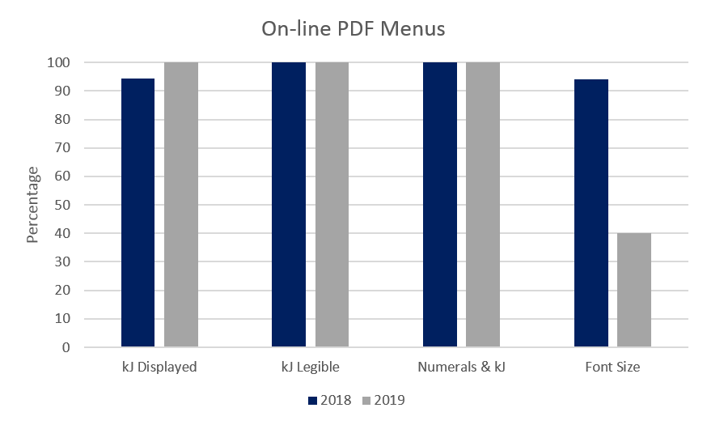
Table 10: On-line Interactive menu – percentage complied 2018
Year | Displayed | Legible | Numerals & kJ | Font size
2018 | 75.0 | 100.0 | 100.0 | 63.3
2019 | 79.0 | 100.0 | 100.0 | 46.7
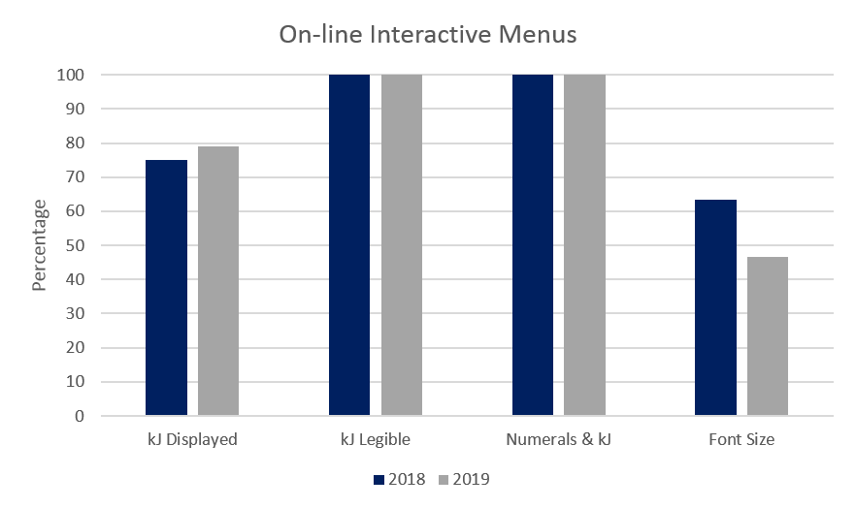

On-line menu – 8,700 kJ reference statement
Table 11: On-line PDF menu – percentage complied 2018
Year | Displayed | Legible | Prominent | Font size
2018 | 50.0 | 100.0 | 100.0 | 75.0
2019 | 60.0 | 100.0 | 100.0 | 100.0

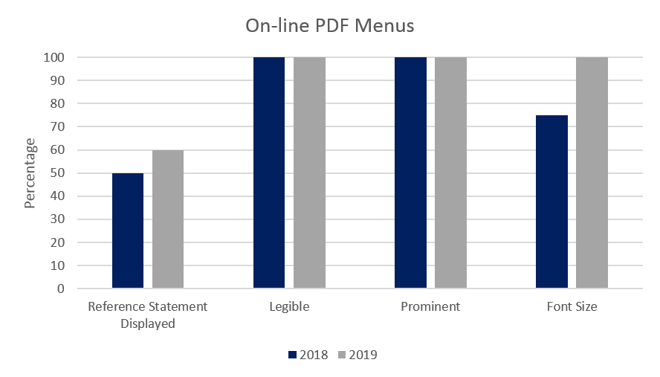

Table 12: On-line Interactive Menu – percentage complied 2018
Year | Displayed | Legible | Prominent | Font size
2018 | 29.3 | 100.0 | 90.9 | 54.5
2019 | 34.2 | 100.0 | 78.6 | 50.0
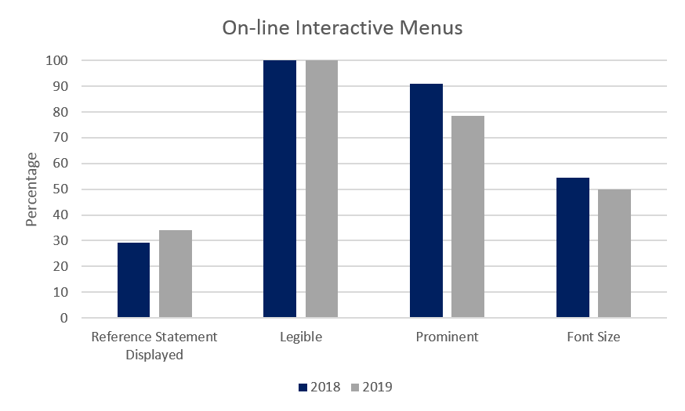

Key points – online menu compliance checks
- Approximately 30 per cent of the chain food businesses captured by the scheme provided kJ/nutrition information in PDF format that could be downloaded by the consumer.
- The frequency of PDF menus displaying the kJ content for standard food items increased from 94.4 per cent in 2018 to 100.0 per cent in 2019. This is an excellent result.
- Online interactive menus displaying the kJ content for standard food items increased from 75.0 per cent in 2018 to 79.0 per cent in 2019. This is a satisfactory result.
- It has also been observed that navigation and presentation of nutrition and kJ information for some food brands’ web pages is constantly changing; in many cases, the information was different each time it was checked.
- The frequency of online PDF menus displaying the ‘8,700 kJ reference statement’ in the correct format increased from 50.0 per cent in 2018 to 60.0 per cent in 2019. This figure would have been higher, but in many cases, websites included a statement relating to the average kJ intake but reworded the reference statement. So, the information was there, but technically not with the correct wording.
- Interactive online menus are a difficult area to assess. These menus are constantly changing, and in many cases, it was necessary to click through numerous pages to find the necessary information. In many instances, the ‘8,700 kJ reference statement’ had been included somewhere on the website, but not on every page.

5.2 Kilojoule Sampling and Verification Program
The public has an expectation that displayed kJ values, such as on menu boards and food tags, correspond with the actual kJ content of the food item.
The aim of the Victorian Sampling and Verification Program (the sampling program) is to determine whether chain food businesses are complying with the scheme and, where there is non-compliance, the extent and type of non-compliance. Sampling in the first year of the scheme occurred between May and June 2018.
Further sampling of standard food items was conducted one year after the inception of the scheme to evaluate the compliance rate against the baseline data collected in the first year. Surveillance took place over the period between April and May 2019.
It is proposed that periodic and ongoing sampling of food items be undertaken as part of the sampling program. This may be subject to Department of Health and Human Services budget constraints.

5.2.1.Sampling methodology
The sampling program was established to support the kJ labelling legislation and to ascertain business compliance and identify any issues arising with the introduction of the scheme.
During May and June 2018, authorised officers of the Food Safety Unit visited 24 food premises and purchased 74 standard food items for kJ sampling analysis In April and May 2019, authorised officers of the Food Safety Unit visited 17 food premises and purchased 70 standard food items for kJ sampling analysis. The chain food businesses and the types of food items that were selected and purchased for kJ sampling were based on the following criteria:
- the number of premises predominantly registered in Victoria, but also taking into account the number of stores nationally
- the types of food items selected had to conform to certain constraints that were specified by the testing laboratory, including that the minimum weight per item required to effectively test for kJ content was 100g per sample
- the food items that were selected had to be ‘standardised’ food items to ensure consistency
  - consideration of the ease of sampling and transporting each food item to the laboratory.

5.2.2 Product sampling
The aim of the sampling regime was to select three items from the menu of each chain food business and purchase the same three items from separate outlets. The purpose of this was to determine whether the kJ content was consistent for the same product prepared and sold at different outlets for the same chain food business.
When attending the food premises to purchase food samples, the following details were recorded, and actions taken:
- the name and address of the store/business and date of sampling
- the name of the food item and the kJ value stated (for example, either from the menu board, food tag, poster)
- a photograph was taken of the food item and its kJ value
- if there was a takeaway menu available, this was also collected
- the food item was placed in a sampling bag, sealed and labelled with the appropriate details
  - the food samples collected were placed into an insulated carrier and delivered to a NATA accredited laboratory for kJ analysis
  - the average energy content of a standard food item was determined in accordance with Standard 1.2.8 of the Code
  - the kJ value of each of the food items sampled was checked on the individual food business’ website if this information was available.
The testing laboratory reported the kJ content of each food item as ‘kJ per serve’ and ‘kJ per 100g’.

6. Results
All details relating to each food item, including the actual kJ value obtained from the testing, the claimed kJ content from the in-store menu, and the claimed kJ content on-line were recorded on the ‘kJ sampling results’ database.

6.1 Analysis of testing results
The kJ content of each food item determined by the laboratory analysis was compared to the claimed kJ value provided by the food business on the day of sampling, and included:
- the kJ value (per serve) printed, for example, on menu boards, food tags, posters
- the kJ value obtained from the company website (where available)
  - the kJ value stated on takeaway printed menus (if available).
Standard 1.2.8 of the Code does not prescribe accuracy requirements relating to nutrition information.
As there is no tolerance prescribed in the Code, the department used a variance of 20 per cent as the benchmark for categorising a pass or fail for each menu item.
The department determined that the kilojoule content was ‘out of specification’ if the actual kJ value differed by more than 20 per cent from the kJ value stated, for example, on the menu board or food tag on the day of sampling.
The tolerance of 20 per cent was determined by taking into consideration limits that other states in Australia had used in conducting kJ sampling analysis, in addition to international regulations and guidelines. For instance, the NSW Food Authority has used a tolerance of 20 per cent in previous kJ sampling programs and the US Food and Drug Administration uses a tolerance of 20 per cent in the United States Code of Federal Regulation - 21 CFR 101.9(g) in relation to label values relating to energy, saturated fat, sodium and nutrients.
The following tables include the proportion of standard food items that were above the tolerance benchmark figure. The information is displayed according to each individual food business chain. The business names have been intentionally de-identified.
Table 13: kJ sampling – standard food items 2018
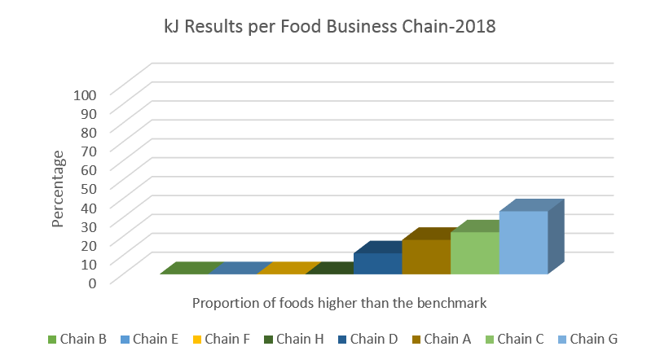
Table 14: kJ sampling – standard food Items 2019
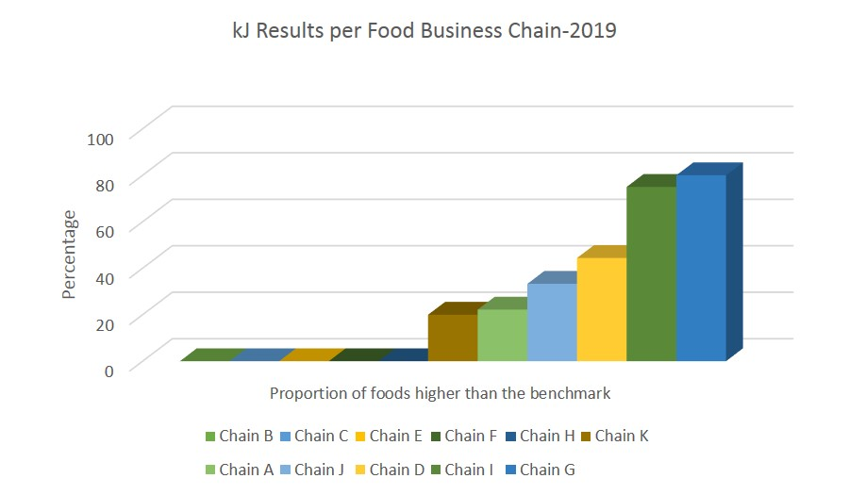
Note: There is no correlation between chains identified in tables 13 and 14.

6.2 Analysis of kilojoule results and key findings
Listed below are the key findings of the kJ Sampling Verification Program.
- In 2018, eight different food business chains were visited, and 74 food samples were collected for kJ analysis. Of these standard food items 78 per cent were within the allowable tolerance.
- Of the chains visited in 2018, 50 per cent were within the tolerance limits for food items sampled.
- In 2019, eleven different food business chains were visited, and 70 food samples were collected for kJ analysis. Of these standard food items 62.8 per cent were within the allowable tolerance.
- Of the chains visited in 2019, 45.5 per cent were within the tolerance limits for food items sampled.
- Most of the sampled food items met the guideline limit for energy, but there were results that point to errors in calculation of the kJ information.
- In Table 2, chains ‘I’ and ‘G’ were new chains that were not sampled in 2018. It should be noted that five samples or less were purchased from each of these chains, so it cannot be assumed that the remainder of their menu items would be outside the allowable tolerance.
  - In some of the chains that had a higher level of non-compliance, it was observed during the preparation of food items at their premises that there appeared to be a degree of variation in the preparation and assembly of each food item. This may have had an effect on the kJ value of the food item.

7. Conclusions
The kJ menu surveillance program was conducted to ascertain the level of compliance in large chain food premises that are required to comply with changes to the Act that came into effect on 1 May 2018. Surveillance was conducted shortly after the scheme came into effect. Approximately one year later in April/May 2019 further surveillance was undertaken to compare results against the baseline results obtained in 2018.
Over the course of 2018 and 2019, officers of the Food Safety Unit visited thirty-two (32) different food business chains or franchises that are captured by the kJ labelling scheme. In total, one hundred and ten (110) premises were visited to check compliance over that period.
It was observed that some food businesses that are not captured by the scheme are also voluntarily displaying kJ information. These businesses are not subject to analysis as they do not need to comply with any of Part ІІA of the Act. Food businesses displaying kJ information voluntarily are not within the scope of this report.
In the first year, over 80 per cent of the menu boards in large chain food businesses captured by the scheme displayed the kJ content of standard food items. In 2019, 100 per cent of food premises that were visited were displaying kJ information which is a very good result.
There were minor issues related to the size and font of the kJ content and the reference statement labelling, but compliance was generally quite high.
In printed menus and posters, the kJ content of standard food items displayed increased from 75 per cent in 2018 to 100 per cent in 2019 for both.
On food tags and labels, the kJ content of standard food items displayed varied, most likely due to food tags and labels changing more frequently than the main menu board. The proportion that displayed the kJ information decreased slightly from 76.2 per cent in 2018 to 72.7 per cent in 2019.
The ‘8,700 kJ reference statement’ being displayed on menu boards increased from 65.4 per cent in 2018 to 100 per cent in 2019.
The ‘8,700 kJ reference statement’ being displayed on food display cabinets increased slightly from 45.5 per cent in 2018 to 58.3 per cent in 2019. It must be noted that in most of these food premises, the reference statement was prominent on the main menu board.
Website compliance varied. Over the period between June 2018 and March 2019, a total of one hundred and forty-one (141) websites were reviewed. It was encouraging that 100 per cent of food business websites that provided nutrition/kJ information in PDF format displayed the kJ content for standard food items. This was up from 94.4 per cent in 2018. This is very encouraging.
Interactive on-line menus on food businesses’ websites displayed the kJ content for standard food items in 100 per cent of cases, up from 75 per cent in 2018.
The display of the ‘8,700 kJ reference statement’ on websites was not shown as frequently. Online PDF menus displaying the reference statement increased from 50 per cent in 2018 to 60 per cent in 2019.
It was noted that food businesses’ websites were constantly changing, most likely driven by the marketing divisions of each business. In some instances, the information and the way it was presented was different every time it was checked.
The kJ Sampling and Verification Program was established to assess the kJ content of a sample of standardised food items purchased from large chain food premises that are required to comply with the scheme.
In 2018, eight food business chains were targeted for food sampling and a total of seventy-four food (74) samples were collected. Approximately 78 per cent of these samples were within the allowable tolerance limits.
In 2019, eleven food business chains were selected for the kJ sampling program, but not all of these were the same businesses as those selected in 2018. Seventy (70) food samples were collected for kJ analysis, with approximately 63 per cent of these food items within the allowable tolerance limits.
The variability of the results obtained between 2018 and 2019 is most likely due to different food businesses being targeted and different food types being sampled. There did not appear to be any particular trend between food types. In future, a larger sample size may identify any particular trends.
As mentioned previously, there was variation observed in the preparation and assembly of some ‘standard food items’, which would have an effect on the final kJ result. It is also questionable if some of the items were in fact standard food items due to the variability of the food items between stores of the same chain.

Recommendation 1:
Subject to budget availability, conduct further menu board surveillance in chain food businesses in the next twelve months to determine whether there has been an improvement in the kJ content labelling and the display of the ‘8700 kJ reference statement’.

Recommendation 2:
Subject to budget availability, conduct further food sampling in future, preferably with a larger sample size, to determine if there has been an improvement in the accuracy of labelling of kJ content in standard food items, and to identify any trends.

Recommendation 3:
The Department of Health and Human Services to provide further support to food businesses if required in future, so that they can improve their kJ menu labelling compliance.

