Vaxelis® vaccine
Factsheet for Immunisation providers July 2023

OFFICIAL

Summary
- From 1 July 2023, the hexavalent (6-in-1) vaccine, Vaxelis® will be added to the National Immunisation Program (NIP) schedule.
- Vaxelis® is used for primary vaccination against diphtheria, tetanus, pertussis, hepatitis B, poliomyelitis and invasive infections caused by Haemophilus influenzae type b (DTPa-hepB-IPV-Hib).
- Vaxelis® is being made available as an alternative hexavalent NIP-funded vaccine to the currently listed Infanrix® hexa, and not as a replacement vaccine.
- There is no preferential recommendation between the use of these two brands.
- The preparation of Vaxelis® and Infanrix® hexa differs.
- Prior to vaccination, immunisation providers should check a child’s immunisation record to determine the DTPa-hepB-IPV-Hib vaccine brand used in any previous primary doses, given elsewhere.
- A primary series of DTPa-hepB-IPV-Hib vaccination should be given using the same vaccine brand where possible.
- The Australian Immunisation Handbook will be updated from 1 July 2023 to reflect vaccine recommendations for Vaxelis®.

Vaxelis® vaccine

Vaxelis® eligibility
Vaxelis® is used for primary vaccination against diphtheria, tetanus, pertussis, hepatitis B, poliomyelitis and invasive infections caused by Haemophilus influenzae type b (DTPa-hepB-IPV-Hib) for children at 2 (from 6 weeks), 4 and 6 months of age.
Vaxelis® is also suitable and funded for use in children less than 10 years of age who have not previously received DTPa-hepB-IPV-Hib vaccination (catch-up vaccination).

National Immunisation Program Schedule
From 1 July 2023, the hexavalent vaccine Vaxelis®, will be added to the National Immunisation Program (NIP) schedule giving immunisation providers an option of two brands of vaccine to protect against DTPa-hepB-IPV-Hib.
Table 1. DTPa-hepB-IPV-Hib vaccine changes to the National Immunisation Program schedule from 1 July 2023
NIP dosing schedule for (DTPa-HepB-IPV-Hib) vaccine: | Current brand option  (up to 30 June 2023) | New brand option/s  (from 1 July 2023)
Dose 1:  2 months (from 6 weeks of age) | Infanrix® hexa (0.5mL) | - Infanrix® hexa (0.5mL)  - Vaxelis® (0.5mL)
Dose 2:  4 months | Infanrix® hexa (0.5mL) | - Infanrix® hexa (0.5mL)  - Vaxelis® (0.5mL)
Dose 3:  6 months | Infanrix® hexa (0.5mL) | - Infanrix® hexa (0.5mL)  - Vaxelis® (0.5mL)
Under 10 years (catch up) * | Infanrix® hexa (0.5mL) | - Infanrix® hexa (0.5mL)  - Vaxelis® (0.5mL)
*In children aged <10 years, the number of doses administered is influenced by the age at which they start catch-up vaccination, the number of doses needed, and the minimum intervals between doses according to the Australian Immunisation Handbook.

Vaxelis® administration
Vaxelis® vaccine is administered as an intramuscular (IM) injection. The recommended injection sites are the anterolateral area of the thigh (preferred site for infants under one year of age) or the deltoid muscle of the upper arm.

Vaxelis® preparation
The preparation of Vaxelis® and Infanrix® hexa differs:
Infanrix® hexa | Vaxelis®
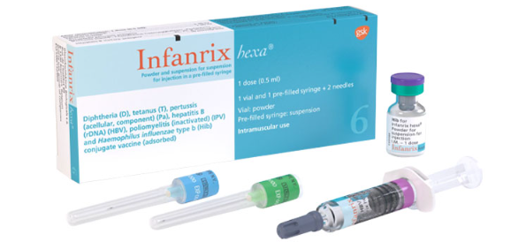  - Supplied as a single dose 0.5 mL pre-filled syringe  - Prefilled syringe of DTPa-hepB-IPV and a vial containing a lyophilised pellet.  - Vial contains Haemophilus influenzae type b  - Reconstitution required  - Light sensitive | 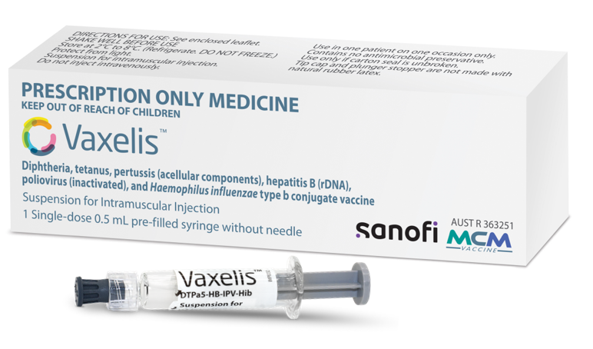  - Supplied as a single dose 0.5mL pre-filled syringe with a luer lock connection  - Prefilled syringe of DTPa-hepB-IPV-Hib  - Reconstitution not required  - Light sensitive

Always check that vaccines are prepared and administered appropriately in accordance with product instructions and official recommendations. Refer to the Australian Immunisation Handbook for advice.

Vaxelis® & Infanrix® hexa interchangeability
A primary course of DTPa-hepB-IPV-Hib vaccination should be given using the same vaccine brand (e.g., three doses of Vaxelis® or three doses of Infanrix® hexa). If this is not possible, providers may use the alternative brand to complete the vaccine course.
Prior to administration, immunisation providers should check the child’s immunisation history, to determine the vaccine brand used in any previous primary doses that were given elsewhere.

Vaxelis® co-administration
When co-administering Vaxelis® with other injectable vaccines, separate injection sites, preferably on separate limbs must be used.
Vaxelis® product information advises that the vaccine can be co-administered with:

- pneumococcal polysaccharide conjugate vaccines
- rotavirus vaccines
- measles, mumps, rubella (MMR) and varicella containing vaccines (live virus vaccines)
- meningococcal C conjugate vaccines
- meningococcal serogroup C

Please refer to the Australian Immunisation Handbook for further advice regarding co-administration. The

handbook will be updated from 1 July 2023 to reflect vaccine recommendations for Vaxelis®.

Vaccine side effects
In clinical trials with Vaxelis®, the most frequently reported adverse events were:

- irritability
- crying
- drowsiness
- injection site reactions (pain, erythema, swelling)
- fever >+38°C
- decreased appetite
- vomiting

All adverse events following immunisation should be reported to Victoria’s vaccine safety service SAEFVIC.

Vaccine storage requirements
Vaxelis® is light sensitive and must be stored in its original packaging to protect from light in a purpose-built vaccine refrigerator between +2°C – + 8°C.
Ensure all staff receiving and storing vaccines are familiar with the National Vaccine Storage Guidelines – Strive for five. It is also recommended they complete the relevant Department of Health’s (the department) eLearning cold chain modules.

Avoid vaccine errors
Vaccine errors can occur when a vaccine is incorrectly stored, prepared or given outside the current clinical guidelines, potentially resulting in an Adverse event following immunisation (AEFI)
Tips to avoid a vaccine error:
- ensure Vaxelis® is stored separate from vaccines with similar brand names e.g., Varivax®, Varilrix®.
- recognise and report cold chain breaches to the department in a timely manner.
- be familiar with the six steps to prevent vaccine errors - right person, right vaccine and preparation, right dose, right time, right route and site and right documentation.
- refer to the department’s vaccine error management web page for further information.

Vaccine ordering
There is no change to vaccine ordering requirements, including DTPa-hepB-IPV-Hib vaccines. Immunisation providers should continue to order through the Onelink online platform, using their login.
NIP funded DTPa-hepB-IPV-Hib stock prioritisation*:
- Infanrix® hexa has been prioritised for councils and hospitals.
- Vaxelis® has been prioritised for all other immunisation providers.

*Prioritisation is to assist with stock supply, presentation splits and brand availability to complete the DTPa-hepB-IPV-Hib vaccination course with the same brand of vaccine. Where an immunisation provider requires the alternative brand to complete a vaccination course, they can request the appropriate via the Onelink online ordering platform.

Immunisation service provider requirements
Report all vaccinations administered to AIR
Immunisation providers must report all NIP vaccinations given to the Australian Immunisation Register (AIR). Ensure clinical practice software reporting program is updated to include Vaxelis®.
Vaccine/Brand Name | Vaccine Code
Vaxelis® | VAXLIS

Update immunisation service information
Where applicable, update immunisation resources to reflect the introduction of Vaxelis® to the NIP.
Further information?
Please email the Immunisation Unit <immunisation@health.vic.gov.au if you have any further enquiries.

Resources
- Department of Health Victoria - Immunisation
- Australian Government Department of Health and Aged Care – Immunisation
- Australian Immunisation Register vaccine code formats
- Australian Immunisation Handbook - Vaxelis® product information
- Better Health Channel – childhood immunisation

To receive this document in another format, email Immunisation Unit <immunisation@health.vic.gov.au>. Authorised and published by the Victorian Government, 1 Treasury Place, Melbourne. © State of Victoria, Australia, Department of Health, July 2023.

