Ban on smoking and vaping at outdoor skate parks
Information for residents of and visitors to Victoria

By law, smoking and the use of e-cigarettes (vaping) is banned within 10 metres of all skate parks (about two car lengths) in outdoor public places in Victoria.

Where does the ban apply?
Under this law, skate parks are defined as being an area specifically designed and equipped with structures for rollerblading, roller-skating and skateboarding or the use of BMX or non-motorised scooters.
The ban applies to outdoor drinking areas that are situated within 10 metres (about two car lengths) of an outdoor skate park.
This diagram shows an example of where the smoking and vaping ban applies.
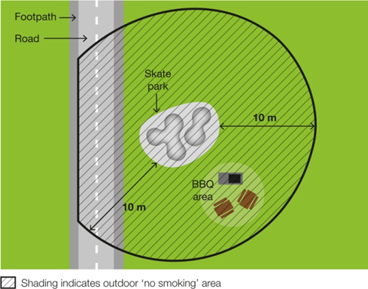

Why does the ban exist?
To protect children and young people from the dangers of second-hand smoke and the aerosol from e-cigarettes
Skate parks attract young people and families with children. This ban creates a smoke-free and vape-free place where children and young people can enjoy themselves without being exposed to harmful second-hand tobacco smoke and the aerosol from e-cigarettes.
Second-hand tobacco smoke exposure is particularly dangerous for children and young people because they have smaller airways and less developed immune systems compared to adults.
To reduce the role modelling of smoking and vaping behaviours around children and young people
Children and young people are more likely to view smoking and vaping as socially acceptable when they regularly see people smoking and vaping. Banning smoking and vaping in areas used by children and young people will help to de-normalise smoking and vaping behaviour and discourage children and young people from taking up smoking and vaping.

Where does the ban not apply?
The ban does not apply to a person:
- at a residential premises (at privately owned homes and land)
- in a motor vehicle that is being driven past the skate park
- in an area that is separated from the skate park by a road.

How will people know about the ban?
Signs will be displayed in the smoke-free and vape-free area.

How will the ban be enforced?
There is strong community support for banning smoking and vaping at public places regularly attended by children. This means most people will voluntarily comply with the smoking and vaping ban and expect others to do so.
Inspectors authorised under the Tobacco Act 1987 may also provide information about and, when necessary, enforce the ban and issue a fine. The first goal of the inspectors is to make sure smokers and vapers understand the ban.
Inspectors may not be available to respond to every complaint, but where circumstances allow, may attend in response.

What penalties might apply?
The maximum penalty for someone breaking this law is five penalty units, with an infringement penalty of one penalty unit.

How can I find out more?
For more information:
- visit the tobacco reforms website <www.health.vic.gov.au/public-health/tobacco-reforms>
- call the Tobacco Information Line on
1300 136 775.
To view the legislation visit the Victorian Government’s legislation website <www.legislation.vic.gov.au> and search Tobacco Act 1987.
To receive this document in another format, phone 1300 136 775, using the National Relay Service 13 36 77 if required, or email tobacco.policy@health.vic.gov.au
Authorised and published by the Victorian Government, 1 Treasury Place, Melbourne.
© State of Victoria, Australia, Department of Health, November 2023.
Except where otherwise indicated, the images in this document show models and illustrative settings only, and do not necessarily depict actual services, facilities or recipients of services.
DISCLAIMER: Please note that any advice contained in this factsheet is for general guidance only. The Department of Health does not accept any liability for any loss or damage suffered as a result of reliance upon the advice contained in this factsheet. Nothing in this factsheet should replace seeking appropriate legal advice.
ISBN 978-1-76131-092-8 (pdf/online/MS word)
Available at tobacco reforms website <www.health.vic.gov.au/public-health/tobacco-reforms>

Section 5RG(1) of the Tobacco Act 1987.
For current penalty unit values, visit the Department of Treasury and Finance website <www.dtf.vic.gov.au/financial-management-government/indexation-fees-and-penalties>

