Tobacco retailers fact sheet

Q1 What is the new law regarding displaying tobacco products?
From 1 January 2011, the display of tobacco products and packaging is banned in retail outlets.
Tobacco products must not be visible from anywhere inside or outside a retail outlet. Tobacco products include cigarettes, cigars and loose tobacco. The ban applies to vending machines.
An exemption applies to on-airport duty free shops and certified specialist tobacconists.

Q2 Can I still sell tobacco products even though I can not display them?
Yes.
You can still sell tobacco products, but they must not be visible from anywhere inside or outside your retail outlet.

Q3 How can I prevent people from seeing tobacco products in my retail outlet?
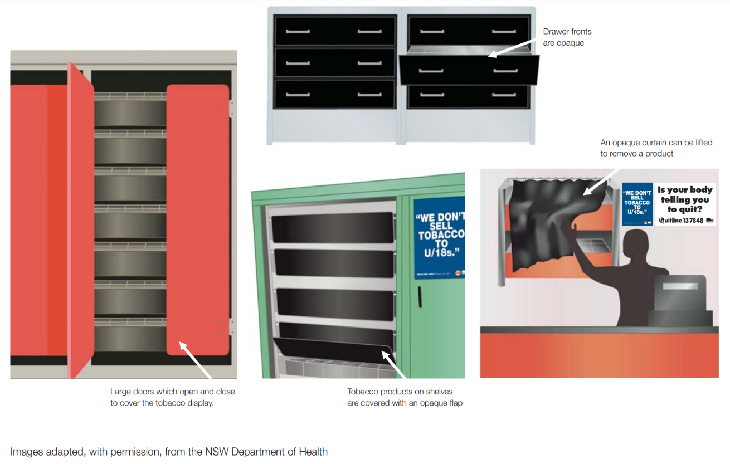
There are a number of ways to cover or remove tobacco products completely out of view. The following diagrams show different examples:

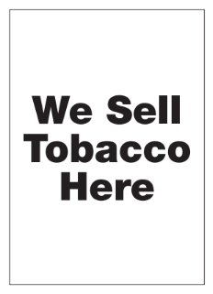
Q4 How will people know I sell tobacco products?
You will be able to display an A4 size prescribed sign (pictured on right) which shows that you sell tobacco.
The sign will be produced by the Victorian Government and will be available from 1 December 2010 at <www.health.vic.gov.au/tobaccoreforms>, by telephoning the Tobacco Information Line on 1300 136 775, or by emailing tobacco.policy@health.vic.gov.au
Q5 How will people know what tobacco products I have for sale and how much they cost?
You may use one prescribed price board to advise customers of products available for sale. Further information about price boards will be provided in the updated Tobacco Retailer Guide which will be forwarded to all known tobacco retailers in late 2010.
Q6 How can I prevent people from seeing tobacco products when I open a cabinet to serve a customer or re-stock my shelves?
Retailers are expected to take all reasonable measures to prevent the visibility of tobacco products. For example, if cigarettes are stored in a cupboard, the cupboard doors must be closed as soon as the tobacco product has been removed.
Q7 Why is the display of tobacco products being banned?
Currently, tobacco products are more visible and widely available than any other consumer product, creating the impression that smoking is more popular than it actually is. This high visibility makes it more likely that young people will start smoking and makes it harder for people to quit smoking.
Current point-of-sale restrictions are detailed and often difficult for retailers to understand. These reforms will make it much simpler for retailers to ensure that they comply with the law.
Q8 What are the penalties?
Breach of tobacco law | Infringement notice |  | Maximum penalties – Magistrates Court
 | Natural person | Body corporate | Natural person | Body corporate
Incorrect display of tobacco product or price board, including non-display of Graphic health warning sign | 3 Penalty Units | 30 Penalty Units | 60 Penalty Units | 300 Penalty Units
Penalty units are indexed annually. For current penalty unit values, visit the Department of Treasury and Finance website <https://www.dtf.vic.gov.au/financial-management-government/indexation-fees-and-penalties>

For further information please call the Tobacco Information Line or visit <https://www.health.vic.gov.au/tobaccoreforms>

DISCLAIMER: Please note that any advice contained in this fact sheet is for general guidance only. The Department of Health does not accept any liability for any loss or damage suffered as a result of reliance upon the advice contained in this fact sheet. Nothing in this fact sheet should replace seeking appropriate legal advice.

