CDIS transfer process
Victorian Maternal and Child Health (MCH) Child Development Information System (CDIS)
Updated December 2020

Contents
Overview 1
Change client record site process 2
Change client record site 2
Check and update client details 2
Check and update client address 2
Check and update primary caregiver details 3
Transfer in from a CDIS MCH Service provider 3
Permission given by primary caregiver to transfer client record 3
Search, select and transfer client record 3
Check that client record is open 4
Check client consent has been recorded for the Victorian MCH service 4
Check and update client details 4
Check and update client address 5
If an incorrect client record is transferred in from a CDIS MCH Service provider 5
Using the ‘MCH Service provider Transfer History’ screen 5
Hint! 6

Overview
CDIS transfers are always performed from the new site or MCH Service provider.
Only transfer in.
The client record remains at the previous site or MCH Service provider until primary caregiver permission has been given to transfer the client record to the new site or MCH Service provider
This ensures that a client will continue to receive appointment reminders from the previous site or MCH Service provider until they engage with the new site or MCH Service provider – therefore increasing MCH engagement.

Change client record site process
This was previously referred to as ‘Internal Transfers’
Note: As per MCH service guidelines (2019):
The child client record remains at the previous MCH service site until the primary caregiver gives permission to transfer the child to another MCH service.
Specific permission needs to be given for others listed in client relationships, this includes parents, siblings and carers.

Change client record site
- From the CDIS Details (child) screen, open the ‘Client Details’ menu and select ‘Open/Change/Close Client’.
- In ‘Current Service Summary’, Select the ‘Update’ button
- In the ‘Open Change Close’ pop up box:
    - Change is selected by default
    - Under Site, select from look-up list or type first 3 letters of site and pick relevant site
    - Select ‘Save’

Check and update client details
- From the CDIS Details (child) screen, open the ‘Client Details’ menu and select ‘Update Client Details’
- Check details and update if relevant
- Select ‘Save’
- Select ‘Ok’ to successfully save.

Check and update client address
- From the CDIS Details (child) screen, open the ‘Client Details’ menu and select ‘Client Addresses’
- Check the address and update if relevant
- Select the ‘Add Address’ button
- In the ‘Update Address’ pop-up box:
- Source: Select from the look-up list
- Address type: Select from look-up list – home is auto-filled by default. Enter other address fields
- Suburb: Enter first 3 letters, then select from the look-up list
- Start date: Defaults to today’s date – edit by using digits or calendar box
- Select ‘Primary Address’ checkbox
- Select ‘Save’
- In the ‘Update Address: Relationships’ pop-up box:
- Select the checkbox of primary caregiver and others if relevant however this will remove all previous address history from other siblings or caregivers.
- It is recommended that each client have their address updated individually.
- Select ‘Save’
- Select ‘Ok’ to successfully save changes.

Check and update primary caregiver details
Note: Ensure all children under six years old and primary caregivers are open.
- From the CDIS Details (child) screen, open the ‘Client Details’ menu and select ‘Client Relationships’
- Open the Client Identifier Number hyperlink of the primary caregiver
- In the CDIS Details (primary caregiver) screen, open the ‘Client Details’ menu and select ‘Update Client Details’
- Check the details and update where needed –particularly home, mobile and email details
- Select ‘Save’
- Select ‘Ok’ to successfully save.
Note: Repeat the Change client record site process for the primary caregiver, any caregivers and siblings if relevant.

Transfer in from a CDIS MCH Service provider
Note: As per MCH service guidelines (2019):
The child client record remains at the previous MCH service site until the primary caregiver gives permission to transfer the child to another MCH service.
Specific permission needs to be given for others listed in client relationships, this includes parents, siblings and carers.

Permission given by primary caregiver to transfer client record
- Specific permission needs to be given for others listed in Client Relationships.

Search, select and transfer client record
- From the Search screen:
- MCH Service provider: Select ‘State’
- Last name: Enter first 3 letters
- First name: Enter first 3 letters
- Select ‘Search’
- Open the Client Identifier Number hyperlink of the relevant client
- In ‘Transfer Client’:
- Transfer Reason: Select ‘Changed Municipality’ from look-up list
- Override (if necessary): Select receiving site from look-up list
- Select the checkbox to tick ‘Cancel client’s appointments in current MCH Service provider’
- Comments: Enter comments in the free text field if relevant, such as ‘Verbal permission given by primary caregiver <name> for the transfer of records.’
- Any current Program enrolments will be listed on the screen. These enrolments will end upon transfer. Take note of any actions to be taken regarding Program enrolment with your service provider.
- Select the ‘Transfer client to my MCH Service provider’ button
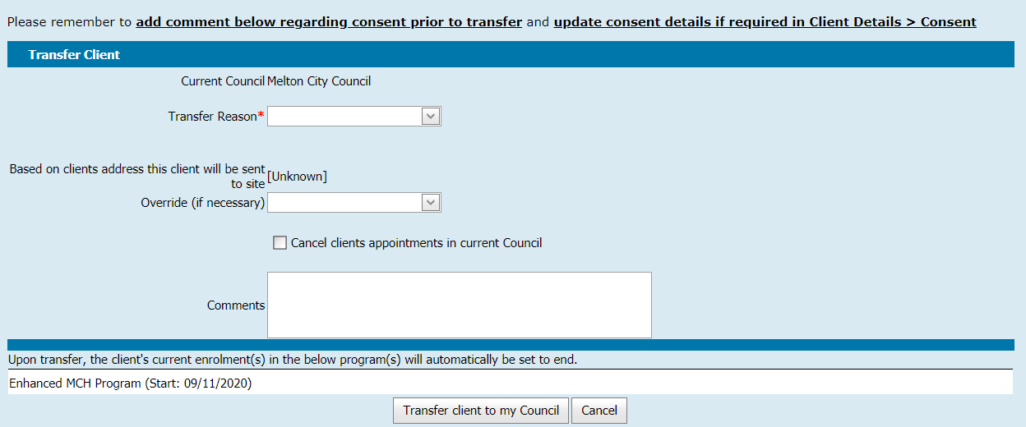

Check that client record is open
Note: Open the client record if closed
- From the CDIS Details (child) screen, open the ‘Client Details’ menu and select ‘Open/Change/Close Client’
- Select the ‘Update’ button
- In the ‘Open Change Close’ pop-up box:
- If ‘Closed’, ‘Open’ is selected by default
- Site: Ensure correct site is selected from look-up
- Select ‘Save’

Check client consent has been recorded for the Victorian MCH service
- From the CDIS Details (child) screen, open the ‘Client Details’ menu and select ‘Consent’
- Under ‘Victorian Maternal and Child Health Service’, select the ‘ Add’ button
- Under ‘Update Consent for Maternal and Child Health Service’:
- Date consent signed or updated: Enter using digits or calendar box
- Type: Select ‘Universal’ from look-up list
- Consent for service: Select appropriate from look-up list
- Privacy information: Select appropriate from look-up list
- ‘Victorian/MCH Service provider’: Select ‘Victorian MCH Service’ from look-up list
- Consent form status: Select appropriate from look-up list – upload attachment as required.
Note: Additional consents for individual MCH Service providers and specific programs may also be needed as per MCH Service provider’s internal policy – attach documents here as needed
- Consent notes: Enter in free text field if relevant
- Select ‘Save’
- Select ‘Ok’ to successfully save.

Check and update client details
See ‘Check and update client details’.

Check and update client address
See: ‘Check and update client address’.
Note: Repeat the process for the primary caregiver, any caregivers and siblings if relevant.

If an incorrect client record is transferred in from a CDIS MCH Service provider
If a client record has been transferred in error, and needs to go back to the original council, you will need to contact that council and ask them to take the record back using the Transfer In process.
Warning: It is not permitted to “push” a client record to another provider, even if the record was moved in error, or for a temporary reason.

Using the ‘MCH Service provider Transfer History’ screen
By policy it is not permitted to “push” a client record to another provider, even if the record was moved in error, or for a temporary reason. However, because this is technically possible and has previously been common practice, it is recommended that each day the ‘Inward Transfers’ are reviewed for the last business day. This is to ensure:
- Checking that records are “Open” - All children under six years old and primary caregivers are open and assigned a site – this is vital to be counted for reporting purposes.
- Checking for cancelled appointments - If a client record has been transferred back into your MCH Service provider, the original appointments may have been cancelled in the Calendar – action is required. Go to the client ‘Summary Page’, ‘Future Appointments’, note appointments and site and re-enter in calendar.
- Checking for cancelled Program enrolments - If a client record has been transferred back into your MCH Service provider, they may need to be re-added into Programs (Program enrolments end when client records are transferred) – action is required. Go to the client record. Open the Notes screen (History / Notes > Notes) and review recent notes to identify Program enrolments.

- From the ‘Home’ screen, open the ‘General’ menu and select ‘MCH Service provider Transfer History’
- MCH Service provider: Defaults to your MCH Service provider
- Date from: Enter using digits or calendar box
- Date to: Enter using digits or calendar box – select dates to reflect the last business day by using digits or calendar box
- In ‘Inward Transfers’, Select the Client ID number
- In the ‘Person Details’ pop-up box, Select the ‘Open’ button
- In the CDIS Details (child) screen, open the ‘Client Details’ menu and select ‘Open/Change/Close Client’
- Select the ‘Update’ button
- In the ‘Open Change Close’ pop-up box:
- If Closed, Open is only option
- ‘Open/Change’: Select as required
- Site: Ensure correct site is selected from look-up list
- Reason: Select ‘Data Entry Error’ from look-up list
- Select ‘Save’

Note: The only reliable way to identify if a client record is open and a site is assigned is via ‘Open/Change/Close Client’.
Once open, a client will be displayed in the ‘Active Universal List’ except where a client is open and ‘Birth Notification Received’ was selected (on initial ‘Create Client/Contact’ screen). In this case, they will be displayed on the ‘Birth Notification List’ until the ‘Offer of a home visit’ via the Birth Notification List Screen is attended.

Hint!
Some find it easier to work from an Excel spreadsheet.
To view in an Excel spreadsheet:
- Highlight all ‘Inward Transfers’ – select, hold and drag across all ‘Inward Transfers’
- ‘Copy’ using Ctrl + C or open the context menu (right select) and select ‘copy’
- Open a new Excel spreadsheet
- ‘Paste’ in cell A1 using Ctrl + V or open the context menu (right select) and select ‘Paste’
To use this Excel spreadsheet:
- Copy the Client Identifier Number
- Paste into CDIS Search
- Select ‘Search’ button
- Open the Client Identifier Number hyperlink to view history
- Ensure client is open with site assigned
Repeat for others on list as necessary
To receive this publication in an accessible format phone 1300 650 172, using the National Relay Service 13 36 77 if required, or email Commissioning Performance and Improvement Aged and Community Based Health Care and Cancer Services <mch@dhhs.vic.gov.au>
Authorised and published by the Victorian Government, 1 Treasury Place, Melbourne.
© State of Victoria, Australia, Department of Health and Human Services December 2020.
Except where otherwise indicated, the images in this publication show models and illustrative settings only, and do not necessarily depict actual services, facilities or recipients of services. This publication may contain images of deceased Aboriginal and Torres Strait Islander peoples.
In this document, ‘Aboriginal’ refers to both Aboriginal and Torres Strait Islander people. ‘Indigenous’ or ‘Koori/Koorie’ is retained when part of the title of a report, program or quotation.
ISBN 978-1-76096-245-6 (pdf/online/MS word)
Available at health.vic – Child Development Information System <https://www2.health.vic.gov.au/primary-and-community-health/maternal-child-health/child-development-information-system>

