RRHACS Repository User guide
Service Provider Guide, October 2021
Version 1.1
OFFICIAL

RRHACS Repository User Guide
Service Provider Guide, October 2021

To receive this document in another format, phone 03 9285 3367, using the National Relay Service 13 36 77 if required, or email CHMDS Help Desk <info.cwhdata@health.vic.gov.au>.
Authorised and published by the Victorian Government, 1 Treasury Place, Melbourne.
© State of Victoria, Australia, Department of Health, July 2021.
Except where otherwise indicated, the images in this document show models and illustrative settings only, and do not necessarily depict actual services, facilities or recipients of services. This document may contain images of deceased Aboriginal and Torres Strait Islander peoples.
In this document, ‘Aboriginal’ refers to both Aboriginal and Torres Strait Islander people. ‘Indigenous’ or ‘Koori/Koorie’ is retained when part of the title of a report, program or quotation.

Available at Community Health Data Reporting <https://www2.health.vic.gov.au/primary-and-community-health/community-health/community-health-program/community-health-data-reporting>

Document Version Control
Version | Release Date | Author | Description
1.0 | December 2020 | G. Boot
1.1 | October 2021 | System Performance & Information | Additional eBusiness approval information  Information about process for testing files added

Contents
RRHACS Data Repository Service Provider Access 8
Introduction 8
Establishing Access 8
First Login to the RRHACS Data Repository 9
General Interface Features 11
Submitting Reporting Files 11
To Submit a File 12
Step 1: Submit New Files - 13
Step 2: Select Files - 13
Step 3: Upload Files- 13
Step 4: Load and Process Files - 14
Step 5 Retrieve Submission Log 15
Reports 16
My Agencies 17
Agencies and Reporting Outlets (Maintain Your Details) 18
Appendix eBusiness 20

RRHACS Data Repository Service Provider Access

Introduction
The RRHACS Data Repository (commonly known as "the Repository") lets service providers load their data submissions directly and receive immediate feedback without the involvement of emails and other intermediaries (such as Funded Agency Channel).
This guide will show you the steps to gain access, how to upload your submission files, how to get submission logs, reports and also how to update your contact details (address, email etc.).

Establishing Access
Access to the Repository is via the eBusiness portal of the Department of Health (DH). If you do not have access to the eBusiness portal you can establish a login by following the procedure outlined in the document embedded in the appendix of this document or by following the registration process as provided on the eBusiness portal "I want to register".
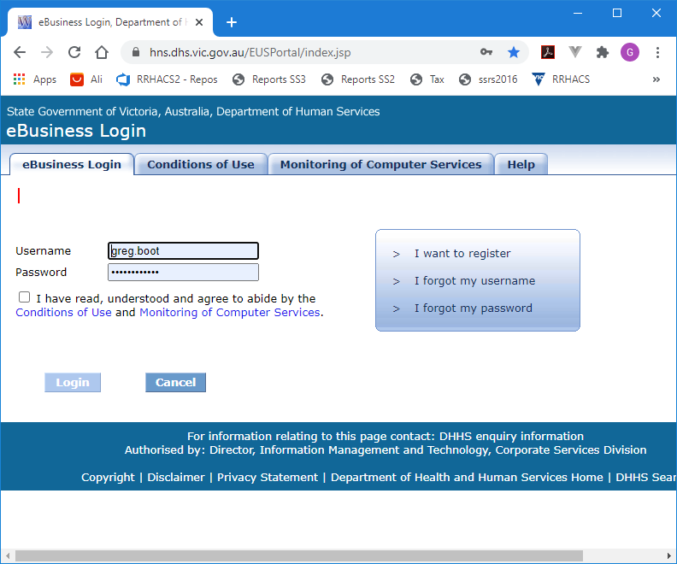

EBusiness receives all new registrations and will email your request to the ‘access approver’ from your organisation. This would normally be a senior staff member who is already registered in the eBusiness system. Once your organisation approves your application (done by a tick box and returned to the department via email) the designated approver from the department will approve your access.
During the registration process or after login if you have an existing login request, access the RRHACS Data Repository in the Application Catalogue.
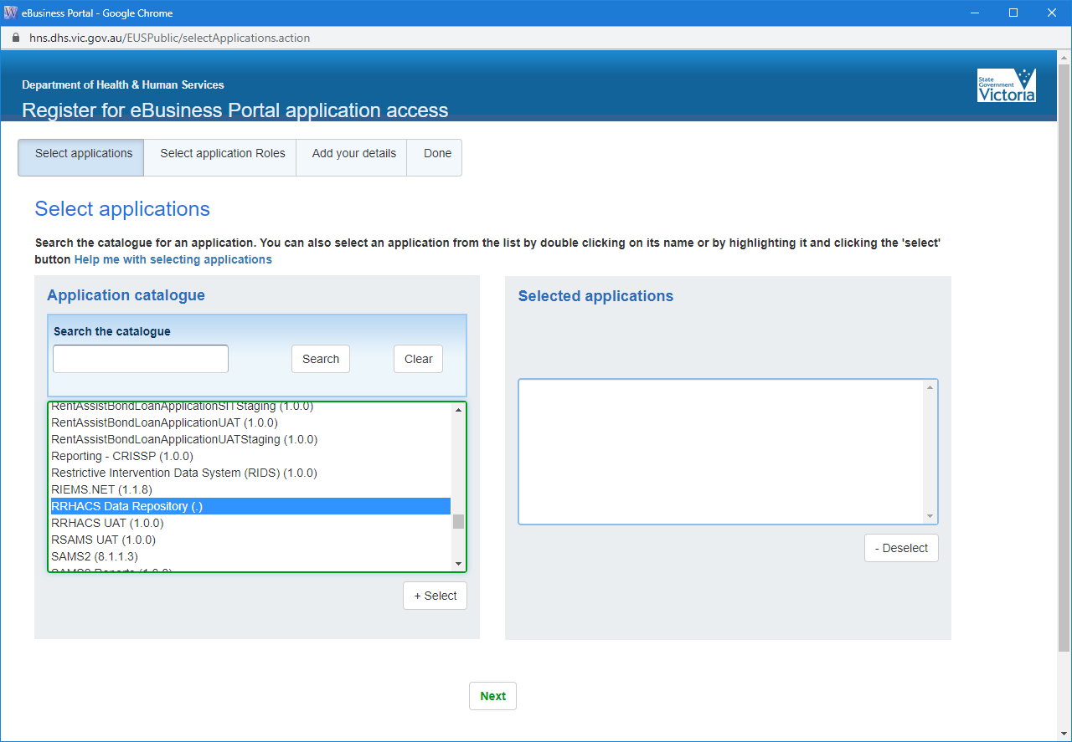
Follow the steps shown (Next) to complete your application.
The Repository relies on your SAMS ID to establish which data collections and outlets you have access to.
You will only have access to data for your SAMS Agency or Agencies and any reporting entities (outlets) associated with that agency or agencies.

First Login to the RRHACS Data Repository
Note Screen Elements Buttons Drop Downs Labels etc. are highlighted in red in the text, e.g. Import, Load etc.
Once you have established a login to eBusiness the Repository will recognise which organisation you belong to and hence the scope of data and information available to you.
To login to the application first log in to the eBusiness Portal and then Select your application.
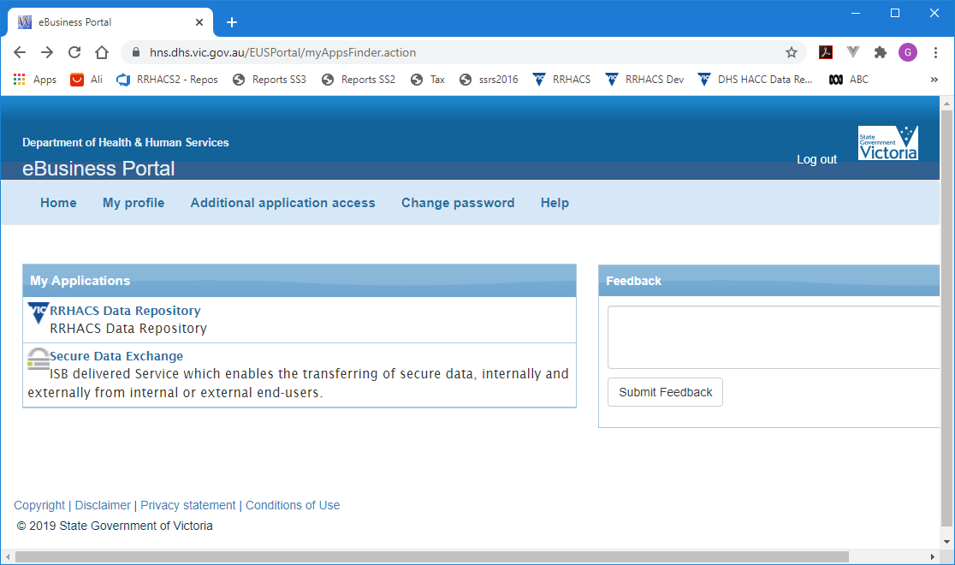
Alternatively, you can create a shortcut directly to the application
Official Application (Production)
https://hns.dhs.vic.gov.au/RepositoryWeb/
Your username and password for eBusiness will be verified before connecting.
Once connected you will see the opening screen below.

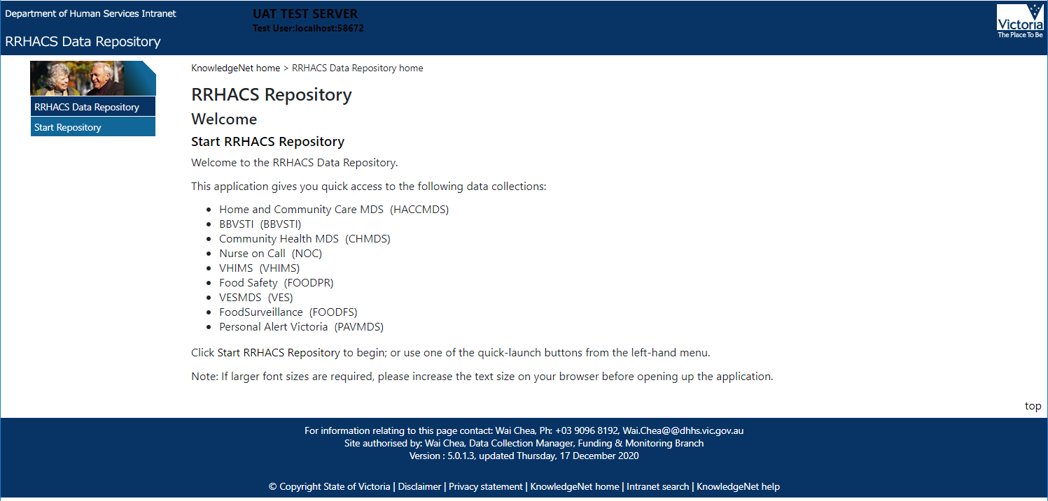
Select "Start RRHACS Repository" and the application will verify your status by the SAMS number of your organisation details. You will be given access to one or more Data Collections based on your organisation’s credentials.

General Interface Features
Your opening page will be the Import page.
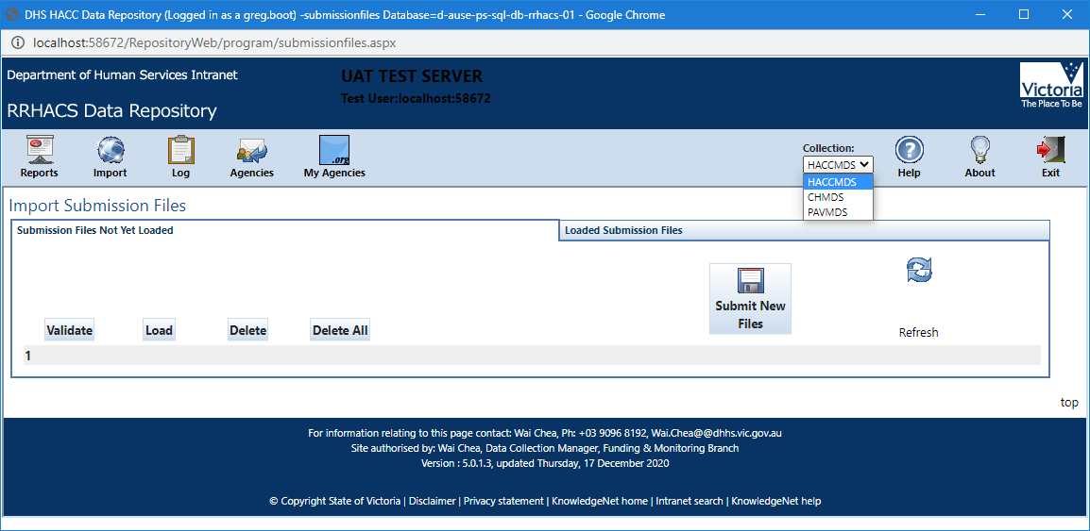
The dropdown box Collections in the top right will show you what collections are available to you and enable you to switch between them. The mode currently selected for the example is HACCMDS. If you want to submit data for Community Health MDS first select that collection CHMDS from the dropdown before proceeding.
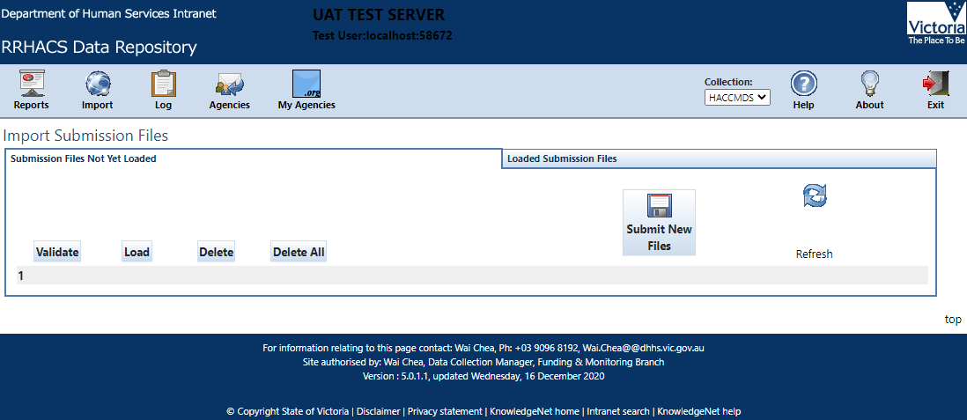
The buttons at the top left Reports, Import (Current Screen), Log, Agencies and My Agencies provide access to other features that will be described further in sections below. The Help Button will download a copy of this document, About provides some software version information (may not show on all browsers) and Exit logs the current user out.
This page shown Import Submission Files is where you will submit your data reporting files.

Submitting Reporting Files
Submission Files are expected to have the correct structure (csv for HACC, xml for CHMDS). They are also expected to apply to an applicable collection period (e.g. 2020/4 for HACC or 2020212 for CHMDS representing the Q2 in 2020-21 financial year) either the current reporting period or one that has been made available for resubmissions
Note: The Validate, Load, Delete and Delete All Buttons are generally only used for dealing with failed submissions and will be dealt with below. For now, we will concentrate on submitting a file for a reporting period. If there are files visible on this page, then they have not yet been loaded.

To Submit a File
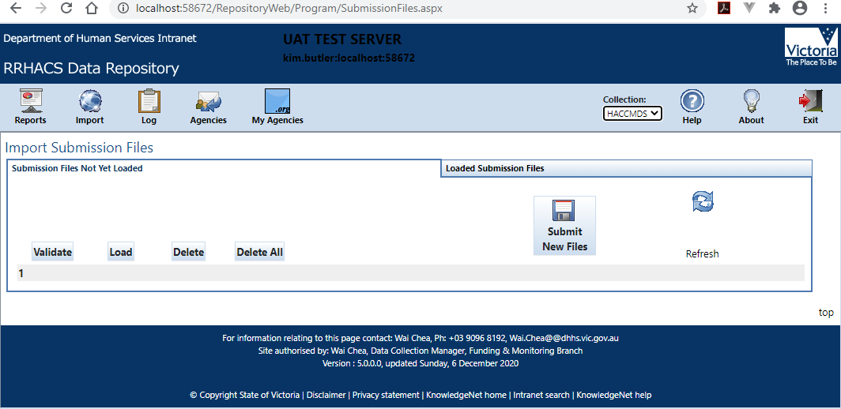
Note: Files can be submitted to the Repository (uploaded) and processed (Loaded or just Validated).
Validation only is usually reserved for testing or previewing the results of a newly created file if there is some doubt about the structure. Agencies do not have access the UAT or testing version of the repository. Please send your files for testing to info.cwhdata@health.vic.gov.au (for CHMDS) or haccmds@health.vic.gov.au (for HACCMDS).

Step 1: Submit New Files - From Import Submission Files page (the page we are currently on), select the 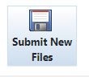Button.
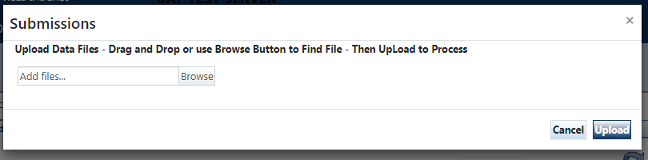
This window will pop up.
Step 2: Select Files - Drag files to this window and drop them OR you can choose the browse button to navigate to the file location and select one or more files to upload.
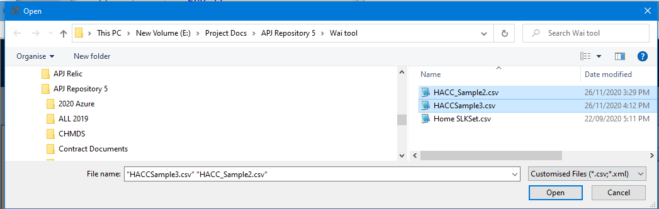
Select Open from the browse window (if not dragging and dropping).
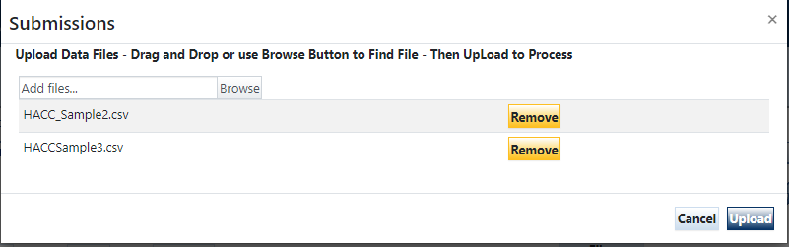
The files you selected or dragged will appear ready for submission. You have the option to Remove any you inadvertently selected files.
For Community Health agencies, you will select files prefixed "CHMDS"
Step 3: Upload Files- Select Upload to move the files into the Repository ready for the Load.
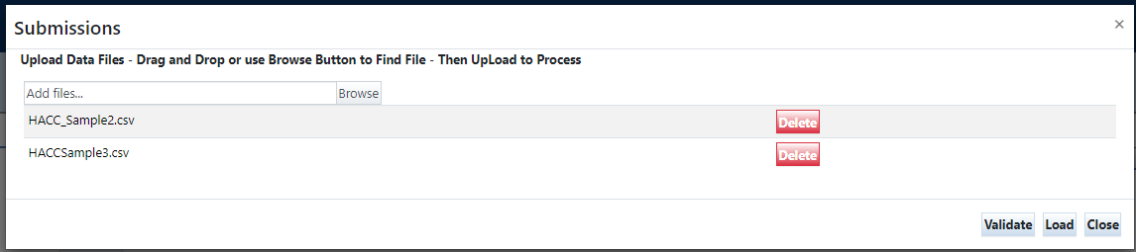
You may get an ‘Error: Unknown error’ message when you upload your files. This could be caused by the traffic in the Repository being heavy, i.e., so many files are being uploaded at the same time causing some files not being able to get through. There are two things you can do: try to reload your files at different times; if this is unsuccessful after few tries, contact the relevant Helpdesk on info.cwhdata@health.vic.gov.au (CHMDS) or haccmds@health.vic.gov.au (HACCMDS) for assistance.
Step 4: Load and Process Files -Load the files by selecting the Load button. (Note: Validate only checks the files for errors it does not load the data. This may be useful when testing new software or data preparation processes. Load is the usual process).
Note: Depending upon how large your files are and other loads on the server it may take some time (several minutes) for your files to be processed. During this time, you may see the status "Pending" or "Processing". Wait until the files have completed and are no longer visible.
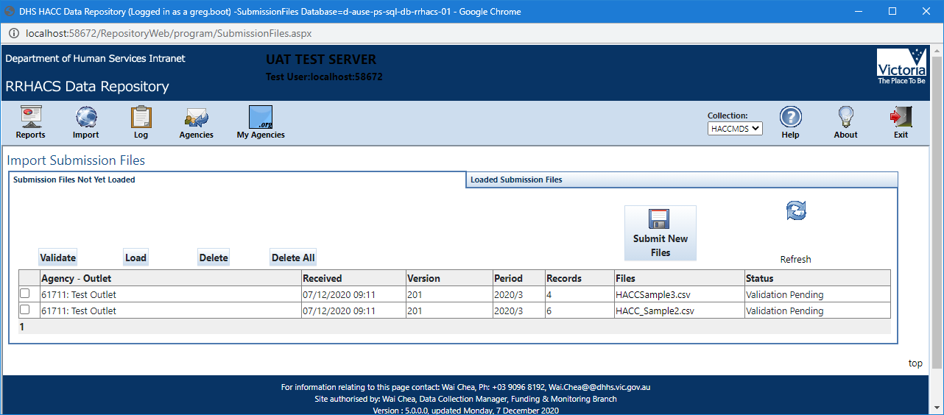
Note: Files that have not been successful (i.e. "Bad Format" or "Wrong Collection Period" can be deleted using the Delete button
Any files that have “bad/invalid format” or “Wrong Collection Period” will not be validated and not have a submission log.

Step 5 Retrieve Submission Log
Once the file(s) has been processed you can retrieve the Log by selecting Log icon to see the result.
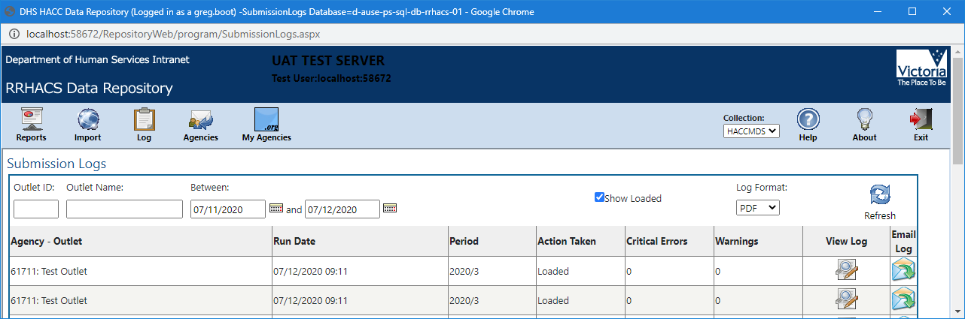
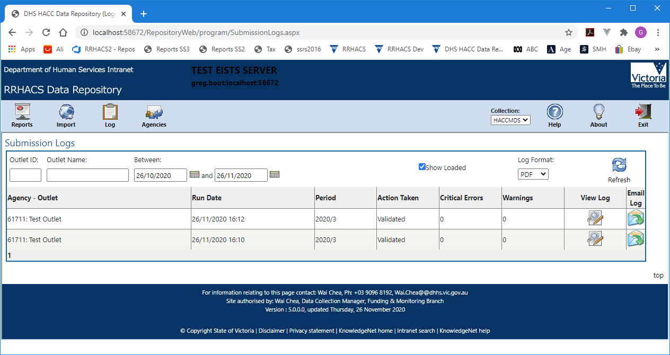
The log can be viewed by selecting the View Log icon in the grid on the right. If you have submitted files previously you will be familiar with these logs. Logs default to a pdf format for convenience. Other formats (HTML, Excel, CSV) can be selected. When the log opens (in Adobe Acrobat or other PDF viewer you can select File Save AS to save it to your own computer.
Note: This list will grow over time so there are some filter parameters you can apply – Outlet ID, Outlet Name Between dates submitted.
Alternatively, you can select Email Log and send it to yourself (or others) by checking the address and selecting Send
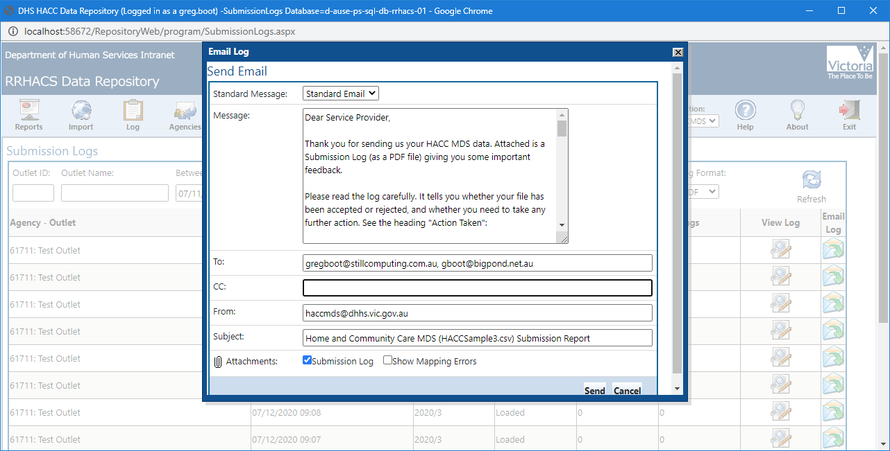

Reports
Once loaded the data can be reviewed by selecting one of the available reports.
Select the Reports icon.
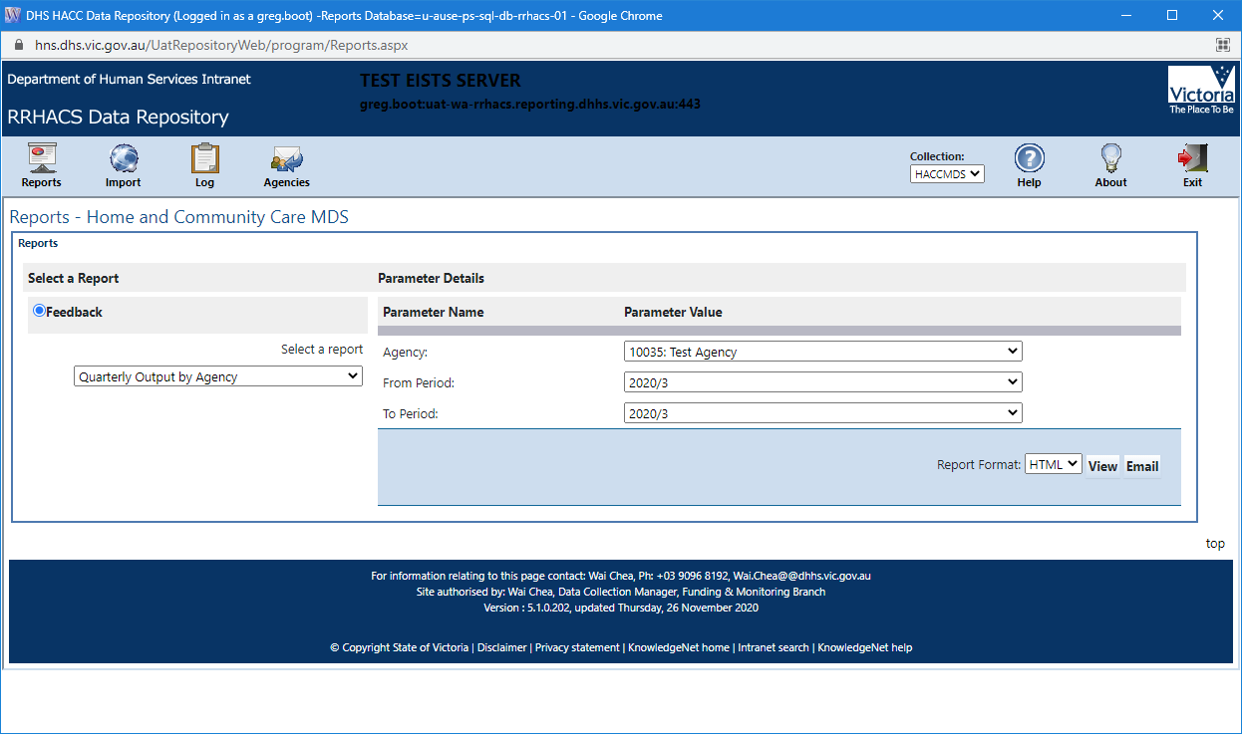
A number of reports will be available to you. (Note the selection may change from time to time in the initial implementation phase).
Select a report from the dropdown under Feedback. Select the parameter on the right make certain you have selected the correct collection period (2020/3 in the screen above as that was the collection period for the files uploaded). For a quick view of data select the HTML Report Format. For a more permanent version select PDF which can be downloaded or emailed.
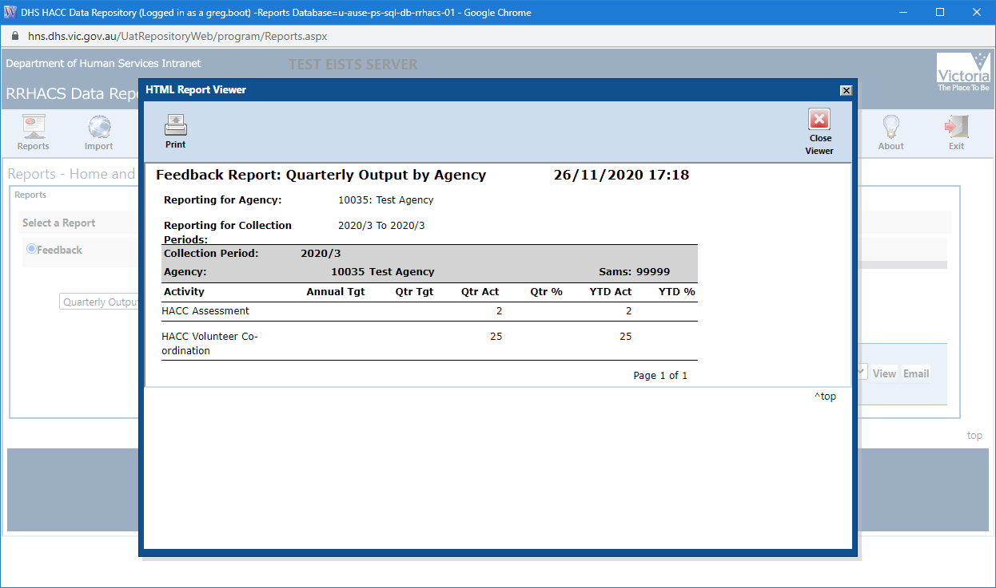
Reports may take some time to render depending upon the amount of data involved (Generally less than a minute).
For CHMDS, the reports available to view and download are: CWH performance, CWH service totals by outlet and CWH across period reports. Select a Report under Other, use the dropdown to select the quarter and click on View (steps shown below).
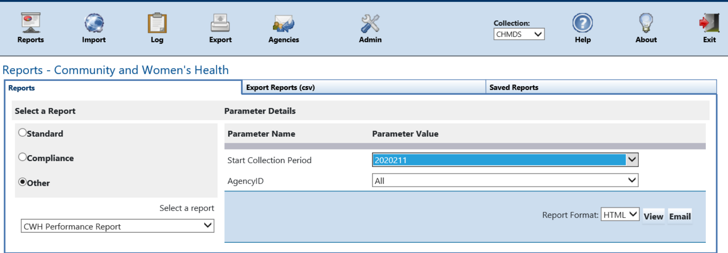

My Agencies
Select this page to review the permissions you have, SAMS Agencies, Outlets and Data Collections.
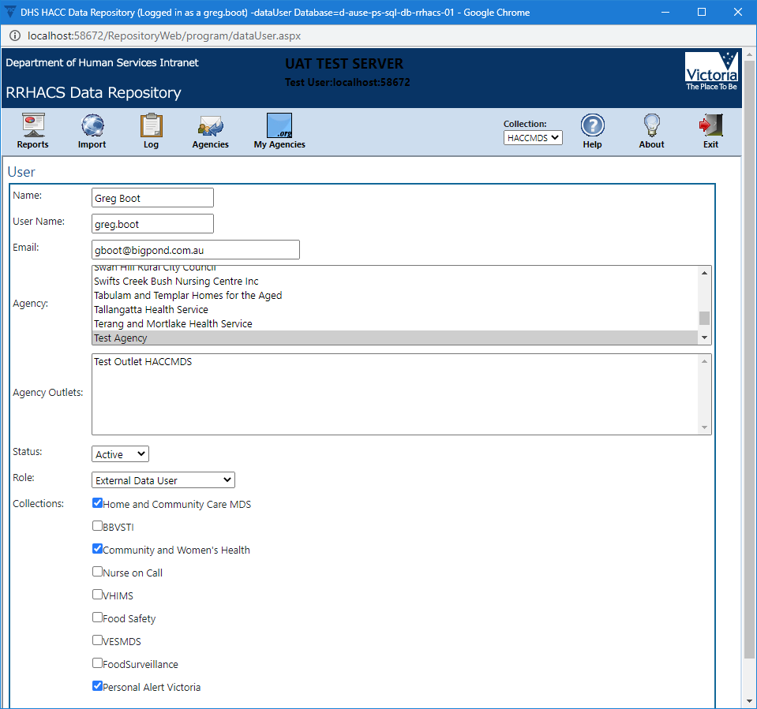

Agencies and Reporting Outlets (Maintain Your Details)
You can update some of the details about your agency and outlets such as address and contact information. The contact persons you provide are the recipient of alert messages and the submission log (in pdf) that is automatically sent from the Repository.
Select Agencies icon.
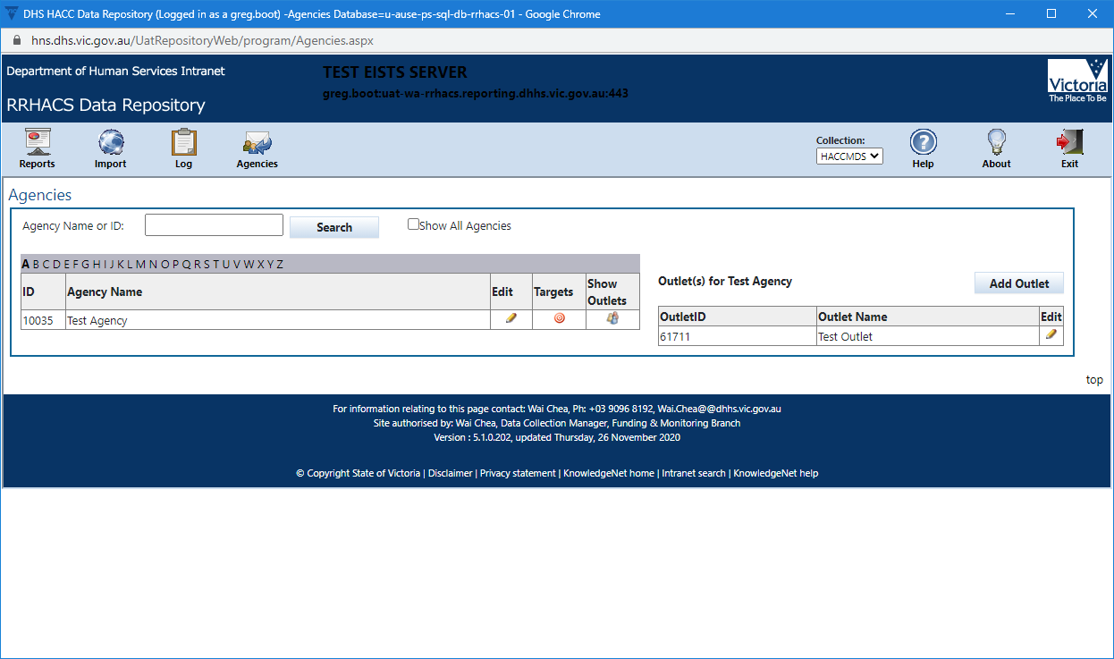
You can view and make some changes to outlet information.
To view your Outlet information if outlets are not visible select Show Outlets then select Edit on the outlet Edit Icon itself.
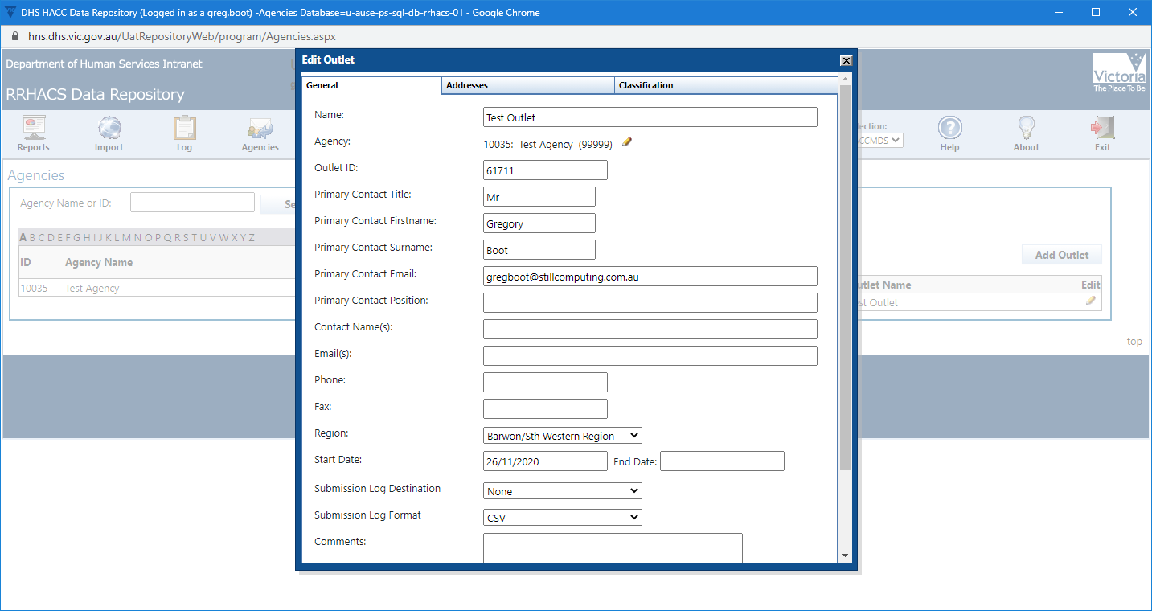
Here you can update your Contact details and email addresses. The Email(s) field is the default email address used when sending submission logs and other message to agencies.
It is important that you keep your contact details up to date as the department will be using this contact information to correspond with the service providers.
The Addresses tab allows you to update the outlet address. The addresses are for information purposes only and are not used by the application for any purpose.
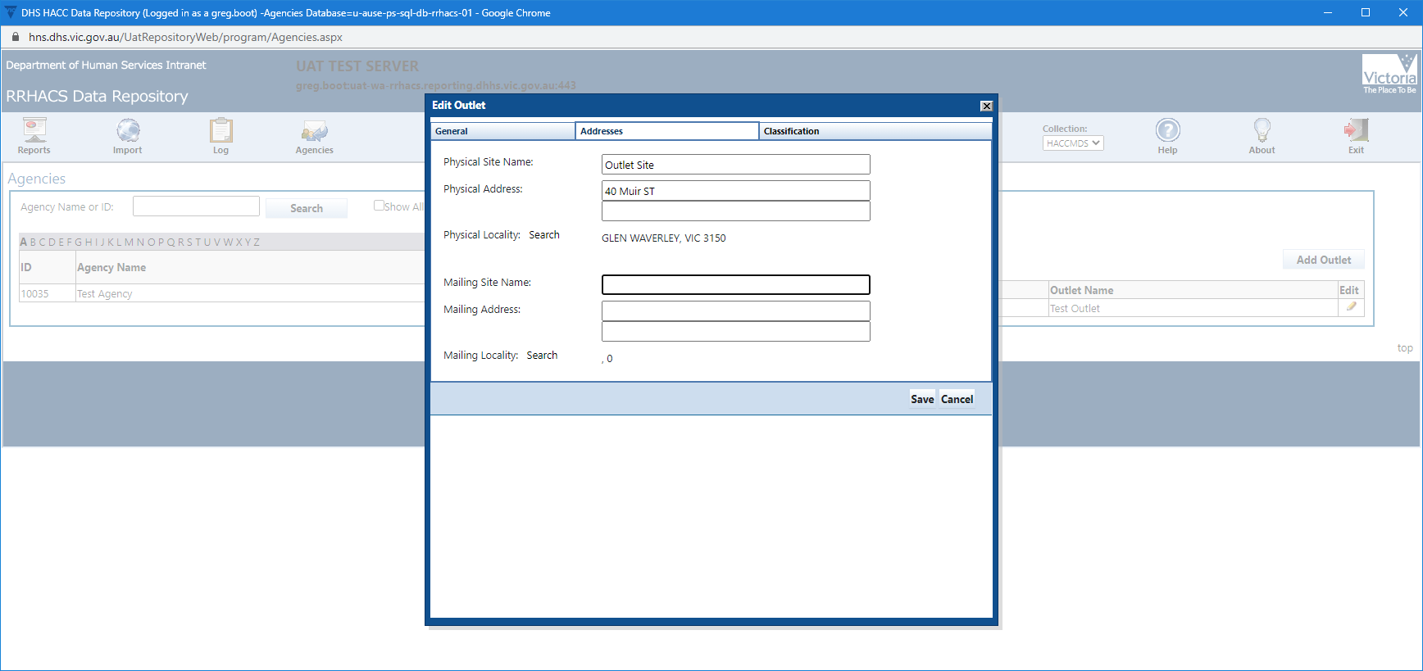
The Classifications tab contains information used for reporting purposes. This is maintained by departmental officers and is not editable.
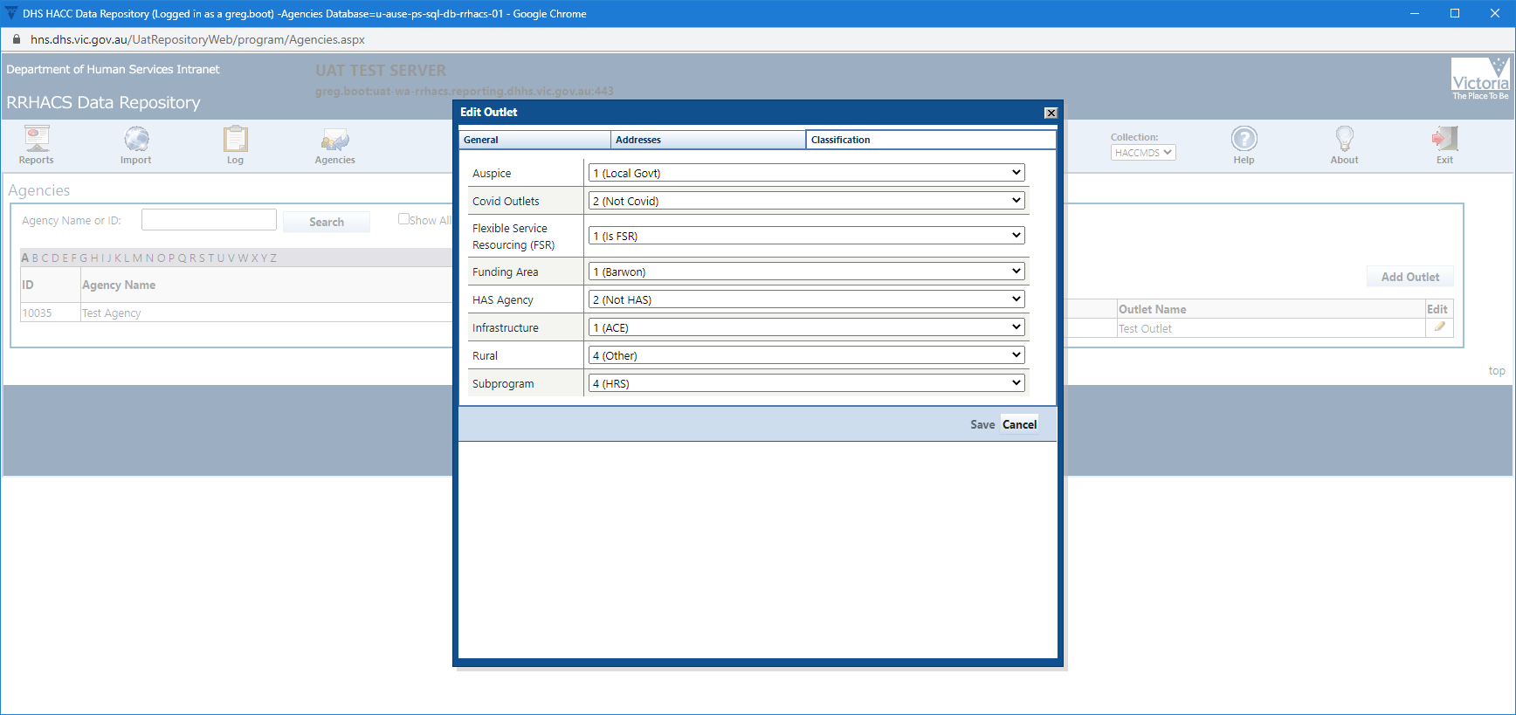

Appendix eBusiness
Guide for applying to eBusiness embedded below-double click to open.

