

|  |
| --- |
| Specifications for revisions to AIMS for 2022-23 |
| December 2021 |
| OFFICIAL |



|  |
| --- |
| To receive this document in another format, [email HDSS help desk](mailto:HDSS.Helpdesk@health.vic.gov.au) <HDSS.helpdesk@health.vic.gov.au>.  Authorised and published by the Victorian Government, 1 Treasury Place, Melbourne.  © State of Victoria, Australia, Department of Health, December 2021.  Available at [HDSS annual changes](https://www2.health.vic.gov.au/hospitals-and-health-services/data-reporting/health-data-standards-systems/annual-changes) < https://www2.health.vic.gov.au/hospitals-and-health-services/data-reporting/health-data-standards-systems/annual-changes> |
|  |

Contents

Executive Summary 4

Introduction 4

Orientation to this document 4

Outcome of proposals 5

Specifications for changes for 2022-23 6

1- Add a new patient payment status to S10 and UCC forms 6

S10 specific amendments 6

UCC specific amendments 7

2 - Amend PSRACS S5 forms in line with Commonwealth reforms 9

3 - Amend due date for submission of AIMS non-admitted collections 11

# Executive Summary

The revisions for the Agency Information Management System (AIMS) for 2022-23 are summarised below:

**Amendment to forms**

* Add an additional patient payment status to the AIMS S10 and AIMS UCC forms
* Add Australian National Aged Care Classification (AN-ACC) data items to the public sector residential aged care services forms AIMS S5_115 and S5_129

**Amendment to business rule**

* Change the due date of AIMS non-admitted patient services forms

# Introduction

Each year the Department of Health reviews AIMS to ensure that the data collections support the department’s business objectives, including national reporting obligations, and reflects changes in hospital funding and service provision arrangements for the coming financial year.

Comments provided by the health sector in response to Proposals for revisions to the Agency Information Management System for 2022-23 have been considered, and where possible, suggestions have been accommodated, resulting in changes to or withdrawal of some proposals.

The revisions set out in this document are complete as at the date of publication. Where further changes are required during the year, for example to reference files such as the postcode locality file, data validation rules or supporting documentation, these will be advised via the HDSS Bulletin.

An updated AIMS manual will be published in due course. Until then, the current AIMS manual and subsequent HDSS Bulletins, together with this document, form the data submission specifications for 2022-23.

Victorian health services must ensure their software can create a submission file in accordance with the revised specifications and ensure reporting capability is achieved to maintain compliance with reporting timeframes set out in the relevant Department of Health policy and funding guidelines or the *Health Services (Health Service Establishments) Regulations 2013.*

## Orientation to this document

* New data elements are marked as (new).
* Changes to existing data elements are highlighted in green
* Redundant values and definitions relating to existing elements are ~~struck through~~.
* Comments relating only to the proposal document appear in *[square brackets and italics].*
* New validations are marked ### if number has not yet been allocated
* Validations to be changed are marked * when listed as part of a data element or below a validation table.
* Changes are shown under the appropriate manual section headings

# Outcome of proposals

**Proposal 1 - Add an additional patient payment status to the AIMS S10 and Urgent Care Centre (UCC) forms**

The proposal proceeds, implementation in 2022-23.

**Proposal 2 - Amend PSRACS S5 forms in line with Commonwealth reforms**

The proposal proceeds, implementation in 2022-23.

**Proposal 3 - Amend due date for submission of non-admitted forms**

The proposal proceeds with amendment, implementation in 2022-23.

# Specifications for changes for 2022-23

# 1- Add a new patient payment status to S10 and UCC forms

|  |  |
| --- | --- |
| **AIMS forms** | * S10: Non-Admitted Clinic Activity * UCC: Urgent Care Centre |
| **Summary of change** | An additional patient payment status ‘S19(2) Exemptions’ is being added to the AIMS S10 and AIMS UCC forms to report urgent care/emergency medicine activity undertaken under the Section 19(2) Exemptions Initiative – Improving Access to Primary Care in Rural and Remote Areas. |
| **Eligibility for reporting** | Local ABF funded health services and small rural health services (SRHS) that provide urgent care/unplanned emergency medical treatment to non-admitted patients who have a current exemption under the Section 19(2) Exemptions Initiative – Improving Access to Primary Care in Rural and Remote Areas are required to report this additional information. |
| **Definition** | **Patient payment status – S19(2) exemption**  S19(2) exemption: A service event or presentation for persons eligible for Medicare where the hospital provides care by its own eligible staff under the Section19(2) Exemptions Initiative – Improving Access to Primary Care in Rural and Remote Areas. |

## S10 specific amendments

|  |  |
| --- | --- |
| **Detail of change** | A new column will appear on the S10 form showing the new patient payment status. The data entry fields will be pre-populated with zeros consistent with other S10 data entry fields.  Local ABF funded health services and small rural health services (SRHS) that provide urgent care/unplanned emergency medical treatment under the Section 19(2) Exemptions Initiative to non-admitted patients must report service events for this activity on the S10 form under the specific urgent care/emergency medicine clinic (clinic id: UCARE). |

Sample S10 form view showing amendment

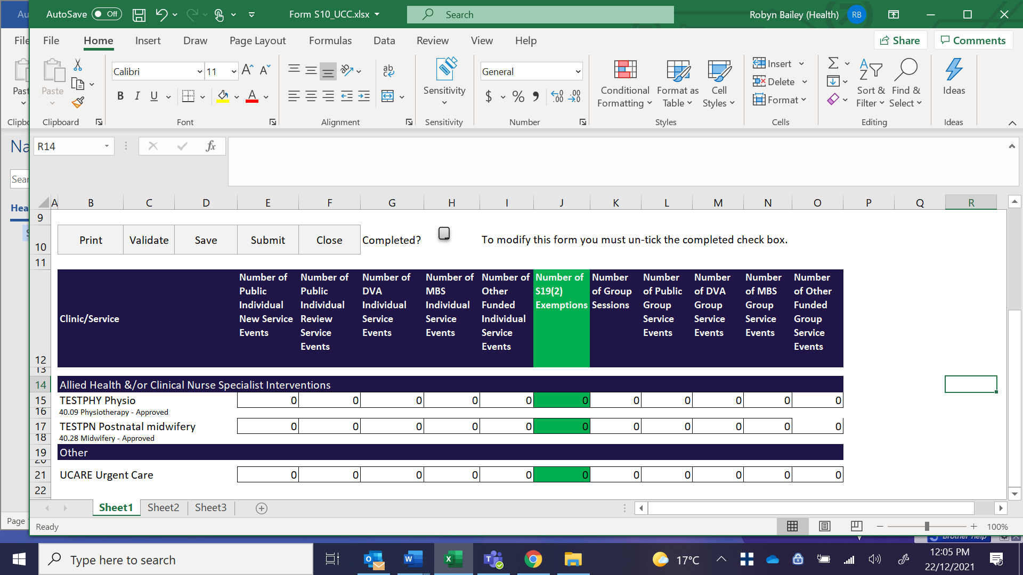

|  |  |
| --- | --- |
| **AIMS S10 File Upload** | Health services/campuses with a registered urgent care clinic on the Non-Admitted Clinic Management System (NACMS) will need to amend the format of their upload file to include a new column to report the new patient payment status field.  **There will be no change to the S10 file structure format for health services/campuses that do not have a registered urgent care clinic on NACMS.**  The S10 file upload function will be modified to include a “file type” with two options:   * 1st option – will be available to select the file type matching the existing S10 file structure format containing 15 fields. This file structure EXCLUDES the new patient payment status field and is to be used for campuses that do not have an urgent care clinic. * 2nd option - will be available to select the file type that INCLUDES the new patient payment status field and must contain 16 fields. This file structure format is to be used for campuses that have an urgent care clinic. |

## UCC specific amendments

|  |  |
| --- | --- |
| **Detail of change** | A new column will appear on the UCC form showing the new patient payment status S19(2) Exemptions.  Eligible departure status and triage categories available for reporting S19(2) Eligible presentations:   * Non-admitted, planned return visit – triage 1 * Non-admitted, planned return visit – triage 2 * Non-admitted, planned return visit – triage 3 * Non-admitted, planned return visit – triage 4 * Non-admitted, planned return visit – triage 5 * Non-admitted, unplanned – triage 1 * Non-admitted, unplanned – triage 2 * Non-admitted, unplanned – triage 3 * Non-admitted, unplanned – triage 4 * Non-admitted, unplanned – triage 5 * Transfer to another health service – any triage * Died in urgent care centre – any triage |

Sample UCC form view showing amendment

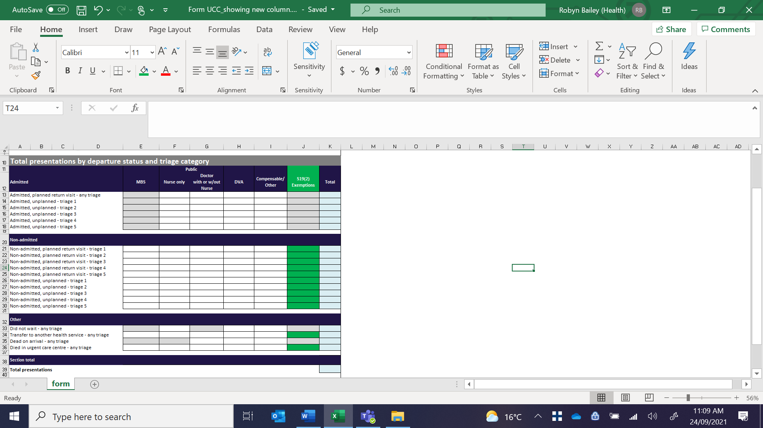

# 2 - Amend PSRACS S5 forms in line with Commonwealth reforms

|  |  |
| --- | --- |
| **Forms** | Aged Persons Mental Health Residential Aged Care Services (Form S5_115)  Generic Residential Aged Care Services (Form AIMS S5_129) |
| **Effective date of change** | 1 October 2022 |
| **Reason for proposed change** | Amendments will be made to the AIMS S5_115 and S5_129 data forms in line with the Commonwealth Government’s new funding model - the Australian National Aged Care Classification (AN-ACC) that will replace the Aged Care Funding Instrument (ACFI).  The amendments will capture the additional sixteen AN-ACC classifications for the Commonwealth’s new funding model. |
| **Detail of change** | Sixteen AN-ACC classifcations   | Description AN-ACC classification | AN-ACC class | | --- | --- | | Admit for Palliative Care | Class 1 | | Independent Mobility without compounding factors | Class 2 | | Independent Mobility with compounding factors | Class 3 | | Assisted Mobility - high cognitive ability with compounding factors | Class 4 | | Assisted Mobility - high cognitive ability without compounding factors | Class 5 | | Assisted Mobility - medium cognitive ability without compounding factors | Class 6 | | Assisted Mobility - medium cognitive ability with compounding factors | Class 7 | | Assisted Mobility – Low cognitive ability | Class 8 | | Not Mobile - Higher function-without compounding factors | Class 9 | | Not Mobile - Higher function-with compounding factors | Class 10 | | Not Mobile - Lower function & lower pressure sore risk | Class 11 | | Not Mobile - Lower function & lower pressure sore risk -without compounding factors | Class 12 | | Not Mobile - Lower function & lower pressure sore risk -with compounding factors | Class 13 | | Existing low respite residents | Respite 101 | | Existing high respite residents | Respite 102 | | Respite residents with very high needs | Respite 103 |  |  |  | | --- | --- | | Existing low respite residents | Respite 101 | | Existing high respite residents | Respite 102 | | Respite residents with very high needs | Respite 103 |   The AN-ACC classification model of the Funding Policy Reform Branch, Commonwealth Department of Health on 27 July 2021 is shown above. It is to be noted that this advice may change and capacity to make further adjustments to the data collection forms may be required between now and October 2022.  It is envisaged that PSRACS will report ACFI classifications plus respite bed day data from July 2022 until at least September 2022 (later if any slippage in the schedule) and AN-ACC classification bed day data from October 2022 to June 2023.  There has been some early discussion about consideration given to separate data collection forms for the AN-ACC reporting to allow the existing data collections forms to cease at end of the 2022-23 financial year.  Further advice on amendments to the AIMS S5 data forms will be circulated as information is released from the Commonwealth Department of Health. |

# 3 - Amend due date for submission of AIMS non-admitted collections

|  |  |
| --- | --- |
| **Details of change** | The due date at the end of each reporting period will change from the 14th day of the following month to the 12th day of the following month, for AIMS forms:   * S10 Acute Non-Admitted Clinic Activity * S11 Sub-Acute Non-Admitted Activity * S11A Sub-Acute Non-Admitted MDCC patient not present * S12 Self-delivered Non-Admitted Services |