Example comprehensive staff travel survey analysis report – major metropolitan hospital
2.10 – Sustainable transport in health care
Contents
Introduction 2
Overview 2
Participation summary 2
Key findings 4
Opportunities for improvement 4
Analysis of survey data 5
Main travel mode 5
Regular use of other modes 5
Typical travel modes (non-travellers on survey day) 6
Journey satisfaction 8
Job role flexibility and remote work 8
Travel behaviour interventions – mean score 12
Travel behaviour intervention – attractiveness 13
Family commitments and mobility choices 15
Journey time and satisfaction 17
Car parking 18
On-site staff car parking 20
Bicycle facilities 22
Bicycle parking and trip issues 24
Motorcycle facilities 25
Public transport 26
Pedestrian facilities 27
General feedback 29
Arrival and departure times 32

Introduction
This report presents data and analysis from an actual travel survey conducted by a major metropolitan hospital in Melbourne.
This survey and report include more questions and detail than would be needed for a smaller site or organisations considering a passive or active travel plan

Overview
[Health Service name] conducted a voluntary staff travel survey on Tuesday 2 and Wednesday 3 March 2021.
Staff were asked to complete a four- to five-minute survey about how they got to work that day. No personal information was collected.
The survey aimed to:
- understand of current travel behaviours
- capture employee perceptions and attitudes about their travel to work
- identify opportunities to improve uptake of sustainable travel options and prioritise investment of transport facilities and on-site services.
The survey results will be used to develop a sustainable travel plan for the hospital.
Staff were not offered incentives to complete the survey.
A communications campaign was conducted before and during survey week including:
- stakeholder briefings and briefing packs
- emails to staff
- digital and printed displays
- intranet news updates
- QR codes to encourage completion on mobile devices
- staff at hospital entry points to promote and encourage completion of the survey.

Participation summary
Based on statistical sampling error, and using a 95 per cent level of confidence, a minimum sample size of 344 staff who travelled on survey day was needed to reliably report mode share for the hospital.
A total of 456 staff who travelled on Tuesday 2 March completed the survey –exceeding the minimum target.
The sample distribution (based on reported travel behaviours) has reduced the ability to conduct detailed analysis and cross-tabulations within some travel modes.

Table 1: Sampling overing
Element | Number
Estimated population | 4,597
Estimated and reported daily staff | 3,218 and 1,409
Target | 344 / 302
Complete | 523
Partially complete | 32
Total valid sample | 555

Table 2: Survey respondents summary
Element | Number of respondents | Sample percentage (%)
Travelled on Tuesday 2 March | 456 | 82.2
Worked from home | 53 | 9.5
Did not work that day | 45 | 8.1
Worked from elsewhere or remotely | 1 | 0.2
Total | 555 | 100.0

Key findings
- Despite the scale of the hospital, car usage remains very high (93.4 per cent) and sustainable and active modes very low.
- Use of other travel options is low (13 per cent) – with car sharing, cycling and walking all displaying some limited usage.
- While many staff believe their non-car options are limited, there may be potential to increase car sharing and use of active modes.
- Job flexibility and uptake of remote work at the hospital is high, with almost half able to work flexibility and a third of staff having done so.
- Most staff report high journey satisfaction and relatively short travel time (under 30 minutes), reducing likely appeal of other travel options.
- Public transport is perceived to be unreliable, infrequent and time consuming.
- On-site car parking facilities receive very mixed ratings and are a source of significant staff commentary and feedback.
- On-street parking may be impacting local amenity.
- While secure racks are available, cycling facilities are considered to be poor and pedestrian facilities also show significant room for improvement, particularly in regard to safety.

Opportunities for improvement
- Provision of lockers, showers and change rooms for cyclists is recommended.
- Safety upgrades are likely needed for pedestrian environment in and around the hospital.
- Incentives and tools to encourage and facilitate car sharing between staff is likely to be the most useful of behaviour change interventions.
- Establishing a car sharing program may be one of the most effective way to increase sustainable travel at the hospital.
- Implementation of a Myki Commuter Club may appeal to around 20 per cent of staff and is an easy incentive to drive public transport usage.

Analysis of survey data

Main travel mode
Question: Thinking about your journey to work today, from leaving home to arriving at work, which of the following methods of transport did you use (excluding any short walks to or from a bus stop, train station, car park and so on)? What was your main method of transport?
Findings:
- ‘Car – as driver’ dominates staff travel behaviour at the hospital, with very low levels of public transport usage.
- 1.1 per cent of staff use public transport.
- 3.3 per cent of staff use sustainable modes.
Figure 1: Main mode of travel on survey day
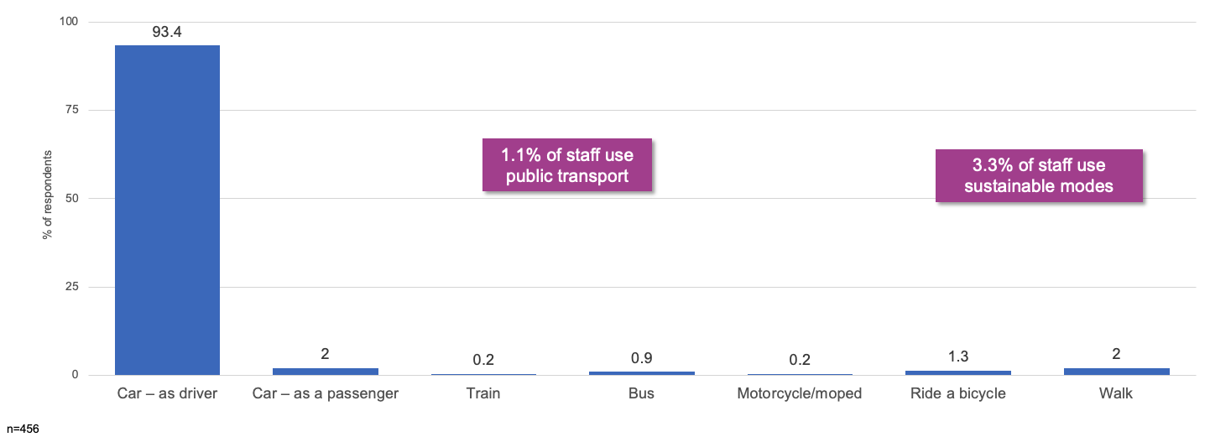
Table 3: Main mode of travel on survey day
Mode | Percentage of respondents (%)
Car – as driver | 93.4
Car – as passenger | 2
Train | 0.2
Bus | 0.9
Motorcycle or moped | 0.2
Ride bicycle | 1.3
Walk | 2
Note: n=456

Regular use of other modes
Question: Excluding how you travelled today, are there other methods you regularly use to travel to work (excluding any short walks to or from a bus stop, train station, car park and so on)?
Findings:
- 13 per cent of people regularly use other travel options. While this is a relatively small proportion of employees, it highlights an opportunity to increase the frequency that these sustainable travel options are used – as well as encourage others to consider them. Car sharing (travel with passengers), cycling and walking show the greatest potential.
Figure 2: Regular use of other modes of travel
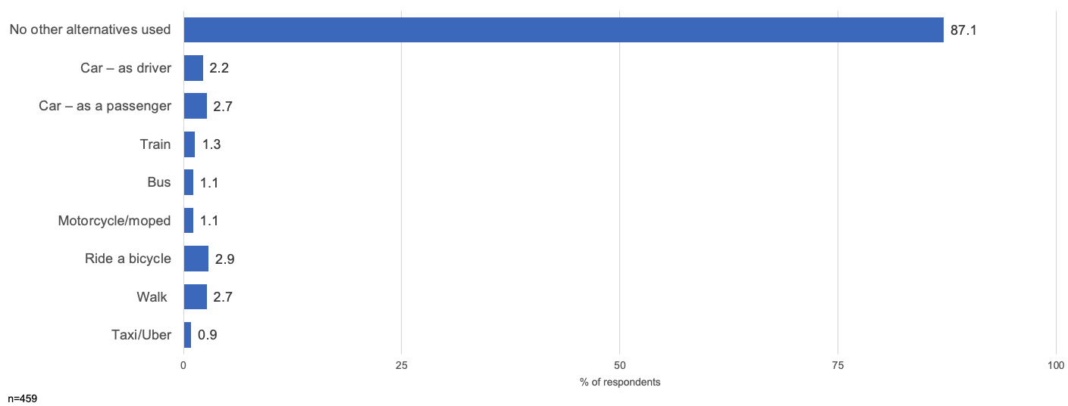
Table 4: Regular use of other modes of travel
Mode | Percentage of respondents (%)
No other alternative used | 87.1
Car – as driver | 2.2
Car – as passenger | 2.7
Train | 1.3
Bus | 1.1
Motorcycle or moped | 1.1
Ride bicycle | 2.9
Walk | 2.7
Taxi or Uber | 0.9
Note: n=459

Typical travel modes (non-travellers on survey day)
Question: Thinking about your typical journey to work, from leaving home to arriving at work, which of the following methods of transport do you usually use? Select all that apply, excluding any short walks to or from a bus stop, train station, car park and so on.
Findings:
- When considering the mix of travel modes reported by those who didn’t travel on the survey day – car usage continues to be high.
- However, there is generally greater overall use of sustainable and active modes. This may indicate an openness by some staff to future increases in travel by these modes.
Figure 3: Typical travel modes
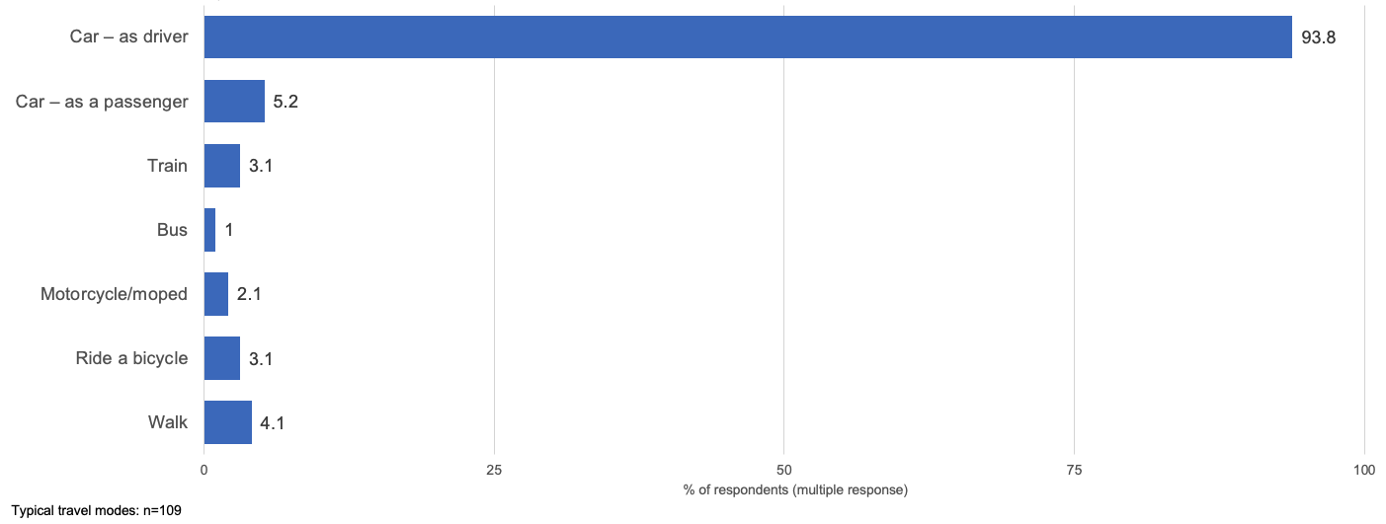
Table 5: Typical travel modes
Mode | Percentage of respondents (%)
Car – as driver | 93.8
Car – as passenger | 5.2
Train | 3.1
Bus | 1
Motorcycle or moped | 2.1
Ride bicycle | 3.1
Walk | 4.1
Note: n=109, multiple responses

Journey satisfaction
Question: How would you rate your satisfaction with your experience travelling to the hospital or hospital campus?
Findings:
- Journey satisfaction (for trips predominantly by car) shows high levels of satisfaction.
- 77 per cent of people are satisfied or very satisfied with their travel. This is a strong behavioural influence for staff to maintain their current travel patterns. This makes behavioural campaigns less likely to have any significant impact on reducing drive-alone rates.
Figure 4: Satisfaction with experience travelling to work
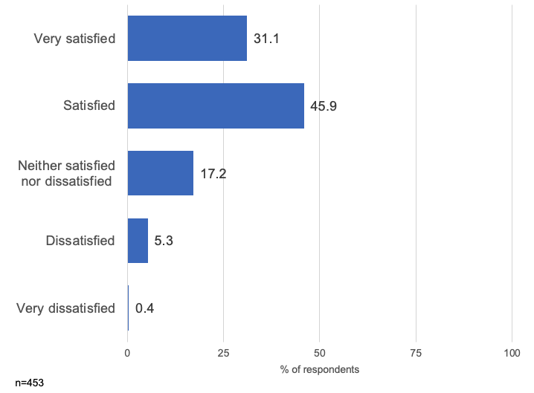
Table 6: Satisfaction with experience travelling to work
Response | Percentage of respondents (%)
Very satisfied | 31.1
Satisfied | 45.9
Neither satisfied not dissatisfied | 17.2
Dissatisfied | 5.3
Very dissatisfied | 0.4
Note: n=453

Job role flexibility and remote work
Questions:
- Which of these descriptions best describes the flexibility of your job role?
- And which of these statements best describes how you have worked over the last six months?
Findings:
- Job flexibility and uptake of remote work are both positive, with around half of employees indicating they can work remotely and a third indicating they have done so in the last six months.
- 47 per cent have some capacity to work flexibly.
- 37 per cent have worked flexibly.
Figure 5: Flexibility of job
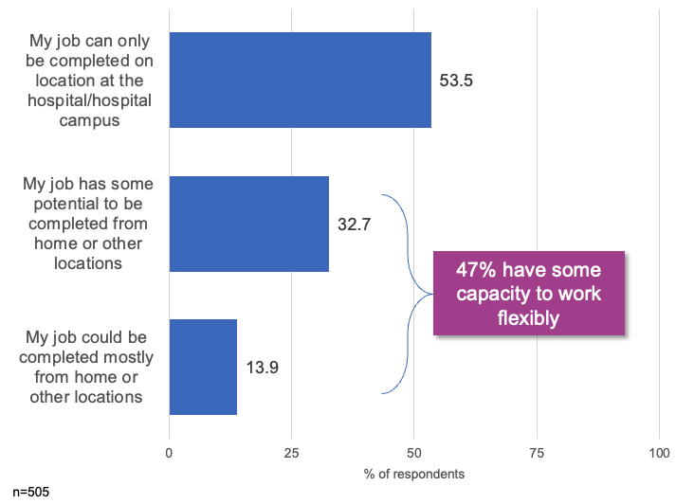
Table 7: Flexibility of job
Response | Percentage of respondents (%)
My job can only be completed on location at the hospital or hospital campus | 53.5
My job has some potential to be completed from home or other locations | 32.7
My job could be complete mostly from home or other locations | 13.9
Note: n=505
Figure 6: Job flexibility over last six months
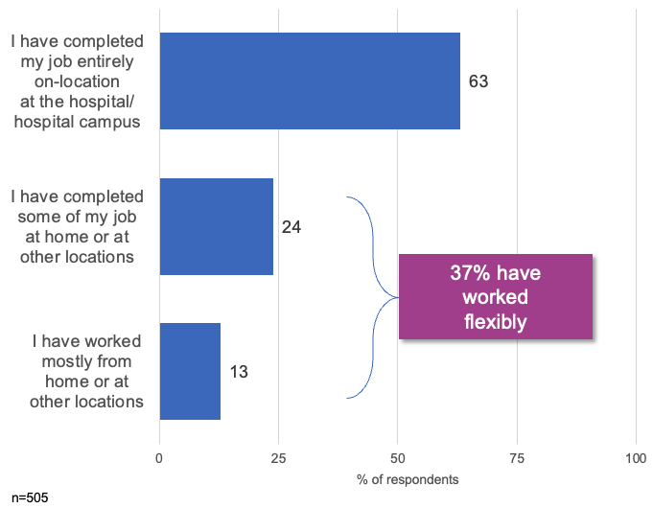
Table 8: Job flexibility over last six months
Response | Percentage of respondents (%)
My job can only be completed on location at the hospital or hospital campus | 63
My job has some potential to be completed from home or other locations | 24
My job could be complete mostly from home or other locations | 13

Remote working exploration
Findings:
- Uptake of remote working by those who are eligible to do so has been strong with 70 per cent of those with high flexibility predominately working remotely. This is not surprising given the remote working requirements under COVID restrictions.
- Capacity remains for growth in remote working, with around a third (33.9 per cent) of those with some potential to do so still only working on site.
Table 9: Analysis of uptake of remote working
Response | My job can only be completed on location | My job has some potential to be completed from home or other locations | My job could be completed mostly from home or other locations | Total
I have completed my job entirely on-location at the hospital or hospital campus | 96.3% | 33.9% | 4.3% | 63.2%
I have completed some of my job at home or at other locations | 3.3% | 57.0% | 25.7% | 24.0%
I have worked mostly from home or at other locations | 0.4% | 9.1% | 70.0% | 12.9%
Total | 53.5% | 32.7% | 13.9% | -

Travel behaviour interventions – mean score
Question: Thinking about the sorts of things that could encourage to you use more or start using other travel options (such as walking, cycling, public transport and car sharing), how likely are each of the following to influence you?
Findings:
- While overall appeal of all potential travel interventions was weak, parking-related incentives for sustainable car-based travel received the most positive evaluation from staff. This aligns with interest in supporting colleagues to car share (such as through a ride-matching app).
- Enhanced end-of-trip facilities are also of some appeal to staff.
Figure 7: Mean appeal of possible travel incentives and interventions
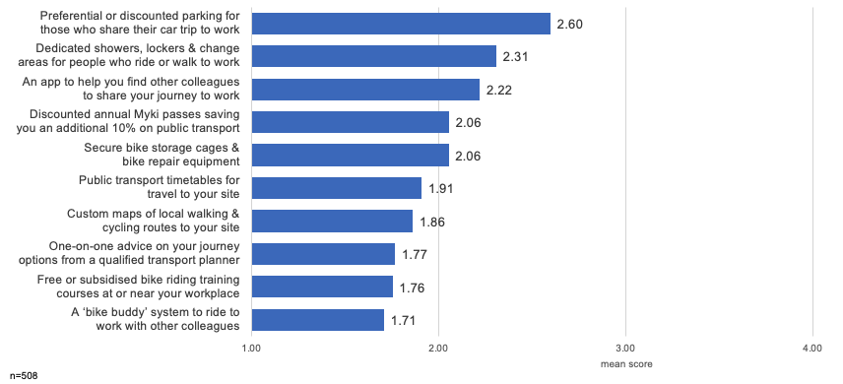
Table 10: Mean appeal of possible travel incentives and interventions
Option | Mean score
Preferential or discounted parking for those who share their car trip to work | 2.6
Dedicated showers, lockers and change areas for people who ride or walk to work | 2.31
An app to help you find other colleagues to share your journey to work | 2.22
Discounted annual Myki passes saving you an additional 10% on public transport | 2.06
Secure bike storage cages and bike repair equipment | 2.06
Public transport timetables for travel to your site | 1.91
Custom maps of local walking and cycling routes to your site | 1.86
One-on-one advice on your journey options from a qualified transport planner | 1.77
Free or subsidised bike riding training courses at or near your workplace | 1.76
A 'bike buddy’ system to ride to work with other colleagues | 1.71
Note: n=508

Travel behaviour intervention – attractiveness
Question: Thinking about the sorts of things that could encourage to you use more or start using other travel options (such as walking, cycling, public transport and car sharing), how likely are each of the following to influence you?
Findings:
- While appeal of most travel interventions was low, preferential or discounted parking for car sharing and enhanced end-of-trip facilities were attractive influencers for almost a third of the workforce.
- Discounted Myki cards and bike storage facilities also rated highly with around 20 per cent of workforce.
Figure 8: Appeal of travel incentives and interventions
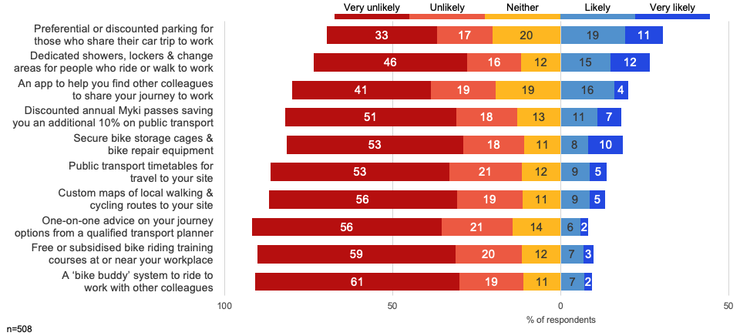

Table 11: Appeal of travel incentives and interventions
Option | Very unlikely (%) | Unlikely (%) | Neither (%) | Likely (%) | Very likely (%)
Preferential or discounted parking for those who share their car trip to work | 33 | 17 | 20 | 19 | 11
Dedicated showers, lockers and change areas for people who ride or walk to work | 46 | 16 | 12 | 15 | 12
An app to help you find other colleagues to share your journey to work | 41 | 19 | 19 | 16 | 4
Discounted annual Myki passes saving you an additional 10% on public transport | 51 | 18 | 13 | 11 | 7
Secure bike storage cages and bike repair equipment | 53 | 18 | 11 | 8 | 10
Public transport timetables for travel to your site | 53 | 21 | 12 | 9 | 5
Custom maps of local walking and cycling routes to your site | 56 | 19 | 11 | 9 | 5
One-on-one advice on your journey options from a qualified transport planner | 56 | 21 | 14 | 6 | 2
Free or subsidised bike riding training courses at or near your workplace | 59 | 20 | 12 | 7 | 3
A 'bike buddy’ system to ride to work with other colleagues | 61 | 19 | 11 | 7 | 2
Note: n=508

Family commitments and mobility choices
Question: Do family or childcare commitments influence your choices of how you travel to work?
Findings:
- Yes – 26.7%
- No – 73.3%
- Over one-quarter of staff have family or childcare commitments influence their travel choices
Figure 9: Family and childcare commitments influencing choice of travel
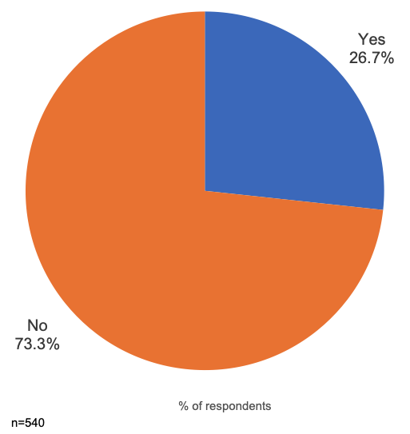

Question: How long was your door-to-door commute to the campus today?
Findings:
- Positively, 65 per cent of staff travel less than 30 minutes to work, with the vast majority (85 per cent) completing their trip in less than 45 minutes.
- These short travel times make other modes less appealing, especially public transport, as the alternative trip would take much longer than by car.
Figure 10: Commute time to campus on survey day
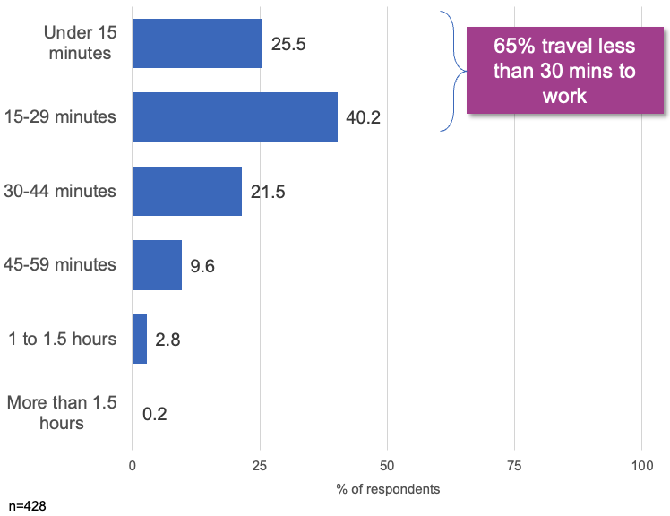
Table 12: Commute time to campus on survey day
Commute time | Percentage of respondents (%)
Under 15 minutes | 25.5
15 to 29 minutes | 40.2
30 to 44 minutes | 21.5
45 to 59 minutes | 9.6
1 to 1.5 hours | 2.8
Over 1.5 hours | 0.2
Note: n=428

Journey time and satisfaction
Questions:
- How long was your door-to-door commute to the campus today?
- How would you rate your satisfaction with your experience travelling to the hospital or hospital campus?
Findings
- There is a strong and statistically significant relationship between total trip time and journey satisfaction.
- Those staff whose journey was under 30 minutes in duration (around two-thirds of the workforce) were much more likely to be ‘very satisfied’ with their trip. This poses challenges to growing use of non-car modes which may increase total trip time.
Figure 11: Satisfaction by journey time
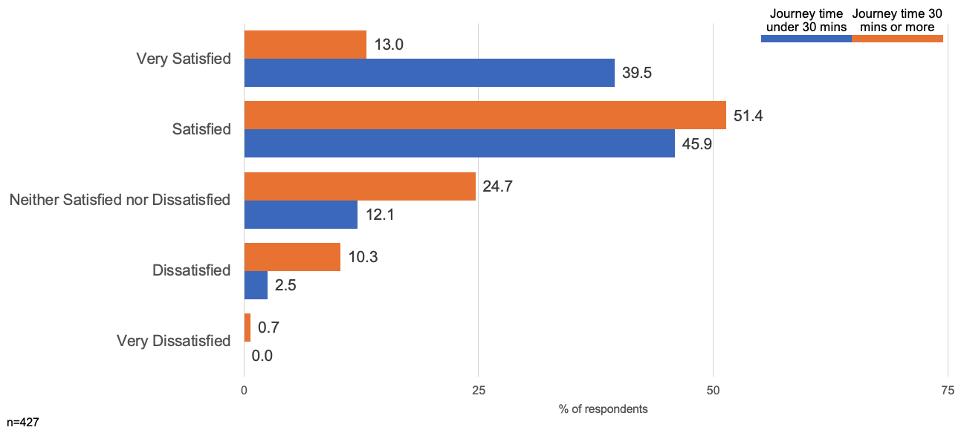
Table 13: Satisfaction by journey time
Response | Under 30 minutes (%) | 30 minutes and over (%)
Very satisfied | 39.5 | 13.0
Satisfied | 45.9 | 51.4
Neither satisfied not dissatisfied | 12.1 | 24.7
Dissatisfied | 2.5 | 10.3
Very dissatisfied | 0.0 | 0.7
Note: n=427

Car parking
Questions:
- Where did you park your car when you arrived at work today?
- Did you pay for your parking (including any passes or arrangements by salary deduction)?
Findings:
- Just under three-quarters of all staff who drive to work park on-site (73 per cent), with local on-street parking being the next most popular option.
- 98 per cent of staff parking users report paying for their parking.
- 96 per cent of street parking was free.
Figure 12: Car park location on survey day
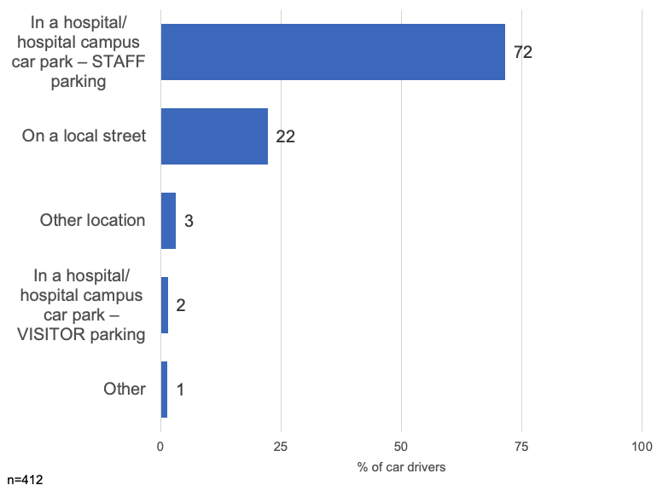
Table 14: Car park location on survey day
Location | Percentage of respondents (%)
Hospital or hospital campus car park – staff parking | 72
Local street | 22
Other location | 3
Hospital or hospital campus car park – visitor parking | 2
Other | 1
Note: n=412
Figure 13: Paid for parking on survey day
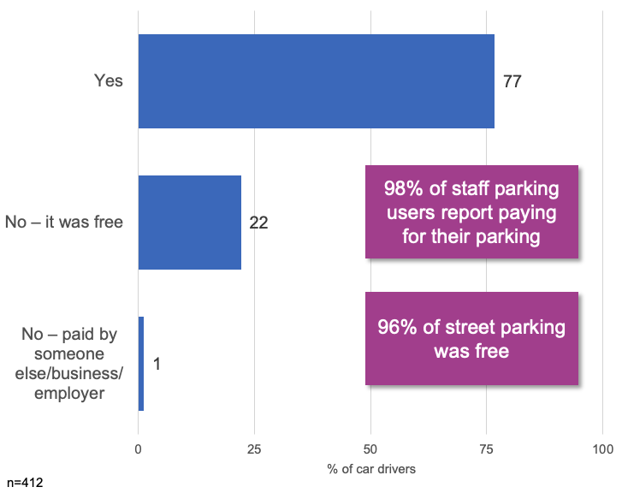
Table 15: Paid for parking on survey day
Response | Percentage of respondents (%)
Yes | 77
No – it was free | 22
No – paid by someone else, business or employer | 1
Note: n=412

On-site staff car parking
Questions:
- Do you have a hospital campus staff car parking permit?
- How do you rate the quality of car parking facilities at the hospital or hospital campus?
Findings:
- A similar proportion of staff that drive also hold a hospital parking permit, suggesting a strong linkage between permits and car park use.
- On-site parking facilities are subject to mixed perceptions, with 23 per cent rating them poorly and 35 per cent rating them positively.
Figure 14: Hold a staff car parking permit
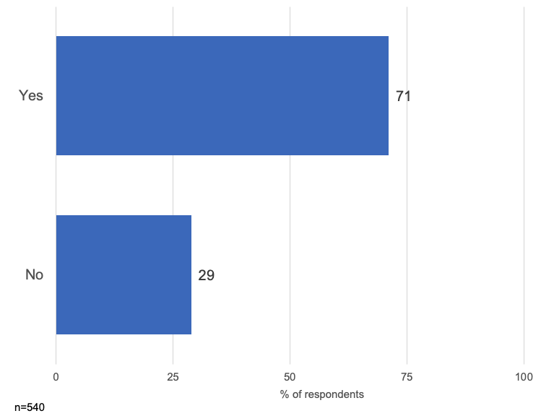
Table 16: Hold a staff car parking permit
Response | Percentage of respondents (%)
Yes | 71
No | 29
Note: n=540
Figure 15: Quality of car parking facilities
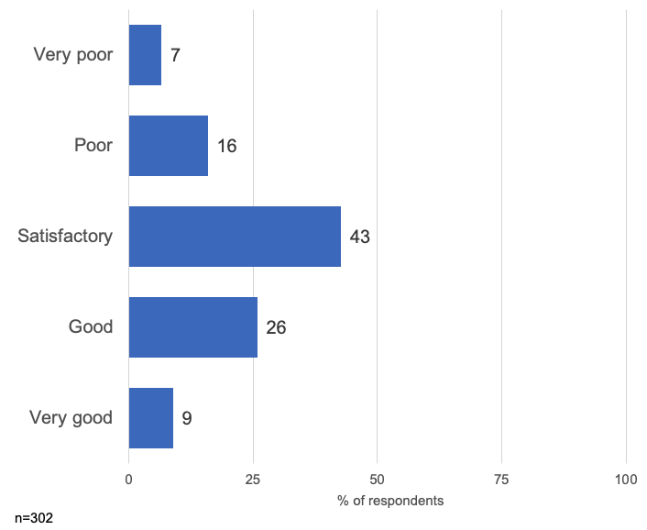
Table 17: Quality of car parking facilities
Response | Percentage of respondents (%)
Very poor | 7
Poor | 16
Satisfactory | 43
Good | 26
Very good | 9
Note: n=302

Bicycle facilities
Questions:
- As a cyclist, which of the following do you have access to?
- How do you rate the quality of facilities for cyclists?
Findings:
- Cycle facilities provide one of the greatest areas for improvement, with 59 per cent of cyclists rating them ‘very poor’ or ‘poor’.
- Only two-thirds report access to suitable and secure bike parking, while more than half do not have (or are not aware they have) access to basic cycling facilities, such as shower or change rooms or lockers.
Figure 16: Access to cycle facilities
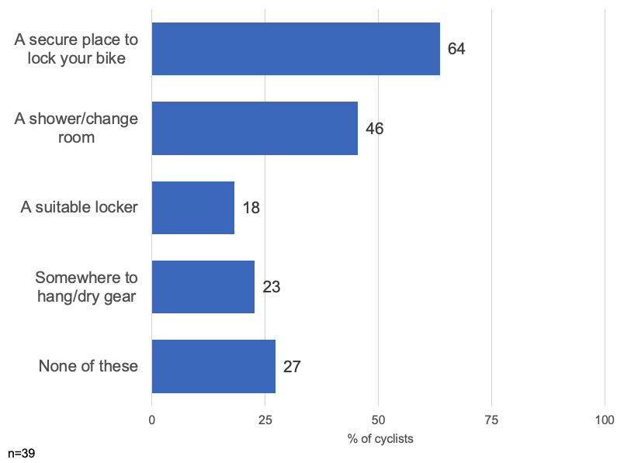
Table 18: Access to cycle facilities
Option | Percentage of cyclists (%)
Secure place to lock bike | 64
Shower or change room | 46
Suitable locker | 18
Somewhere to hang or dry gear | 23
None of these | 27
Note: n=39
Figure 17: Quality of cycle facilities
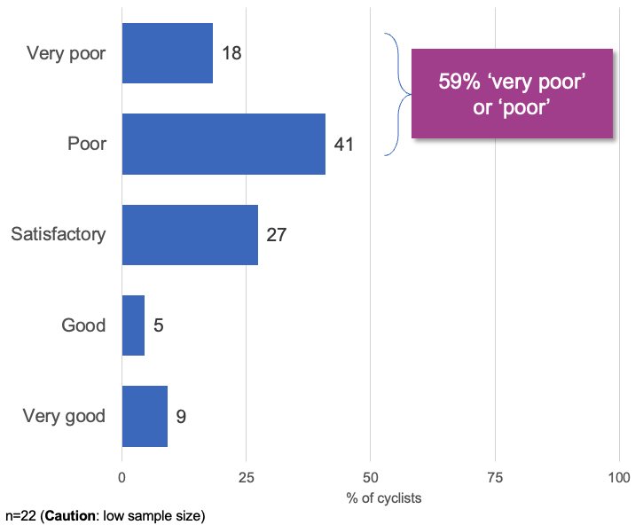
Table 19: Quality of cycle facilities
Response | Percentage of cyclists (%)
Very poor | 18
Poor | 41
Satisfactory | 27
Good | 5
Very good | 9
Note: n=22 (caution: low sample size)

Bicycle parking and trip issues
Questions:
- Where did you park your bicycle when you arrived at work today?
- What are your greatest challenges when riding to work?
Findings:
- Staff choosing to park their bikes within office areas may suggest a need for better secure storage options.
- The vast majority of challenges for cyclists related to the lack of end-of-trip facilities.
Table 20: Where cyclists parked their bike on survey day
Location | Number of cyclists
Inside a building or office – in a non-clinical area | 2
On campus – secure bike storage facility | 1
On campus – open bike racks located at X | 1
On campus – open bike racks located at Y | 1
On campus – open bike racks located at Z | 1
Note: n=6 (caution: small sample size)
Table 21: Greatest challenges riding to work
Issue | Comments | Number of cyclists
General weather | - | 4
End-of-trip facilities | - Distance between bike locker and shower facilities  - Facilities for bike riders are over the other side of the hospital, no secure facilities near community health  - No secure bike facilities (when travelling to) other hospital  - Nowhere to hang or dry cycle gear  - Place to store the bike and clothes  - Somewhere to lock it up and change  - Unable to shower when I arrive, can only change clothes | 7
Lifestyle and other | - Normally what I am doing for the day.  - Takes longer to get to work. Once ridden to work not flexible to pick up kids from school and so on.  - Access to appropriate breakfast food after riding for 1.25 hours | 3
Trip and en route | - Distance  - Navigating entry roads with high traffic and limited bike paths | 2
Total | - | 16
Note: n=16 (caution: small sample size)

Motorcycle facilities
Questions:
- As a cyclist, which of the following do you have access to?
- Where did you park your motorcycle or moped?
Findings:
- Provision of end-of-trip facilities may encourage greater uptake of motorcycling – which could relieve some pressure on on-site parking facilities.
Figure 18: Access to end-of-trip facilities for motorcyclists
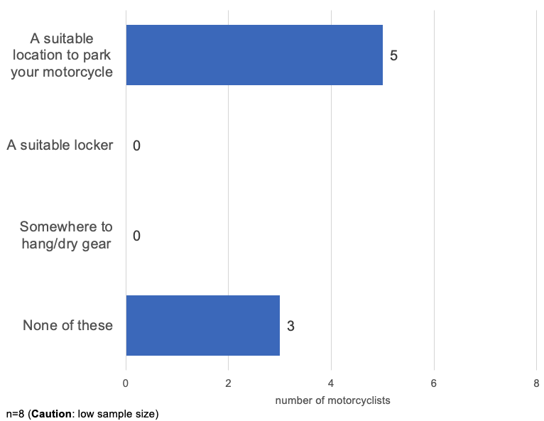
Table 22: Access to end-of-trip facilities for motorcyclists
Option | Number of motorcyclists
Suitable place to park motorbike | 5
Suitable locker | 0
Somewhere to hang or dry gear | 0
None of these | 3
Note: n=8 (caution: low sample size)
Table 23: Motorcycle parking location on survey day
Location | Number of motorcyclists
Hospital or hospital campus staff car park | 3
Non-marked outdoor space at the hospital or hospital campus | 3
On a local street | 1
Elsewhere | 1
Note: n=8 (caution: low sample size)

Public transport
Q: What is your greatest challenge when using public transport to get to work?
Findings:
- Comments regarding public transport focused primarily on service frequency and reliability, followed by factors relating to travel duration
Table 24: Public transport issues
Issue | Comments | Number of respondents
Service operation, reliability, scheduling | - Bus never on time, bus always too early. I miss them more than I catch them. Bus full of school kids. Buses should wait at bus stops for the actual scheduled time, then depart (like in England). They don't.  - Reliability.  - Not very frequent as per my time schedule.  - The timetable.  - The frequency of the bus from X and the time it takes.  - I'm quite happy with service. Very occasionally there may be a cancellation. | 6
Time and duration | - It takes slightly longer, so I need to get up earlier  - Length of time spent on public transport to get to work  - Takes twice the time than driving | 3
Family commitments | - Unable to use more often, because have to drop daughter at childcare first. Can't access childcare from public transport  - Childcare timing. If I could start 30 minutes earlier in the day, then I would be able to time childcare pick up and full working hours | 2
General comments | - If having to get to other campuses other than the hospital, the public transport is poor.  - Transport from station to work. | 2
Note: n=14

Pedestrian facilities
Questions:
- How do you rate the quality of pedestrian facilities in and around the hospital/hospital campus?
- What are your greatest challenges when walking to work?
Findings:
- Pedestrian facilities show significant room for improvement, with less than a third giving positive ratings.
- Safety concerns, particularly around interactions with vehicle traffic both on campus and in the local area, pose the greatest pedestrian challenges.
Figure 19: Quality of pedestrian facilities
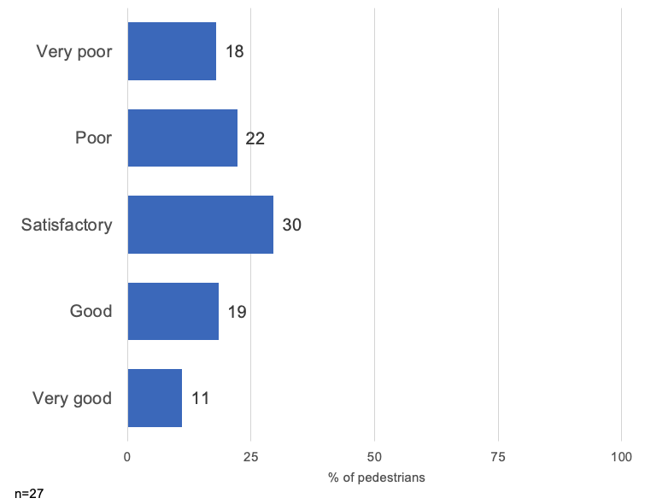
Table 25: Quality of pedestrian facilities
Response | Percentage of pedestrians (%)
Very poor | 18
Poor | 22
Satisfactory | 30
Good | 19
Very good | 11
Note: n=27
Table 26: Pedestrian issues
Issue | Comments | Number of pedestrians
Safety | - Safety.  - Time it takes not to leave late. Or dark at night – safety.  - Safety, particularly early morning or later evening – plus there are not many walking paths on campus (have to walk on the road for part of the journey).  - Lack of pedestrian crossing in obvious places, vehicles not respecting pedestrian crossing, vehicles burning the red light when the alarm goes for pedestrian to cross – very dangerous.  - If entering hospital grounds from the park or X, you have to walk along the road to access the buildings. It is a wonder no one has been hit by a car.  - Walking from Y to main reception without getting in the way of cars as there is no safe path to walk on.  - Walking lanes are too narrow and not separated from car lanes. There are also no zebra crossings near Gate 3. | 7
Distance and terrain | - Distance from train station.  - Distance or time.  - Just time and wanting to do it.  - Hills. | 4
Pedestrian infrastructure | - No formal separate path from the road at the X St entry.  - No path to the staff entrance – have to cut through the staff car park.  - Path access on the western side of the hospital site. | 2
Weather | - Weather.  - To me it is fun walking to work and it is good to start the day with some exercise. The only little challenge is when it is cold, windy and raining. But that is part of the excitement too I guess. | 2

General feedback
Question: Is there any other feedback you’d like to provide?
Findings:
- General feedback reflected a highly driver-centric culture, with the majority of comments relating to the capacity, design or operation of existing car parks.
- Most respondents felt that they had little option but to drive.
- Those who had explored alternatives were frustrated with public transport reliability, trip times and access.
Figure 20: General feedback
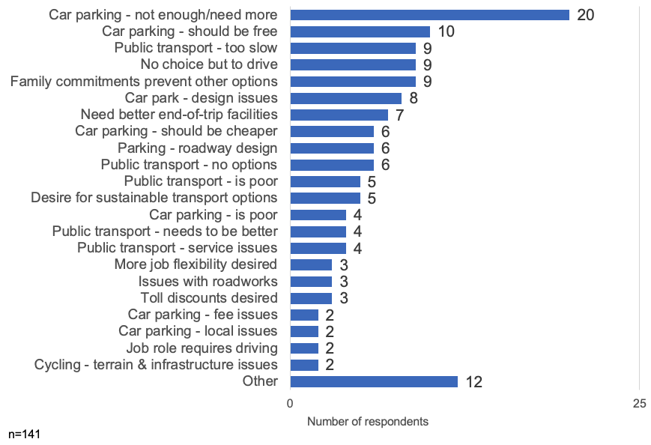

Table 27: General feedback
Feedback | Number of respondents
Car parking – not enough or need more | 20
Car parking – should be free | 10
Public transport – too slow | 9
No choice but to drive | 9
Family commitments prevent other options | 9
Car park – design issues | 8
Need better end-of-trip facilities | 7
Car parking – should be cheaper | 6
Parking – roadway design | 6
Public transport – no options | 6
Public transport – is poor | 5
Desire for sustainable transport options | 5
Car parking – is poor | 4
Public transport – needs to be better | 4
Public transport – service issues | 4
More job flexibility desired | 3
Issues with roadworks | 3
Toll discounts desired | 3
Car parking – fee issues | 2
Car parking – local issues | 2
Job role requires driving | 2
Cycling – terrain and infrastructure issues | 2
Other | 12

Quotes
- ‘I would love to take public transport. But I have to take the train (15 minutes) and then walk about 20 minutes or take a bus. I can drive in about 15 minutes. It would be great if there were some ways to make it easier to commute to work by public transport.’
- ‘I can only travel to work via car. Public transport would take over 2 hours each way, which I am not willing to undertake. The fact that I have the opportunity to work from home some of the weeks has allowed me to keep working for [health service], otherwise I probably would have found alternative employment closer to home.’
- ‘Having a bike path from X to Y, bike path – separated from cars – with a shower at work would get me back on my bike!
- ‘Fragmented connections and timetables on public transport make driving the only sensible option.’

Arrival and departure times
Questions:
- What time did you arrive at the hospital or hospital campus?
- What time do you expect to leave the hospital or hospital campus?
Findings:
- Despite the afternoon peak being slightly more dispersed, the majority of campus staff still travel during traditional peak travel hours. This is useful context for communications when ‘shift work’ is often presented as a barrier to change. This regular travel pattern also supports more ride sharing.
Figure 21: Arrival and departure times on survey day
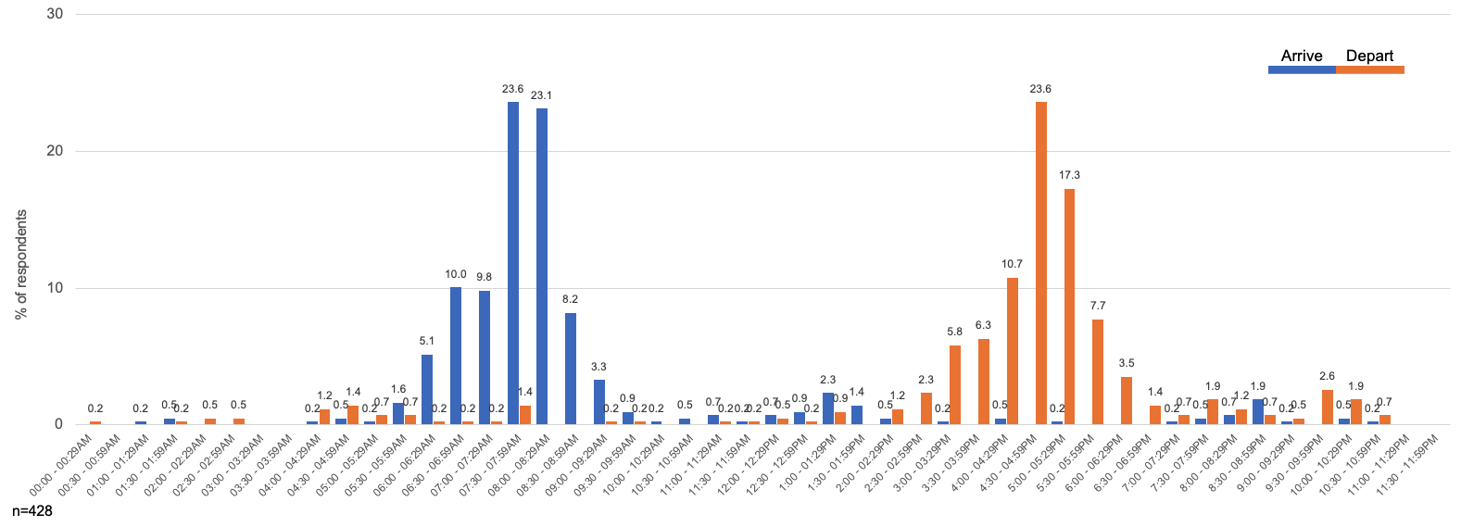
Table 28: Arrival and departure times on survey day
Time | Arrive (%) | Depart (%)
00:00 to 00:29 am | 0 | 0.2
00:30 to 00:59 am | 0 | 0
01:00 to 01:29 am | 0.2 | 0
01:30 to 01:59 am | 0.5 | 0.2
02:00 to 02:29 am | 0 | 0.5
02:30 to 02:59 am | 0 | 0.5
03:00 to 03:29 am | 0 | 0
03:30 to 03:59 am | 0 | 0
04:00 to 04:29 am | 0.2 | 1.2
04:30 to 04:59 am | 0.5 | 1.4
05:00 to 05:29 am | 0.2 | 0.7
05:30 to 05:59 am | 1.6 | 0.7
06:00 to 06:29 am | 5.1 | 0.2
06:30 to 06:59 am | 10.0 | 0.2
07:00 to 07:29 am | 9.8 | 0.2
07:30 to 07:59 am | 23.6 | 1.4
08:00 to 08:29 am | 23.1 | 0
08:30 to 08:59 am | 8.2 | 0
09:00 to 09:29 am | 3.3 | 0.2
09:30 to 09:59 am | 0.9 | 0.2
10:00 to 10:29 am | 0.2 | 0
10:30 to 10:59 am | 0.5 | 0
11:00 to 11:29 am | 0.7 | 0.2
11:30 to 11:59 am | 0.2 | 0.2
12:00 to 12:29 pm | 0.7 | 0.5
12:30 to 00:59 pm | 0.9 | 0.2
01:00 to 01:29 pm | 2.3 | 0.9
01:30 to 01:59 pm | 1.4 | 0
02:00 to 02:29 pm | 0.5 | 1.2
02:30 to 02:59 pm | 0 | 2.3
03:00 to 03:29 pm | 0.2 | 5.8
03:30 to 03:59 pm | 0 | 6.3
04:00 to 04:29 pm | 0.5 | 10.7
04:30 to 04:59 pm | 0 | 23.6
05:00 to 05:29 pm | 0.2 | 17.3
05:30 to 05:59 pm | 0 | 7.7
06:00 to 06:29 pm | 0 | 3.5
06:30 to 06:59 pm | 0 | 1.4
07:00 to 07:29 pm | 0.2 | 0.7
07:30 to 07:59 pm | 0.5 | 1.9
08:00 to 08:29 pm | 0.7 | 1.2
08:30 to 08:59 pm | 1.9 | 0.7
09:00 to 09:29 pm | 0.2 | 0.5
09:30 to 09:59 pm | 0 | 2.6
10:00 to 10:29 pm | 0.5 | 1.9
10:30 to 10:59 pm | 0.2 | 0.7
11:00 to 11:29 pm | 0 | 0
11:30 to 11:59 pm | 0 | 0
Note: n=428

To receive this document in another format, phone 9595 2898, using the National Relay Service 13 36 77 if required, or email sustainability <sustainability@health.vic.gov.au>.
Authorised and published by the Victorian Government, 1 Treasury Place, Melbourne.
© State of Victoria, Australia, Department of Health, August 2022.
Refer to the main reference document ISBN 978-1-76096-951-6 (pdf/online/MS word)
Available at Department of Health website <www.health.vic.gov.au/sustainability>

