Hospital travel plan guide for Victorian health services
1.0 – Sustainable transport in health care

To receive this document in another format, phone 9595 2898, using the National Relay Service 13 36 77 if required, or email Sustainability <sustainability@health.vic.gov.au>.
Authorised and published by the Victorian Government, 1 Treasury Place, Melbourne.
© State of Victoria, Australia, Department of Health, August 2022.
ISBN 978-1-76096-951-6 (pdf/online/MS word)
Available at Department of Health website's Sustainability in healthcare section <https://www.health.vic.gov.au/sustainability>

Contents
Introduction 5
Acknowledgements 5
Effective workplace travel plans 5
Our travel plan approach 6
Travel plan development process 8
How long will this take? 9
Step 1: Analysis and assessment 10
Assessment: understand interacting success factors 10
Travel plan analysis and assessment 11
Step 2: Select travel plan level 12
Travel plan levels 12
Travel plan resources 12
Step 3: Review and confirm objectives 13
Travel plan objectives and targets 13
Step 4: Identify travel plan actions 14
Approach 14
Organisational success factors 14
Identify actions, create the travel plan 15
Step 5: Implement actions 16
Implementing the travel plan 16
Step 6: Evaluate progress 17
Evaluating the success of your travel plan 17
Resources 18
Travel plan approach 18
Travel plan assessment, analysis and evaluation 18
Travel plan development and reporting 19
Actions 19
Attachment A: Hospital travel plan case studies (1.1) 20
Attachment B: Travel plan resources (1.2) 25
Attachment C: Travel plan assessment tool (2.0) 28
Attachment D: Site access audit template (2.1) 33
Attachment E: Staff home location analysis (2.2) 43
Attachment F: Simple staff travel survey template (2.3) 45
Attachment G: Staff travel survey implementation guide (2.4) 50
Attachment H: Comprehensive staff travel survey template (2.5) 52
Attachment I: Example staff travel survey implementation plan (2.6) 62
Attachment J: Stakeholder engagement matrix (2.7) 67
Attachment K: Example staff travel survey communications copy (2.8) 69
Attachment L: Stakeholder travel survey example briefing pack (2.9) 72
Attachment M: Example comprehensive staff travel survey analysis report – major metropolitan hospital (2.10) 73
Attachment N: Tips for running a focus group (2.11) 106
Attachment O: Example travel plan objectives and targets (3.0) 109
Attachment P: Travel plan actions template (3.1) 111
Attachment Q: Travel plan strategic presentation template (3.2) 112
Attachment R: Interpreting results and identifying actions (3.3) 113
Attachment S: ‘How to get to…’ web page examples (4.1) 116
Attachment T: Example transport access guide (4.2) 120
Attachment U: Create a transport access guide (4.3) 124
Attachment V: The Alfred’s high-quality end-of-trip facilities (4.4) 126
Attachment W: Example Myki commuter club policy (4.5) 129
Attachment X: Carpooling program summary guide (4.6) 135
Attachment Y: Example priority car parking policy (4.7) 137

Introduction
The Department of Health has developed the Hospital travel plan toolkit to help health services develop sustainable travel plans for metropolitan and large regional hospitals by 2023, as required under the department’s Environmental sustainability strategy.
A workplace travel plan identifies actions an organisation can implement that make sustainable transport options (such as walking, cycling, public transport and carpooling) easier to use and helps to reduce the amount of drive-alone commuting by staff.
This guide sets out the ‘what, why and how’ of developing a sustainable travel plan for a hospital or other health service site in Victoria. It includes:
- an introduction to travel planning
- a standard methodology to develop, implement and report on travel plans that is consistent but responsive to each health service’s context
- an assessment framework that identifies the type of travel plan to develop based on each workplace’s opportunity for staff to change to non-car options and the organisation’s capacity to implement actions
- resources to help develop, implement and evaluate travel plan actions.
Most of these resources are included as attachments to this guide but are also available as individual downloads on the Department of Health website's Transport page <https://www.health.vic.gov.au/planning-infrastructure/transport>.

Acknowledgements
This material has been developed for the Department of Health by Alice Woodruff at Active City as part of a partnership between Peninsula Health, Eastern Health and the department. We thank the project partners for delivering the project including Western District Health Service who trialled the materials and provided feedback.

Effective workplace travel plans
A workplace travel plan identifies actions that an organisation can implement to make sustainable transport options (like walking, cycling, public transport and carpooling) easier to use and reduce the amount of drive-alone trips by staff. A secondary purpose is to reduce an organisation’s drive-alone business-related trips.
A travel plan applies a mix of tailored measures based on a location’s transport options and the specific organisational context (including its culture, capacity and needs of its staff) to increase use of sustainable travel options.

Theme | Measures
Policy and regulations | Organisational changes that increase travel choice. Includes:  - salary packaging  - supportive remote work policies  - parking management (allocation based on need, pricing incentives, say, for carpooling)  - funding allocated to support other modes.
Better infrastructure and services | Improving options and making it easier to use other modes. Includes:  - paths for walking desire lines  - end-of-trip facilities  - wayfinding to public transport  - lighting along walking routes  - advocacy or subsidy for public transport services  - shuttle buses.
Behavioural interventions | Building staff capabilities and promoting choice. Includes:  - information on travel options (website, staff induction and so on)  - local area transport maps  - communications campaigns, events, promotions and advice  - financial incentives (such as reduced parking costs for carpooling).

Our travel plan approach
The department’s sustainable travel plan framework has three levels:
- passive
- active
- comprehensive.
A combination of factors influences the level of travel plan a health service may implement for a hospital or other service location. One or more of these factors may support or hinder a plan’s development and outcomes. These factors include:
- the opportunity for employees to change to non-car travel – this relates to the total number of employees at the workplace, the availability of public transport, and walking and cycling access
- how pressing travel-related issues are for the workplace (such as parking availability, local access and issues on the way to work like traffic congestion)
- the organisation’s resources and capacity to respond to these issues.
The levels are not static. For example, an organisation may start with a passive plan and then expand it to an active plan as resources and other success factors are in place.

Table 1: Travel plan levels
Plan type | Description
Passive: promote choice of options | At a minimum, a travel plan aims to promote all travel options and make it easier to choose to work remotely, carpool, use public transport, walk or ride to work (instead of driving alone).  A passive plan has little staff engagement but puts in place supporting information, facilities and policies.
Active: encourage other options | More effective travel plans actively encourage and incentivise sustainable travel options.  They engage directly with employees and run regular events and programs (such as carpooling).  They strengthen changes in behaviour with parking policies.
Comprehensive: maximise use of other options | A comprehensive plan actively reduces the number and frequency of employees driving alone to work.  It applies a range of measures, including parking management, to actively encourage more employees with other travel options to use them more often.
Figure 1: Travel plan framework
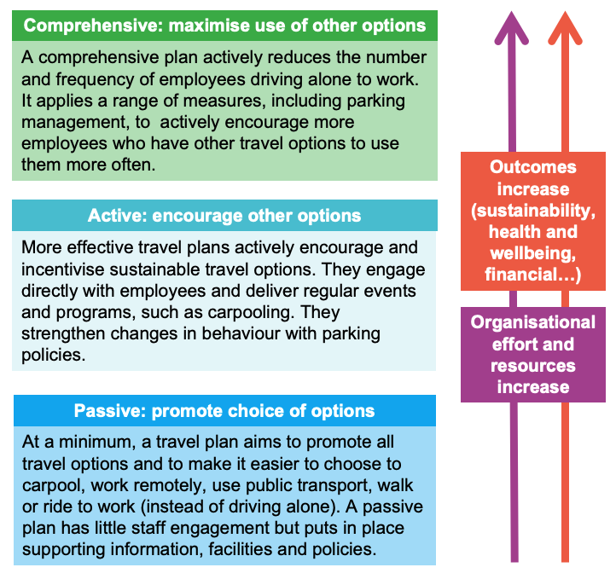

Travel plan development process
The following is the recommended method for developing a travel plan for an individual workplace.
The rest of this guide explains each step of the process and the relevant toolkit resources for each step.
Figure 2: Plan development process
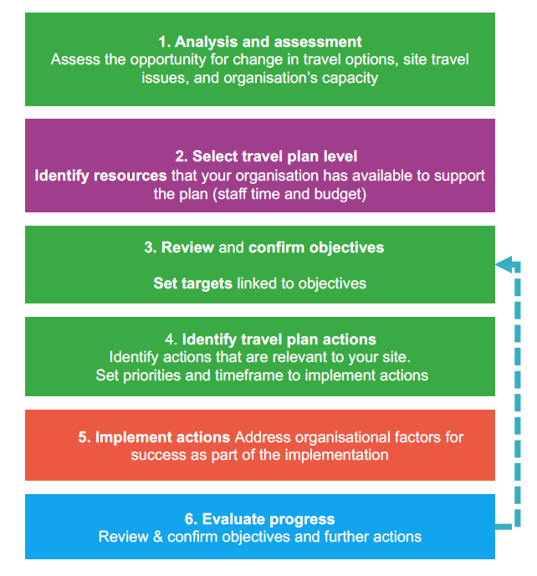

Step 1: Analysis and assessment
- Assess the opportunity for change in travel options, site travel issues, and organisation’s capacity.
Step 2: Select travel plan level
- Identify resources that your organisation has available to support the plan (staff time and budget).
Step 3: Review and confirm objectives
- Set targets linked to objectives.
Step 4: Identify travel plan actions
- Identify actions that are relevant to your site.
- Set priorities and timeframe to implement actions.
Step 5: Implement actions
- Address organisational factors for success as part of the implementation.
Step 6: Evaluate progress
- Review and confirm objectives and further actions.

How long will this take?
It may take six to 12 months to prepare a travel plan and seek executive endorsement to implement it if the project is an addition to your usual role (at 0.2 EFT).
This includes:
- completing the background analysis and staff travel survey
- developing the travel plan actions and priorities.

Step 1: Analysis and assessment
Assess opportunity for change in travel options, local travel issues, organisation’s capacity:
- Desktop analysis of travel options, site audit of access, facilities and access.
- Internal stakeholder discussions, travel survey analysis and report.

Assessment: understand interacting success factors
The first step looks at the interacting factors that will influence how effective a plan will be. This will inform decisions on whether to develop and implement a passive, active or comprehensive plan.
The analysis and assessment step includes:
- an audit of transport facilities and access by all travel options to the site (walking, bike riding, public transport, carpooling and driving alone)
- desktop review and a walking audit of the local area to assess ease of access by public transport, walking and bike riding
- desktop review of public transport availability (proximity, number and frequency of services)
- simple staff travel survey to identify current travel patterns, staff interests, opportunities and challenges to changing the way people travel
- internal stakeholder discussions and feedback to assess current processes and organisational success factors (such as human resources, facilities, parking management and sustainability).
The overall assessment compares the potential opportunity for change and the organisation’s capacity to implement the travel plan.
Figure 3: The overall assessment
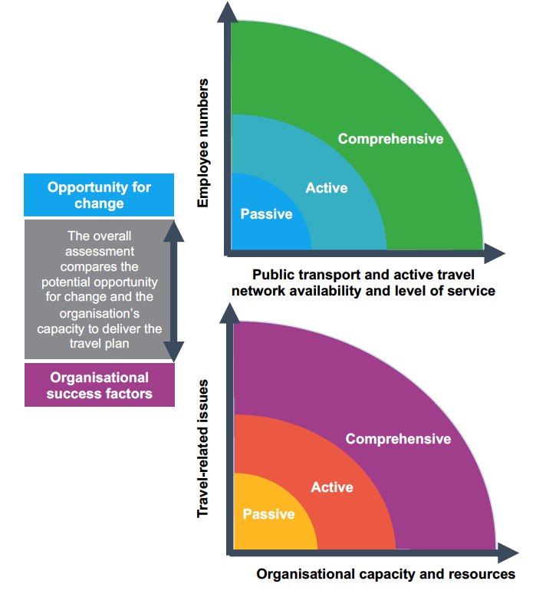

Travel plan analysis and assessment
Use the Travel plan assessment tool (2.0) to review the interacting factors that will determine whether to develop a passive, active or comprehensive travel plan.
This assessment is done after analysing the workplace and its local transport context. The analysis uses some data that is already available. It also needs information collected from a site audit and a simple travel survey to help inform the assessment.
The coordinator will also need to talk to colleagues to understand the organisational factors that will influence the plan’s development and success, such as resources and staff available to implement actions.

Toolkit resources to support this step
- Travel plan assessment tool (2.0)
- Site access audit template (2.1)
- Staff home location analysis (2.2)
- staff travel survey templates (simple and comprehensive) (2.3, 2.5)
- Staff travel survey implementation guide (2.4)
- Example staff travel survey implementation plan (2.6)
- Stakeholder engagement matrix (2.7)
- Example staff travel survey communications copy (2.8)
- Stakeholder travel survey briefing pack example (2.9)
- Example comprehensive staff survey analysis report (2.10)
- Tips for running a focus group (2.11)

Step 2: Select travel plan level
- Select the most relevant travel plan level for your site.
- Identify resources that your organisation has available to support the plan (staff time and budget).

Travel plan levels
- Passive or Passive+
- Active or Active+
- Comprehensive

Toolkit resources to support this step
- Travel plan assessment tool (2.0)
- Site access audit template (2.1)
- Staff home location analysis (2.2)
- staff travel survey templates (simple and comprehensive) (2.3, 2.5)
- Staff travel survey implementation guide (2.4)
- Example staff travel survey implementation plan (2.6)
- Stakeholder engagement matrix (2.7)
- Example staff travel survey communications copy (2.8)
- Stakeholder travel survey briefing pack example (2.9)
- Example comprehensive staff survey analysis report (2.10)
- Tips for running a focus group (2.11)

Travel plan resources
Identify the resources (people, operational and capital budgets) that are likely to be available or committed to the travel plan. This will influence the travel plan’s:
- objectives
- targets
- range of actions
- priorities
- phasing of actions over the duration of plan.
This is an iterative process as resources will be reviewed again once actions have been identified.

Toolkit resources to support this step:
- Example travel plan objectives and targets (3.0)
- Hospital travel plan case studies (1.1)
- Travel plan resources (1.2)

Step 3: Review and confirm objectives
Set targets linked to objectives.

Travel plan objectives and targets
Select objectives and targets to achieve outcomes most relevant to the organisation’s priorities.
Use the Example travel plan objectives and targets (3.0) as a guide.

Toolkit resources to support this step:
- Example travel plan objectives and targets (3.0)
- Hospital travel plan case studies (1.1)
- Travel plan resources (1.2)

Step 4: Identify travel plan actions
Identify actions relevant to your site and set priorities and timeframe to implement actions:
- Select and prioritise travel plan actions from spreadsheet.
- Prepare travel plan strategic document – linking analysis and assessment to actions.
- Gain commitment for plan: Agree roles, responsibilities and timelines.

Approach
A travel plan aims to remove workplace-related barriers to make it easier to walk, ride a bike, use public transport or carpool to work.
This travel plan approach uses the Behavioural Insights Team’s EAST framework. The framework encourages change by making it:
- easier
- attractive
- social
- timely.
Based on the background analysis, for all levels of travel plan, look for opportunities to make it:
- easier to learn about all transport options and highlight available options
- timely by giving staff information when and where it is most relevant (such as staff induction)
- easier and more attractive by improving bike end-of-trip facilities
- attractive by implementing policies that support travel choice (such as remote work practices and parking management based on need).
For active and comprehensive travel plans, also include actions to make it:
- attractive and social through events, campaigns and programs
- easier by advocating for improvements to the local area and public transport.

Organisational success factors
- Alongside identifying actions and creating the travel plan, it is essential to build early executive support and resources to ensure the plan is effective.
- Review the organisational success factors from the assessment tool and put them in place.
- Present the survey findings and strategic travel plan report to leadership to gain their commitment.
- Advocate for an executive to champion the plan.
- Identify a coordinator to oversee the plan and the time to manage it.
- Set up a working group to share actions.
- Work with your communications area to implement early priority actions and build staff awareness.

Identify actions, create the travel plan
Use the Travel plan actions template spreadsheet to select and prioritise actions that:
- match the plan level and objectives
- respond to the issues and opportunities identified in the analysis and assessment steps.
Depending on the context and resources, it may be useful to implement actions from a higher level to make the plan more effective. If a site needs a comprehensive plan, a workplace may work towards this in phases.
Use the Interpreting results and identifying actions guide to help assess what actions may be most relevant based on your site audit, survey analysis and stakeholder feedback.
Present the strategic approach to the travel plan to your executive or leadership team using the Travel plan strategy presentation template. This describes how the analysis has informed the plan’s development and priorities.

Toolkit resources to support this step
- Interpreting results and identifying actions (3.3)
- Travel plan actions template (3.1)
- Hospital travel plan strategic presentation template (3.2)
- Hospital travel plan case studies (1.1)
- Travel plan resources (1.2)

Step 5: Implement actions
Address factors for success as part of the implementation.

Implementing the travel plan
The toolkit resources will help you implement a range of core actions for all travel plans, such as preparing ‘all transport options’ information for health service websites and how to design a transport access guide.
Key resources include:
- Travel plan resources (1.2)
- Explanations and notes included in the Travel plan actions template (3.1)
- Hospital travel plan case studies (1.1).

Toolkit resources to support these steps
- Travel plan actions template (3.1) explanation and notes
- Travel plan resources (1.2) to help implement different actions
- Hospital travel plan case studies (1.1)
- ‘How to get to…’ webpage examples (4.1)
- Example transport access guide (4.2)
- Create a transport access guide (4.3)
- High quality end-of-trip facilities at The Alfred: case study (4.4)
- Myki Commuter Club example policy (4.5)
- Carpooling program summary guide (4.6)
- Example priority car parking policy (4.7)
- Simple staff travel survey template (2.3)

Step 6: Evaluate progress
Review and confirm objectives and further actions.

Evaluating the success of your travel plan
Evaluating progress against objectives and targets is part of implementation.
For active and comprehensive plans, a two- or three-question travel survey every one to two years will help track the proportion of sustainable travel by staff.
Staff time and resources to implement a travel plan will vary based on the plan level and identified actions.
An active plan for a larger workplace would need around 0.2 to 0.4 EFT and a working group to support implementation.
Allocating more resources and time will accelerate implementation and improve the plan’s effectiveness and outcomes.

Toolkit resources to support these steps
- Travel plan actions template (3.1) explanation and notes
- Travel plan resources (1.2) to help implement different actions
- Hospital travel plan case studies (1.1)
- ‘How to get to…’ webpage examples (4.1)
- Example transport access guide (4.2)
- Create a transport access guide (4.3)
- High quality end-of-trip facilities at The Alfred: case study (4.4)
- Myki Commuter Club example policy (4.5)
- Carpooling program summary guide (4.6)
- Example priority car parking policy (4.7)
- Simple staff travel survey template (2.3)

Resources

Travel plan approach
Resource type | Description | Resource name
Guide to developing a travel plan, case studies and resources | Travel plan approach – introduction to framework | 1.0 Travel plan guide
Guide to developing a travel plan, case studies and resources | Hospital travel plan case studies: Liverpool, QEII Hospital, Hawkes Bay, Lismore Base Hospital | 1.1 Hospital travel plan case studies
Guide to developing a travel plan, case studies and resources | Travel plan resources – case studies and guides for implementing different actions | 1.2 Travel plan resources

Travel plan assessment, analysis and evaluation
Resource type | Description | Resource name
Travel plan assessment | Travel plan assessment framework | 2.0 Travel plan assessment tool
Site audit | Site audit template | 2.1 Site audit template
Staff home location analysis | How to complete a catchment analysis of staff | 2.2 Staff home location analysis
Staff travel survey design, delivery and communications | Simple travel survey to inform a passive or active travel plan | 2.3 Simple staff travel survey
Staff travel survey design, delivery and communications | Survey delivery guide – approach and communications | 2.4 Staff travel survey implementation guide
Staff travel survey design, delivery and communications | Detailed travel survey for a comprehensive travel plan | 2.5 Comprehensive staff travel survey
Staff travel survey design, delivery and communications | Example engagement and communications plan | 2.6 Example staff travel survey implementation plan
Staff travel survey design, delivery and communications | Example stakeholder matrix to support delivery of travel survey and other travel plan actions | 2.7 Stakeholder engagement matrix
Staff travel survey design, delivery and communications | Example survey communications emails | 2.8 Example staff travel survey communications copy
Staff travel survey design, delivery and communications | Example presentation for health service stakeholders to raise awareness and encourage participation | 2.9 Stakeholder travel survey briefing pack example
Staff survey analysis report | Example report presenting survey results from a comprehensive travel survey for a large hospital | 2.10 Example staff survey analysis report
Conducting focus groups | Focus group tips including prompts and questions | 2.11 Tips for running a focus group

Travel plan development and reporting
Resource type | Description | Resource name
Develop travel plan actions, set priorities; track and report on progress | Travel plan objectives and targets examples | 3.0 Example travel plan objectives and targets
Develop travel plan actions, set priorities; track and report on progress | Travel plan actions template | 3.1 Travel plan actions template
Develop travel plan actions, set priorities; track and report on progress | Travel plan template: sets out objectives, analysis of issues and opportunities, priorities and implementation | 3.2 Travel plan strategic presentation template
Develop travel plan actions, set priorities; track and report on progress | Tips on interpreting results and guide to relevant actions | 3.3 Interpreting results and identifying actions

Actions
Resource type | Description | Resource name
Information: ‘How to get to…’ webpage | Examples from other health services | 4.1 'How to get to…' webpage examples
Information: Local access guide for transport and on-site facilities | What to include in a transport access guide and an example from another health service | 4.2 Example transport access guide: Royal North Shore Hospital  4.3 Create a transport access guide
Facilities: High quality end-of-trip facilities | Case study Alfred Hospital, other workplaces or hospitals | 4.4 High quality end-of-trip facilities at The Alfred: case study
Programs and events: Offer discounted annual Myki tickets | Example policy to use for a staff Myki Commuter Club | 4.5 Myki Commuter Club policy example
Programs and events: Establish carpooling program | Example case studies and links to resources | 4.6 Carpooling program summary guide
Policy: Comprehensive parking policy | Example adapted from QEII Hospital parking policy | 4.7 Car parking policy example

Attachment A: Hospital travel plan case studies (1.1)

Introduction
A workplace travel plan applies a mix of tailored measures that respond to a location’s transport access options and the specific organisational context of a workplace (which includes its culture, attitudes and needs of its employees) to increase the use of sustainable travel options for commuting to work.
These three case studies of hospital travel plans illustrate the integrated approach of successful workplace travel plans across metropolitan, suburban and regional settings.

Liverpool Hospital, Sydney
- A major acute care hospital in an outer suburban growth area.
- 4,000 staff (at time of project).
- Travel plan delivered over three years from 2012 to 2014.
- Executive commitment from the health service
- A three-year funded program.
- Led by a coordinator and supported by a coordination committee (health promotion team).
- No changes to parking management as a disincentive to drive.
- Main actions included:
  - new end of trip facilities
  - carpooling
  - events
  - an access guide (excerpt shown in Figure 1)
  - individual journey planning sessions for interested staff
  - a clear brand – ‘Staff travel choices’.
- Drive alone rates dropped from 83 per cent to 70 per cent in three years (10 per cent drop in the first year).
- Success evaluated with annual staff travel surveys – statistically robust evaluation of change in travel (travel plan was part of a PhD study).
- Study conclusion: ‘A workplace travel plan which only included strategies to encourage active travel to work achieved small but significant increases in active travel.’
Figure 4: Excerpt from Liverpool Hospital access guide
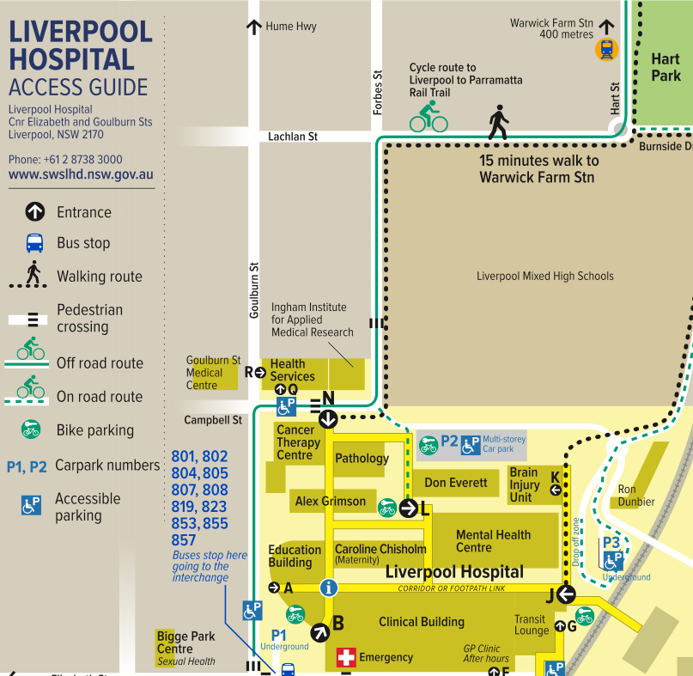

Hawkes Bay District Health Board, New Zealand
- A major regional hospital with over 3000 staff.
- Travel plan implemented over four years from 2015 to 2018.
- Changed focus from parking provision to transport access.
- Program funded by introducing a small daily staff parking charge.
- Sustainability officer appointed to lead program.
- Actions included:
  - small public transport subsidy for bus travel and end of trip facilities
  - staff access guide.
- ‘Go well’ campaign to promote access options – used on all travel plan materials
- To keep the campaign positive and inclusive, messages focused on choice and making it easier – ‘However you choose to get here, we want to make it easier.’
- Drive-alone travel dropped from 78 per cent to 60 per cent of total trips.
- Annual parking complaints dropped from 88 to zero.
Figure 5: Go Well sign

QEII Medical Centre, Perth
- Travel plan implemented from 2006 (5,000 staff at the start and up to 8,000 during the six-year implementation).
- Central city hospital – greater travel choice compared to suburban and regional settings.
- Comprehensive parking management (reduced number of staff car parks available on-site)
  - access to parking divided into three priority groups based on need – Priority group 2 includes green commuters, registered carpooling staff and staff whose journey is not served by public transport (see Table 1)
  - policy developed in consultation with staff
  - permits renewed annually
  - relatively complex to manage.
- Funding and promotion of other travel options (increased bus services, carpooling and so on)
- 2015 research findings comparing QEII and adjacent Hollywood Private Hospital implementing travel plans over six years:
  - QEII drive alone reduced from 85 per cent to 43 per cent
  - Hollywood Private drive alone down from 80 per cent to 75 per cent.
- Over 10 years later, QEII access program has a lower profile with less promotion.
Table 2: Categories for parking priority at QEII Medical Centre
Group | Description
Priority group 1 | Designated parking area.  - Regular shift workers starting before 7 am or end after 6:30 pm  - Staff who are on-call, medical consultants and other permit holders  - Staff approved by QEIIMC parking permit appeals committee
Priority group 2 | Designated parking area.  - Green commuters (use other modes at least 60 per cent of the working week)  - Registered carpooling staff (two or more arrive together)  - Staff with demonstrated primary carer needs  - Staff whose journey to site is not serviced by public transport
Priority group 3 | Restricted access to parking areas.  - Staff who work between 7 am and 6:30 pm  - If insufficient car spaces – priority given to staff with the greatest time differential between driving and using public transport

Other hospital travel plan case studies
Hospital travel plan case studies | Link and description
Global Green and Healthy Hospitals (GGHH) Transportation case studies | Available on the GGHH website's Case studies from GGHH members page – under ‘Transportation’ <https://www.greenhospitals.net/case-studies-transportation>
Mater Services South Brisbane Transport Actions – ‘Transport at Mater Health Services’ | Available on the GGHH website's Case studies from GGHH members page – under ‘Transportation’ <https://www.greenhospitals.net/case-studies-transportation>
Lismore Hospital case study | Available on Northern NSW LHD website's Lismore Base Hospital Precinct draft travel plan page <https://nnswlhd.health.nsw.gov.au/blog/2015/08/25/lismore-base-hospital-precinct-draft-travel-plan>
Royal North Shore – Workplace travel plan 2016 to 2018 | Clear and easy to read.  Available on the Northern NSW LHD website's Active travel page – under ‘Workplace travel plans’ <https://www.nslhd.health.nsw.gov.au/HealthPromotion/Pages/ActiveTravel.aspx>.
Northern Beaches Health Service – Workforce travel plan | Simple 3-page travel plan.  Available on the Northern NSW LHD website's Active travel page – under ‘Workplace travel plans’ <https://www.nslhd.health.nsw.gov.au/HealthPromotion/Pages/ActiveTravel.aspx>.
Transport for NSW Hospital travel plan case studies 2018 | PDF of hospital travel plan case study summaries accessible at <http://data.mysydney.nsw.gov.au/files/Hospital+travel+plan+case+studies.pdf>
Hawkes Bay District Health Board, NZ – ‘Go Well travel’ campaign and supporting travel plan | Available on the GGHH website's Case studies from GGHH members page – under ‘Transportation’ <https://www.greenhospitals.net/case-studies-transportation>

Attachment B: Travel plan resources (1.2)

Introduction
If you cannot find what you need in the toolkit, the following information, guides and tools can help you to develop or implement your travel plan actions.

Assessment
Resource | Description and link
Audits – local area walking audit | Victoria Walks’ information on conducting a walking audit  - Victoria Walks website’s Assessing walkability page <https://www.victoriawalks.org.au/How_to_assess_walkability>

Facilities
Resource | Description and link
Bicycle parking | Australian bike parking standards made easy  - Five at Heart website's Standards and codes page <https://fiveatheart.com/all/australian-bike-parking-standards-made-easy>  Bicycle Network website's Bike parking design and installation service page <https://www.bicyclenetwork.com.au/our-services/bike-parking-experts/installation>  Australian Standards AS2890.3:2015
End of trip facilities – standards and guides for good quality facilities | Victoria Planning Provisions for bicycle facilities  - Victoria Planning Provisions website’s 52.34 Bicycle facilities page <https://planning-schemes.app.planning.vic.gov.au/Victoria%20Planning%20Provisions/ordinance/52.34>  Requirements for bike parking, showers and change rooms:  - Your Move website’s How to set up cycle facilities in your workplace page <https://www.yourmove.org.au/resources/how-to-set-up-cycle-facilities-in-your-workplace>  - examples of end of trip facilities – Cora website’s End of trip facilities – the new normal page <https://www.cora.com.au/blog/end-of-trip-facilities-the-new-normal>
Shared zones (low speed limits in car parks) | Information on assessment and of speed limits in car parks and designation of shared zones: Traffic Engineering Manual Vol 3 Part 2.11 Speed Zoning Technical Guidelines <https://www.vicroads.vic.gov.au/business-and-industry/technical-publications>
Parking management | Divvy parking management software to support staff parking management including allocating parking for carpooling  - Divvy website <https://www.divvyparking.com>

Programs, events and policies
Resource | Description and link
Bike services and support for workplaces | Bicycle Network employer guide to support employees to ride  - Bicycle Network website's New business guide supports more riding page <https://www.bicyclenetwork.com.au/newsroom/2020/10/21/new-business-guide-supports-more-riding>  Ride2Work information  - Bicycle Network website’s Bike-friendly workplaces page <https://www.bicyclenetwork.com.au/newsroom/2020/10/21/new-business-guide-supports-more-riding>
Information for people new to riding to work | Bicycle Network information for new riders including road rules, riding tips, bike maintenance  - Bicycle Network website’s Ride2Work bike riding resources section <https://www.bicyclenetwork.com.au/rides-and-events/ride2work/resources>
Carpooling program – set up and promotion | Connect Macquarie Park website's Car pooling publicity kit page <https://www.connectmpid.com.au/members-carpool-publicity-toolkit>  New Zealand Transport Agency website's Carpooling resources page <https://www.nzta.govt.nz/resources/carpooling/carpooling.html>  - includes New Zealand Transport Agency carpooling guide
Carpooling staff tips | Connect Macquarie Park website's Carpooling tips and etiquette page <https://www.connectmpid.com.au/members-carpooling-tips-and-etiquette>
Carpooling publicity | Connect Macquarie Park website's Car pooling publicity kit page <https://www.connectmpid.com.au/members-carpool-publicity-toolkit>
Guaranteed ride home policy for carpooling | Connect Macquarie Park website's Guaranteed ride home page <https://www.connectmpid.com.au/members-guaranteed-ride-home>
National Ride2Work Day | Bicycle Network registration for workplaces for Ride2Work Day
Salary-sacrificing e-bikes | e-stralian helps organisations offer your staff a healthy commuting option as an FBT exempt fringe benefit.  - e-stralian website <https://www.e-stralian.com.au>
Public Transport Victoria (PTV) Myki Commuter Club | For discounted annual public transport tickets for employees (metropolitan Melbourne only)  - PTV website’s Myki Commuter Club page <https://www.ptv.vic.gov.au/tickets/myki/buy-a-myki-and-top-up/myki-pass/myki-commuter-club>

Travel plan case studies and general resources
Resource | Description and link
Your Move WA Workplace resources | Your Move workplaces resources to support non-car travel to your workplace  - Your Move website’s Resources for workplaces page <https://www.yourmove.org.au/resources/?organisation=4>
Transport for NSW travel plan resources | Travel Choices – travel planning resources  - MySydney website’s Travel demand management page <https://www.mysydney.nsw.gov.au/travelchoices/tdm>
Global Green and Healthy Hospitals (GGHH) Transportation case studies | Case studies of different transport actions by hospitals that are part of the GGHH network:  - GGHH website's Case studies from GGHH members page – under ‘Transportation’ <https://www.greenhospitals.net/case-studies-transportation>
Mater Services South Brisbane Transport Actions – ‘Transport at Mater Health Services’ | Available on the GGHH website's Case studies from GGHH members page – under ‘Transportation’ <https://www.greenhospitals.net/case-studies-transportation>
Lismore Hospital case study | Available on Northern NSW LHD website's Lismore Base Hospital Precinct draft travel plan page <https://nnswlhd.health.nsw.gov.au/blog/2015/08/25/lismore-base-hospital-precinct-draft-travel-plan>
Royal North Shore – Workplace travel plan 2016 to 2018 | Available on the Northern NSW LHD website's Active travel page – under ‘Workplace travel plans’ <https://www.nslhd.health.nsw.gov.au/HealthPromotion/Pages/ActiveTravel.aspx>.
Northern Beaches Health Service – Workforce travel plan | Available on the Northern NSW LHD website's Active travel page – under ‘Workplace travel plans’ <https://www.nslhd.health.nsw.gov.au/HealthPromotion/Pages/ActiveTravel.aspx>.
Transport for NSW Hospital travel plan case studies 2018 | PDF of hospital travel plan case study summaries accessible at <http://data.mysydney.nsw.gov.au/files/Hospital+travel+plan+case+studies.pdf>
Hawkes Bay District Health Board, NZ – ‘Go Well travel’ campaign and supporting travel plan | Available on the GGHH website's Case studies from GGHH members page – under ‘Transportation’ <https://www.greenhospitals.net/case-studies-transportation>

Attachment C: Travel plan assessment tool (2.0)

Introduction
This assessment tool helps a health service to review the interacting factors that will guide its decision to develop either a passive, active or comprehensive travel plan for a specific workplace (hospital or other health service facility). Unique factors at some sites may warrant extra initiatives be delivered within a level, such as passive+ and active+.
This is a qualitative assessment to inform the approach and effort of a workplace travel plan.
To complete this assessment, first collect and analyse data relating to:
- how staff travel
- local transport context
- your organisation's capacity to support an effective travel plan.
Refer to steps in the Travel plan guide and toolkit resources to help with your analysis and assessment.

1. Staff numbers
The ‘default’ level travel plan is based on the total number of staff. This level may go up or down (such as passive to passive+ or active), depending on other factors in this assessment.
Input:
- Total staff EFT (equivalent full time) primarily based at the workplace (hospital or health service site).
Number of staff | Default level
Less than 50 | Passive
50 to 249 | Passive+
250 to 749 | Active
750 to 2,000 | Active+
Over 2,000 | Comprehensive
Note: A small workplace is unlikely to develop more than a passive plan unless many staff live close by and there are very strong organisational factors (such as resources, staff interest and leadership).

2. Location
Geographic location broadly influences the opportunity for change (due to variation in transport options and the ease of car travel).
Locations:
- regional town or city
- metropolitan fringe or outer suburban
- inner or middle metropolitan.

3. Transport access
Two locational factors further influence the opportunity for change:
- public transport availability
- staff proximity to work.
Inputs:
- staff home location analysis – percentage of staff within five kilometres
- site audit desktop review of public transport access.
Transport access | Location | Assessment
Less than 20 per cent of staff within 5 km and limited public transport | - regional town or city  - metropolitan fringe or outer suburban | Reduce level
Over 20 per cent of staff within 5 km or  some public transport access (such as train less than 1.2 km) | - regional town or city  - metropolitan fringe or outer suburban | Maintain level
Less than 10 per cent of staff within 5 km and limited public transport (such as train over 1.2 km, no or few buses) | Inner or middle metropolitan | Reduce level
Over 10 per cent of staff within 5 km or  good public transport (such as train less than 1.2 km and buses) | Inner or middle metropolitan | Maintain level
Over 20 per cent of staff within 5 km or  very good public transport (train, tram, buses) | Inner or middle metropolitan | Increase level

4. Travel-related issues
How significant are travel-related issues for the workplace and staff?
Inputs:
- Human resources area and parking management stakeholders.
- Staff survey – proportion of off-site parking, satisfaction with current travel, proportion of short travel times (under 30 minutes), amount of parking complaints.
- Pressures on car parking: long waiting lists, limited availability, high proportion off-site parking, leasing external parking.
- Projected growth (development or expansion plans).
- Staff experience – ease of travel and satisfaction with current travel, free parking.
Significance of issues | Assessment
High level of issues | Maintain level
Low level of issues | Reduce level

5. Organisational success factors
Your organisation’s capacity and motivation to implement a travel plan. Order of factors reflects their relative importance
- Travel plan coordinator: Person with capacity to lead the plan, 0.2 to 0.4 EFT for active plan. Working group to support.
- Resources: Dedicated funding and independence to implement. What budget and staff are available for implementation?
- Leadership: Executive endorsement and commitment to implement. How supportive are they? IS there an executive champion?
- Outcomes focused: Responds to a clear need and interest – such as managing growth, sustainability and health policies?
- Employee relevance: Staff see value or are interested in encouraging non-car travel (reflected in survey comments).
- Presence and engagement: Able to support change with regular communications. Communications team is supportive and has capacity to participate.

Assessment
Assess the overall strengths and weaknesses of each of the factors. Also consider the potential to strengthen each factor. Then determine whether to reduce, maintain or increase the plan level.
- Plot the assessment outcome for ‘Opportunity for Change’
Figure 6: Opportunity for change
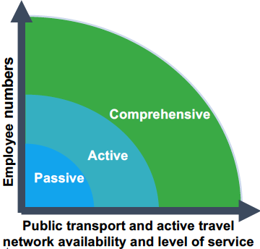
- Plot the assessment outcome for ‘Organisational success factors’
Figure 7: Organisational success factors
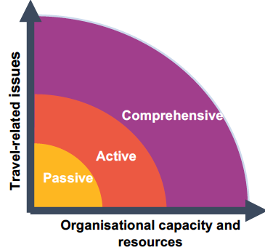
- Overall assessment: Compare assessment outcomes for opportunity for change and organisation capacity to determine travel plan level.

Attachment D: Site access audit template (2.1)

Introduction
This site access audit template helps a health service to review a site’s transport and access infrastructure and facilities.
You may wish to add your organisation’s branding or logo to the header or footer. Or you may prefer to copy and paste the audit into your organisation’s Word template.

Site access audit

How to complete this audit
Look at Google maps and Google Street View and any site maps to identify:
- access, convenience and issues for people walking, bike riding, using public transport (PT) and driving
- nearby destinations and public transport stops/stations and how close they are to the workplace.
Walk around the site and the local area (up to 1 km radius, depending on nearby destinations) to:
- assess the infrastructure, facilities and access routes for people walking and bike riding
- get a ‘feel’ for how easy it is to use different travel options.
Take photos to show access routes, facilities (such as bus stops) and any issues. Use these to illustrate your audit and travel plan.
Talk with colleagues who work on-site to collect information about site policies, car park access and bike end-of-trip facilities (secure bike racks, showers, change rooms and lockers), if any.
You may want to attach a site map showing on-site access and main transport options available to the site.
You can adjust the height of table rows if you want to complete the audit by hand. If completing it electronically (such as on a computer, tablet or mobile phone), rows will automatically increase to accommodate your notes.

Site
Question | Answer
Site (workplace) name
Location

Site characteristics
Questions | Things to consider | Your notes
Total employees working at this site | Employees and on-site contractors
Number on-site each day (estimate) | Operational number
Site operating hours and shift times (if any) | Arrival and departure times
Do other organisations share the site? | Include these in employee site numbers
Main staff access points for arriving to work | Access and distance from car or bike parking, public transport stops
Other on-site facilities | Such as childcare

On-site access
Question | Things to consider | Your notes
Walking routes between buildings on-site | - Signed speed limits less than 20km  - Are all routes paved?  - Curb-side ramps for wheelchairs and prams  - Lighting  - Shelter from rain and sun  - Obstructions  - Accessible
Wayfinding | Is it clear and well-signed?
Any conflict points | - Between pedestrians and vehicles  - Safe crossings in place

Site facilities – bike parking and end-of-trip facilities
Questions | Things to consider | Your notes
Numbers of secure parking | Number and location of secure bike parking
Convenience and secure access | - Ease of access to building entry  - Shelter from rain  - Well lit  - CCTV
Number of bike hoops | Number and location of unsecure parking
Showers available for staff | - Number and location  - Ease of access from parking
Staff lockers | - Number and location  - Staff access (such as all or only clinical staff)

Site facilities – car parking
Questions | Things to consider | Your notes
Number on-site car parks | Number and location of car parking
Leased off-site car parks | Any leased off-site parking for staff?
Parking fees | Fees paid by employees for parking on-site
Parking access | - Open or secure  - Employee application process  - Waitlist
Current on-site car park availability | - Is it often full or over-subscribed?  - Staff issue?  - How significant?  - Much staff parking in local streets?
Near future car park availability | Is projected growth likely to impact demand for car parks?
Local congestion | Traffic congestion issues around the site?
Local council interactions | Any issues raised by council about staff car parking?

Site facilities – motorcycle and scooter parking
Question | Things to consider | Your notes
Numbers of secure parking | Number and location of secure parking
Convenience and secure access | - Ease of access to building entry  - Shelter from rain  - Well lit  - CCTV
Staff lockers | - Number and location  - Staff access (such as all or only clinical staff)

Local access – public transport (bus, train, tram)
Identify all services within at least 800 metres. Include train stations that are within 1.5 km of the site.
You can add more rows by tabbing in the last cell of the table.
Service | Nearest stop or station | Peak service frequency | First and last service time | Walk time and distance to site (estimate)
Example: Bus 774 | Yuille St, Frankston Tennis Club | 20 minutes |  | 7 minutes, 650 metres

Local access to the site – walking and bike riding networks
Question | Things to consider | Your notes
Local destinations | Availability and distance to shops and services
Walking routes to main off-site locations (such as shops or public transport) | - Topography (steep/flat)  - Are all routes paved?  - Lighting  - Shelter from rain and sun  - Obstructions  - Accessible
Wayfinding | - Can you work it out without signs?  - Any signs?
Road crossings | - Are there pedestrian crossings on main walking routes?  - Conflict points
Roads and traffic speeds | Speed limits of roads that are walking routes to local destinations
Bike lanes and shared paths | Identify roads with on-street bike lanes and shared paths that access the site.  - Are they continuous?  - What condition?  - Are the routes steep or flat?

Site policies relating to access and travel
Question | Things to consider | Your notes
Salary packaging | - Are people offered the option to salary sacrifice a car or other travel options (such as an annual myki card)  - Before or after tax?
Free parking | - Any staff offered free parking?  - Any staff offered a car as part of their position?
Parking fees | Parking fees deducted before or after tax?
Flexible working arrangements | - Availability to staff  - Level of use  - Ease of application process
Technology to support remote work | - Technology available to staff for remote access  - Ease of use  - Telehealth services
Business travel options | - Videoconferencing policy  - Business travel
Fleet cars or bikes available for business travel | Number of vehicles and booking system
Public transport cards for business | A system to give staff myki cards for business travel
Commuter Club | Myki Commuter Club for staff?
Shuttle buses | Organisation-run shuttle service to any destinations?
Travel plan coordinator | Staff member available to prepare and implement travel plan?  How many hours a week?
Resources | Any resources allocated for a travel plan?
Working group | Level of interest and support?  - Existing committee that could facilitate a travel plan?  - People who can help or are interested?

Attachment E: Staff home location analysis (2.2)

Introduction
The purpose of a staff home location catchment analysis is to:
- assess the proportion of people living close to work (usually within five kilometres) who may be able to walk or ride to work one or more days a week
- assess the proportion of people travelling long distances to work
- look at areas with larger numbers of staff living near to each other, which may enable some people to carpool to work.
Use the steps in this document to help you perform a staff home location analysis for your organisation.

Workplaces within metropolitan Melbourne and some regional centres
- Request the home postcode data for all staff and contractors working on the site from your organisation’s human resources area.
- Identify all postcodes within or partially within five km of the site and add up the number of staff living within these postcodes.
- Estimate the number of staff living within five km and calculate the percentage of total staff within this area.
- Map the number of staff within each postcode area. This gives a useful visual assessment of the proximity and distribution of staff. This can be outsourced at low cost. Depending on the total number of staff and the range in values, you will need to work out what the appropriate ranges are to use for the legend (see Figure 2 for an example). For example, small sites with less than 50 people may use ranges of ‘1 to 2’, ‘3 to 5’ and so on. For large numbers of staff, the ranges would be greater. The example map (Figure 1) shows there over 20 per cent of staff live within five km of the workplace.

Workplaces within areas with very large postcode boundaries
- Seek approval to map de-identified address data (where address data does not include names and other identifiable information)
- Map the data with the hospital site at the centre of the map and home location dots ‘generalised’ (so they are not placed on the exact home location) for staff privacy.
- Calculate (as part of the mapping process) the number of staff living within five km and calculate the percentage of total staff within this area.
Figure 8: Example map of staff locations
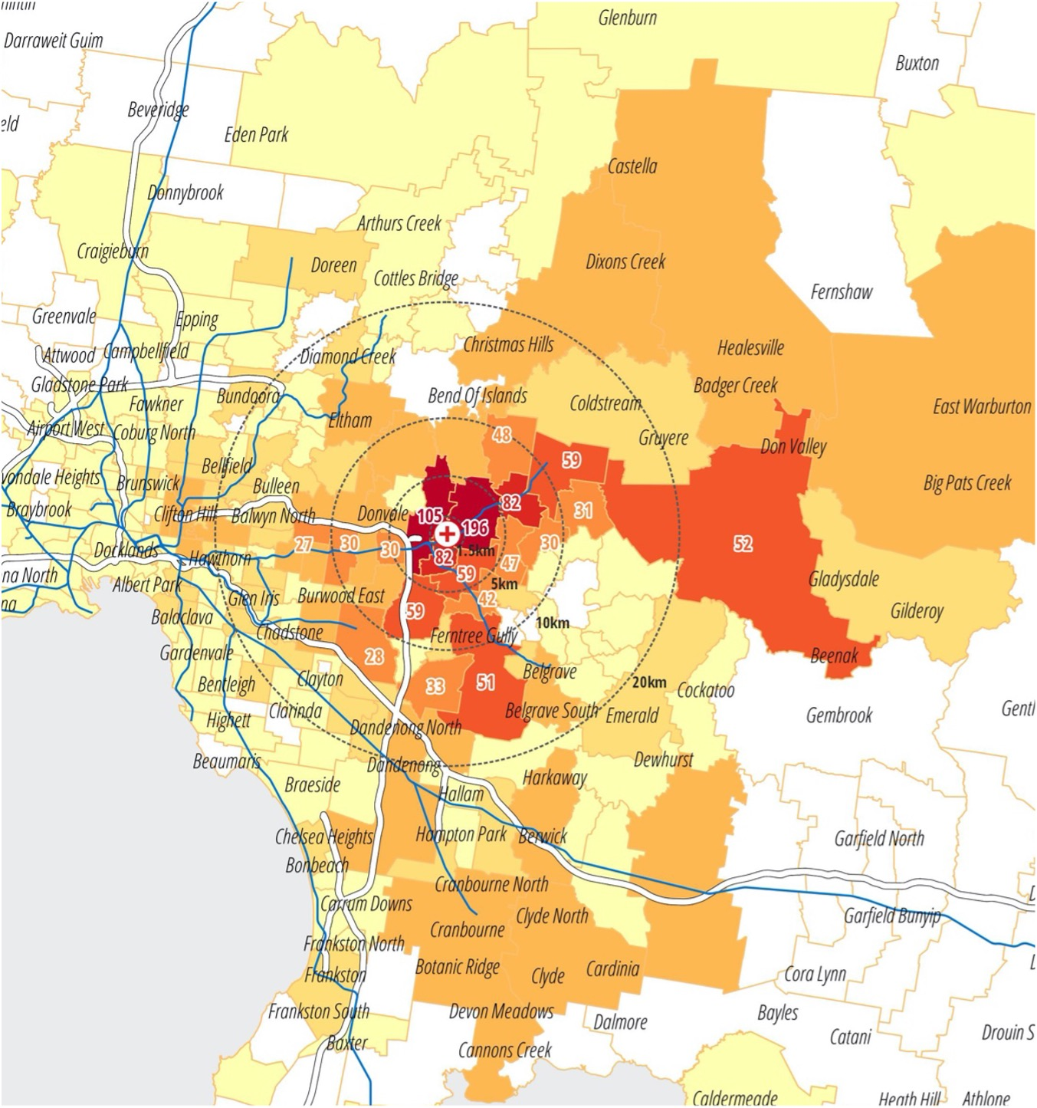
Figure 9: Example map legend
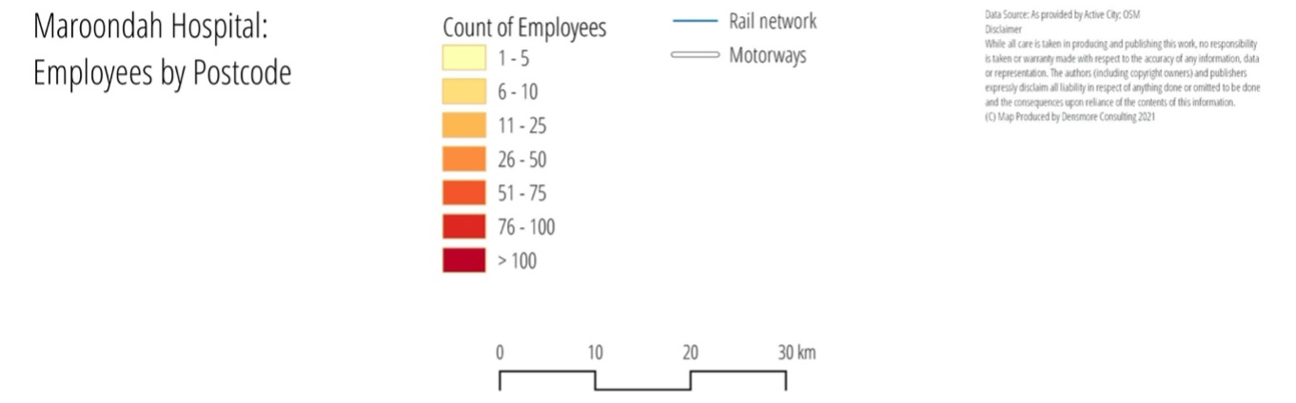

Attachment F: Simple staff travel survey template (2.3)

Introduction
The questions in this survey will give you useful information about:
- how your staff currently travel to work
- issues with travel options and travel-related facilities at your workplace
- opportunities for encouraging greater use of non-drive-alone travel options
The survey results will help you to develop a passive or active-level travel plan for your site.
Note: Placeholder text for you to replace is shown in square brackets and with red text – [example].

Core and supplementary questions
The core survey has only seven questions, which will give you basic information about staff travel.
Other questions are included, which help to identify staff preferences and interests about their travel to work.
- Give people the opportunity to vent about known major issues (such as car parking construction issues) in an open-ended question to allow space for the data you want.
- The more questions you ask, the more insights you will get. However, you may choose to limit the survey to the core questions to make it very easy for staff to complete.
- Shorter surveys generally increase the total survey responses.

Survey approach
Prepare and design your survey as a document in Microsoft Word (also for use in getting sign-off) before starting online design
The survey is designed to be run online, using platforms like Survey Monkey, Typeform or Microsoft Forms.
The survey needs to be supported by communications to promote the survey. This will maximise the number of staff responses you get and give you more valid and credible results. Refer to the Staff travel survey implementation guide (2.4) for more information.

Survey questions
This survey takes about [estimated time] minutes. Your answers will help improve travel options and choices for getting to work at your hospital or hospital campus. You can only complete the survey once.

Core questions

Q1: How did you travel to work today? (From leaving home to arriving at work, what was the method of transport you travelled the greatest distance on?)
- Car – as driver
- Car – as a passenger
- Train
- Bus
- Tram
- Motorcycle or moped
- Ride a bicycle
- Ride other personal mobility device
- Walk (do not include walking from local bus stop, car park and so on)
- Taxi, Uber or ride share
- I did not travel, I worked remotely

Q2: Excluding how you travelled today, are there other methods you regularly use to travel to work?
Select all that apply, excluding any short walks to or from a bus stop, train station, car park and so on.
[Programming note: select all that apply]
- I don't use any other methods
- Car – as a driver
- Car – as a passenger
- Train
- Bus
- Tram
- Motorcycle or moped
- Ride a bicycle
- Ride other mobility device
- Walk (do not include walking from local bus stop, car park and so on)
- Taxi, Uber or ride share
- Working remotely

Q3: How long was your door-to-door commute to the hospital today?
- Under 15 minutes
- 15 to 29 minutes
- 30 to 44 minutes
- 45 to 59 minutes
- 1 to 1.5 hours
- More than 1.5 hours

Q4: What time did you arrive at the hospital today?
[Programming note: Present times in half-hour increments]

Q5: What time do you expect to leave the hospital today?
[Programming note: Present times in half-hour increments]

Q6: Thinking about the sorts of things that could encourage to you start using other travel options (such as walking, cycling, public transport and car sharing) or use them more often, how likely are each of the following to influence you?
- Very unlikely
- Unlikely
- Neither unlikely or likely
- Likely
- Very Likely

Options to assess (random rotation – add or remove ones applicable to your site)
- Free or subsidised bike riding training courses at or near your workplace
- Discounted annual Myki passes, saving you an additional 10 per cent on public transport
- A 'bike buddy' system to ride to work with other colleagues
- An app to help you find other colleagues to share your journey to work
- Preferential or discounted parking for those who share their car trip to work
- Custom maps of local walking and cycling routes to your site
- Public transport timetables for travel to your site
- One-on-one advice on your journey options from a qualified transport planner
- Dedicated showers, lockers and change areas for people who ride or walk to work
- Secure bike storage cages and bike repair equipment

Q7: Is there any feedback you'd like to provide about your travel to and from the hospital or transport-related facilities at the hospital?
[Programming note: Open answer].

Optional questions
Add extra questions to your survey to learn more about your staff travel to work.

Influences

Q8: How satisfied are you with your experience travelling to the hospital or hospital campus by [include response given for Q1]?
- Very satisfied
- Satisfied
- Neither satisfied nor dissatisfied
- Dissatisfied
- Very dissatisfied

Q9: Do personal, family or childcare commitments influence your choice of how you travel to work?
- Yes
- No

Q10: Do you have a hospital campus staff car parking permit?
- Yes
- No

Q11: Did you share your ride to the hospital or hospital campus with any other adult passengers?
- Yes
- No

Flexibility

Q12: Which of these best describes the flexibility of your job?
- My job can only be completed on location at the hospital or hospital campus
- My job has some potential to be completed from home or other locations
- My job could be completed mostly from home or other locations

Q13: Which of these statements best describes how you have worked over the last six-months?
- I have completed my job role entirely on-location at the hospital or hospital campus
- I have completed some of my job at home or at other locations
- I have worked mostly from home or at other locations

Demographics

Q14: What is your age?
- 16 to 17 years
- 18 to 30 years
- 31 to 40 years
- 41 to 50 years
- 51 to 65 years
- Over 65 years
- Prefer not to say

Q15: What is your gender?
- Female
- Male
- Non-binary
- Other [option for in your own words]
- Prefer not to say

Q16: Which of the following best describes your type of work?
- Clinical
- Non-clinical

End text
Thank you for your time.
To submit your survey results, please select 'Done'.
If you have any questions about this survey, please email us at [insert contact email].

Attachment G: Staff travel survey implementation guide (2.4)

Introduction
A travel survey gives you valuable information about the way people are travelling to your site. It also picks up issues and opportunities for encouraging more people to use non-car options more often.
Implementing a successful staff travel survey – whether simple or comprehensive – needs:
- forward planning (two to four months depending on the size of the workplace)
- to involve key hospital stakeholders (site management, communications staff, nurse unit managers and IT support) to ensure smooth delivery and buy-in
- good communications to encourage staff to participate.
An effective survey needs management buy-in, time and resources. You need to determine the relative value of the insights you may gain versus the effort involved in implementing the survey. This is in part based on the size of your organisation and whether you are aiming to implement a passive, active or comprehensive plan.

Things to address for a successful survey
Small site (less than 250 staff) and no budget to deliver a survey? Consider whether you need to run a survey at this time. Other data and analysis may be enough for now. Run some focus groups to hear directly from staff.
Local workplace management buy-in: ensure the survey has strong executive and local management awareness, endorsement and support to ensure the survey is well promoted.
Employees are more likely to respond to a travel survey if:
- there are significant current or upcoming issues relating to travel (such as a new development that may put pressure on car parking)
- you offer incentives to respond (this can be as simple as chocolates handed out on the day or hot beverages to win)
- you have intensive communications about the upcoming survey that are specific to the site you are surveying, and staff are directly encouraged to respond
- communicate and share summary results with staff to boost likelihood of participation in future surveys.
Plan and allow enough time for coordination and approvals:
- resource survey implementation appropriately – example implementation plan outlines what you need to do over a three- to four-month timeline for a large workplace.
- avoid running the survey when other major surveys are held.
Manage privacy requirements: research and choose an online survey tool or method that meets your organisation’s privacy requirements:
- you do not need to collect any identifiable personal information for a travel survey
- you may wish to ask people to share their email address so you can give them an incentive for participation – this is personally identifiable information.

Make sure your IT system supports the survey: talk to your IT and ensure:
- the online survey domains will be accessible (not blocked by security firewalls)
- there will be no issues when many people access the survey at the same time.
Provide options for completing the survey:
- often it is easier for clinical staff to complete a survey on their personal device
- use a QR code to access the survey as well as an email link.
Test the survey with staff: ask a number of staff volunteers (10 or more) to test the survey on different hospital computers and personal devices to ensure it works and it makes sense.
Work out your sample size: you need a minimum response rate, based on your total on-site employee numbers, to ensure you have valid and credible results. Use the Australian Bureau of Statistics online calculator to work out the sample size you need.
- Australian Bureau of Statistics’ Sample size calculator <https://www.abs.gov.au/websitedbs/d3310114.nsf/home/sample+size+calculator>
Work with your communications team to promote the survey through a range of channels:
- options include: digital signs, desktop and email banners, posters at key sites, emails before and on the day of the survey
- have survey staff at entries and key sites on the day to encourage people to complete the survey
- ensure communications stand out – this needs highly visible messaging across multiple channels and media types
- Refer to Survey implementation: example communications copy (2.8) for more advice.
Work with hospital stakeholders to promote your survey to their teams ahead of time and on the day:
- make it fun and create buy in – there should be a positive energy and visibility on the ground with champions and team members
- Refer to Stakeholder engagement matrix (2.7) and Stakeholder travel survey briefing pack example (2.9).

Attachment H: Comprehensive staff travel survey template (2.5)

Introduction
Responses from this survey will provide detailed information about the current travel patterns of your staff; travel and facilities issues; and opportunities for encouraging a greater use of non-car travel options.
It is useful for very large workplaces (over 750 staff) to inform the development of a comprehensive-level travel plan.
Organisations surveying smaller workplaces, or considering passive or active travel plans may, want use the simple travel survey instead.
Note: Placeholder text for you to replace is shown in square brackets and with red text – [example].

Survey approach
The survey is designed to be:
- run online, using platforms like Survey Monkey, Typeform or Microsoft Forms
- a census, requesting information for one travel day
- set up with routing to minimise total questions (that is, follow-on questions relate only to previous responses) and the time it takes to complete the survey (preferably around four minutes or less). Routing has not been specified as some organisations may choose to leave out certain questions
- supported by a communications and engagement campaign about the survey to maximise the number of staff responses to get valid and credible results.
Prepare and design your survey as a document in Microsoft Word (also for use in getting sign-off) before starting online design
Implementing a comprehensive travel survey requires time and resources (such as preparing digital or print communications materials to promote the survey).
Refer to:
- Simple staff travel survey (2.3) for guidance on core survey questions to ask
- Staff travel survey implementation guide (2.4) for how to effectively promote and run the survey.

Survey questions
This survey takes about [estimated time] minutes. Your answers will help improve travel options and choices for getting to work at your hospital or hospital campus. You can only complete the survey once.

Introductory question

Q1: Did you travel to work today?
- Yes
- No – I worked from home
- No – I worked from elsewhere or remotely (please specify)
- No - I did not work on this day

Travel modes

Q2 : Thinking about your journey to work today, from leaving home to getting to work, which of the following methods of transport did you use?
Select all that apply, excluding any short walks to or from a bus stop, train station, car park and so on.
- Car – as driver
- Car – as a passenger
- Train
- Bus
- Tram
- Motorcycle or moped
- Ride a bicycle
- Ride other personal mobility device
- Walk (do not include walking from local bus stop, car park and so on)
- Taxi, Uber or ride share

Q3: Which of those was your main method of transport today (the one you travelled the greatest distance on)?
[Programming note: Follow-on question for those selecting more than one method]
- Car – as driver
- Car – as a passenger
- Train
- Bus
- Tram
- Motorcycle or moped
- Bicycle
- Other personal mobility device
- Walk (do not include walking from local bus stop, car park and so on)
- Taxi, Uber or ride share

Q4: How would you rate your satisfaction with your experience travelling to the hospital or hospital campus by [main mode]?
- Very satisfied
- Satisfied
- Neither satisfied nor dissatisfied
- Dissatisfied
- Very dissatisfied

Q5: Excluding how you travelled today, are there other methods you regularly use to travel to work?
Select all that apply, excluding any short walks to or from a bus stop, train station, car park and so on.
- I don't use any other methods
- Car – as a driver
- Car – as a passenger
- Train
- Bus
- Tram
- Motorcycle or moped
- Ride a bicycle
- Ride other mobility device
- Walk (do not include walking from local bus stop, car park and so on)
- Taxi, Uber or ride share

Q6: Thinking about your typical journey to work, from leaving home to arriving at work, which of the following methods of transport do you usually use?
Select all that apply, excluding any short walks to or from a bus stop, train station, car park and so on.
[Programming note: Question for those who did not travel to work]
- Car – as driver
- Car – as a passenger
- Train
- Bus
- Tram
- Motorcycle or moped
- Bicycle
- Other personal mobility device
- Walk (do not include walking from local bus stop, car park and so on)
- Taxi, Uber or ride share

Influences

Q7: Do you have a hospital campus staff car parking permit?
- Yes
- No

Q8: Do you currently have access to a privately-owned motor vehicle on working days?
- Yes
- No

Q9: Do personal, family or childcare commitments influence your choice of how you travel to work?
- Yes
- No

Car driving

Q10: Did you share your ride to the hospital or hospital campus with any other adult passengers?
- Yes
- No

Q11: Where did you park your car when you arrived at work today?
[Programming note: Drivers only]
- In a hospital or hospital campus car park
- In an offsite privately-operated car park
- On a local street
- At a third-party office or residential location
- Prefer not to say
- Other (please specify)

Q12: Did you pay for your parking today (including any passes or arrangements by salary deduction)?
- Yes
- No – it was free
- No – it was paid by someone else, a business or employer

Q 13: How do you rate the quality of car parking facilities at the hospital or hospital campus?
[Programming note: If parked at hospital]
- Very poor
- Poor
- Satisfactory
- Good
- Very good

Cycling

Q14: Where did you park your bicycle when you arrived at work today?
[Programming note: Cyclists only, from main mode]
- Inside a building or office – in a non-clinical area
- Inside a building or office – in a clinical area
- [Insert location and facility] bike cage or secure bike racks
- At another dedicated bike rack
- Against a pole, rail or other fixture somewhere at the hospital or hospital campus
- Arrived by some other method or did not park bike at the hospital or hospital campus
- Elsewhere (please specify which building and where, such as storage space)

Q 15: As a person who rides to work, which of the following do you have access to at the hospital or hospital campus
- A secure place to lock your bike
- A suitable locker
- A shower or change room
- Somewhere to hang or dry your cycling gear
- None of these

Q 16: How do you rate the quality of facilities for people riding to work at your hospital or hospital campus?
- Very poor
- Poor
- Satisfactory
- Good
- Very good

Q17: What is your greatest challenge when riding your bicycle to work? (optional)
[Programming note: Open answer]

Walking

Q18: How do you rate the quality of pedestrian facilities in and around the hospital or hospital campus?
[Programming note: Walkers only, from main mode]
- Very poor
- Poor
- Satisfactory
- Good
- Very good

Q19: What is your greatest challenge when walking to work? (optional)
[Programming note: Open answer]

Motorcyclists

Q20: Where did you park your motorcycle or moped?
[Programming note: Motorcyclists only, from main mode]
- In a hospital or hospital campus staff car park
- In a privately-operated car park
- On a local street
- At third-party office or residential location
- In a marked bay or outdoor space at the hospital or hospital campus
- In a non-marked outdoor space at the hospital or hospital campus
- Elsewhere (specify)
- Arrived by other mode or did not park at the hospital or hospital campus

Q21: As a motorcyclist, which of the following do you have access to on campus?
- A suitable location to park your motorcycle
- A suitable locker
- Somewhere to hang or dry your gear
- None of these

Public transport

Q22: What, is your greatest challenge when using public transport to get to work? (optional)
[Programming note: Public transport only, from main mode]
[Programming note: Open answer]

Journey and working times
[Programming note: These questions are for all respondents]

Q23: What time did you arrive at the hospital today?
[Programming note: Present times in half-hour increments]

Q24: What time do you expect to leave the hospital today?
[Programming note: Present times in half-hour increments]

Q25: What is your home or Victorian residential suburb (such as Frankston)?
[Programming note: Open answer]

Q26: Are your typical working hours…?
- Regular hours (such as Monday to Friday, 8:30 am to 5 pm, or similar)
- Shift hours – fixed roster
- Shift hours – variable roster or changeable

Q27: How long was your door-to-door commute to the hospital today?
- Under 15 minutes
- 15 to 29 minutes
- 30 to 44 minutes
- 45 to 59 minutes
- 1 to 1.5 hours

Help with other travel options

Q28: Thinking about the sorts of things that could encourage to you start using other travel options (such as walking, cycling, public transport and car sharing) or use them more often, how likely are each of the following to influence you?
- Very unlikely
- Unlikely
- Neither unlikely or likely
- Likely
- Very Likely

Options to assess (random rotation – add or remove ones applicable to your site)
- Free or subsidised bike riding training courses at or near your workplace
- Discounted annual Myki passes, saving you an additional 10 per cent on public transport
- A 'bike buddy' system to ride to work with other colleagues
- An app to help you find other colleagues to share your journey to work
- Preferential or discounted parking for those who share their car trip to work
- Custom maps of local walking and cycling routes to your site
- Public transport timetables for travel to your site
- One-on-one advice on your journey options from a qualified transport planner
- Dedicated showers, lockers and change areas for people who ride or walk to work
- Secure bike storage cages and bike repair equipment

Flexibility and change

Q29: Which of these best describes the flexibility of your job?
- My job can only be completed on location at the hospital or hospital campus
- My job has some potential to be completed from home or other locations
- My job could be completed mostly from home or other locations

Q30: Which of these statements best describes how you have worked over the last six-months?
- I have completed my job role entirely on-location at the hospital or hospital campus
- I have completed some of my job at home or at other locations
- I have worked mostly from home or at other locations

Demographics

Q31: What is your age?
- 16 to 17 years
- 18 to 30 years
- 31 to 40 years
- 41 to 50 years
- 51 to 65 years
- Over 65 years
- Prefer not to say

Q32: What is your gender?
- Female
- Male
- Non-binary
- Other [option for in your own words]
- Prefer not to say

Q33: What is the main organisation you work for?
- [Health service]
- Retail service on site
- Construction project supplier or contractor
- Not listed or Other (please specify)

Q34: Which of the following best describes your type of work?
- Clinical
- Non-clinical – support services
- Non-clinical – retail
- Non-clinical – other non-clinical

Q36: Is there any other feedback you’d like to provide about your journey to or from the hospital or hospital campus?
[Programming note: Open answer]

End text
Thank you for your time.
To submit your survey results, please select 'Done'.
If you have any questions about this survey, please email us at [insert contact email].

Attachment I: Example staff travel survey implementation plan (2.6)

Introduction
This example plan shows a four-month timeline for implementing a successful staff travel survey in a large workplace (over 750 staff).
This approach is recommended for a comprehensive travel plan. It can be pared back for a simple staff travel survey but all staff surveys will need some forward communications and work with site stakeholders to ensure a good response rate and credible sample.
You know your own organisation – to ensure a successful survey, allow for the time you need:
- to coordinate the set-up
- for approvals processes
- for communications and engagement.

Before the survey

15 weeks before
Activity | People needed, inputs
Form survey campaign team | Project team, communications representatives
Agree online survey platform. Decide whether to use external survey webpage.

14 weeks
Activity | People needed, inputs
Confirm campaign budget and approach – digital, print, incentives | Comms team cooperation
Questionnaire design underway – review template, add locally relevant information. Add or remove questions
Complete stakeholder engagement matrix – see example in travel plan resources | Stakeholder lists  Toolkit resource: Stakeholder engagement matrix
Identify any third-party employers on site to participate in the survey – include in matrix | Site and employer entity lists
Agree engagement and communications plan for all employer entities on site | Survey promotion channels (like intercept, email) and engagement (such as staff entry points)

12 weeks
Activity | People needed, inputs
If using incentives, agree what and how they will be used | Retailer options, preferences
Draft communications copy – use communications copy template as a guide | - Toolkit resource: Example communications copy  - Logo and brand guidelines
Provide draft questionnaire to project team for review and edits | Required sign-offs?
Engage graphic designer to create a visual identity or assets for the survey campaign

10 weeks
Activity | People needed, inputs
Final questionnaire sign-off | Management approval?
Finalise communications copy | Management approval
Graphic design underway for survey campaign materials (such as digital email footers, intranet banners, print posters, pull-up banner) | Agree any print materials based on engagement or communications plan
Confirm email addresses or lists for staff survey mailout

8 weeks
Activity | People needed, inputs
Final graphics delivered | Required sign-offs?
Prepare intranet content based on communications copy | Comms team cooperation
Print materials (such as posters, upright desk display cards) ready for production
Finalise content for stakeholder briefings

6 weeks
Activity | People needed, inputs
Load survey on online platform
Complete user testing to get feedback on understanding, completion time and ease | Staff volunteers from all organisations to test
Prepare question and answer packs (for staff questions and frequently asked questions resources) and email responses | Comms team cooperation

4 weeks
Activity | People needed, inputs
Finalise online survey programming
IT systems liaison, including to whitelist domains
Launch intranet content | Comms team cooperation

3 weeks
Activity | People needed, inputs
Key employer and stakeholder briefings and emails | Toolkit resource: Stakeholder travel survey briefing pack example

2 weeks
Activity | People needed, inputs
Confirm survey week run sheet and activities
All comms material on site – posters and similar promotional materials on display
Start pre-survey digital campaign

1 week
Activity | People needed, inputs
Review response to comms and briefings | Core team
Final go or no-go decision | Assess weather and other critical influences

Survey week
Activity | People needed, inputs
Go live
Stakeholder pre-launch email
Final pre-launch meeting
Project team briefs to Nurse Unit Manager (NUM) and executive meetings
Intercept team member briefing
Car park and data collection begins | Car parking teams and operators
Go-live collateral installation and distribution by agreed helpers (in project team or in hospital areas)

Survey day
Activity | People needed, inputs
Survey goes live
Send email | Comms team cooperation
Track survey response rates
Entrance activations to encourage participation
Bicycle, site audit starts
End-of-day review

After the survey
Timeframe | Activities | People needed, inputs
Day after | - Employee travel survey reminder email  - Final day to complete survey  - End-of-day review | Comms team cooperation
2 days after | - Thank you email  - Incentives, if any, distributed to staff | Comms team cooperation
1 week after | Analysis underway
2 weeks | Draft analysis and top-line reporting review
4 weeks | Reporting available to core team and executive
5 to 6 weeks | Results shared with staff and stakeholders

Attachment J: Stakeholder engagement matrix (2.7)

Introduction
Prepare a stakeholder engagement matrix to support delivery of your staff travel survey. It will also help to identify stakeholders to support other travel plan actions.

Function overview
Function | Description
Brief | Provide information and materials to ensure license to proceed or approvals
Inform | Provide overview and summary materials for distribution
Engage | Provide detail and seek input to optimise project delivery
Partner | Form a close working relationship with these stakeholders or direct input in delivery plans

Matrix and stakeholder example
Stakeholder or group | Function | Names and contact details
Senior leaders  Individuals we need to inform of the project or seek endorsement | Brief | Include at least name, title and email address
Key people leaders  People who influence staff and can demonstrate support and encourage/role model participation | Engage
Key governance meetings and forums  Executive leadership team, NUM, bed meetings – suitable for survey pre-briefings and information dissemination | Inform | Include timing and contact
Third party employers  Other on-site employers who lead teams or staff that might not be in core comms channels | Inform
Delivery partners  For access to key data or approvals on activity | Engage or Partner
Facility managers
Car park operators, car parking data
IT team – email and website whitelisting
COVID-19 or hygiene approvals and advice
Internal communications | Engage or Partner
Approvers or signoffs
Access to comms channels or distribution
Site champions
Passionate staff to drive participation among staff locally | Engage

Attachment K: Example staff travel survey communications copy (2.8)

Introduction
Use or adapt these sample communications copy for your organisation’s travel survey.
Placeholder text for you to replace is shown in square brackets and with red text – [example].

Positioning
How do you get to work?
Take 3 minutes this month to help improve your journey

Posters, digital displays and intranet
How do you get to work?
Take 3 minutes this month to improve your journey and travel choices
The [Hospital or Health service name] Staff Travel Survey is on this [month]!
No matter how you get to work, we need you to tell us about your journey.
Information collected will help plan better local and on-site transport options for the future.
On survey day, open the link in your survey email or scan the QR code on your mobile device.

Staff emails

Pre-launch email or intranet post
Subject: Improve your travel options – Staff Survey coming this [month]
[Salutation]
The [Hospital or Health Service name] Staff Travel Survey is on this [month], and regardless of how you get to work, we need you to tell us about your journey.
By taking 3 minutes to share information about your journey, you’ll help us plan better local and on-site transport options and improve access to the hospital campus - benefiting all current and future staff.
To ensure we incorporate the needs of all hospital campus staff, it’s important we hear from you.
How did you get to work? What worked well? What could be better?
This February, you’ll receive an email on the survey day asking you to participate. Please click the link in your survey email on the day.
Thanks

Survey Day launch email to all staff
Subject: Improve your travel options – Staff Survey is now live for only 48 hours!
[Salutation if email]
How do you get to work?
Take 3 minutes today to help us improve your travel choices.
The [Hospital or Health Service name] Staff Travel Survey is on today!
No matter how you get to work, we need you to tell us about your journey.
The survey is only open today and tomorrow – so it’s important you get in quickly to have your say to help us plan better local and on-site transport options for the future.
Start the survey now!
We’ll be sharing the results with you soon.
Thank you again for participating to help improve your local transport options.

Management dissemination, teams messaging link
Subject: Staff Travel Survey on today
Hi Team
You might have seen an email or a piece on the intranet about the [Hospital or Health Service name] Staff Travel Survey, which is taking place today and tomorrow.
This is a really important project for us to be involved in. It will help to shape the way you and all of us get to work here in the future.
Please spare 3 minutes to complete the survey today and encourage your teams and colleagues to do so too.
Don’t hesitate to give me a call if you have any questions or just open the survey link for more information.
If you haven’t received the email link, you can open the survey or go to [survey web address].
Best Regards
[Manager]

Reminder email the day after survey day
Note: Only send if low response rate (enhance urgency – last chance)
Subject: Staff Travel Survey closing – last chance to have your say!
Hi,
This week is [Hospital or Health Service name] Staff Travel Survey Week and we really need you to tell us how you got to work yesterday.
Information collected will help plan better local and on-site transport options and increase and improve access to the hospital campus. This will benefit all current and future staff.
It’s really important that as many staff take part in this survey as possible – and today is the last day to have your say.
If you haven’t already shared your trip with us, please start the survey now or visit [survey web address].
We’ll be sharing the results with you soon.
Thank you again for participating to help improve our local transport options.

Attachment L: Stakeholder travel survey example briefing pack (2.9)
Use this slide pack as part of your briefings to key stakeholder groups.
The PowerPoint file is available as a separate file on the [website’s x page] [<URL>].
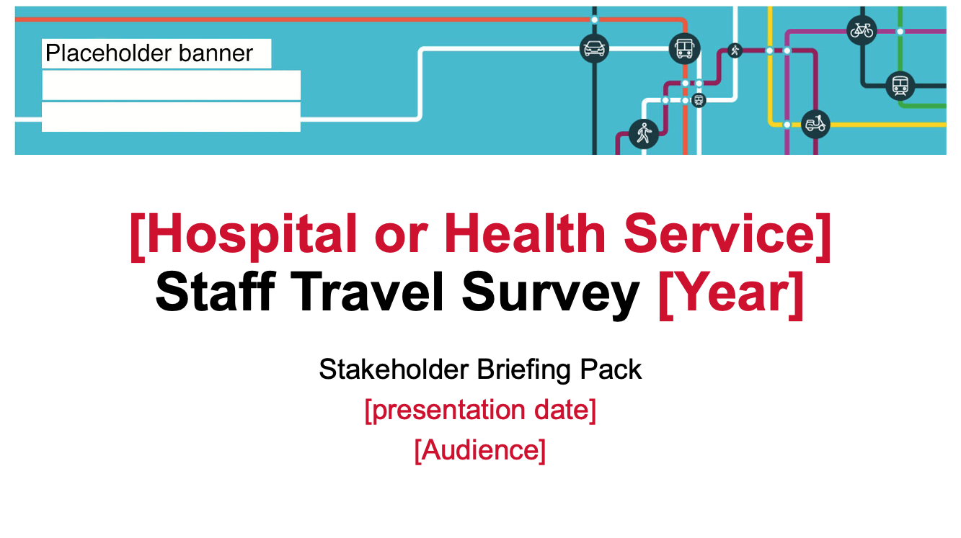

Attachment M: Example comprehensive staff travel survey analysis report – major metropolitan hospital (2.10)

Introduction
This report presents data and analysis from an actual travel survey conducted by a major metropolitan hospital in Melbourne.
This survey and report include more questions and detail than would be needed for a smaller site or organisations considering a passive or active travel plan

Overview
[Health Service name] conducted a voluntary staff travel survey on Tuesday 2 and Wednesday 3 March 2021.
Staff were asked to complete a four- to five-minute survey about how they got to work that day. No personal information was collected.
The survey aimed to:
- understand of current travel behaviours
- capture employee perceptions and attitudes about their travel to work
- identify opportunities to improve uptake of sustainable travel options and prioritise investment of transport facilities and on-site services.
The survey results will be used to develop a sustainable travel plan for the hospital.
Staff were not offered incentives to complete the survey.
A communications campaign was conducted before and during survey week including:
- stakeholder briefings and briefing packs
- emails to staff
- digital and printed displays
- intranet news updates
- QR codes to encourage completion on mobile devices
- staff at hospital entry points to promote and encourage completion of the survey.

Participation summary
Based on statistical sampling error, and using a 95 per cent level of confidence, a minimum sample size of 344 staff who travelled on survey day was needed to reliably report mode share for the hospital.
A total of 456 staff who travelled on Tuesday 2 March completed the survey –exceeding the minimum target.
The sample distribution (based on reported travel behaviours) has reduced the ability to conduct detailed analysis and cross-tabulations within some travel modes.

Table 3: Sampling overing
Element | Number
Estimated population | 4,597
Estimated and reported daily staff | 3,218 and 1,409
Target | 344 / 302
Complete | 523
Partially complete | 32
Total valid sample | 555

Table 4: Survey respondents summary
Element | Number of respondents | Sample percentage (%)
Travelled on Tuesday 2 March | 456 | 82.2
Worked from home | 53 | 9.5
Did not work that day | 45 | 8.1
Worked from elsewhere or remotely | 1 | 0.2
Total | 555 | 100.0

Key findings
- Despite the scale of the hospital, car usage remains very high (93.4 per cent) and sustainable and active modes very low.
- Use of other travel options is low (13 per cent) – with car sharing, cycling and walking all displaying some limited usage.
- While many staff believe their non-car options are limited, there may be potential to increase car sharing and use of active modes.
- Job flexibility and uptake of remote work at the hospital is high, with almost half able to work flexibility and a third of staff having done so.
- Most staff report high journey satisfaction and relatively short travel time (under 30 minutes), reducing likely appeal of other travel options.
- Public transport is perceived to be unreliable, infrequent and time consuming.
- On-site car parking facilities receive very mixed ratings and are a source of significant staff commentary and feedback.
- On-street parking may be impacting local amenity.
- While secure racks are available, cycling facilities are considered to be poor and pedestrian facilities also show significant room for improvement, particularly in regard to safety.

Opportunities for improvement
- Provision of lockers, showers and change rooms for cyclists is recommended.
- Safety upgrades are likely needed for pedestrian environment in and around the hospital.
- Incentives and tools to encourage and facilitate car sharing between staff is likely to be the most useful of behaviour change interventions.
- Establishing a car sharing program may be one of the most effective way to increase sustainable travel at the hospital.
- Implementation of a Myki Commuter Club may appeal to around 20 per cent of staff and is an easy incentive to drive public transport usage.

Analysis of survey data

Main travel mode
Question: Thinking about your journey to work today, from leaving home to arriving at work, which of the following methods of transport did you use (excluding any short walks to or from a bus stop, train station, car park and so on)? What was your main method of transport?
Findings:
- ‘Car – as driver’ dominates staff travel behaviour at the hospital, with very low levels of public transport usage.
- 1.1 per cent of staff use public transport.
- 3.3 per cent of staff use sustainable modes.
Figure 10: Main mode of travel on survey day
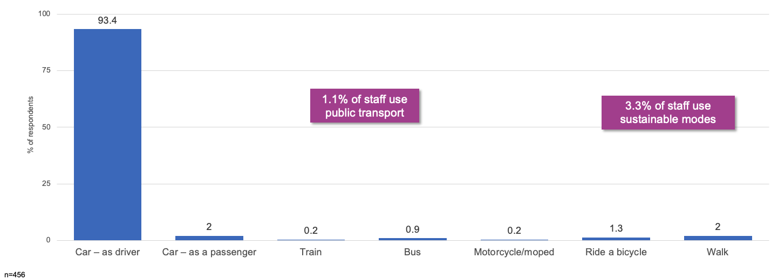
Table 5: Main mode of travel on survey day
Mode | Percentage of respondents (%)
Car – as driver | 93.4
Car – as passenger | 2
Train | 0.2
Bus | 0.9
Motorcycle or moped | 0.2
Ride bicycle | 1.3
Walk | 2
Note: n=456

Regular use of other modes
Question: Excluding how you travelled today, are there other methods you regularly use to travel to work (excluding any short walks to or from a bus stop, train station, car park and so on)?
Findings:
- 13 per cent of people regularly use other travel options. While this is a relatively small proportion of employees, it highlights an opportunity to increase the frequency that these sustainable travel options are used – as well as encourage others to consider them. Car sharing (travel with passengers), cycling and walking show the greatest potential.
Figure 11: Regular use of other modes of travel
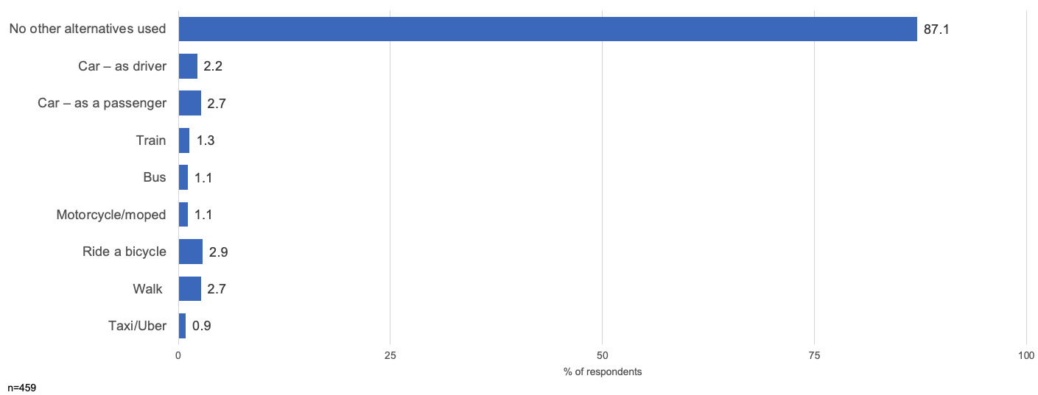
Table 6: Regular use of other modes of travel
Mode | Percentage of respondents (%)
No other alternative used | 87.1
Car – as driver | 2.2
Car – as passenger | 2.7
Train | 1.3
Bus | 1.1
Motorcycle or moped | 1.1
Ride bicycle | 2.9
Walk | 2.7
Taxi or Uber | 0.9
Note: n=459

Typical travel modes (non-travellers on survey day)
Question: Thinking about your typical journey to work, from leaving home to arriving at work, which of the following methods of transport do you usually use? Select all that apply, excluding any short walks to or from a bus stop, train station, car park and so on.
Findings:
- When considering the mix of travel modes reported by those who didn’t travel on the survey day – car usage continues to be high.
- However, there is generally greater overall use of sustainable and active modes. This may indicate an openness by some staff to future increases in travel by these modes.
Figure 12: Typical travel modes
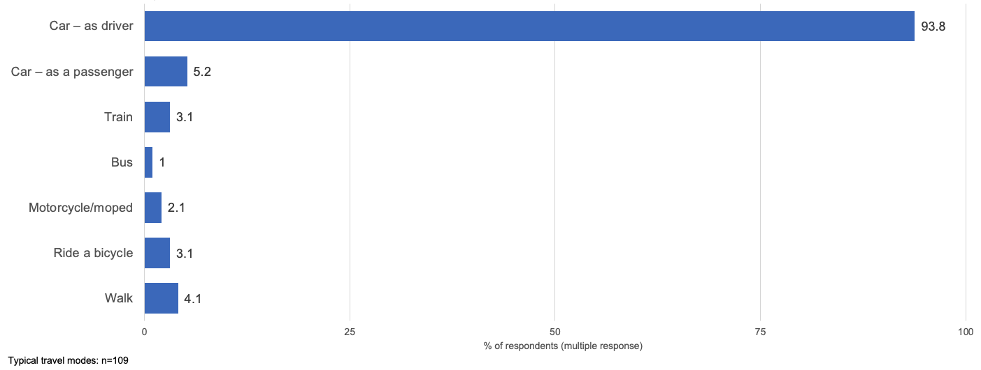
Table 7: Typical travel modes
Mode | Percentage of respondents (%)
Car – as driver | 93.8
Car – as passenger | 5.2
Train | 3.1
Bus | 1
Motorcycle or moped | 2.1
Ride bicycle | 3.1
Walk | 4.1
Note: n=109, multiple responses

Journey satisfaction
Question: How would you rate your satisfaction with your experience travelling to the hospital or hospital campus?
Findings:
- Journey satisfaction (for trips predominantly by car) shows high levels of satisfaction.
- 77 per cent of people are satisfied or very satisfied with their travel. This is a strong behavioural influence for staff to maintain their current travel patterns. This makes behavioural campaigns less likely to have any significant impact on reducing drive-alone rates.
Figure 13: Satisfaction with experience travelling to work
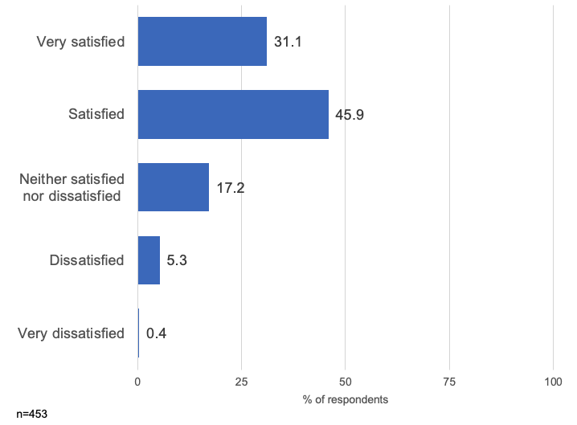
Table 8: Satisfaction with experience travelling to work
Response | Percentage of respondents (%)
Very satisfied | 31.1
Satisfied | 45.9
Neither satisfied not dissatisfied | 17.2
Dissatisfied | 5.3
Very dissatisfied | 0.4
Note: n=453

Job role flexibility and remote work
Questions:
- Which of these descriptions best describes the flexibility of your job role?
- And which of these statements best describes how you have worked over the last six months?
Findings:
- Job flexibility and uptake of remote work are both positive, with around half of employees indicating they can work remotely and a third indicating they have done so in the last six months.
- 47 per cent have some capacity to work flexibly.
- 37 per cent have worked flexibly.
Figure 14: Flexibility of job
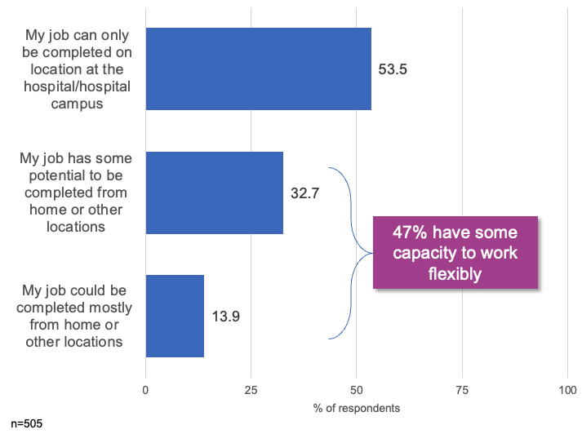
Table 9: Flexibility of job
Response | Percentage of respondents (%)
My job can only be completed on location at the hospital or hospital campus | 53.5
My job has some potential to be completed from home or other locations | 32.7
My job could be complete mostly from home or other locations | 13.9
Note: n=505
Figure 15: Job flexibility over last six months
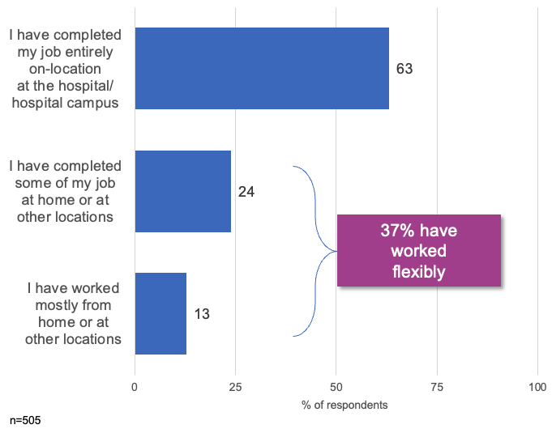
Table 10: Job flexibility over last six months
Response | Percentage of respondents (%)
My job can only be completed on location at the hospital or hospital campus | 63
My job has some potential to be completed from home or other locations | 24
My job could be complete mostly from home or other locations | 13

Remote working exploration
Findings:
- Uptake of remote working by those who are eligible to do so has been strong with 70 per cent of those with high flexibility predominately working remotely. This is not surprising given the remote working requirements under COVID restrictions.
- Capacity remains for growth in remote working, with around a third (33.9 per cent) of those with some potential to do so still only working on site.
Table 11: Analysis of uptake of remote working
Response | My job can only be completed on location | My job has some potential to be completed from home or other locations | My job could be completed mostly from home or other locations | Total
I have completed my job entirely on-location at the hospital or hospital campus | 96.3% | 33.9% | 4.3% | 63.2%
I have completed some of my job at home or at other locations | 3.3% | 57.0% | 25.7% | 24.0%
I have worked mostly from home or at other locations | 0.4% | 9.1% | 70.0% | 12.9%
Total | 53.5% | 32.7% | 13.9% | -

Travel behaviour interventions – mean score
Question: Thinking about the sorts of things that could encourage to you use more or start using other travel options (such as walking, cycling, public transport and car sharing), how likely are each of the following to influence you?
Findings:
- While overall appeal of all potential travel interventions was weak, parking-related incentives for sustainable car-based travel received the most positive evaluation from staff. This aligns with interest in supporting colleagues to car share (such as through a ride-matching app).
- Enhanced end-of-trip facilities are also of some appeal to staff.
Figure 16: Mean appeal of possible travel incentives and interventions
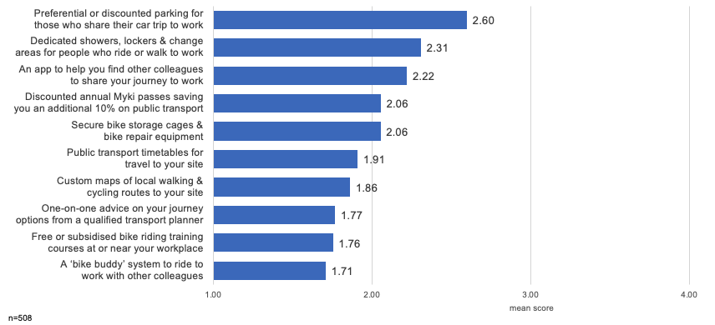
Table 12: Mean appeal of possible travel incentives and interventions
Option | Mean score
Preferential or discounted parking for those who share their car trip to work | 2.6
Dedicated showers, lockers and change areas for people who ride or walk to work | 2.31
An app to help you find other colleagues to share your journey to work | 2.22
Discounted annual Myki passes saving you an additional 10% on public transport | 2.06
Secure bike storage cages and bike repair equipment | 2.06
Public transport timetables for travel to your site | 1.91
Custom maps of local walking and cycling routes to your site | 1.86
One-on-one advice on your journey options from a qualified transport planner | 1.77
Free or subsidised bike riding training courses at or near your workplace | 1.76
A 'bike buddy’ system to ride to work with other colleagues | 1.71
Note: n=508

Travel behaviour intervention – attractiveness
Question: Thinking about the sorts of things that could encourage to you use more or start using other travel options (such as walking, cycling, public transport and car sharing), how likely are each of the following to influence you?
Findings:
- While appeal of most travel interventions was low, preferential or discounted parking for car sharing and enhanced end-of-trip facilities were attractive influencers for almost a third of the workforce.
- Discounted Myki cards and bike storage facilities also rated highly with around 20 per cent of workforce.
Figure 17: Appeal of travel incentives and interventions
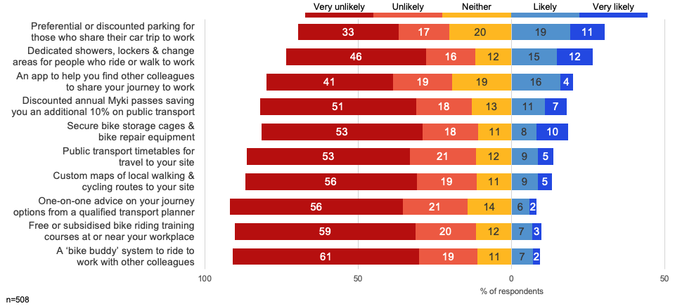

Table 13: Appeal of travel incentives and interventions
Option | Very unlikely (%) | Unlikely (%) | Neither (%) | Likely (%) | Very likely (%)
Preferential or discounted parking for those who share their car trip to work | 33 | 17 | 20 | 19 | 11
Dedicated showers, lockers and change areas for people who ride or walk to work | 46 | 16 | 12 | 15 | 12
An app to help you find other colleagues to share your journey to work | 41 | 19 | 19 | 16 | 4
Discounted annual Myki passes saving you an additional 10% on public transport | 51 | 18 | 13 | 11 | 7
Secure bike storage cages and bike repair equipment | 53 | 18 | 11 | 8 | 10
Public transport timetables for travel to your site | 53 | 21 | 12 | 9 | 5
Custom maps of local walking and cycling routes to your site | 56 | 19 | 11 | 9 | 5
One-on-one advice on your journey options from a qualified transport planner | 56 | 21 | 14 | 6 | 2
Free or subsidised bike riding training courses at or near your workplace | 59 | 20 | 12 | 7 | 3
A 'bike buddy’ system to ride to work with other colleagues | 61 | 19 | 11 | 7 | 2
Note: n=508

Family commitments and mobility choices
Question: Do family or childcare commitments influence your choices of how you travel to work?
Findings:
- Yes – 26.7%
- No – 73.3%
- Over one-quarter of staff have family or childcare commitments influence their travel choices
Figure 18: Family and childcare commitments influencing choice of travel
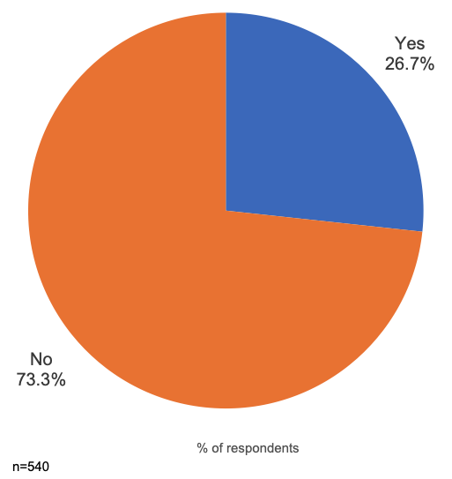

Question: How long was your door-to-door commute to the campus today?
Findings:
- Positively, 65 per cent of staff travel less than 30 minutes to work, with the vast majority (85 per cent) completing their trip in less than 45 minutes.
- These short travel times make other modes less appealing, especially public transport, as the alternative trip would take much longer than by car.
Figure 19: Commute time to campus on survey day
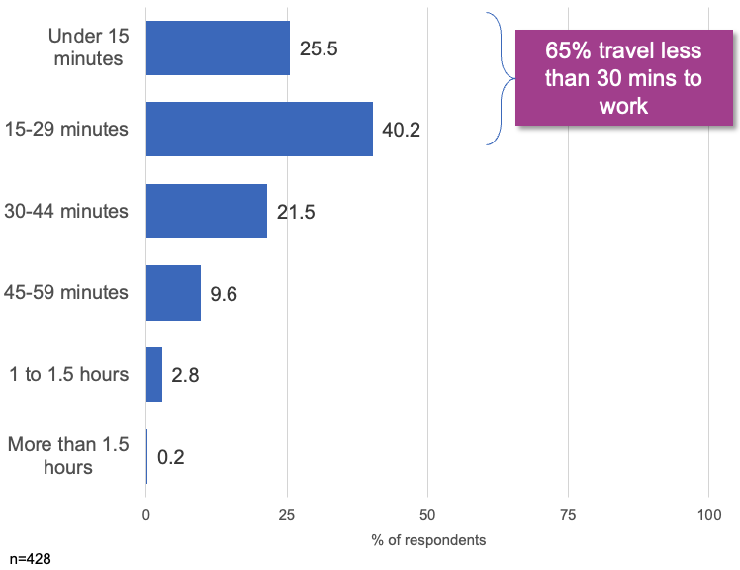
Table 14: Commute time to campus on survey day
Commute time | Percentage of respondents (%)
Under 15 minutes | 25.5
15 to 29 minutes | 40.2
30 to 44 minutes | 21.5
45 to 59 minutes | 9.6
1 to 1.5 hours | 2.8
Over 1.5 hours | 0.2
Note: n=428

Journey time and satisfaction
Questions:
- How long was your door-to-door commute to the campus today?
- How would you rate your satisfaction with your experience travelling to the hospital or hospital campus?
Findings
- There is a strong and statistically significant relationship between total trip time and journey satisfaction.
- Those staff whose journey was under 30 minutes in duration (around two-thirds of the workforce) were much more likely to be ‘very satisfied’ with their trip. This poses challenges to growing use of non-car modes which may increase total trip time.
Figure 20: Satisfaction by journey time
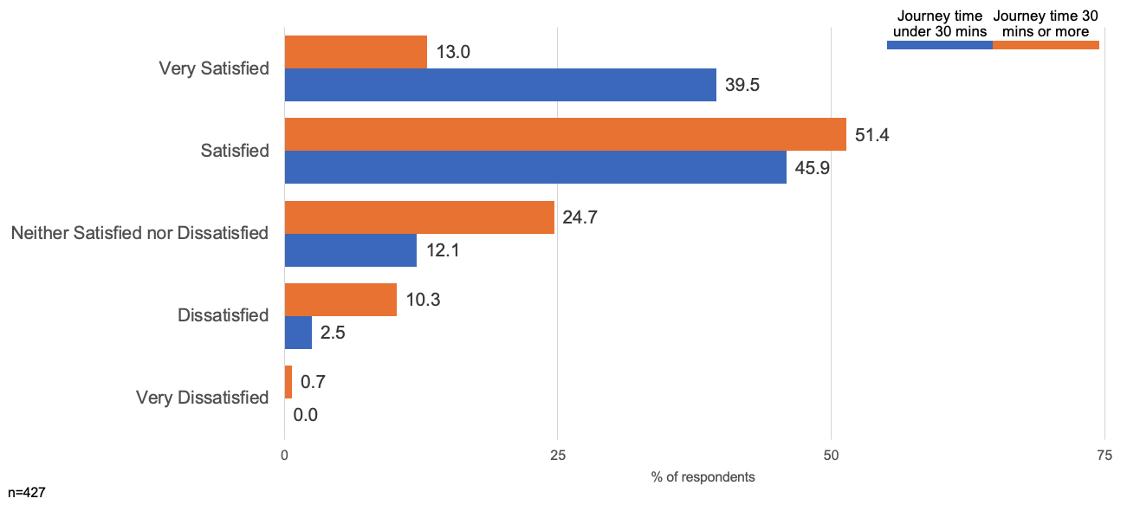
Table 15: Satisfaction by journey time
Response | Under 30 minutes (%) | 30 minutes and over (%)
Very satisfied | 39.5 | 13.0
Satisfied | 45.9 | 51.4
Neither satisfied not dissatisfied | 12.1 | 24.7
Dissatisfied | 2.5 | 10.3
Very dissatisfied | 0.0 | 0.7
Note: n=427

Car parking
Questions:
- Where did you park your car when you arrived at work today?
- Did you pay for your parking (including any passes or arrangements by salary deduction)?
Findings:
- Just under three-quarters of all staff who drive to work park on-site (73 per cent), with local on-street parking being the next most popular option.
- 98 per cent of staff parking users report paying for their parking.
- 96 per cent of street parking was free.
Figure 21: Car park location on survey day
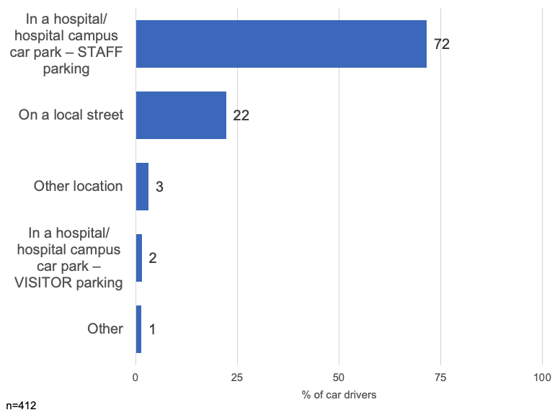
Table 16: Car park location on survey day
Location | Percentage of respondents (%)
Hospital or hospital campus car park – staff parking | 72
Local street | 22
Other location | 3
Hospital or hospital campus car park – visitor parking | 2
Other | 1
Note: n=412
Figure 22: Paid for parking on survey day
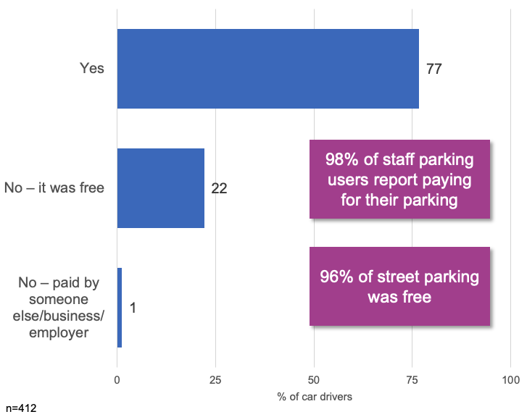
Table 17: Paid for parking on survey day
Response | Percentage of respondents (%)
Yes | 77
No – it was free | 22
No – paid by someone else, business or employer | 1
Note: n=412

On-site staff car parking
Questions:
- Do you have a hospital campus staff car parking permit?
- How do you rate the quality of car parking facilities at the hospital or hospital campus?
Findings:
- A similar proportion of staff that drive also hold a hospital parking permit, suggesting a strong linkage between permits and car park use.
- On-site parking facilities are subject to mixed perceptions, with 23 per cent rating them poorly and 35 per cent rating them positively.
Figure 23: Hold a staff car parking permit
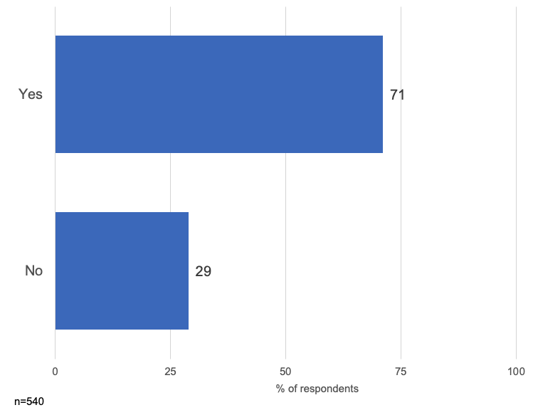
Table 18: Hold a staff car parking permit
Response | Percentage of respondents (%)
Yes | 71
No | 29
Note: n=540
Figure 24: Quality of car parking facilities
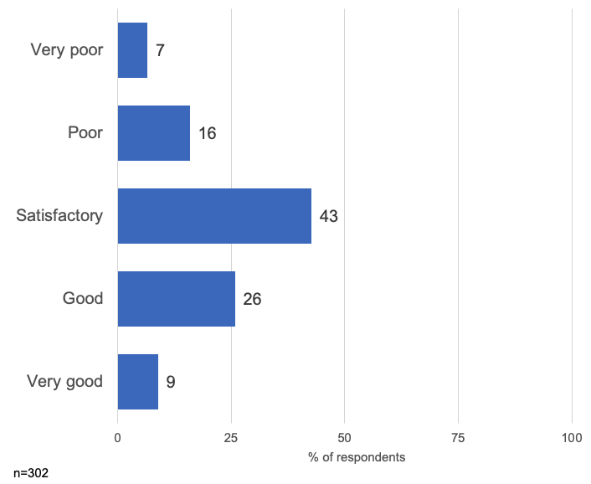
Table 19: Quality of car parking facilities
Response | Percentage of respondents (%)
Very poor | 7
Poor | 16
Satisfactory | 43
Good | 26
Very good | 9
Note: n=302

Bicycle facilities
Questions:
- As a cyclist, which of the following do you have access to?
- How do you rate the quality of facilities for cyclists?
Findings:
- Cycle facilities provide one of the greatest areas for improvement, with 59 per cent of cyclists rating them ‘very poor’ or ‘poor’.
- Only two-thirds report access to suitable and secure bike parking, while more than half do not have (or are not aware they have) access to basic cycling facilities, such as shower or change rooms or lockers.
Figure 25: Access to cycle facilities
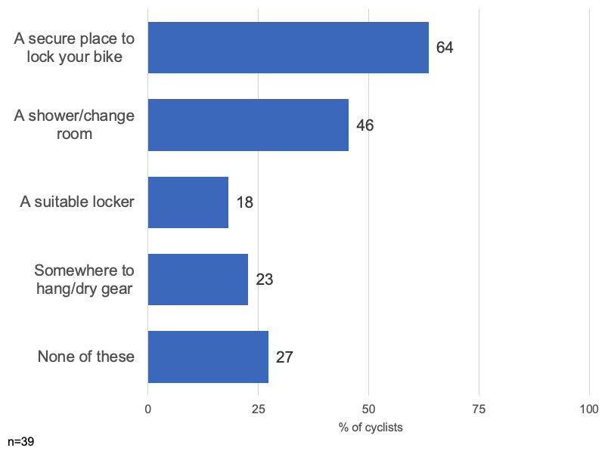
Table 20: Access to cycle facilities
Option | Percentage of cyclists (%)
Secure place to lock bike | 64
Shower or change room | 46
Suitable locker | 18
Somewhere to hang or dry gear | 23
None of these | 27
Note: n=39
Figure 26: Quality of cycle facilities
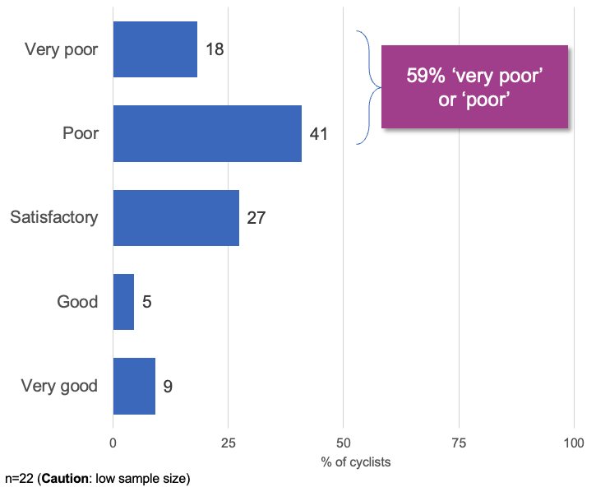
Table 21: Quality of cycle facilities
Response | Percentage of cyclists (%)
Very poor | 18
Poor | 41
Satisfactory | 27
Good | 5
Very good | 9
Note: n=22 (caution: low sample size)

Bicycle parking and trip issues
Questions:
- Where did you park your bicycle when you arrived at work today?
- What are your greatest challenges when riding to work?
Findings:
- Staff choosing to park their bikes within office areas may suggest a need for better secure storage options.
- The vast majority of challenges for cyclists related to the lack of end-of-trip facilities.
Table 22: Where cyclists parked their bike on survey day
Location | Number of cyclists
Inside a building or office – in a non-clinical area | 2
On campus – secure bike storage facility | 1
On campus – open bike racks located at X | 1
On campus – open bike racks located at Y | 1
On campus – open bike racks located at Z | 1
Note: n=6 (caution: small sample size)
Table 23: Greatest challenges riding to work
Issue | Comments | Number of cyclists
General weather | - | 4
End-of-trip facilities | - Distance between bike locker and shower facilities  - Facilities for bike riders are over the other side of the hospital, no secure facilities near community health  - No secure bike facilities (when travelling to) other hospital  - Nowhere to hang or dry cycle gear  - Place to store the bike and clothes  - Somewhere to lock it up and change  - Unable to shower when I arrive, can only change clothes | 7
Lifestyle and other | - Normally what I am doing for the day.  - Takes longer to get to work. Once ridden to work not flexible to pick up kids from school and so on.  - Access to appropriate breakfast food after riding for 1.25 hours | 3
Trip and en route | - Distance  - Navigating entry roads with high traffic and limited bike paths | 2
Total | - | 16
Note: n=16 (caution: small sample size)

Motorcycle facilities
Questions:
- As a cyclist, which of the following do you have access to?
- Where did you park your motorcycle or moped?
Findings:
- Provision of end-of-trip facilities may encourage greater uptake of motorcycling – which could relieve some pressure on on-site parking facilities.
Figure 27: Access to end-of-trip facilities for motorcyclists
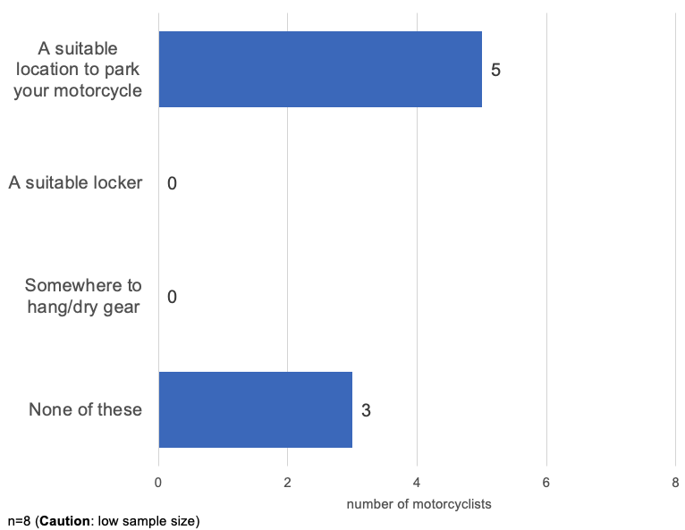
Table 24: Access to end-of-trip facilities for motorcyclists
Option | Number of motorcyclists
Suitable place to park motorbike | 5
Suitable locker | 0
Somewhere to hang or dry gear | 0
None of these | 3
Note: n=8 (caution: low sample size)
Table 25: Motorcycle parking location on survey day
Location | Number of motorcyclists
Hospital or hospital campus staff car park | 3
Non-marked outdoor space at the hospital or hospital campus | 3
On a local street | 1
Elsewhere | 1
Note: n=8 (caution: low sample size)

Public transport
Q: What is your greatest challenge when using public transport to get to work?
Findings:
- Comments regarding public transport focused primarily on service frequency and reliability, followed by factors relating to travel duration
Table 26: Public transport issues
Issue | Comments | Number of respondents
Service operation, reliability, scheduling | - Bus never on time, bus always too early. I miss them more than I catch them. Bus full of school kids. Buses should wait at bus stops for the actual scheduled time, then depart (like in England). They don't.  - Reliability.  - Not very frequent as per my time schedule.  - The timetable.  - The frequency of the bus from X and the time it takes.  - I'm quite happy with service. Very occasionally there may be a cancellation. | 6
Time and duration | - It takes slightly longer, so I need to get up earlier  - Length of time spent on public transport to get to work  - Takes twice the time than driving | 3
Family commitments | - Unable to use more often, because have to drop daughter at childcare first. Can't access childcare from public transport  - Childcare timing. If I could start 30 minutes earlier in the day, then I would be able to time childcare pick up and full working hours | 2
General comments | - If having to get to other campuses other than the hospital, the public transport is poor.  - Transport from station to work. | 2
Note: n=14

Pedestrian facilities
Questions:
- How do you rate the quality of pedestrian facilities in and around the hospital/hospital campus?
- What are your greatest challenges when walking to work?
Findings:
- Pedestrian facilities show significant room for improvement, with less than a third giving positive ratings.
- Safety concerns, particularly around interactions with vehicle traffic both on campus and in the local area, pose the greatest pedestrian challenges.
Figure 28: Quality of pedestrian facilities
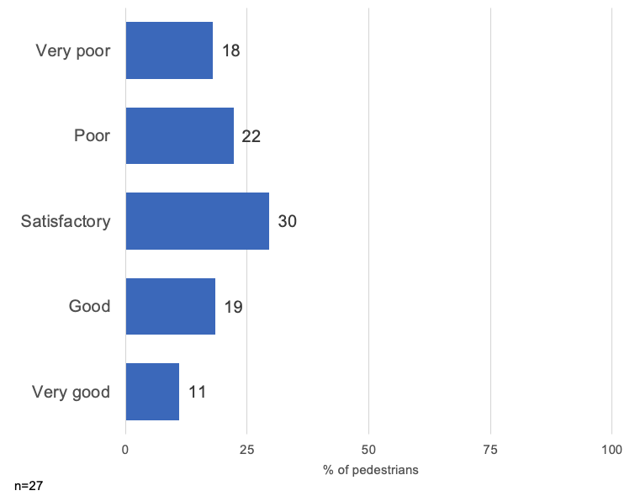
Table 27: Quality of pedestrian facilities
Response | Percentage of pedestrians (%)
Very poor | 18
Poor | 22
Satisfactory | 30
Good | 19
Very good | 11
Note: n=27
Table 28: Pedestrian issues
Issue | Comments | Number of pedestrians
Safety | - Safety.  - Time it takes not to leave late. Or dark at night – safety.  - Safety, particularly early morning or later evening – plus there are not many walking paths on campus (have to walk on the road for part of the journey).  - Lack of pedestrian crossing in obvious places, vehicles not respecting pedestrian crossing, vehicles burning the red light when the alarm goes for pedestrian to cross – very dangerous.  - If entering hospital grounds from the park or X, you have to walk along the road to access the buildings. It is a wonder no one has been hit by a car.  - Walking from Y to main reception without getting in the way of cars as there is no safe path to walk on.  - Walking lanes are too narrow and not separated from car lanes. There are also no zebra crossings near Gate 3. | 7
Distance and terrain | - Distance from train station.  - Distance or time.  - Just time and wanting to do it.  - Hills. | 4
Pedestrian infrastructure | - No formal separate path from the road at the X St entry.  - No path to the staff entrance – have to cut through the staff car park.  - Path access on the western side of the hospital site. | 2
Weather | - Weather.  - To me it is fun walking to work and it is good to start the day with some exercise. The only little challenge is when it is cold, windy and raining. But that is part of the excitement too I guess. | 2

General feedback
Question: Is there any other feedback you’d like to provide?
Findings:
- General feedback reflected a highly driver-centric culture, with the majority of comments relating to the capacity, design or operation of existing car parks.
- Most respondents felt that they had little option but to drive.
- Those who had explored alternatives were frustrated with public transport reliability, trip times and access.
Figure 29: General feedback
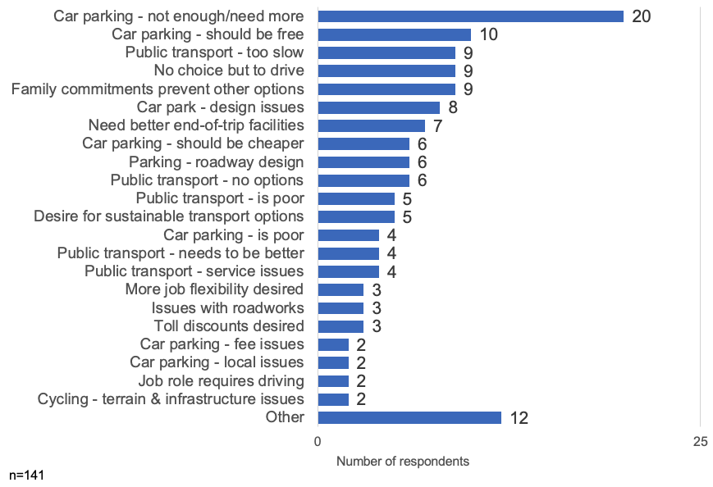

Table 29: General feedback
Feedback | Number of respondents
Car parking – not enough or need more | 20
Car parking – should be free | 10
Public transport – too slow | 9
No choice but to drive | 9
Family commitments prevent other options | 9
Car park – design issues | 8
Need better end-of-trip facilities | 7
Car parking – should be cheaper | 6
Parking – roadway design | 6
Public transport – no options | 6
Public transport – is poor | 5
Desire for sustainable transport options | 5
Car parking – is poor | 4
Public transport – needs to be better | 4
Public transport – service issues | 4
More job flexibility desired | 3
Issues with roadworks | 3
Toll discounts desired | 3
Car parking – fee issues | 2
Car parking – local issues | 2
Job role requires driving | 2
Cycling – terrain and infrastructure issues | 2
Other | 12

Quotes
- ‘I would love to take public transport. But I have to take the train (15 minutes) and then walk about 20 minutes or take a bus. I can drive in about 15 minutes. It would be great if there were some ways to make it easier to commute to work by public transport.’
- ‘I can only travel to work via car. Public transport would take over 2 hours each way, which I am not willing to undertake. The fact that I have the opportunity to work from home some of the weeks has allowed me to keep working for [health service], otherwise I probably would have found alternative employment closer to home.’
- ‘Having a bike path from X to Y, bike path – separated from cars – with a shower at work would get me back on my bike!
- ‘Fragmented connections and timetables on public transport make driving the only sensible option.’

Arrival and departure times
Questions:
- What time did you arrive at the hospital or hospital campus?
- What time do you expect to leave the hospital or hospital campus?
Findings:
- Despite the afternoon peak being slightly more dispersed, the majority of campus staff still travel during traditional peak travel hours. This is useful context for communications when ‘shift work’ is often presented as a barrier to change. This regular travel pattern also supports more ride sharing.
Figure 30: Arrival and departure times on survey day
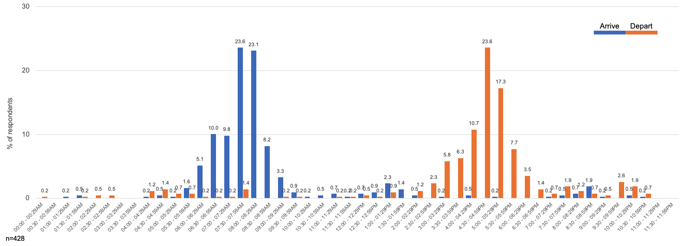
Table 30: Arrival and departure times on survey day
Time | Arrive (%) | Depart (%)
00:00 to 00:29 am | 0 | 0.2
00:30 to 00:59 am | 0 | 0
01:00 to 01:29 am | 0.2 | 0
01:30 to 01:59 am | 0.5 | 0.2
02:00 to 02:29 am | 0 | 0.5
02:30 to 02:59 am | 0 | 0.5
03:00 to 03:29 am | 0 | 0
03:30 to 03:59 am | 0 | 0
04:00 to 04:29 am | 0.2 | 1.2
04:30 to 04:59 am | 0.5 | 1.4
05:00 to 05:29 am | 0.2 | 0.7
05:30 to 05:59 am | 1.6 | 0.7
06:00 to 06:29 am | 5.1 | 0.2
06:30 to 06:59 am | 10.0 | 0.2
07:00 to 07:29 am | 9.8 | 0.2
07:30 to 07:59 am | 23.6 | 1.4
08:00 to 08:29 am | 23.1 | 0
08:30 to 08:59 am | 8.2 | 0
09:00 to 09:29 am | 3.3 | 0.2
09:30 to 09:59 am | 0.9 | 0.2
10:00 to 10:29 am | 0.2 | 0
10:30 to 10:59 am | 0.5 | 0
11:00 to 11:29 am | 0.7 | 0.2
11:30 to 11:59 am | 0.2 | 0.2
12:00 to 12:29 pm | 0.7 | 0.5
12:30 to 00:59 pm | 0.9 | 0.2
01:00 to 01:29 pm | 2.3 | 0.9
01:30 to 01:59 pm | 1.4 | 0
02:00 to 02:29 pm | 0.5 | 1.2
02:30 to 02:59 pm | 0 | 2.3
03:00 to 03:29 pm | 0.2 | 5.8
03:30 to 03:59 pm | 0 | 6.3
04:00 to 04:29 pm | 0.5 | 10.7
04:30 to 04:59 pm | 0 | 23.6
05:00 to 05:29 pm | 0.2 | 17.3
05:30 to 05:59 pm | 0 | 7.7
06:00 to 06:29 pm | 0 | 3.5
06:30 to 06:59 pm | 0 | 1.4
07:00 to 07:29 pm | 0.2 | 0.7
07:30 to 07:59 pm | 0.5 | 1.9
08:00 to 08:29 pm | 0.7 | 1.2
08:30 to 08:59 pm | 1.9 | 0.7
09:00 to 09:29 pm | 0.2 | 0.5
09:30 to 09:59 pm | 0 | 2.6
10:00 to 10:29 pm | 0.5 | 1.9
10:30 to 10:59 pm | 0.2 | 0.7
11:00 to 11:29 pm | 0 | 0
11:30 to 11:59 pm | 0 | 0
Note: n=428

Attachment N: Tips for running a focus group (2.11)

Introduction
Understanding why people travel the way they do and learning about their travel preferences, challenges and interests can help you develop travel plan actions that are most relevant to your workplace.
Focus groups are a common way to collect useful qualitative data on preferences and behaviours.

Plan your session
- Be clear on your purpose and what you want to achieve. Are you exploring behaviours, issues and challenges? Do you also want to explore solutions?
- Write out your purpose and questions to guide discussion. Fit them to the time you have available.
- Decide whether you will run the focus group online or face-to-face. Consider the particular accessibility requirements for the format you choose.
- Decide if you are able to recruit enough people to have separate groups to explore different issues (such as one group for people who drive and one for people who use active modes, or one for administrative staff and one for clinical staff).

Finding participants
- Offer incentives and promote them. Example incentives are a coffee voucher, morning tea or a prize draw.
- Pick times that suit the most people to ensure attendance.
- Seek senior management support to encourage people to attend.
- Assume some people will not show up and account for this. Aim for about 10 participants for each group.

Running the focus group
- Explain the purpose and approach to your group.
- Seek consent to record the session so you can review and reflect on the discussion later.
- Set clear ground rules (such as respecting others’ comments, using the chat function in online forums).
- Introduce yourself and ask participants to introduce themselves.
- Use your questions to guide discussion.
- Seek input from all the group. Encourage others to speak if one or two dominate discussion.
- Encourage exploratory discussion and aim to build rapport.
- Be extra engaging – especially for online forums.
- It helps to have a co-facilitator or note-taker (for example, to manage multiple online chat responses).

Analysing feedback
- Don’t just rely on your initial observations – these may be influenced by one or two more assertive participants.
- Review the recording of the discussion and ask your co-facilitator what they heard.

Limitations – validate your findings
- Small sample bias: due to their small size, focus groups are at risk of not reflecting the sentiments of your whole workforce.
- Observer bias: participant comments may be influenced or changed by observer bias – they may tell you what they think you want to hear or may be influenced by social pressures from the group.
- Look for other ways to compare focus group findings, such as from staff surveys or discussions with your human resources area.

Sample questions
These questions can help you structure a group discussion.
You will need to follow up with prompts or other exploratory questions based on what people say to clarify and understand what is influencing people’s perceptions or behaviours.
Question: Let’s first talk about how each of you travel to work:
- Why do you usually travel this way?
- What do you like about it?
- Is there anything you don’t like or find challenging?
Question: Has anyone got to work a different way?
- For example, if your car was in for a service? Tell me about that experience?
- Has anyone thought about getting to work a different way (such as public transport, carpooling, bike riding)? Why did you think about it? What stopped you?
Question: Let’s explore a future world, where everything is in place to allow you to not use your car if you don’t want to.
- How would you like to travel to work?
- What needs to change? What can your organisation do to help?

Alternatives to focus groups
- Travel survey: comments from a travel survey may give you good insights into more pressing issues or suggestions for how to improve staff access and travel.
- One-on-one conversations or conversations with small groups in the tea room: look for opportunities to have short conversations with a variety of staff. Have one or two prompt questions to guide the brief chat.
- Talk to people who are already using travel options that you are trying to encourage: for example, find people who ride to work and discuss what works and what is a challenge.

Attachment O: Example travel plan objectives and targets (3.0)

Introduction
Identify objectives to achieve outcomes that are most relevant to your organisation’s priorities, site context and staff needs.
These example objectives and targets cover a range of health and wellbeing, sustainability and corporate social responsibility outcomes.
You may identify other objectives or adapt these to guide the implementation of your travel plan (based on what is important for your organisation to focus on).
Select targets to measure progress towards each objective. Specific measures need to be identified by the health service itself, based on program efforts and organisational support.

Example objectives and targets
General objective | Specific objective | Target
Support the mental and physical health and wellbeing of our employees | - Support staff health and wellbeing by building physical activity into their travel  - Help reduce commute stresses | - Increase proportion of employees using active travel to work one or more day a week  - Increase participation in active travel events and promotions  - Increase remote work hours for non-contact roles  - Reduce journey stress
Fairly manage our limited parking resources and reduce barriers to other travel options | - Fairly manage access to parking based on need  - Reduce or manage car park waiting lists  - Provide real choice for other travel options by reducing work-related barriers to these options | - Reduce waiting lists for car parking  - Reduce number of complaints about car parking  - Reduce barriers to non-car travel options
Support financial responsibility in managing growth and access to limited parking resources | - Reduce costs of car parking to organisation  - Avoid additional costs of new car parks due to growth  - Reduce vehicle fleet and petrol costs | - Reduce costs of car park operation  - Reduce proportion of vehicle fleet costs over a period of time  - Reduce petrol costs for business travel by X per cent
Contribute to reducing our carbon footprint | - Reduces private car travel for commuting and business travel, reducing health service’s indirect emissions | - Reduce vehicle kilometres to work by X per cent  - Reduce drive-alone business travel by X per cent
Reduce impact of hospital growth and services on local community amenity | - Reduce impact of hospital growth and services on local community amenity, including local congestion and pollution | - Reduce drive-alone travel to work by X per cent  - Increase engagement with council on local area access
Implement a program that is scalable, efficient and gives users safe and active travel options | - Apply standard methods and shared resources  - Embed actions into related work programs (such as health promotion)  - Address health and safety concerns and requirements in implementing actions | - Program objectives and actions are embedded in other programs/work areas

Attachment P: Travel plan actions template (3.1)
Use this travel plan actions template to select and prioritise actions that match the plan level and objectives, and respond to the issues and opportunities identified through the site audit, survey, stakeholder discussions and analysis.
The Excel file is available as a separate file on the Department of Health website's Transport page <https://www.health.vic.gov.au/planning-infrastructure/transport>.
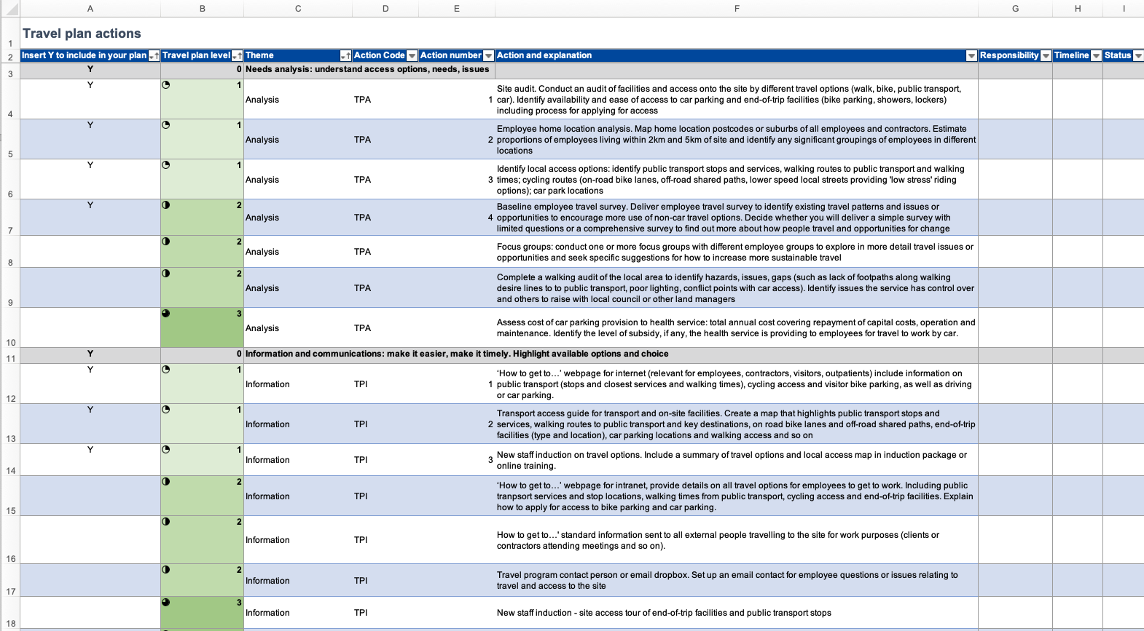

Attachment Q: Travel plan strategic presentation template (3.2)
Use this slide pack to present the purpose, objectives and approach to your hospital travel plan. It includes a summary of your framework assessment, background analysis and staff survey results, which together inform the type of travel plan you are delivering (passive, active, comprehensive) and the priority actions you will deliver.
The PowerPoint file is available as a separate file on the Department of Health website's Transport page <https://www.health.vic.gov.au/planning-infrastructure/transport>.
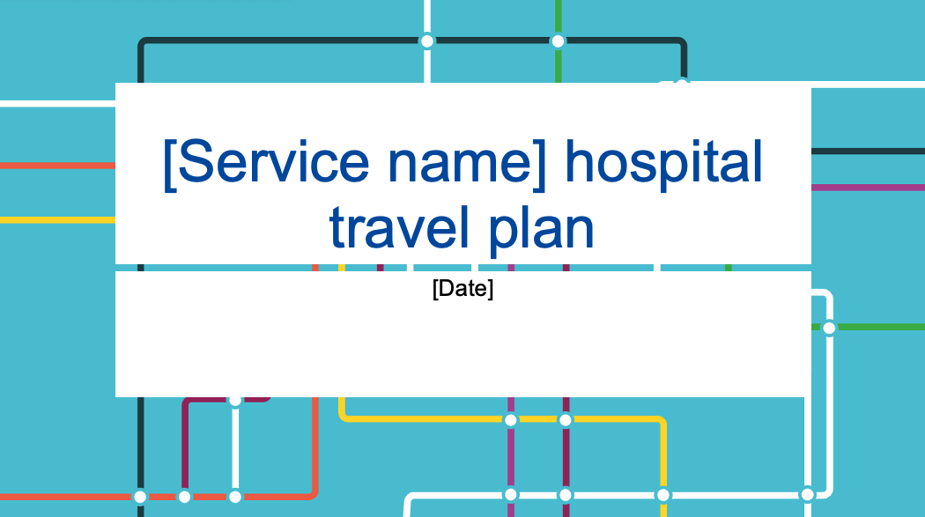

Attachment R: Interpreting results and identifying actions (3.3)

About this guide
This guide helps to interpret the results of a site audit and survey, and then assess what actions may be most relevant to include in a travel plan.
Actions need to be appropriate to the size and context of your organisation. For example, if survey results indicate a ‘high interest’ in riding to work, a site with 30 staff will respond differently to one with 3,000.
You can use the Travel plan actions template to identify the most appropriate actions for the level of travel plan being considered by your workplace.

Overall approach
A travel plan aims to remove workplace barriers to walk, ride a bike, use public transport or carpool to work.
Based on the background analysis, look for opportunities to:
- make it easier for staff to learn about all their transport options and promote available options
- make it timely by giving information when it is most relevant (such as at staff induction)
- make it easier and more attractive by improving bicycle end-of-trip facilities
- make it fair by implementing policies that support travel choice (such as remote work practices or parking management based on need)
- encourage incremental changes, such as using a sustainable travel option one day a week or one day more than currently used.
For active and comprehensive travel plans, also include actions to make it:
- attractive and social through events, campaigns and programs
- easier by advocating for improvements to the local area and public transport.

Tips when analysing your results
Survey questions | Possible interpretation and actions
Usual travel option (on survey day) | - Car travel will dominate travel options except for central city locations with good public transport, walking and cycling access.  - Consider proportion of staff within 5 km to assess potential to increase walking or bike riding.  - If some travel options are not usually used or are less than one per cent, it indicates that transport access (such as public transport availability) is the biggest barrier and may be difficult to encourage.
Other travel options used | - It is a positive sign if a reasonable proportion of staff (over 15 per cent) regularly use other travel options. This indicates potential to increase how frequently other travel options are used and to encourage other staff to use these options.  - Compare results with comments and staff interest in other interventions to identify the best actions to target. For example, if:  - five per cent of people sometimes ride  - there is feedback on wanting to improve end-of-trip facilities  - there is interest in bike riding interventions  this suggests that actions to improve end-of-trip facilities would boost riding.  - Workplace size will be an influence here. It may change the priority of actions or the timeline of implementation due to available budget.  For example, if five per cent of staff out of 3,000 ride more often, that can free up 150 car spaces. In a smaller organisation of 300 staff, this is only 15 car spaces.
Travel time | - If travel times by car are short, it is unlikely that promotional campaigns will influence travel choices. This is because it is very convenient and most often much faster than the same trip by public transport (unless in the inner city, with high frequency public transport).  - Compare proportion of short travel times against satisfaction with current travel. If people are highly satisfied then passive-level actions may have limited effect.  - Short travel times may indicate an opportunity to shift some travel to walking and bike riding. Assess the potential for this against staff interest in these options.  - If a large proportion of staff travel long distances, assess the potential to increase remote working or for carpooling (it may be an incentive to save money). Further incentivising carpooling may help, such as by providing priority parking.
Satisfaction with current travel | - If most staff (over 50 to 60 per cent) are satisfied or highly satisfied then passive-level actions may have limited effect.  - If there are higher levels of dissatisfaction, this may be a motivator to shift travel. Compare with interest in specific interventions to encourage change to help identify potential actions.
Arrival and departure times | - What proportion of staff arrive and leave work at the same time each day? If this is high (such as 40 per cent arriving between 7:30 am and 8:30 am, and leaving between 4:30 pm and 5:30 pm), it may enable more people to carpool. Assess interest in carpooling from responses to other questions and comments.  - Toolkit resources: Travel plan resources, Carpooling program summary guide
Interventions that would encourage using other travel options | - This is a general indicator of interest in specific actions. However, what someone says they might do does not guarantee they will change their travel if that action is implemented.  - Look at the overall ranking of options to inform what is more or less appealing. For example, if most bike riding actions rate very low, it may not be worth making significant investments in bike riding (through events or facilities).  - If some options receive very high interest (higher proportions of ‘very likely’), add these actions into the plan but get more input through focus groups or other staff feedback.
Other commitments influencing travel choice | - This may indicate restrictions on shifting travel choices if percentage is high.  - If percentage is low, it may challenge perceptions that hospital staff have little flexibility. For example, four recent hospital travel surveys identified only 25 per cent of staff had other commitments that influenced their travel choice.
Flexibility | - Comparing how people are currently working to their perception about whether their role can be completed remotely helps to assess the overall culture of flexible work.  - If fewer people are working remotely than are able to, this may indicate organisational barriers to supporting remote work – which should be investigated. This will inform actions to increase remote working rates.
Open comments and feedback | - These are important to uncover general staff sentiment, issues and site-specific recommendations. Comments may reiterate findings from the site audit, which makes the identified actions (such as filling gaps in footpath connections) a higher priority for the travel plan.
Demographics | - For very large workplaces, the survey sample may be large enough to look at whether demographic factors influence travel choice. For example, comparing the usual travel option against age or work.

Attachment S: ‘How to get to…’ web page examples (4.1)

Introduction
Your health service website is often the first place a new employee, contractor or visitor finds information on how to travel to the hospital or health service. Google displays street addresses and travel times.
Your website needs to give people enough information to make their travel easy, no matter how they choose to travel.
If you only focus on car parking, most people will assume driving is the only option. Some people do not have access to a car. Presenting all options available helps people to decide what will work best for them.

Tips for presenting access and transport information
- Make travel information easy to find – have a prominent link on the homepage.
- Make sure your information is accessible to all people, including people with disabilities.
- Have one page on all travel options so that people can find and compare them. Do not have car parking in one section and all other transport options in another place.
- If you have a transport access guide, add it as another web page or as a download.
- Include a site map to show accessible entry points and location of facilities (such as car parks, secure bike parking and public transport stops).
- Include enough detail to make it easy for people. For example, if a bike cage has secure access, explain how to get access. Add walk times from nearby public transport or other destinations and include parking fees.

Examples

Liverpool Hospital, Sydney
- Liverpool Hospital website <https://www.swslhd.health.nsw.gov.au/liverpool>
‘Getting here’ is on the top level of website’s main navigation menu. This makes it easy for people to get to travel information from any page of the website, including the home page. Figure 1 shows this left-hand side menu being selected.
The ‘Getting here’ menu links to information for all travel options (such as cycling, public transport or driving).
The transport access guide (also a link in the ‘Getting here’ menu) shows walk times to major destinations, accessible access on-site and explains travel options.
Public transport stops and services are explained in detail, including access to different hospital entries, on Liverpool Hospital’s Public transport page <https://www.swslhd.health.nsw.gov.au/liverpool/public_transport.html>.
Figure 31: Main navigation menu on Liverpool Hospital's website
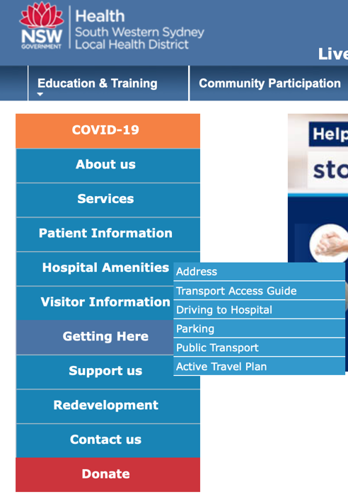

Queen Elizabeth II (QEII) Hospital, Perth
- QEII Hospital website <https://qeiimc.health.wa.gov.au>
- QEII Hospital's Parking and access page <https://qeiimc.health.wa.gov.au/travel-access>
Parking and access information has been given a prominent position on the home page (see Figure 2). ‘Parking and access’ appears in the first promotional tile immediately after the homepage welcome text.
‘Parking and access’ is also a top-level item in the main navigation menu (at the top of the website). This means that it is easy for people to get to travel information from any page of the website.
The Parking and access page highlights many options: ‘Parking’ (driving), ‘Bus’, ‘Taxi’ and ‘Cycle’ (see Figure 3).
The Parking and access section includes information for both staff and visitors.
Figure 32: QEII Hospital homepage
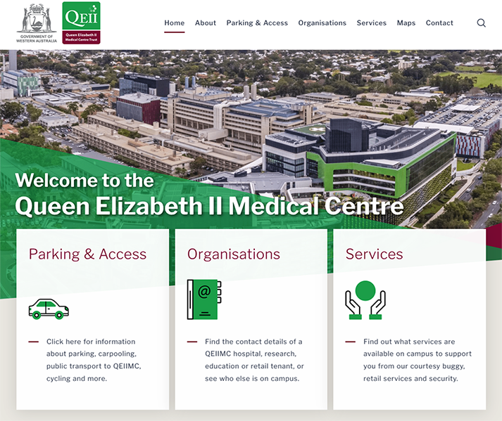
Figure 33: Promoted travel options
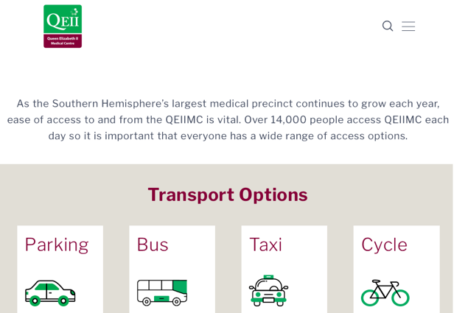

Attachment T: Example transport access guide (4.2)
The PDF version of this transport access guide is available as a separate file on the Department of Health website's Transport page <https://www.health.vic.gov.au/planning-infrastructure/transport>.

Royal North Shore Hospital transport access guide

Note
This is an accessible version of Royal North Shore Hospital’s transport access guide brochure. It is intended as an example to demonstrate the kind of content that is usually included. As such, the specific information in the maps has not been described in depth (such as specifying the particular bus numbers or including the locations of bus stops).
Figure 34: Cover of brochure
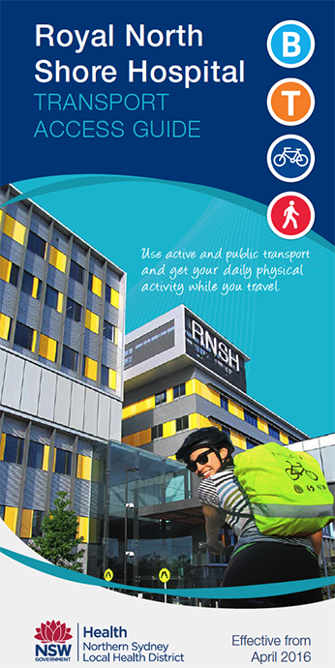

Your guide to using active transport to get to Royal North Shore Hospital

Walking
Suggested walking routes are shown overleaf on the map. Please note walking times are approximate only and are calculated from the main hospital entrance.

Cycling
Suggested cycling routes are shown overleaf on the map. For detailed cycling maps:
- staff can visit the Go Active Hub (P2 visitor car park) or search ‘Go Active’ on the intranet.
- visitors can search online for the ‘Northern Sydney Cycling Map’.

Bicycle parking
Bike racks are located in the P1 car park, outside the Kolling Building, at the front of and in the car park below the Community Health Centre on Herbert St. Staff bike racks (and other facilities) are also located in the P2 car park.

Bus
The nearest bus stop to the hospital’s main entrance is on Reserve Road and is serviced by Route 144 only. For all other routes, the nearest bus interchange is located on Pacific Highway, outside St Leonard’s Station.
For up-to-date timetables and maps, visit transportnsw.info or call 131 500.

Train
The hospital is a 10-minute walk from nearby St Leonards Station (T1 North Shore, Northern and Western Line). The station is wheelchair accessible. For up-to-date timetables and maps, visit transportnsw.info or call 131 500.

Community transport
The Artarmon Loop is a free shuttle service travelling between St Leonards and Artarmon, Monday to Friday. See map overleaf for more details. For service information search ‘Artarmon Loop’ online.

Taxi
Taxi pick up and drop off is available at the main entrance. The nearest taxi rank is located on Reserve Rd, approximately 2 minutes’ walk from the main hospital entrance.

Parking
Parking facilities are available on the hospital campus. Fees apply, so please check signage.
Disabled parking is available at all on-street paid parking areas and multi-storey car parks. A valid disabled parking permit must be displayed when parking in a disabled bay.
A 15-minute drop off and pick up point is located outside the main entry, on French’s Place.
Figure 35: Campus map
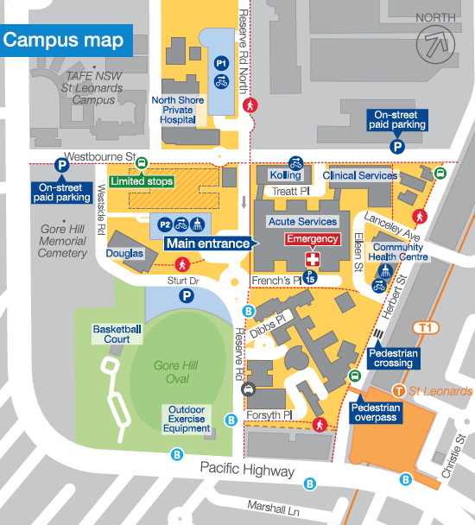
- A: Royal North Shore Hospital, Reserve Road, St Leonards NSW 2065
- T: 02 9926 7111
- W: nslhd.health.nsw.gov.au/Hospitals/RNSH

Local area map
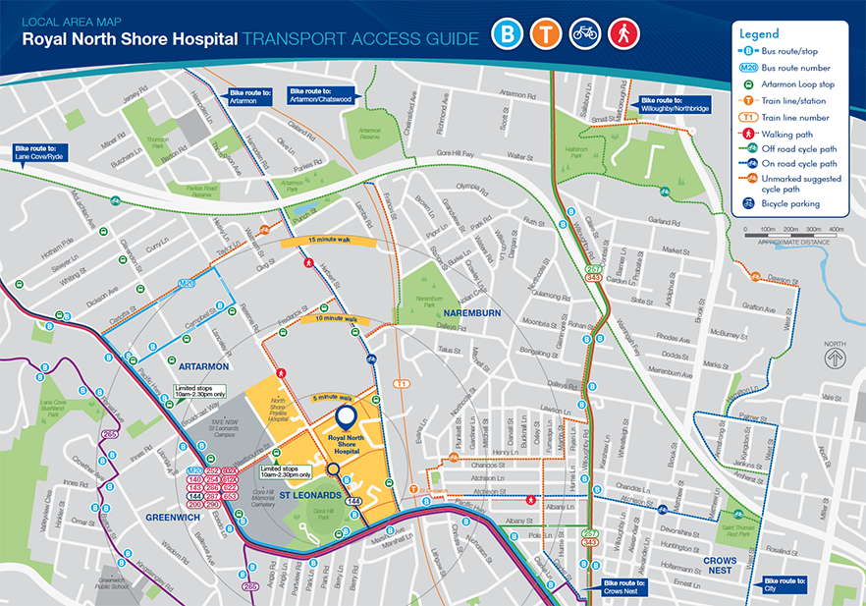

Attachment U: Create a transport access guide (4.3)

Introduction
Having information on all the travel options to your site, in one easy to read guide, is a good first step to support staff and visitors to use public transport, walk or ride to work more often.
A transport access guide– also known as a travel access or local access guide – includes all the options for getting to your site in one place, including:
- accessible access points on the site
- walking access and approximate travel times from nearby destinations
- bike paths and on-road bike lanes
- end-of-trip facilities (secure bike parking, lockers and showers)
- public transport services and stops nearby
- car parking locations and management (such as fees or permit system)
- freight access (optional).

Getting started
- Determine your audience – will the guide just be for employees and contractors or for visitors too? Will it be shared with and cover facilities of other organisations on-site?
- What is the budget for the guide?
- What format will the guide be in? Digital only (such as for the intranet), a print brochure or poster? How will you make it accessible and useable for everyone in your audience?
- What mapping and graphic design services do you need?
- Research transport and access options for the span of hours people travel to the site. Complete a site audit to collect the information you need.

What to include
A map of the local area:
- mark out public transport stations and stops, and nearby destinations
- include bike routes (on- or off-road) and popular walking routes and travel times
- cover a 15- to 20-minute walking catchment unless there are major destinations beyond this.
A map of the site, showing:
- access points (accessible access and other)
- location of facilities (such as bike and car parking).

Information on arriving by each travel option:
- walking – highlight easy and safe routes
- bike riding – describe end-of-trip facilities available, locations and access
- public transport services to the site or a short walk away
- driving – parking locations, any access restrictions and fees
- taxis and car share, if available.
Also include:
- links to resources, such as public transport timetables
- publication date
- contact details for more information.

How to include information
- Highlight public transport, walking and bike riding options to make them more visible.
- Create an appealing visual identity for the guide and other materials that promote travel-related policies and programs.
- Use maps and diagrams to help reduce text.
- Create accessible alternatives to ensure all staff can use the materials.

Examples
North Shore Hospital transport access guide:
- easy-to-read brochure with map
- available on the Northern NSW LHD website's Active travel page – under ‘Transport access guides’ <https://www.nslhd.health.nsw.gov.au/HealthPromotion/Pages/ActiveTravel.aspx>
7 Harvest Street Macquarie Park travel access guide:
- detailed transport access guide
- PDF version is at <http://data.mysydney.nsw.gov.au/TDM/Sample+Travel+Access+Guide_7+Harvest+St+Macquarie+Park.pdf>

Attachment V: The Alfred’s high-quality end-of-trip facilities (4.4)

Case study
As one of Melbourne’s largest hospitals, The Alfred has parking pressures – not only for staff who drive but also for people who ride.
Back in 2014, bikes cluttering walkways and chained to railings were becoming a potential work safety and access issue. This was the impetus to transform the hospital’s existing bike parking into award-winning end-of-trip facilities.
A survey of people who were currently riding collected valuable data on the demand for riding to work, as well as riders’ needs. This helped support a business case that was developed and approved over 18 months.
Upgrading facilities is a significant capital cost. However, The Alfred’s executive supported the compelling case that improving staff health and wellbeing, and reducing car parking pressures by encouraging more people to ride would outweigh these costs.
An architect was appointed to design the facility to ensure it was high quality and made best use of the space. 19 car spaces were converted to 300 bike spaces, 237 lockers, and showers and change facilities – all in the one location.
A huge mural of a bicycle makes it obvious where to enter the end-of-trip facility. Access is completely separate from cars, which makes it easier for both riders and drivers.
Figure 36: Entrance to The Alfred's end-of-trip facilities
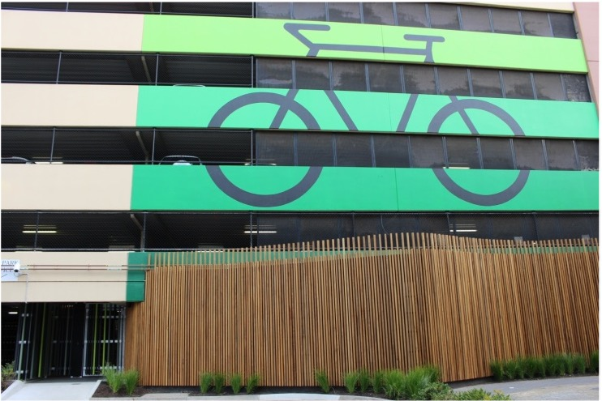
It is also secure and all users are registered. Its location near the car park office provides useful oversight and makes it feel safer for riders.
Everyone who applies for parking fills out the same form, whether they want a car park or a secure bike rack. This makes the option to ride visible to all staff.
People pay to use the facility – one dollar a week for entry and three to four dollars for a locker. In exchange their bike is secure and dry, they have a towel service, shampoo and hairdryers and plenty of space to store their clothes. And a great way to end their ride into work.
Converting 19 car spaces into bike parking now gives over 600 registered users secure parking and lockers.
Figure 37: Outside the shower and changing facilities
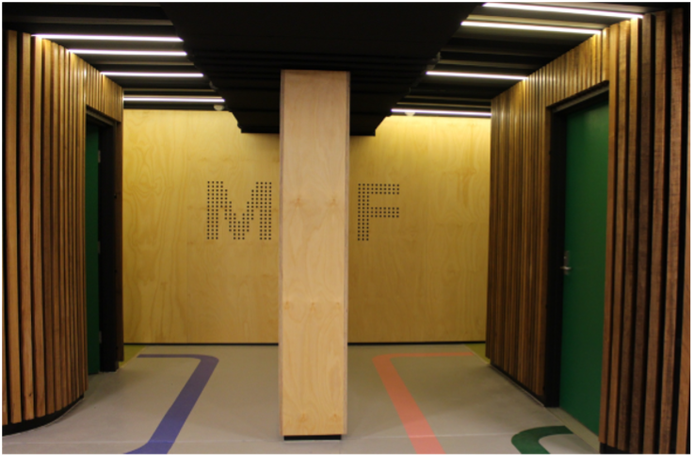

Highlights
- Fee for service – pre-tax charges for parking and lockers go back into operational costs and to procure more lockers
- Co-payment approach builds ownership and ensures high-demand lockers are being used
- Registered access makes the facility secure
- Easy application process makes it a visible option for all staff
- High quality facilities make it an attractive, feasible, and effortless option for staff to undertake active travel to and from work
- Regular evaluation from staff show high levels of satisfaction
Figure 38: Secure bike racks
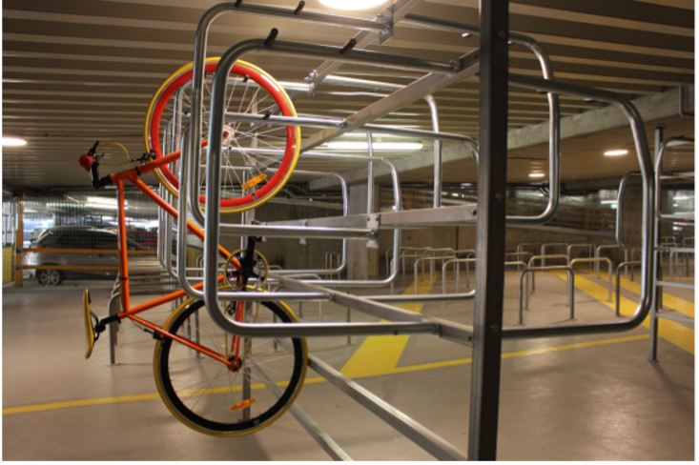

Attachment W: Example Myki commuter club policy (4.5)

Overview
The Rail Commuter Club arranges the purchase of 365-day passes for department paid employees at a discount, with the employee repaying the department through fortnightly salary deductions.
Myki passes can only be purchased by department employees for their own use. Cards cannot be purchased for relatives or friends. Only one myki pass is available to an employee each year.
All 365-day myki passes are non-transferable and are recorded on an internal database with the name, personnel number and address of the relevant employee.
A 365-day myki pass is available for metropolitan trains, trams and buses in the specified zones and on V/Line country trains and buses. All employees are bound by the Public Transport Victoria (PTV) terms and conditions and the myki terms of use. Please review these at:
- PTV website's Travelling on the network page <https://www.ptv.vic.gov.au/more/travelling-on-the-network>
- PTV website's Myki terms of use page <https://www.ptv.vic.gov.au/myki-terms-of-use>.

Purchasing a myki pass
When purchasing a new myki pass, you are agreeing to the terms and conditions of this policy and the terms and conditions set out by PTV.
Please ensure you are familiar with all information contained in this policy before completing the applicable myki application form. Submit the completed form to the Commuter Club Coordinator in line with the submission timeline.
The Commuter Club Coordinator must receive your myki application form by the 15th of the month before you need the myki pass. For example, if you need a pass in December, you must submit your completed application on or before 15 November.
Applications will be deemed late if received after the 15th of the month and will be processed in the following month. For example, an application received on 16 November would result in the pass not being available until January.

Renewing a myki pass
Card holders are solely responsible for their card and pass renewal. There are no automatic renewals and email reminders will not be sent.
To renew a pass, the myki application form must be completed and submitted each year.
Application forms to renew a myki pass must be submitted to the Commuter Club Coordinator by the 15th of the month before the existing pass is due to expire. For example, an application form would be submitted on or before the 15 November to renew a pass that was due to expire in December.
Applications to renew a pass will be deemed late if received after the 15th of the month and will be processed in the following month. For example, an application received on 16 November would result in the pass not being available until January.

Reload process and myki money
Your existing myki card issued from the Commuter Club will be automatically reloaded with 365 days’ travel from the date of expiry of your myki pass.
Please check the myki touch-on screen for verification as no written notification will be issued when the transaction has been completed.
Your myki card can store two myki passes at a time. This means that when your current myki pass is almost expired, you can purchase your next pass so it is ready to activate when you need it. Only one myki pass can be active at a time from the expired date of your old pass.
If your yearly myki pass has expired and you have to top up (with myki money) to travel, you must ensure the amount on your myki is always in the positive otherwise PTV will be unable to reload your yearly pass. You cannot choose to use myki money if you have a valid yearly myki pass on your card. A valid myki pass takes precedence over your personal myki money.

What are the costs?

Metropolitan myki pass
The department buys metropolitan myki cards at a 10 per cent discount on the standard 365-day pass price.
Note: the fortnightly cost to the employee includes a three per cent administration fee added by the department on top of the discounted price.
Please visit PTV website's Metropolitan fares page for current myki pass (365 day) fare amounts <https://www.ptv.vic.gov.au/tickets/fares/metropolitan-fares>.

V/Line myki pass
The 10 per cent discount does not apply to V/Line myki passes. However, V/Line myki passes offer 365 days’ travel at the rate of 325 days, offering the commuter 40 days of free travel.
Please visit the PTV website's Regional fares page for current myki pass (365 day) fare amounts <https://www.ptv.vic.gov.au/tickets/fares/regional-fares>.

Fortnightly payroll deductions
If a 365-day pass is ordered for March, the first deduction from your pay is the first payday in March. Deductions then continue for 26 pays in total. This is irrespective of when you first validate your card. The payroll deductions then automatically cease after 26 fortnights, unless a renewal pass is requested. If you renew your pass, payroll deductions restart at the current rate.
Although cards are inactive until validated, payroll deductions for the new or renewed pass start from the pay period in which the new pass is issued. Deductions continue for a period of 26 pays regardless of when the card is first validated.
If no salary is earned in any particular period, the amount which would have been deducted in that period will be deducted from the next or subsequent salary payment.
In the event of resignation, retirement or death, any outstanding balance owed will be recouped from the final payment accordingly.

Example payroll deduction calculations

Example 1: 365-day myki metro pass – Zone 1
- Retail price: $1,430.00
- Department discount: $143.00 (10% of retail)
- Discounted price: $1,287.00
- Administration fee (3%): $38.61
- Total cost to staff: $1,325.61
- Fortnightly pay deductions (total cost divided by 26 fortnights): $50.99 each fortnight.

Example 2: V/Line trip from Geelong to Southern Cross station
- 365-day myki V/Line pass price: $2,860.00
- Fortnightly pay deductions (pass price divided by 26 fortnights): $110.00 each fortnight.

Cancelling a metropolitan myki pass
Two weeks’ notice must be given when cancelling cards to enable the account to be finalised. With any card cancellation, the department must recover the outstanding cost of the card.
Cards that have been held for 293 days or more cannot be cancelled. You retain the card and pay the outstanding balance due. The discount is retained in this instance.
Cancellations are only available for passes held for less than 293 days because the discount rate on a Commuter Club myki pass means that you receive 365 days travel but only pay for 293 days. Therefore, the discount is redeemed and a cancellation cost is payable based on the used portion of the card being converted into the retail cost of days used as set by PTV.
Employees must notify the Commuter Club Coordinator to cancel their myki pass:
- email Rail Ticket <railticket@dhhs.vic.gov.au>.
To provide accurate cancellation costs, employees will need to give the Commuter Club Coordinator the following information:
- zone of pass
- actual expiry date of the pass (this information is provided on myki readers and myki checks) – note: your myki pass expires at 3 am on the date shown
- actual date the card will be returned to the department.
If any of these details change before the card is surrendered, the cancellation cost quoted will change.
The Commuter Club Coordinator will calculate the remaining balance of the rail ticket debt and a salary deduction will be made for any outstanding debt owed to the department. The Commuter Club Coordinator will confirm the amount owed and the pay period the deduction will take place.
Employees have two options available once the remaining rail ticket debt has been finalised:
- keep the myki pass and use the remaining travel balance or days
- apply to PTV for a refund of any remaining days.

Employees requesting a refund must either:
- apply for a refund online – PTV website’s Apply for a refund or reimbursement page <https://www.ptv.vic.gov.au/tickets/myki#refund-reimburse>
- contact PTV on 1800 800 007 between 6 am to midnight daily to arrange the refund.
When applying for a refund through PTV, the employee will need to provide PTV with the email confirming their refund request and the myki pass being refunded. Forward these to PTV at the following address:
- Myki Mailbox
Reply Paid 4318
Melbourne VIC 3000
For more information on refunds for myki passes:
- visit PTV website’s Refunds page <https://www.ptv.vic.gov.au/tickets/refunds-compensation-and-replacement-tickets/refunds>
- call PTV’s myki ticketing and retail services on 1300 951 182 (select option 3).

Cancelling a V/Line myki pass
Two weeks’ notice must be given when cancelling cards to enable the account to be finalised. With any card cancellation, the department must recover the outstanding cost of the card.
In the event of cancellation within the first 70 days, the 40 days’ free travel is lost and a cancellation cost is payable based on the used portion of the ticket being converted into the cost of total days used.
Employees must notify the Commuter Club Coordinator to cancel their myki pass:
- email Rail Ticket <railticket@dhhs.vic.gov.au>.
To provide accurate cancellation costs, employees will need to give the Commuter Club Coordinator the following information:
- zone of pass
- actual expiry date of the pass (this information is provided on myki readers and myki checks) – note: your myki pass expires at 3 am on the date shown
- actual date the card will be returned to the department.
If any of these details change before the card is surrendered, the cancellation cost quoted will change.
The Commuter Club Coordinator will calculate the remaining balance of the rail ticket debt and a salary deduction will be made for any outstanding debt owed to the department. The Commuter Club Coordinator will confirm the amount owed and the pay period the deduction will take place.
Employees have two options available once the remaining rail ticket debt has been finalised:
- keep the myki pass and use the remaining travel balance or days
- apply to PTV for a refund of any remaining days.
Employees requesting a refund must either:
- apply for a refund online – PTV website’s Apply for a refund or reimbursement page <https://www.ptv.vic.gov.au/tickets/myki#refund-reimburse>
- contact PTV on 1800 800 007 between 6 am to midnight daily to arrange the refund.
When applying for a refund through PTV, the employee will need to provide PTV with the email confirming their refund request and the myki pass being refunded. Forward these to PTV at the following address:
- Myki Mailbox
Reply Paid 4318
Melbourne VIC 3000
For more information on refunds for myki passes:
- visit PTV website’s Refunds page <https://www.ptv.vic.gov.au/tickets/refunds-compensation-and-replacement-tickets/refunds
- call PTV’s myki ticketing and retail services on 1300 951 182 (select option 3).

Lost or stolen card
In the event of a myki pass being lost or stolen, the easiest option is to call PTV on 1800 800 007 between 6 am and midnight.
The lost card will be blocked and a replacement card mailed to you within 10 business days, with the remaining balance transferred to your new card.
Alternatively, you can block a lost or stolen myki pass online and report your card as lost or stolen.
You can report your registered myki smartcard as lost or stolen by:
- logging into your myki account
- calling PTV on 1800 800 007
- visiting a PTV Hub
A replacement myki pass will be mailed to you. Replacements usually take up to 10 business days and include the remaining balance of the old card.
If you need to travel straight away, you will need to buy a new myki pass with your own money while you report your card as lost or stolen.
A credit for the cost of the new myki plus any balance on your registered lost or stolen myki pass will be transferred to the new myki pass within 14 business days.
Call PTV on 1800 800 007 for more details and help. The Commuter Club Coordinator does not have the authority to arrange a replacement card on your behalf. You will need to arrange the replacement with PTV.

Faulty card
If your myki card has stopped working, visit a staffed metropolitan station or myki-enabled V/Line station. They will give you a free replacement card of the same type. Your faulty card will be linked to the replacement card and any balance will be transferred as part of the replacement process.
Please call PTV on 1800 800 007 for more details and help. The Commuter Club Coordinator does not have the authority to arrange a replacement card on your behalf. You will need to arrange replacement with PTV.

Zone changes

Zone change from single zone to two zones
There are two options available to commuters in this scenario:
- cancel existing card and apply for a new card – note: this may incur cancellation costs
- keep your myki topped up with sufficient myki money to pay for travel outside your myki pass zone – for example, if you have a Zone 1 myki pass and travel in Zones 1 and 2, your myki pass covers the Zone 1 portion of your trip and myki money pays for the Zone 2 portion of your trip.

Zone change from zone 1 and 2 to single zone
To change a myki pass with zone 1 and 2 to a single zone, apply for a refund online to receive a refund for the reduced cost. See PTV website’s Apply for a refund or reimbursement page <https://www.ptv.vic.gov.au/tickets/myki#refund-reimburse>
Once the request has been lodged, you will need to complete a new myki application form for a single zone pass. Sent the completed application to the Commuter Club Coordinator (email Rail Ticket <railticket@dhhs.vic.gov.au>).
Your payroll deductions will be adjusted to account for the zone changes.

Reportable fringe benefits (FBT) implications
The myki pass is considered to be a loan fringe benefit. This is because the department pays for the card in full on purchase and the employee then repays the loan through salary deductions made throughout the year.
The taxable value of the loan is a deemed interest amount calculated according to a standard rate set by the Australian Taxation Office. Based on the value of most cards, the interest is less than $100 and is classed as a minor fringe benefit. As such it is not assessed for Fringe Benefits Tax (FBT) or for inclusion as a reportable fringe benefits amount on the employee's payment summary.
If employees have other reportable fringe benefits in the same year, the myki pass amount will be included in the employee's reportable fringe benefit amount if the taxable value of all their benefits is greater than $2,000.

More information
For more information and details, contact the Commuter Club Coordinator:
- call (03) 9096 2560
- email Rail Ticket <railticket@dhhs.vic.gov.au>.
Send your completed form:
- email Rail Ticket <railticket@dhhs.vic.gov.au>
- by mail to:
Commuter Club Coordinator
Payroll Business Support
Department of Health and Human Services
50 Lonsdale Street
Melbourne VIC 3000.

Attachment X: Carpooling program summary guide (4.6)

Introduction
A workplace carpooling program encourages staff to share the drive to work with two or more people in a car. This can help reduce workplace parking pressures.
It also has great benefits for employees, including:
- reduced commute costs (such as fuel, parking and tolls)
- workplace incentives and rewards like priority parking
- social connections.
Often there are informal arrangements among staff to carpool sometimes or regularly. Encourage these informal approaches in smaller workplaces. Larger workplaces (over 250 employees) have the opportunity to support more people to carpool by setting up a program that promotes and incentivises carpooling.
A successful carpooling program needs to be well promoted. Ride matching software (that matches participating staff by their home location and other characteristics) and other tools are useful but only when supported by workplace efforts to promote social activities for people to find carpool buddies and to be comfortable to carpool together.

The basics

Gauge interest in carpooling
Run a travel survey to find out:
- how many people may consider carpooling
- the proportion of staff arriving and departing at peak times
- staff home postcode data to analyse how many people may live near each other.
Use this information to assess whether a carpooling program has potential. Also use it in your promotions, for example, to highlight how many people travel to work from the same suburb.

Use incentives to make carpooling appealing
The most effective incentives involve a parking management arrangement, such as discounted fees or priority locations.
Other rewards programs for regular, ongoing carpooling are also useful.

Promote carpooling
Promote carpooling to staff who have flexibility in start and finish times to allow people to adjust their hours to fit in with their carpool buddy. It may also work well for some shift workers who are confident about regular start and finish times.

Promote carpooling and encourage social interactions for staff to find potential carpool buddies:
- set up a carpooling page on your internal social media or intranet
- hold carpooling morning teas or lunches to help people meet potential carpool buddies who travel from nearby areas.

Guaranteed ride home policy
Put in place a guaranteed ride home policy to reassure people who carpool that they will not be stuck if plans change unexpectedly. See Connect Macquarie Park’s guaranteed ride policy for an example.

Share tips
Share tips and etiquette for workplace carpooling. This will help set ground rules and reassure staff who share their car travel to work.

Carpooling resources
These resources will help you create a carpooling program. Adapt them to suit your organisation.
Connect Macquarie Park guaranteed ride home policy:
- available on Connect Macquarie Park website's Guaranteed ride home page <https://www.connectmpid.com.au/members-guaranteed-ride-home>
Connect Macquarie Park carpooling publicity toolkit:
- available on Connect Macquarie Park website's Car pooling publicity kit page <https://www.connectmpid.com.au/members-carpool-publicity-toolkit>
Connect Macquarie Park carpooling tips and etiquette:
- available on Connect Macquarie Park website's Carpooling tips and etiquette page <https://www.connectmpid.com.au/members-carpooling-tips-and-etiquette>.
New Zealand Transport Agency carpooling resources:
- available on New Zealand Transport Agency website's Carpooling resources page <https://www.nzta.govt.nz/resources/carpooling/carpooling.html>
- Includes the New Zealand Transport Agency carpooling guide.

Attachment Y: Example priority car parking policy (4.7)

Overview
This example has been adapted from a policy previously used by Queen Elizabeth II Medical Centre, Perth. It presents a way to prioritise parking access based on need. Categories and prioritisation could be adjusted to reflect different policy objectives and health service needs.

What you need to implement this policy
- Resources to manage and review permit applications to confirm that people meet the criteria for each priority group.
- Additional analysis of staff travel options for staff identified as not having public transport options and for ‘green commuters’ using other travel options for 60 per cent of their working week.
- Allocate designated parking areas for each permit priority group and manage compliance.
- Identify and manage a parking permit appeals process.
- A carpooling program in place as a complementary policy to reduce overall demand for car parking.

Introduction
The [Health Service] priority parking policy is designed to:
- categorise the various types of staff, patients and visitors that may park at the [Health Service]
- provide an equitable and transparent framework for assigning parking based on genuine need.

Definitions for the purpose of this policy
Term | Definition
Staff who start before 7 am or finish after 6:30 pm | Staff who are regularly required to start before 7 am or finish after 6:30 pm for work purposes.  Staff who have the option to work between 7 am and 6:30 pm but choose to work outside these hours for personal preference or other reasons not related to their employment will be deemed Priority group 3.
Staff on-call | An employee who receives an on-call allowance and is directed by their employer to remain readily available outside their normal hours of duty to return to their workplace at short notice.  On-call staff will be considered Priority group 1 for any days they are rostered to be on-call, subject to parking availability.
Volunteers | Volunteers will receive a parking permit to park in the designated staff parking areas.  A volunteer’s right to a parking permit is limited to periods when they are providing rostered volunteer services at [hospital site].
Courier and delivery vehicles | Short-term delivery vehicles that may use the signed, time-limited courier bays across the campus.
Contractors | Contractors working on campus on a temporary, short-term basis are not considered staff.
Service contractors | Contractors who regularly attend the campus on business days as part of an ongoing service contract of 12 months or more with a [Health Service] tenant are considered staff
Staff with demonstrated primary carer needs | A person who is principally responsible for providing most ongoing informal care or help to a child, or someone with disabilities or long-term health conditions but not under a service contract.
Green commuters | Someone who uses other transport (public transport, walk or ride a bike) for at least 60 per cent of their working days each week. They are entitled to park in the Green commuter car park.
Carpoolers | Carpooling is when two or more staff share a vehicle. They travel and arrive together at [hospital site].  Carpoolers must register with the parking department.  Carpoolers park in a dedicated car park, as directed by the parking department.
Staff whose journey to site is not serviced by public transport | Staff whose public transport journey to [hospital site] is shown to be not viable due to excessive travel time or lack of public transport availability, as identified on the Public Transport Victoria journey planner.
Staff who work between 7 am and 6:30 pm | Staff who work during the core hours of the day. They may be granted access to on-site parking if higher priority parkers have been granted access and there are still staff parking spaces available.  If the parking department determines there are empty spaces regularly available for only a proportion of staff who work between 7 am and 6:30 pm then access will be allocated based on the time differential of public transport and driving to [hospital site]. This is determined based on Public Transport Victoria’s journey planner and Google maps. This time differential will be determined for all Priority group 3 applications and preference will be given to applicants with the greatest differential.

Staff
For the purpose of this policy, staff means an employee of any [Health Service] tenant or sub tenant who spends a portion of their rostered hours working at the [insert hospital site].
Any staff member, regardless of their employer, may apply for a parking permit. All parking applications will be assessed against the priority groups.
All staff who wish to park on-site must apply for a parking permit on an annual basis.
Staff must display a valid [Health Service] staff car parking permit when parking at [hospital site]. This permit will have an annual expiry date. Staff are responsible for renewing their permits.
A staff parking permit does not guarantee the availability of a parking space.
Access granted by a staff parking permit is subject to change upon notice from the [Health Service] parking department.
Staff permits are not valid in the visitor car parks at any time.
Staff permits will be allocated to a specific vehicle nominated in the parking application.
A parking permit will be replaced in exceptional circumstances and will incur an administration fee of [$X].
Individual staff permits are not transferable between staff members or between vehicles

Priority groups
Access to parking for [Health Service] staff will be equitable and applied in a fair and transparent manner. In the event that the total number of parking spaces is less than the total demand for parking, access to parking will be restricted on the basis of priority of needs. Unsuccessful parking applications can be appealed.
Priority group 1, which will have access to designated parking areas, comprises:
- staff whose regular rostered shift requires them to start before 7:00am or finish after 6:30pm
- staff who are on-call
- medical consultants
- government and departmental vehicles
- volunteers during the periods when they are providing volunteer services
- couriers, laboratory and maintenance service contractor vehicles
- staff approved by the [Health Service] parking permit appeals committee.
Priority group 2, which will have access to designated parking areas, comprises:
- green commuters (they use other modes of travel at least 60 per cent of the working week)
- registered carpooling staff (at least two people arriving together)
- staff with demonstrated primary carer needs
- staff whose journey to site is not serviced by public transport.
Priority group 3, which will have restricted access to staff parking areas, comprises:
- staff who work between 7 am and 6:30 pm
- if insufficient car spaces – priority given to staff with the greatest time differential between driving and using public transport.

Students
Students attending [hospital site] are not automatically entitled to parking at the site, unless classified as staff.
Students are classified as staff when they hold a valid student card issued by a tertiary education institution recognised by [Health Service] and are undertaking [Health Service]-related activities at the site.
Students on placement at [Health Service] who start before 7 am or finish after 6:30 pm will be permitted to park on-site for the duration of their placement for the times they work between these hours as Priority group 1 staff.
Students on placement at [Health Service] who work between 7 am and 6:30 pm will be permitted to park on-site for the duration of their placement for the times they work between these hours as Priority group 3 staff.

Motorcycles and scooters
Designated motorcycle bays are allocated for motorcycle parking.
No parking fees are payable for motorcycles.
Staff motorcycle users must register with the parking department.

Approved staff parking permit appeals
[Health Service] staff who wish to appeal against the staff parking permit they have been assigned must complete a permit appeal form.
They must include a comprehensive reason for why they feel they should be issued a parking permit or why their priority level should be changed.
The permit appeal form must be approved by their manager.
The parking permit appeals committee will review the parking permit appeal.
A staff member can only appeal to the committee once unless there has been a significant change in circumstances since the first appeal.

Petrunoff N et al, 2015 Carrots and sticks vs carrots: Comparing approaches to workplace travel plans using disincentives for driving and incentives for active travel, Journal of Transport & Health

