‘How to get to…’ web page examples
4.1 – Sustainable transport in health care
Contents
Introduction 1
Tips for presenting access and transport information 1
Examples 2
Liverpool Hospital, Sydney 2
Queen Elizabeth II (QEII) Hospital, Perth 3

Introduction
Your health service website is often the first place a new employee, contractor or visitor finds information on how to travel to the hospital or health service. Google displays street addresses and travel times.
Your website needs to give people enough information to make their travel easy, no matter how they choose to travel.
If you only focus on car parking, most people will assume driving is the only option. Some people do not have access to a car. Presenting all options available helps people to decide what will work best for them.

Tips for presenting access and transport information
- Make travel information easy to find – have a prominent link on the homepage.
- Make sure your information is accessible to all people, including people with disabilities.
- Have one page on all travel options so that people can find and compare them. Do not have car parking in one section and all other transport options in another place.
- If you have a transport access guide, add it as another web page or as a download.
- Include a site map to show accessible entry points and location of facilities (such as car parks, secure bike parking and public transport stops).
- Include enough detail to make it easy for people. For example, if a bike cage has secure access, explain how to get access. Add walk times from nearby public transport or other destinations and include parking fees.

Examples

Liverpool Hospital, Sydney
- Liverpool Hospital website <https://www.swslhd.health.nsw.gov.au/liverpool>
‘Getting here’ is on the top level of website’s main navigation menu. This makes it easy for people to get to travel information from any page of the website, including the home page. Figure 1 shows this left-hand side menu being selected.
The ‘Getting here’ menu links to information for all travel options (such as cycling, public transport or driving).
The transport access guide (also a link in the ‘Getting here’ menu) shows walk times to major destinations, accessible access on-site and explains travel options.
Public transport stops and services are explained in detail, including access to different hospital entries, on Liverpool Hospital’s Public transport page <https://www.swslhd.health.nsw.gov.au/liverpool/public_transport.html>.
Figure 1: Main navigation menu on Liverpool Hospital's website
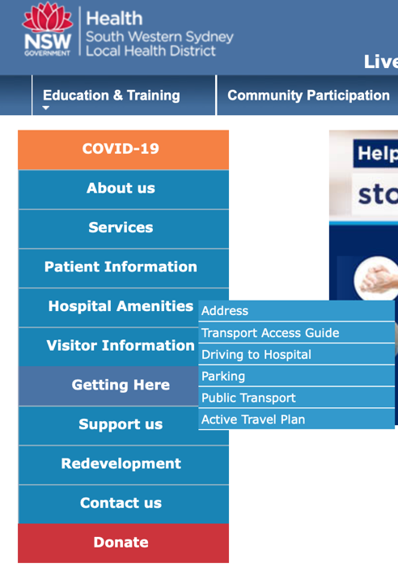

Queen Elizabeth II (QEII) Hospital, Perth
- QEII Hospital website https://qeiimc.health.wa.gov.au
- QEII Hospital's Parking and access page <https://qeiimc.health.wa.gov.au/travel-access>
Parking and access information has been given a prominent position on the home page (see Figure 2). ‘Parking and access’ appears in the first promotional tile immediately after the homepage welcome text.
‘Parking and access’ is also a top-level item in the main navigation menu (at the top of the website). This means that it is easy for people to get to travel information from any page of the website.
The Parking and access page highlights many options: ‘Parking’ (driving), ‘Bus’, ‘Taxi’ and ‘Cycle’ (see Figure 3).
The Parking and access section includes information for both staff and visitors.
Figure 2: QEII Hospital homepage
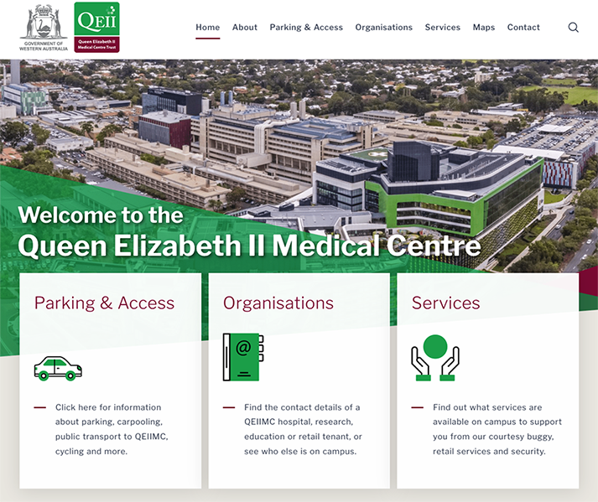
Figure 3: Promoted travel options
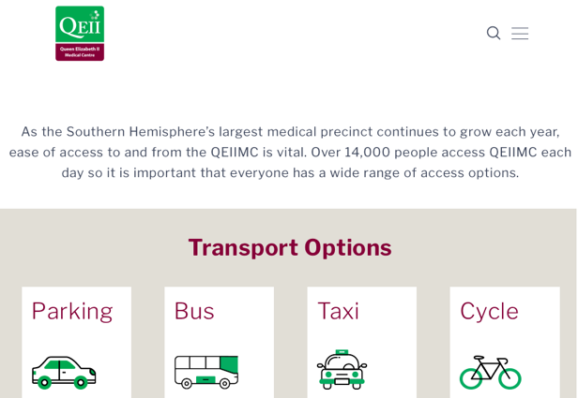

To receive this document in another format, phone 9595 2898, using the National Relay Service 13 36 77 if required, or email sustainability <sustainability@health.vic.gov.au>.
Authorised and published by the Victorian Government, 1 Treasury Place, Melbourne.
© State of Victoria, Australia, Department of Health, August 2022.
Refer to the main reference document ISBN 978-1-76096-951-6 (pdf/online/MS word)
Available at Department of Health website <www.health.vic.gov.au/sustainability>

