Keeping your rainwater tank safe from mosquitoes
Community information
Mosquitoes can breed in and around water tanks. Areas such as the rainwater tank inlets, overflows, gutters and roofs can pool water and make favourable mosquito breeding grounds. Mosquitoes can carry diseases, that can be passed on to people through mosquito bites . In Australia, some of these include Murray Valley encephalitis virus, Ross River virus and Barmah Forest virus. Mosquito borne diseases can make people ill and, in severe cases, can cause death.
Protect your rainwater tank from mosquito breeding by routinely maintaining your tank and ensuring it is sealed and fitted with mosquito-proof screens and/or flap valves on every opening, including overflows. You can use plastic or steel mesh around any pipes, valves or access points that mosquitoes can get through. Inlets and any overflows can be covered by a removable mesh or lid.
Type of mesh to use:
- Mesh should be no coarser than 1–1.5 mm gap per hole.
- Materials can include brass, copper, aluminium or bronze wire and, for removable mesh, you can use a plastic mesh substitute.
- For more information on meshing your tank, call a tank specialist or your local council’s environmental health unit via the Know Your Council website <https://knowyourcouncil.vic.gov.au>.
To prevent mosquitoes from breeding around your rainwater tank, i make sure gutters, pipes and outlets are self‑draining and not pooling water. Do regular maintenance checks such as:
- Check your first flush diverters every three months and for any signs of pooling around your rainwater tank.
- Conduct maintenance checks every six months:
- Check for holes or defects in any of the mosquito-proof meshing on your rainwater tank.
- Check for build-up of debris from animals or overhanging trees on your roof and in your gutters and remove this safely. Make sure there is no pooling of water left behind.
Degraded or unused rainwater tanks on your property can contain pools of water and openings for mosquitoes to breed in. When you no longer need your tank, have it professionally drained, cut up and removed to an appropriate waste disposal facility. Contact your local council for more information.

Ways to protect your rainwater tank from mosquito infestation diagram
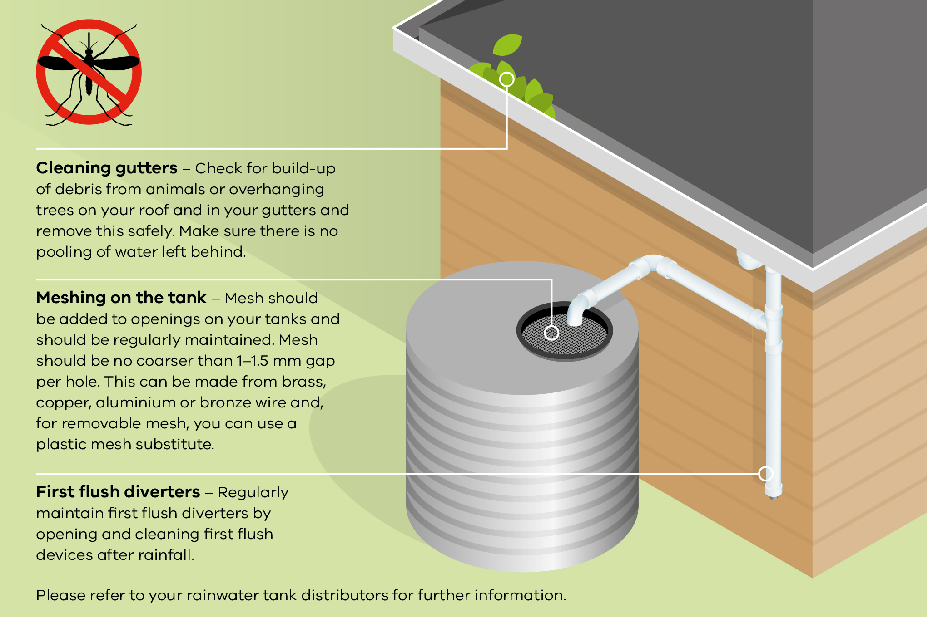
Cleaning gutters – Check for build-up of debris from animals or overhanging trees on your roof and in your gutters and remove this safely. Make sure there is no pooling of water left behind.
Meshing on the tank – Mesh should be added to openings on your tanks and should be regularly maintained. Mesh should be no coarser than 1–1.5 mm gap per hole. This can be made from brass, copper, aluminium or bronze wire and, for removable mesh, you can use a plastic mesh substitute.
First flush diverters – Regularly maintain first flush diverters by opening and cleaning first flush devices after rainfall.
Please refer to your rainwater tank distributors for further information.

First flush diverter diagram
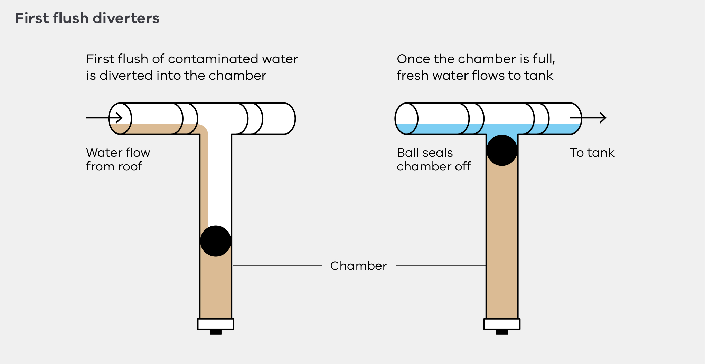

More information
See the Protect yourself from mosquito-borne disease webpage <https://www.betterhealth.vic.gov.au/protect-yourself-mosquito-borne-disease > for information on how to protect yourself from mosquitoes.
Contact the Department of Health, Water Unit on 1300 761 874 or email the Water Unit <Water@health.vic.gov.au>.
If you have any concerns about your health, see your doctor or call NURSE-ON-CALL on 1300 60 60 24.
Contact your local council via the Know Your Council website <https://knowyourcouncil.vic.gov.au>.
To receive this document in another format, phone 1300 761 874, using the National Relay Service 13 36 77 if required, or email the Water Unit <Water@health.vic.gov.au>.
Authorised and published by the Victorian Government, 1 Treasury Place, Melbourne.
© State of Victoria, Australia, Department of Health, May 2022. (DH 2205216)
ISBN 978-1-76096-414-6 (pdf/online/MS word)
Available from the Raintwater page on the Department of Health Website <https://www.health.vic.gov.au/water/private-drinking-water>

