Proposals for revisions to Agency Information Management System (AIMS) for 2024–25
October 2023
OFFICIAL

To receive this document in another format, email HDSS help desk <HDSS.helpdesk@health.vic.gov.au>.
Authorised and published by the Victorian Government, 1 Treasury Place, Melbourne.
© State of Victoria, Australia, Department of Health, October 2023.
Available at HDSS annual changes < https://www.health.vic.gov.au/data-reporting/annual-changes>

Contents
Executive summary 4
Introduction 5
Orientation to this document 5
Proposal 3: Amend Urgent Care Centre form – expand scope to include reporting from all Small Rural Health Services (SRHSs) 6
Proposal withdrawn 10

Executive summary
Each year the Department of Health reviews the Agency Information Management System (AIMS) to ensure that the data collection supports the department’s business objectives, including national reporting obligations, and reflects changes in hospital funding and service provision arrangements for the coming financial year.
To avoid duplication, the department has prepared a separate Proposals document that details proposals relating to items reported in more than one data collection. The Proposals for revisions across multiple data collections (AIMS, ESIS, VAED, VEMD, and VINAH) for 2024-25 must be considered alongside the Proposals for revisions to the Agency Information Management System (AIMS) for 2024-25.
The proposed revisions for the AIMS for 2024-25 include:
- Amend Urgent Care Centre form – expand scope to include reporting from all SRHSs.
The proposed revisions across multiple data collections (including AIMS) for 2024-25 include:
- New and amended streams – Victorian Respiratory Support Service (VRSS) Program [AIMS, VINAH]

Introduction
This document is intended to invite comment and stimulate discussion on the proposals outlined. Health services and software vendors should review this document and assess the feasibility of the proposals. Written feedback must be submitted using the online feedback form by 5.00pm Friday 20 October 2023.
This proposal document and the online feedback form are available at HDSS annual changes <https://www.health.vic.gov.au/data-reporting/annual-changes>
Specifications for revisions to the AIMS for 2024-25 will be published later and may include additions, amendments or removal of information in this document.

Orientation to this document
- New data elements are marked as (new).
- Changes to existing data elements are highlighted in green
- Redundant values and definitions relating to existing elements are struck through.
- Comments relating only to the proposal document appear in [square brackets and italics].
- New validations are marked ###
- Validations to be changed are marked * when listed as part of a data element or below a validation table.
- Anticipated changes are shown under the appropriate manual section headings.

Proposal 3: Amend Urgent Care Centre form – expand scope to include reporting from all Small Rural Health Services (SRHSs)
It is proposed to Expand the scope of reporting to the AIMS Urgent Care Centre data collection to include all Small Rural Health Services (SRHSs) with an Urgent Care Centre (UCC), in lieu of those sites reporting Urgent Care Centre activity on the AIMS S10: Acute Non-Admitted Clinic Activity form.
Proposed by Commissioning and System Improvement Division, Department of Health
Reason for proposed change
Currently, all SRHSs complete the AIMS S10 form to report all their non-admitted activity data, including UCC activity. The S10 form reports total presentations by patient payment status, but not detailed information eg ‘triage category’ and ‘departure status’, which are reported on the Urgent Care Centre form (see image of Urgent Care Centre webform, below). The data reported on the S10 form does not meet the national reporting requirements for Emergency Department presentations (ABF Aggregate Emergency Service Care - Data Request Specifications).
Because of the limited data on the AIMS S10 form, all SRHS UCC activity submitted to IHACPA is manually classified as non-admitted triage category level 5 which is among the Urgency Disposition Group (UDG) classes with the lowest price weights. This conservative classification means Victoria is potentially foregoing earned Commonwealth funding due to inability to classify UCC activity to the correct UDG class as delivered by the SRHS.
The department’s limited data on UCC activity is also a barrier for funding policy and classification development. Improved reporting from SRHS is a key deliverable under the transition to the National Funding Model, a key department priority.
The AIMS Urgent Care Centre form is already used by activity-based funding (ABF) funded health services with a UCC so expanding its use to SRHSs will promote consistency across all health services with UCCs.
The change represents a minimal increase in burden on SRHSs. The AIMS Urgent Care Centre form will require more time to complete compared to the S10 form. The department understands SRHSs may be already collecting this information for their own records in line with best practice, however if not, staff may need to change data collection practices, and to familiarise themselves with the details of the new form. The AIMS manual provides information on completing the Urgent Care Centre form. No changes should be needed to SRHSs’ systems, as the Urgent Care Centre is an AIMS webform.
An AIMS Urgent Care Centre form image is below, along with a list of campuses proposed to start reporting UCC activity via the Urgent Care Centre form in lieu of reporting only on the S10 form.

Existing AIMS Urgent Care Centre form:
Imag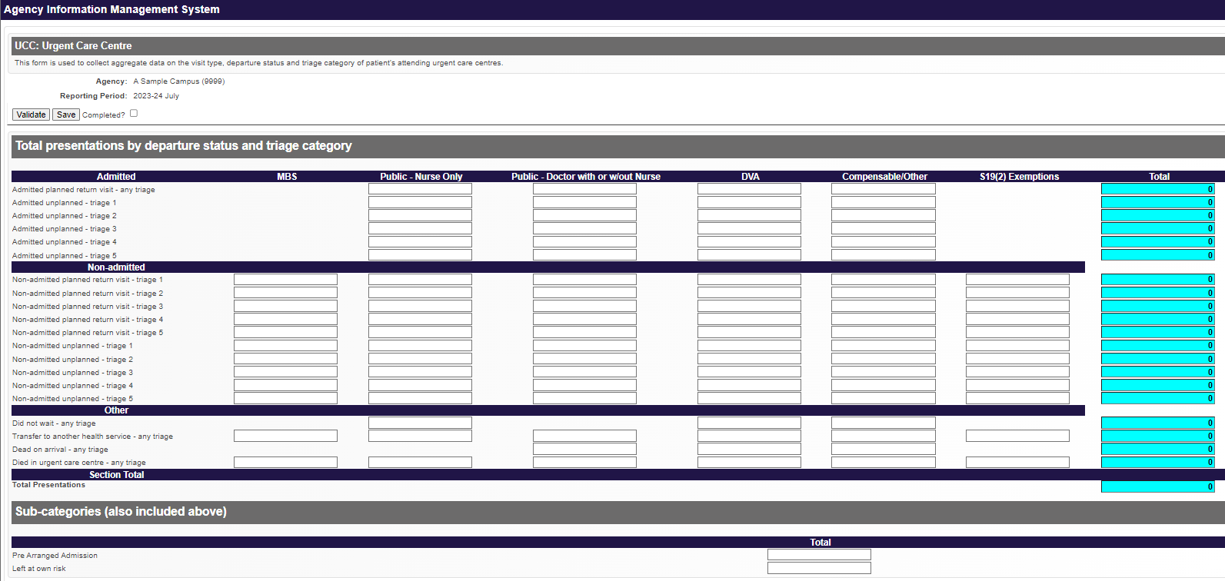

The following SRHSs are proposed to report Urgent Care activity using the AIMS Urgent Care Centre form in lieu of reporting UCC activity only to the S10 form from 1.7.2024:
Alexandra District Hospital
Alpine Health (Bright)
Alpine Health (Mount Beauty)
Alpine Health (Myrtleford)
Beaufort & Skipton Health Service (Beaufort)
Beaufort & Skipton Health Service (Skipton)
Beechworth Health Service
Boort District Health
Casterton Memorial Hospital
Cobram District Hospital
Cohuna District Hospital
Creswick District Hospital
Daylesford District Hospital
East Wimmera Health Service (Birchip)
East Wimmera Health Service (Charlton)
East Wimmera Health Service (Donald)
East Wimmera Health Service (St Arnaud)
East Wimmera Health Service (Wycheproof)
Edenhope and District Memorial Hospital
Heathcote Health
Hesse Rural Health Service (Winchelsea)
Heywood Rural Health
Inglewood and District Health Service
Kerang District Health
Kooweerup Regional Health Service
Kyneton District Health Service
Lorne Community Hospital
Maldon Hospital
Mallee Track Health and Community Service (Ouyen)
Mallee Track Health and Community Service (Sea Lake)
Manangatang and District Hospital
Mansfield District Hospital
Moyne Health Services (Port Fairy)
Nathalia District Hospital
Numurkah and District Health Service
Omeo District Health
Orbost Regional Health
Otway Health (Apollo Bay)
Robinvale District Health Services
Rochester and Elmore District Health Service
Rural Northwest Health (Hopetoun)
Rural Northwest Health (Warracknabeal)
Seymour District Memorial Hospital
South Gippsland Hospital (Foster)
South West Healthcare (Camperdown)
Tallangatta Health Service
Terang and Mortlake Health Service (Terang)
The Kilmore and District Hospital
Timboon and District Healthcare Service
Upper Murray Health and Community Services (Corryong)
West Wimmera Health Service (Dunmunkle)
West Wimmera Health Service (Jeparit)
West Wimmera Health Service (Kaniva)
West Wimmera Health Service (Nhill)
West Wimmera Health Service (Rainbow)
Western District Health Service (Coleraine District Health Service)
Yarram and District Health Service
Yarrawonga District Health Service
Yea and District Memorial Hospital

Existing S10 form on which UCC activity is currently reported by all sites with a UCC:
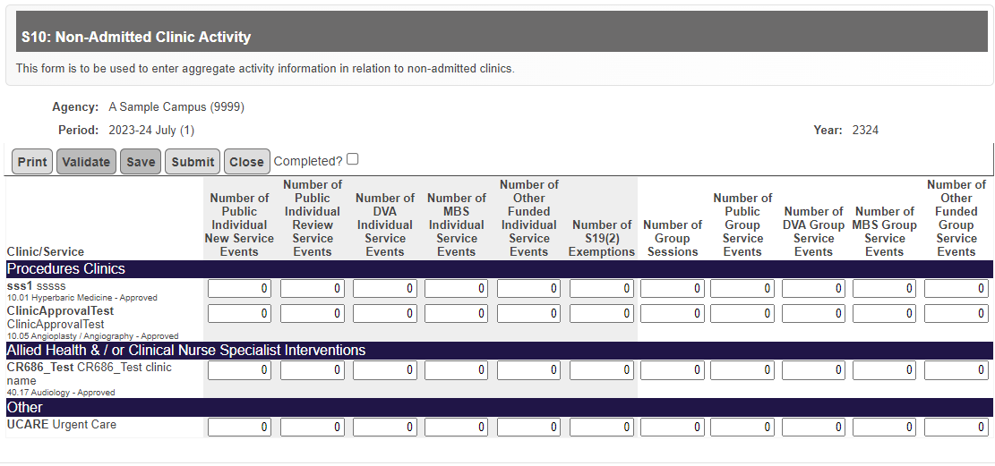

Proposal withdrawn
The following proposal was withdrawn after advice from Safer Care Victoria was conveyed to the proposer.
Proposal 4 Amend Statutory Duty of Candour data collection
The proposed change is not in line with Safer Care Victoria’s data requirements from this data collection.

