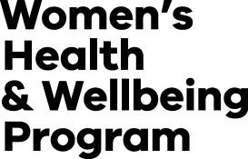

Inquiry into Women’s Pain
OFFICIAL

Privacy Collection Notice
The Department of Health (the Department) is inviting written submissions from the Victorian community and stakeholders for the purposes of informing the Inquiry into Women’s Pain in Victoria (Inquiry). The Inquiry will provide an opportunity for the experiences of girls 12 years and over and women to be heard and acknowledged, report on these experiences and inform the Inquiry’s understanding of systemic issues and solutions that will form the basis for recommendations to improve existing models of care and healthcare service delivery for girls and women in Victoria.

The Department is committed to protecting your privacy as part of this process. The Department will collect and handle your information in accordance with the requirements of the Privacy and Data Protection Act 2014 (Vic), Health Records Act 2001 (Vic) and Public Records Act 1973 (Vic).

Your submission will be kept confidential. Submissions will not be responded to individually. The Department may contact you for further details if necessary to process your submission but will only do so if you have agreed to be contacted in the Submission Form.
The Department acknowledges the need to protect privacy of minors. Accordingly, if you are under the age of 18, the Submission Form should be completed by a parent or legal guardian.
The submissions will be aggregated and analysed to generate summaries of key findings for the purposes of the Inquiry report and recommendations.
You are not asked to provide identifying information in your submission. Any identifying information you do provide, such as names, health service providers, contact details, will not be shared or used in reporting. You are asked not to include any identifying information relating to other individuals.
The Department will not attempt to link any unit-level data collected from submissions with any other unit-level data.
De-identified and aggregated information from submissions may be shared with third-party analysts for the purposes of informing the Inquiry. Identifiable personal information will not be shared with third party analysts.
Quotes or excerpts from responses may be used in the Inquiry public report and other materials used by the Department and other departments and agencies in the Victorian Government to support the Women’s Health and Wellbeing Program - https://www.health.vic.gov.au/public-health/womens-health-wellbeing-program. The Department will take all reasonable steps to de-identify any quotes or excerpts used. (Note that individual researchers, groups and organisations who expressly wish and consent to have their name appear with quotes or excerpts from their submissions used in public reports, may indicate this in the Submission Form.)
For more information on the Department’s collection and handling of personal and health information, please refer to the department’s privacy policy at https://www.health.vic.gov.au/department-of-health-privacy-policy.
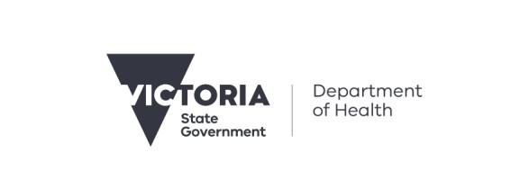
The Department can be contacted by emailing WomensHealth@health.vic.gov.auYou may contact the department to request access to any personal information that the department holds about you. You can also

contact the Department’s Privacy Unit by emailing privacy@health.vic.gov.au or by telephone on 1300 024 759.
Please note that once you provide your submission, you will be unable to change the information you have provided. We ask that you please read your submission carefully before submitting it.
By providing your submission, you acknowledge that you have read and understood all the information detailed in this collection notice and agreed to provide your submission.

To receive this document in another format email
<pph.communications@health.vic.gov.au>
Authorised and published by the Victorian Government, 1 Treasury Place, Melbourne.
© State of Victoria, Australia, Department of Health, Month 2024.

