Breast cancer in Victoria
Optimal care pathway data summary report 2021
OFFICIAL

To receive this document in another format, phone (03) 9456 3332, using the National Relay Service 13 36 77 if required, or email the Cancer Support, Treatment and Research unit <cancerplanning@health.vic.gov.au>.
Authorised and published by the Victorian Government, 1 Treasury Place, Melbourne.
© State of Victoria, Australia, Department of Health, May 2023.
ISBN 978-1-76096-993-6 (pdf/online/MS word)
Available at the department’s cancer webpage <www.health.vic.gov.au/health-strategies/cancer-care>.

Foreword
This report summarises the data analyses prepared for the Breast Cancer Summit, which took place online on Friday 23 July 2021. There were approximately 96 people in attendance and 85 active participants.
The Breast Cancer 2021 Summit is a newly activated tumour stream of the Victorian Tumour Summits, which are clinician-led forums to review analyses of routine datasets and identify unwarranted variations in tumour-based clinical practice and cancer outcomes. We were honoured to co-chair the Breast Cancer Summit Working Group, which was convened to guide the analyses of state-wide routine datasets to understand the current patterns of care for Victorians with breast cancer. The summit facilitates dialogue about quality of care and variations in clinical care, informs priority actions to address variations, and supports state-wide, tumour-based clinician engagement and leadership.
We thank members of the working group and participants of the summit for their time, effort, active contributions and their support throughout the summit process. We also acknowledge Norah Finn and Ella Stuart who undertook the analyses of the linked dataset.

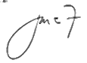

Ms Jane Fox
Co-chair, Breast Cancer Summit
Dr Belinda Yeo
Co-chair, Breast Cancer Summit

Contents
List of figures 6
List of tables 7
Acknowledgements 8
Introduction 9
More information 9
Data sources 10
Linked dataset 10
Other data sources 11
At a glance 12
Key findings 12
Key variations for action 14
Incidence and demographics of DCIS and invasive breast cancer 15
Clinical commentary – incidence and demographics of DCIS and invasive breast cancer 16
Diagnosis pathway 17
Stage at diagnosis 17
Diagnosis through BreastScreen Victoria 18
Grade at diagnosis 19
Histological subtype at diagnosis 21
Multidisciplinary meeting 23
Clinical commentary – multidisciplinary meeting 23
Treatment of invasive breast cancer and DCIS 24
Breast surgery 24
Chemotherapy 32
Adjuvant radiotherapy 37
Survival 42
De novo metastatic breast cancer 43
Demographics of metastatic breast cancer 43
Grade and subtype of metastatic breast cancer 43
Survival of metastatic breast cancer 44
Supportive care 46
Male breast cancer 47
Incidence, demographics, and tumour characteristics 47
Abbreviations 48
Victorian Integrated Cancer Services 48
Glossary 49
Supplementary material 51
Codes 51

List of figures
Figure 1: Age-standardised incidence rate of invasive breast cancer by socioeconomic quintiles (n = 13,375) 16
Figure 2: Stage at diagnosis of screen-detected and non–screen detected invasive breast cancer and DCIS (N = 8,832) 19
Figure 3: Proportion of invasive breast cancer patients with documented evidence of an MDM in their medical record, by ICS and campus of treatment (N = 465) 23
Figure 4: Proportion of DCIS and invasive breast cancer patients that received breast surgery (mastectomy or breast-conserving surgery) within one year of diagnosis, by stage at diagnosis (N = 15,312) 24
Figure 5: Proportion of early breast cancer patients whose first treatment was surgery, who received surgery within five weeks of diagnosis, by surgical campus (N = 10,287) 26
Figure 6: Time from diagnosis to surgery for early breast cancer patients, by hospital type 26
Figure 7: Annual volume of breast surgery (mastectomy and breast-conserving surgery) for DCIS and invasive breast cancer, by hospital campus and hospital type (N = 6,092) 28
Figure 8: Proportion of early breast cancer patients who had a reconstruction after mastectomy, by ICS of residence and age group (under 65 years old and over 65 years old) 30
Figure 9: Chemotherapy utilisation within one year of invasive breast cancer diagnosis, by stage at diagnosis (N = 13,375) 32
Figure 12: Proportion of surgically treated early breast cancer patients who received neoadjuvant chemotherapy, by ICS of surgery campus (N = 11,867) 33
Figure 13: Surgery type used to treat early breast cancer patients who received neoadjuvant chemotherapy 34
Figure 10: Time from surgery to chemotherapy for early breast cancer patients (N = 3,581) 35
Figure 11: Proportion of early breast cancer patients who had chemotherapy within 28 days of surgery, by histological subtype (N = 3,442) 36
Figure 14: Radiotherapy utilisation by stage at diagnosis for DCIS and invasive breast cancer (N = 15,312) 37
Figure 15: Time from surgery to adjuvant radical radiotherapy for early breast cancer patients (N = 3,953) 39
Figure 16: Proportion of early breast cancer patients who had adjuvant radiotherapy within 56 days of surgery (N = 3.953) 40
Figure 17: Victorian radiotherapy centre average yearly volume for DCIS and invasive breast cancer (N = 3,645) 40
Figure 18: Five-year relative survival of invasive breast cancer, by ICS of residence 42
Figure 19: Hazard ratios of five-year survival, by ICS of residence compared with the Victorian average, adjusted for age and comorbidities 45
Figure 20: Proportion of invasive breast cancer patients with documented evidence of supportive care screening in their medical record by ICS and campus of treatment (N = 465) 46

List of tables
Table 1: Demographics of invasive breast cancer and DCIS patients (n = 15,312) 15
Table 2: Stage at diagnosis for invasive breast cancer (n = 13,375) 17
Table 3: Stage at diagnosis of invasive breast cancer, by ICS of residence (N = 12,039) 17
Table 4: BreastScreen Australia participation rate and BreastScreen Victoria–detected diagnosis rate for invasive breast cancer and DCIS, by ICS of residence (N = 6,323) 18
Table 5: Grade at diagnosis of invasive breast cancer and DCIS (N= 15,312) 20
Table 6: Grade at diagnosis of invasive breast cancer by screen-detection status (N = 7,927) 20
Table 7: Grade at diagnosis of DCIS diagnoses by screen-detection status (N = 1,422) 20
Table 8: Subtype at diagnosis of invasive breast cancer (N = 11,896) 22
Table 9: Proportion of invasive breast cancer and DCIS breast cancer that had axillary surgery, by stage at diagnosis (N = 15,312) 25
Table 10: Median time to surgery and proportion of early breast cancer patients who had surgery within 30, 35 and 40 days of diagnosis, by hospital type (N = 10,287) 27
Table 11: Early breast cancer patient flow for mastectomy (N = 3,737) 27
Table 12: Summary of annual volume of breast surgery for DCIS and invasive breast cancer (N = 6,092) 28
Table 13: Number and proportion of early breast cancer patients who had a reconstruction after mastectomy (N = 3,737) 29
Table 14: Timing of reconstruction for early breast cancer patients diagnosed in 2016, by ICS of residence (N = 505) 30
Table 15: Early breast cancer patient flow for reconstruction (N = 1,335) 31
Table 16: Proportion of surgically treated early breast cancer patients who received neoadjuvant chemotherapy, by histological subtype 33
Table 17: Early breast cancer patient flow for radiotherapy (N = 7,964) 38
Table 18: Demographics of de novo metastatic breast cancer patients (N = 1,147) 43
Table 19: Grade and subtype of de novo metastatic breast cancer (N = 1,147) 44
Table 20: Unadjusted absolute survival for de novo metastatic breast cancer, by ICS of residence (N = 1,147) 44
Table 21: Demographics of male breast cancer (n = 139) 47
Supplementary Table 1: Breast cancer diagnosis codes 51
Supplementary Table 2: Surgical procedure codes used to identify patients who underwent mastectomy, breast-conserving surgery, biopsy or reconstruction 51
Supplementary Table 3: Diagnosis, procedure and diagnosis related group codes used to identify patients who received chemotherapy 52

Acknowledgements
The data, analysis and commentary provided in this report represent a joint effort by key contributors from the following groups.
Team | Membership
Breast Cancer Summit Working Party | Miss Caroline Baker  Dr Rob Blum  Ms Karen Botting  Ms Andrea Cannon  Dr Jill Evans  Prof. Sue Evans  Ms Gillian Kruss  Prof. Bruce Mann  A/Prof. Paul Mitchell  Dr Inger Olesen  Dr Liu-Ming Schmidt  Dr Karen Taylor  Dr Michelle White
Data analysis | Ms Norah Finn  Ms Ella Stuart
Victorian Tumour Summits Project Team | Ms Lori Cameron  Ms Diana Fayle  Ms Rebecca Miller  Ms Janine Scott  Ms Sam Whitcher
We also gratefully acknowledge the providers of the Victorian Cancer Registry data, Victorian Admitted Episodes Dataset and the Victorian Radiotherapy Minimum Dataset, as well as the Centre for Victorian Data Linkage for performing the linkages between the Victorian Cancer Registry and administrative datasets.
To view the Breast summit data presentation and related documents, visit the Breast Summit meeting webpage <https://www.tumoursummits.org.au/breast>.

Introduction
The data presented in this report are a summary of the analyses prepared for the 2021 Breast Cancer Summit. The Breast Cancer Summit is part of the Victorian Tumour Summits program, an initiative of the Victorian Integrated Cancer Services (ICS) delivered in collaboration with the Department of Health and Cancer Council Victoria. The summits support the broader program of work of implementing the optimal care pathways (OCPs).
The Breast Cancer Summit was held online via a four-hour Zoom session on 23 July 2021 with 85 participants in attendance. In this summit, data were presented on cancer care and outcomes for breast cancer patients that were diagnosed between 2016 and 2018.

More information
- Find out more about the Breast Cancer Summit from the Victorian Tumour Summits website <https://www.tumoursummits.org.au/breast>.
- The breast cancer OCP can be viewed and downloaded from the Cancer Council Australia website <www.cancer.org.au/OCP>.

Data sources

Linked dataset

Datasets
The Victorian Cancer Registry (VCR) is a population-based cancer registry that collects demographic and tumour details, including diagnosis date and region of residence, for all Victorian residents who are diagnosed with cancer. The department’s Centre for Victorian Data Linkage performs an annual data linkage between the VCR and administrative datasets including the Victorian Admitted Episodes Dataset (VAED), the Victorian Radiotherapy Minimum Data Set (VRMDS) and the Victorian Death Index. Linking the VCR to the VAED provides information captured within the inpatient setting in all Victorian public and private hospitals such as patient diagnoses (for example, comorbidities, distant metastases) and cancer treatment, including surgery and intravenous chemotherapy (excluding oral chemotherapy). Linking the VCR to the VRMDS provides information on admitted and non-admitted radical and palliative radiotherapy courses provided in Victorian public and private radiotherapy centres. Unless otherwise specified, the data source used for the report analyses was the linked dataset for female breast cancer patients diagnosed between 2016 and 2018.

Patient selection
The VCR was used to identify female Victorian residents aged 18 years or older with a primary diagnosis of breast cancer or ductal carcinoma in situ (DCIS) (refer to Supplementary Table 1) between 2016 and 2018. Patients whose cancer diagnosis was notified to the VCR by death certificate only (2016–2018, n = 81, see glossary for definition) were excluded. When a person was diagnosed with two or more incident breast cancers or DCIS during the study period, the record of the earliest diagnosis was retained (53 patients with more than one diagnosis). Male breast cancer patients were excluded from the main component of the analysis (2016–2018, n = 139), although a high-level summary was provided on these patients. For metastatic breast cancer patients, the diagnosis timeframe was expanded to diagnoses between 2014 and 2018 to capture a larger cohort of patients.
Using hormone receptor status (identified through the VCR), breast cancer patients were grouped into histological subtypes (luminal, human epidermal growth factor receptor 2 [HER2] amplified, triple-negative, or unclassified). Patients were also classified as having early breast cancer or metastatic breast cancer based on their stage at diagnosis (refer to the glossary for more information).

Data limitations
Victorians with cancer living in HRICS may receive treatment in New South Wales (Albury) hospitals, which is not captured in the VAED. Therefore, variables in this report that are derived using the VAED (comorbidity count, distant metastases, surgery and chemotherapy) are likely to be underestimated for Victorians living in HRICS. Table and figure footnote text highlight where this limitation may apply. This limitation does not affect the VCR (including death notification from Births Deaths and Marriages Registry) or the VRMDS data collections.
The VCR captures data on screen-detected breast cancers, but this was limited to tumours identified through BreastScreen Victoria (BSV) participation. Therefore, tumours identified through BreastScreen Australia in another state, or identified through private screening, would not be identified as screen-detected tumours in the VCR data. Metastatic disease recorded in the VCR data only reliably captures metastatic breast cancer at diagnosis (de novo metastatic breast cancer) and does not include data on all patients initially treated for earlier stage breast cancer and who later progress or relapse.

Other data sources
In addition to the linked dataset, this report includes data from the following sources:
- Victorian Cancer Statistics, Cancer Council Victoria <http://vcrdata.cancervic.org.au> includes Victorian breast cancer incidence data from 1982 to 2018.
- The Cancer Services Performance Indicator (CSPI) medical record audit 2018 collected data such as multidisciplinary meetings (MDM) use from the medical records of a random sample of cancer patients treated across 43 Victorian hospitals. There were 465 breast cancer patients audited across 35 campuses (30 public and five private).
- The Australian Institute of Health and Welfare website <https://www.aihw.gov.au/reports/cancer-screening/national-cancer-screening-programs-participation/data> contains screening participation rates in BreastScreen Australia from 1 July 2014 to 30 June 2019.
- The Estimated Resident Population, Australian Bureau of Statistics (ABS) <https://explore.data.abs.gov.au/> website includes data on estimated resident population by Statistical Area 2.

At a glance

Key findings

Incidence and demographics of DCIS and invasive breast cancer
- Between 2016 and 2018, there were 1,972 incident cases of DCIS and 13,375 incident cases of invasive breast cancer across Victoria.
  - The median age at diagnosis was slightly higher for breast cancer (62 years old) compared with DCIS (59 years old).
  - Approximately 23 per cent of women diagnosed were in the least disadvantaged socioeconomic status (SES) quintile.
  - More than 80 per cent of women had no comorbidities.

Diagnosis pathway
- Most invasive breast cancer diagnoses were stage 1 or 2 (39 and 37 per cent respectively).
- 51 per cent of all diagnoses were detected through BSV.
- A higher proportion of BSV-detected tumours were DCIS or stage 1 (72 per cent of BSV-detected cancers were stage 1, compared with 41 per cent for non–BSV detected).
- For invasive breast cancer, of those detected by BSV a higher proportion were low grade tumours and a lower proportion were high grade tumours compared with non–BSV detected tumours.
- For invasive breast cancer, 79 per cent were luminal, 12 per cent were HER2-amplified, and 9 per cent were triple-negative.

Multidisciplinary meeting
- From the CSPI medical record audit on diagnoses in 2018, 84 per cent of patients had documented evidence of MDM recommendations in the central medical record .
- Nearly all metro campuses reached the 85 per cent target, whilst several regional campuses fell short of this target.

Treatment: breast surgery
- Most (> 90 per cent) patients with DCIS or a stage 1 to 3 breast cancer diagnosis had surgical treatment within a year of diagnosis.
- Breast-conserving surgery was more common for DCIS, stage 1 and stage 2 cancers (72 per cent, 79 per cent and 60 per cent respectively).
- Most (> 94 per cent) of early breast cancer patients had lymph node biopsy or dissection.
- Across Victoria, 83 per cent of early breast cancer patients whose first treatment was mastectomy or breast-conserving surgery were treated within five weeks of diagnosis. There was variation across campuses, and time to treatment was generally slower for patients treated at public campuses compared with private campuses.
- A higher proportion of women from metropolitan ICS had a reconstruction following mastectomy (at least 41 per cent in metropolitan ICS compared with less than 29 per cent in regional ICS).

Treatment: neoadjuvant chemotherapy
- Across Victoria, 10 per cent of surgically treated early breast cancer patients received neoadjuvant chemotherapy, with variation between ICS.
- Neoadjuvant chemotherapy use was highest for surgically treated HER2 and triple-negative breast cancer (29 and 30 per cent respectively) and lowest for surgically treated luminal breast cancer (5 per cent).

Treatment: adjuvant chemotherapy
- Chemotherapy use was most common following a stage 3 diagnosis, with 76 per cent of these patients treated with chemotherapy.
- Of the surgically treated early breast cancer patients who had adjuvant chemotherapy, only 22 per cent started chemotherapy within four weeks of surgery (OCP recommendation).

Treatment: adjuvant radiotherapy
- Radiotherapy utilisation varied between stage at diagnosis, ranging from 37 per cent for DCIS to 79 per cent for stage 3 breast cancer.
- Most (84 per cent) patients had radiotherapy at a centre within their ICS of residence.
- 66 per cent of early breast cancer patients had radiotherapy within eight weeks of surgery (OCP recommendation).

Survival
- The five-year relative survival for invasive breast cancer patients diagnosed between 2014 and 2018 was 91.0 (95 per cent confidence interval [CI]: [90.5–91.6]), with survival statistically higher in NEMICS with 93 per cent relative survival (95 per cent CI: [92.0–94.0]).

De novo metastatic breast cancer
- From 2014 to 2018, there were 1,147 incident cases of de novo metastatic breast cancer across Victoria.
  - The median age at diagnosis was 64 years old.
  - A quarter of Victorian women with de novo metastatic breast cancer were in the most disadvantaged SES quintile.
  - 78 per cent did not have comorbidities.
- The tumour grade at diagnosis for de novo metastatic breast cancer was 2 per cent low-grade, 22 per cent intermediate-grade and 28 per cent high-grade.
- The subtype at diagnosis for de novo metastatic breast cancer was 49 per cent luminal, 14 per cent HER2-amplified, and 9 per cent triple-negative.
- The five-year unadjusted absolute survival for de novo metastatic breast cancer patients diagnosed from 2014 to 2018 was 38 per cent (95 per cent CI: [34–42]).

Supportive care screening
- From the CSPI medical record audit 2018, 54 per cent of women had documented evidence of supportive care screening.

Male breast cancer
- From 2016 to 2018, there were 139 incident cases of male breast cancer across Victoria.
  - The median age at diagnosis was 72 years.
  - 22 per cent of men diagnosed were in the most disadvantaged SES quintile.
  - 76 per cent of men had no comorbidities.
  - 92 per cent of cases were invasive breast cancer, and 8 per cent were DCIS.

Key variations for action
- There is variation in the proportion of patients with documented evidence of MDM recommendations for treatment in the central medical record, between and within ICS. Several campuses and regional areas did not reach the target for documented evidence set at 85 per cent.
- There is variation in documented evidence of supportive care screening across and within ICS. The average across Victoria was 54 per cent, lower than the target of 80 per cent.
- There is variation in timeliness of care:
  - From diagnosis to surgery: Less than 76 per cent of patients had surgery within the target of 35 days from diagnosis (73 per cent for public patients, 93 per cent for private patients).
  - From surgery to adjuvant chemotherapy: 22 per cent of patients had chemotherapy within the target of four weeks, 69 per cent within six weeks.
  - From surgery to radiotherapy: 66 per cent of patients had radiotherapy within the target of eight weeks.
- Those with lived experience identified inconsistency in the content and the way information was provided at diagnosis and during treatment.
- Those with lived experience identified inconsistency in overall coordination of care.

Incidence and demographics of DCIS and invasive breast cancer
- From 2016 to 2018, there were 1,972 incident cases of DCIS and 13,375 invasive breast cancer cases in women across Victoria (Table 1). A breakdown of demographics for de novo metastatic breast cancer is presented in Table 18.
  - The median age at diagnosis was 59 years old for DCIS and 62 years old for invasive breast cancer.
  - For women diagnosed with DCIS and invasive breast cancer, 23 and 22 per cent respectively were in the least disadvantaged SES quintile.
  - 88 per cent of DCIS and 82 per cent of invasive breast cancer did not have comorbidities (identified in the period one year prior to, through to one month after diagnosis).
- The age-standardised incidence rate of invasive breast cancer across Victoria was 90.4 per 100,000 (95 per cent CI: [88.8–92.0]) (Figure 1).
  - Incidence increased with increasing SES (from 84 per 100,000 for women in the most disadvantaged SES quintile to 98 per 100,000 for women in the least disadvantaged SES quintile).
Table 1: Demographics of invasive breast cancer and DCIS patients (n = 15,312)
Variable | Level | DCIS  (n = 1,972), N (%) | Invasive breast cancer  (n = 13,375), N (%)
Age, median [IQR] | N/A | 59 [51–67] | 62 [51–71]
Socioeconomic status | Disadvantaged (Q1) | 325 (17%) | 2,507 (19%)
Socioeconomic status | Middle (Q2–Q4) | 1,174 (61%) | 7,873 (59%)
Socioeconomic status | Affluent (Q5) | 438 (23%) | 2,993 (22%)
Comorbidity count (VAED derived 1 year prior; 1 month after diagnosis; Quan 2011; excl. cancer) | 0 | 1,709 (88%) | 11,032 (82%)
Comorbidity count | 1 | 176 (9%) | 1,553 (12%)
Comorbidity count | 2+ | 52 (3%) | 790 (6%)
Figure 1: Age-standardised incidence rate of invasive breast cancer by socioeconomic quintiles (n = 13,375)
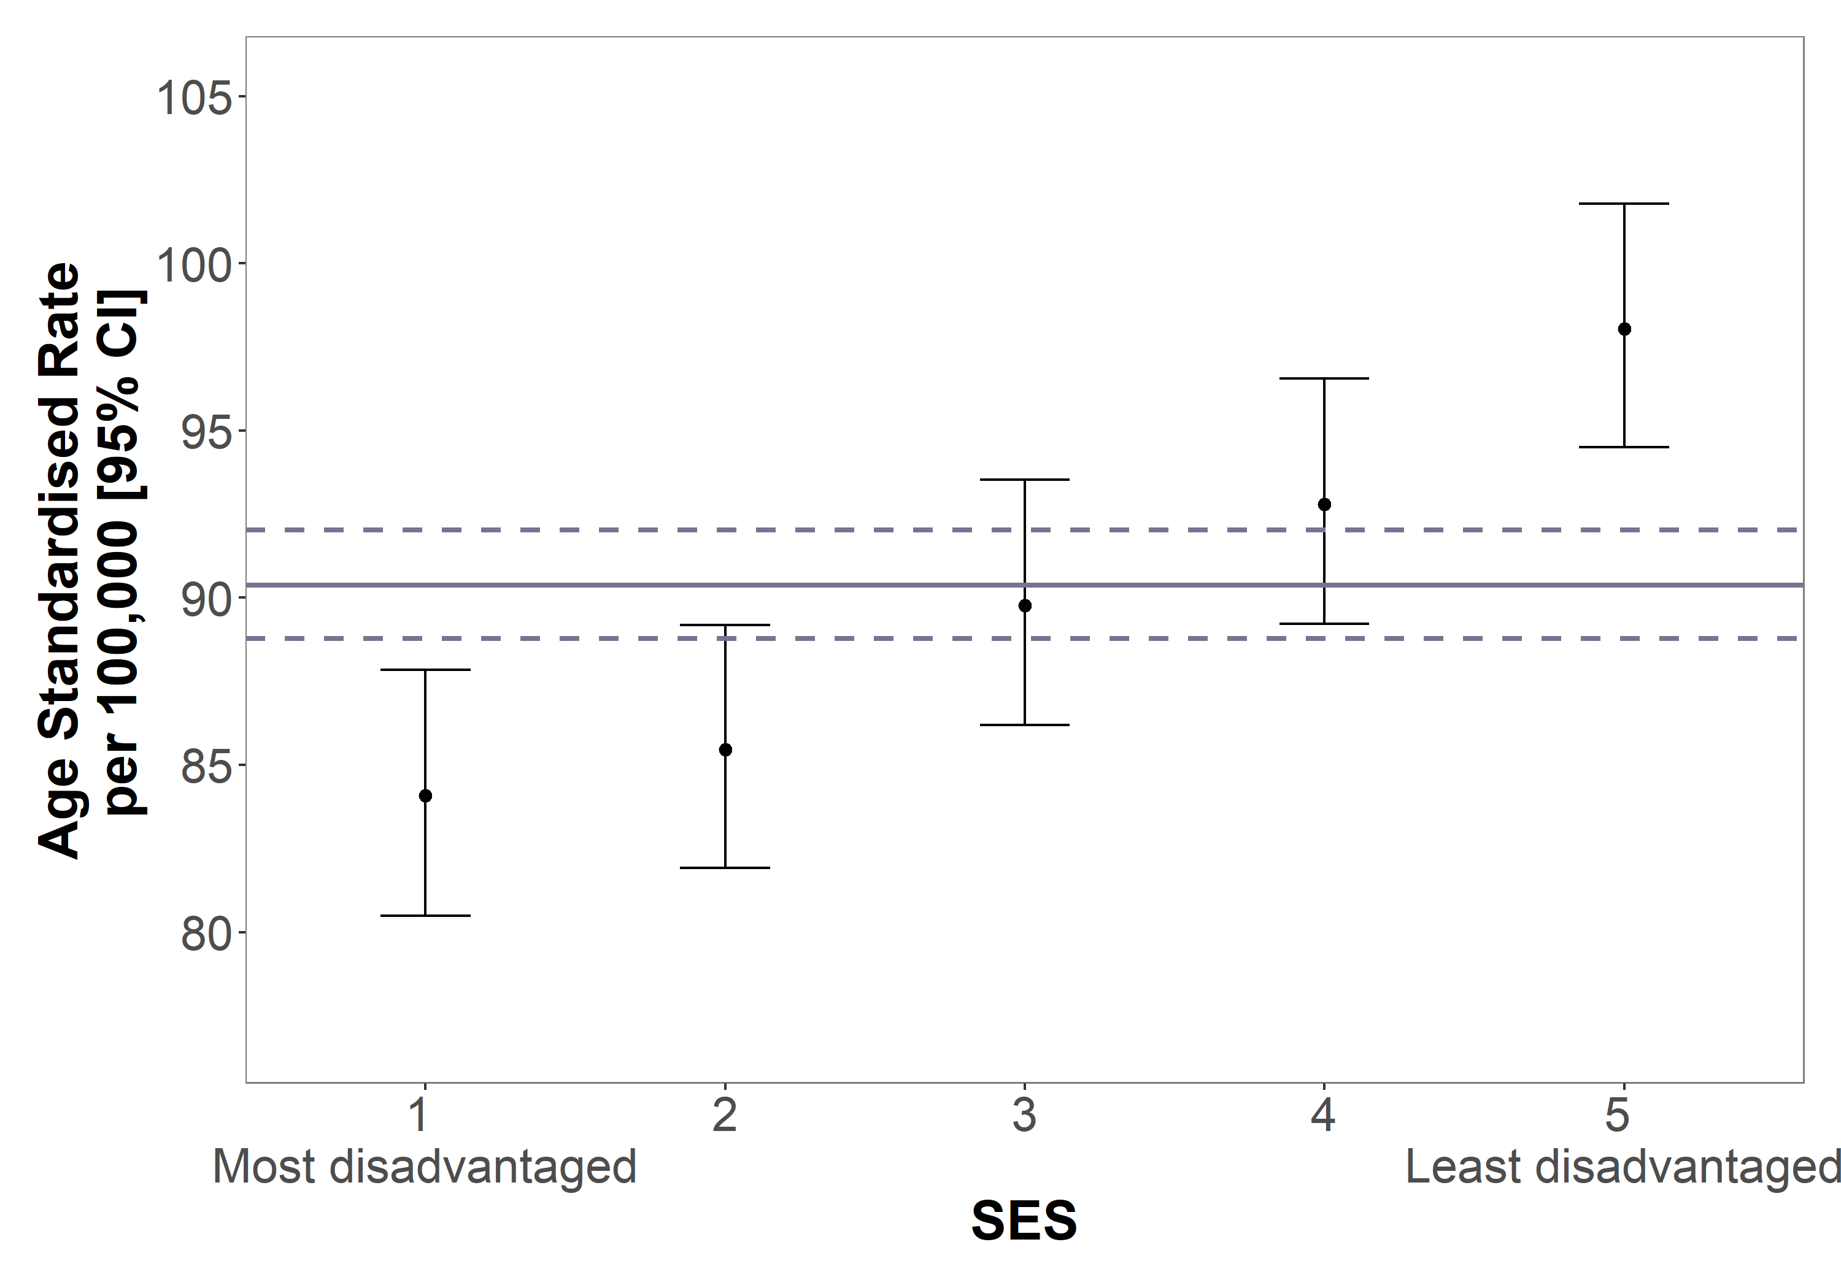
Data source: VCR; ABS population data
Standardised to the World Standard Population.
SES based on Statistical Area 2 at diagnosis.

Clinical commentary – incidence and demographics of DCIS and invasive breast cancer
Female invasive breast cancer primarily affects late-middle age women (median age 62) and is in part a disease of affluence, with an almost linear relationship between socioeconomic advantage and incidence rate of breast cancer. This is likely due to multiple factors including higher rates of screening in people of higher SES and potentially lifestyle factors associated with affluence.

Diagnosis pathway

Stage at diagnosis
- Across Victoria between 2016 and 2018, 76 per cent of female invasive breast cancers were diagnosed as stage 1 or 2 (Table 2).
- Stage at diagnosis varied significantly by ICS of residence (Table 3).
  - The proportion of patients that were stage 1 at diagnosis ranged from 37 to 47 per cent.
  - The proportion of patients that were stage 3 at diagnosis ranged from 6 to 13 per cent.
Table 2: Stage at diagnosis for invasive breast cancer (n = 13,375)
Stage at diagnosis | Invasive breast cancer  (n = 13,375), N (%)
I | 5,248 (39%)
II | 5,007 (37%)
III | 1,096 (8%)
IV (de novo metastatic) | 688 (5%)
Unknown | 1,336 (10%)
Stage derived from VCR. Updated to stage 4 where metastatic disease codes are present in a VAED admission within one month prior and four months post diagnosis.
Table 3: Stage at diagnosis of invasive breast cancer, by ICS of residence (N = 12,039)
ICS of residence | Stage I | Stage II | Stage III | Stage IV
NEMICS, N = 3,056 | 44% | 41% | 10% | 5%
SMICS, N = 3,228 | 45% | 42% | 8% | 5%
WCMICS, N = 2,248 | 43% | 41% | 10% | 6%
BSWRICS, N = 873 | 43% | 43% | 8% | 6%
GRICS, N = 691 | 47% | 41% | 6% | 6%
HRICS, N = 674 | 45% | 42% | 8% | 5%
LMICS, N = 774 | 40% | 40% | 13% | 7%
GICS, N = 495 | 37% | 47% | 10% | 6%
Victoria, N = 12,039 | 44% | 42% | 9% | 6%
Excludes unknown stage at diagnosis

Diagnosis through BreastScreen Victoria
- Across Victoria from 1 July 2016 to 30 June 2018, 54 per cent of women aged 50 to 75 years old participated in Breast Screen Australia (Table 4).
  - Participation was higher in regional ICS, where participation ranged from 54 to 60 per cent, compared with metropolitan ICS, which ranged from 51 to 55 per cent.
- In this same period, 51 per cent of all diagnoses (DCIS and invasive breast cancer) were detected through BSV.
  - The proportion of diagnoses that were BSV-detected ranged from 48 per cent in SMICS to 55 per cent in BSWRICS.
- 72 per cent of screen-detected tumours were stage 1 or DCIS, compared with 41 per cent of non–screen detected tumours (Figure 2).
Table 4: BreastScreen Australia participation rate and BreastScreen Victoria–detected diagnosis rate for invasive breast cancer and DCIS, by ICS of residence (N = 6,323)
ICS of residence | Total diagnoses | Screen-detected diagnoses | % of total diagnoses detected through BSV | BreastScreen Australia participation rate
NEMICS | 1,571 | 803 | 51% | 55%
SMICS | 1,720 | 834 | 48% | 52%
WCMICS | 1,131 | 571 | 50% | 51%
BSWRICS | 456 | 251 | 55% | 60%
GRICS | 381 | 197 | 52% | 57%
HRICS (West) | 204 | 101 | 50% | 55%*
LMICS | 439 | 225 | 51% | 58%
GICS | 251 | 129 | 51% | 57%
Victoria | 6,153 | 3,111 | 51% | 54%
Data source: VCR, financial years 2016–17 to 2017–18
Screening participation from BreastScreen Australia.
BSV-detected rates only reported for HRICS West.
Includes women aged 50 to 75 years old.
*BreastScreen Australia participation rates for Hume include all of HRICS (HRICS East and West).

Figure 2: Stage at diagnosis of screen-detected and non–screen detected
invasive breast cancer and DCIS (N = 8,832)
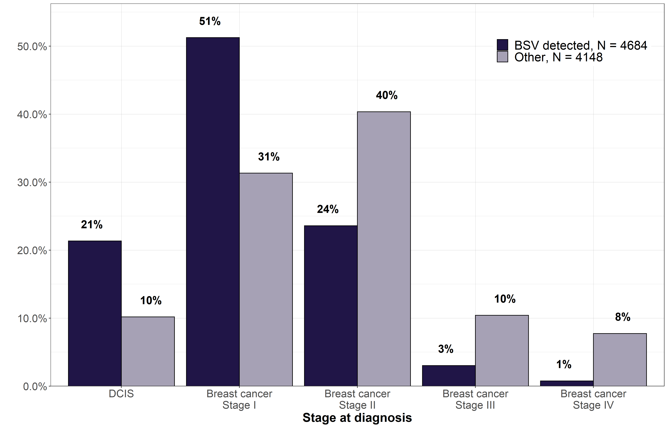
Excludes women from Hume East.
Includes women aged 50 to 75 years old.
Screen-detected diagnoses include tumours identified through BSV only.

Grade at diagnosis
- Across Victoria, from 2016–2018, 71 per cent of women diagnosed with invasive breast cancer had grade 2 or 3 tumours (Table 5).
  - 36 per cent of DCIS and 14 per cent of invasive breast cancer did not have a recorded grade.
- For invasive breast cancer, grade at diagnosis varied for BSV and non–BSV detected tumours (Table 6).
  - A lower proportion of BSV-detected cancers were high grade at diagnosis (21 per cent of BSV-detected compared with 33 per cent of non–BSV detected).
  - A higher proportion of BSV-detected cancers were low grade at diagnosis (25 per cent of BSV-detected compared with 11 per cent of non–BSV detected).
- For DCIS, 23 per cent of non–BSV detected cancers were high grade, compared with 40 per cent for screen-detected DCIS (Table 7). However, there was a higher proportion of diagnoses with unknown grade for non–BSV detected cancers.
Table 5: Grade at diagnosis of invasive breast cancer and DCIS (N= 15,312)
Grade | DCIS  (n = 1,937), N (%) | Invasive breast cancer  (n = 13,375), N (%)
Grade 1: Low | 164 (8%) | 1,981 (15%)
Grade 2: Intermediate | 436 (23%) | 5,513 (41%)
Grade 3: High | 645 (33%) | 3,989 (30%)
Unknown | 692 (36%) | 1,892 (14%)
Table 6: Grade at diagnosis of invasive breast cancer by screen-detection status (N = 7,927)
Grade | BSV-detected (n = 3,756) | Non–BSV detected (n = 4,171)
Grade 1: Low | 25% | 11%
Grade 2: Intermediate | 48% | 40%
Grade 3: High | 21% | 33%
Unknown | 6% | 16%
Excludes women from Hume East.
Excludes diagnoses where recorded stage was unknown.
Includes women aged 50 to 75 years old.
Screen-detected diagnoses include tumours identified through BSV only.
Table 7: Grade at diagnosis of DCIS diagnoses by screen-detection status (N = 1,422)
Grade | BSV-detected (n = 1,000) | Non–BSV detected (n = 422)
Grade 1: Low | 7% | 12%
Grade 2: Intermediate | 23% | 22%
Grade 3: High | 40% | 23%
Unknown | 30% | 43%
Excludes women from Hume East.
Excludes diagnoses where recorded stage was unknown.
Includes women aged 50 to 75 years old.
Screen-detected diagnoses include tumours identified through BSV only.

Clinical commentary – diagnosis pathway
Most women diagnosed with breast cancer were diagnosed at an early stage where the intent of treatment is curative. The data for stage and grade at diagnosis had some limitations:
- The data for metastatic disease was limited to those with metastatic disease at diagnosis (de novo metastatic breast cancer) and did not include women who were initially treated for an early stage cancer and later relapsed.
- Some women had no grade and/or stage at diagnosis available in the VCR data. Reasons for this data being unavailable included:
  - patient had systemic treatment before the surgical procedure
  - patient had conservative management or alternative treatment to surgery after imaging (noting imaging data is not captured in the VCR)
  - pathology was only available from metastatic disease tissue
  - no grade reported on core biopsy (or not reported as Scarff-Bloom-Richardson (SBR) grade)
  - no pathology report received (hospital notification only).
The data on screen-detected cancers had some limitations in that it only included those screened by BSV. Cancers were not identified as screen-detected where they were diagnosed through other BreastScreen Australia centres, or through private screening (for example, asymptomatic women who were referred for breast imaging outside of BreastScreen, perhaps because of mammographic density, family history or benign breast changes). Approximately 20 per cent of BreastScreen-detected cancer were DCIS, and this percentage has been stable across many jurisdictions over a long period. DCIS, when detected by screening, tends to be intermediate or high grade (63 per cent), given that low-grade DCIS is often diagnosed incidental to other pathology and often does not present with any imaging abnormalities. As expected, we see from the data that more aggressive cancers are likely to be symptomatic and less likely to be screen-detected.

Histological subtype at diagnosis
Understanding the subtypes of a breast cancer diagnosis can help guide decisions about which treatments are most suitable. Patients were grouped into three subtypes (luminal, HER2-amplified, and triple-negative) based on whether their breast cancer was positive or negative for oestrogen receptor (ER), progesterone receptor (PR) and HER2. In Australia, an immunohistochemistry (IHC) score of 3+ (HER2 positive) is insufficient to classify a patient as HER2-amplified, and an additional in situ hybridisation (ISH) test is required for patients to be able to receive treatment as a HER2-amplified diagnosis. Refer to the Glossary for further details of the subtypes.
Histological subtype varied slightly between early and metastatic breast cancer (Table 8).
- 79 per cent of early breast cancer diagnoses were classified as luminal compared with 69 per cent of metastatic breast cancer diagnoses.
- 129 of the 551 early breast cancer diagnoses that could not be classified had IHC3+ but no ISH test results recorded. Twenty-one of the 186 metastatic breast cancer diagnoses that could not be classified had IHC3+ but no ISH test results recorded.
Table 8: Subtype at diagnosis of invasive breast cancer (N = 11,896)
Histological subtype | Early breast cancer | Metastatic breast cancer
Luminal | 9,050 (79%) | 348 (69%)
HER2-amplified | 1,317 (12%) | 93 (19%)
Triple-negative | 1,027 (9%) | 61 (12%)
Unable to be classified | 551 | 186
Excludes diagnoses where recorded stage was unknown.
Excludes diagnoses unable to be classified into subtype: 551 early breast cancer (5 per cent) and 186 metastatic breast cancer (27 per cent).
HER2-amplified must be confirmed by ISH.

Clinical commentary – histological subtype at diagnosis
As expected, most women were diagnosed with luminal breast cancer. Many clinicians tend to estimate HER2-amplified as around 20 per cent of all diagnoses, but this figure of 12 per cent is consistent with what is reported in many populations. A small number of patients (129 early breast cancers and 21 metastatic breast cancers) had IHC3+ but no ISH test results recorded. This resulted in little overall change in the subtype distribution whether the definition of HER2-amplified included or excluded ISH test confirmation.

Multidisciplinary meeting
From the CSPI medical record audit on diagnoses in 2018, 84 per cent of patients audited across Victoria had documented evidence of MDM recommendations for treatment in the central medical record (Figure 3).
Nearly all campuses within metropolitan ICS reached the target of 85 per cent, but there was greater variation across regional campuses.
Figure 3: Proportion of invasive breast cancer patients with documented evidence of an MDM in their medical record, by ICS and campus of treatment (N = 465)
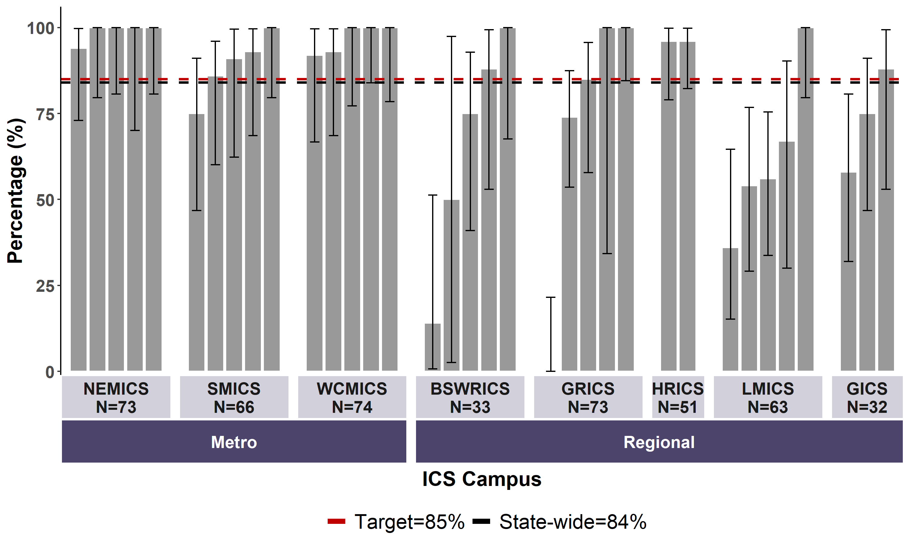
Data source: CSPI medical record audit 2018
Bars represent 95 per cent CI.
Includes patients with a diagnosis of invasive breast cancer.
Includes 35 campuses: 30 public and five private hospitals.

Clinical commentary – multidisciplinary meeting
There were some campuses in regional ICS with low MDM participation rates, but overall the statewide rate was just at the target rate. It is important to note that the patients audited were patients diagnosed in 2018. From 2020, there was more online delivery of MDMs due to the COVID-19 pandemic, potentially allowing for greater participation, particularly for remote areas. Timing of MDMs may be interesting to consider because it is not uncommon for early breast cancer patients to have an MDM discussion after surgery because the surgical pathology may inform the discussion.

Treatment of invasive breast cancer and DCIS

Breast surgery

Breast surgery utilisation
- The majority (> 90 per cent) of DCIS and stage 1 to 3 diagnoses had surgical treatment within a year of diagnosis (Figure 4).
  - For DCIS, stage 1 and stage 2 cancers, 72 per cent, 79 per cent and 60 per cent respectively had breast-conserving surgery.
  - For stage 3 cancers, more patients were treated with mastectomy than breast-conserving surgery (66 per cent compared with 28 per cent).
- For stage 4 cancers, 26 per cent were treated with surgery, with slightly more patients treated with mastectomy than breast-conserving surgery (14 and 11 per cent respectively).
- For those with unknown stage at diagnosis, 57 per cent had surgery, split equally between mastectomy and breast-conserving surgery (29 and 28 per cent respectively).
- Utilisation of lymph node biopsy and/or dissection varied based on stage at diagnosis (Table 9).
  - Over 94 per cent of stage 1 to stage 3 diagnoses had either a lymph node biopsy or lymph node dissection, compared with stage 4 and DCIS with 28 and 27 per cent respectively
Figure 4: Proportion of DCIS and invasive breast cancer patients that received breast surgery (mastectomy or breast-conserving surgery) within one year of diagnosis, by stage at diagnosis (N = 15,312)
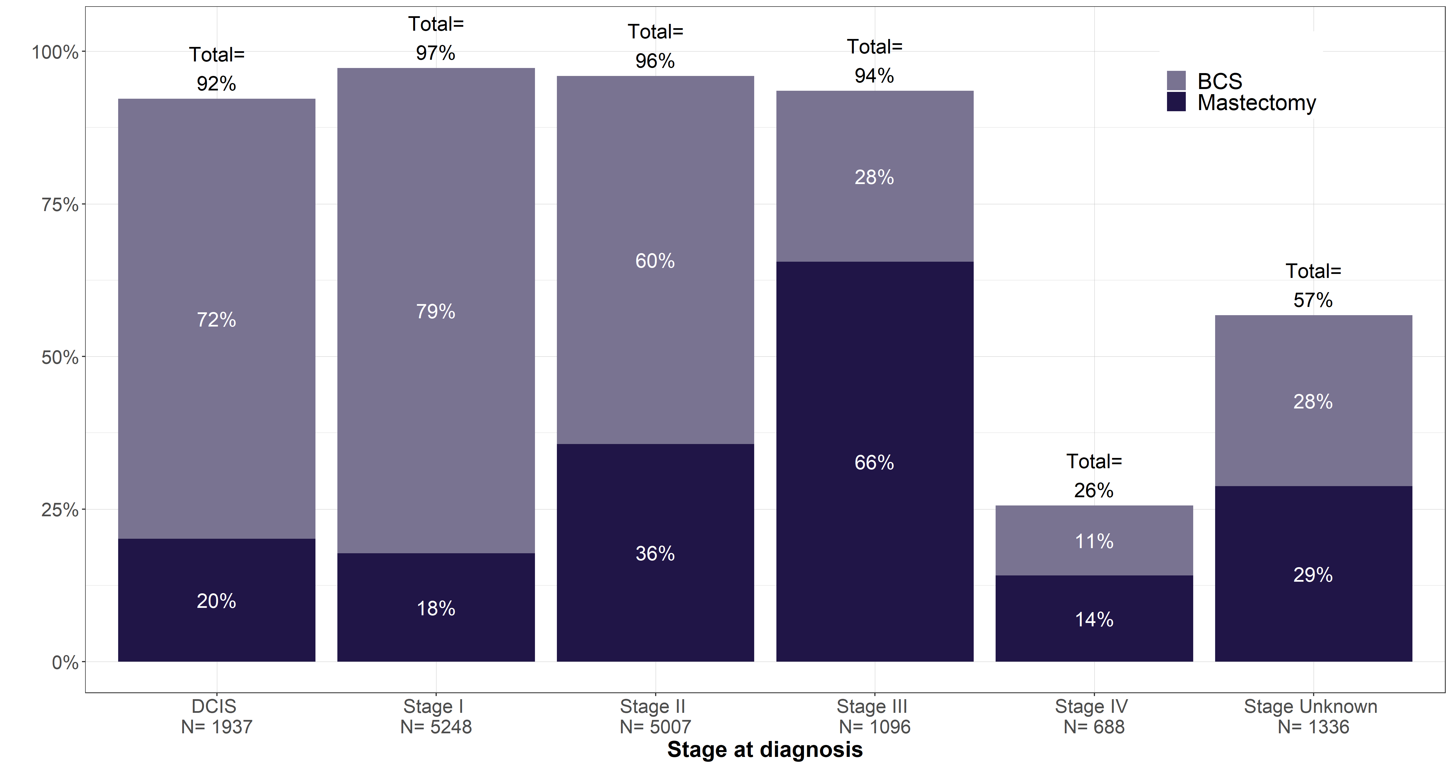
‘Stage unknown’ includes individuals who had neoadjuvant treatment and the recorded stage was after neoadjuvant treatment.
Table 9: Proportion of invasive breast cancer and DCIS breast cancer that had axillary surgery, by stage at diagnosis (N = 15,312)
Axillary surgery | Stage I  (n = 5,248) | Stage II  (n = 5,007) | Stage III  (n = 1,096) | Stage IV  (n = 688) | Invasive – stage unknown  (n = 1,336) | DCIS  (n = 1,937)
Lymph node biopsy | 4,835  (92%) | 3,719  (74%) | 430  (39%) | 102  (15%) | 468  (35%) | 501  (26%)
Lymph node dissection | 293  (6%) | 1840  (37%) | 929  (85%) | 126  (18%) | 291  (22%) | 33  (2%)
Lymph node biopsy and/or dissection | 4,982  (95%) | 4,702  (94%) | 1,033  (94%) | 195  (28%) | 691  (52%) | 520  (27%)
Includes all treatment within 30 days prior to and up to one year from diagnosis date

Clinical commentary – breast surgery utilisation
Most women with early-stage disease had breast-conserving surgery, which has been stable for quite a while. For the stage 3 cohort, there was a higher proportion of patients who had a mastectomy. Some patients in this cohort will receive neoadjuvant treatment to attempt to downstage the tumour, and to potentially change the surgical treatment from mastectomy to breast-conserving surgery. The data indicated that 26 per cent of patients diagnosed with metastatic breast cancer underwent breast surgery within a year of diagnosis, despite breast surgery not being the standard treatment for metastatic disease. We cannot tell from the data if these patients had surgery for what was believed to be early-stage disease and then had metastatic disease diagnosed because of imaging after surgery, or whether they had surgery to achieve local control even in the presence of metastatic disease.
DCIS patients who had axillary surgery are likely a cohort of patients who either had mastectomies for DCIS or patients who had other features on their DCIS diagnosis where it is more likely for the final pathology to disclose invasive cancers such as those who have palpable DCIS.

Timeliness of breast surgery
Across Victoria, 83 per cent of early breast cancer patients whose first treatment was surgery (mastectomy or breast-conserving surgery) were treated within five weeks of diagnosis (Figure 5).
Time to surgery varied significantly by hospital, with 16 campuses having a significantly smaller proportion of patients who were treated within five weeks.
Time to surgery also varied by hospital type:
- Compared with the statewide average of 83 per cent, 19 out of 44 public hospitals treated a higher proportion within five weeks of diagnosis, and 39 of the 41 private hospitals treated a higher proportion of patients within five weeks.
- 73 per cent of patients treated at a public hospital were treated within five weeks of diagnosis, compared with 93 per cent of patients treated at a private hospital (Figure 6).
- The median time to surgery for patients in public hospitals was 27 days, compared with 15 days for patients in private hospitals (Table 10).
Figure 5: Proportion of early breast cancer patients whose first treatment was surgery, who received surgery within five weeks of diagnosis, by surgical campus (N = 10,287)
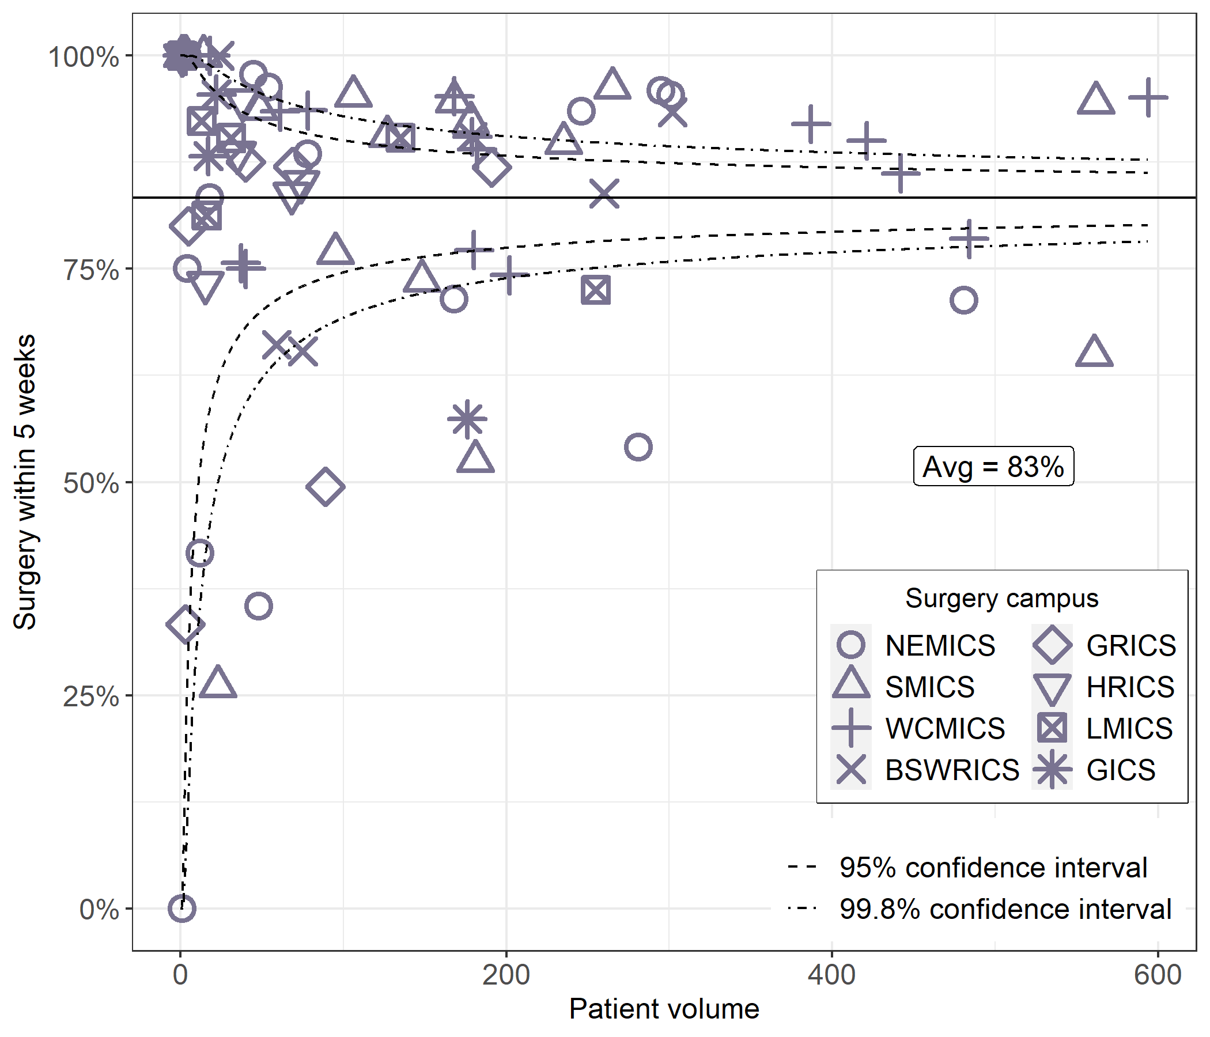
Figure 6: Time from diagnosis to surgery for early breast cancer patients, by hospital type
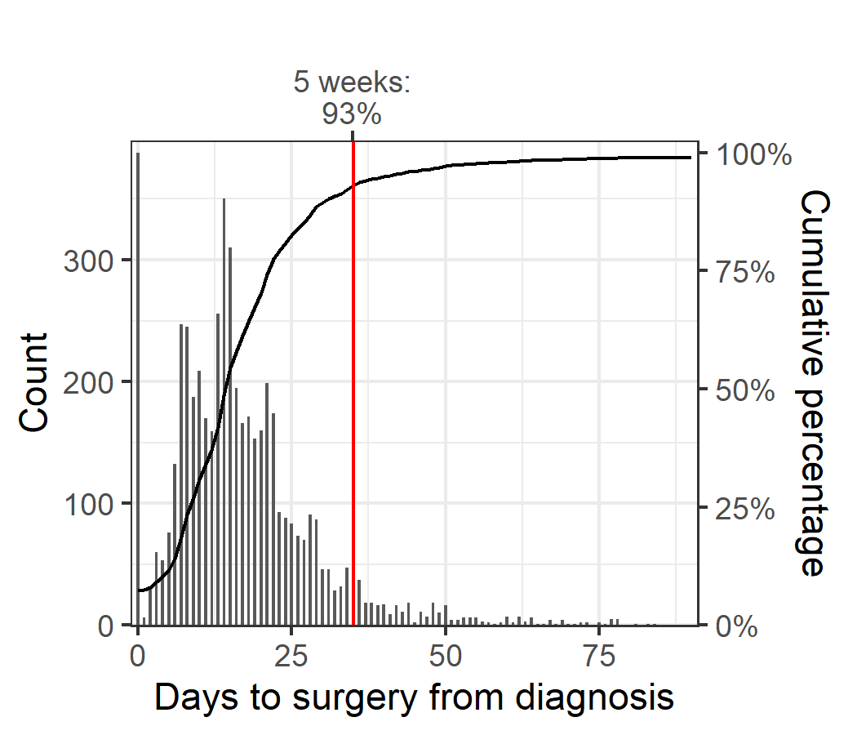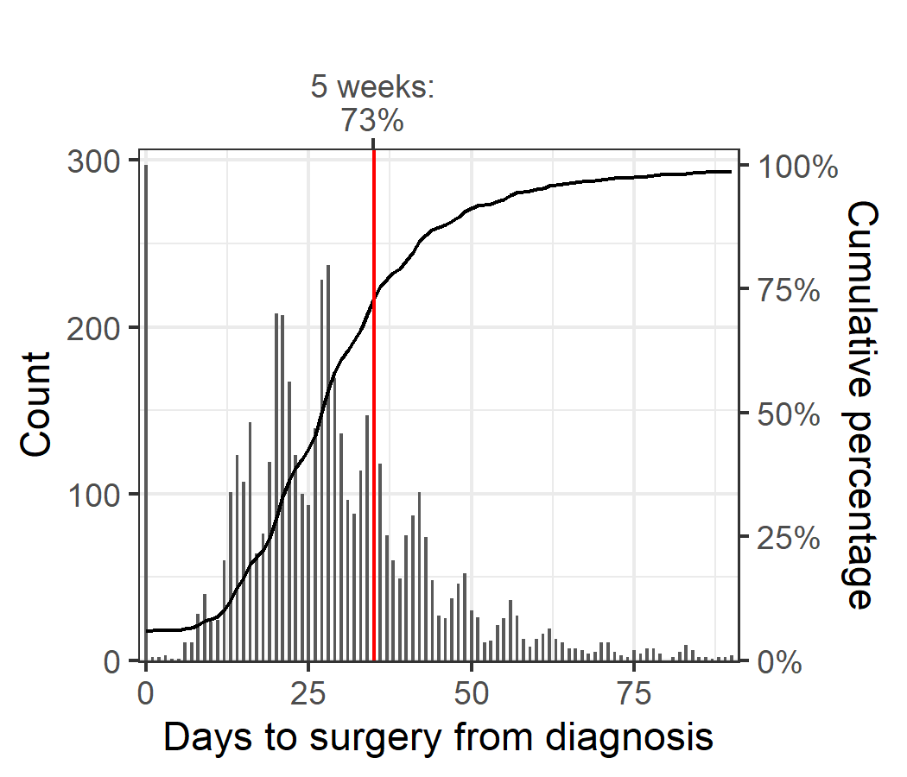
Public campus (N = 4,998)
Private campus (N = 5,289)
Table 10: Median time to surgery and proportion of early breast cancer patients who had surgery within 30, 35 and 40 days of diagnosis, by hospital type (N = 10,287)
Hospital type | Median [IQR] time to surgery | Surgery within 30 days | Surgery within 35 days | Surgery within 40 days
Public  (n = 4,998 patients) | 27 [20,36] | 61% | 73% | 81%
Private  (n = 5,289 patients) | 15 [9,22] | 89% | 93% | 95%
Includes people for whom their first treatment was surgery.

Patient flow for breast surgery
Across Victoria, 73 per cent of early breast cancer (stage 1, 2 and 3) patients had their mastectomy locally (Table 11).
HRICS and GRICS had 46 and 55 per cent of patients treated locally, with nearly all remaining patients treated at a metropolitan ICS (noting the Hume data limitation for surgical data).
Table 11: Early breast cancer patient flow for mastectomy (N = 3,737)
ICS campus (down) / ICS of residence (across) | NEMICS | SMICS | WCMICS | BSWRICS | GRICS | HRICS | LMICS | GICS
NEMICS | 575  (60%) | 22  (2%) | 48  (7%) |  | 7  (3%) | 34  (18%) | 5  (2%)
SMICS | 75  (8%) | 774  (78%) | 24  (4%) | 1  (0%) | 53  (24%) | 3  (2%) | 5  (2%) | 2  (1%)
WCMICS | 301  (32%) | 187  (19%) | 601  (89%) | 7  (3%) | 41  (18%) | 62  (33%) | 70  (24%) | 21  (12%)
BSWRICS |  |  | 2  (0%) | 228  (96%) |  | 1  (1%) | 1  (0%) | 2  (1%)
GRICS |  | 3  (0%) |  |  | 124  (55%)
HRICS | 2  (0%) | 1  (0%) |  |  |  | 88  (46%) | 4  (1%)
LMICS |  |  |  | 1  (0%) |  | 2  (1%) | 198  (69%) | 2  (1%)
GICS | 1  (0%) |  | 4  (1%) |  |  |  | 5  (2%) | 150  (85%)
Victoria | 954 | 987 | 679 | 237 | 225 | 190 | 288 | 177
Patients living in HRICS may have been treated in New South Wales.
Includes all mastectomies conducted within one year of diagnosis.

Volume of breast surgery
Within the 2019–20 financial year, 40 public hospitals performed 3,145 surgeries, with a median of 35.5 surgeries. Thirty-six private hospitals performed 2,947 surgeries, with a median of 38.5 surgeries (Figure 7, Table 12).
There were 10 public and seven private hospitals that performed fewer than 10 surgeries in a year.
Figure 7: Annual volume of breast surgery (mastectomy and breast-conserving surgery) for DCIS and invasive breast cancer, by hospital campus and hospital type (N = 6,092)
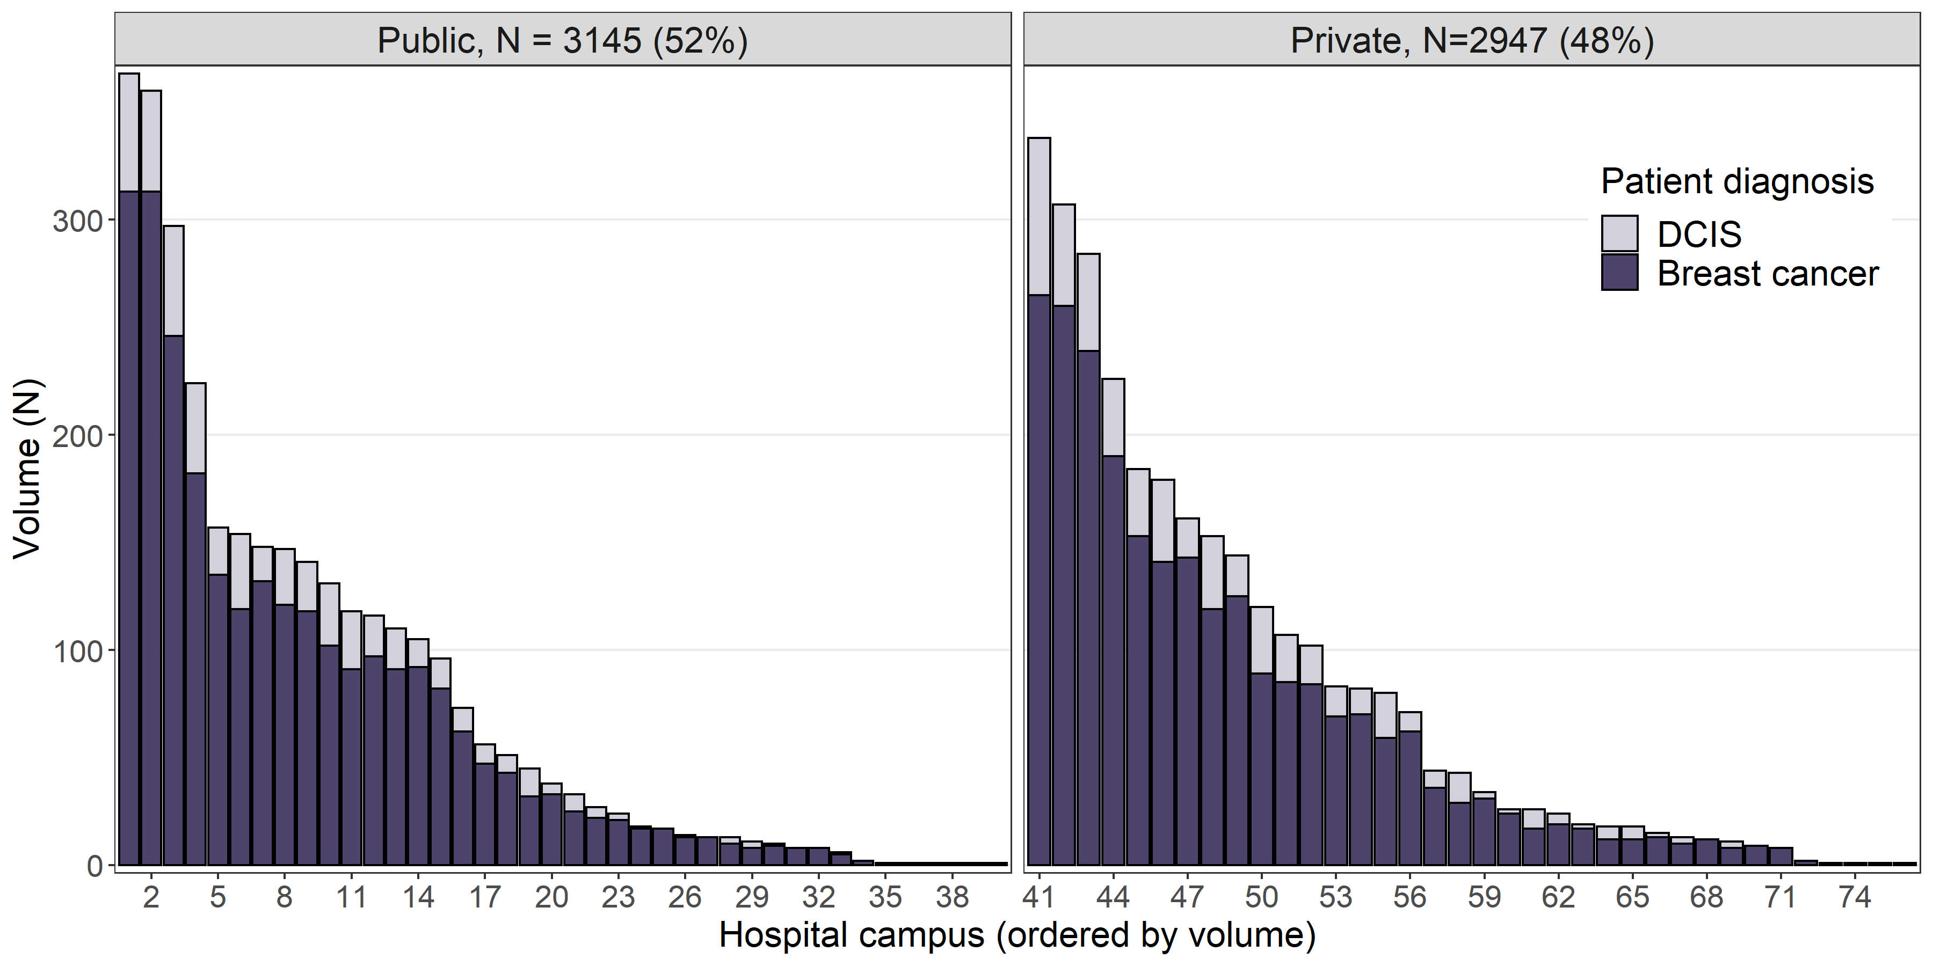
Data source: VAED financial year 2019–20
Each bar represents a de-identified campus.
Table 12: Summary of annual volume of breast surgery for DCIS and invasive breast cancer (N = 6,092)
Variable | Public | Private
Median no. admissions | 35.5 | 38.5
Total no. hospitals | 40 | 36
Volume: < 10 | 10 campuses | 7 campuses
Volume: < 20 | 17 campuses | 14 campuses
Data source: VAED 2019–20

Reconstructions after mastectomy
- For women with early breast cancer who had a mastectomy, there was variation across Victoria in the proportion who had a reconstruction following mastectomy (Table 13).
  - Reconstruction rates were higher in metro ICS, ranging from 41 to 49 per cent of patients, compared with regional ICS where the range was 14 to 29 per cent.
- Reconstruction rates following mastectomy was higher for younger women, with 53 per cent of women aged under 65 years having had a reconstruction compared with 8 per cent of women aged 65 or older (Figure 8).
- Reconstruction rates tended to be lower for patients from regional ICS for both age groups (aged under 65 years and aged 65 or older).
  - The proportion of patients that had reconstruction was lower for those living in regional ICS, ranging from 2 to 9 per cent for women aged 65 or older and 25 to 47 per cent for women under 65.
  - For those living in a metro ICS, 8 to 12 per cent of women aged 65 or older and 57 to 62 per cent of women aged under 65 had a reconstruction.
- For women diagnosed in 2016 who had a reconstruction following mastectomy, 83 per cent had the reconstruction during the same admission as the mastectomy, 6 per cent had the reconstruction within 12 months of their mastectomy, and 11 per cent was after 12 months following their mastectomy (Table 14).
  - There was variation across ICS of residence for the proportion of patients that waited over 12 months for their reconstruction, ranging from 8 per cent in NEMICS up to 24 per cent in BSWRICS and HRICS (noting the Hume data limitation).
- 59 per cent of patients had reconstructions locally (Table 15).
  - Excluding BSWRICS where 90 per cent of residents were treated locally, most patients from regional ICS had a reconstruction in a metro ICS.
Table 13: Number and proportion of early breast cancer patients who had a reconstruction after mastectomy (N = 3,737)
ICS of residence | Total patients | Total having reconstruction
NEMICS | 954 | 392 (41%)
SMICS | 987 | 420 (43%)
WCMICS | 679 | 331 (49%)
BSWRICS | 237 | 46 (19%)
GRICS | 225 | 58 (26%)
HRICS | 190 | 55 (29%)
LMICS | 288 | 53 (18%)
GICS | 177 | 24 (14%)
Victoria | 3,737 | 1,379 (37%)
Patients living in HRICS may have been treated in New South Wales.
Includes all patients who had a mastectomy within one year of diagnosis.
Figure 8: Proportion of early breast cancer patients who had a reconstruction after mastectomy, by ICS of residence and age group (under 65 years old and over 65 years old)
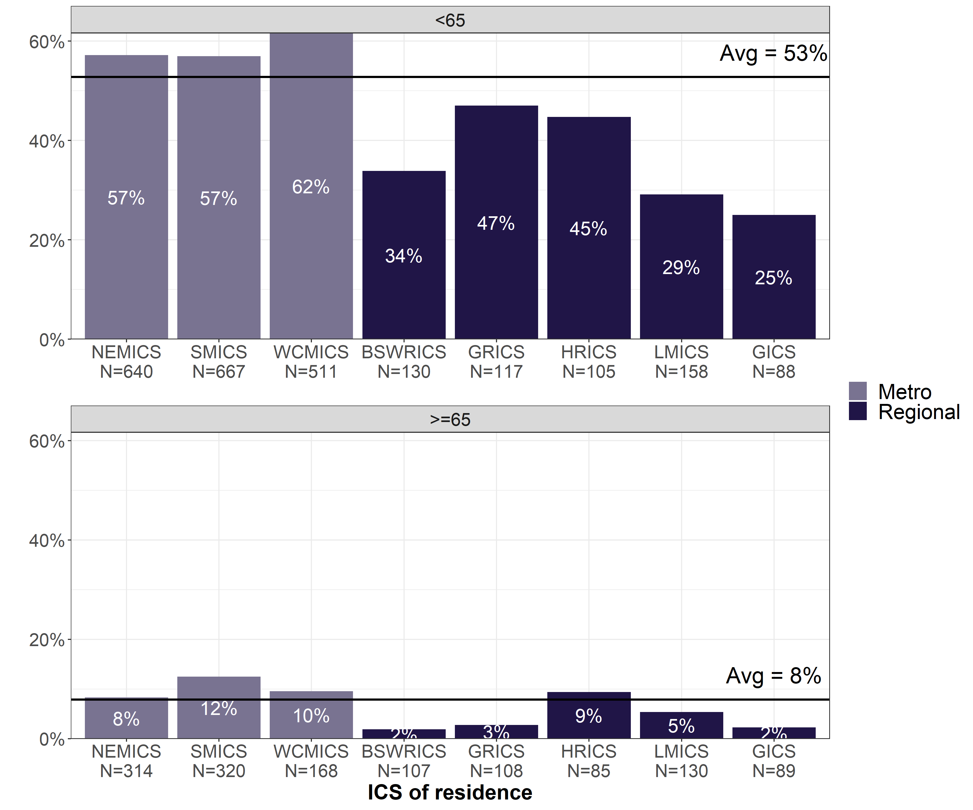
Table 14: Timing of reconstruction for early breast cancer patients diagnosed in 2016, by ICS of residence (N = 505)
ICS of residence | Same admission | Within 12 months | After 12 months
NEMICS (n = 149) | 87% | 5% | 8%
SMICS (n = 155) | 81% | 7% | 12%
WCMICS (n = 118) | 88% | 3% | 9%
BSWRICS (n = 17) | 65% | 12% | 24%
GRICS (n = 26) | 77% | 12% | 12%
HRICS (n = 17) | 65% | 12% | 24%
LMICS (n = 16) | 81% | 0% | 19%
GICS (n = 7) | 86% | 0% | 14%
Victoria (n = 505) | 83% | 6% | 11%
Table 15: Early breast cancer patient flow for reconstruction (N = 1,335)
ICS campus (down) / ICS of residence (across) | NEMICS | SMICS | WCMICS | BSWRICS | GRICS | HRICS | LMICS | GICS
NEMICS | 160  (42%) | 6  (1%) | 16  (5%) |  | 2  (3%) | 17  (31%) | 2  (4%)
SMICS | 40  (10%) | 285 (71%) | 13  (4%) | 1  (2%) | 32 (54%) | 2 (4%) | 1  (2%)
WCMICS | 184  (48%) | 112  (28%) | 294 (90%) | 3  (8%) | 25  (42%) | 33 (61%) | 39 (80%) | 14 (70%)
BSWRICS |  |  | 1  (0%) | 36 (90%) |  |  | 1  (2%)
GRICS
HRICS |  |  |  |  |  | 2  (4%)
LMICS |  |  |  |  |  |  | 6  (12%)
GICS |  |  | 2  (1%) |  |  |  |  | 6  (30%)
Victoria | 384 | 403 | 326 | 40 | 59 | 54 | 49 | 20

Clinical commentary – breast surgery
Reassuringly, most people had surgery close to home (73 per cent of mastectomies and 59 per cent of reconstructions after mastectomy).
There was large variation in the timeliness of surgery between campuses, even within individual ICS. Patients treated at private campuses were nearly always treated within five weeks from diagnosis, whereas this was much lower for public patients. This difference does reduce as we look at treatment within 40 days, but there is still a delay for public patients.
Hospitals that perform low volumes of surgery are concerning, though not necessarily reflecting a lack of facility, clinician expertise or access to breast care nurses. It does raise issues of whether there are differential experiences in terms of where people are being treated. We currently do not have good measures for that because we do not routinely collect patient-reported outcome measures in the state.
Reconstruction rates in Victoria are very high. There were more reconstructions for women from metro areas, predominantly due to access to reconstruction resources. There was a very clear division in the rates of reconstructions between women aged 65 or older compared with those under 65, which was expected. There is an element of patient choice to reconstruction that cannot be measured, nor are we able to measure whether delays to reconstruction were due to choice or availability.

Chemotherapy

Chemotherapy utilisation
Chemotherapy was most common as a treatment for those diagnosed with stage 3 cancers, with 76 per cent of these patients receiving chemotherapy (Figure 9).
Figure 9: Chemotherapy utilisation within one year of invasive breast cancer diagnosis, by stage at diagnosis (N = 13,375)
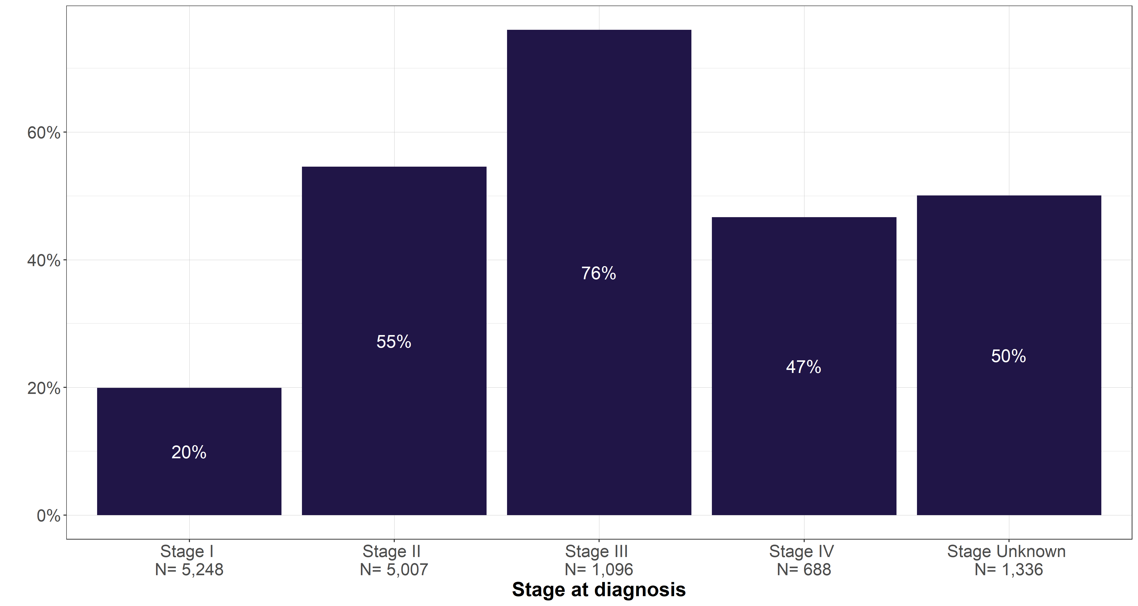

Neoadjuvant chemotherapy
- Across Victoria, 10 per cent of surgically treated early breast cancer patients received neoadjuvant chemotherapy. Variation between ICS of surgical campus was statistically significant (p < 0.001), ranging from 5 per cent in HRICS to 14 per cent in SMICS (Figure 10).
- The proportion of surgically treated early breast cancer patients that received neoadjuvant chemotherapy varied by histological subtype, from 5 per cent for luminal subtype to 29–30 per cent for HER2-amplified and triple-negative breast cancer (Table 16).
  - Among surgically treated patients who received neoadjuvant treatment, 53 per cent of luminal, 56 per cent of HER2-amplified and 45 per cent of triple-negative breast cancer patients had a mastectomy (Figure 11).
Figure 10: Proportion of surgically treated early breast cancer patients who received neoadjuvant chemotherapy, by ICS of surgery campus (N = 11,867)
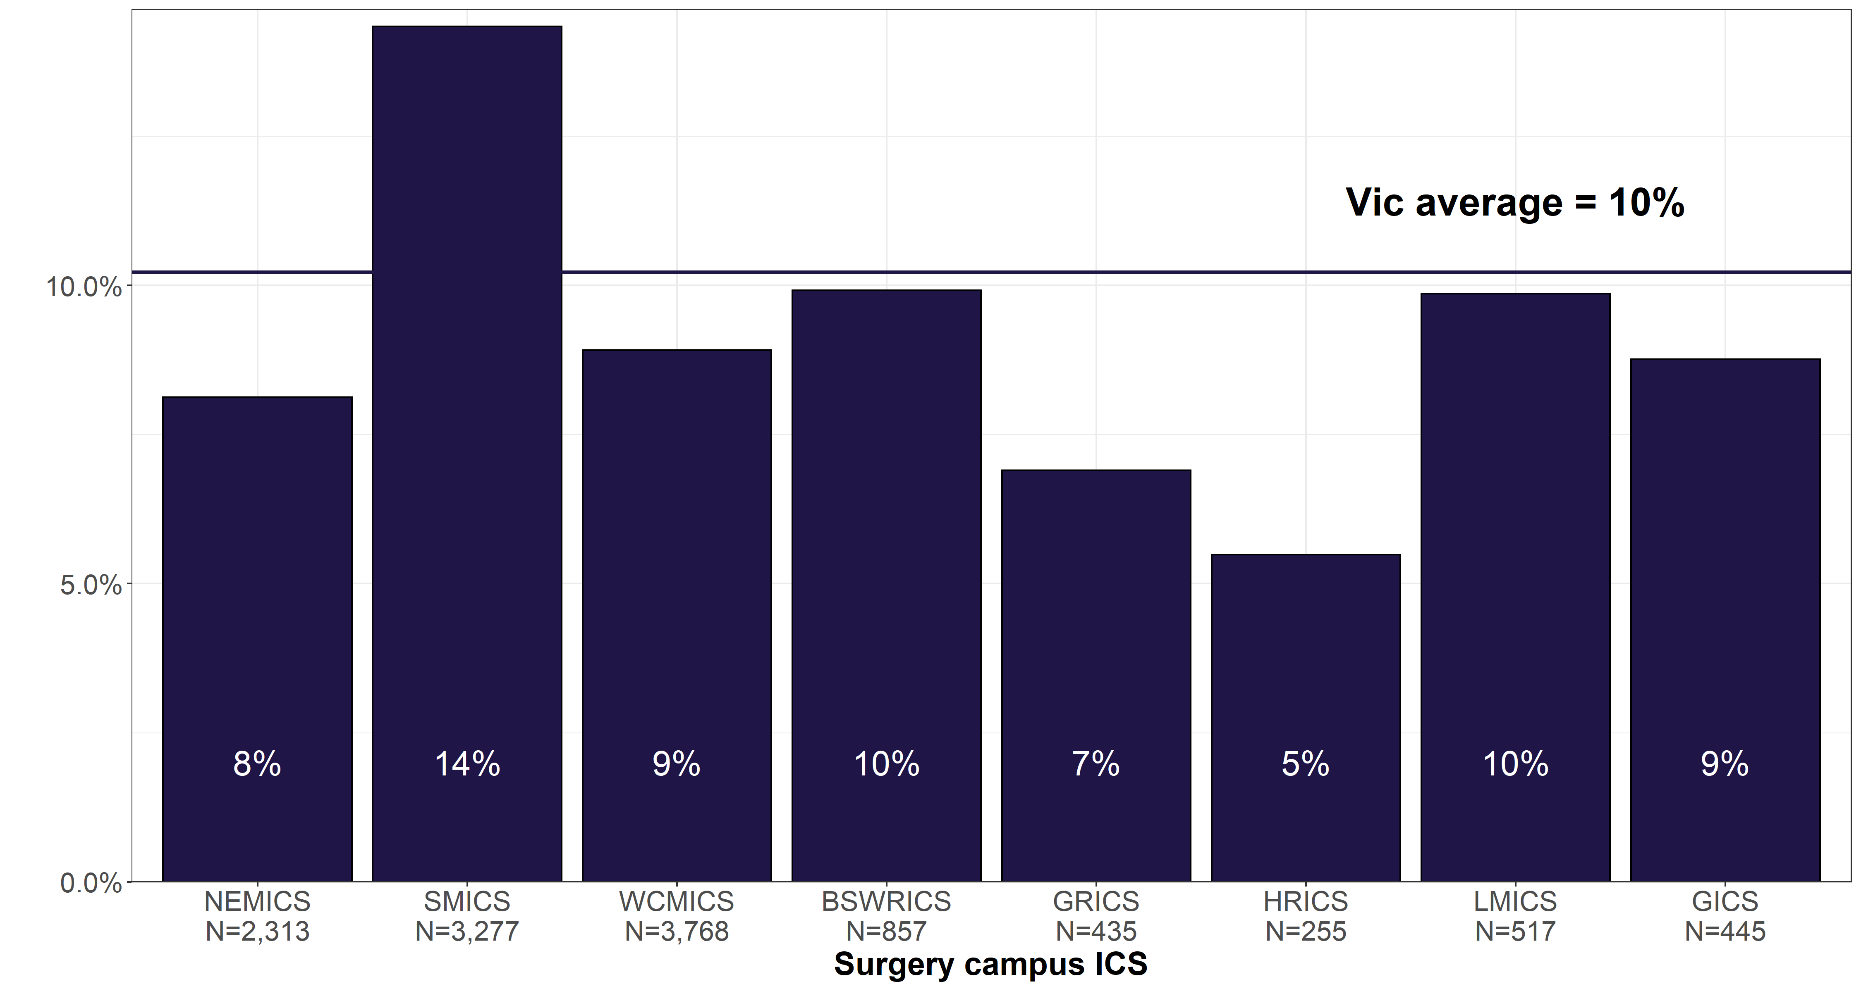
Patients living in HRICS may have been treated in New South Wales.
Includes people who were treated with surgery within one year of diagnosis.
Treatment is considered neoadjuvant where intravenous chemotherapy was received within three months before surgery.
Table 16: Proportion of surgically treated early breast cancer patients who received neoadjuvant chemotherapy, by histological subtype
Histological subtype | Proportion receiving neoadjuvant treatment
Luminal (n = 8,935) | 407 (5%)
HER2-amplified (n = 1301) | 383 (29%)
Triple-negative (n = 1,041) | 317 (30%)
Includes people who were treated with surgery within one year of diagnosis.
Treatment is considered neoadjuvant where intravenous chemotherapy was received within three months before surgery.
Figure 11: Surgery type used to treat early breast cancer patients who received neoadjuvant chemotherapy
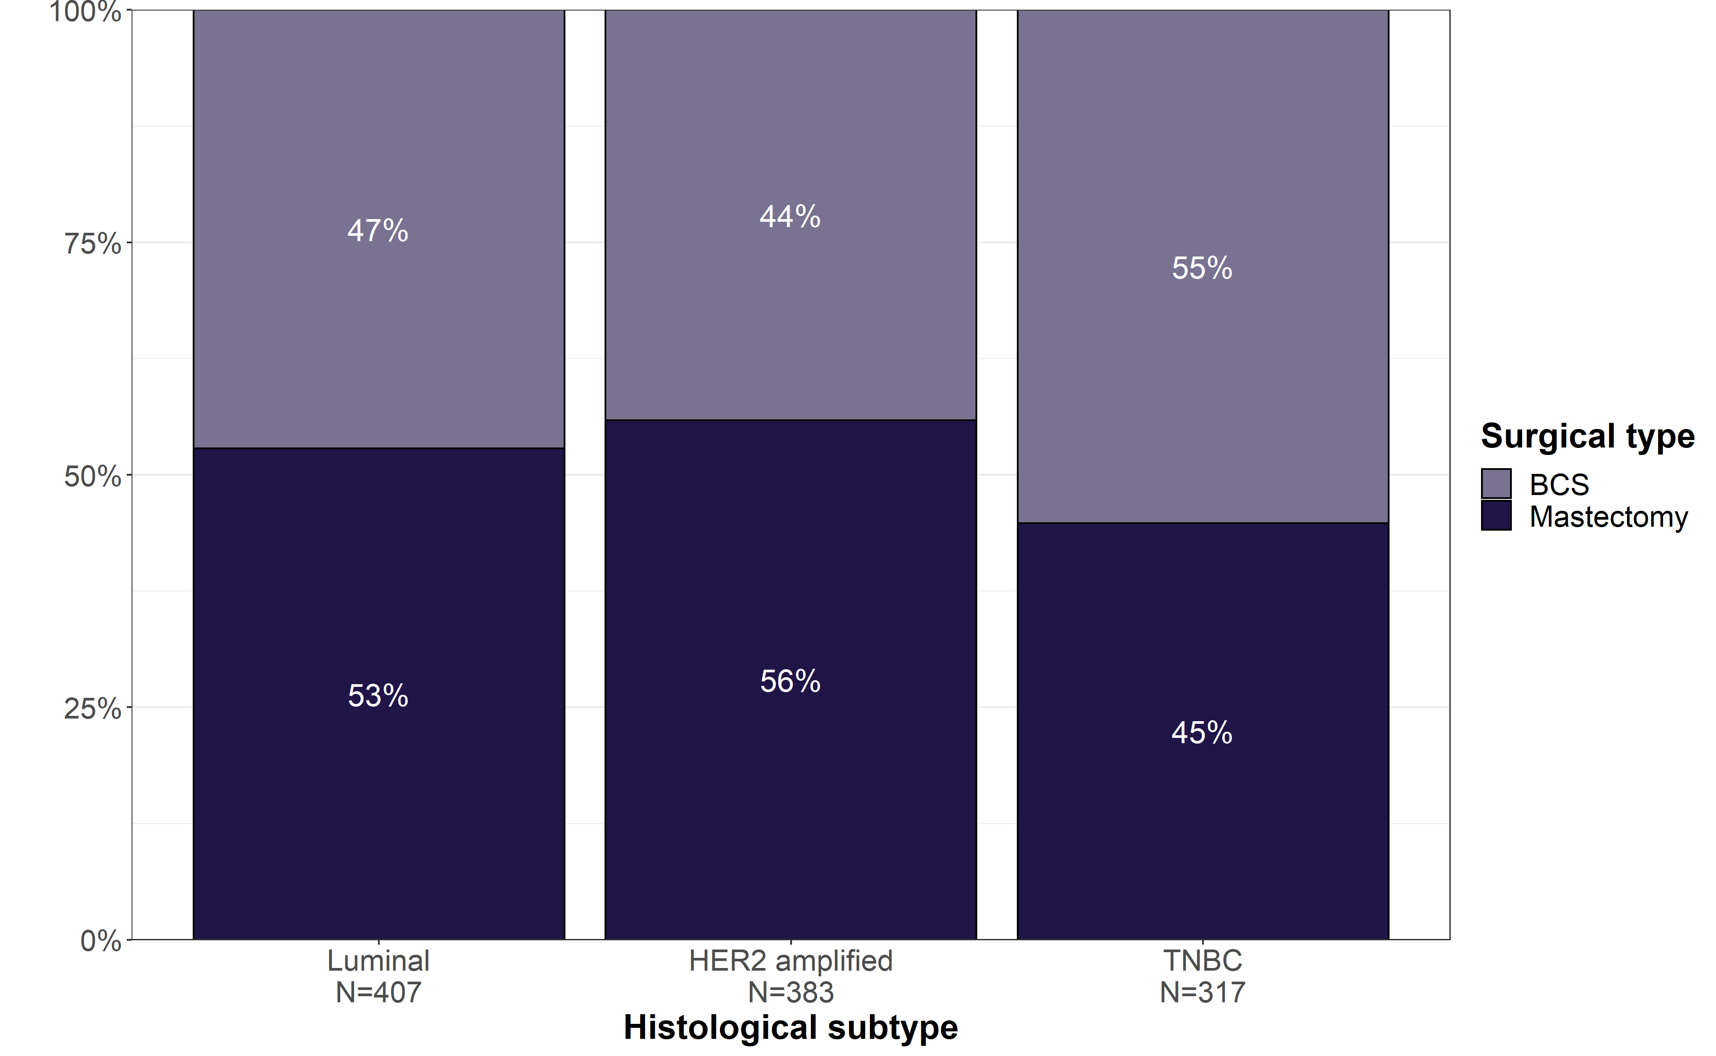

Clinical commentary – neoadjuvant chemotherapy
Although individual institutions have looked at neoadjuvant chemotherapy, it was informative to be able to look at how often neoadjuvant chemotherapy was given across the state, acknowledging that there may be some data gaps. There was some variation across the state in neoadjuvant chemotherapy rates, grouped by ICS of surgical campus. Around 40 per cent of those who were treated with neoadjuvant therapy were luminal disease, and although it is often seen as a therapy for the more aggressive subtypes like HER2-amplified and triple-negative, these may have been cases where the purpose was down staging in high-grade tumours with low ER and PR expression.

Adjuvant chemotherapy
- Of the surgically treated early breast cancer patients who had adjuvant chemotherapy, 22 per cent started chemotherapy within four weeks of surgery, and 69 per cent within six weeks of surgery (Figure 12).
- Across Victoria, the average proportion of patients who had adjuvant chemotherapy within six weeks of surgery was 18 per cent for luminal, 24 per cent for HER2 and 35 per cent triple-negative breast cancer (Figure 13).
- There was significant variation between campuses for each subtype.
Figure 12: Time from surgery to chemotherapy for early breast cancer patients (N = 3,581)
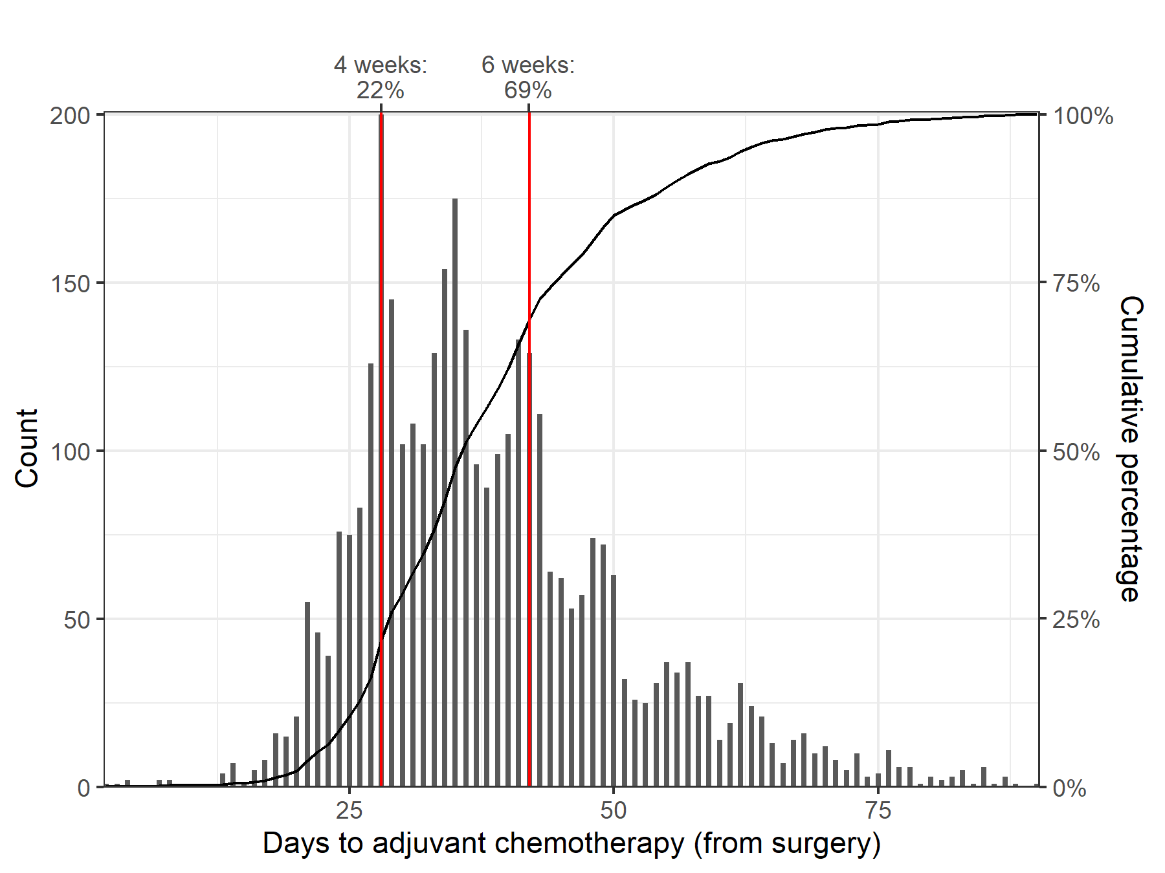
For those treated with chemotherapy within three months of surgical admission.
Excludes women who had a secondary surgical admission prior to chemotherapy (for example, breast-conserving surgery followed by mastectomy; mastectomy followed by reconstruction).

Figure 13: Proportion of early breast cancer patients who had chemotherapy within 28 days of surgery, by histological subtype (N = 3,442)
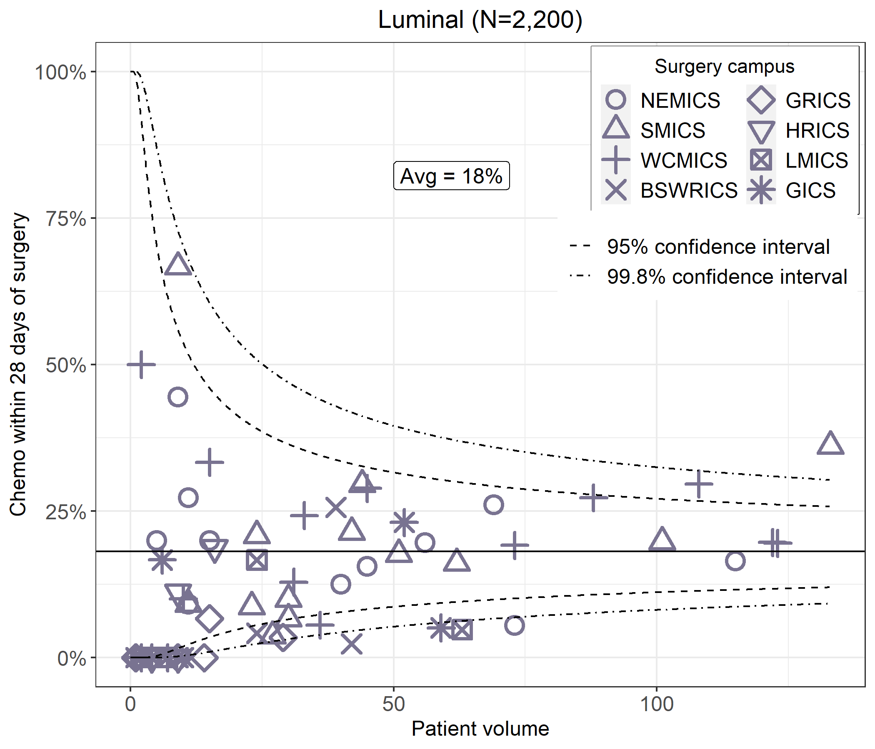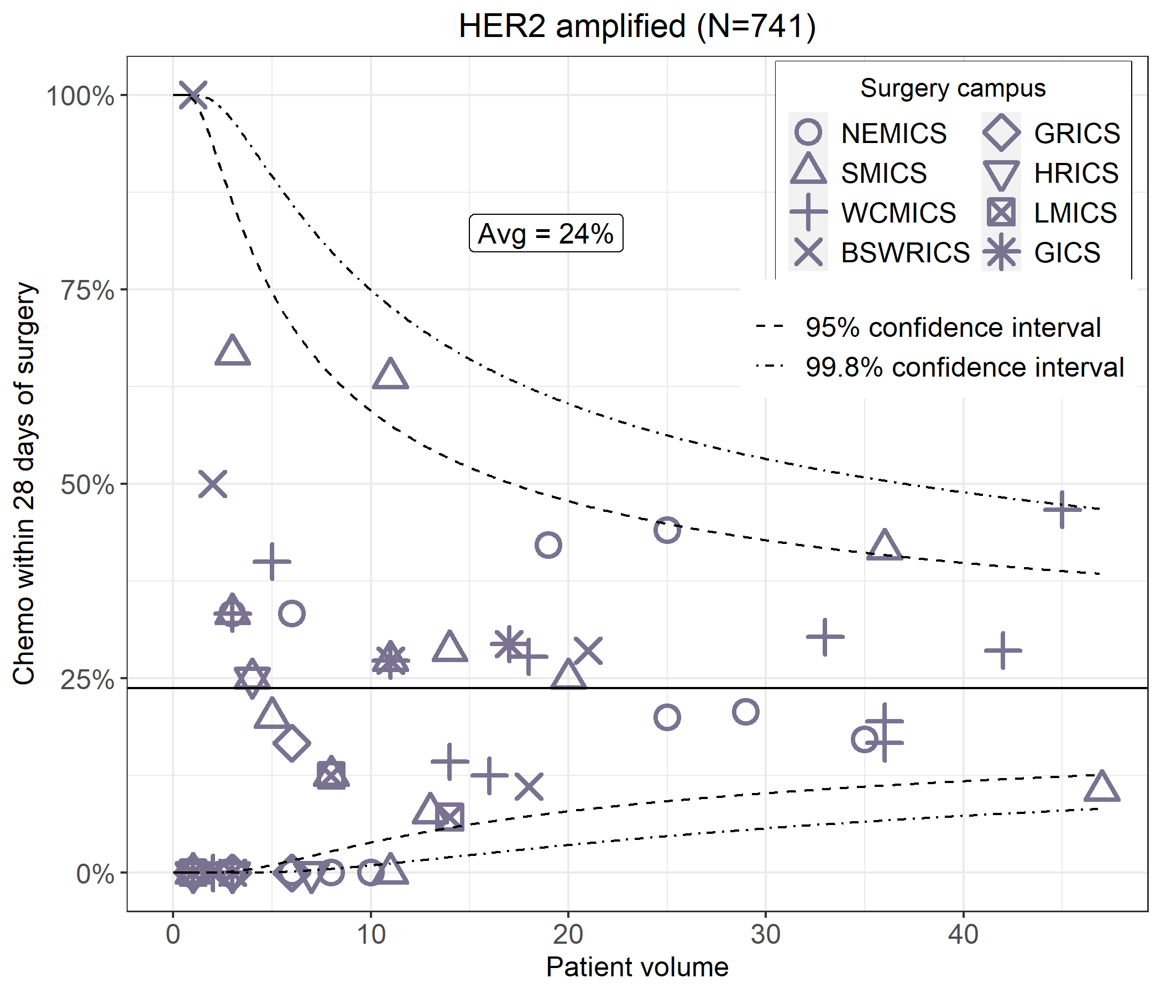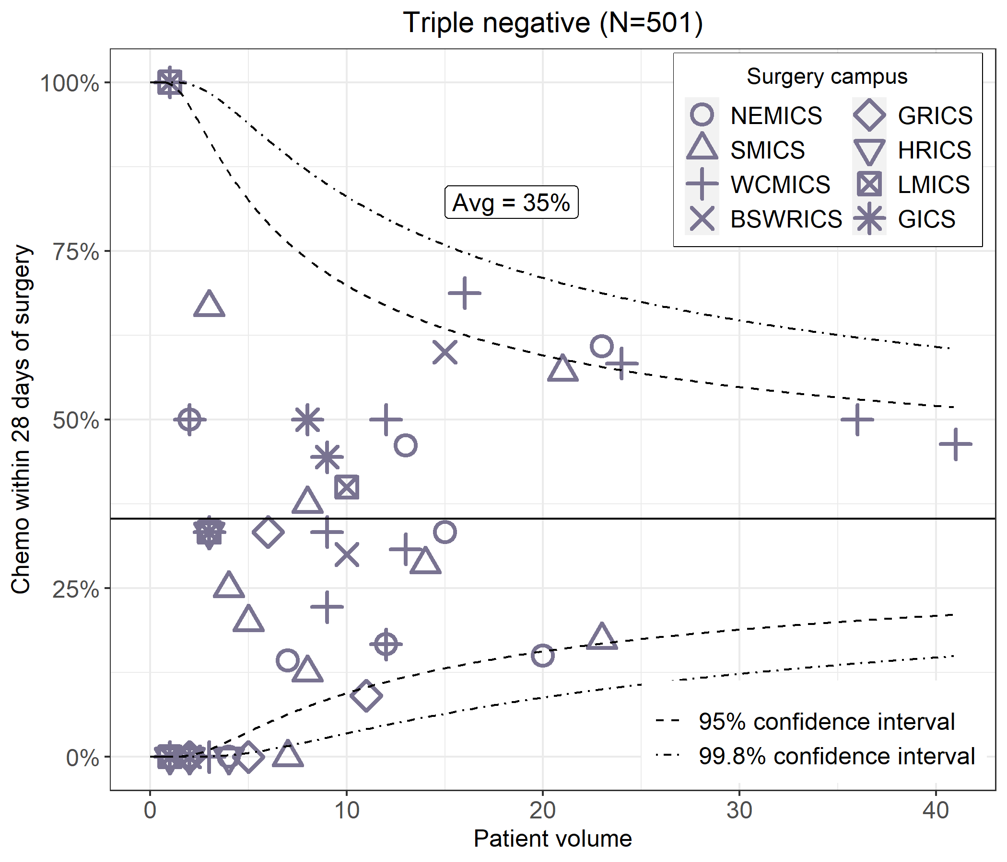
For those treated with chemotherapy within three months of surgical admission.
Excludes women who had a secondary surgical admission before chemotherapy.
Each point represents a surgery campus.

Clinical commentary – chemotherapy utilisation
The percentage of patients treated with chemotherapy within the recommended four weeks post-surgery is low (22 per cent, all subtypes), even for the triple-negative subtype where timeliness of chemotherapy after surgery is more crucial (35 per cent). There were changes to timelines in the second edition OCP for adjuvant chemotherapy, where the new guidelines recommend adjuvant chemotherapy within four weeks of surgery for triple-negative and HER2-amplified breast cancer (no update), and within six weeks post-surgery for other subtypes (previously four weeks).

Adjuvant radiotherapy
- Radiotherapy utilisation ranged from 37 per cent in DCIS to 79 per cent for stage 3 breast cancer (Figure 14).
- 84 per cent of patients had radiotherapy locally, ranging from 52 per cent for patients living in HRICS to 98 per cent for patients living in BSWRICS (Table 17).
- For women with early breast cancer who had adjuvant radiotherapy within six months following surgery, 66 per cent had radiotherapy within eight weeks of surgery (Figure 15).
  - This varied by radiotherapy campuses (Figure 16). There were eight campuses that significantly varied from the state average (outside the widest confidence intervals of 99.8 per cent); three were lower than the state average and five were higher.
- For the 2019–20 financial year, 62 per cent of the radiotherapy volume was undertaken in public hospitals (Figure 17).
  - There were three low-volume private campuses with annual volume less than 20.
Figure 14: Radiotherapy utilisation by stage at diagnosis for DCIS and invasive breast cancer (N = 15,312)
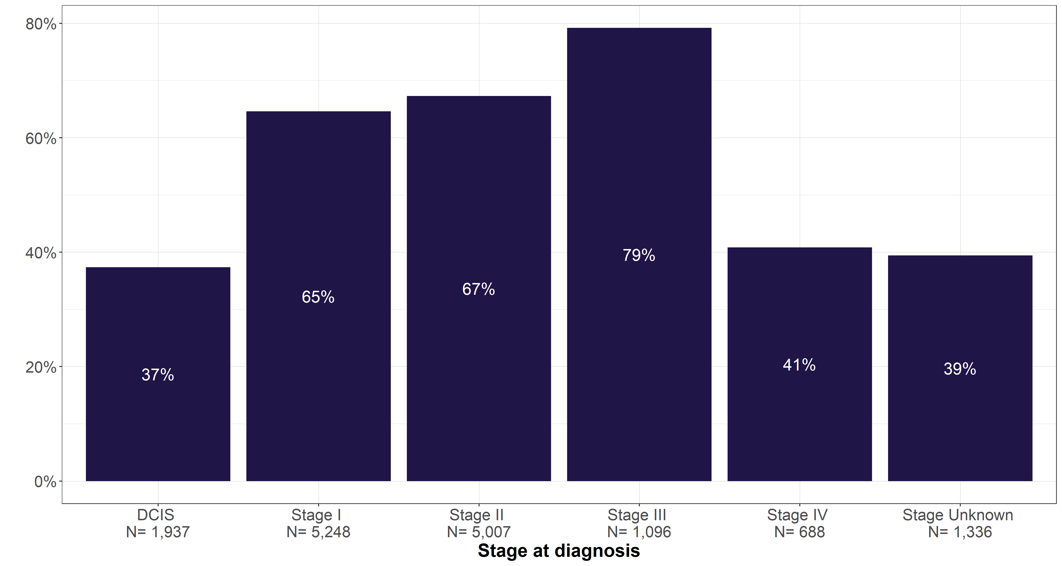
Table 17: Early breast cancer patient flow for radiotherapy (N = 7,964)
ICS campus (down) / ICS of residence (across) | NEMICS | SMICS | WCMICS | BSWRICS | GRICS | HRICS | LMICS | GICS
NEMICS | 1,700  (82%) | 55  (2%) | 157  (12%) | 2  (0%) | 7  (2%) | 69  (16%) | 9  (2%) | 3  (1%)
SMICS | 125  (6%) | 2,016  (91%) | 26  (2%) | 2  (0%) | 52  (11%) | 4  (1%) | 4  (1%) | 1  (0%)
WCMICS | 245  (12%) | 127  (6%) | 1,167  (85%) | 5  (1%) | 15  (3%) | 43  (10%) | 90  (19%) | 18  (6%)
BSWRICS | 3  (0%) |  | 10  (1%) | 602  (98%) | 1  (0%) | 2  (0%) | 1  (0%) | 25  (8%)
GRICS |  | 2  (0%) |  |  | 383  (83%)
HRICS | 2  (0%) | 2  (0%) | 1  (0%) |  |  | 225  (52%)
LMICS |  | 2  (0%) |  |  | 2  (0%) | 91  (21%) | 337  (70%) | 13  (4%)
GICS | 3  (0%) |  | 4  (0%) | 6  (1%) |  | 1  (0%) | 38  (8%) | 266  (82%)
Victoria | 2,078 | 2,204 | 1,365 | 617 | 460 | 435 | 479 | 326
Radiotherapy within one year of diagnosis.

Figure 15: Time from surgery to adjuvant radical radiotherapy for early breast cancer patients (N = 3,953)
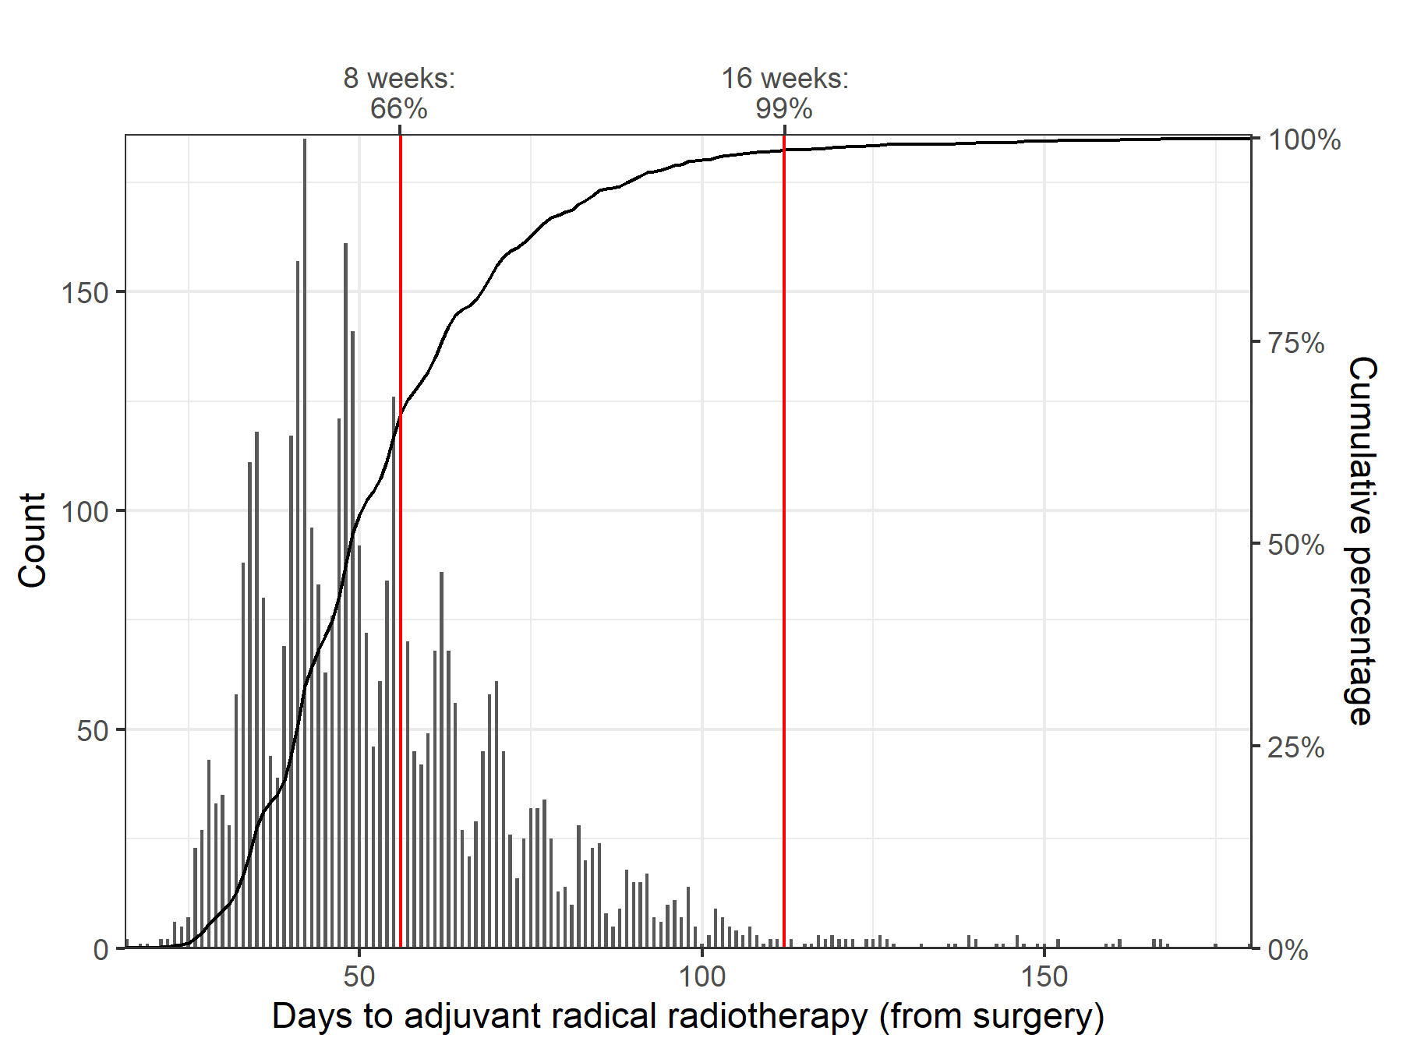
Includes women who had radiotherapy within six months after surgery (breast-conserving surgery and mastectomy).
Excludes women who had adjuvant chemotherapy and women who had a secondary surgical admission before radiotherapy (for example, breast-conserving surgery followed by mastectomy; mastectomy followed by reconstruction).
Figure 16: Proportion of early breast cancer patients who had adjuvant radiotherapy within 56 days of surgery (N = 3.953)
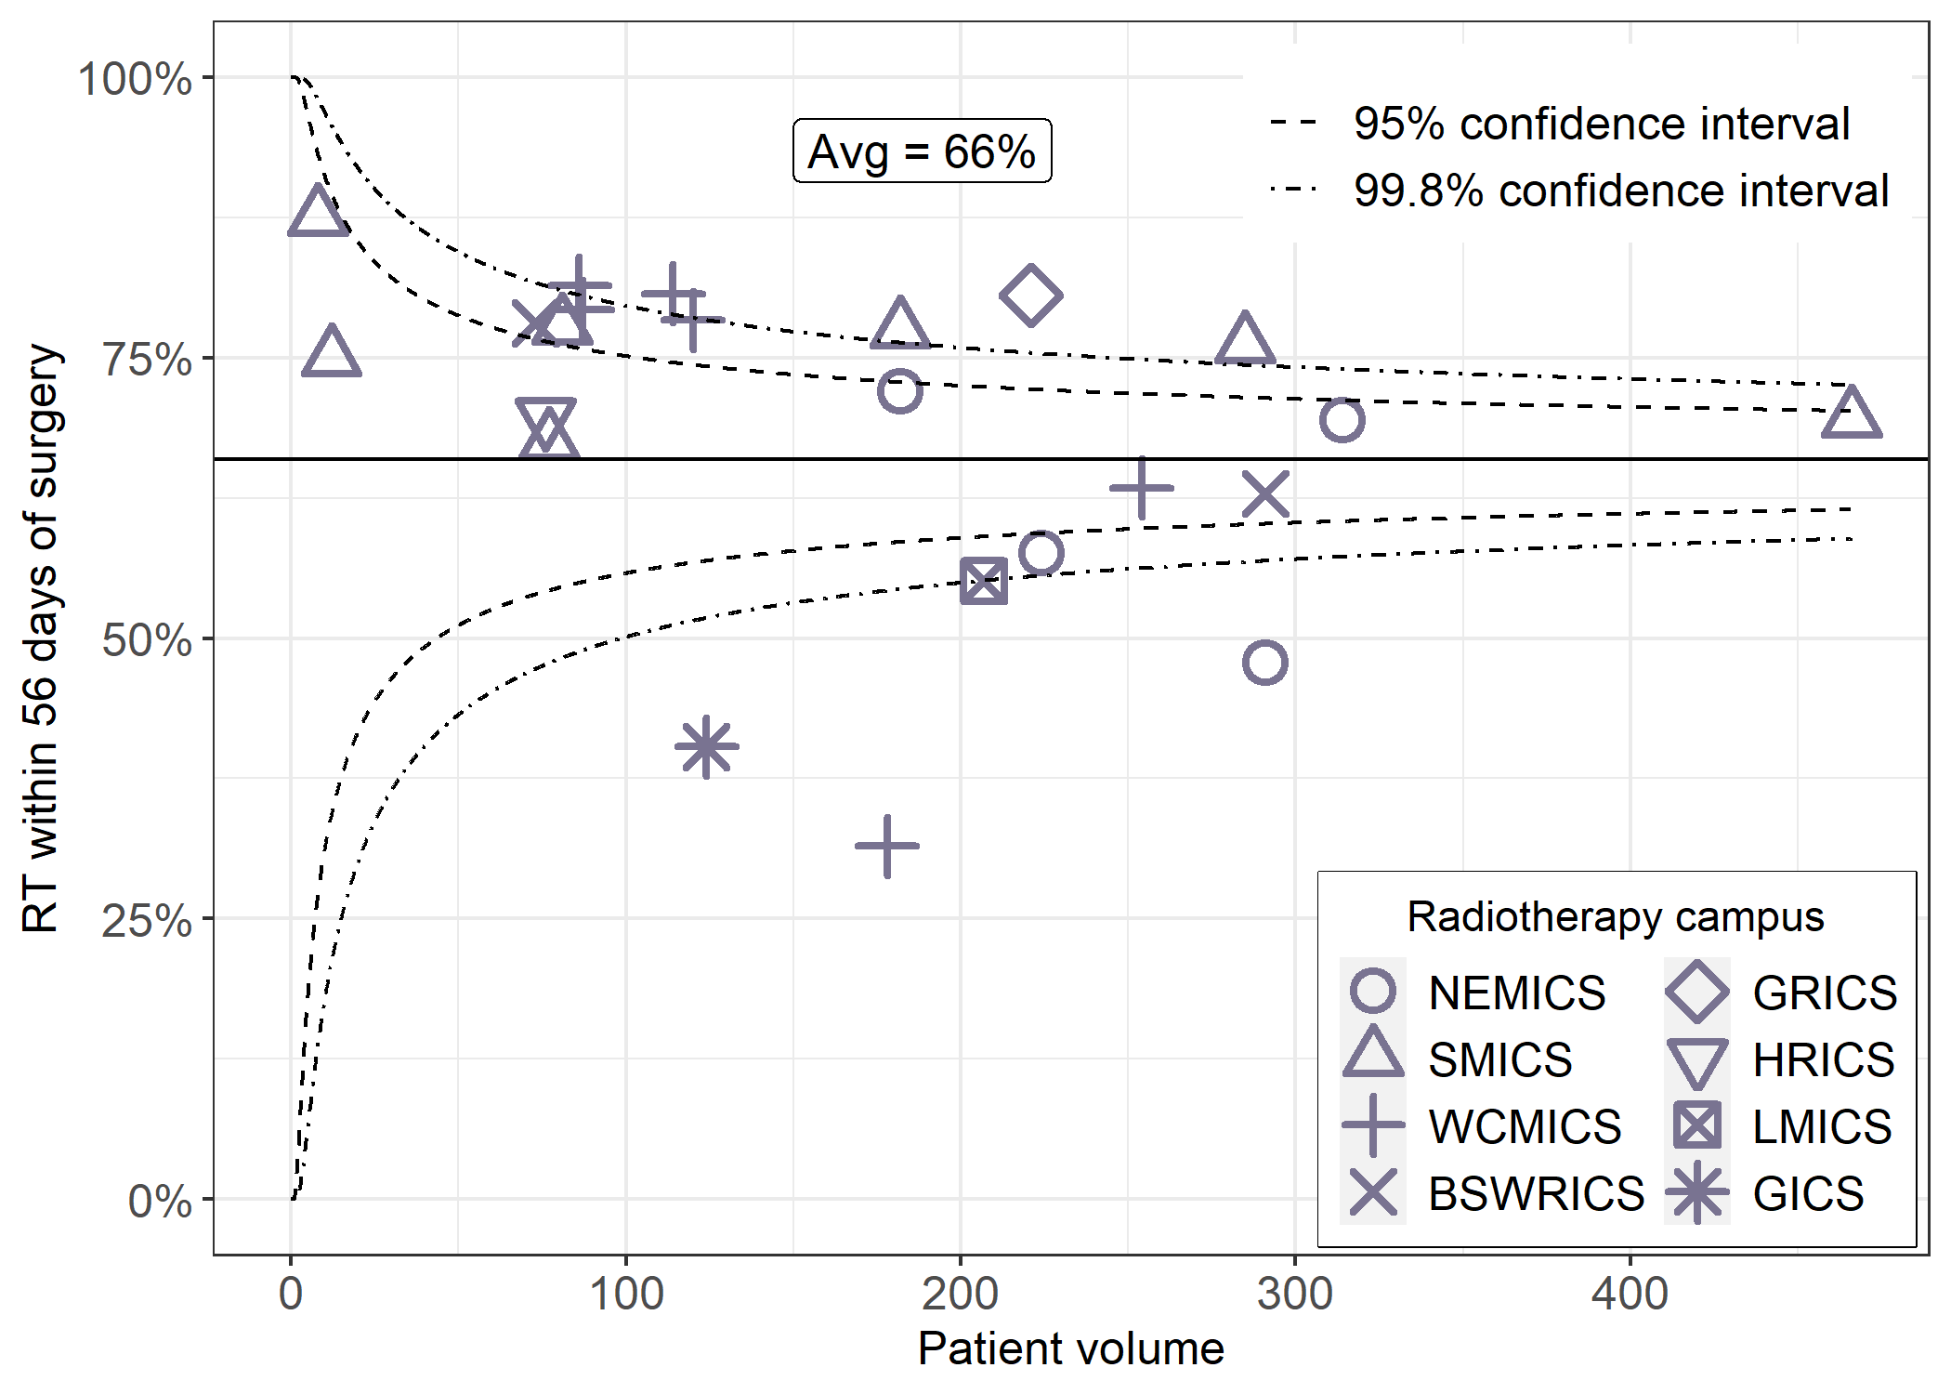
Figure 17: Victorian radiotherapy centre average yearly volume for DCIS and invasive breast cancer (N = 3,645)
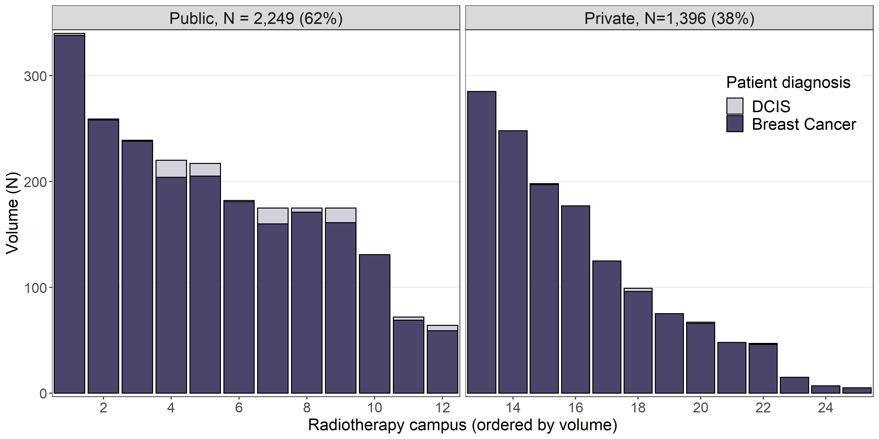
Data source: VRMDS, 2019–20 financial year
Includes courses with a non-palliative intent.

Clinical commentary – adjuvant chemotherapy
It was unsurprising that radiotherapy use was higher for stage 3 compared with stage 1 or 2 cancer (79 per cent versus 65–67 per cent) due to the more locally advanced disease. Reassuringly, most patients had their radiotherapy locally (84 per cent). Timeliness of radiotherapy was more aligned to OCP recommendations than for adjuvant chemotherapy, with 66 per cent starting treatment within eight weeks of surgery.

Survival
Across Victoria, the five-year relative survival for invasive breast cancer is 91.0 [90.5–91.6] (Figure 18). Refer to the Glossary for a definition of relative survival.
The five-year relative survival for residents of NEMICS of 93 per cent was statistically higher than the Victorian average for women with invasive breast cancer.
Figure 18: Five-year relative survival of invasive breast cancer, by ICS of residence
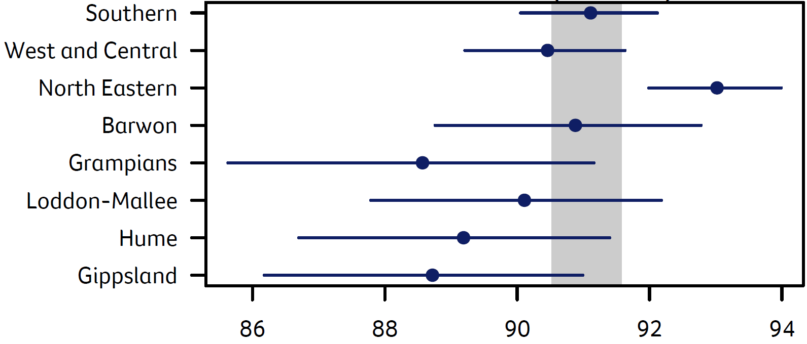
Five-year relative survival (%)
Data source: VCR, 2014–2018
Grey segment indicates 95 per cent survival Cis.

De novo metastatic breast cancer

Demographics of metastatic breast cancer
- From 2014 to 2018, there were 1,147 metastatic breast cancer cases across Victoria (Table 18).
  - The median age at diagnosis was 64 years old, which is similar to the median age of 62 for all invasive breast cancer (Table 18).
  - A quarter of Victorian women with de novo metastatic breast cancer were in the most disadvantaged SES quintile. This is higher than the overall invasive breast cancer cohort where 19 per cent of women were in the most disadvantaged SES quintile (Table 18).
  - 78 per cent of metastatic breast cancer patients did not have comorbidities in the period one year prior to one month after diagnosis.
Table 18: Demographics of de novo metastatic breast cancer patients (N = 1,147)
Variable | Level | Median [IQR] or  N (%)
Age, median [IQR] | N/A | 64 [53–76]
Socioeconomic status | Disadvantaged (Q1) | 276 (24%)
Socioeconomic status | Middle (Q2–Q4) | 679 (59%)
Socioeconomic status | Affluent (Q5) | 192 (17%)
Comorbidity count (VAED derived 1 year prior; 1 month after diagnosis; Quan 2011; excl. cancer) | 0 | 891 (78%)
Comorbidity count | 1 | 162 (14%)
Comorbidity count | 2+ | 94 (8%)
Data source: VCR, VAED, 2014–2018

Grade and subtype of metastatic breast cancer
- 2 per cent of metastatic breast cancer was grade 1, 22 per cent grade 2, 28 per cent grade 3, and 47 per cent had unknown grade (Table 19).
- 68 per cent of metastatic breast cancer was luminal, 19 per cent HER2-amplified, 13 per cent triple-negative.
Table 19: Grade and subtype of de novo metastatic breast cancer (N = 1,147)
Variable | Level | N (%)
Grade | Grade 1 | 28 (2%)
Grade | Grade 2 | 256 (22%)
Grade | Grade 3 | 324 (28%)
Grade | Unknown | 539 (47%)
Histological subtype | Luminal | 561 (68%)
Histological subtype | HER2-amplified | 159 (19%)
Histological subtype | Triple-negative | 106 (13%)
Histological subtype | Unable to be classified | 321
Data source: VCR, VAED, 2014–2018

Survival of metastatic breast cancer
Across Victoria, the one-year survival of metastatic breast cancer was 73 per cent, ranging from 65 per cent in LMICS to 79 per cent in GRICS. The five-year survival was 38 per cent, ranging from 28 per cent in GICS to 45 per cent in BSWRICS (Table 20).
The variation among ICS was not statistically significant, including when adjusting for age and comorbidities (Figure 19).
Table 20: Unadjusted absolute survival for de novo metastatic breast cancer, by ICS of residence (N = 1,147)
ICS of residence | One-year survival | Five-year survival
NEMICS | 73.7% [68.6,79.3] | 38.6% [30.9,48.2]
SMICS | 71% [66.1,76.4] | 35.4% [29.2,42.9]
WCMICS | 73.3% [67.8,79.2] | 41.1% [32.8,51.4]
BSWRICS | 76.3% [68.3,85.2] | 45.1% [35,58.1]
GRICS | 78.6% [69.5,88.8] | 43.3% [30.5,61.4]
HRICS | 72.1% [61.7,84.3] | 35.4% [22.6,55.6]
LMICS | 64.9% [55.1,76.5] | 28.5% [16.7,48.7]
GICS | 75.9% [65.3,88.2] | 27.7% [14.9,51.2]
Victoria | 72.9% [70.4,75.5] | 37.9% [34.3,41.9]
Data source: VCR, VAED, 2014–2018
Figure 19: Hazard ratios of five-year survival, by ICS of residence compared with the Victorian average, adjusted for age and comorbidities
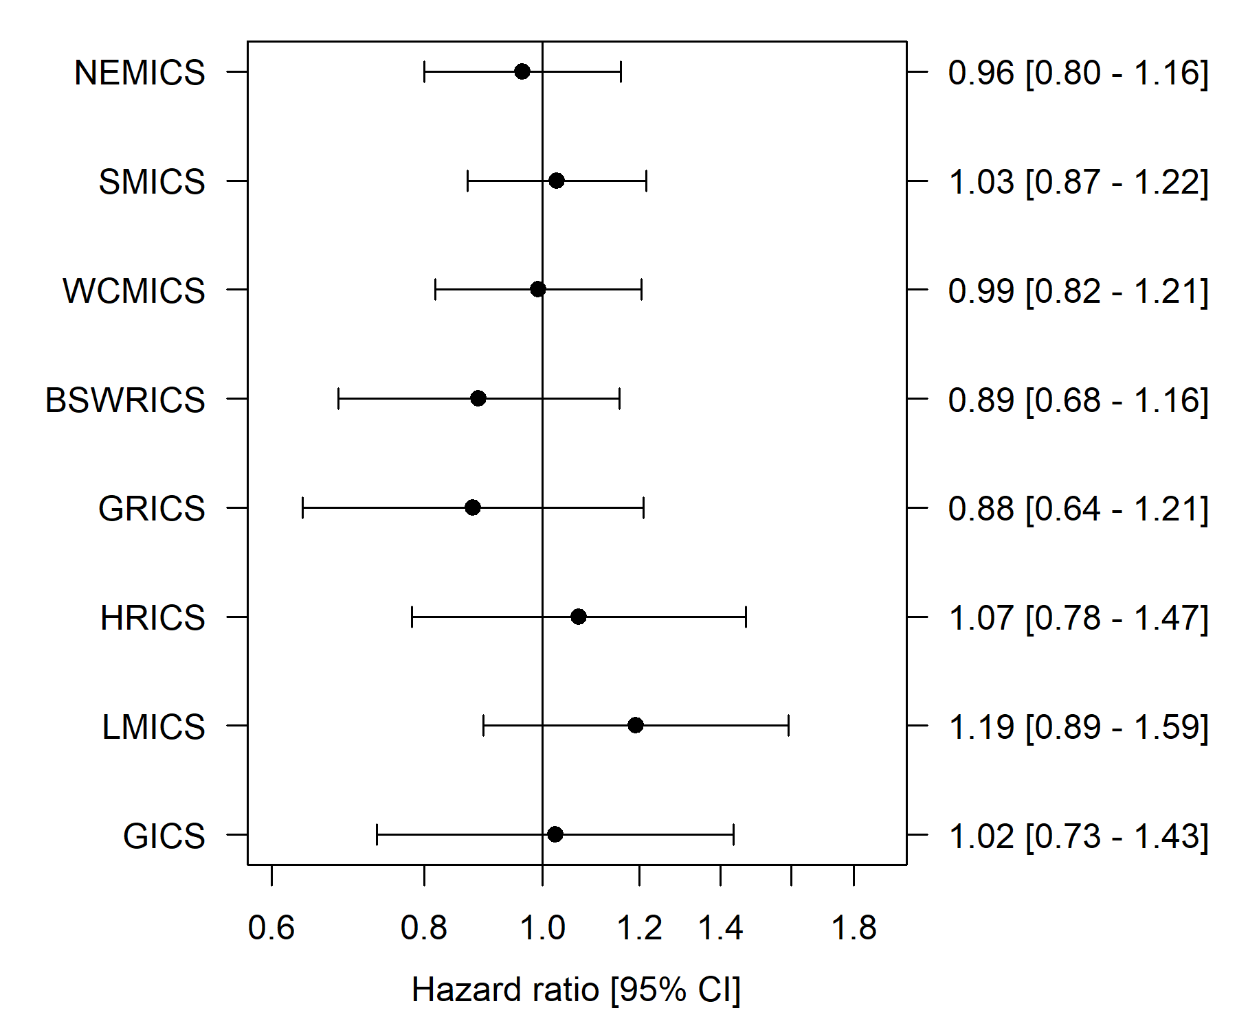
Poorer survival--->
<---Better survival
Hazard ratio
[95% CI]
Data source: VCR, VAED, 2014–2018
Bars represent 95 per cent CI.
Victorian average = 1.0.

Clinical commentary – de novo metastatic breast cancer
For the do novo metastatic patients, we increased the period of diagnosis to 2014–2018 to capture a larger cohort. Most patients (78 per cent) did not have comorbidities. For de novo metastatic disease, it was uncommon to be diagnosed with a grade 1 cancer (2 per cent), and a higher proportion of diagnoses were HER2-amplified compared with early breast cancer.

Supportive care
From the CSPI medical record audit 2018, 54 per cent of breast cancer patients audited had documented evidence of supportive care screening (Figure 20).
Only nine (out of 35) campuses reached the 80 per cent target.
Figure 20: Proportion of invasive breast cancer patients with documented evidence of supportive care screening in their medical record by ICS and campus of treatment (N = 465)
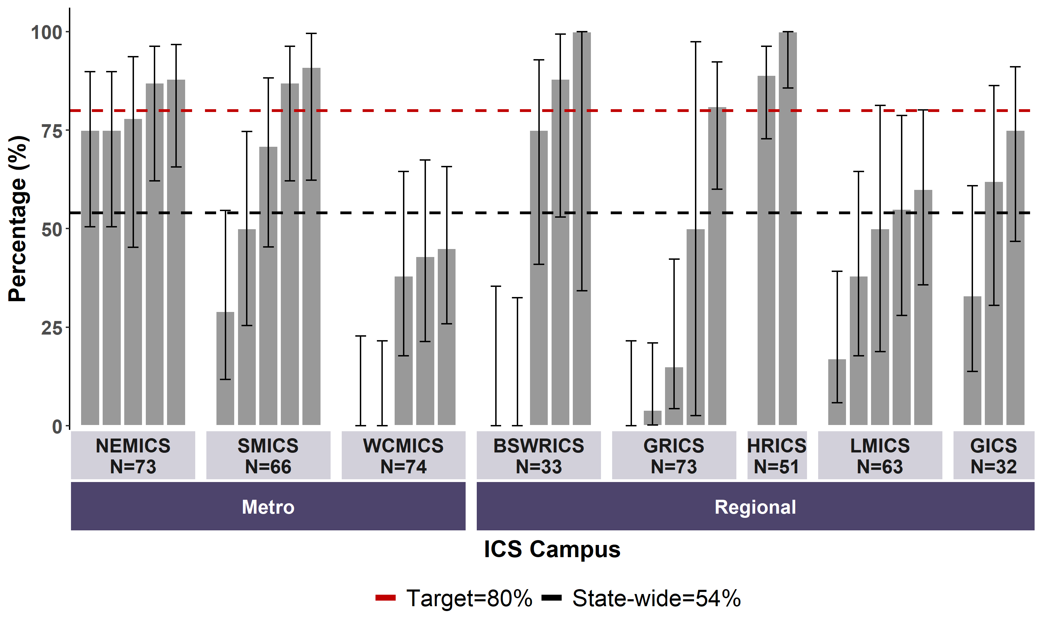
Data source: CSPI medical record audit 2018
Bars represent 95 per cent CI.
Patients with a C50 diagnosis.
Includes 35 campuses: 30 public and five private hospitals.

Male breast cancer

Incidence, demographics, and tumour characteristics
Between 2016 and 2018, there were 139 incident cases of male breast cancer across Victoria (Table 21).
- The median age at diagnosis was 72 years old.
- 76 per cent had no comorbidities identified from admitted episodes in the period one year prior and up to one month after diagnosis.
- 92 per cent of male breast cancers were invasive.
- 63 per cent were diagnosed with grade 2 or 3 tumours; 25 per cent did not have a recorded grade.
Table 21: Demographics of male breast cancer (n = 139)
Variable | Level | Median [IQR] or N (%)
Age, median [IQR] | N/A | 72 [65–79]
Socioeconomic status | Disadvantaged (Q1) | 31 (22%)
Socioeconomic status | Middle (Q2–Q4) | 83 (60%)
Socioeconomic status | Affluent (Q5) | 25 (18%)
Comorbidity count (VAED derived 1 year prior; 1 month after diagnosis; Quan 2011; excl. cancer) | 0 | 106 (76%)
Comorbidity count | 1 | 25 (18%)
Comorbidity count | 2+ | 8 (6%)
Diagnosis | Invasive breast cancer | 128 (92%)
Diagnosis | DCIS | 11 (8%)
Grade | Grade 1 | 16 (12%)
Grade | Grade 2 | 46 (33%)
Grade | Grade 3 | 42 (30%)
Grade | Unknown | 35 (25%)
Data source: VCR, VAED, 2016–2018

Clinical commentary – male breast cancer
Male breast cancer patients were diagnosed at a slightly older age (median age 72), with more comorbidities than female breast cancer patients. It is noted in the literature that approximately one in a hundred breast cancers occur in men, and this is reflected in the Victorian data.

Abbreviations
ABS | Australian Bureau of Statistics
BSV | BreastScreen Victoria
CI | confidence interval
CSPI | Cancer Services Performance Indicator
DCIS | ductal carcinoma in situ
HER2 | human epidermal growth factor receptor 2
ICS | Integrated Cancer Service
IHC | immunohistochemistry
ISH | in situ hybridisation
MDM | multidisciplinary meeting
OCP | optimal care pathway
SES | socioeconomic status
VAED | Victorian Admitted Episodes Dataset
VCR | Victorian Cancer Registry
VRMDS | Victorian Radiotherapy Minimum Data Set

Victorian Integrated Cancer Services
NEMICS | North Eastern Melbourne Integrated Cancer Service
SMICS | Southern Melbourne Integrated Cancer Service
WCMICS | Western and Central Melbourne Integrated Cancer Service
BSWRICS | Barwon South Western Regional Integrated Cancer Service
GRICS | Gippsland Regional Integrated Cancer Services
HRICS | Hume Regional Integrated Cancer Service
LMICS | Loddon Mallee Integrated Cancer Service
GICS | Grampians Integrated Cancer Service

Glossary
BSV-detected | Tumours that were detected though routine screening through BreastScreen Victoria. This does not include:  - tumours detected through BreastScreen centres outside Victoria  - tumours detected through private screening.
Chemotherapy | An admitted episode in the VAED where the admission date was between 30 days prior and one year after the patient’s breast cancer diagnosis date and included a chemotherapy diagnosis, procedure or diagnosis related group code (Supplementary Table 3).
Comorbidity count | A count measuring the number of comorbid conditions a patient has at diagnosis, which may influence their prognosis. Data on patient comorbidities was extracted from diagnosis codes of admitted episodes in the VAED in the year prior up until 30 days after the patient’s breast cancer diagnosis date. Patients without admitted episodes were assumed to have no comorbidities. The comorbidity count was calculated for each patient according to Quan et al. (excluding cancer and metastases) and grouped into four categories (0, 1, 2 and 3+).  Diagnosis codes for comorbidities can only be assigned in the admitted episode when the comorbidities meet criteria for coding in line with the Australian Coding Standards. As a result, the identification of comorbidities is underestimated.  Conditions included in the comorbidity count:  - AIDS/HIV  - congestive heart failure  - chronic pulmonary disease  - dementia  - diabetes with chronic complications  - hemiplegia or paraplegia  - mild liver disease  - moderate/severe liver disease  - renal disease  - rheumatic disease.
Death certificate only | A method of cancer notification to the VCR whereby the death certificate provides the only notification of a person’s cancer to the registry.
Diagnosis date | The date of the pathology report or other investigative report where the diagnosis of breast cancer was first confirmed to the VCR.
Early breast cancer | Invasive breast cancer was classified as early breast cancer where the stage at diagnosis was stage 1, 2 or 3. It also includes patients whose recorded stage was after neoadjuvant treatment (their stage at diagnosis was unknown).
Neoadjuvant chemotherapy | Chemotherapy was considered neoadjuvant where there was at least one chemotherapy admission within three months before surgery (breast-conserving surgery or mastectomy).
Radiotherapy (non-palliative intent) | Radiotherapy courses in the VRMDS where the start date was between 30 days before and one year after the patient’s breast cancer diagnosis date, the primary site was a breast cancer code (ICD-10-AM C50) or DCIS code (D05), the target site was ‘breast’, ‘breast/lymph nodes’, ‘chest wall’ or ‘chest wall/lymph nodes’ and the treatment intent was radical.
Histological subtypes | Breast cancer diagnoses were grouped into the following groups based on oestrogen receptor (ER) status, progesterone receptor (PR) status, and human epidermal growth factor receptor 2 (HER2) status at the time of diagnosis.  - luminal: ER positive  - HER2-amplified: HER2-amplified as confirmed by ISH test (IHC3+ insufficient)  - triple-negative: ER negative, PR negative, HER2 negative.  Receptor status is an important prognostic indicator for breast cancer.
(De novo) metastatic breast cancer | Metastatic breast cancer was determined by VCR TNM-M (M1) and admitted episodes in the VAED between 30 days before and four months after the diagnosis date, which contained metastatic cancer diagnosis codes (neoplasm and morphology codes).
Relative survival | Relative survival measures the survival of the cancer cohort compared with the survival of the general population, grouped by age and sex. For example, 56 per cent five-year relative survival indicates that the survival for the cancer cohort is just over half of what we would expect in a group of the same age and sex without cancer.
Socioeconomic status (SES) | A measure of a person’s economic and social position within society, which tends to be positively associated with better health. In this report SES is based on the Index of Relative Socio-Economic Disadvantage (IRSD) included in the Socio-Economic Index of Areas published by the Australian Bureau of Statistics. Victorians were assigned an IRSD score using their residential address at the time of their diagnosis. IRSD scores have been grouped into quintiles (from 1 – most disadvantaged, to 5 – least disadvantaged).
Surgery | An admitted episode in the VAED where the admission date was between 30 days before and one year after the patient’s breast cancer diagnosis date and the episode included a breast cancer surgery procedure code (Supplementary Table 2, ‘Mastectomy’ and ‘Breast-conserving surgery’ group).
VCR diagnosis date | The date of the pathology report or other investigative report where the diagnosis of cancer was first confirmed to the VCR.

Supplementary material

Codes

Diagnosis
Supplementary Table 1: Breast cancer diagnosis codes
ICD-10-AM | Description
C500 | Malignant neoplasm of nipple and areola
C501 | Malignant neoplasm of central portion of breast
C502 | Malignant neoplasm of upper-inner quadrant of breast
C503 | Malignant neoplasm of lower-inner quadrant of breast
C504 | Malignant neoplasm of upper-outer quadrant of breast
C505 | Malignant neoplasm of lower-outer quadrant of breast
C506 | Malignant neoplasm of axillary tail of breast
C508 | Overlapping malignant lesion of breast
C509 | Malignant neoplasm of breast, unspecified part
D050 | Lobular carcinoma in situ of breast
D051 | Intraductal carcinoma in situ of breast
D057 | Other carcinoma in situ of breast
D059 | Carcinoma in situ of breast, unspecified

Surgery
Supplementary Table 2: Surgical procedure codes used to identify patients who underwent mastectomy, breast-conserving surgery, biopsy or reconstruction
Group | ICD-10-AM/ ACHI/ACS code | Description
Mastectomy | 3151800 | Simple mastectomy, unilateral
Mastectomy | 3151801 | Simple mastectomy, bilateral
Mastectomy | 3152400 | Subcutaneous mastectomy, unilateral
Mastectomy | 3152401 | Subcutaneous mastectomy, bilateral
Breast-conserving surgery | 3150000 | Excision of lesion of breast
Breast-conserving surgery | 3151500 | Re-excision of lesion of breast
Breast-conserving surgery | 3153600 | Localisation of lesion of breast
Reconstruction | 4553000 | Reconstruction of breast using flap
Reconstruction | 4553002 | Reconstruction of breast using flap
Reconstruction | 4553300 | Reconstruction of breast using breast sharing technique, first stage
Reconstruction | 4553600 | Reconstruction of breast using breast sharing technique, second stage
Reconstruction | 4553900 | Reconstruction of breast with insertion of tissue expander
Reconstruction | 4554200 | Removal of breast tissue expander and insertion of permanent prosthesis
Lymph node biopsy | 3007500 | Biopsy of lymph node
Lymph node biopsy | 3030000 | Sentinel lymph node biopsy of axilla
Lymph node biopsy | 3030001 | Sentinel lymph node biopsy, not elsewhere classified
Lymph node excision | 3033200 | Excision of lymph node of axilla
Lymph node excision | 3033500 | Regional excision of lymph nodes of axilla
Lymph node excision | 3033600 | Radical excision of lymph nodes of axilla
Biopsy | 3150001 | Open biopsy of breast
Biopsy | 3153300 | Fine needle biopsy of breast
Biopsy | 3154800 | Core biopsy of breast

Chemotherapy
Supplementary Table 3: Diagnosis, procedure and diagnosis related group codes used to identify patients who received chemotherapy
Code group | Code | Description
Diagnosis | Z511 | Pharmacotherapy session for neoplasm
Procedure | 9619600 | Intra-arterial administration of pharmacological agent, antineoplastic agent
Procedure | 9619700 | Intramuscular administration of pharmacological agent, antineoplastic agent
Procedure | 9619800 | Intrathecal administration of pharmacological agent, antineoplastic agent
Procedure | 9619900 | Intravenous administration of pharmacological agent, antineoplastic agent
Procedure | 9620000 | Subcutaneous administration of pharmacological agent, antineoplastic agent
Procedure | 9620100 | Intracavitary administration of pharmacological agent, antineoplastic agent
Procedure | 9620200 | Enteral administration of pharmacological agent, antineoplastic agent
Procedure | 9620300 | Oral administration of pharmacological agent, antineoplastic agent
Procedure | 9620500 | Other administration of pharmacological agent, antineoplastic agent
Procedure | 9620600 | Unspecified administration of pharmacological agent, antineoplastic agent
Procedure | 9620900 | Loading of drug delivery device, antineoplastic agent
Diagnosis related group | R63Z | Chemotherapy
Where an admission had one of the codes listed in Supplementary Table 3 and also had a diagnosis code ‘Z53’, the admission was not included as a chemotherapy admission.
Code group | Code | Description
Diagnosis | Z53 | Procedure not carried out

Refer to the ‘Abbreviations’ page for the naming of the eight Victorian ICS.
Documenting MDM recommendations in the medical record ensures such information is accessible to all team members. The target of 85 per cent aims to drive quality improvement and equity of access to MDMs and applies to all tumour streams.
“De novo” breast cancer refers to breast cancer that is first diagnosed when it has already spread outside of the breast to distant parts of the body.
Supportive care addresses a wide range of needs across the continuum of care for those affected by cancer. The measure of documented evidence of screening for supportive care needs is set at 80% to drive quality improvement and equity of access to supportive care services. The target applies to all tumour streams.
Quan H, Li B, Couris C, et al. 2011, ‘Updating and validating the Charlson comorbidity index and score for risk adjustment in hospital discharge abstracts using data from 6 countries’, American Journal of Epidemiology, vol. 173, no. 6, pp. 676–682.
Also shown in the Victorian Cancer Registry Data Explorer, Cancer Council Victoria, Melbourne, viewed on 13 April 2022, <https://www.cancervic.org.au/research/vcr>.
Department of Health Victoria, Cancer services performance indicator audit 2018, viewed on 27 April 2023 <https://www.health.vic.gov.au/publications/cancer-services-performance-indicator-audit-2018>
Online delivery means via an online communication platform.
Quan H, Li B, Couris C, et al. 2011, ‘Updating and validating the Charlson comorbidity index and score for risk adjustment in hospital discharge abstracts using data from 6 countries’, American Journal of Epidemiology, vol. 173, no. 6, pp. 676–682.
Quan H, Li B, Couris C, et al. 2011, ‘Updating and validating the Charlson comorbidity index and score for risk adjustment in hospital discharge abstracts using data from 6 countries’, American Journal of Epidemiology, vol. 173, no. 6, pp. 676–682.
Australian Coding Standard ACS 0002 Additional Diagnoses.

