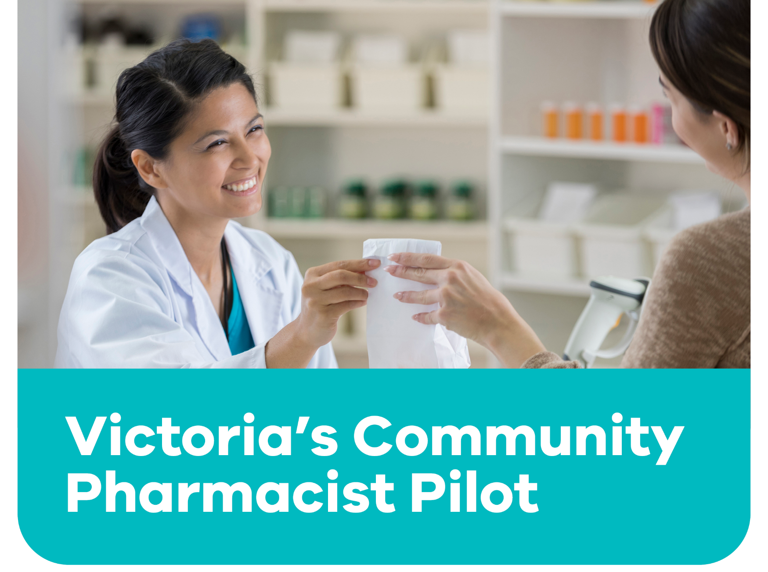

The 12-month pilot will allow people to receive some treatment at a local pharmacy without needing to see a doctor to get a prescription first.
Insert your logo then delete this text

Current services include:

For more information
speak with your pharmacist, or
visit Better Health Channel
- Continued supply of oral contraceptive pills, without a prescription.
Insert QR Code then delete this text
- Treatment for uncomplicated urinary tract infections in women.
- Travel and other vaccines.
- Treatment for shingles and mild plaque psoriasis

