Community Pharmacist Pilot
Stakeholder communications pack and marketing guidelines (May 2024)
OFFICIAL

Background
The Victorian Department of Health commenced a 12-month Community Pharmacist Pilot (the pilot) in October 2023 to test an expanded role for community pharmacists.
During this time, participating and appropriately trained community pharmacists can provide certain Schedule 4 medications under a structured prescribing model for:
- Treatment for herpes zoster (shingles) (aged 18 years and over)
- Treatment for a flare up of mild plaque psoriasis (aged 18 years and over)
- Resupply of select oral contraceptive pills without a prescription for people who are taking the oral contraceptive pill (aged 16 - 50 years)
- Treatment for uncomplicated urinary tract infections in women and gender diverse people (aged 18 – 65 years)
Following the completion of additional training, pharmacist immunisers participating in the pilot will be authorised to administer select travel health and other vaccines.
The pilot aims to increase access to affordable primary health care, ensuring Victorians can get the healthcare they need quickly and locally.

Promotion
To ensure consistency of branding, the department asks participating pharmacies to use the provided communications materials in their promotion of pilot services: https://www.health.vic.gov.au/primary-care/victorian-community-pharmacist-statewide-pilot-resources-for-pharmacists.
These materials will continue to be reviewed and updated according to consumer and other stakeholder feedback.
The department will continue to promote the pilot for the duration of the pilot. Participating pharmacies and other stakeholders are encouraged to utilise the provided materials for promotion within their own networks. See Appendix 1 for sample social posts and newsletter/web article content.
The Better Health Channel page (https://www.betterhealth.vic.gov.au/community-pharmacist-pilot) will serve as the ‘single source of truth’ for public messaging and lists participating pharmacy details. Please use this link for general promotion of pilot services.

Key messages
Please use these messages when communicating publicly about your service.
- The statewide pilot will help to make it easier and cheaper for Victorians to get the healthcare they need for some common health conditions.
- Communities with participating pharmacies can now easily access more local services – especially in areas where it is hard to get a GP appointment.
- To check if your local pharmacy is providing additional services, visit https://www.betterhealth.vic.gov.au/community-pharmacist-pilot.
The Victorian Government is helping communities get greater access to the right care, in the right place, at the right time while helping to ease pressure on our broader health system.

Additional Information

Consultation and medicine costs
Under the pilot, there is no consultation fee for patients to access treatment for the herpes zoster (shingles), flare up of mild plaque psoriasis or an uncomplicated urinary tract infection, or if they need further supply of their usual oral contraceptive pill.
Medication costs will be the same as patients usually pay. If a medicine is not listed under the Pharmaceutical Benefits Scheme (PBS), consumers will pay full price – the same as they would if they had a prescription from their doctor. However, as medications supplied as part of the pilot are not PBS funded, payment amounts do not contribute towards the PBS SafetyNet.
For travel health consultations, pharmacies may charge the patient a consultation fee, plus the cost of any vaccines administered. The pharmacist will discuss all fees with the patient before starting the consultation and providing any vaccines.

Appendix 1 – marketing content
An editable flyer and posters (along with social assets and other collateral) are available for download at: https://www.health.vic.gov.au/primary-care/victorian-community-pharmacist-statewide-pilot-resources-for-pharmacists.

Social media
Platform | Text | Assets
Facebook | Our pharmacy is excited to be part of the Victorian Government’s Community Pharmacist Pilot!  The Community Pharmacist Pilot allows people to receive some treatments at a local pharmacy without needing to see a doctor to get a prescription first.  This 12-month pilot allows pharmacies to provide:  🔵 Treatment for shingles  🔵 Treatment for a flare up of mild plaque psoriasis  🔵 Resupply of the oral contraceptive pill without a prescription  🔵 Treatment for uncomplicated urinary tract infections  🔵 Provision of travel and other vaccines  This pilot is especially beneficial for women and individuals in areas with limited access to general practitioners.  For more information and to locate participating <insert name/brand of pharmacy>, visit https://www.betterhealth.vic.gov.au/community-pharmacist-pilot | Animated video screenshot  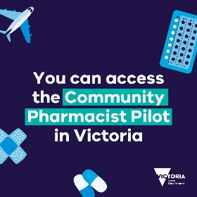  The video will automatically download via Zip file when you download this stakeholder pack.
Instagram | Our pharmacy is excited to be part of the Victorian Government’s Community Pharmacist Pilot!  The Community Pharmacist Pilot allows people to receive some treatments at a local pharmacy without needing to see a doctor to get a prescription first.  This 12-month pilot allows pharmacies to provide:  🔵 Treatment for shingles  🔵 Treatment for flare up of mild plaque psoriasis  🔵 Resupply of the contraceptive pill without a prescription  🔵 Uncomplicated urinary tract infection  🔵 Provision of travel and other vaccines  This pilot is especially beneficial for women and individuals in areas with limited access to general practitioners.  For more information and to locate participating <insert name/brand of pharmacy>, visit https://www.betterhealth.vic.gov.au/community-pharmacist-pilot | Carousel images  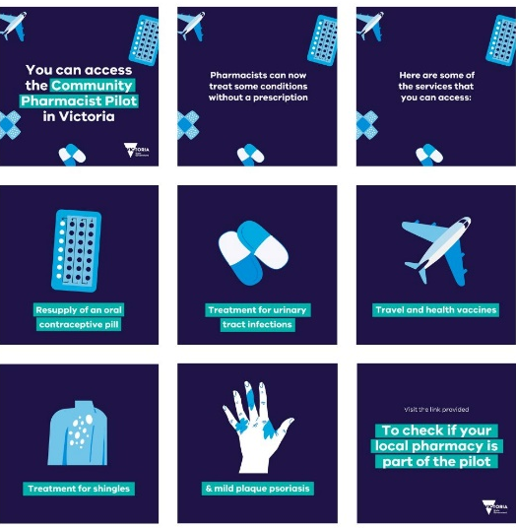  These images will automatically download via Zip file when you download this stakeholder pack.
X/Twitter | Our pharmacy is excited to be part of the Victorian Government’s Community Pharmacist Pilot!  This means that Victorians can now receive some treatment at our pharmacies without needing to get a prescription first.  For more information and to locate participating <insert name/brand of pharmacy>, visit https://www.betterhealth.vic.gov.au/community-pharmacist-pilot | Animated GIF screenshot  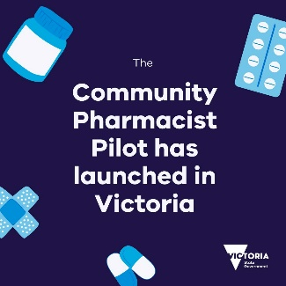  The GIF will automatically download via Zip file when you download this stakeholder pack.

Newsletter/web article
Victoria is piloting a new approach to making healthcare more accessible.
A 12-month pilot is allowing Victorians to receive some treatments at a local pharmacy without needing to see a doctor to get a prescription first.
It particularly benefits women and people living in areas where it is hard to get a general practitioner (GP) appointment.
During this time, you can attend a pharmacy for treatment of the following common health concerns:
- People who are taking the oral contraceptive pill can request a resupply of their usual pill they are already using, without needing a prescription.
- Women and gender diverse people with uncomplicated urinary tract infections can access treatment.
- Treatment for shingles
- Treatment for a flare up of mild plaque psoriasis
- Pharmacist immunisers can provide some vaccinations for travel and other vaccines including hepatitis A, hepatitis B, poliomyelitis and typhoid.
For more information and locations of participating pharmacies, please visit: https://www.betterhealth.vic.gov.au/community-pharmacist-pilot.

Your own branded advertising
If your pharmacy would like to reference the Community Pharmacist Pilot or the extra services in your own branded advertising, please add in the following line or voice over: "The Community Pharmacist Pilot is funded by the Victorian State Government".

Use of the Victorian Government logo
If you would like to use the Victorian Government logo in any of your advertising, please contact the Department of Health’s Marketing team for consideration, review and approval.
Campaigns@health.vic.gov.au

Referring to the Pilot on your website
If your pharmacy would like to reference the Pilot on your website, please include the Victorian Government logo and the following line: "The Community Pharmacist Pilot is funded by the Victorian Government".
Please contact the Department of Health’s Marketing team for review and approval.
Campaigns@health.vic.gov.au

To receive this document in another format, email Community Pharmacist Pilot: cpp@health.vic.gov.au.
Authorised and published by the Victorian Government, 1 Treasury Place, Melbourne.
© State of Victoria, Australia, Department of Health, September 2023.
Available at Victorian Community Pharmacist Pilot: https://www.health.vic.gov.au/primary-care/victorian-community-pharmacist-statewide-pilot-resources-for-pharmacists

