Germicidal Ultraviolet Lights
Information for residential aged care staff, residents and families
OFFICIAL

What is germicidal ultraviolet lighting?

Ultraviolet (also called UV) light is a light that humans cannot see but it can make viruses and bacteria harmless and unable to cause disease. Germicidal ultraviolet lights are specially designed to produce UV light to disinfect the air and have been shown to reduce the spread of several diseases. They are placed so the UV light is only in the upper part of the room, like in the image opposite. Bacteria and viruses are carried into the path of the light by normal air movement. This allows people to use the room in the usual way.
For more information on germicidal lighting please visit the Department of Health webpage <https://www.health.vic.gov.au/infectious-diseases-guidelines-and-advice/germicidal-ultraviolet-light-combatting-airborne-virus-transmission>

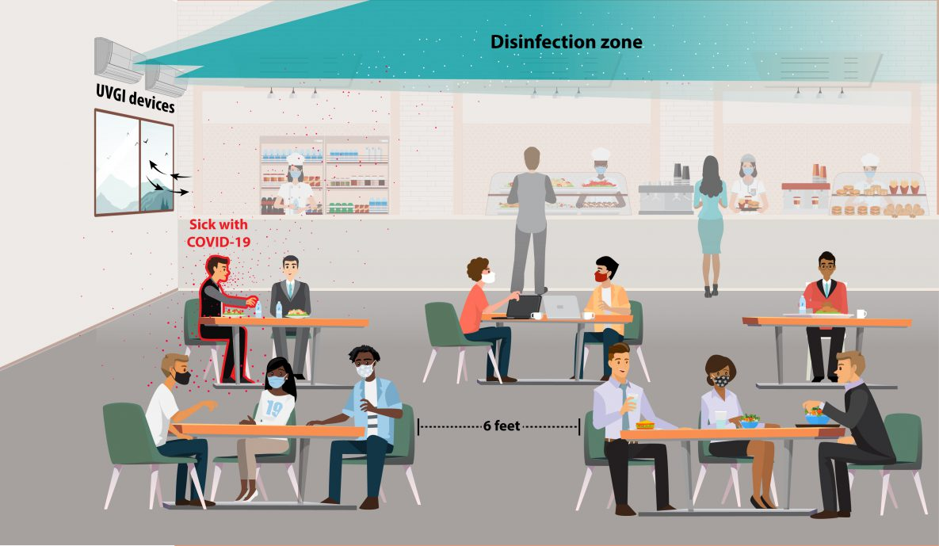
Figure 1: US CDC: https://www.cdc.gov/coronavirus/ 1

Why do people install Germicidal Ultraviolet lighting?
Germicidal ultraviolet lighting has been used in hospitals for many years to reduce the spread of disease. Laboratory tests show that the viruses which cause COVID-19 and the flu can be inactivated by UV light.
This is an additional way to prevent the spread of infectious diseases and is sometimes used in combination with other methods like masks and high-quality filters.

Are these lights being used in buildings?
Yes, germicidal ultraviolet lights are operating in Australia in some residential aged care facilities, childcare centres and schools. There are also many schools, hospitals, homeless shelters, and other public buildings with ultraviolet light installations in the United States, Europe and other countries around the world. Ultraviolet lights have been used to disinfect rooms for nearly 70 years.

Are they safe?
Yes, the ultraviolet lights are positioned to only operate in the upper part of the room above the area normally used by people. It would not be safe to be directly exposed to the germicidal ultraviolet light for an extended period, so there should always be checks to make sure they are installed correctly and that the light is directed up and away from people. They will be monitored frequently to make sure that the germicidal ultraviolet lights continue to operate properly.

How do viruses move up to where the ultraviolet light is?
Indoor air moves around naturally due to different activities. When heaters, air conditioners, or fans operate, they create air movement. People coming in and out of rooms also cause air to flow. Also, the warmth from our bodies and electrical devices makes the air rise upwards. This movement carries tiny particles, like viruses, upward into the area where the ultraviolet light can disinfect them.

Can the lights be switched off?
Yes, the lights have a switch to turn them off. They need to be turned off if there is work to be done at height, for example if someone needs to work on a ladder near them.

Will the lights disinfect surfaces?
No, when the lights are used in the upper room they can disinfect the air but they will not clean surfaces. The usual cleaning protocols for surfaces are still required when germicidal ultraviolet lights are used.

To receive this document in another format, phone 1800 519 722, using the National Relay Service 13 36 77 if required, or email guvproject@health.vic.gov.au
Authorised and published by the Victorian Government, 1 Treasury Place, Melbourne.
© State of Victoria, Australia, Department of Health, May 2024.
Available at Health.vic.gov.au - Germicidal ultraviolet light - combatting airborne virus transmission <https://www.health.vic.gov.au/infectious-diseases-guidelines-and-advice/germicidal-ultraviolet-light-combatting-airborne-virus-transmission>

