Reporting home births
Guidelines for midwives reporting home births to the Victorian Perinatal Data Collection (VPDC)
OFFICIAL
Contents
Introduction 1
Public homebirth programs 2
Private practice homebirth midwives 5
Further information and assistance 6
Flow chart – Victorian Perinatal Data Collection (VPDC) homebirth data reporting 7

Introduction
These guidelines have been developed to support consistent VPDC reporting of births occurring in the home. For many reasons, users of VPDC data need to be able to distinguish between births occurring in the home and births occurring in the hospital.

Public Health and Wellbeing Act 2008
The Public Health and Wellbeing Act 2008 (s.48) requires that births are reported by the health service in which the birth occurs, or if the birth does not occur in a health service, that the birth is reported by the midwife in attendance at the time of the birth, or by the registered medical practitioner in attendance at the time of the birth (if no midwife present), or in other circumstances, the birth is to be reported by the health service to which the mother/baby is admitted due to the birth, or the registered medical practitioner who cares for/treats the mother or child due to the birth.

Definitions
All data reported to the VPDC reflects the antenatal course, and events, conditions and care provided during the birth episode until the separation date. Care provided, or events occurring, after the birth episode, for example in the care of a postnatal domiciliary service or after transfer to another hospital campus, are not reported to the VPDC because they did not occur during the birth episode.

Birth episode
A birth episode is a period of admitted care during which a birth occurs. The birth episode commences on the mother’s admission date.

Admission date
For births planned to occur in the home, the admission date is the date the homebirth midwife arrives at the mother’s home or other homebirth location for the birth.

Separation date
For births in the care of private practice homebirth midwives, the separation date is the date the midwife leaves the place of birth after the birth, or when the baby or mother is transferred to a hospital or dies.
A public homebirth program provides care from an authorised hospital campus. For the purposes of VPDC reporting, the birth episode concludes when the mother and baby are no longer receiving admitted care from that hospital campus. Therefore, for public homebirths, separation date can be when the midwife leaves the place of birth after the birth, or when the mother or baby is discharged from that hospital campus having been transferred there after the birth, or is transferred to another hospital campus, or dies.

Public homebirth programs
Public homebirth programs are operated by authorised public hospital campuses. Births occurring in public homebirth programs must be reported to the VPDC along with births occurring at that hospital campus.
The following section outlines specific requirements for selected data items to enable births occurring at home under a public homebirth program to be identified in VPDC data.

Setting of birth – actual
The setting of birth is reported as a public homebirth program birth when the birth occurs in the home setting under the care of the public homebirth program midwife.
Code | Reporting guide
0007 Home – Public homebirth program | Birth attended by a public midwife in the mother’s home. The midwife arrived at the home before the birth and was present for the birth.
0003 Home (other) | Birth in the mother’s home, public midwife not present for the birth (baby born before midwife’s arrival).

Date of admission – mother
Report the mother’s date of admission as the date the public homebirth midwife arrived at the mother’s home for the birth episode (regardless of whether this was before or after baby’s birth).

Separation
Separation details for the mother and baby will depend on the circumstances of the birth episode for both baby and mother.
- Midwife leaves and baby and mother remain at the birth location, no further admitted care is provided to the baby or mother during the birth episode. Birth episode concludes.
Baby remains at home
Data item | Reporting guide
Separation date – baby | Date the midwife leaves the birth location.
Separation status – baby | - Discharged  - Died

Mother remains at home
Data item | Reporting guide
Separation date – mother | Date the midwife leaves the birth location.
Separation status – mother | 1 Discharged  2 Died

- Baby or mother (or both) transferred to the hospital campus that is the base for this public homebirth program immediately following the birth (before the midwife leaves the home birth location). Birth episode continues until separation of mother or baby (or both) from admitted care provided by the base hospital campus.
Do not report as a transfer from the homebirth location to the homebirth program base campus: the admitted episode continues under the same hospital campus.
Baby transferred to public homebirth program base campus
Data item | Reporting guide
Separation date – baby | The date on which the homebirth hospital campus concludes admitted care to the baby at the end of the birth episode – that is, baby is discharged, transferred to another hospital campus, or dies.
Neonatal Morbidity (baby) | The baby’s condition/s (if any) requiring care in the hospital setting.
Admission to special care nursery (SCN) / neonatal intensive care unit (NICU) – baby | Report whether care is provided in SCN/NICU at the homebirth program base campus during the birth episode

Mother transferred to public homebirth program base campus
Data item | Reporting guide
Separation date – mother | The date on which the homebirth hospital campus concludes admitted care to the mother at the end of the birth episode – that is, mother is discharged, transferred to another hospital campus, or dies.
Events of labour and birth (mother) | The mother’s condition/s (if any) requiring care in the hospital setting.
Postpartum complications (mother)
Admission to high dependency unit (HDU) / intensive care unit (ICU) – mother | Report whether care is provided in HDU/ICU at the homebirth program base campus during the birth episode

- Baby or mother (or both) transferred immediately following the birth (before the midwife leaves the home birth location) to another hospital campus that is not the base for this public homebirth program. Birth episode concludes with the transfer.
Transfer from the homebirth location to another hospital campus is reported as a transfer because admitted care is transferred to that other campus.
Baby transferred to another hospital campus
Data item | Reporting guide
Separation status – baby | 3 Transferred
Transfer destination – baby | Hospital campus to which the baby is transferred  (reported as the four-digit Campus code).
Reason for transfer out – baby | 1 Higher level of care
Separation date – baby | The date on which the baby is transferred from the home birth location to the other hospital campus.
Neonatal Morbidity (baby) | The baby’s condition/s (if any) requiring care in the other hospital setting.
Admission to special care nursery (SCN) / neonatal intensive care unit (NICU) – baby | 3 Not admitted to SCN or NICU  (because no SCN or NICU at the homebirth location during the birth episode)

Mother transferred to another hospital campus
Data item | Reporting guide
Separation status – mother | 3 Transferred
Transfer destination – mother | Hospital campus to which the mother is transferred  (reported as the four-digit Campus code).
Reason for transfer out – mother | 1 Higher level of care
Separation date – mother | The date on which the mother is transferred from the home birth location to the other hospital.
Events of labour and birth (mother) | The mother’s condition/s (if any) requiring care in the other hospital setting
Postpartum complications (mother)
Admission to high dependency unit (HDU) / intensive care unit (ICU) – mother | 2 Not admitted to HDU or CCU  (because no HCU or CCU at the homebirth location during the birth episode)

Private practice homebirth midwives
The lead private practice homebirth midwife in attendance at the birth must report the VPDC data using the Perinatal webform via their personal individual login to the HealthCollect secure data platform.
The following section outlines specific requirements for selected data items to enable births occurring at home in the care of a private practice homebirth midwife to be identified in VPDC data.

Setting of birth – actual
The setting of birth is reported as private midwife care when the birth occurs in the home setting under the care of a private practice homebirth midwife.
Code | Reporting guide
0006 Home – Private midwife care | Birth attended by a private midwife practitioner in the mother’s own home or a home environment. The midwife arrived at the home before the birth and was present for the birth.
0003 Home (other) | Birth in the mother’s home, private practice homebirth midwife not present for the birth (baby born before midwife’s arrival).

Date of admission – mother
Report the mother’s date of admission as the date the private practice homebirth midwife arrived at the mother’s home for the birth episode (regardless of whether this was before or after baby’s birth).

Separation
Separation details for the mother and baby will depend on the circumstances of the birth episode for both baby and mother.
- Midwife leaves and baby and mother remain at the birth location, no further admitted care is provided to the baby or mother by that midwife. Birth episode concludes with the departure of the midwife from the home.
Baby remains at home
Data item | Reporting guide
Separation date – baby | Date the midwife leaves the birth location.
Separation status – baby | - Discharged  - Died

Mother remains at home
Data item | Reporting guide
Separation date – mother | Date the midwife leaves the birth location.
Separation status – mother | 1 Discharged  2 Died

- Baby or mother (or both) transferred to a hospital immediately following the birth (before the midwife leaves the home birth location). Birth episode concludes with the transfer to hospital. The private homebirth midwife does not report on any of the care provided at the transfer destination, including whether baby is admitted to SCN or NICU, or mother to HDU or ICU. Those details will be reported by the hospital to other data collections.
Baby transferred to a hospital campus
Data item | Reporting guide
Separation status – baby | 3 Transferred
Transfer destination – baby | Hospital campus to which the baby is transferred  (reported as the four-digit Campus code).
Reason for transfer out – baby | 1 Higher level of care
Separation date – baby | The date on which the baby is transferred from the home birth location to the hospital.
Neonatal Morbidity (baby) | The baby’s condition/s (if any) requiring care in the hospital setting.
Admission to special care nursery (SCN) / neonatal intensive care unit (NICU) – baby | 3 Not admitted to SCN or NICU  (because no SCN or NICU at the homebirth location during the birth episode)

Mother transferred to a hospital campus
Data item | Reporting guide
Separation status – mother | 3 Transferred
Transfer destination – mother | Hospital campus to which the mother is transferred  (reported as the four-digit Campus code).
Reason for transfer out – mother | 1 Higher level of care
Separation date – mother | The date on which the mother is transferred from the home birth location to the hospital.
Events of labour and birth (mother) | The mother’s condition/s (if any) requiring care in the hospital setting.
Postpartum complications (mother)
Admission to high dependency unit (HDU) / intensive care unit (ICU) – mother | 2 Not admitted to HDU or CCU  (because no HCU or CCU at the homebirth location during the birth episode)

Further information and assistance
The flow chart on the next page provides a summarised visual of the above advice.
Refer to the VPDC manual relevant for the baby’s date of birth for complete data specifications, code sets, reporting guidelines and business rules for data items not listed in these guidelines. The VPDC manual is available on the VPDC website < https://www.health.vic.gov.au/quality-safety-service/victorian-perinatal-data-collection> .
Questions about these guidelines or reporting data to the VPDC can be emailed to the HDSS HelpDesk <hdss.helpdesk@health.vic.gov.au>.

Flow chart – Victorian Perinatal Data Collection (VPDC) homebirth data reporting
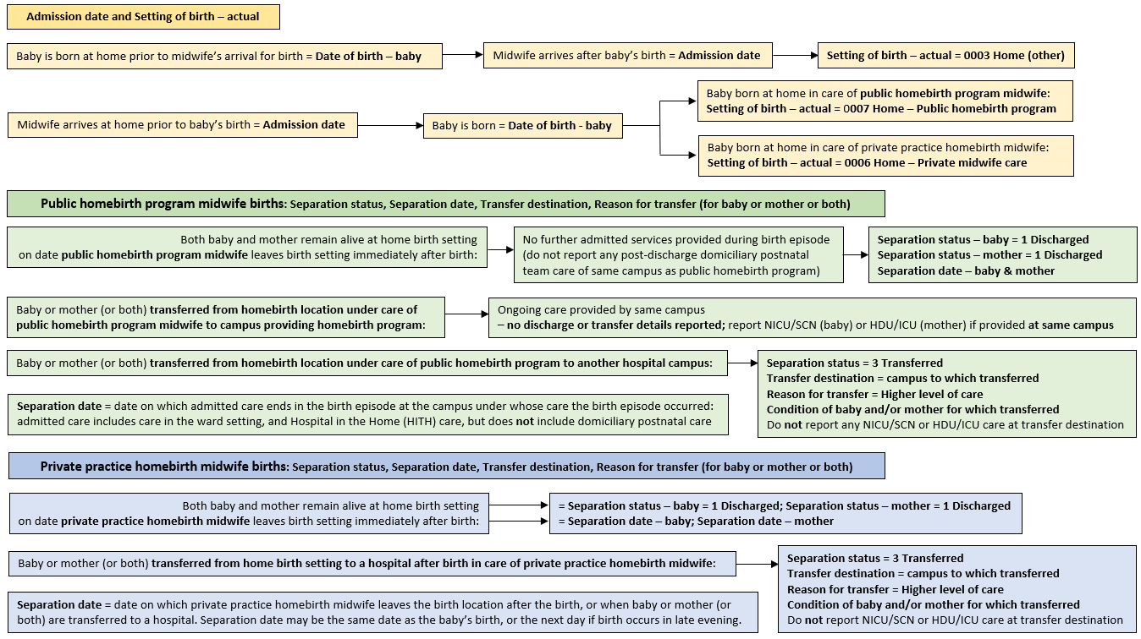

To receive this document in another format email the HDSS HelpDesk <hdss.helpdesk@health.vic.gov.au>.
Authorised and published by the Victorian Government, 1 Treasury Place, Melbourne.
© State of Victoria, Australia, Department of Health, May 2024.
Available at the VPDC webpage < https://www.health.vic.gov.au/quality-safety-service/victorian-perinatal-data-collection >

