Non-enclosed X-ray analysis units – Mandatory radiation safety requirements
Licence condition M1770
Document reference: HHSD/23/483253
OFFICIAL

Introduction
The Victorian Radiation Act 2005 (the Act) has the objective of protecting the health and safety of persons and the environment from the harmful effects of radiation. The Department of Health (the department) administers this legislation.
The Act seeks to fulfil this objective by establishing a licensing framework to regulate the conduct of radiation practices and the use of radiation sources.
Any person who conducts a radiation practice must hold a management licence (unless exempted from that requirement). The management licence holder must comply with every condition of their licence.

Scope
A management licence issued by the department that authorises a radiation practice involving the possession of a non-enclosed X-ray analysis unit for the purpose of analysing materials includes a condition that requires the management licence holder to meet the requirements described in this document.
The requirements apply to both a non-enclosed X-ray analysis unit incorporating an X-ray tube and to a non-enclosed X-ray analysis unit incorporating a sealed source when:
- the unit is used in the handheld mode and emits X-rays by depressing the trigger; or
- the unit is used on a benchtop and mounted on a proprietary stand fitted with shielding and emits radiation when engaged remotely through software installed on a function interface device.

General requirements

3.1 Training
The management licence holder must ensure that:
- at least one person within the company or business entity completes training from the supplier of the non-enclosed X-ray analysis unit before using the apparatus;
- the training from the supplier is promulgated to additional users of the non-enclosed X-ray analysis unit within the organisation by the person who successfully completed the training provided by the apparatus supplier. In this case, the organisation must develop a training package covering all aspects of training delivered by the supplier; and
- any person that has not completed the training as described above does not use a non-enclosed X-ray analysis unit.

3.2 Interlocks
The management licence holder must ensure that interlocks and/or proximity sensors:
- are maintained in good working condition; and
- are not modified to enable the unit to function in any other way other than that which the unit was originally designed for.

3.3 General working rules
The management licence holder must ensure that standard operating procedures are developed for use of non-enclosed X-ray analysis units and made available to all users of the unit(s).
Note: Under no circumstances must the unit be used to analyse a sample that is being positioned by any part of the body (e.g. jewellery or ore sample held in the hand).

3.4 Storage
The management licence holder must ensure that:
- the non-enclosed X-ray analysis unit is stored in a locked cabinet or similar space (e.g. drawer, foot locker, safe, etc) when not in use; and
- if deployed for field applications, the non-enclosed X-ray analysis unit is stored in a locked carry case when not in use and stored in a secure location (e.g. locked vehicle, field shed, etc) when possible.

3.5 X-ray warning lights
The management licence holder must ensure that the non-enclosed X-ray analysis unit incorporates a light that illuminates when the apparatus is emitting X-rays and that this warning light is maintained in working order.

3.6 Radiation warning lights
The management licence holder must ensure that:
- the non-enclosed X-ray analysis unit housing is clearly marked with a label indicating that ionising radiation is produced by the apparatus when energised. This may include a combination of the trefoil symbol and a “caution” and “X-ray apparatus” label; and
- the storage cabinet or similar space in 3.4(a) is clearly marked with a label indicating that an ionising radiation apparatus is being stored within the space. This may include a combination of the trefoil symbol and a “caution” and “X-ray apparatus” label.

3.7 Servicing
The management licence holder must ensure that:
- a non-enclosed X-ray analysis unit is serviced every 3 years in accordance with the manufacturer’s recommendations to confirm that it is operating within the designed safety specifications; and
- if the unit suffers a significant impact or is visibly damaged, it is serviced to confirm that it is operating safely.

Radiation Management Plan
The management licence holder must ensure that a Radiation Management Plan is developed, documented, resourced, implemented, and regularly reviewed. The Radiation Management Plan must include the following:
- roles and responsibilities;
- work practices;
- training;
- control and management of incidents; and
- any other requirement that may have a bearing on radiation safety.

Note: a template radiation management plan for X-ray analysis units is available on the department’s website:
<https://www.health.vic.gov.au/publications/radiation-management-plan-rmp-x-ray-analysis-unit-template>

Record keeping
The management licence holder must ensure that records are kept of:
- the storage location, including a floor plan of the premises showing where the X-ray analysis unit is stored (this does not apply to field use locations);
- when the portable X-ray analysis unit is removed from its storage location to be deployed in the field;
- training completed by personnel authorised to use the unit; and
- maintenance and repairs conducted on the units.

Additional requirements for non-enclosed X-ray analysis units incorporating a sealed source
6.1 Personal radiation monitoring
The management licence holder must ensure that an individual operating a non-enclosed X-ray analysis unit incorporating a sealed source is issued with and wears a personal radiation dosimeter unless it can be demonstrated through dose assessments that the operators are not likely to receive a dose of more than 1 millisievert per year.
6.2 Contamination checks
The management licence holder must ensure that:
- wipe tests are conducted to determine the presence of surface contamination for a non-enclosed X-ray analysis unit incorporating a sealed source if the unit has suffered a significant impact or if the unit is visibly damaged; and
- routine wipe tests for a non-enclosed X-ray analysis unit incorporating a sealed source be carried out every 5 years.
6.3 Transport
The management licence holder must ensure when transporting a non-enclosed X-ray analysis unit incorporating a sealed source that:
- the unit is packaged in accordance with the responsibilities of the consigner in accordance with the requirements of the Code of Practice for the Safe Transport of Radioactive Material 2014; and
- the vehicle used for transporting the non-enclosed X-ray analysis unit incorporating a sealed is placarded in accordance with the requirements of the Code of Practice for the Safe Transport of Radioactive Material 2014.
6.4 Record keeping
In addition to the records required in Section 5, the management licence holder must ensure that records are kept of:
- results of contamination checks (wipe tests);
- doses received by users if personal radiation monitoring is being conducted; or
- dose assessments demonstrating that users are unlikely to receive a dose of more than 1 millisievert per year when operating the unit.

Glossary
Interlock
An interlock is a feature which prevents an operation being undertaken if a feature is not in the desired state, for example it prevents radiation being generated if a guard or shielding has been removed.

Radiation warning light
Radiation warning lights are illuminated signs warning of the production of radiation from the irradiation unit.

Radiation warning sign
A sign that warns of the radiation hazard and includes the following:
- ionising radiation warning symbol (trefoil) and the word “Caution” in black print with yellow background
- additional description of the nature of the ionising radiation hazard

Examples of a suitable sign is shown below:
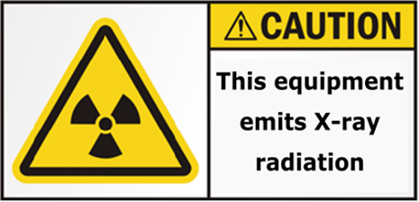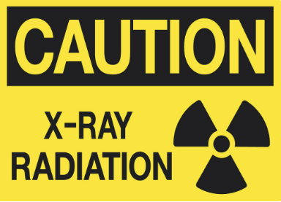

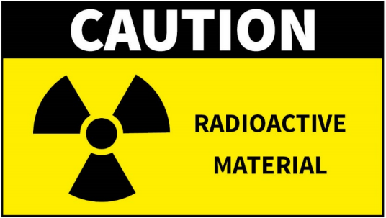

To receive this document in another format, phone 1300 767 469, using the National Relay Service 13 36 77 if required, or email Radiation Team <Radiation.Safety@health.vic.gov.au>.
Authorised and published by the Victorian Government, 1 Treasury Place, Melbourne.
© State of Victoria, Australia, Department of Health, February 2024.
Available at X-ray analysis unit <https://www.health.vic.gov.au/radiation/x-ray-analysis-unit>

