Pathway to Good Health
Service Framework
(Targeted Health Support for Children in Care initiative)

Service framework
October 2023

Contents
Contents 2
1. Purpose 4
2. Introduction 4
What is being delivered 4
Service and care principles 6
3. Service model 8
Eligibility 8
Reducing barriers to access 8
Service components 9
Child protection and health service provider’s roles and responsibilities 11
Health records 12
Client brokerage funding 12
4. Locally tailored models of care 13
Care for Aboriginal children in care services 13
5. Workforce 14
Statewide clinical leadership 15
6. Service governance 17
Clinical governance 17
7. Monitoring and evaluation 19
Activity data collection and reporting 19
Evaluation 19

To receive this document in another format, email pathwaytogoodhealth@health.vic.gov.au <pathwaytogoodhealth@health.vic.gov.au>.
Authorised and published by the Victorian Government, 1 Treasury Place, Melbourne.
© State of Victoria, Australia, Department of Health, April 2024.
In this document, ‘Aboriginal’ refers to both Aboriginal and Torres Strait Islander people. ‘Indigenous’ or ‘Koori/Koorie’ is retained when part of the title of a report, program or quotation.
ISBN/ISSN 978-1-76131-576-3 (online/PDF/Word)
Available at Pathway to good health for children in care <https://www.health.vic.gov.au/populations/vulnerable-children/pathway-to-good-health-for-children-in-care>

1. Purpose
This service framework (the framework) provides guidance to health services to support the development of consistent and high-quality models of care delivered to children who are entering statutory care settings through the Pathway to Good Health program. This program is funded through a recent four-year Victorian government investment into the Targeted Health Support for Children in Care initiative.
The framework describes the service components to be delivered across Victoria under the program and includes the service principles, roles and responsibilities and partnership expectations to improve access to services and health outcomes for children and young people in care (formerly ‘out of home care’).
The framework is a ‘living’ document that over time will be informed by the success and lessons of the rollout of the program. Updates to the framework will ensure that consistent and high-quality services are maintained while also supporting local innovation and service improvement.

2. Introduction
Children placed in statutory care are known to have poorer health outcomes than the general population, across all domains of health: physical, developmental and emotional/mental health. As of 30 June 2022, there are 9,124 children in care in Victoria (6.4 per 1,000 children) (Child Protection Australia 2021-22, AIHW). Long wait lists and the complexity in navigating health and social care systems contribute to vulnerable cohorts such as children in care being excluded from receiving the right healthcare at the right time.
This program aims to improve access and target services to better meet the health needs of children and young people entering care in Victoria. The 2023 -24 State Budget provided four years of funding ($37.7 million) for the program that will support early assessment and improved care planning for children and young people as they enter care with the aim of improving health outcomes and reduce avoidable downstream costs.
Building on evidence and previous projects to support this cohort of children, this program aims to provide a tiered approach to care that improves integration across the health and child protection systems, education and care services. The term “child protection system” is used throughout this document to refer to the range of programs and services delivered by or subcontracted by the Department of Families Fairness and housing (DFFH) that support children and young people subject to statutory intervention under the Children, Youth and Families Act (2005). This includes but is not limited to the child protection workforce, Aboriginal Children in Aboriginal Care (ACAC) workforce, Health and Education Assessment Coordinators (HEAC) Kinship Engagement Teams, Care Support Helpdesk (further detail can be found at Appendix 1).

What is being delivered
This service framework for Victoria aligns with the National Clinical Assessment Framework for Children and Young People in Out of Home Care (2011) <https://www.health.gov.au/resources/publications/national-clinical-assessment-framework-for-children-and-young-people-in-out-of-home-care?language=en>
The framework outlines a tiered model for the delivery of health screening, assessment and planning for children in care. Service delivery responses will be designed to provide triage, screening, referral and assessment for all children entering care in Victoria, as well as a clear point for consultation and liaison with child protection and carers.
All children entering care (for the first or subsequent time) will have their health needs reviewed to ensure they receive the recommended age-appropriate health checks and are referred for necessary screening, assessment and/or treatment services relevant to their identified needs.
Children and young people with multiple and/or more complex health needs will be able to be referred for a multidisciplinary assessment and the development of a health management plan to inform referrals and service delivery for their health needs.
Once a triage, screening or multidisciplinary assessment has been completed, this program will link through referrals with the existing service system (including NDIS funded services, health or education) to access allied health or paediatric interventions or treatments.
Services will be delivered by a lead provider within the existing community-based platforms delivering health services such as Community Health Service (CHS) and Aboriginal Community Controlled Health Organisation (ACCHO). Sites for the delivery of this initiative will leverage and expand existing service capacity and capability and utilise the established connection with communities, local partnerships and non-stigmatising entry to services to support the holistic care of children and young people.
Service delivery should be flexible, accessible and responsive to the needs of children and young people in the local Area. This could include outreach to other settings such as schools, early learning and residential care. In some areas where access to specialist clinicians is limited and/ or geographic isolation impacts on access, telehealth services may also utilised.
Services will be located in each of the seventeen Department of Families, Fairness and Housing (DFFH) Areas as shown in Figure 1 and lead health providers will be expected to deliver health services to all children entering care in these Areas.
Figure 1: DFFH divisions and areas
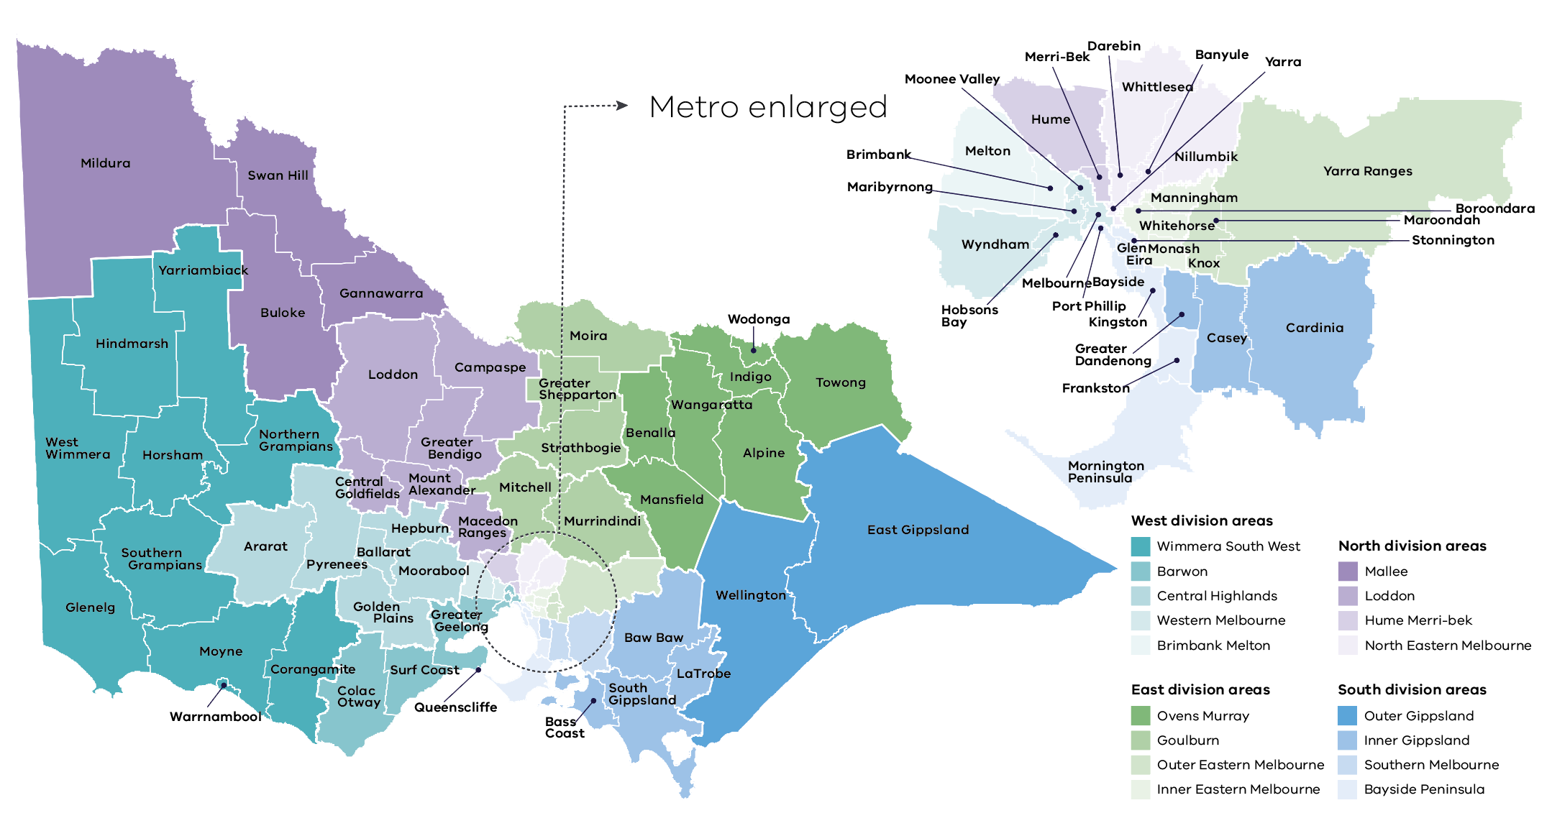

Service and care principles
The principles of “child centred care” and “culturally safe care” underpin the delivery of services and apply to all aspects of service planning, program design and service delivery for this program.
The diagram below has been adapted from the Community Health Integrated Program guidelines 2019 and the Child Health Services: Guidelines for the Community Health Program 2019. Further detail about the service principles can be found at Appendix 2.
Figure 2: Service and care principles
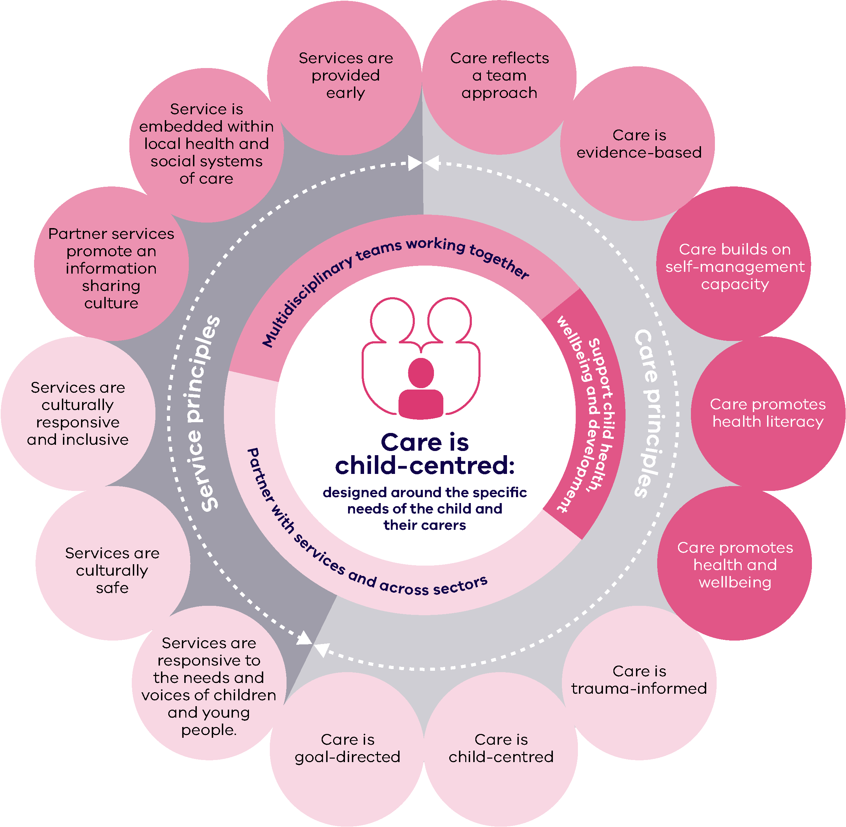

3. Service model

Eligibility
Children will be eligible for services if they are:
- aged from birth up to and including 17 years; and
- currently in care (including kinship care, foster care, or residential care) as a result of a statutory court order, excluding permanent care orders.
- the priority cohort to receive services are those children who have recently entered care (in the last three months) either for the first or subsequent times.
It is expected that Child Protection or ACAC providers will refer all entrants to care in an agreed format containing relevant information to the identified CHS or ACCHO.
The health provider will prioritise all children entering care to ensure a health triage and screening is completed at the earliest opportunity. Any child already in care who is identified as needing health support due to lack of any previous health contact can also be referred by workers in the Child Protection System, carers or other health services noting that services for this cohort will be subject to service capacity.

Reducing barriers to access
Children in care and their carers face a range of challenges to accessing mainstream health services. The absence of a Medicare card, lack of access to previous health records and limited referral information should not be a barrier to receiving a responsive and flexible service by health providers.
The Information Sharing protocol between the Commonwealth and Child Protection Agencies Appendix 2 <https://www.dffh.vic.gov.au/publications/community-services-quality-governance-framework> outlines the process for information sharing including obtaining Medicare cards for children and young people in care and also notes at clause 5.3 arrangements for payment of services where a child is not enrolled on a Medicare card.
A GP referral is not a prerequisite for access to any paediatric health care funded through this program. Health providers may use MBS funding where appropriate for children and young people in the program but should be mindful that the use of this funding should not create any delay or cost in receiving services. Lead providers are encouraged to make close connections with primary care services in their local area to ensure there are no barriers in accessing services.
It should also be noted that there is no cost for receiving services under this program.

Service components
Figure 3: Client journey diagram
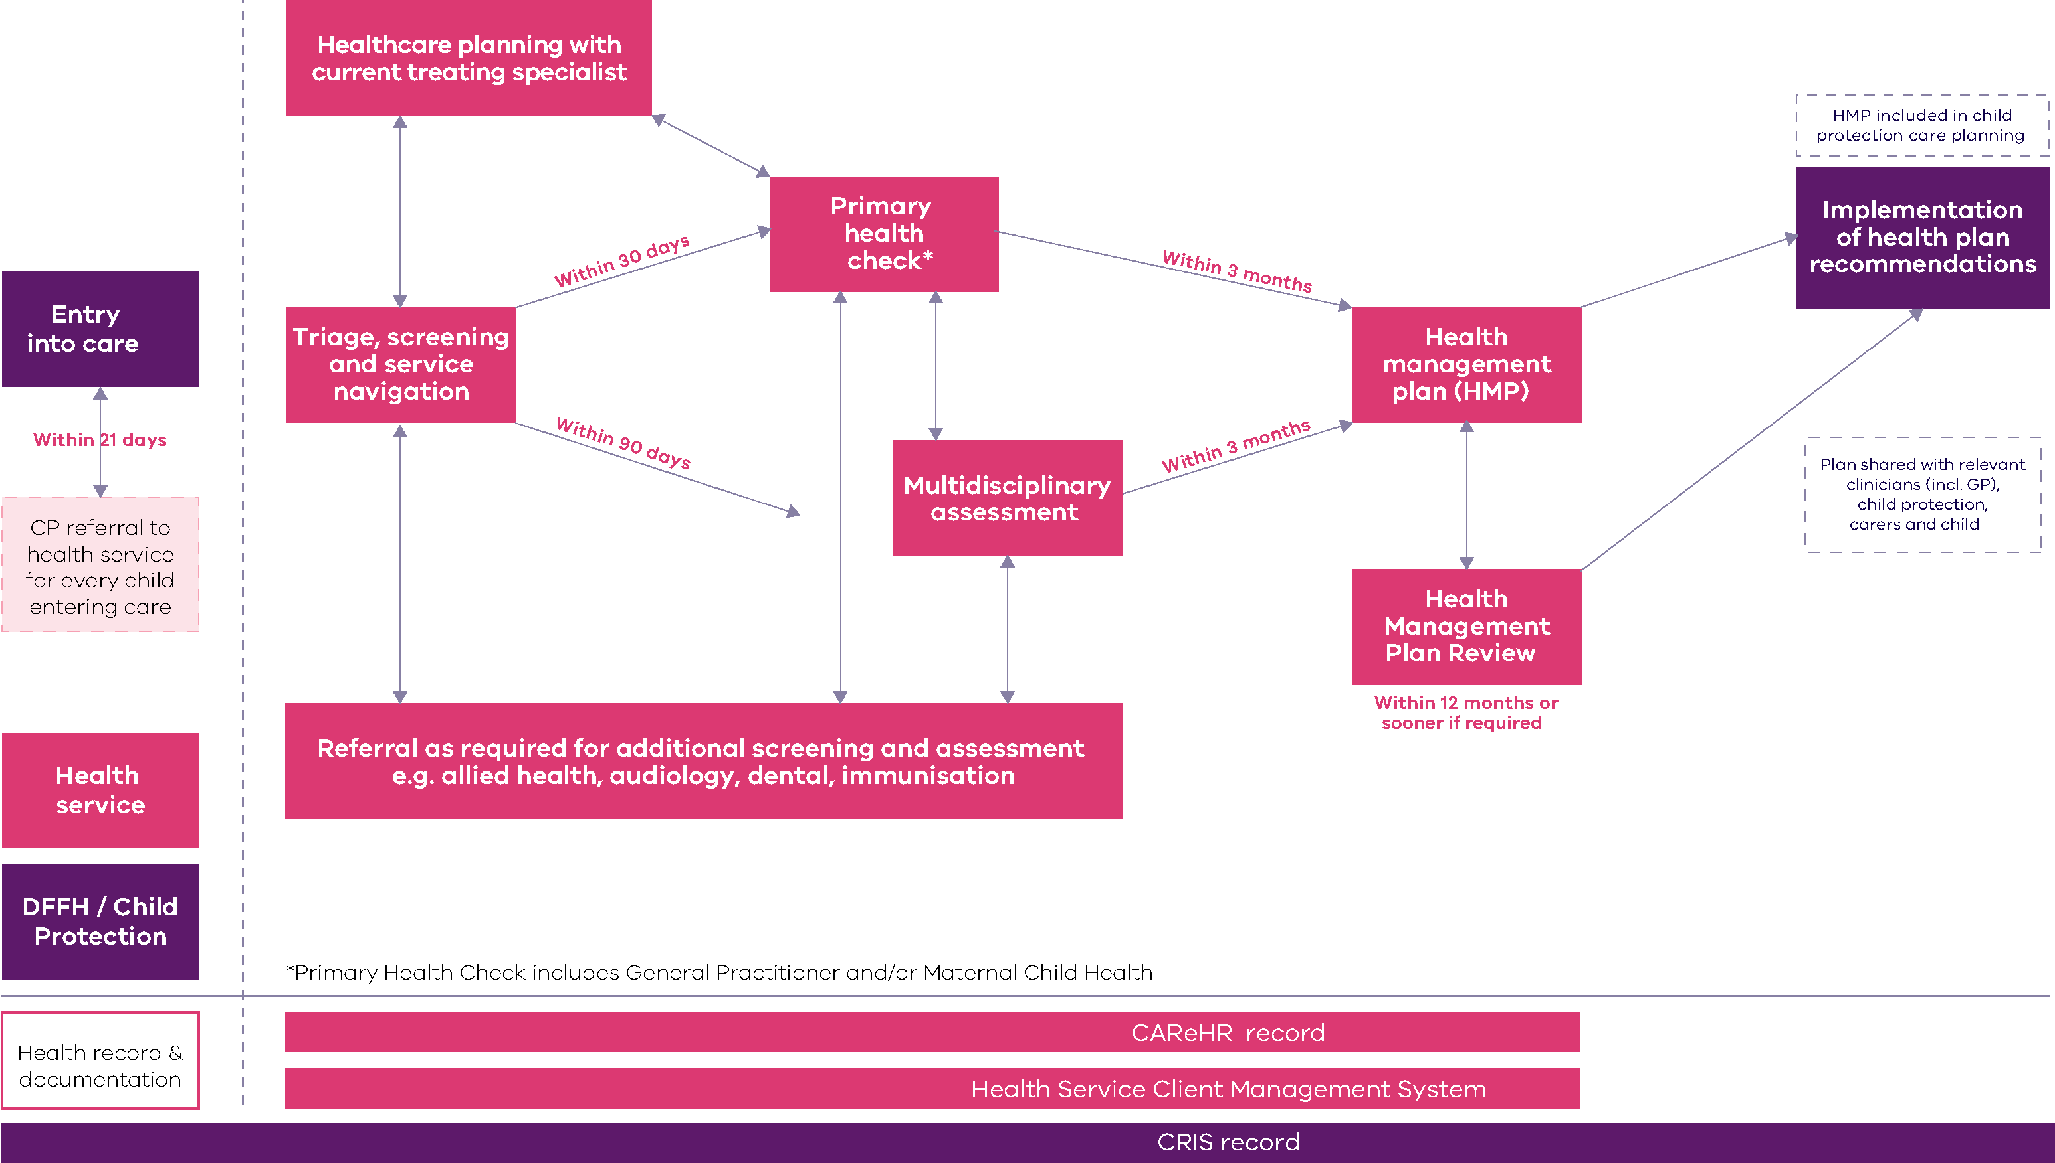

As outlined in the client journey diagram (Figure 3), this program provides funding for the provision of health triage, connection and navigation as well as multidisciplinary assessments for children and young people in care with more complex needs. Services will need to establish connections that support access to primary health services including Maternal and Child Health services to support routine age-appropriate screening as well as access to allied health therapy or interventions for children and young people.
The model of care designed by lead health providers in each Area will provide the following service components.

Health triage, screening, connecting and navigation
Specialist intake and triage services will be provided by practitioners such as nurses or allied health workers. These clinicians will work closely and may be embedded within local Area child protection offices to ensure that:
- Relevant information is provided about children and young people entering care so that carers can be engaged, culturally safety can be addressed and relevant referrals and health appointments made in a timely manner. A recommended example of health and social history information completed by child protection staff in the Pathway to Good Health program is provided at Appendix 2.
- The needs of children and young people can be quickly, accurately and sensitively assessed and prioritised within a trauma-informed framework and using evidence-based clinical tools.
- Carers, including parents when appropriate, are supported to access and navigate the range of required health services, including primary health services, (eg GPs, maternal and child health services, hearing or vision screening services, dental health services), early intervention services, and specialist services such as hospitals, mental health or disability supports.
- Initial child/young person health needs are assessed, brief health history and any recommended screening or referrals are consistently documented and shared with Child Protection and relevant health providers.

Multidisciplinary assessment and planning
Where children and young people in care are identified (through triage, or other health professionals involved with the child or young person) as having more complex needs, they can be referred for a multidisciplinary clinical assessment. This will inform the development of a comprehensive health management plan for the child.
Paediatricians and appropriate allied health practitioners such as speech pathologists, occupational therapists and psychologists will provide a multidisciplinary assessment and health management plans for children.
Clinical services will be delivered in a way that best meets the child, young person and carer’s needs and services will need to be flexible and employ a range of strategies in their approach to supporting attendance at assessments.
Health management plans and associated treatment recommendations will be shared with Child Protection who are responsible for following through on treatment recommendations in collaboration with the health care team. Where health management plans include a review date, it is the responsibility of the health service to follow up and schedule the review in a timely manner.

Secondary consultation, support and liaison with child protection and carers
Health services funded through this program must strengthen relationships and partnerships with local child protection and care service providers, through a range of strategies such as:
- embedding a triage clinician or in-reaching to local child protection Area offices to improve partnerships, referrals and foster an improved understanding of health.
- working collaboratively with children, young people and their carers and other service providers to avoid any unnecessary duplication and ensure that care is coordinated and tailored to the specific needs and priorities of children and young people.
- supporting carers, children and young people to build the knowledge, skills and confidence they need to navigate the service system and access the services they need.
- advocating, sharing learnings and building partnerships between service providers that engage and support children and young people in care and their carers.
- supporting services such as child protection, schools and early years with secondary consultation to assist and link children with the right health service as early as possible.

Child protection and health service provider’s roles and responsibilities
Clear delineation of roles and responsibilities for the implementation of this service model will be critical to ensuring that children and young people are referred in a timely manner and receive the health services they need.

Core roles and responsibilities of Child Protection and ACAC providers:
- Referral and provision of relevant information for all children entering care to the nominated CHS or ACCHO delivering the service in the relevant area within 30 days of entering care
- Obtaining consent where required, to enable the exchange of relevant information and provide treatment for children and young people Appendix 3
- Management of any urgent health concerns for children in care (e.g. facilitating an immediate primary care appointment or emergency department presentation)
- Enabling triage or health navigators to work closely with child protection practitioners to maximise efficient and timely consultation and transfer of information
- Receive health management plans and update the relevant information, health contacts, management plan and review date where applicable on the child or young person’s CRIS record (the Child Protection information database).
- Engaging and sharing relevant information with parents about health services children are receiving
- Implement recommendations of the health management plan as part of the child’s statutory case planning process.

Core roles and responsibilities of lead health service providers:
- Acknowledge all referrals received from Child Protection within 7 to 10 days of the receipt of the referral.
- Enable health practitioners to work closely with local child protection offices to support connections, secondary consultation and strong working relationships.
- Maintain health record via CAReHR or other approved ehealth system and share health management plans and treatment recommendations with child protection in a timely manner.
- Facilitate referrals and connection to any recommended treatment services following consultation with Child Protection and in collaboration with carers and parents where appropriate.
- Set review dates and undertake reviews of health management plans as determined by clinical need.
- Facilitate and record the expenditure of brokerage for this program.

Health records
The lack of a single coordinated and accessible health record for a child in care presents a significant challenge to coordinated healthcare for this group of children. CAReHR is a web-based software application that enables health assessments, care plan and data analysis on health needs and referrals for children in care. The CAReHR system has been used previously by health providers for this cohort of children and lead providers funded under this program will be required to use and maintain screening and assessment records for children receiving a service using this platform. The Department of Health will support the licensing and access to the CAReHR platform.
Health providers should ensure that the confidentiality and sharing of patient records is in accordance with Victorian legislative requirements applicable to all health providers.

Client brokerage funding
Service providers will receive a component of funding under this program to be used flexibly for brokerage to address barriers in accessing health services for children and young people in care, for example, out of pocket expenses, gap fees or transportation costs.
Where other State or Commonwealth sources of funding are available for a particular purpose this should be explored first, such as Medicare or NDIS funding. It should be noted that there are other available sources of brokerage to support the health needs of children and young people in care through Child Protection and Care Services within DFFH.
Appropriate records of brokerage expenditure (including the item or service the brokerage was used for) are to be maintained by services to ensure accountability. Details of brokerage recording requirements will be provided by the Department of Health.

4. Locally tailored models of care
Developing locally tailored models of care will be a critical part of the establishment of this program. While local models of care will be designed to meet community need and leverage existing service capacity, they should also focus on the development of innovative, integrated models that can deliver tailored, flexible and responsive care to children and young people living in care including those in residential care.
Services will need to consider creative partnerships with other local health providers and ACCHO/ ACCO’s to enable coverage across DFFH service Areas and the provision of culturally safe healthcare for Aboriginal children and young people.
It is expected that service providers will work to commence service delivery whilst also working to engage local partners and develop a model over time that engages and delivers services across their catchment in line with the guidance in this framework.
Local service development and design will be led by the lead provider and in line with the service principles and functions outlined in this framework will also address the following domains:
- Creating health equity by connecting children experiencing adversity to healthcare
- Delivering accessible care through service innovation that is inclusive of cultural safety, diversity and reduces geographic barriers to care
- Supporting right care at the right time that reflects local service capability, service partnerships and pathways of care
- Holistic care that supports health, wellbeing and social care needs and reflects a locally diverse and skilled workforce
- Reflecting lived experience and the voice of children and young people in care in service design, delivery and monitoring
- Sustainable services that integrate and leverage existing local platforms and establish robust local governance and strong service partnerships.

Care for Aboriginal children in care services
As part of this program, the Department of Health will be working with VACCHO (Victorian Aboriginal Community Controlled Health Organisation) to support self- determined models that deliver culturally safe care for Aboriginal children, young people and their carers.
Notwithstanding this work, it is expected that lead providers will work closely with local Aboriginal communities through ACCHO/ ACCO’s and Aboriginal Child and Family Services in their DFFH Area to provide culturally safe service options that best meet the needs of Aboriginal children and young people and their carers.

5. Workforce
The workforce employed to deliver services under this program should support a model that:
- promotes high quality and safe care overseen by strong clinical governance
- promotes a trauma informed approach to healthcare
- supports collaborative professional relationships and shared professional development opportunities across services
- supports professional collaboration and shared learning with other local providers including primary care, universal and acute services
- reflects an understanding of the social determinants of health in the delivery of care
- reflects the lived experience of children and families
- supports the cultural competence of staff and develops their capacity to work effectively within the cultural context of each child and their family of origin
- supports staff to develop the relevant knowledge, skills and experience to deliver appropriate and inclusive services to all children and families including peoples of CALD and refugee backgrounds, LGBTIQ+ and Aboriginal and Torres Strait Islander people.
Clinicians and support workers must work within the required scope of practice and adhere to professional standards and ethics. Appropriate supervision and management arrangements are a requirement of funded services to support both clinical and non-clinical staff.
Services should also look for opportunities to provide graduate and training positions/placements for a range of disciplines through joint appointments across acute and community settings.
Teams will be designed with the appropriate workforce mix of disciplines and seniority to ensure the range of services can be delivered. The design and governance of teams will ensure that services are evidence based, safe and are tailored to address local needs. Table 2 provides guidance to the potential workforce disciplines and roles.

Table 1: Workforce
Discipline | Role
Allied health & nursing (includes paediatric)  Can be made up of the following disciplines:  psychologist, speech therapist, occupational therapist, nursing, physiotherapist, social worker, dietitian | Regular liaison and possible co-location where appropriate with Area-based Child Protection and Care Services.  Specialised Intake /triage, assessment, in reach services, navigation and referrals  Assessments and health care planning, secondary consultation  Multidisciplinary or transdisciplinary work  Case review
Paediatrician | Assessment, diagnosis, care planning, clinical review, referrals to other specialist services  Multidisciplinary or transdisciplinary work  Secondary consultation  Case review
Aboriginal Health Workers | Engage and support Aboriginal children and carers to access health services through advocacy, support, liaison and health promotion work.  Support clinicians in the provision of culturally safe service delivery.
Administration and implementation support | Specific support to establish the local model of care and maintain the ongoing operation through:  - project management and business development,  - formalising working arrangements and governance with local partners including child protection, ACAC and ACCHOs  - establishing and maintaining localised pathways of care  - ongoing data reporting and administrative duties

Statewide clinical leadership
Clinical leadership will be developed as part of the program to support a statewide network of clinicians working with children and young people in care.
The statewide clinical leadership will support the following key functions over the four years of funded services:
- workforce capacity building, including a Community of Practice
- quality improvement, including consistent practice guidance
- connecting care including information sharing and continuity of care

Fetal Alcohol Spectrum Disorder (FASD)
In addition to the statewide clinical leadership, additional support and secondary consultation will also be provided to service providers by VicFAS Fetal Alcohol Service (state-wide FASD assessment and capability building service).
This is in recognition of the significant number of children in the care system and those are known to child protection who experience or are at risk of fetal alcohol spectrum disorder. The work of VicFAS will assist in clinicians improving their understanding and skills to support identification, assessment and referral for FASD.

6. Service governance
The lead provider of services for children and young people in care will be responsible for leading the design, implementation, monitoring and quality improvement of services in the program. Lead providers will be responsible for:
- the establishment of service partnerships with a range of relevant services in their local Area, including child protection system providers, primary health services such as GPs, doctors in secondary schools, dental health services, maternal and child health services.
- co-designing a culturally safe model of care and service pathways with local service partners, community and people with lived experience.
- management and oversight of health services for children in care including the establishment of effective and appropriate operational and clinical governance structures in accordance with Community Services Quality Governance Framework.
- maintaining record keeping in accordance with relevant policy and legislative obligations
- maintaining a health record that is accessible and can travel with the child if they change placements
- the employment and management of relevant staff
- financial and performance accountability requirements as set out in the service agreement between the department and the agency
- participation in the community of practice
- participation the evaluation of the program.

Clinical governance
Appropriate clinical governance structures will be established to ensure that services funded through this program are providing responsive, safe and high-quality care.
A lead provider should ensure that a formal and effective clinical governance framework is in place that delivers:
- a commitment to shared decision making with children and young people and their carers
- shared ownership and accountability for the quality and safety of the treatment, care and support between the lead provider and any partner agencies
- regular evaluation of performance to identify areas for improvement and a commitment to continuous improvement
- a range of clinical supervision techniques to support the multidisciplinary team including group supervision, reflective practice and independent clinical supervisors
- a system where practitioners and clinical teams are directly accountable for the safety and quality of care they provide
- a structure where boards of governance, chief executive officers and management are accountable for the systems and processes to provide safe, high-quality healthcare, and for ensuring practitioners participate in clinical governance activities.
The clinical supervision arrangements within services will respect the different professional arrangements relating to registration and professional association requirements.
The Department of Health has developed the Victorian clinical governance framework <https://bettersafercare.vic.gov.au/reports-and-publications/clinical-governance-framework> along with additional resources to assist organisations implement a high-quality clinical governance framework.

7. Monitoring and evaluation
Understanding how the program is performing against the desired outcomes will inform future planning, investment and implementation. Monitoring and evaluation frameworks developed as part of the service's establishment may initially focus on shorter term process outcomes with service activity collected consistent with the current service requirements.
Over time as the model of care matures, evaluation and monitoring frameworks may include quantitative and qualitative data to measure achievement of the desired outputs, impact and outcomes for both service and child and family outcomes.
A program logic outlines the key outcomes for this program at Appendix 4 and will be regularly reviewed.

Activity data collection and reporting
Service providers funded for this initiative will use their existing data collection systems to record service activity. Services will also be required to provide quarterly reports on their implementation progress to the Department of Health. Details of the quarterly report and progress indicators will be provided by the department.

Evaluation
With the support and guidance of the Community of Practice and in consultation with funded service providers, child protection, children and carers. An evaluation of this initiative will seek to:
- assess how the initiative was implemented
- assess the extent to which the initiative has achieved the identified outcomes for children, carers and the service system.
- assess the extent to which the initiative has been delivered within budget
- identify successes and areas for improvement and, where relevant, inform future policy development, investment, service design and delivery for communities.

Appendix 1: Detail on service principles
Service principles | Care principles
Services are responsive to the needs and voices of children and young people. | Care is child-centred around the specific needs of children, young people and their carers, including recognition of and response to their voices.
Services are culturally safe for Aboriginal people and Torres Strait Islanders, including recognition of identity and experience. | Care is trauma-informed and based on understanding how trauma affects the lives of children, young people and their needs.
Services are provided early to ensure that developmental delay, emotional and behavioural issues for children and young people are addressed early in life and early in illness. | Care is goal-directed where practitioners agree on goals with children, young people and their carers based on their needs, preferences and priorities, plan how goals will be met and chart progress against them.
Services are culturally responsive and inclusive, with the capacity to respond to diverse cohorts of children and young people. | Care builds on self-management capacity to empower children, young people and carers to increase control over and improve their health.
Service is embedded within local health and social systems of care, building on and learning from local relationships and networks. | Care promotes health literacy where children and carers can navigate, understand and use health information and services.
Partner services promote an information sharing culture where services record and share information in a record that is accessible to health and social services. | Care promotes health and wellbeing, supporting children, young people and their carers to increase control over and improve their health.
 | Care reflects a team approach to ensure that multidisciplinary assessment, intervention and support is developmental and relational, and tailored to the unique needs of children and young people entering care.
 | Care is evidence based, using the best available evidence and expertise to plan with children, young people and their carers the best care and support for them.

Appendix 2

PATHWAY TO GOOD HEALTH:
HEALTH AND SOCIAL HISTORY INFORMATION

Introduction
This form is to be used to gather information about a child or young person who has entered or re-entered care to enable the Pathway to Good Health program to determine the type of assessment needed to support the child or young person’s health and wellbeing.
This form should be completed through consultation between the Child Protection practitioner and the Pathway to Good Health provider’s Health Navigator. Information from parents or carers may also be needed to answer some questions.

While some information may not be available, please complete as much information as best you can. Even an indication of what is not known, may be useful.
Child Name:
Child DOB:
Carer Name:
Carer phone number:

DFFH Child Protection Practitioner or ACAC worker:
- Phone number:
- Email:
Placement Support Worker:
- Agency:
- Phone number:
- Email:
Complete the following information for each child or young person and attach any additional information as required.

- Out-of-Home Care History
Brief current reason for child being placed in care:
Length of time in care:

Number, length and type of placements:

Current care arrangements:

Frequency of access contact with family – including parents and siblings

- Parental Background
Any known cognitive challenges including any NDIS plans?

Any known or chronic medical issues?

Where any of these issues detected in pregnancy?
- Hepatitis B/C, HIV, Syphilis status.
- Drug and alcohol use
Cultural background
- Language spoken at home
- Born overseas

- Child’s birth (under 6 years)
Name of birth hospital

Birth details:
- Premature or term birth
- Birth weight / length / head circumference
Maternal Child Health attendance
- Date and location of last visit

- Child / Young Person Medical History
Any hospitalisations & serious illnesses including operations?
Any chronic illness (i.e. asthma, diabetes, epilepsy)?

Any disabilities (i.e. physical / cognitive)?

Any accidents and injuries?

Any soiling or bed wetting?

Any Diagnosed Conditions?
- dates and diagnosing Dr’s name and Clinic contact details if possible.
Any current medication?
– date and prescribing Dr’s name and Clinic contact details.
Any known allergies?

Is there a current General Practitioner? Name and contact details.

- Child / Young Person Psychological History
Emotional issues (e.g. anxiety, depression)

Risk behaviours (e.g. sexual, behavioural)

Drug and alcohol issues

Current involvement with counselling or mental health services (e.g. Take Two or CYMHS)

- Other Health Services
Optometry
- Does the child wear glasses?
- Date of last known vision check?
Dental
- Date of last known dental check?
Audiology
- Has the child’s hearing been checked?
- Date of check?
Other allied health services
(e.g. speech therapy, occupational therapy) – list contact details

Victorian Forensic Paediatric Medical Service (VFPMS)
- Has an assessment been completed (date and details)

- Speech and language (under 6 years)
Sucking, chewing, feeding ability?
First words and sentences (0-3 yrs)
Identification of first sounds in names
Ability to remember and repeat songs/rhymes (3-5 yrs)

- Nutrition, exercise and sleep
Eating habits
- what are the child/young person’s food likes/dislikes?
- are there concerns around food consumption
Nutritional intake
- does the child/young person have a balanced diet?
- do they eat a lot of sweet or salty food/ snacks?
- do they drink water / milk/ soft drink
Exercise routines
- do they play an organised sport?
- do they do outdoor activities i.e. bike riding, swimming?
Sleep routines
- do they have a regular bedtime?

- Childcare/Education
Current childcare/kinder/school:
- Do they regularly attend?
- Year level at school / kinder
- How long have they been at the current school or early years setting?
Achievement of developmental milestones and academic progress?

Social connections established?

Educations Needs Assessment completed
- Date of assessment and details
Funded under any education program for disability or inclusion?

- NDIS
Does the child have a NDIS Plan?
- Attach copy of the plan
Who is the case planner?

Referred to Early Childhood Intervention Service (ECIS)?
- Location of ECIS service

- ANY OTHER RELEVANT INFORMATION

Date form completed / /

Appendix 3: Consent guidance

Health care consent for children in out-of-home care

Information for health care providers

Introduction
This sheet provides information for health care providers about who can provide consent to health care and treatment for a child in out-of-home care. The individual who can provide consent is dependent on the Children’s Court order the child is subject to, their permanency objective (detailed in the child’s case plan), placement type and who has parental responsibility for the child. However, generally, consent will be provided by:
- the child if they are aged 14 years or over and able to demonstrate they have the level of maturity and understanding required to make a decision (mature minor)
- the parents of the child if they retain parental responsibility
- the delegate of the Secretary, Department of Health and Human Services, if the Secretary has parental responsibility for the child, or under s597 of the Children, Youth and Families Act 2005 (the Act)
- the child’s carer if they are authorised by the child’s case planner (child protection) or by the Chief Executive Officer of a Community Service Organisation (CSO) – via a standard authorisation or child specific authorisation
- a CSO authorised under s597 of the Act. The CSO will be able to provide the relevant authorisation detailing the consent provided, and the role of the person in the CSO who has been authorised to provide consent.
- Health care and treatment consent applies to children in out-of-home care, residing with a kinship carer, foster carer or in residential care, subject to one of the following Children’s Court orders:
- interim accommodation order
- family reunification order
- care by Secretary order
- long-term care order
- therapeutic treatment (placement) order.
The consent typically provided by children and parents (verbal or implied consent) is sufficient and does not require any paperwork. If consent is provided by the delegate of the Secretary, they will be able to evidence their authority to do this by presenting a copy of a Children’s Court order, or for a CSO by way of an instrument of authorisation. If a carer has been authorised to make specified decisions for a child or have a standard authorisation, they will be able to provide a copy of the instrument of authorisation to health care professionals on request.

The authorisation of carers
The Act allows for the authorisation of carers by Child Protection, or Chief Executive Officers of CSOs to make specified decisions about a child. This can take the form of a standard authorisation, with is specific to the carer for any child in their care, or a child specific authorisation, which outlines decisions a carer can make for an individual child.
Carers are provided with an instrument of authorisation by child protection that specifies the type of decisions the carer can make in relation to a particular child. This is an A4 document that is valid while the child resides with the carer and the court order remains in force. The carer is provided with a copy of the instrument of authorisation, and a copy of the Children’s Court order to verify the authority they have to make particular decisions.

What types of health care decisions can be made?
Everyday care decisions.
Related orders – interim accommodation order, family reunification order, care by Secretary order, long-term care order and therapeutic treatment (placement) order.
Carers make many decisions about a child’s day-to-day care such as the ensuring the child has taken their Ventolin as required. They are expected to make these decisions and authorisation is not required.
Decisions of a short-term nature
Related orders – interim accommodation order, family reunification order and therapeutic treatment (placement) order
There are times when routine decisions are needed about issues of a short-term nature. Carers may be authorised to make decisions about specified issues that are more than everyday care decisions. Examples include consenting to routine medical care which includes immunisations (confirmed in section 3 Children, Youth and Families Act 2005 under the definition of ‘major long-term issue’), arranging treatment consistent with an established treatment plan for a chronic medical condition, and having a tooth filled by the dentist.
Decisions of a long-term nature
Related orders – care by Secretary order and long-term care order
Decisions about major long-term issues also need to be made from time to time and may include issues such as agreeing for the child to have a non-urgent medical procedure, or elective surgery. The delegate of the Secretary, a CSO or carer if either have been authorised, only have the ability to agree to a long-term health issue if the Secretary has exclusive parental responsibility for the child. Otherwise the agreement of the parent is also required.
Who should I contact if I have any questions?
If you have any questions, please contact the child protection practitioner or contracted case manager for the child.
Additional information regarding Children’s Court orders, consent for medical examination and treatment, and the authorisation of carers can be found on the child protection manual – <https://www.cpmanual.vic.gov.au/>

Appendix 4: Program Logic (I)
Inputs | Activities | Outputs
- Victorian Government $37.7m million funding over four years for statewide service delivery.  - Existing Pathway To Good Health (PTGH) organisations.  - Community health service providers in 17 DFFH Areas.  - ACCO/ACCHOs in 17 DFFH Areas.  - Child Protection and care services staff.  - Foster care services.  - Clinical workforce including mix of practitioners currently working in PTGH, Community Health and ACCHOs. | - Design a phased 4-year funding and service delivery strategy.  - Design a service framework to inform services’ model of care and to provide statewide consistency.  - Commission and fund service leads in each DFFH Area.  - Commission self-determined Aboriginal models of care in partnership with VACCHO.  - Expand the CAReHR electronic record platform to support statewide data collection and production of health management plans and health histories.  - Develop the Child Protection Client Management Record to support the integration of health records and health information.  - Establish statewide clinical leadership to share learnings and develop common policies, resources and tools.  - Implement departmental reporting framework and monitor service implementation.  - Develop an evaluation framework to guide the evaluation of the implementation and service outcomes over four years. | - Number of Child Protection referrals to identified CHS* or ACCHO/ACCO.  - Number of Navigator Triage and Screening.  - Number of triage summaries created.  - Number of health management plans.  - Number of referrals for Primary Health checks.  - Number of referrals to allied health and/or screening services.  - Number of multidisciplinary clinic assessments.  - Number of specialist referrals.  - Number of secondary consultations.  - Number of health management plans reviewed.  - Number of CoP meetings.  - Number and type of workforce training activities.

Appendix 4: Program Logic (II)
Outcomes - short term  (1-2 years) | Outcomes – medium term  (2-4 years) | Outcomes – long term  (4−10 years)
Children entering care  1. All children entering care are referred to the program within required time frames.  2. All children receive triage and screening, including a triage summary.  3. Children requiring more comprehensive assessment are referred and receive a health management plan.  4. Children requiring further health checks or interventions receive and take up referrals appropriate to their needs.  5. Children obtain a Medicare card.  6. CP care teams ensure children’s health management plans are regularly reviewed as part of case planning.  Service providers  7. CP and health workforces collaborate to ensure timely referral of children entering care.  8. CP and health workforces collaborate to build strong connections that facilitate information sharing, secondary consultation and health literacy.  9. CP and health workforces develop and follow shared protocols for navigating service pathways for children entering care.  10. Culturally safe care is demonstrated in service delivery, workforce practice and local partnerships.  11. Community of Practice contributes to upskilling the workforce with increased confidence and knowledge to address the needs of children and carers.  Service system  12. Health records are developed and shared to create a health history that travels with the child. | Children entering care  1. Children and carers continue to engage with health services as necessary based on a health management plan.  2. Children’s health outcomes show improvement or slowed progression of health challenges.  3. Children receive assessments that enable eligible supports to be provided through the NDIS.  Service providers  4. CP and health workforces demonstrate coordinated practice and integrated service delivery.  5. Program health services leverage off and become part of the broader child health offering in local areas.  6. Aboriginal self-determined models of care are designed and tested in local communities.  Service system  7. Coordinated, integrated and culturally safe care is developing across a tiered system of primary, secondary and specialist care.  8. Care pathways reflect the National Clinical Assessment Framework for Children and Young People in Out-of-Home Care (OOHC).  9. Health records and health histories are current and accessible to all parts of the service system supporting the child.  10. Establish an outcomes framework that measures the impact of health and wellbeing outcomes for children in care. | Children entering care  1. Reduced impact of physical, developmental, emotional and/or behavioural concerns.  2. Reduction in preventable emergency presentations  3. Reductions in preventable hospital admissions  4. Reduction in number of unplanned school absences  5. More children are engaged in early childhood education and school.  6. More children receive appropriate supports through the NDIS.  Service providers  7. Co-designed models of care are refreshed to provide continuous improvement, cultural safety and local responsiveness.  Service system  8. Integrated care is well established across a tiered system of primary, secondary and specialist care.  9. Health care pathways are accessible and easy to navigate for every child in the care system.  10. Health records and health histories form part of a shared record with the Child Protection Client Management System.

Community Health Integrated Program (CHIP) guidelines - health.vic
Child health services: Guidelines for the community health program - health.vic
young people can be deemed to be able to provide consent for their own treatment if they meet the ‘mature minor’ or ‘Gillick principle’.

