Voluntary assisted dying
Information for people considering voluntary assisted dying
This document is not for electronic distribution

Disclaimer
This document is not for electronic distribution.
Information published by the Department of Health and Human Services about the Voluntary Assisted Dying Act 2017 is for general use only. It does not replace the advice of a registered health practitioner or other professional. Decisions around end of life choices are intensely personal. Decisions to seek voluntary assisted dying must be voluntary, enduring and fully informed of the person’s unique circumstances. This information should not be relied on to make any decisions about voluntary assisted dying, by patients, health practitioners or any other person.
This document will be reviewed from time to time, and it is the responsibility of the user to ensure that they have obtained the current version. These documents have been prepared having regard to the information available at the time of their preparation, and the user should therefore have regard to any information, research or material which may have been published or become available subsequently.
Whilst the department endeavours to ensure that documents are as current as possible at the time of their preparation, it takes no responsibility for matters arising from changed circumstances or information or material which may have become available subsequently.

To receive this publication in an accessible format, email the Person Directed Care team <endoflifecare@dhhs.vic.gov.au>
Authorised and published by the Victorian Government, 1 Treasury Place, Melbourne.
© State of Victoria, Department of Health and Human Services, August 2019.
ISBN 978-1-76069-919-2 (Print)
ISBN 978-1-76069-872-0 (pdf/online/MS word)
Available at health.vic Community and consumer information <https://www2.health.vic.gov.au/hospitals-and-health-services/patient-care/end-of-lifecare/voluntary-assisted-dying/community-and-consumers>
Printed by Razer Graphics, Bayswater (1903200 figures)

Voluntary assisted dying
Information for people considering voluntary assisted dying

Contents
Considering end-of-life care 5
Making decisions about end-of-life care 5
Do I meet the conditions for voluntary assisted dying? 7
Getting information from your doctor about voluntary assisted dying 10
Talking to your doctor about voluntary assisted dying 13
The voluntary assisted dying process 17
What process do my doctor and I need to follow? 17
Voluntary assisted dying process checklist 30
What if my doctor is unwilling to help me? 33
The dying process 34
Preparing for and taking the voluntary assisted dying medication 34
After death occurs 37
Support 39
Getting support 39
Talking about your end-of-life preferences 41
Supporting your family member or friend through the voluntary assisted dying process 42
Additional information 44
Terms you may need to know 44
Feedback or concerns 46
Appendix 1: Figure descriptions 47
Figures 47

Considering end-of-life care

Making decisions about end-of-life care
In Victoria, voluntary assisted dying may be an option for you at the end of life if you have an incurable, advanced disease, which is causing you suffering that you consider to be unacceptable. To be eligible for voluntary assisted dying, you must be expected to die in the not too distant future (normally within weeks or months, but not more than six months, or 12 months for people with a neurodegenerative condition). If you are thinking about voluntary assisted dying, then you may be considering making decisions about this last period of your life.
Often people want to make the best of the time they have left. The decisions people make are very personal. Some people may want to continue with treatment options, aiming for a longer life. People usually make decisions balancing out the effects of treatment, their quality of life and what matters to them as well as the suffering they are experiencing.
Care at the end of life can be provided in a range of settings. For example, in hospitals, at home or in aged care services. It can also be provided by a range of different health practitioners, including GPs, medical specialists, nurses, social workers and others.

Advance care planning
If you don’t already have an advance care plan <https://www.betterhealth.vic.gov.au/health/servicesandsupport/advance-care-plans> you may want to make one. If you already have one, you may want to update it so that it is relevant to the way your disease is likely to develop. Advance care plans are important to help those close to you know about the level and type of health care you want, if you become unable to make those decisions yourself.
If you haven’t already done so, you can appoint a medical treatment decision maker <https://www.betterhealth.vic.gov.au/health/servicesandsupport/medical-treatment-decision-maker> to make healthcare decisions for you if you are no longer able to do so. Your medical treatment decision maker should be someone you trust to make decisions that reflect your values and wishes.
Discussing and writing down your values and preferences in a values directive <https://www.publicadvocate.vic.gov.au/our-services/publications-forms/medical-consent/advance-care-directive/> may help your medical treatment decision maker feel more comfortable about the decisions they make on your behalf. You can also complete an instructional directive <https://www.publicadvocate.vic.gov.au/our-services/publications-forms/medical-consent/advance-care-directive/> consenting to or refusing particular medical treatments in anticipation of losing the ability to make your own decisions.

You cannot ask for voluntary assisted dying in your advance care plan because the plan can only be used if you lose your decision-making ability. However, it may still be useful to have one to guide your medical treatment decision maker in making other decisions for you at the end of life.

Palliative care
At some point, people may start to explore what palliative care <https://www.
betterhealth.vic.gov.au/servicesandsupport/end-of-life-and-palliative-care-services> offers. Palliative care aims to help people live well with an advanced disease that will limit their life. Palliative care takes a whole-person approach, helping people to take control over the time they have and concentrating on what quality of life means to them. Palliative care can help make people feel more comfortable by treating symptoms such as:
- pain
- nausea
- loss of appetite or sleep
- fatigue
- exhaustion
- restlessness
- delirium
  - feelings of breathlessness.
Palliative care plays a very important role in supporting people who are dying, wherever they die, by helping to relieve their pain and suffering and supporting their carers. For many people, palliative care can provide the reassurance they want about dying.
If you decide to ask for voluntary assisted dying, the two doctors who assess your request must tell you about your treatment and palliative care options. They will also encourage you to use palliative care services during the voluntary assisted dying process, if you are not already, to help improve your symptoms and quality of life.

Voluntary assisted dying
Voluntary assisted dying may be a further choice for a small number of people in the late stages of an advanced disease. Voluntary assisted dying involves choosing to take life-ending medication prescribed by a doctor.
There are a number of conditions you must meet to access voluntary assisted dying. There is also a voluntary assisted dying process that must be followed. See ‘What process do my doctor and I need to follow?’ for more information about the process.

Do I meet the conditions for voluntary assisted dying?

Summary
You can only access the voluntary assisted dying medication if you meet the conditions set out in the law. These conditions are:
  - You are in the late stages of an advanced disease and expected to die within weeks or months, but not more than six months (or 12 months if you have a neurodegenerative disease, such as motor neurone disease).
  - You are experiencing suffering, which you consider unacceptable.
  - You have the ability to make and communicate an informed decision about voluntary assisted dying.
  - You are making a voluntary, continuing and fully informed decision about voluntary assisted dying.
  - You are an adult, 18 years old or over.
  - You are an Australian citizen or permanent resident.
  - You live in Victoria and have lived in Victoria for the last 12 months.
If you do not think you will meet these conditions but are thinking about voluntary assisted dying, you can still discuss this with your doctor.

Conditions for voluntary assisted dying

1. You are in the late stages of an advanced disease
The advanced disease must be:
        - incurable
        - progressive (getting worse) and will cause death
        - expected to cause your death within weeks or months, but not more than six months (or within 12 months for neurodegenerative diseases, such as motor neurone disease).

2. You are experiencing suffering you consider unacceptable
The advanced disease must be causing you suffering that cannot be relieved in a way that is acceptable to you. People experience suffering in different and personal ways.

3. You have the ability to make and communicate an informed decision about voluntary assisted dying
This means you must be able to:
        - understand what voluntary assisted dying is and what the medication will do
        - remember the information about voluntary assisted dying so you can make a decision
        - think about voluntary assisted dying alongside the other options available to you (including treatment and palliative care options)
          - communicate your decision verbally or using other means (such as gestures or a communication aid).
You have to keep the ability to make and communicate a decision about voluntary assisted dying throughout the process. This means that you cannot request it in an advance care directive, because voluntary assisted dying is not available to you once you have lost the ability to make a decision about it.

4. You are making a voluntary, continuing and fully informed decision about voluntary assisted dying
Your decision to seek voluntary assisted dying must be:
        - voluntary (your own decision)
        - consistent (you must make three separate requests for voluntary assisted dying during the process)
          - fully informed (you are well-informed about your disease, treatment and palliative care options).
Only you can start a discussion with your doctor or health practitioner about voluntary assisted dying. Your doctor or health practitioner cannot start the discussion. Your family member or friend can be with you when you ask about voluntary assisted dying, but they cannot ask for you. This helps to make sure your decision to seek voluntary assisted dying is voluntary.

5. You are an adult 18 years old or over
You can only start the formal process to seek voluntary assisted dying when you are an adult 18 years or over. If you are under 18, you may like to discuss your treatment and care options with:
        - your family
        - a close friend
        - your doctor or another health practitioner
        - someone else you feel comfortable talking to.

6. You are an Australian citizen or permanent resident
You must be an Australian citizen or permanent resident to receive voluntary assisted dying. You will be asked to show proof of your citizenship or permanent residency during the assessment process.
Australian citizenship
The easiest way to prove you are a citizen is to show your current Australian passport. However, if you don’t have a passport, you can use one of the following:
        - Australian birth certificate if you were born before 20 August 1986.
        - Australian birth certificate if you were born on or after 20 August 1986, plus proof that at least one of your parents was an Australian citizen or permanent resident at the time of your birth. This proof could include your parent’s passport or citizenship certificate.
          - Australian citizenship certificate.
If your name has changed since obtaining this documentation, you will need to provide evidence to link your change of name (e.g. a marriage or registered relationship certificate).
If you don’t have these documents, you may apply for evidence of Australian citizenship through the Department of Home Affairs. Processing times attach to these applications and timeframes may vary depending on your circumstances. There is also a cost associated with the application. For further information see Get a citizen certificate page on the Department of Home Affairs website.
Permanent resident
Permanent residency can be established through the provision of:
- Permanent Resident Visa: or
- Permanent Resident Visa Grant Number.
The Visa Entitlement Verification Online (VEVO) tool can be used to:
- email or print out your permanent resident status; or
- give permission for an organisation or a government agency to perform a VEVO check.
If your name has changed since obtaining this documentation, you will need to provide evidence to link your change of name (e.g. a marriage or registered relationship certificate).
If you migrated to Australia before 1990 and haven’t travelled outside of Australia, you may not have a record in VEVO. You can apply to have a record created and then use VEVO to prove you have a permanent visa. Processing times attach to these applications. For further information see Proof of permanent residence page on the Department of Home Affairs website.
You may want to get the proof of your Australian citizenship or permanent residency organised while you are thinking about seeking voluntary assisted dying. This will make things easier if you decide to go ahead.

7. You live in Victoria and have lived in Victoria for at least 12 months
To receive voluntary assisted dying, you must:
      - live in Victoria
      - at the time of making the first request have lived in Victoria for at least 12 months.
If you use Victorian health services, but do not live in Victoria, you will not meet this condition.
Documents that could help to prove that you have lived in Victoria for the past 12 months include:
        - rates notice or rental agreement
        - driver’s licence (renewed at least 12-months prior)
          - utilities bills or medical records covering a 12-month period (you don’t need to show every bill within that period if it’s the same account number or Victorian address).
You may want to collect your proof of Victorian residency while you are thinking about seeking voluntary assisted dying. This will make things easier if you decide to go ahead.

I do not think I will meet these conditions. What can I do?
If you are thinking about voluntary assisted dying, but do not think you will meet the conditions, it might still be a good idea to talk to your doctor about how you are feeling. Your doctor can help you explore why you are thinking about voluntary assisted dying, and also what treatment, palliative care and practical support services may help you.

Who can I speak to for information about voluntary assisted dying?
You can speak with your doctor or another health practitioner to find out more about voluntary assisted dying.

Getting information from your doctor about voluntary assisted dying

Summary
        - You should speak to a doctor or other health practitioner when you are thinking about voluntary assisted dying.
        - You should only discuss voluntary assisted dying face to face with your doctor or other health practitioner.
        - Only you can start a conversation about voluntary assisted dying with your doctor or registered health practitioner; they cannot talk about it unless you raise it first.
        - Not all doctors and other health practitioners want to participate in voluntary assisted dying. They may suggest another health practitioner for you to see, or you can contact a voluntary assisted dying care navigator to find someone who can help you.

Talking with your doctor or health practitioner
Dealing with the experience and impacts of advanced disease and getting near the end of your life is often very difficult, both physically and emotionally. If you are thinking about asking for voluntary assisted dying, you should discuss this with your doctor (GP or specialist) or another trusted health practitioner (such as a nurse).
You should only discuss voluntary assisted dying face to face with your doctor or other health practitioner. Doctors and other health practitioners cannot discuss voluntary assisted dying with you over the phone, email or the internet. There are some good reasons to talk to your doctor or health practitioner if you are thinking about voluntary assisted dying:
        - They can help you explore why you are thinking about voluntary assisted dying.
        - They can give you more information about your disease, treatment, advance care planning and palliative care options.
        - They can suggest other supports to help you manage your wellbeing (such as home help, equipment and aids, emotional and financial support).
        - They can answer your questions about voluntary assisted dying and care at the end of life.
        - They can explain what you need to do if you decide to make the first request (see ‘Step 1: Make the first request’) to seek voluntary assisted dying.

You need to start the conversation
Only you can start the conversation with your doctor or health practitioner about voluntary assisted dying; the law says they cannot give you information about it unless you ask first. See ‘Talking with your doctor about voluntary assisted dying’ for ways to raise voluntary assisted dying with your doctor or health practitioner.

Asking for information does not mean you have started the process. The process only starts when you have made your decision and make the first request. Getting information is a way to help you get the facts you need to make a decision about voluntary assisted dying, if and when you are ready.
If you decide you do want to seek voluntary assisted dying, you will need to make the first request. Only a doctor can help you with this. But even once you have made your first request and started the process, you can change your mind at any time, up until the moment when you take the medication.

Some doctors and health practitioners do not agree with voluntary assisted dying
Not all doctors or other health practitioners agree with voluntary assisted dying. They do not have to discuss this option with you if they do not want to. If your doctor or health practitioner will not discuss voluntary assisted dying with you, they may suggest another health practitioner who can help you. If they do not, you can contact a voluntary assisted dying care navigator who will assist you (See ‘Voluntary assisted dying care navigators’ for more information). A voluntary assisted dying care navigator is a health practitioner whose role is to support people who need information about voluntary assisted dying or assistance going through the process.
Contact: email voluntary assisted dying care navigator vadcarenavigator@petermac.org or call (03) 8559 5823.

After you have talked to your doctor or health practitioner about voluntary assisted dying
Figure 1 may help you to decide what your next step is after you have talked to your doctor or health practitioner about voluntary assisted dying.
Figure 1. Talking to your doctor about voluntary assisted dying
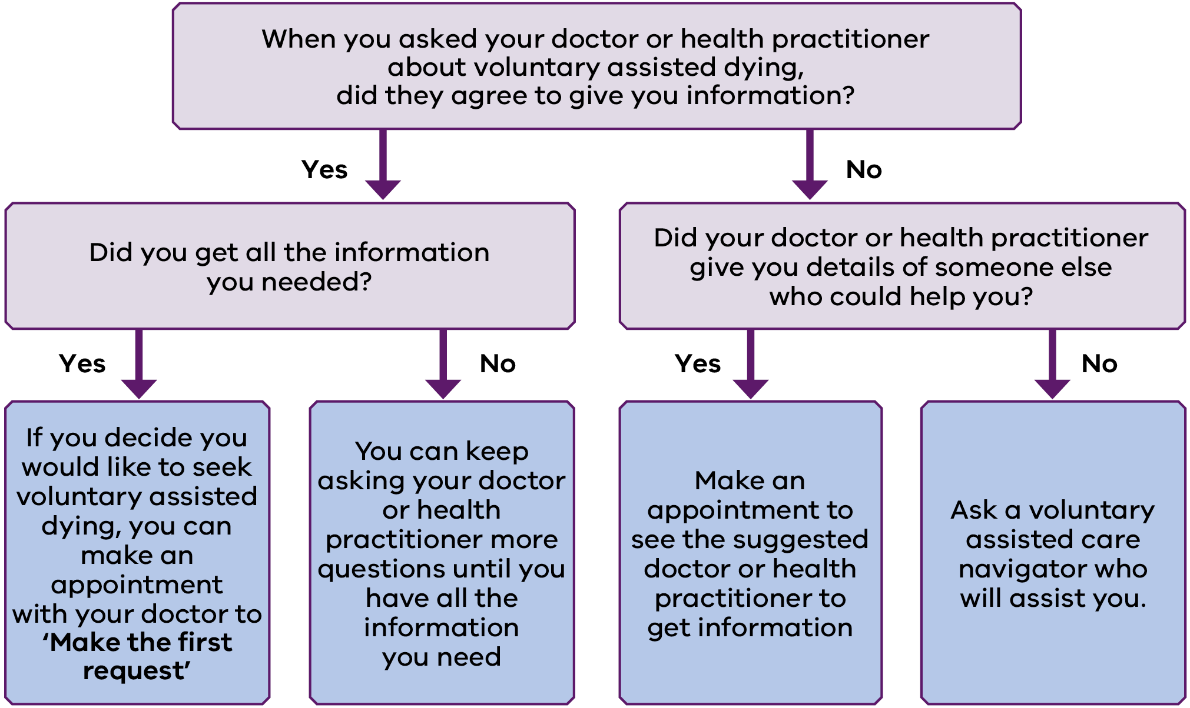
After talking with your doctor – or at any point when you feel you have enough information, and have decided to seek voluntary assisted dying – the next step is to make the first request to your doctor.
You may make a first request for voluntary assisted dying at the first appointment or you may need more than one visit to your doctor or health practitioner before you feel you have enough information about voluntary assisted dying. You can keep meeting with them and asking questions until you feel comfortable to make a decision (if at all).
If your doctor or health practitioner does not want to give you information about voluntary assisted dying, and they have suggested another doctor or health practitioner to talk to, you may want to make an appointment with that person. Otherwise, you can contact a voluntary assisted dying care navigator who can link you with a doctor or health practitioner who will assist you.

Talking to your doctor about voluntary assisted dying

Introduction
This information will help you get ready to talk to your doctor about voluntary assisted dying. You may find this useful if you are thinking about voluntary assisted dying, and need some further information.
When you want to talk to your doctor about voluntary assisted dying, you must bring it up first. Even if you only have a few questions, your doctor cannot talk about it unless you raise it first. Because talking about voluntary assisted dying with your doctor may feel difficult, this information will give you some ideas about how to prepare, what to say and what to expect from your doctor.

Making the appointment
You should make a long appointment with your general practitioner (GP) or your specialist doctor (for example, neurologist or oncologist).
If you are in hospital, you should let the staff know you want to talk to your doctor about voluntary assisted dying, so they can arrange a time for the doctor to discuss it with you.
You can also ask a health practitioner (such as a nurse) for information if you want to.
Asking for information about voluntary assisted dying does not mean you have started the process for voluntary assisted dying. It is a way to help you get the facts you need to make a decision, if and when you are ready. Talking with your doctor may also help you figure out if you are likely to be eligible for voluntary assisted dying.

What you can do before the appointment
        - Think about the reasons why you are considering voluntary assisted dying.
        - Think about any symptoms you are experiencing (for example, pain, fatigue, delirium or difficulty breathing).
        - Think about your fears about your disease and how your life will end, so that you can ask what supports are available.
        - Consider taking a trusted person with you to the appointment.
        - Let the doctor or receptionist know if you need an interpreter or speech pathologist at the appointment.
          - Think about any questions you want to ask your doctor or anything else you think they should know.
If you can, you may also want to write notes about the points above to take to the appointment with you. You could also take this information pack with you.
Some questions you may want to ask your doctor about your disease include:
        - What happens to people like me with this disease?
        - What are the ways my disease can be treated?
        - How will things change as my disease gets worse?
        - Where will I be treated?
        - What symptoms am I likely to experience as my disease gets worse?
        - After treatment stops being effective, what could be done to help me manage my symptoms?
        - What support will I be able to get while I am dying?
        - What are the types of support available in my area?
          - What usually happens to people with my disease in the last weeks or days of life?
Some questions you may want to ask your doctor about voluntary assisted dying include:
        - What is the process I have to go through?
        - Can I decide when to take the medication?
        - How do I get the medication?
        - How does the medication work?
        - How do I take the medication? Will it hurt?
        - Can anything go wrong?
        - What if I get worse and I can’t take the medication myself?
        - Can I choose where I take the medication?
        - Can I have people with me when I take the medication?
        - What if I change my mind?
        - What will my death certificate say?
        - What costs should I expect?
        - I would like help to talk to my family. Can you suggest some information I could use?
        - What other information is available about voluntary assisted dying?
        - Who else can I talk to about voluntary assisted dying? Are there organisations I can speak to?

At the appointment
Your doctor can only talk to you about voluntary assisted dying after you have asked them about it first. If you have a trusted person with you at the appointment, they cannot ask for you. Only you can start the conversation.
When asking about it, you do not need to use the term ‘voluntary assisted dying’ but it will help to be really clear with your doctor about what you are asking. If you feel more comfortable with terms like ‘euthanasia’ or ‘dying with dignity’ you can use those instead.
Examples of ways to start the discussion include:
        - I feel like I can’t go on like this; would voluntary assisted dying be an option for me?
        - I don’t see the point of another couple of months slowly dying. Can you give me a drug to speed things up?
        - Can you tell me about the voluntary assisted dying laws?
        - Can you tell me how I can get the medicine to end my life?
        - I want to know how you can help me to die.
        - How do I get that medicine to end it all when it gets too much?

What to expect from your doctor
Once you ask about voluntary assisted dying – or if your doctor is unsure whether you are talking about voluntary assisted dying - they may ask you some questions to help find out what you want. For example, if you ask a more general question like ‘I wish my life was over, can you help me?’ the doctor may ask you for more information to check what you are asking about.
Some questions your doctor may ask include:
        - How long have you been feeling like this?
        - What are your main concerns?
        - What do you know about your disease and how it is progressing?
        - What do you know about your treatment options? How do you feel about these options?
        - What help with your symptoms would make your life more comfortable?
        - What practical help would make your life more comfortable?
          - Have you heard of palliative care? How do you feel about getting palliative care support?
Your doctor may also:
        - Encourage you to talk with someone you trust about your situation and how it is affecting you.
        - Arrange a meeting with your carer, family, friend or support person, if you agree.

What if your doctor cannot or will not help you?
Doctors, and other health practitioners, have the right not to give you information about voluntary assisted dying.
Your doctor may not want to give you information because:
        - they do not agree with voluntary assisted dying
        - they work in a health service that does not offer voluntary assisted dying
          - they are not qualified to give you the information you need.
In these cases, your doctor or health practitioner may refer you to someone who can help. If they do not, you can contact a voluntary assisted dying care navigator who can link you with the right person.

If you make the decision to go through the voluntary assisted dying process
If you feel you have enough information, and decide you want to go through the process to seek voluntary assisted dying, and access the medication, you will need to make your first request. You can make your first request at this appointment or you can wait and make another appointment and then make your first request if you choose. Your first request should be clear, so the doctor understands exactly what you are asking.
Even after you have started the process for voluntary assisted dying, you can change your mind at any time, up until the time when you take the medication.

Where to get more information
You can get more information about voluntary assisted dying from:
        - your doctor or health practitioner
        - a voluntary assisted dying care navigator.

The voluntary assisted dying process

What process do my doctor and I need to follow?

Summary
The process to ask for voluntary assisted dying and access the medication is set out in law. To complete the process, you must:
        - Make two verbal requests (if you have difficulty speaking, you can make the requests using any means of communication available to you).
        - Sign a written request (if you have difficulty writing, another person can sign this request for you in your presence).
        - Be assessed as eligible for voluntary assisted dying by two different doctors (one of the doctors must be a specialist in the field of your disease).
          - Choose a contact person who agrees to return any unused voluntary assisted dying medication after your death or if you decide not to take the medication.
It is important to be aware that accessing voluntary assisted dying requires considerable preparation and planning.
There is no maximum time limit for completing the voluntary assisted dying process. However, the process cannot be completed in less than 10 days (unless both doctors agree that you are likely to die within this time).
You can use a qualified interpreter or accredited speech pathologist during the process if needed.

The assessment and prescription process for voluntary assisted dying
Figure 2 shows a summary of the process you and your doctor will need to follow to receive access to the voluntary assisted dying medication.
Figure 2. The voluntary assisted dying assessment and prescription process
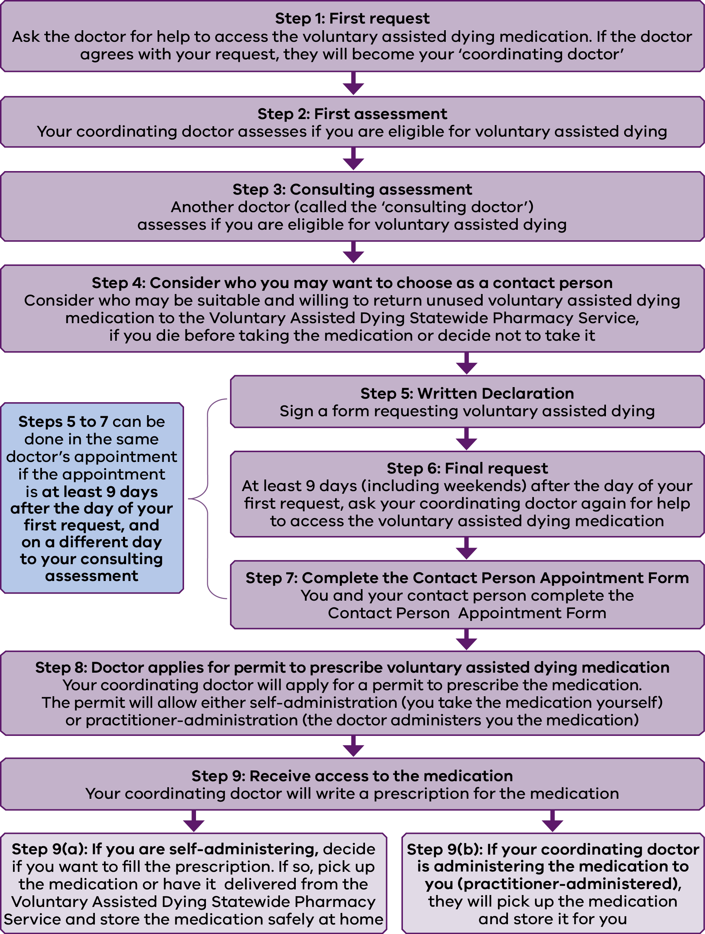

Step 1: Make the first request
If you decide to seek voluntary assisted dying, you will need to make the first request to your doctor (GP or specialist doctor). Only a doctor can accept your first request.
Ask for a sufficient amount of time with your doctor to discuss voluntary assisted dying.
You can choose to have a family member or friend with you when you talk to the doctor.
Your first request needs to be made to the doctor in person. You will need to start the discussion with your doctor when you make your request. The law says that your doctor cannot talk to you about voluntary assisted dying, unless you raise it first.
Your request should be clear, so the doctor knows exactly what you are asking. If you use the words ‘voluntary assisted dying’, it will help the doctor understand that you are making your first request. A suggested way of making your first request is to ask: ‘Will you help me to access the voluntary assisted dying medication?’
However, you do not have to use the term ‘voluntary assisted dying’ or any particular words in the request. The most important thing is to make clear that you are asking the doctor for help to end your life. You may find that the doctor asks you questions to clarify that you are asking for voluntary assisted dying.
If you have difficulty speaking, you can make the request using other means of communication, such as gesture or a communication aid. You can also use a qualified interpreter or speech pathologist if needed. See ‘Use of an interpreter’ and ‘Use of a speech pathologist’ for more information about requirements for interpreters and speech pathologists.

After the first request
Within seven days of making your first request, your doctor must either:
        - accept your request
        - refuse your request.

Doctor accepts your request
If the doctor accepts your request, they will become your coordinating doctor for the voluntary assisted dying process.

Doctor refuses your request
The doctor may refuse your request if they:
        - do not agree with voluntary assisted dying
        - will not be available to help you through the process
          - are not qualified to help you through the process.
If the doctor refuses your request, they may suggest another doctor who can help you. If they do not, you can contact a voluntary assisted dying care navigator to help you find a doctor who would be willing to assist you.
See ‘Voluntary assisted dying care navigators’ for more information.
Contact: email voluntary assisted dying care navigator <vadcarenavigator@petermac.org> or call (03) 8559 5823.

If you do not hear from your doctor within seven days
If you do not hear from your doctor within seven days of making the first request, you should contact your doctor to follow up. If you do not receive a response, contact a voluntary assisted dying care navigator for advice.
Figure 3 shows what you can do if your request is accepted or refused.
Figure 3. First request to access the voluntary assisted dying medication
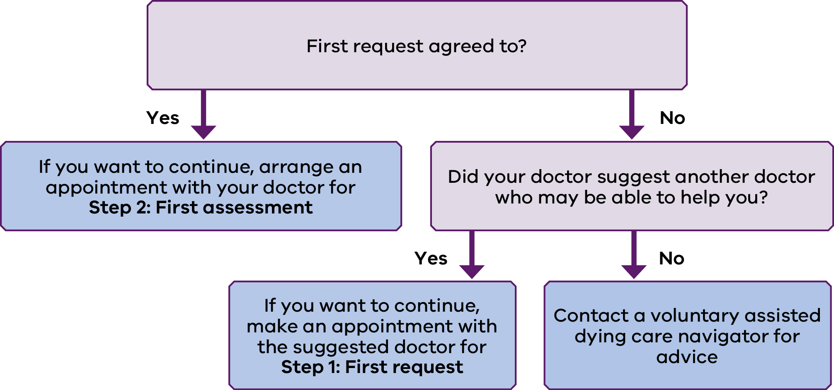

Step 2: Complete the first assessment with your doctor
Complete the first assessment for voluntary assisted dying with your coordinating doctor.
Your coordinating doctor must have completed training before they can assess you for voluntary assisted dying. If your doctor has not already completed the training when you make your first request, they must do so before you have the first assessment. The training can be done in one day.
During the first assessment (and the consulting assessment – see Step 3), the doctor must be satisfied you meet the conditions for voluntary assisted dying. See ‘Do I meet the conditions for voluntary assisted dying?’ for more information about meeting the conditions.

Meeting the decision-making ability condition
Your doctor will have a conversation with you to make sure you fully understand your disease and any treatment options you may still have. Under the law, they have a responsibility to talk to you about your prognosis – how the disease is likely to progress from here. They also need to talk to you about your treatment and palliative care <https://www.betterhealth.vic.gov.au/servicesandsupport/end-of-life-and-palliative-care-services> options.
Your doctor will also explain the voluntary assisted dying process to you. They will talk about the medication, and what will happen if you decide to take it. They will assess whether you have the ability to understand this information, and can make a decision for yourself about voluntary assisted dying. They must be sure that no-one is putting any pressure on you to make this decision.
It will be easier if you come to the assessment as informed about your disease, treatment and palliative care options as possible. Your doctor may be able to give you additional information about the disease and its effects. They may have further advice about some ways you can manage the suffering you are experiencing. If you are not already receiving support from palliative care, they are likely to encourage you to do so.

Meeting the ‘late stages of advanced disease’ condition
The doctor must be satisfied that you have an advanced disease that cannot be cured, is getting worse and will cause your death. They must assess that the disease is expected to cause your death in weeks or months, but not more than six months (or within 12 months for neurodegenerative diseases, such as motor neurone disease).

Meeting the citizenship and residency conditions
You will need to show the doctor evidence that you meet the citizenship and residency conditions to receive voluntary assisted dying. These conditions are:
        - that you are an Australian citizen or permanent resident
          - that you have lived in Victoria for at least 12 months (at the time you made the first request).
There are a range of ways you can show you are an Australian citizen or permanent resident and a Victorian resident for the last 12 months.

Your doctor may need a specialist opinion
In some cases, your doctor will need a specialist opinion before they can complete the first assessment. This will happen if:
        - Your doctor is unsure whether you are able to make your own decision about voluntary assisted dying. For example, when your doctor is concerned a mental illness or cognitive impairment may be affecting your decision-making ability, they must ask you to see a specialist, such as a psychiatrist or neurologist, for advice.
        - Your doctor is unsure whether your disease is incurable, progressive (getting worse) and will cause death within weeks or months, but not more than six months (or within 12 months for neurodegenerative diseases, such as motor neurone disease).
          - You have a neurodegenerative disease (such as motor neurone disease) that is expected to cause your death in the next six to 12 months.

After the first assessment
The coordinating doctor will usually, but not always, be able to complete the first assessment in one appointment. If they have referred you for a specialist opinion, their assessment will not be finished until you have seen the specialist and your doctor has received their report.
Once the coordinating doctor has all of the information they need for the assessment, they will assess that you are either:
        - eligible for voluntary assisted dying
        - not eligible for voluntary assisted dying.

Eligible for voluntary assisted dying
If the doctor assesses you are eligible for voluntary assisted dying, and you want to go ahead, you will need to complete the next step in the process – Step 3: Consulting assessment. For the next step, the doctor will refer you to another doctor (the ‘consulting doctor’) to complete the consulting assessment. Either the coordinating doctor or the consulting doctor must be a specialist in the field of your disease.

Not eligible for voluntary assisted dying
If the doctor determines you are not eligible for voluntary assisted dying, the process ordinarily ends. Your doctor can discuss other options available to you.
If you choose to, you can start the process again (starting at Step 1: First request) with another doctor. You can also ask to start the process again in the future, if things change.
If the doctor determines you are not eligible because they assess that you do not have decision-making capacity or that you are not a Victorian resident, you can apply to the Victorian Civil and Administrative Tribunal (VCAT) for a review of that assessment.
Figure 4 shows what you can do if the coordinating doctor says you are eligible, or not eligible for voluntary assisted dying.
Figure 4. Coordinating doctor assessment
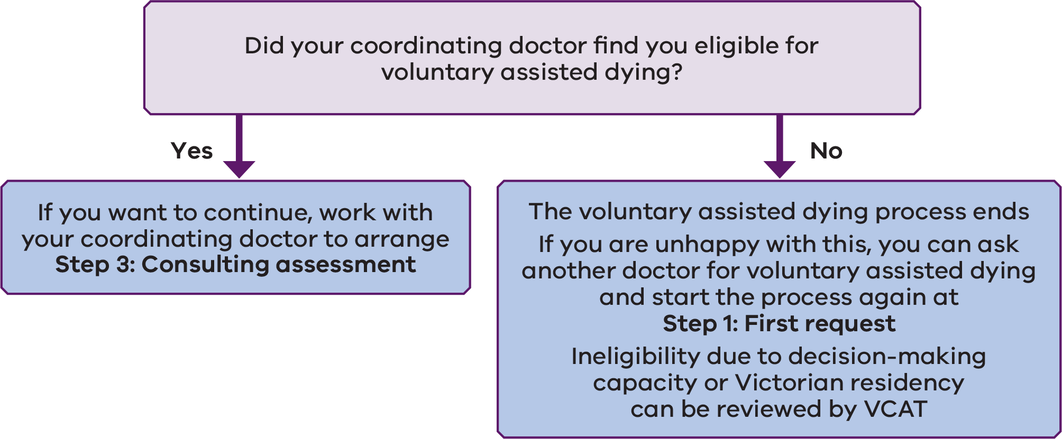

Step 3: Complete the consulting assessment with the consulting doctor
The consulting assessment will be the same as the first assessment, except with the consulting doctor. The consulting doctor may also refer you for a specialist opinion if needed.
You can choose to bring a family member or friend to the assessment. You will also need to bring the same documents you took to the first assessment that prove you are an Australian citizen or permanent resident and have lived in Victoria for at least the last 12 months.

After the consulting assessment
The consulting doctor will usually, but not always, be able to complete the consulting assessment in one meeting. If they have referred you for a specialist opinion, their assessment will not be finished until you have seen the specialist and the consulting doctor has received their report.
Once the consulting doctor has all of the information they need for the assessment, they will assess whether you are either:
        - eligible for voluntary assisted dying
        - not eligible for voluntary assisted dying.

Eligible for voluntary assisted dying
If the consulting doctor assesses you are eligible for voluntary assisted dying, and you want to go ahead, you can move to Step 4: Consider who you may want to choose as a contact person.

Not eligible for voluntary assisted dying
If the consulting doctor assesses you are not eligible for voluntary assisted dying, you and your coordinating doctor may agree to refer you to another ‘consulting doctor’ for another assessment. But if your coordinating doctor does not think it is appropriate to refer you, the process ends. You may want to talk to your doctor about other options available to you, including palliative care. If you choose to, you can start the process again with another doctor (starting at Step 1: First request).
Figure 5 shows what you and your coordinating doctor can do if the consulting doctor says you are eligible, or not eligible for voluntary assisted dying.
Figure 5. Consulting doctor assessment
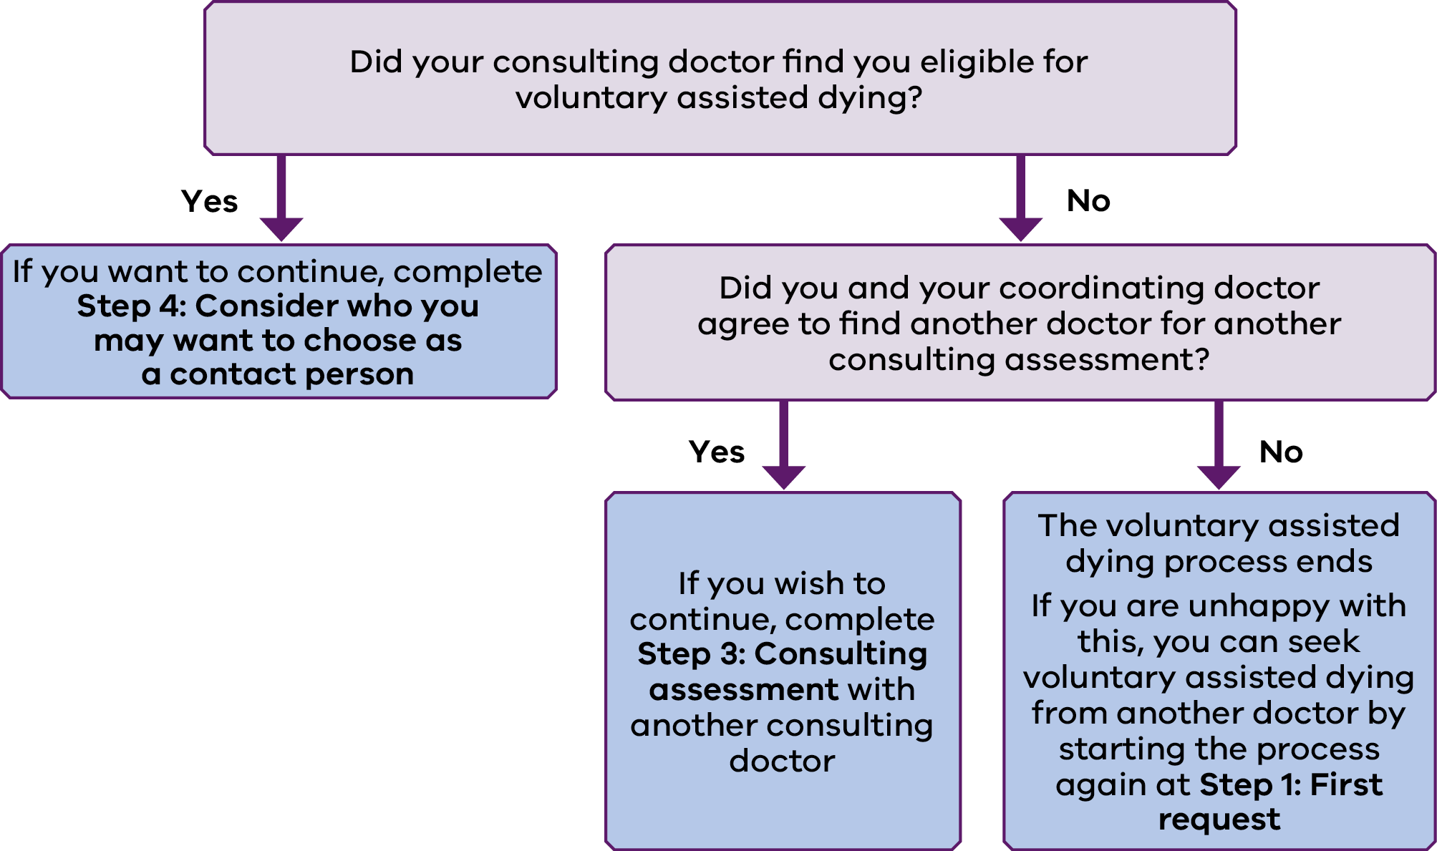

Step 4: Consider who you may want to choose as a contact person
At this point in the process, you should start thinking about who you will ask to be your ‘contact person’ for voluntary assisted dying.

What does the contact person do?
Your contact person will be the person responsible for returning any unused voluntary assisted dying medication to the Voluntary Assisted Dying Statewide Pharmacy Service (the service that dispenses the medication – see Step 9: Receive access to the medication).
This will happen if you get a prescription for medication you administer yourself, and you fill the prescription, but:
        - later decide not to take the medication
        - you deteriorate and the doctor agrees to administer the medication to you instead
          - you die without taking the medication.
Your contact person will be contacted by the Voluntary Assisted Dying Review Board in the days following your death. They will be asked about their experience of the process. If there is unused medication at this point, the board will also monitor that your contact person returns the medication to the Voluntary Assisted Dying Statewide Pharmacy Service.

Who should I choose?
Your contact person does not have to be your spouse or partner. In fact, those closest to you may find it too hard to have an extra responsibility in the days after your death. Ideally, you should choose someone you think could manage this role, without being too weighed down by it. You should also consider how they would have access to any unused or remaining medication after your death. The contact person must be 18 years of age or older. They must also agree to take on this role.
You and your contact person will both need to fill in the Contact Person Appointment Form later in the process (see Step 7: Complete the Contact Person Appointment Form).

Step 5: Complete the Written Declaration Form
Please note: You can complete steps 5 to 7 within the same doctor’s appointment if the appointment is at least nine days after the day of your first request, and at least one day after the consulting doctor’s assessment.
Once you have been assessed as eligible for voluntary assisted dying by your coordinating and consulting doctors, you can complete the Written Declaration Form.
The Written Declaration Form must be signed by you in front of your coordinating doctor and two witnesses. Only one witness can be a family member. Family members are defined as your spouse or domestic partner, parent, sibling, child or grandchild. The family member as well as any other witnesses cannot:
        - know or believe they will benefit from your will, or gain from your death
        - be an owner or manager of a facility where you are living or getting treatment
          - be directly involved in providing you with health or professional care services.
If you cannot write, you can ask another person to sign the form for you. They must do so in your presence. You can also use a qualified interpreter if needed.

Step 6: Make the final request
Ask for enough time with your doctor to make the final request for voluntary assisted dying. You cannot make your final request on the same day as the consulting assessment. The final request must also be at least nine days (including weekends) after you made the first request. The nine-day period can only be shortened if the two doctors agree your death is likely to happen within that time.
You can have a family member or friend with you when you meet with the doctor.
During the meeting, you should tell your doctor you want to make your final request for voluntary assisted dying.
Your request should be clear, so the doctor knows exactly what you are asking. If you use the words ‘voluntary assisted dying’, it will help the doctor understand you are making your final request. A suggested way of making your final request is to say:
‘This is my final request for voluntary assisted dying. I would like to ask for voluntary assisted dying.’
However, you do not have to use the term ‘voluntary assisted dying’ or any particular words in the request. The most important thing is to make clear that you are asking the doctor for help to end your life. So, for example, saying ‘This is my final request. Will you help me to end my life?’ should be enough for the doctor to know you are making your final request.
If you cannot communicate verbally, you can make the request using your preferred means of communication (such as gestures or a communication aid). You can also use a qualified interpreter or speech pathologist to help you make the request if needed.

Step 7: Complete the Contact Person Appointment Form with your contact person
Important note: If you are completing steps 5 to 7 in one appointment, the contact person will either need to come with you to the doctor’s appointment or you can bring the completed Contact Person Appointment Form with you to the appointment.
Both you and your contact person will need to fill in the Contact Person Appointment Form.
The form must be signed by you, and your contact person, in front of a witness who is 18 years old or over. If you cannot write, you can ask another person to sign for you in your presence. A person who signs for you cannot be a witness or the person that you are appointing as your contact person.
Once the form has been completed, you should give it to your coordinating doctor.

Step 8: The doctor will apply for a permit to prescribe the medication
Once the assessments and paperwork from steps 1 to 7 are completed, the coordinating doctor may apply for a permit to prescribe you the medication.
There are two types of permits:
        - Self-administration permit: the doctor must apply for this type of permit when you are able to administer and digest the medication yourself.
          - Practitioner administration permit: the doctor may apply for this type of permit when you are not physically able to take the medication yourself or digest the medication. In this case, the permit means the doctor can help by administering the medication to you.

If you deteriorate after receiving a self-administration permit and can no longer physically take the medication yourself
If your doctor asks for a self-administration permit, but your disease gets worse and you cannot physically take or digest the medication yourself anymore, you can ask them to apply for a practitioner-administration permit. To do this, follow these steps:
  - If you have not filled your prescription for the self-administered medication, tell your coordinating doctor who will cancel the prescription.
  - If you have already received the medication, you or your contact person should return the medication to the Voluntary Assisted Dying Statewide Pharmacy Service or arrange for the medication to be collected.
  - In person, verbally ask the doctor to apply for a practitioner administration permit for you. You do not need to use the term ‘practitioner-administered’ in your request. You only need to make it clear that you are physically unable to take the medication yourself now, and want the doctor to give you the medication instead. If you have difficulty speaking, you can use whatever means of communication you prefer (for example, gesture or a communication aid).
  - If the doctor agrees, they will apply for the practitioner-administration permit. They will then get the prescription filled, and store the medication for you.

Step 9: Receive access to the voluntary assisted dying medication

Step 9(a) If you are self-administering
Your coordinating doctor will arrange a prescription for the voluntary assisted dying medication. You do not have to fill this prescription if you do not want to. Knowing that you can get the medication at a later point in time, if you need it, may be sufficient.
If you do decide to fill the prescription, you can only get the medication from the Voluntary Assisted Dying Statewide Pharmacy Service. This service is based at the Pharmacy Department in the Alfred Hospital, Melbourne, and will deliver the medication to you. There is no charge for the medication or its delivery.
There are strict rules for storing the voluntary assisted dying medication. The pharmacist will give you the medication in a locked box. You must keep it in this box until (and if) you decide to take the medication.
If you change your mind after you have received the medication, you or your contact person should return the medication to the Voluntary Assisted Dying Statewide Pharmacy Service or arrange to have it collected.

Step 9(b) If your coordinating doctor is administering the medication to you (practitioner administration)
Your coordinating doctor will get the prescription filled for you. They will keep the medication until you decide if and when you want to use it. You or your contact person will not be required to return the medication if you do not end up using it.

Use of an interpreter
A suitably qualified interpreter can be used throughout the voluntary assisted dying process if you need one. The interpreter must not:
        - be a family member
        - know or believe they will benefit from your will, or gain from your death
        - be an owner or manager of a facility where you are living or having treatment
          - be directly involved in providing you with health or professional care services.
The interpreter must be accredited by the National Accreditation Authority for Translators and Interpreters <https://www.naati.com.au>.

Use of a speech pathologist
If you have difficulty speaking, a speech pathologist may be able to assist you to communicate with doctors during the voluntary assisted dying process. Only speech pathologists who are certified practising members of Speech Pathology Australia <https://www.speechpathologyaustralia.org.au> can be used during the process. The speech pathologist must not:
        - be a family member
        - know or believe they will benefit from your will, or gain from your death
        - be an owner or manager of a facility where you are living or having treatment
        - be directly involved in providing you with health or professional care services.

Time limits for the assessment and prescription process
It is important to be aware that accessing voluntary assisted dying requires considerable preparation and planning.
There is no time limit for completing the assessment and prescription process. This means if you start the process, but get delayed for some reason (for example, you are unsure whether to move to the next step) you can pick up where you left off at any time. You can also withdraw from the voluntary assisted dying process at any time.
You should be aware that if you lose your ability to make a decision about voluntary assisted dying during the assessment and prescription process, the process will end.
The law says that the shortest time you can complete the process is 10 days. However, there is an exception so that if you are very sick and the two doctors agree you are not expected to live for 10 days, the process can happen more quickly.
The availability of the two medical practitioners required to assess your eligibility may impact on the total length of time the process takes. If you have concerns about the length of time the process will take, talk to your coordinating medical practitioner about your concerns.

Voluntary Assisted Dying Review Board
The Voluntary Assisted Dying Review Board has been appointed by the Health Minister to review voluntary assisted dying in Victoria. Doctors (and pharmacists) must provide forms to the Voluntary Assisted Dying Review Board at each stage of the voluntary assisted dying process. This allows the Review Board to make sure that the law is followed. Your coordinating and consulting doctors will also collect and provide to the Voluntary Assisted Dying Review Board other personal and heath information about you as required by the law.

Costs
As with other healthcare, there may be some costs associated with the process. For example, you may need to pay for the doctors’ appointments, and any specialists you need to see. You should discuss any costs you may need to cover with your doctor at the start of the process. There are no costs for the medication or its delivery.

Taking the medication
See ‘Taking the medication’ for information about deciding whether you want to take the voluntary assisted dying medication and if so, how to prepare.

Voluntary assisted dying process checklist
Purpose: This checklist is for people going through the assessment and prescription process for voluntary assisted dying. The checklist should be used alongside the detailed information in ‘What process do my doctor and I need to follow?’ The checklist is designed to help you keep track of your progress. You do not need to complete the checklist or show it to your doctor.

Steps

Step 1: First request
            - Make a time to see your doctor (either a GP or specialist doctor)
            - Ask the doctor to arrange a qualified interpreter or speech pathologist to attend, if needed
            - Ask your carer, family member, friend or support person to come with you, if you want to
            - Be ready to talk about voluntary assisted dying, your disease and prognosis, as well as other treatment and palliative care options available to you
            - Make the first request to your doctor in person, verbally, or using any other means of communication available to you
            - Check if the doctor has agreed to your request (they must agree or refuse within seven days)

Step 2: First assessment
            - Ask your carer, family member, friend or support person to come with you to the assessment, if you want to
            - Ask the doctor to arrange a qualified interpreter or speech pathologist to attend, if needed
            - Be ready to talk about voluntary assisted dying, your disease and prognosis, as well as other treatment and palliative care options available to you
            - Take proof of your Australian citizenship or permanent residency
            - Take proof that you have been a resident of Victoria for at least the last 12 months
            - Complete the first assessment with the coordinating doctor
            - Complete ‘specialist opinion’ appointments you have been referred for by your coordinating doctor (if any)
            - Discuss the results of the first assessment with your coordinating doctor

Step 3: Consulting assessment
            - Ask your carer, family member, friend or support person to come with you to the assessment, if you want to
            - Ask the doctor to arrange a qualified interpreter or speech pathologist to come to the appointment, if needed
            - Be ready to talk about voluntary assisted dying, your disease and prognosis, as well as other treatment and palliative care options available to you
            - Take proof of your Australian citizenship or permanent residency
            - Take proof that you have been a resident of Victoria for at least the last 12 months
            - Complete the consulting assessment with the consulting doctor
            - Complete ‘specialist opinion’ appointments you have been referred for by the consulting doctor (if any)
            - Discuss the results of the consulting assessment with the consulting doctor and your coordinating doctor

Step 4: Consider who you may want to choose as a contact person
            - Choose a contact person who agrees to take responsibility for returning any unused voluntary assisted dying medication
Steps 5 to 7 below can be completed within the same doctor’s appointment, if you make the appointment at least nine days after your first request, and at least one day after the consulting assessment.
If you do steps 5 to 7 together, you will either need to bring your contact person to the appointment or both sign the Contact Person Appointment Form beforehand (in front of a witness) and bring the form to the appointment.

Step 5: Written declaration
            - Make a time to see your coordinating doctor
            - Ask the doctor to arrange a qualified interpreter or speech pathologist to attend, if needed
            - Ask your carer, family member, friend or support person to come with you to the doctor, if you want to
            - Sign the Written Declaration Form in front of the coordinating doctor and two eligible witnesses who are 18 years old or over (if you are unable to write, ask another person to sign the Written Declaration Form in your presence, and in front of the coordinating medical practitioner and two witnesses who are 18 years of age or older)

Step 6: Final request
            - Make a time to see your coordinating doctor. The appointment must be at least nine days after your first request (unless there are exceptional circumstances) and at least one day after the consulting assessment
            - Ask the doctor to arrange a qualified interpreter or speech pathologist to attend, if needed
            - Ask your carer, family member, friend or support person to come with you to the doctor, if you want to
            - Make the final request to your doctor in person, verbally, or using any other means of communication available to you

Step 7: Complete the Contact Person Appointment Form
            - With your contact person, complete the Contact Person Appointment Form in front of a witness who is 18 years of age or older
            - Give the completed Contact Person Appointment Form to your coordinating doctor

Step 8: Doctor applies for a permit to prescribe voluntary assisted dying medication
No action required by you.

Step 9: Receive access to the medication

Step 9(a): If you are self-administering
            - Decide if you want to fill the prescription
            - If you decide to fill the prescription, arrange for delivery of the medication from the Voluntary Assisted Dying Statewide Pharmacy Service
            - Store the medication as directed by the Voluntary Assisted Dying Statewide Pharmacy Service

Step 9(b) If your coordinating doctor is administering the medication to you (practitioner administration)
            - Your coordinating doctor will collect and store the medication for you
If you have any questions about completing this checklist, please speak to your coordinating doctor.

What if my doctor is unwilling to help me?
Not all doctors or other health practitioners (such as nurses) agree with voluntary assisted dying. They do not have to discuss this option with you if they do not want to.
If you ask a doctor or health practitioner about voluntary assisted dying, and they do not want to talk about it, they may suggest another health practitioner who can help you.
If they do not, you can contact a voluntary assisted dying care navigator who will link you with a willing doctor or health practitioner.
Contact: email voluntary assisted dying care navigator <vadcarenavigator@petermac.org> or call (03) 8559 5823.

The dying process

Preparing for and taking the voluntary assisted dying medication

Summary
Once you have the voluntary assisted dying medication, there are some things to think about and prepare for if you decide you want to take it:
        - You do not have to take the medication at all, if you do not want to.
        - Most people will take the voluntary assisted dying medication themselves.
        - Knowing the right time to take the medication is different for everyone.
        - You should think about where and when you want to take the medication, and who you would like with you (if anyone).
        - If you are self-administering, you can take the medication at any time.
        - People who cannot physically take the medication themselves or digest the medication can ask the doctor to administer it in a different way.
        - If the doctor is giving you the medication, you will need to make an administration request before they can administer the medication.
        - There is only a very small risk that something could go wrong once you have taken the medication.

Getting access to the medication
You can only get access to the medication once you have been through the process for voluntary assisted dying.

Deciding whether to take the medication
Once you have access to the medication, you can keep it for as long as you want. You do not have to use the medication within a particular time. Deciding whether you want to take the medication, and if so, the right time, is entirely up to you.
Some people will never take the medication – knowing they have the option to control the timing and manner of their death gives them enough comfort. It is okay if you decide the time is never right.
If you decide you do want to go ahead, you can talk with your doctor about the timing you would prefer. Knowing the right time to take the medication is different for everyone. You are the only one who can decide if and when you take the medication. Talking with those you trust and your doctor may help as they will also be noticing changes as your disease progresses.

Arrangements to put in place before taking the medication

Decide where you will take the medication
Most people will take the medication in their home. If you want to take the medication outside of your home, such as in a hospital, hospice or residential facility, you will need to check with the facility if they are able to support you. Some hospitals, hospices and residential facilities may not agree with voluntary assisted dying, or may not have the staff or privacy needed when you are taking the medication. You should start talking to your coordinating doctor as early as possible about where you would prefer to take the medication.

Decide who you want with you
You should think about who you want with you when you take the medication. You are encouraged to have at least one other person there so you are not alone, but you do not have to.
Some people will want to have their carer, family members, friends or support person with them. If they cannot be with you or you have no one available, talk with your coordinating doctor about how someone could be there to support you.
If you choose not to have someone present it is important to let someone you trust know when and where you plan to take the medication. This is so that your death can be certified.
If the doctor is giving you the medication, they will need to be with you during the process.
If you are self-administering, you may want to have a doctor or other health practitioner (such as a nurse) with you, so they can make sure you are comfortable during the dying process. You will need to arrange this with your doctor or other health practitioner.

Other arrangements to think about
Planning at the end of life is important to make sure your end-of-life wishes are known. You may find it helpful to talk to your carer, family, friend or support person about the following:
        - religious and cultural considerations at the end of life
        - care after death
        - your will and financial matters
        - funeral and burial arrangements
          - other personal matters that are important to you.
Your palliative care team or coordinating doctor can help you have these discussions.
If you have life insurance, you may want to check with the insurance company whether your cover will be affected if you take the voluntary assisted dying medication.

Taking the medication

Can anyone stop you?
The only person who can decide whether to take the medication is you.
If your decision to take the medication is difficult for those close to you, your coordinating doctor may be able to help you find ways to talk about voluntary assisted dying with them. See ‘Talking about your end-of-life preferences’.

I am self-administering. How do I take the medication?
The coordinating doctor will talk to you about how to take the medication when they arrange the prescription. The pharmacist will also give you verbal and written instructions when you access the medication.
You are encouraged to have your coordinating doctor or another health practitioner with you, if they agree, so they can make sure you are comfortable during the dying process . They cannot help you take the medication.

What if I can no longer self-administer?
Some people who were going to self-administer may later become unable to digest, swallow or physically take the medication themselves. If this happens to you, you can ask your coordinating doctor to apply for a practitioner-administration permit. This will allow them to give you the medication instead.

The doctor is administering me the medication. What do I need to do?
If your coordinating doctor is going to administer the medication, you will need to make a plan with them about when and where this will happen, and ensure their availability at a mutually acceptable time.
Once the coordinating doctor arrives, and you’re ready, you will need to make an administration request to them. The request needs to be made:
        - by you verbally, or using other means of communication (such as gestures or a communication device)
          - in the presence of a witness.
If you have difficulty speaking, you can use any other means of communication available to you to make the request (such as gesture, sign language or a communication aid).
If you need the help of a qualified interpreter or speech pathologist to make the request, ask your coordinating doctor to organise for them to be there.
Once you have made the administration request, the coordinating doctor will give you the medication in a way you can best digest it.

Could something go wrong?
Your coordinating medical practitioner will talk to you about the likely outcome and any risks of the voluntary assisted dying medication. If something does go wrong, and a health practitioner is present, the health practitioner can make sure you are comfortable during the dying process.

After death occurs

Summary
Different people have different preferences for how much they want to know about death and dying. There is no right or wrong way to deal with this difficult time. Your family and friends’ responses will be shaped by their beliefs, values, culture, experiences and circumstances.
The following information may be helpful if your carer, family, friend or support person wants to know what to expect after your death. It includes practical information about what to do immediately after your death, as well as support services they can contact to help them through their grief.

What to do first

Death at home
Different people approach the death of a family member or friend at home in different ways. Some may want to sit with the person for a while; others may prefer to make arrangements immediately. For more information about the dying process visit the Better Health Channel <https://www.betterhealth.vic.gov.au/health/servicesandsupport/At-the-end-dying-explained> and for palliative care resources visit Palliative Care Australia <https://palliativecare.org.au/resources>.
After your death your carer, family, friend or support person will, when ready, notify your palliative care service (if one has been involved in your care) or your doctor, or can directly contact the funeral director of your choice. If you have been receiving palliative care, usually a nurse from the service will visit to support your carer, family, friend or support person.
Any doctor can fill out the Medical Certificate of Cause of Death as long as they know your medical history and are prepared to certify the cause and manner of your death. The Medical Certificate Cause of Death must be completed within 48 hours of death. The doctor will also notify the Registrar of Births, Deaths and Marriages.
For more information about what to do after a person has died visit the Better Health Channel <https://www.betterhealth.vic.gov.au/health/servicesandsupport/what-to-do-after-someone-dies>.

Death in a hospital or care facility
If death happens in a hospital or care facility, the staff can help and support your family members through the process.

Notification to the Coroner
The doctor who certifies the death must also notify the Coroner. In most cases, the Coroner will not need to investigate the death.

Returning any unused medication
If you were planning to self-administer the medication your contact person will need to return any unused voluntary assisted dying medication to the Voluntary Assisted Dying Statewide Pharmacy Service within 15 days of your death. The Voluntary Assisted Dying Review Board will follow up with your contact person after your death to check they have returned the medication to the Voluntary Assisted Dying Statewide Pharmacy Service.
If your coordinating doctor was going to administer the medication to you, the contact person will not have a role in returning any unused medication after death (as the doctor will do this). However, the Voluntary Assisted Dying Review Board will still contact them to check how the process went.

Death certificate
For people who access voluntary assisted dying, the Register of Births, Deaths and Marriages will record both the cause and manner of death. The cause of death will be the underlying disease (for example, cancer, motor neurone disease). The manner of death will be recorded as ‘voluntary assisted dying’. The extract from the Register (commonly called the death certificate) that your family receives will not say that you accessed voluntary assisted dying. It will only record your underlying disease.

Bereavement support for carers, family and friends
After death, family members and friends may experience a range of emotions such as sadness, anger, relief, disbelief, anxiety or numbness. Supporting each other is important in helping people who have experienced bereavement. Grief can be very painful, but most people can gradually find ways to live with their loss.
There are several community organisations that offer support and counselling services to help with managing grief. For example, the Australian Centre for Grief and Bereavement <https://www.grief.org.au> offers face-to-face counselling and support groups for people experiencing grief. They also offer telephone counselling for people in remote areas of Victoria. They can be contacted on 1800 642 066.
Your doctor or a voluntary assisted dying care navigator can also help your carer, family, friends or support person link with the right supports, including counselling services.
Contact: email voluntary assisted dying care navigator <vadcarenavigator@petermac.org> or call (03) 8559 5823.

Support

Getting support

Summary
If you are thinking about or going through the process of voluntary assisted dying, it is likely you will need some support. Support is available from:
        - your doctor and your healthcare team
        - carers, family, friends or your support person
        - voluntary assisted dying care navigator
        - other services.

Getting support from your doctor and healthcare team
Any willing doctor or other health practitioner (for example, nurse or social worker) can support you while you are thinking about, or in the process of asking for voluntary assisted dying.
Either your doctor or another health practitioner can provide you with information about the process and help you to think through your options. If you want to speak with them about voluntary assisted dying though, you will need to raise it first; a doctor or health practitioner cannot talk about it unless you start the conversation. See ‘Talking to your doctor about voluntary assisted dying’ for advice about how to start the discussion.
If you decide to go through the process for voluntary assisted dying, only a doctor can help you with the assessments and the medication.
Not all doctors or other health practitioners agree with voluntary assisted dying. If your doctor or health practitioner does not want to discuss voluntary assisted dying, they may suggest another health practitioner who can help you. If they do not, you can contact a voluntary assisted dying care navigator who will link you with a willing doctor or health practitioner.

Carers, family members, friends or your support person
Your carers, family, friends or support person may also help you think about or go through the process for voluntary assisted dying (see ‘Talking to your family and friends about end of life and voluntary assisted dying’). If you would like, they can accompany you to your doctors appointments, and be part of your discussions about voluntary assisted dying. They can also be with you if you decide to take the medication.

Voluntary assisted dying care navigators
Voluntary assisted dying care navigators can help you if you need information or assistance with the voluntary assisted dying process. Many people will be well supported through the voluntary assisted dying process by their coordinating doctor, their healthcare team or the health service they use. However, some people may need extra support during the process. In these cases, voluntary assisted dying care navigators can work closely with the person, their carers, family or friends, doctors, and healthcare team to make sure the person gets the right support.
Voluntary assisted dying care navigators can also help you to find a willing doctor, if your doctor or health practitioner does not agree to talk to you about voluntary assisted dying.
The first two voluntary assisted dying care navigators will be based at Peter MacCallum Cancer Centre while the statewide care navigator service is set up. Voluntary assisted dying care navigators can support you if you have an incurable disease that is advanced, progressive, and will cause your death; not only if you have cancer. You can contact them for support from anywhere in Victoria.
Contact: email voluntary assisted dying care navigator <vadcarenavigator@petermac.org> or call (03) 8559 5823.

Counselling services
Other services that can provide you with emotional and psychological support while you are considering or asking for voluntary assisted dying include:
        - BeyondBlue 1300 22 4636
        - Australian Centre for Grief and Bereavement 1800 642 066.

Talking about your end-of-life preferences

Talking to your carer, family, friend or support person about your end-of-life preferences and voluntary assisted dying
Talking to people you trust about your preferences for the end of life can be difficult and emotional. Many people do not like to talk about death and dying. However, having an open discussion about your death and how you want it to happen, may help those close to you to understand your end-of-life wishes. They may also feel relieved that the subject has been brought into the open.
There is no right or wrong way to talk about death and dying. Your doctor can support you to have this conversation with those close to you.

Talking about voluntary assisted dying
You do not need to tell your family and friends that you are thinking about voluntary assisted dying, but you may find it helpful if you do. Discussing the option early with them may help them understand your reasons, even if they do not agree.
If you decide to go ahead and ask for voluntary assisted dying, your doctor will encourage you to discuss the decision with your family and friends. The process can be challenging when you are very sick and you may find it easier if you have support from people you trust. Your family and friends may also appreciate the opportunity to understand your decision and to help you during your final weeks and days.
Every person is different and it is common to have some strained relationships. Even if you have not been in touch with family or friends for some time, the time before death may help people to re-connect. When family members or friends learn what you are dealing with, they may want to re-establish communication and offer support.
If a family member or friend does not support your decision, you may wish to let them know that they do not have to agree with it. If needed, you could consider asking them to respect your wishes. Even if your family or friends do not support your decision, they may still be able to give you the help you need.
Your doctor or another health practitioner can support you to talk about voluntary assisted dying with those close to you. If needed, they may also suggest counselling services to support you and your family and friends through the process.
There is also information about voluntary assisted dying available for your family and friends.

Supporting your family member or friend through the voluntary assisted dying process

Summary
This information may help you support a family member or friend who is talking about or has decided to seek voluntary assisted dying.
Key points include:
        - You may find discussing end-of-life care and voluntary assisted dying difficult and emotional.
        - Your friend or family member has the right to make their own decision about voluntary assisted dying, even if you do not agree.
        - You can provide practical and emotional support during the voluntary assisted dying process.
        - There are resources to support you while your friend or family member is thinking about or asking for voluntary assisted dying.

Responding to the person’s decision
For many people, discussions about end-of-life planning and death are difficult and emotional. You may find your family member or friend’s decision to ask for voluntary assisted dying hard to understand. Alternatively, you may not be surprised that they are thinking about voluntary assisted dying, if they have talked about it for some time.
If your family member or friend does decide to ask for voluntary assisted dying, you may find it confronting they are planning their death and how it will happen. You may also feel uncomfortable they are talking about death and dying, as people often prefer not to talk about the end of life. However, you may also be comforted in knowing they can choose the time and place of their death, and that their suffering will soon be over. You may also find you have more time to prepare for and accept their death than you would otherwise. The opportunity to say farewell to your family member or friend while they are still fully aware may help you when you feel all the grief people feel when someone they are close to dies. Knowing these things may make it easier to accept their decision.

How to support the person
You can provide support by asking your family member or friend how you can help. Ways you can provide practical assistance may include cooking, gardening or driving them to their doctor’s visits. The Better Health Channel has some useful information about services and support <https://www.betterhealth.vic.gov.au/health/servicesandsupport/At-the-end-dying-explained>.
As a family member or friend, you can ask their doctor for general information about voluntary assisted dying. However, you cannot request voluntary assisted dying for your family member or friend; only they can make this request.
If the person wants you to, you can attend their visits with the doctor during the assessment process, and be part of their discussions about voluntary assisted dying. With their permission, the doctor may ask how you feel about their decision to ask for voluntary assisted dying.
If your family member or friend asks for voluntary assisted dying and plans to self-administer the medication, their doctor may involve you in discussions about a plan for supporting this to happen.
Your family member or friend may ask you to be present when they take the voluntary assisted dying medication. If this is right for you, it is important to consider how being present during death might affect you.

Getting help
There are resources to support you while your friend or family member is thinking about or going through the voluntary assisted dying process. If you are providing a lot of practical support to the person, you may be getting physically and emotionally tired. Their doctor may be able to provide advice about getting special equipment, medical care or help if you need a break. With the person’s permission, their doctor may also help you to understand how the person’s disease will progress and any treatment, palliative care or end-of-life options.
There are also a range of services that can provide you with emotional support while your family member or friend is thinking about or going through the voluntary assisted dying process. These services include:
        - your local doctor
        - Carer Advisory Service <http://www.carersaustralia.com.au>
phone: 1800 242 636
        - BeyondBlue https://www.beyondblue.org.au
phone: 1300 22 4636
        - Australian Centre for Grief and Bereavement <https://www.grief.org.au>
phone: 1800 642 066.

Additional information

Terms you may need to know
Advance care plan – a way of ensuring your preferences for medical treatment and care are known, if you become unable to make decisions for yourself. An advance care plan can include appointing a medical treatment decision-maker, making a values directive, making an instructional directive, or all of these.
Assessment and prescription process – this is the process you and your doctor must follow to receive access to the voluntary assisted dying medication.
Conditions – these are the criteria you need to meet to be eligible for voluntary assisted dying.
Contact person – a person who agrees to return any unused or remaining voluntary assisted dying medication to the Voluntary Assisted Dying Statewide Pharmacy Service if you die before you use the medication, or if you decide not to use it.
Consulting assessment – a step during the assessment and prescription process when a doctor (who is not your coordinating doctor) assesses if you are eligible for voluntary assisted dying.
Consulting doctor – the doctor who does the consulting assessment of your eligibility for voluntary assisted dying.
Coordinating doctor – the doctor who is your key contact during the voluntary assisted dying process. The coordinating doctor will do the first assessment of your eligibility for voluntary assisted dying. They will organise the prescription for the voluntary assisted dying medication and administer the medication to you if required (in the case where you are unable to administer or digest the medication yourself).
Eligibility – when the coordinating doctor or the consulting doctor assesses that you meet the conditions for voluntary assisted dying.
First assessment – a step during the assessment and prescription process when the coordinating doctor assesses whether you are eligible for voluntary assisted dying.
Health practitioner – refers to a range of different health practitioners, both registered under the Health Practitioner Regulation National Law (for example, GPs, specialists, nurses, psychologists, physiotherapists, occupational therapists) and unregistered, including speech pathologists and social workers.
Instructional directive – a binding document that says under what circumstances you would want, or not want certain medical treatments.
Interpreter – a person accredited by the National Accreditation Authority for Translators and Interpreters <https://www.naati.com.au> to interpret what each speaker is saying or signing into that person’s language.
Medical treatment decision-maker – a person you choose to make healthcare decisions for you if you are no longer able to do so.
Palliative care – a type of healthcare that aims to help you if you have a life-limiting or life-threatening illness. The focus of this type of care is managing symptoms and providing comfort and assistance.
Permits:
        - Self-administration permit – an official document that allows you to access the voluntary assisted dying medication that you take yourself, and to store the medication securely.
          - Practitioner administration permit – an official document that allows the coordinating doctor to administer the voluntary assisted dying medication to you.
Requests for voluntary assisted dying:
        - First request – the first time during the assessment and prescription process that you ask the doctor for voluntary assisted dying
        - Final request – the final time during the assessment and prescription process that you ask the coordinating doctor for voluntary assisted dying
        - Administration request – the request you make if you decide you are ready to take the voluntary assisted dying medication, and the doctor is administering the medication to you.
Speech pathologist – a health practitioner who is trained to diagnose and treat communication disorders, including difficulties with speaking, listening, understanding language, reading, writing, social skills, stuttering and using voice.
Values directive – an official document that records your priorities and preferences for medical treatment to help guide your future healthcare.
Voluntary assisted dying – allows a person in the late stages of advanced disease to take medication prescribed by a doctor that will bring about their death at a time they choose.
Voluntary assisted dying care navigator – a health practitioner whose role is to support people who need information about voluntary assisted dying or assistance going through the process.
Voluntary Assisted Dying Review Board – a body appointed by the Health Minister to oversee voluntary assisted dying in Victoria.
Voluntary Assisted Dying Statewide Pharmacy Service – a pharmacy service based at the Alfred Hospital in Melbourne. This service will provide you with the voluntary assisted dying medication, once you have completed the required process and a voluntary assisted dying permit for self-administration or practitioner administration has been issued.
Witness – a person who watches you do something (for example, sign a form), and is willing to confirm that you have done it.
Written Declaration Form – a form you sign during the assessment and prescription process that says you want to access the voluntary assisted dying medication.

Feedback or concerns
After every death of a person who has accessed the voluntary assisted dying medication, the Voluntary Assisted Dying Review Board will speak to their contact person to ask them about their experience. The reason for this is to see if there are ways to improve people’s experience of the voluntary assisted dying process.
If you have any feedback or concerns about your experiences with the voluntary assisted dying process, you can:
- Speak directly with your health service provider. Feedback or concerns are usually managed by a complaint liaison officer or patient representative or advocate – ask the hospital or health service for more information.
- If you are unable to resolve the concerns yourself, you can lodge a complaint with the Health Complaints Commissioner online <https://hcc.vic.gov.au>, by phone, by mail or in person.

Appendix 1: Figure descriptions

Figures

Figure 1. Talking to your doctor about voluntary assisted dying
Option 1: Doctor says yes
When you asked your doctor or health practitioner about voluntary assisted dying, did they agree to give you information?
If yes – Did you get all the information you needed?
If yes – If you decide you would like to seek voluntary assisted dying, you can make an appointment with your doctor to ‘Make the first request’
If no – You can keep asking your doctor or health practitioner more questions until you have all the information you need
Option 2: Doctor says no
When you asked your doctor or health practitioner about voluntary assisted dying, did they agree to give you information?
If no – Did your doctor or health practitioner give you details of someone else who could help you?
If yes – Make an appointment to see the suggested doctor or health practitioner to get information
If no – Ask a voluntary assisted dying care navigator who will assist you

Figure 2. The voluntary assisted dying assessment and prescription process
Step 1: First request
Ask the doctor for help to access the voluntary assisted dying medication. If the doctor agrees with your request, they will become your ‘coordinating doctor’
Step 2: First assessment
Your coordinating doctor assesses if you are eligible for voluntary assisted dying
Step 3: Consulting assessment
Another doctor (called the ‘consulting doctor’) assesses if you are eligible for voluntary assisted dying
Step 4: Consider who you may want to choose as a contact person
Consider who may be suitable and willing to return unused voluntary assisted dying medication to the Voluntary Assisted Dying Statewide Pharmacy Service, if you die before taking the medication or decide not to take it
Step 5: Written Declaration
Sign a form requesting voluntary assisted dying
Step 6: Final request
At least 9 days (including weekends) after the day of your first request, ask your coordinating doctor again for help to access the voluntary assisted dying medication
Step 7: Complete the Contact Person Appointment form
You and your contact person complete the Contact Person Appointment Form
Please note: Steps 5 to 7 can be done in the same doctor’s appointment if the appointment is at least 9 days after the day of your first request, and on a different day to your consulting assessment
Step 8: Doctor applies for permit to prescribe voluntary assisted dying medication
Your coordinating doctor will apply for a permit to prescribe the medication. The permit will allow either self-administration (you take the medication yourself) or practitioner-administration (the doctor administers you the medication)
Step 9: Receive access to the medication
Your coordinating doctor will write a prescription for the medication
Step 9(a): If you are self-administering, decide if you want to fill the prescription. If so, pick up the medication or have it delivered from the Voluntary Assisted Dying Statewide Pharmacy Service and store the medication safely at home
Step 9(b): If your coordinating doctor is administering the medication to you (practitioner-administered), they will pick up the medication and store it for you

Figure 3. First request to access the voluntary assisted dying medication
First request agreed to?
If yes – If you want to continue, arrange an appointment with your doctor for Step 2: First assessment
If no – Did your doctor suggest another doctor who may be able to help you?
If yes – If you want to continue, make an appointment with the suggested doctor for Step 1: First request
If no – Contact a voluntary assisted dying care navigator for advice

Figure 4. Coordinating doctor assessment
Did your coordinating doctor find you eligible for voluntary assisted dying?
If yes – If you want to continue, work with your coordinating doctor to arrange Step 3: Consulting assessment
If no –The voluntary assisted dying process ends
If you are unhappy with this, you can ask another doctor for voluntary assisted dying and start the process again at Step 1: First request
Ineligibility due to decision-making capacity or Victorian residency can be reviewed by VCAT.

Figure 5. Consulting doctor assessment
Did your consulting doctor find you eligible for voluntary assisted dying?
If yes – If you want to continue, you should complete Step 4: Consider who you may want to choose as a contact person
If no – Did you and your coordinating doctor agree to find another doctor for another consulting assessment?
If yes – If you wish to continue, complete Step 3: Consulting assessment with another consulting doctor
Did your consulting doctor find you eligible for voluntary assisted dying?
If no – voluntary assisted dying process ends
If you are unhappy with this, you can seek voluntary assisted dying from another doctor by starting the process again at Step 1: First request

