Maama Tāmate Siemu (Germicidal Ultraviolet Lights)
Tongan | lea faka-Tonga
Fakamatala maʻae kau ngāue, kau nofo heni mo e ngaahi fāmilí
OFFICIAL

Ko e hā ʻa e maama tāmate siemu?

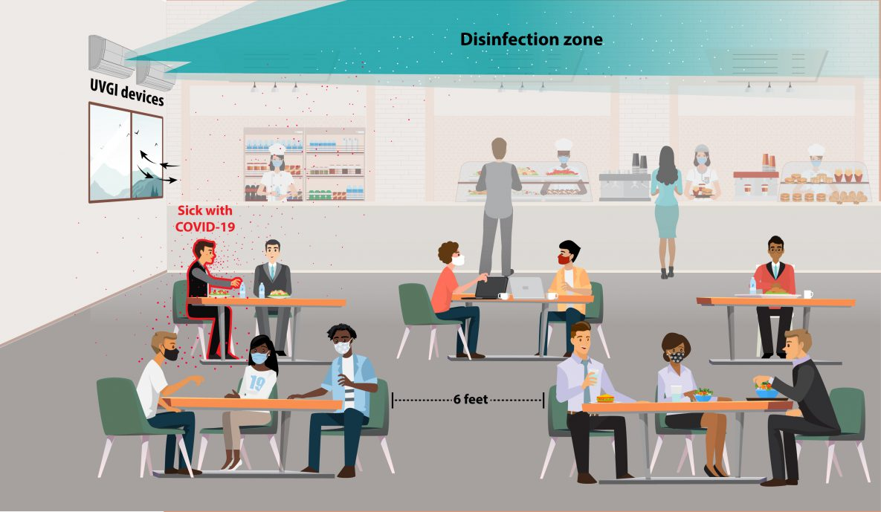
Ko e maama ko ení (ʻoku toe ui ko e UV) ʻoku ʻikai lava ke sio ki ai ʻa e tangatá ka ʻoku lava ke ne ngaohi ʻa e vailasí mo e pekitīliá ke ʻikai ke kovi mo ʻikai lava ke fakatupunga ha mahaki. Ko e maama tāmate siemú ʻoku foʻu ke ʻomi ʻa e maama UV ke ne fufulu ʻa e ʻeá pea kuo ʻosi fakamoʻoniʻi te ne holoki ʻa e mafola ʻa e ngaahi mahaki ʻe niʻihi. ʻOku fokotuʻu ke ʻi he konga pē ki ʻolunga ʻo e lokí ʻa e maama UV, ʻo hangē ha ʻata ʻoku tuʻu fehangahangai. ʻOku fetuku ki he halanga ʻo e maama ko ení ʻa e ngaahi pekitīlia mo e vailasí ʻe he feʻaluʻaki angamaheni pē ʻa e ʻeá. ʻOkú ne fakaʻatā heni ke nōmolo pē hono ngāueʻaki ʻa e lokí ʻi he founga angamahení.
Ki ha toe fakamatala lahiange ki he maama tāmate siemú kātaki ʻo ʻaʻahi ki he peesi ʻi he uepisaiti ʻa e Potungāue Moʻuí https://www.health.vic.gov.au/infectious-diseases-guidelines-and-advice/germicidal-ultraviolet-light-combatting-airborne-virus-transmission

US CDC: https://www.cdc.gov/coronavirus/ 1

Ko e hā nai ʻa e ʻuhinga ʻoku fokotuʻu ai ʻe he kakaí ʻa e maama tāmate siemú?
Ko e maama tāmate siemú kuo ngāueʻaki ia ʻi he ngaahi falemahakí ʻi he ngaahi taʻu lahi ke fakasiʻisiʻi ʻa e mafola ʻa e mahakí. Ko e ngaahi tesi mei he leepí ʻoku hā ai ko e ngaahi vailasi ʻokú ne fakatupunga ʻa e KŌVITI-19 mo e fulū ʻe lava ke taʻofi ia ʻe he maama UV.
Ko e founga eni ʻe taha ki hono taʻofi ʻa e mafola ʻa e ngaahi mahaki pipihí pea ʻoku faʻa ngāueʻaki fakataha ia mo e ngaahi founga kehe ʻo hangē ko e meʻa maluʻi mānava lelei ʻaupito.

ʻOku ngāueʻaki ʻa e ngaahi maama ko ení ʻi he ngaahi falé?
ʻIo, ʻoku ngāueʻaki ʻa e ngaahi maama tāmate siemu ko ení ʻi ʻAositelēlia ʻi he ngaahi nofoʻanga ʻo e kau toulekeleká, ngaahi senitā ako tokamuʻá mo e ngaahi ʻapiakó. ʻOku lahi ʻa e ngaahi ako, falemahaki, ngaahi nofoʻanga kiate kinautolu ʻoku ʻikai hanau nofoʻangá, mo e ngaahi fale fakapuleʻangá ʻoku ʻosi fokotuʻu ai ʻa e maamá ni ʻi ʻAmelika, ʻIulope mo e ngaahi fonua kehe takatakai ʻi māmani. Naʻe ngāueʻaki ʻa e maama UV ke fufulu ʻa e ngaahi loki ʻi he meimei taʻu ʻe 70.

ʻOku nau malu?
ʻIo, ko e maama ko ení ʻoku fokotuʻu pē ke ngāue ʻi he konga ki ʻolunga ʻo ha loki ʻi ʻolunga ʻi he ʻēlia ʻoku ngāueʻaki angamaheni ʻe he kakaí. ʻE ʻikai ke malu ke nofo hangatonu ʻi he maama UV tāmate siemú ʻi ha taimi lōloa, ko ia ʻoku totonu ke ʻi ai maʻu pē ʻa e ngaahi sivi ke fakapapauʻi ʻoku tonu hono fokotuʻú pea ʻoku fakahanga ʻa e maamá ki ʻolunga mo mamaʻo mei he kakaí. ʻE toutou siofi maʻu pē kinautolu ke fakapapauʻi ʻoku ngāue lelei maʻu pē ʻa e maama tāmate siemú.

ʻOku anga-fēfē ʻa e ngaʻunu ʻa e vailasí ki he feituʻu ʻoku ʻi ai ʻa e maama UV?
ʻOku fetāfeaki fakanatula ʻa e ʻea ʻi lotó koeʻuhi ko e ngaahi ngāue kehekehe. ʻI he taimi ʻoku ngāue ai ha hita, ʻea koni, pe ī, ʻokú ne fakatupunga ʻa e ngaʻunu holo ʻa e ʻeá. Ko e hū maí mo e hū atu ha taha mei ha loki ʻokú ne fakatupu ʻa e tafe ʻa e ʻeá. Pehē foki, ko e māfana ko ia mei ho tau sinó mo e ngaahi naunau fakaʻuhilá ʻokú ne ʻai ʻa e ʻeá ke ngaʻunu ki ʻolunga. Ko e ngaʻunu ko ení ʻokú ne fetuku ʻa e fanga kiʻi konga iiki, ʻo hangē ko e vailasi, ki ʻolunga ki he ʻēlia ʻa ia ʻoku ʻi ai ʻa e maama UV ʻo fufulu kinautolu.

ʻE lava ke tamateʻi ʻa e maama?
ʻIo, ʻoku ʻi ai ʻa e meʻa kamosi he maamá ke tamateʻiʻaki. ʻOku fiemaʻu ke tamateʻi kapau ʻoku fai ha ngāue maʻolunga, ko e fakatātaá kapau ʻoku fiemaʻu ha taha ke ngāue ʻi ha tuʻunga ofi ki ai.

ʻOku hanga ʻe he maamá ʻo fufulu ʻa e ngaahi funga hiliʻanga meʻá?
ʻIkai, ko e taimi ʻoku ngāueʻaki ai ʻa e maama ʻi he konga ki ʻolunga ʻo e lokí te nau fufulu ʻa e ʻeá, ka heʻikai te nau fufulu ʻa e ngaahi funga hiliʻanga meʻá. Ko e ngaahi founga angamaheni ki hono fufulu ʻa e ngaahi funga hiliʻanga meʻá ʻoku kei fiemaʻu pē ke fai he taimi ʻoku ngāueʻaki ai ʻa e maamá.

