Victorian Admitted Episodes Dataset (VAED) manual 2024-25
Section 5 Compilation and submission
34th edition
OFFICIAL

To receive this document in another format, email HDSS help desk <HDSS.Helpdesk@health.vic.gov.au>.
Authorised and published by the Victorian Government, 1 Treasury Place, Melbourne.
© State of Victoria, Australia, Department of Health, June 2024.
ISBN 978-1-76131-597-8 (pdf/online/MS word)

Available at HDSS VAED < https://www.health.vic.gov.au/data-reporting/victorian-admitted-episodes-dataset >

Contents
Compilation 4
Transaction Record Specification and File Structure 5
Unique key links data records for one episode of care 5
Data processing 5
Header Record 6
Episode Record 8
Extra Episode Record 13
Diagnosis Record 15
Extra Diagnosis Record 17
Subacute Record 19
Palliative Record 21
DVA and TAC Record 23
Trailer Records 25
Submission timeline 33
Data submission timeline 33
Submitting data to the VAED 34
Managed File Transfer (MFT) portal 34
Requesting access to the MFT portal for VAED reporting 34
System requirements 34
Connection information 34
Setting your Password for a new/existing account 35
Logging into the MFT Portal 37
Uploading a submission file 39
Collecting reports 40
Retention of reports in MFT pickup and backup folders 40
Help with using the MFT portal 40
Common problems when uploading files through the MFT 40
MFT FAQs 41
Support 41
Manipulation of data extracts 42
End of financial year reporting 43
Test submissions for 1 July changes 43

Compilation
A VAED submission has three components: Header Record; Data Records; Trailer Records.
This section specifies the reporting requirements for data elements relating to the compilation of a VAED submission file. That is, all data elements reported in the Header and Trailer Records, and those in the Data Records that do not relate to individual episodes of care. Refer to Section 3 of this manual which provides details of data elements that relate to individual episodes of care.
Header Record (H5)
Identifies the source of the file, the month the file relates to, and facilitates report requests.
Data Records – all episodes
All episodes of care require an Episode Record and Diagnosis Record to be reported:
Episode Record (E5): Containing demographic, admission, separation, and accounting data, specific to that episode.
Diagnosis Record with or without an Extra Diagnosis Record X5, Y5): Containing diagnosis and procedure codes and other selected items.
Additional data Records – public hospitals only
Extra Episode Record (J5): Additional information, specific to that episode
Subacute Record (S5): Episodes with Care Type P, 6 Rehabilitation or 9 Geriatric Evaluation and Management
Palliative Record (P5): Episodes with Care Type 8 Palliative Care or MC Maintenance Care
DVA and TAC Record (V5): Episodes with Account Class V- DVA or T- TAC

Trailer Records (T5, U5)
Each submission to VAED commences with a Header Record followed by Data Records and ends with two Trailer Records

Transmitted Transactions Reports (Control Reports)
A Transmitted Transactions Report is produced following processing and validation of each VAED submission file in the Transmitted Transactions Report, data records are listed in order of Transaction Type code (i.e. E5, J5, S5, P5, V5, X5, Y5), in the order in which the health service submitted them.

Transaction Record Specification and File Structure
File Structure Notes:
- All fields are data type text
- All alpha characters must be in UPPERCASE
- Fields with numeric characters are right justified and zero filled
- When not required to report a data item, report spaces
Mandatory items
- Mandatory items are marked M in Notes column
- Additional codes in this column indicate conditions under which other items become mandatory

Unique key links data records for one episode of care
The hospital-generated Unique Key links each set of data records relating to the one episode of care. That is, the Unique Key for one episode of care will be the same across the record types reported for that episode - Episode Record, Diagnosis Record, and so on.
When a file is created for submission to VAED, the related data records for a particular episode of care will include the components known at the time. This could be all record components, for a completed episode; that is, the Episode Record, Diagnosis/Extra Diagnosis Record, and possibly the Sub-Acute or Palliative Record or DVA and TAC Record, if applicable. If the patient is still in hospital, however, only the admission component and Status Segments of the Episode Record and the DVA and TAC Record, if applicable, can be completed.
Each time a file is submitted, these records will be updated until the episode itself and the data relating to it are completed. If necessary, the Diagnosis/Extra Diagnosis Record and Sub-Acute Record and Palliative may be reported in a later submission than the completed Episode Record.
Submissions can occur more than once a day.

Data processing
Processing of VAED submission files:
- validates data submitted by hospitals
- calculates or derives additional VAED data items such as
  - patient age
  - Diagnosis Related Group (DRG)
  - length of stay
- produces a control report for each VAED submission file
- retains data (for records accepted during validation process) in the database
Once a month a year-to-date copy of data is extracted from the VAED processing database and provided to the department to update the Victorian Admitted Episodes Dataset (VAED) database.

Header Record
Header Record File Structure
Note | Data Item | Field Size | Record Position | Layout/Code Set
M | Transaction Type | 2 | 1 | H5
M | Hospital Code | 3 | 3 | NNN
M | Start Date | 8 | 6 | DDMMYYYY
M | End Date | 8 | 14 | DDMMYYYY
O | Reporting Option | 1 | 22 | Space, 2
O | Reporting Type Control | 1 | 23 | Space, E
O | Reporting Type Request | 1 | 24 | Space, E
O | 1st request Report Code | 2 | 25
O | Report Parameter | 12 | 27
O | 2nd request Report Code | 2 | 39
O | Report Parameter | 12 | 41
O | 3rd request Report Code | 2 | 53
O | Report Parameter | 12 | 55
O | 4th request Report Code | 2 | 67
O | Report Parameter | 12 | 69
O | 5th request Report Code | 2 | 81
O | Report Parameter | 12 | 83
O | 6th request Report Code | 2 | 95
O | Report Parameter | 12 | 97
O | Software version/edition identifier | 3 | 109 | Optional field, free text, or spaces
Total |  | 111
Refer to Section 6 Request reports for details of reports available
All alpha characters are uppercase. All numeric fields are right justified and zero filled.
M Mandatory
O Optional
Reported by all Victorian hospitals (public and private).
Reported for all VAED data submission files
Reported when a file is submitted to VAED

Reporting guide
The Header Record identifies the source of the VAED submission file, the period of time to which the file relates, and facilitates report requests.
Data Items
Transaction Type
The value identifying the Header Record is ‘H5’
Hospital Code
Hospital Code for the submitting hospital
Start Date – a valid date, one day greater than the End Date in the Header Record of the previous submission (except where the submission has the same Start and End Dates as the previous submission).
End Date - a valid date greater than the current Header Record’s Start Date but less than, or equal to, the End-of-Month date (being the last day of the month in which the Header Record’s Start Date is included). End Date must be less than date of submission.
Report Option
Default format for the Transmission Control and Reconciliation Report for this submission.
2 Validation messages, then full (accepted) transaction trail
Reporting Type Control
Transmission Control and Reconciliation Reports are electronic only
E Electronic only
Reporting Type Request
Request Reports for this submission are electronic only
E Electronic only
Report Requests
Up to six Request Reports may be ordered in the Header Record. Refer to Section 6 for details on ordering these reports.
Software Version/Edition Number
Report the version/edition of software being used by this hospital (optional). Otherwise report spaces.

Episode Record
Refer to Section 3 for code sets for data elements
Episode Record File Structure
Note | Data Item | Field Size | Record Position | Layout
M | Transaction Type | 2 | 1 | E5
M | Unique Key | 9 | 3 | AAAAAAAAA (Hospital-generated)  Right justified, zero filled
M | Patient Identifier | 10 | 12 | AAAAAAAAAA (Hospital generated)  Right justified, zero filled
M | Campus Code | 4 | 22 | NNNN
M | Medicare Number | 11 | 26 | NNNNNNNNNNN
M | Medicare Suffix | 3 | 37 | AAA or A-A
M | Sex at birth | 1 | 40 | N
M | Marital Status | 1 | 41 | N
M | Date of Birth | 8 | 42 | DDMMYYYY
M | Postcode | 4 | 50 | NNNN
M | Locality | 22 | 54 | Alphanumeric, left justified
M | Admission Date | 8 | 76 | DDMMYYYY
M | Admission Time | 4 | 84 | HHMM
M | Admission Type | 1 | 88 | A
M | Admission Source | 1 | 89 | A
1 | Transfer Source | 4 | 90 | NNNN
 | Leave with permission days MTD | 2 | 94 | NN  Right justified, zero filled
 | Leave with permission days Financial YTD | 3 | 96 | NNN  Right justified, zero filled
 | Leave with permission days Tot | 3 | 99 | NNN  Right justified, zero filled
2 - Status Segment occurs 7 times
2 | Account Class | 2 | 102, 115, 128, 141, 154, 167, 180 | AA or AN
2 | Accommodation Type | 1 | 104, 117, 130, 143, 156, 169, 182 | N or A
2 | Qualification Status | 1 | 105, 118, 131, 144, 157, 170, 183 | A
2 | Patient Days MTD | 2 | 106, 119, 132, 145, 158, 171, 184 | NN  Right justified, zero filled
2 | Patient Days Financial YTD | 3 | 108, 121, 134, 147, 160, 173, 186 | NNN  Right justified, zero filled
2 | Patient Days Total | 4 | 111, 124, 137, 150, 163, 176, 189 | NNNN  Right justified, zero filled
3 | Separation Date | 8 | 193 | DDMMYYYY
3 | Separation Time | 4 | 201 | HHMM
3 | Separation Mode | 1 | 205 | A
1 | Transfer Destination | 4 | 206 | NNNN
4 | Separation Referral | 4 | 210 | AAAA  Left justified, trailing spaces
5 | Carer Availability | 1 | 214 | N or space
3 | Account Class on Separation | 2 | 215 | AA or AN
3 | Accommodation Type on Separation | 1 | 217 | N or A
M | Care Type | 2 | 218 | AA or NN or NA  Left justified, trailing space
M | Country of Birth | 4 | 220 | NNNN
M | Indigenous Status | 1 | 224 | N
M,6 | Criterion for Admission | 1 | 225 | A
M | Intended Duration of Stay | 1 | 226 | N
17 | Hospital Insurance Fund (no longer reported) | 3 | 227 | Spaces or AAA or NNN
M | Hospital Insurance Status | 1 | 230 | N
18 | Mental Health Legal Status (no longer reported) | 1 | 231 | Space or N
7 | Funding Arrangement | 1 | 232 | N
8 | Contract Type | 1 | 233 | N
8 | Contract Role | 1 | 234 | A
9 | Contract/Spoke Identifier | 4 | 235 | NNNN
10 | Contract Leave Days - MTD | 2 | 239 | NN  Right justified, zero filled
10 | Contract Leave Days - Financial YTD | 2 | 241 | NN  Right justified, zero filled
10 | Contract Leave Days - Total | 2 | 243 | NN  Right justified, zero filled
 | User Flag | 1 | 245 | Optional field, free text
12 | Preferred Language | 4 | 246 | NNNN
12 | Interpreter Required | 1 | 250 | N
13 | ACAS Status | 1 | 251 | N
15 | Mental Health Statewide Patient Identifier | 10 | 252 | ODS generated 10 digit number (NNNNNNNNNN)  Right justified, zero filled
 | Leave Without Permission Days MTD | 2 | 262 | NN  Right justified, zero filled
 | Leave Without Permission Days Financial YTD | 3 | 264 | NNN  Right justified, zero filled
 | Leave Without Permission Days Total | 3 | 267 | NNN  Right justified, zero filled
3 | Intention to Readmit | 1 | 270 | N
M | Date of Birth Accuracy Flag | 3 | 271 | A
7, 14 | Program Identifier | 2 | 274 | NN
16,14 | Mother’s UR | 10 | 276 | AAAAAAAAAA  Right justified, zero filled
M | Admitting Unit/Specialty | 4 | 286 | AAAspace or AAAA
3 | Discharging Unit/Specialty | 4 | 290 | Spaces or AAAspace or AAAA
19 | Unplanned return to theatre (reported in X5 from 2023-24) | 1 | 294 | space
M | Gender | 1 | 295 | N or space
21 | NDIS Participant flag | 1 | 296 | N or space
22 | NDIS Participant Identifier | 9 | 297 | NNNNNNNNN
Total |  | 305
All alpha characters uppercase. All numeric fields are right justified and zero filled.
M Mandatory
1 Transfer Source: Mandatory if Admission Source = T, else spaces. Transfer Destination: Mandatory if Separation Mode = T
2 Mandatory in first Status Segment. In any subsequent Status Segment, if any field is present, then all fields for that segment must be present.
3 Mandatory but submit only when Separation Date is reported
4 Mandatory for public hospital if Separation Mode = H but report only when Separation Date is reported.
5 Mandatory for public hospitals where Care Type is 1, P, 6, 8, 9 or MC and Separation Mode is H.
6 Criterion for Admission: Code S only for use by Early Parenting Centres.
7 Mandatory for all hospitals involved in contracted care, hub and spoke arrangements, or the specified funding arrangements, programs or initiatives
8 Mandatory for all hospitals involved in contracted care arrangements
9 Mandatory for all hospitals involved in contracted care or Hub and Spoke (only Hub reports) arrangements
10 Mandatory for contracting hospitals, in specific instances. Refer to Section 3.
12 Mandatory for all public hospitals
13 Mandatory for public hospitals when Care Type is 1, 4, 6, 8, 9 or MC, and patient age is greater than or equal to 50, and where the episode is not a same day episode, but report only when Separation Date is reported.
14 Where a field at the end of a record has a value of space, the record can be ended at the last field where a value is not space(s).
15 Mandatory for all public hospitals with an approved Mental Health Service when Care Type is 5x or any episode where an ECT has been performed.
16 Mandatory for newborn episodes where the baby is born in the hospital.
17 Hospital Insurance Fund reported up to 2013-14 Optional field from 2014-15
18 Mental Health Legal Status reported up to 2017-18, optional field from 2018-19
19 Unplanned return to theatre reported in X5 Diagnosis Record from 2023-24
21 Moved from J5 in 2023-24. Reported by public hospitals. Mandatory if Care Type is 1, 4, 6, 8, 9, P, or MC
22 Reported by public hospitals for registered NDIS participants
Reported by all Victorian hospitals (public and private)
Reported for all admitted patient episodes of care
Reported when an episode of care has commenced, and in subsequent VAED data submission (updates) until the episode, and the data relating to that episode, are complete and correct.
Reporting guide - general
The Episode Record (E5) contains demographic, admission, and separation data. In addition, there are up to seven Status Segments containing accounting information recorded at admission (first Status Segment) and up to six times when there is a change to this information. In each Status Segment, there are fields for patient day counts that must be provided by the in-house system; the VAED processor does not calculate patient days.
The processor deals with counts of days (patient days, leave days with and without permission) according to the field’s relationship with the month and year in the Header Record dates.
If the Header Record identifies the month as July 2024, all the month-to-date fields in the submission will be treated as July 2024 and the year-to-date as 2024-25.
The validation process checks data in the E5, and data already held in the VAED processing database for the same Unique Key and Patient Identifier.
E5 and V5 must be submitted together
DVA /TAC Record, if required, must be in the same submission file as the Episode Record for the same Unique Key.
E5 required for J5, X5/Y5, S5, P5, V5 to be accepted
Extra Episode Record, Diagnosis Record, Sub-Acute Record, Palliative Record or DVA and TAC Record can only be accepted or retained on the VAED processing database if there is an Episode Record with the same Unique Key currently held in the database.
Separation Date required for J5, X5/Y5, P5 S5 to be accepted
Extra Episode Record, Diagnosis/Extra Diagnosis Record, Palliative Record or Sub-Acute Record can only be accepted when the Episode Record contains a Separation Date.
Correction/Update
To amend or update an Episode Record, re-submit the entire record containing the updated data. This will overwrite the Episode Record already accepted and held on the database.
For patients remaining in hospital at the end of the month, the Episode Record needs to be re-submitted with the next month’s data until the separation details are submitted, to update the counts of patient days and leave days each month, and for the financial year-to-date, and in total.
Deletion
To delete an entire Episode Record:
Either re-submit the Episode Record containing all 9s in the Medicare Number field, or
Submit only the Unique Key and the Medicare Number containing all 9s.
Deleting an Episode Record will also delete any other type of record with the same Unique Key held by the VAED processing database.
If the deletion is submitted after a DVA and TAC Record has been sent to DVA or TAC, the record will be flagged as deleted but will remain on the file available to the department.
A record can be deleted and re-submitted in the same submission as long as the deletion is sequenced first.
Data Items - Transaction Type
The value identifying the Episode Record is ‘E5’.
Status Segments
There are seven Status Segments available in each Episode Record.
Each Status Segment comprises a new combination of following fields – Account Class, Accommodation Type, Qualification Status
Each Status Segment records the number of Patient Days relating to that segment:
Patient Days Month-to-Date (ie, the month indicated by the Header Record)
Patient Days Financial Year-to-date (ie, the financial year indicated by the Header Record)
Patient Days Total (ie, from the Admission Date to the Separation Date/End Date for this submission, regardless of month or financial year)
User Flag - Optional field

Extra Episode Record
Refer to Section 3 for code sets for data elements.
Extra Episode Record File Structure
Note | Data Item | Field Size | Record Position | Layout
M | Transaction Type | 2 | 1 | J5
M | Unique Key | 9 | 3 | AAAAAAAAA (Hospital-generated)  Right justified, zero filled
2 | Advance Care Directive Alert | 1 | 12 | N or space
1 | Clinical Group | 12 | 13 | Characters or spaces
3 | NDIS Participant Flag (reported in E5 from 2023-24) | 1 | 25 | space
4 | Clinically Ready for Discharge Date | 8 | 26 | DDMMYYYY or spaces
5 | Reason for Discharge Delay | 1 | 34 | N or space
Total |  |  | 34
M Mandatory
1 Optional
2 Mandatory if Care Type is not 10 or U, optional for Care Type 10 or U
3 Reported in E5 Record from 2023-24
4 Reported for episode if Care Type is 1, 4,5x, 6, 8, 9, P, or MC and an administrative or non-clinical reason delays discharge from hospital
5 Mandatory if Clinically Ready for Discharge Date is reported

Reported by public hospitals
Reported for all admitted patient episodes of care
Reported when a Separation Date is reported in the Episode Record
Reporting guide - general
The Extra Episode Record (J5) contains additional data relevant to the episode. When a J5 is submitted, the validation process checks data in the J5 and data already held in the VAED processing database for the same Unique Key.
E5 required for J5, X5/Y5, S5, P5, V5 to be accepted
Extra Episode Record, Diagnosis/Extra Diagnosis Record, Sub-Acute Record, Palliative Record or DVA and TAC Record can only be accepted if there is an Episode Record with the same Unique Key currently held on the VAED processing.
Separation Date required for J5, X5/Y5, P5, S5 to be accepted
Extra Episode Record, Diagnosis/Extra Diagnosis Record, Palliative Record or Sub-Acute Record can only be accepted when the Episode Record contains a Separation Date.
Correction/Update
To amend or update an Extra Episode Record, re-submit the entire record containing the updated data. This will overwrite the Extra Episode Record already accepted and held on the VAED processing database.
Data Items - Transaction Type
The value identifying the Extra Episode Record is ‘J5’.

Diagnosis Record
Refer to Section 3 for code sets for data elements. When not required to report a data element, report spaces.
Diagnosis Record File Structure
Note | Data Item | Field Size | Record Position | Layout
M | Transaction Type | 2 | 1 | X5
M | Unique Key | 9 | 3 | AAAAAAAAA (Hospital generated)  Right justified, zero filled
1 | Diagnosis Code x 12 each code | 8  (8 x 12) | 12 | AANNNN  Each left justified, trailing spaces
2 | Procedure Code x 12 each code | 8  (8 x 12) | 108 | NNNNNNNA  Each left justified, trailing spaces
3 | Admission Weight | 4 | 204 | NNNN (Admission Weight in grams)
8 | User Flag | 1 | 208 | Optional field, free text
4, 8 | Duration of Stay in Intensive Care Unit | 4 | 209 | NNNN  Right justified, zero filled
5, 8 | Duration of Mechanical Ventilation in ICU | 4 | 213 | NNNN  Right justified, zero filled
6, 8 | Hospital Generated DRG | 4 | 217 | ANNA or NNNA
7, 8 | Duration of Stay in Cardiac/Coronary Care Unit | 4 | 221 | NNNN  Right justified, zero filled
8, 11 | Duration of Non-Invasive Ventilation in ICU | 4 | 225 | NNNN  Right justified, zero filled
9 | Procedure Start Date Time | 12 | 229 | DDMMYYYYHHMM
10 | Care Plan Documented Date | 8 | 241 | DDMMYYYY
12 | Proceduralist ID | 13 | 249 | XXXXXXXXXXXXX
13 | Unplanned return to theatre | 1 | 262 | N or space
Total |  | 262
All alpha characters uppercase. All numeric fields right justified with leading zeros
M Mandatory
1 First diagnosis code is mandatory.
2 Eighth character is F or N for procedures occurring in the contracted hospital when reported by the contracting hospital
3 Mandatory if patient aged <1 year at admission
4 Mandatory for patients cared for in an approved ICU, contracting hospitals (refer Section 3)
5 Mandatory for patients who received mechanical ventilation in an approved ICU, contracting hospitals (refer Section 3)
6 Optional but recommended for all hospitals with grouping software
7 Mandatory for patients cared for in an approved CCU, contracting hospitals (refer Section 3)
8 Where a field at the end of a record has a value of space(s), the record can be ended at the last field where a value is not space
9 Mandatory (Time – conditional mandatory) for all episodes where the first coded procedure is one identified in the ICD-10-AM/ACHI Library file as requiring Procedure Start Date Time, Mandatory for private hospital episodes in which an ECT has been performed
10 Mandatory for episodes with Care Types 6, P, 8, 9, or MC with Separation Date 7 days or more after Admission Date
11 Mandatory for public hospitals providing NIV in an approved ICU, public contracting hospitals (refer Section 3).
12 Mandatory for episodes where the first coded procedure is one identified in the ICD-10- AM/ACHI Library file as requiring Procedure Start Date Time, and episodes where Procedure Start Date Time is reported.
13 Mandatory for episodes where the patient has a surgical procedure/operation identified in the ICD-10-AM/ACHI library file as requiring this data element to be reported.
Reported by all Victorian hospitals (public and private)
Reported for all admitted patient episodes of care
Reported when a Separation Date is reported in the Episode Record (Data Submission Scheduling)
Reporting guide - general
The Diagnosis Record accepts up to 12 diagnosis and 12 procedure codes, along with a range of other items, as listed in the file structure. Each admitted patient episode of care must be coded regardless of whether the DRG allocated is relevant for funding.
When an X5 is submitted, the validation process checks data in the X5 and data already held in the VAED processing database for the same Unique Key and Patient Identifier.
Correction/Update
To amend a Diagnosis Record, re-submit the Diagnosis Record. This will overwrite the record held in the database and cause the DRG to be re assigned.
Deletion
To delete a Diagnosis Record, zero-fill the first diagnosis code and leave the rest of the record blank, then re-submit the Diagnosis Record.
If an Episode Record is deleted, the Diagnosis Record is deleted automatically. Re-submitting the Episode Record alone will not re-generate the Diagnosis Record; the Diagnosis Record must also be re-submitted.
A record can be deleted and re-submitted in the same file, provided the deletion is sequenced first.
Data items - Transaction Type
The value identifying the Diagnosis Record is ‘X5’.
User Flag Optional field

Extra Diagnosis Record
Refer to Section 3 for code sets for data elements. When not required to report a data element, report spaces.
Extra Diagnosis Record File Structure
Note | Data Item | Field Size | Record Position | Layout/Code Set
M | Transaction Type | 2 | 1 | Y5
M | Unique Key | 9 | 3 | AAAAAAAAA (Hospital generated)  Right justified, zero filled
 | Diagnosis Code (13 to 25) | 8  (8 x 13) | 12 | AANNNN  Each left justified and with trailing spaces
1, 2 | Procedure Code (13 to 25) | 8  (8 x 13) | 116 | NNNNNNNA  Each left justified and with trailing spaces
2 | Diagnosis Code (26 to 40) | 8  (8 x 15) | 220 | AANNNN  Each left justified and with trailing spaces
1, 2 | Procedure Code (26 to 40) | 8  (8 x 15) | 340 | NNNNNNNA  Each left justified and with trailing spaces
2 | Diagnosis Code (41 to 100) | 8  (8 X 60) | 460 | AANNNN  Each left justified and with trailing spaces
Total |  | 939

M Mandatory
1 Eighth character is F or N for procedures occurring in the contracted hospital when reported by the contracting hospital, else space.
2 Where a field at the end of a record has a value of space(s), the record can be ended at the last field where a value is not space(s).
Reported by public and private hospitals – optional
That is, a hospital may choose whether to report more than 12 diagnosis and 12 procedure codes for episodes where more than 12 of either have been assigned.
Reported for each episode that has more than 12 diagnosis and/or 12 procedure codes assigned.
Reported when a Separation Date has been reported in the Episode Record.
Reporting guide - general
The Extra Diagnosis Record accepts up to 88 extra diagnosis codes and up to 28 extra procedure codes, for each applicable episode of care, therefore a maximum of 100 diagnosis and 40 procedure codes. (The Diagnosis Record accepts the first twelve of each.)
Always submit the Extra Diagnosis Record immediately following the corresponding Diagnosis Record (matching Unique Keys).
When a Y5 is submitted with an X5 the validation process checks data in the X5/Y5 and data already held in the database for the same Unique Key and Patient Identifier.
Correction/Update
To correct or update an Extra Diagnosis Record, re-submit the Diagnosis Record immediately followed by the updated Extra Diagnosis Record. This will overwrite all fields already held in the VAED processing database and re assign the DRG.
Deletion
To delete an Extra Diagnosis Record, zero-fill the first diagnosis code and leave the rest of the record blank, then re-submit the Extra Diagnosis Record.
A record can be deleted and re-submitted in the same file, provided the deletion is sequenced first.
If an Episode Record is deleted, both the Diagnosis Record and Extra Diagnosis Record will automatically be deleted from the VAED processing database. Re-submitting the Episode Record alone will not re-generate the Diagnosis Record and Extra Diagnosis Record; they must also be re-submitted.
Data Items
Transaction Type
The value identifying the Extra Diagnosis Record is ‘Y5’.

Subacute Record
Refer to Section 3 for code sets for data elements. When not required to report a data element, report spaces.
Subacute Record File Structure
Note | Data Item | Field Size | Record Position | Layout/Code Set
M | Transaction Type | 2 | 1 | S5
M | Unique Key | 9 | 3 | Hospital generated  Right justified, zero filled
M | Patient Identifier | 10 | 12 | Hospital generated  Right justified, zero filled
F | Barthel Index Score on Admission (no longer reported) | 3 | 22 | Spaces
F | Barthel Index Score on Separation (no longer reported) | 3 | 25 | Spaces
E | Clinical Sub-program (no longer reported) | 3 | 28 | Spaces
C | Onset Date | 8 | 31 | DDMMYYYY or spaces
F | Admission/Re-admission to Rehabilitation (no longer reported) | 1 | 39 | Space
O | User Flag | 1 | 40 | Optional field, free text
B | Functional Assessment Date on Admission | 8 | 41 | DDMMYYYY or spaces
B | Functional Assessment Date on Separation | 8 | 49 | DDMMYYYY or spaces
C | Impairment | 6 | 57 | From code list or spaces
B | FIMTM Score on Admission | 18 | 63 | NNNNNNNNNNNNNNNNNN  or spaces  Right justified, zero filled
B | FIMTM Score on Separation | 18 | 81 | NNNNNNNNNNNNNNNNNN or spaces  Right justified, zero filled
Total |  | Total 98
All alpha characters uppercase. All numeric fields right justified and zero filled.
M Mandatory
B Mandatory if Care Type = 6 or 9
C Mandatory if Care type = 6 or P
E Clinical Sub-program reported up to 2012-13. Report spaces.
F Barthel Index Score and Admission/ Re-admission to Rehabilitation reported up to 2013-14. Report spaces
O Optional
Reported by public hospital (private hospitals do not report S5s)
Reported for Care Types P, 6, 9 only
Reported when a Separation Date is reported in the Episode Record
Reporting guide General
The data items collected in the Subacute Record (marked with an * in the table below) are needed for the support and further development of casemix classifications for subacute episodes.
S5 Subacute Record – reporting by Care Type
Subacute Record field | Rehab  Care Type 6 | Rehab  Care Type P | GEM  Care Type 9
Transaction Type | S5 | S5 | S5
Unique Key | * | * | *
Patient Identifier | * | * | *
Functional Assessment Date on Admission | * | Spaces | *
Functional Assessment Date on Separation | * | Spaces | *
Onset Date | * | * | Spaces
Impairment | * | * | Spaces
FIMTM Score on Admission | * | Spaces | *
FIMTM Score on Separation | * | Spaces | *
When an S5 is submitted, the validation process checks data in the S5 and data already held in the VAED processing database for the same Unique Key and Patient Identifier.
Correction
To correct a Subacute Record, re-submit the entire Subacute Record, including the corrections. This will overwrite the existing record.
Deletion
To delete a Subacute Record (S5), re-submit S5 with the same Unique Key and all 9s in the Impairment field (including GEM episodes).
If an Episode Record (E5) is deleted, the S5 will automatically be deleted. Re-submitting the E5 alone will not re-generate the S5; the S5 must also be re-submitted. A record can be deleted and re-submitted in the same submission if the deletion is sequenced first.
Data Items - Transaction Type
The value identifying the Subacute Record is ‘S5’.

Palliative Record
Palliative Record File Structure
Note | Data Item | Field Size | Record Position | Layout/Code Set
M, A | Transaction Type | 2 | 1 | P5
M, A | Unique Key | 9 | 3 | AAAAAAAAA (Hospital generated)  Right justified, zero filled
M, A | Patient Identifier | 10 | 12 | AAAAAAAAAA (Hospital generated)  Right justified, zero filled
M, A | RUG ADL on Admission | 2 | 22 | NN  Right justified, zero filled
M, A | RUG ADL on Separation | 2 | 24 | NN  Right justified, zero filled
M | Source of Referral to Palliative Care | 2 | 26 | NN
M | Phase of Care on Admission | 1 | 28 | N
2 | Final Phase of Care | 1 | 29 | N
1 | Phase of Care Change Date | 8 | 30, 41, 52, 63, 74, 85, 96, 107, 118, 129 | DDMMYYYY
1 | Phase of Care on Phase Change | 1 | 38, 49, 60, 71, 82, 93, 104, 115, 126, 137 | N
1 | RUG ADL on Phase Change | 2 | 39, 50, 61, 72, 83, 94, 105, 116, 127, 138 | NN
O | User Flag | 1 | 140 | Optional field, free text
2 | Final Phase of Care Start Date | 8 | 141 | DDMMYYYY
2 | RUG ADL on start Final Phase of Care | 2 | 149 | NN  Right justified, zero filled
M | Preferred Death Place | 2 | 151 | NN
O | Triage Score on Admission | 3 | 153 | NNN
3 | Leave days – Phase of Care on Admission | 2 | 156 | NN  Right justified, zero filled
3 | Leave days – Phase of Care Change (1-10) | 2 | 158, 160, 162, 164, 166, 168, 170, 172, 174, 176 | NN  Right justified, zero filled
3 | Leave days – Final Phase of Care | 2 | 178 | NN  Right justified, zero filled
Total |  | 179
All alpha characters uppercase. All numeric fields right justified and zero filled. Notes M, 1 and 2 apply only to Palliative Care.
M Mandatory for Palliative Care
1 In each segment if any field is present, then all fields for that segment must be present
O Optional
2 Only reported when more than 10 changes of Phase of Care occur. If any field is present, then all three fields must be present
A Mandatory for Maintenance Care
3 Report leave days for each Phase of Care. (Note: Leave days – Final Phase of Care (c) includes leave days during the Final Phase of Care plus leave days during any Phases of Care omitted from reporting)

Reported by public hospitals (private hospitals do not report P5s)
Reported for Care Type 8 Palliative Care and MC Maintenance Care
Reported when a Separation Date is reported in the Episode Record
Reporting guide
When a P5 is submitted, the validation process checks data in the P5 and data already held in the VAED processing database for the same Unique Key and Patient Identifier.
Correction
To correct a Palliative Record, re-submit the entire Palliative Record, including the corrections. This will overwrite the existing record.
Deletion
To delete a Palliative Record (P5), re-submit a P5 with the same Unique Key, and enter all 9s in the RUG ADL on Admission.
If an Episode Record (E5) is deleted, the P5 will automatically be deleted. Re-submitting the E5 alone will not re-generate the P5; the P5 must also be re-submitted.
A record can be deleted and re-submitted in the same submission as long as the hospital sequences the deletion first.
Data Items
Transaction Type
The value identifying the Palliative Record is ‘P5’.
User Flag
Optional field

DVA and TAC Record
DVA and TAC Record File Structure
Note | Data Item | Field Size | Record Position | Layout/Code Set
M | Transaction Type | 2 | 1 | V5
M | Unique Key | 9 | 3 | AAAAAAAAA (Hospital generated)  Right justified, zero filled
M | Patient Identifier | 10 | 12 | AAAAAAAAAA (Hospital generated)  Right justified, zero filled
M | DVA ID /  TAC Claim Number | 9 | 22 | AAAANNNNX or AAAANNNNXA (DVA)  YYXXXXX (TAC)  Refer to Section 3
M | Surname | 25 | 31 | Refer to Section 3
M | Given Name(s) | 15 | 56 | Refer to Section 3
1 | Admission Date | 8 | 71 | DDMMYYYY
1 | Separation Date | 8 | 79 | DDMMYYYY
2, 3 | Date of Accident | 8 | 87 | DDMMYYYY
3 | User Flag | 1 | 95 | Optional field, free text or space
Total |  | 95
All alpha characters must be uppercase. All numeric fields right justified and zero filled.
M Mandatory
1 These dates must match those in the corresponding Episode Record.
2 Mandatory if Account Class = T- TAC, else spaces.
3 Where a field at the end of a record has a value of space(s), the record can be ended at the last field where a value is not space(s).

Reported by public hospitals (private hospitals do not report V5s)
Reported for admitted patient episodes with an Account Class of V- DVA or T- TAC.
Reported when the Episode Record is reported (each time)
Reporting guide General
The DVA and TAC Record (V5) allows public hospitals to report the necessary additional information about a DVA or TAC patient to facilitate payment for the episode.
Correction/Update
To correct a V5, re-submit the entire V5 (together with the E5), including the corrections. This will overwrite the existing record.

Deletion
VAED processing requires a matching Episode (E5) and DVA and TAC (V5) pair of records to be retained on the system.
The only way to delete a DVA and TAC Record is to delete the corresponding E5. This will automatically delete the V5.
Re-submitting the E5 alone will not re-generate the V5; the V5 must also be re-submitted. If the deletion is submitted after the DVA and TAC Record has been sent to DVA or TAC as relevant, the record will be flagged as cancelled but will remain on the file available to the department.
A record can be deleted and re-submitted in the same submission provided the deletion is sequenced first.
Data Items
Transaction Type
The value identifying the DVA and TAC Record is ‘V5’.
User Flag
Optional field
Validation
The following rules apply to DVA and TAC data:
- If, in this submission, there is an E5 with Account Class V- DVA or T- TAC, then there must be a V5 with the same Unique Key in this submission.
- If either the E5 or V5 fails the validation, both E5 and V5 will be rejected.
- The E5 and V5 Records of DVA and TAC patients are subject to the Transaction Matching process before the Submitted Transaction process:
The Transaction Match process:
- verifies the presence of one E5 and one V5 for any Unique Key
- checks Admission and Separation Dates for consistency between the E5 and V5
- checks V5s for validity
- rejects the pairs of records which fail these checks.

Trailer Records
General
Two Trailer Records end each VAED submission.
The only mandatory data items are:
Transaction Type and Hospital code
Reporting of all other data items is optional
Mapping VAED fields to Trailer Records
The Trailer Records contain fields which report separations and patient days by aggregated Account Class groups. This section describes the mapping between Account Classes and these groups (‘Trailer Record Categories’), which differ between public and private hospitals.
Public Hospitals - Account Class
Trailer Record Category | Account Classes
Public – Acute (both Separations and Patient Days) | MP, ME, MF, MA, JP
Private – Acute (both Separations and Patient Days) | PA, PB, PC, PD, PE, PF, PG, PH, PI, PJ, PK, PL, PM, PN, PO, PP, PQ, PR, VX
Compensable – Acute (both Separations and Patient Days) | WC, TA, AS, SS, CL, OO
Ineligible – Acute (both Separations and Patient Days) | XX
Public NHT – NH5 (both Separations and Patient Days) | M5
Public NHT – Non NH5 (both Separations and Patient Days) | MN, JN
Private NHT – NH5 (both Separations and Patient Days) | PT, PV, V5
Private NHT – Non NH5 (both Separations and Patient Days) | PS, PU, VN
Compensable – Non-Acute (both Separations and Patient Days) | WN, TN, AN, SN, CN, ON
Ineligible – Non-Acute (both Separations and Patient Days) | XN
Public – Same Day | MP, ME, MF, MN, M5, MA, JP, JN
Private – Same Day | PA, PB, PC, PD, PE, PF, PG, PH, PI, PJ, PK, PL, PM, PN, PO, PP, PQ, PR, PS, PT, PU, PV, VX, VN, V5
Compensable – Same Day | WC, WN, TA, TN, AS, AN, SS, SN, CL, CN, OO, ON
Ineligible – Same Day | XX, XN
Posthumous Organ Procurement | KK
Private Hospitals and Day Procedure Centres - Account Class
Trailer Record Category | Account Classes
Private – Acute (both Separations and Patient Days) | PA, PB, PC, PD, PE, PF, PG, PH, PI, PJ, PK, PL, PM, PN, PO, PP, PQ, PR, VX
Private – Nursing Home Type (both Separations and Patient Days) | PS, PT, PU, PV, VN, V5
Compensable (both Separations and Patient Days) | WC, WN, TA, TN, AS, AN, SS, SN, CL, CN, OO, ON
Ineligible (both Separations and Patient Days) | XX, XN
Public – Under Contract (both Separations and Patient Days) | MP
Private – Same Day | PA, PB, PC, PD, PE, PF, PG, PH, PI, PJ, PK, PL, PM, PN, PO, PP, PQ, PR, PS, PT, PU, PV, VX, VN, V5
Compensable – Same Day | WC, WN, TA, TN, AS, AN, SS, SN, CL, CN, OO, ON
Ineligible – Same Day | XX, XN
Public – Under Contract – Same Day | MP

Trailer Record 1: Private Hospitals and Day Procedure Centres File Structure
Note | Data Item | Field Size | Record Position | Layout/Code Set
M | Transaction Type | 2 | 1 | T5
M | Hospital Code | 3 | 3 | NNN
O | Total Number of Records | 5 | 6 | NNNNN
O | Episode New | 4 | 11 | NNNN
O | Episode Corrections | 4 | 15 | NNNN
O | Episode Deletions | 4 | 19 | NNNN
O | Diagnosis New | 4 | 23 | NNNN
O | Diagnosis Corrections | 4 | 27 | NNNN
O | Diagnosis Deletions | 4 | 31 | NNNN
O | MTD Admissions (includes Statistical) | 4 | 35 | NNNN
O | MTD Separations (includes Statistical) | 4 | 39 | NNNN
O | MTD Statistical Separations | 4 | 43 | NNNN
O | MTD On Leave With or Without Permission at End Date | 3 | 47 | NNN
O | Actual Remaining in at End Date | 4 | 50 | NNNN
O | MTD Patient Days | 5 | 54 | NNNNN
O | Fin YTD Admissions (includes Statistical) | 5 | 59 | NNNNN
O | Fin YTD Statistical Separations | 5 | 69 | NNNNN
O | Fin YTD Patient Days | 6 | 74 | NNNNNN
O | Private Separations | 4 | 80 | NNNN or spaces
O | Private Patient Days | 5 | 84 | NNNNN or spaces
O | Private NHT Separations | 4 | 89 | NNNN or spaces
O | Private NHT Patient Days | 5 | 93 | NNNNN or spaces
O | Compensable Separations | 4 | 98 | NNNN or spaces
O | Compensable Patient Days | 5 | 102 | NNNNN or spaces
O | Ineligible Separations | 4 | 107 | NNNN or spaces
O | Ineligible Patient Days | 5 | 111 | NNNNN or spaces
O | Public contract Separations | 4 | 116 | NNNN or spaces
O | Public contract Patient Days | 5 | 120 | NNNNN or spaces
O | Private - Same Day | 4 | 125 | NNNN or spaces
O | Compensable - Same Day | 4 | 129 | NNNN or spaces
O | Ineligible - Same Day | 4 | 133 | NNNN or spaces
O | Public - Under Contract – Same-Day | 4 | 137 | NNNN or spaces
All numeric fields must be right justified and zero-filled.
M Mandatory
O Optional
Trailer Record 1: Public Hospitals File Structure
Note | Data Item | Field Size | Record Position | Layout/Code Set
M | Transaction Type | 2 | 1 | T5
M | Hospital Code | 3 | 3 | NNN
O | Total Number of Records | 5 | 6 | Spaces or NNNNN
O | Episode New | 4 | 11 | Spaces or NNNN
O | Episode Corrections | 4 | 15 | Spaces or NNNN
O | Diagnosis New | 4 | 23 | Spaces or NNNN
O | Diagnosis Corrections | 4 | 27 | Spaces or NNNN
O | Diagnosis Deletions | 4 | 31 | Spaces or NNNN
O | DVA and TAC New | 4 | 35 | Spaces or NNNN
O | DVA and TAC Corrections | 4 | 39 | Spaces or NNNN
O | DVA and TAC Deletions | 4 | 43 | Spaces or NNNN
O | Subacute New | 4 | 47 | Spaces or NNNN
O | Subacute Corrections | 4 | 51 | Spaces or NNNN
O | Subacute Deletions | 4 | 55 | Spaces or NNNN
O | Palliative New | 4 | 59 | Spaces or NNNN
O | Palliative Corrections | 4 | 63 | Spaces or NNNN
O | Palliative Deletions | 4 | 67 | Spaces or NNNN
O | MTD Admissions (includes Statistical) | 4 | 71 | Spaces or NNNN
O | MTD Statistical Separations | 4 | 79 | Spaces or NNNN
O | On Leave With or Without Permission at End Date | 3 | 83 | NNN
O | Actual Remaining In at End Date | 4 | 86 | NNNN
O | Patient Days | 5 | 90 | NNNNN
O | Fin YTD Admissions (includes Statistical) | 5 | 95 | NNNNN
O | Fin YTD Separations (includes Statistical) | 5 | 100 | NNNNN
O | Fin YTD Statistical Separations | 5 | 105 | NNNNN
O | Patient Days | 6 | 110 | NNNNNN
O | EOM public acute Separations | 4 | 116 | NNNN or spaces
O | EOM public acute Patient Days | 5 | 120 | NNNNN or spaces
O | Private Acute Separations | 4 | 125 | NNNN or spaces
O | Private Acute Patient Days | 5 | 129 | NNNNN or spaces
O | Compensable Acute Separations | 4 | 134 | NNNN or spaces
O | Compensable Acute Patient days | 5 | 138 | NNNNN or spaces
O | Ineligible Acute Separations | 4 | 143 | NNNN or spaces
O | Ineligible Acute Patient Days | 5 | 147 | NNNNN or spaces
O | Public NHT NH5 Separations | 4 | 152 | NNNN or spaces
O | Patient days | 5 | 156 | NNNNN or spaces
O | Public NHT Non NH5 Separations | 4 | 161 | NNNN or spaces
O | Patient days | 5 | 165 | NNNNN or spaces
O | Private NHT NH5 Separations | 4 | 170 | NNNN or spaces
O | Patient days | 5 | 174 | NNNNN or spaces
O | Private NHT Non NH5 Separations | 4 | 179 | NNNN or spaces
O | Patient days | 5 | 183 | NNNNN or spaces
O | Compensable non-acute Separations | 4 | 188 | NNNN or spaces
O | Patient days | 5 | 192 | NNNNN or spaces
O | Ineligible non-acute Separations | 4 | 197 | NNNN or spaces
O | Patient days | 5 | 201 | NNNNN or spaces
O | Public - Same Day | 4 | 206 | NNNN or spaces
O | Private – Same Day | 4 | 210 | NNNN or spaces
O | Compensable - Same Day | 4 | 214 | NNNN or spaces
O | Ineligible - Same Day | 4 | 218 | NNNN or spaces
O | Number of Entirely Unqualified Episodes | 3 | 222 | NNN or spaces
O | Number of Unqualified Days | 4 | 225 | NNNN or spaces
O | Posthumous Organ Procurement Separations | 2 | 229 | NN or spaces
O | Patient Days | 3 | 231 | NNN or spaces
O | Filler | 7 | 234 | Spaces
Total |  | 240
All numeric fields must be right justified and zero-filled.
M Mandatory
O Optional
Trailer Record 2: Private Hospitals and Day Procedure Centres File Structure
Note | Data Item | Field Size | Record Position | Layout/Code Set
M | Transaction Type | 2 | 1 | U5
M | Hospital Code | 3 | 3 | NNN
O | Private Acute - YTD Separations | 5 | 6 | NNNNN or spaces
O | Private Acute - YTD Patient Days | 6 | 11 | NNNNNN or spaces
O | Total Patient Days for YTD Separations | 6 | 17 | NNNNNN or spaces
O | Private NHT - YTD Separations | 5 | 23 | NNNNN or spaces
O | Private NHT - YTD Patient Days | 6 | 28 | NNNNNN or spaces
O | Total Patient Days for YTD  Separations | 6 | 34 | NNNNNN or spaces
O | Compensable - YTD Separations | 5 | 40 | NNNNN or spaces
O | Compensable - YTD Patient Days | 6 | 45 | NNNNNN or spaces
O | Total Patient Days for YTD Separations | 6 | 51 | NNNNNN or spaces
O | Ineligible YTD Separations | 5 | 57 | NNNNN or spaces
O | Ineligible YTD Patient Days | 6 | 62 | NNNNNN or spaces
O | Total Patient Days for YTD Separations | 6 | 68 | NNNNNN or spaces
O | Ineligible Public under contract YTD Separations | 5 | 74 | NNNNN or spaces
O | Ineligible Public under contract YTD Patient Days | 6 | 79 | NNNNNN or spaces
O | Total Patient Days for YTD Separations | 6 | 85 | NNNNNN or spaces
O | YTD Private - Same Day | 5 | 91 | NNNNN or spaces
O | YTD Ineligible - Same Day | 5 | 101 | NNNNN or spaces
O | YTD Public - Under Contract -Same Day | 5 | 106 | NNNNN or spaces
All numeric fields must be right justified and zero-filled.
M Mandatory
O Optional
Trailer Record 2: Public Hospitals File Structure
Note | Data Item | Field Size | Record Position | Layout/Code Set
M | Transaction Type | 2 | 1 | U5
M | Hospital Code | 3 | 3 | NNN
O | Public Acute YTD Separations | 5 | 6 | NNNNN or spaces
O | Public Acute YTD Patient Days | 6 | 11 | NNNNNN or spaces
O | Total Patient Days for YTD Separations | 6 | 17 | NNNNNN or spaces
O | Private Acute YTD Separations | 5 | 23 | NNNNN or spaces
O | Private Acute YTD Patient Days | 6 | 28 | NNNNNN or spaces
O | Total Patient Days for YTD Separations | 6 | 34 | NNNNNN or spaces
O | Compensable Acute YTD Separations | 5 | 40 | NNNNN or spaces
O | Compensable Acute YTD Patient Days | 6 | 45 | NNNNNN or spaces
O | Total Patient Days for YTD Separations | 6 | 51 | NNNNNN or spaces
O | Ineligible Acute YTD Separations | 5 | 57 | NNNN or spaces
O | Ineligible Acute YTD Patient Days | 6 | 62 | NNNNNN or spaces
O | Total Patient Days for YTD Separations | 6 | 68 | NNNNNN or spaces
O | Public NHT YTD Separations | 5 | 74 | NNNNN or spaces
O | Public NHT YTD Patient Days | 6 | 79 | NNNNNN or spaces
O | Total Patient Days for YTD Separations | 6 | 85 | NNNNNN or spaces
O | Public Acute Non NH5 YTD Separations | 5 | 91 | NNNNN or spaces
O | Public Acute Non NH5 YTD Patient Days | 6 | 96 | NNNNNN or spaces
O | Total Patient Days for YTD Separations | 6 | 102 | NNNNNN or spaces
O | Private NHT NH5 YTD Separations | 5 | 108 | NNNNN or spaces
O | Private NHT NH5 YTD Patient Days | 6 | 113 | NNNNNN or spaces
O | Total Patient Days for YTD Separations | 6 | 119 | NNNNNN or spaces
O | Private NHT Non NH5 YTD Separations | 5 | 125 | NNNNN or spaces
O | Private NHT Non NH5YTD Patient Days | 6 | 130 | NNNNNN or spaces
O | Total Patient Days for YTD Separations | 6 | 136 | NNNNNN or spaces
O | Compensable non-acute YTD Separations | 5 | 142 | NNNNN or spaces
O | Compensable non acute YTD Patient days | 6 | 147 | NNNNNN or spaces
O | Total Patient Days for YTD Separations | 6 | 153 | NNNNNN or spaces
O | Ineligible non-acute YTD Separations | 5 | 159 | NNNNN or spaces
O | Ineligible non-acute YTD Patient Days | 6 | 164 | NNNNNN or spaces
O | Total Patient Days for YTD Separations | 6 | 170 | NNNNNN or spaces
O | Separations YTD Public — Same Day | 5 | 176 | NNNNN or spaces
O | Separations YTD Private — Same Day | 5 | 181 | NNNNN or spaces
O | Separations YTD Compensable — Same Day | 5 | 186 | NNNNN or spaces
O | Separations YTD Ineligible — Same Day | 5 | 191 | NNNNN or spaces
O | Number of Entirely Unqualified Episodes | 4 | 196 | NNNN or spaces
O | Number of Unqualified Days | 5 | 200 | NNNNN or spaces
O | Posthumous organ procurement YTD Separations | 4 | 205 | NNNN or spaces
O | Posthumous organ procurement YTD Patient Days | 5 | 209 | NNNNNN or spaces
O | Total Patient Days for YTD Separations | 5 | 214 | NNNNNN or spaces
All numeric fields must be right justified and zero-filled.
M Mandatory
O Optional

Submission timeline
Data must be submitted in ASCII CR/LF delimited files generated by hospital management systems.

Data submission timeline
All Victorian hospitals are required to submit data to the VAED at least monthly.
Public hospitals – data submission timeline for 2024-25
2024-25 | Timeline
Admission and separation details for the month (E5, J5 and V5 records) | Must be submitted by 5.00pm on the 10th day of the following month
Diagnosis and procedure, sub-acute and palliative details (X5, Y5, S5 and P5 records) | Must be submitted by 5.00pm on the 10th day of the second month following separation
Data for the 2024-25 financial year | Must be submitted by 5.00pm on 10 August 2025
Final corrections to data for 2024-25 | Must be submitted by 5.00pm on the date advised in the Policy and funding guidelines 2024-25
Where public health services are noncompliant with the timelines specified above, penalties may apply. Refer to the Policy and funding guidelines 2024-25. Public hospitals unable to submit patient-level data to the VAED must submit aggregate data via the AIMS S1A form by the 10th of the month.
Private hospitals – data submission timeline for 2024-25
2024-25 | Timeline
Admission and separation details for the month (E5 records) | Must be submitted by the 17th day of the following month
Diagnosis and procedure details (X5, Y5 records) | Must be submitted by the 17th day of the second month following separation
Final corrections to data for 2024-25 | Must be submitted by 5.00pm on the date advised in the Policy and funding guidelines 2024-25
It is a condition of registration that private hospitals and registered day procedure centres submit data to the VAED monthly, as set out in the Health Services (Health Service Establishments) Regulations 2013.
VAED monthly file consolidation - the VAED is updated with data from the processing database after the 10th day of each month.
VAED annual file consolidation - the department creates an annual consolidated file of the VAED by combining data from all contributing hospitals. Once the consolidated file has been locked, the file is not amended or updated to maintain the integrity of reports and datasets released for analysis. The department maintains separate notes on any significant data anomalies identified in the locked file.

Documented process requirements
It is expected that sites will have a robust succession policy to ensure that more than one staff member is aware of processes relating to submission and management of VAED data at any point in time.
To ensure that management of VAED data is not compromised by staff turnover or modifications to software all procedures relating to the extraction, correction, completeness, and accuracy of VAED data must be clearly documented and accessible.
Leave and staff turnover issues will not automatically be viewed as sufficient grounds for waiving penalties for late submission.

Submitting data to the VAED

Managed File Transfer (MFT) portal
Health services that use software systems to capture and report VAED data must submit electronic files to the department using the managed file transfer (MFT) portal.
The MFT portal provides a secure data transfer for VAED data submission, and for return of reports generated following the processing of submission files.

Requesting access to the MFT portal for VAED reporting
Each person submitting VAED data and/or retrieving reports via the MFT must have their own user account, to request access to the MFT portal:
- Email your request to the HDSS HelpDesk <hdss.helpdesk@health.vic.gov.au> providing your given name, surname, day and month of birth (not year) and work email address. The health service campus code and hospital/site name you will be reporting VAED data for are also required. If you would like to receive the MFA authentication code (one time password) via SMS text message, include your mobile phone number
- Each person submitting VAED data for a health service must have their own individual Login identifier (Login ID) to submit VAED data files and retrieve VAED report files.
- You will receive an email advising your MFT Login ID and the link to the MFT login page and the MFT password reset site.
- If you have not received an email in response to your request within 5 business days, please contact the HDSS HelpDesk by email for assistance.

System requirements
The MFT system can be utilised using the following browsers:
Chrome - latest version (must be opened in INCOGNITO mode)
Microsoft Edge – latest version (must be opened in PRIVACY mode)
Please note that Cookies and JavaScript must be enabled in the browser.

Connection information
The URLs for access to the environments are:
Managed File Transfer: Connect to the Managed File Transfer (MFT) application to send your data file and retrieve your electronic reports. MFT production services <https://prs2-mft.prod.services>
Multi-Factor Authentication requires all users to obtain their one-time MFA Token code (one time password) before proceeding to connect to the MFT portal.
Self Service Password Reset: Access the self-service password reset (SSPR) to reset your password at initial use and then on password expiry. Password reset <https://ehvfimpwdreset.prod.services>

Setting your Password for a new/existing account
- Once you have your MFT Login ID you will need to create a password. Go to the self-service password reset site <https://ehvfimpwdreset.prod.services>, enter your Login ID in the space beneath the instruction ‘Please enter your username below’, and click on the ‘Next’ button:

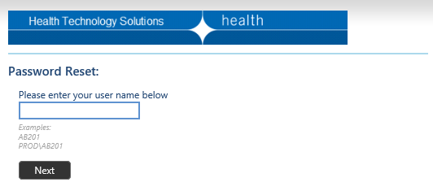
- A security code will be sent to the email address linked to your MFT account. Enter this security code and click ‘Next’:

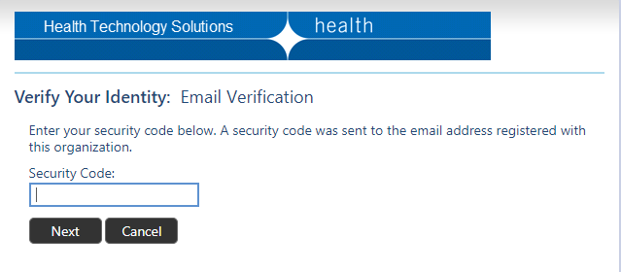

- In a few moments you will be taken to a new screen which displays your unique User ID (e.g., ZX987 below) into which you can enter and repeat a new password, then click on the ‘Next’ button:
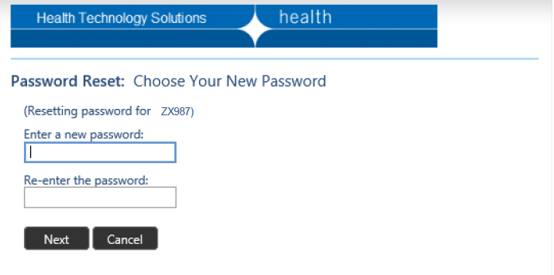
- If your proposed new password doesn’t meet the system requirements, you will be notified and the restrictions on passwords message is displayed. Enter a new password that meets the requirements, re-enter the same password and click the ‘Next’ button:

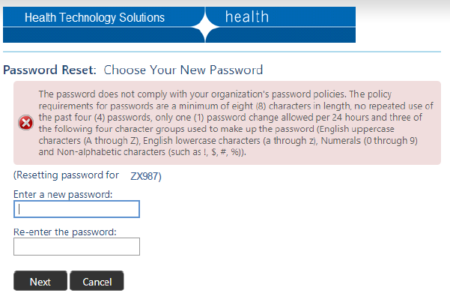
- When you have entered a password that meets system requirements you will receive confirmation of acceptance:
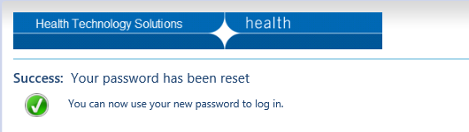
Password expiry is enforced for all MFT user accounts. Users will need to reset their account passwords regularly to continue accessing the portal
If your account password has expired, you can set a new password using the “FORGOT PASSWORD” link from MFT login page. This link will re-direct you to the Password Reset portal where you can follow the steps listed above to set a new MFT account password.

Logging into the MFT Portal
- Open the internet browser, and enter the MFT portal address <https://prs2-mft.prod.services>
- Bookmark this address to facilitate easy access in future

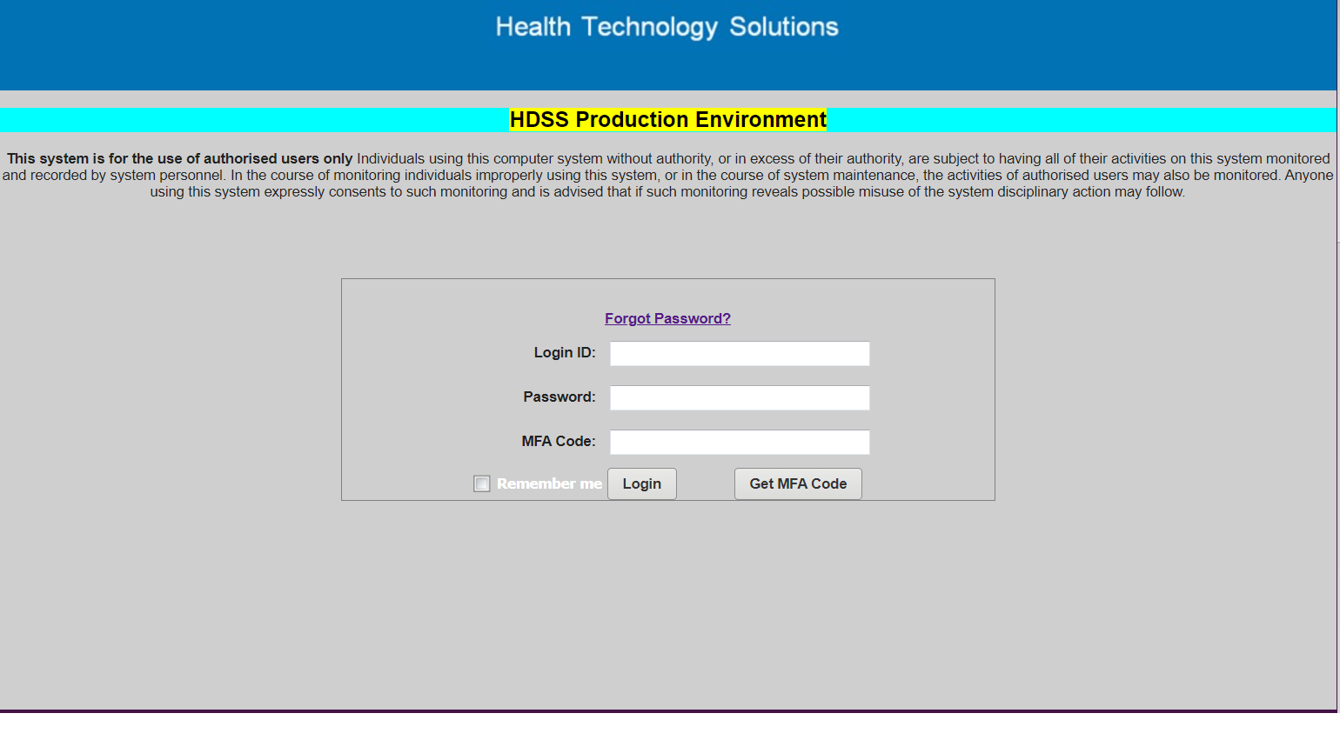
- Leave all field entries blank, select the ‘Get MFA Code’ button which will redirect you to the MFA Login page shown below:
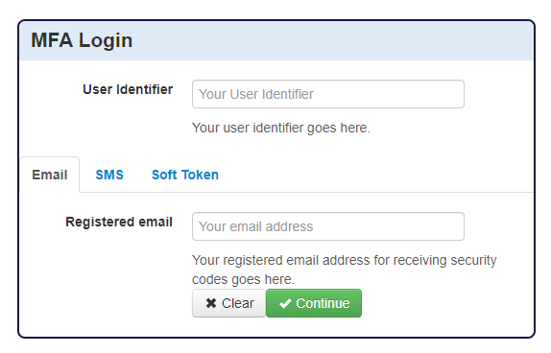
- Enter your MFT User Identifier (User ID) in the top box and select Email option and then enter the email address that is registered to your MFT User ID account in the bottom box and select ‘Continue’ (you will be prompted to enter the User Identifier (MFT login ID) again
- If you have your mobile phone number linked to your MFT User ID you can select ‘SMS’ option in the window shown above. You must then enter your mobile phone number in the lower box and select ‘Continue’. Only one option may be selected
- You will then be redirected to the following window to confirm that you have requested a MFA security code. Select ‘Continue’ and the MFA authentication code (one time password) should be received quickly via the method you selected – either email or SMS.

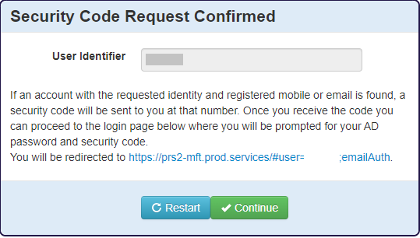
- You will then be re-directed back to the MFT login page where your MFT Login ID has been loaded, enter your account password and the MFA code you have just received.
Do not tick the ‘Remember me’ box as you are required to obtain a new unique MFA code each time you log into the MFT portal

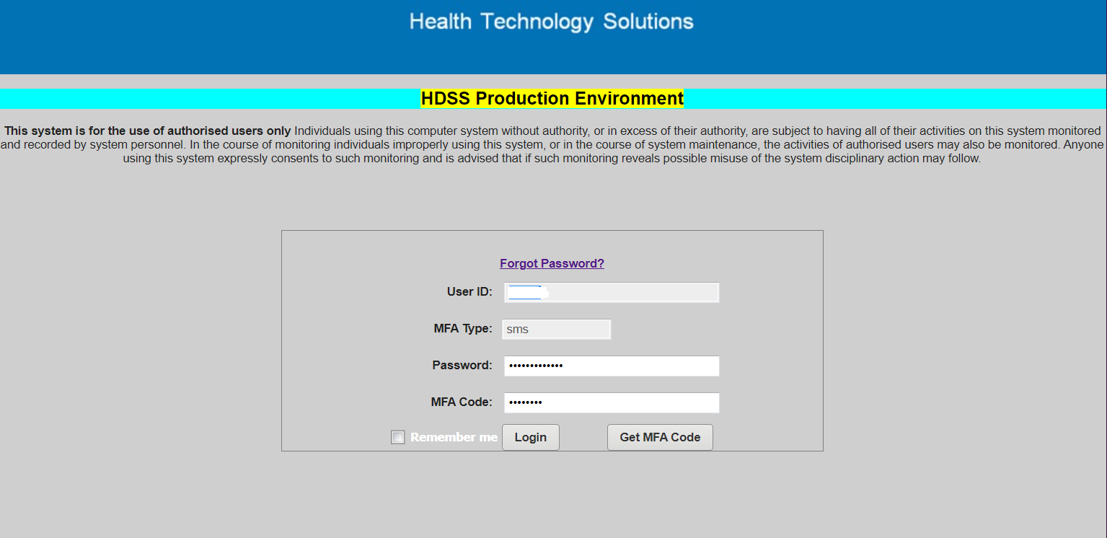

- Once you have entered your MFT Login ID, account password and MFA authentication code (one time password) the following message box is displayed:

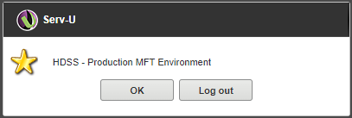

- HDSS – Production MFT Environment: - select ‘OK’ if you wish to proceed or ‘Log out’ if you wish to log out.

Uploading a submission file
- Once connected to the MFT portal the site folders your MFT account has access to will be listed, they will appear as OHCXNNF where XNN is the hospital’s PRS2 code (such as Z98).
- The next step is to move to the HOME directory/folder for the site by double clicking on the folder.
- For users with access to multiple data collections and/or multiple sites ensure the correct MFT site folder is selected.
- All VAED data files must be uploaded into the site’s HOME directory. Within the HOME directory use the Upload option to submit the file. The file is identified from your local drive/directory and selected using the Open option and then uploaded:
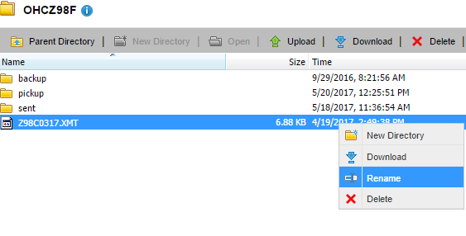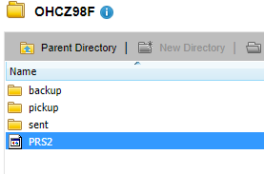
- The upload process once completed will place the transferred file in the sent folder, the file must be renamed as below to complete the process.
Right click on your file and select Rename to change file name to PRS2
- Any file name extension (such as .xmt or .txt) must be deleted in the renaming process. Failing to rename the file to PRS2 and removing any filename extension will result in the file being ignored by the MFT data file collection process and eventually deleted without being processed.
- Note: PRS2 (VAED) submission files must not be uploaded into the backup, pickup or sent sub-folders.
- PRS2 test data files must be renamed to PRS2TEST (please contact HDSS HelpDesk prior to uploading any test data files).

Collecting reports
After the data file has processed your validation report file will be available to download from the \pickup folder. Select this folder by double clicking on it and use the Download option and open and save the report file to your local drive.
Once the report file has been opened/downloaded it is moved to the \backup folder and saved here for 7 days before MFT automatically archives the file. The report file may be downloaded as many times as required from \backup folder within the 7 days.

Retention of reports in MFT pickup and backup folders
- Reports files in the MFT \pickup folder are retained for 35 days only, after this time MFT will archive the files whether they have been downloaded or not
- When reports are downloaded from the \pickup folder, the file is transferred to the \backup folder where it is retained for 7 days before being archived
- A copy of the uploaded submission file is transferred to the \sent folder where it is retained for 7 days before being archived. All sites are advised to retain copies of their submission files on their local network.
- MFT archiving is automatic, so users must take care to download files within these timeframes.
- Contact the HDSS HelpDesk if seeking access to a report no longer present in an MFT folder.

Help with using the MFT portal
- A short tutorial video <https://vimeo.com/629735934/8100600020> shows how to access the MFT portal using the Multi Factor Authentication (MFA).

Common problems when uploading files through the MFT
- Submission files uploaded into the wrong folder/location or with an incorrect filename will not be collected/transferred by MFT and will not be processed. These files are ignored and eventually removed from the MFT folder.
- The following error message is displayed if the user attempts to upload a submission file to the MFT portal without first selecting the site folder and navigating to the HOME directory:
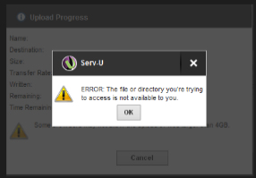
- If you encounter this error message, click ‘OK’ and return to the MFT portal then select the required MFT site folder and double click to navigate to the site’s HOME directory
- Failure to connect to the portal after followig the login steps: your MFT account password may have expired. Use the FORGOT PASSWORD link from the MFT login page to set a new MFT account password (users are not notified when their MFT account passwords have expired)

MFT FAQs
Can I upload multiple files for the same site at the same time?
NO – it’s not possible to upload multiple files at the same time.
For multiple PRS2 data files to be submitted users must allow a 5-minute interval between each file upload. MFT must collect/transfer the current file before proceeding to upload the next PRS2 submission file. This process may be repeated as often as required as long as a 5-minute interval is allowed for each file submission.
Can one person send a file and another person download the data validation report?
Yes. One user account can submit the data file and another user account can login and collect the validation report files – if all required user accounts have been nominated for this site.
How many times can I enter an incorrect MFT password?
You can enter an incorrect MFT password three times. After the third time, your account will be locked for 24 hours. It is not possible to unlock or reset your password if it has been locked.

Support
Note that any queries relating to your service’s internal network and firewall configuration must be directed to IT support within your organisation.
For assistance, please contact our help desk:
Email HDSS help desk <hdss.helpdesk@health.vic.gov.au>

Manipulation of data extracts
The department does not approve manipulation of data extracts (for example using Microsoft Excel, Notepad, or any other data manipulation tool) leading to changes in data values before the data is submitted.
It is expected that health services' contractual arrangements with software vendors require vendors to provide software that allows health services to meet their statutory reporting requirements. When negotiating contracts with software vendors, health services are strongly advised to consider the impact of data quality and timeliness penalties that can apply if the vendor fails to deliver software that meets statutory reporting requirements.
The software provided must deliver an extract in the format documented in this manual. Software vendors and health services should work together to ensure that when ‘validations’ are triggered in a submission; corrections can be made in the health service’s relevant operational database.
Any ‘corrections’ made to the extract but not reflected in the health service’s operational database may cause inconsistencies between data held by the department and the health service, and impact on data quality. An audit requirement exists that data received by the department is an accurate reflection of the health service’s medico-legal system of record.

Responsibilities: Health Service
When faulty or inadequate reporting software prevents the health service meeting its reporting obligations, the health service should notify its software vendor immediately so the problem can be addressed as a high priority issue. The health service should also immediately notify the HDSS help desk in writing and describe:
- the exact problem, including the affected data fields
- the plan between the health service and software vendor, and the anticipated timeframe, for the resolution of the situation
If the problem is not resolved by the agreed timeframe, the health service must again contact the department and inform of progress.
The department monitors and records such incidences. Penalties due to lack of data quality or timeliness can apply if the health service does not comply with these provisions.

Responsibilities: Department of Health
Occasionally a health service may request that the department make a manual adjustment to address a specific data quality issue. The department will only consider this when:
- all other avenues have been exhausted
- the health service requests the change in writing via the HDSS help desk, confirming that it has made the change to its own data (or indicating that this is not possible)
- the change accurately reflects the health service’s medico-legal system of record.
The department maintains records of all such incidences for monitoring data quality.

End of financial year reporting
As shown in the table below:
- Submissions with header dates prior to 1 July 2024 must use 2023-24 format/values for all records
- For submissions with header dates of 1 July 2024 onwards, the Separation Date of the episode determines the format/values applicable
  - Separation Date prior to 1 July 2024 must use 2023-24 format/values
  - Separation Date 1 July 2024 or later must use 2024-25 format/values
  - For patients ‘remaining in’ on 30 June 2024 this may involve updating episode data previously reported in a June submission from 2023-24 format/values to 2024-25 format/values
Format / values by submission month and Separation Date
Submission month | Admission Date | Separation Date | Unique Key | Format/Values
June | 01/06/2024 | 30/06/2024 | 000055555 | 2023-24
June | 20/06/2024 | 00/00/0000 | 000066666 | 2023-24
July | 25/06/2024 | 30/06/2024 | 000077777 | 2023-24
July | 20/06/2024 | 00/00/0000 | 000066666 | 2024-25
July | 01/07/2024 | 10/07/2024 | 000088888 | 2024-25
July | 02/07/2024 | 00/00/0000 | 000033333 | 2024-25

Test submissions for 1 July changes
Information regarding testing for 1 July changes will be published in the HDSS Bulletin.
To request inclusion on the HDSS Bulletin mailing list, complete the MS Form <https://forms.office.com/pages/responsepage.aspx?id=H2DgwKwPnESciKEExOufKII_2IfNHexFkH_EAj2AB_tUNFZQSkpIRVk0Q1dCQ1JJTVM3M1c4REszQiQlQCN0PWcu>

