

|  |
| --- |
| CDIS Discharge summary process |
| Victorian Maternal and Child Health (MCH)  Child Development Information System (CDIS)  July 2024 |
| OFFICIAL |

Contents

Scope 1

Purpose 1

Background 1

Process 2

# Scope

Discharge summaries are a key component of the transition of care from Maternity and other health services to Maternal and Child Health (MCH) services that assist the MCH service in understanding the family situation, safety concerns and particular needs of the infant to assist prioritising the allocation of the initial home visit and ongoing plan of care for the family.

# Purpose

This practice note has been developed to clarify the role and responsibilities of the MCH team following receipt of discharge summaries.

Best practice is for the MCH nurse to read the discharge summary (if available) prior to home visit.

# Background

Maternity, Paediatric units, Early Parenting Centres (EPC) provide discharge summaries such as Birthing Outcome System (BOS) for the transition of care process. These can be received via email (preferred option) or in person via the client.

Services will adopt specific processes for receipt of information relevant to the size of their team and birth notification numbers. MCH services may have established a dedicated inbox that receives the birth notification and discharge summary.

# Process

* Under the *Health Records Act and Information Privacy Act 2002* MCH nursing and administration staffcan attach the discharge summary to CDIS record. Using the discharge summary MCH nurses are responsible for completing the *Pregnancy and Delivery screen* in CDIS from within the infants CDIS record, via the menu History / Notes > Pregnancy & Delivery.
* MCH nurses should record the discharge weight and date into CDIS following the last weight recorded from the maternity service prior to MCH service commencing e.g. Domiciliary (DOM) / Post Acute Care Unit (PACU) / Hospital in the Home (HITH).
* This is recorded in the *Pregnancy & Delivery Screen.* Access this screen from within the infants CDIS record, via the menu History / Notes > Pregnancy & Delivery. See Figure 1.

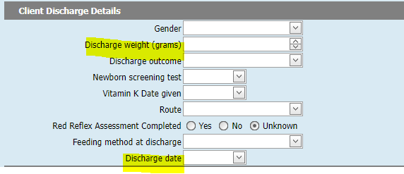

*Figure 1: Client Discharge Details within the Pregnancy & Delivery Screen in CDIS*

Discharge information received via email in addition to discharge summaries must be recorded in CDIS via:

* A C*lient Not Present* entry by the MCH nurse / Team leader / Clinical Coordinator, citing the author of the email and contact details, position, name of the agency providing, and reference “see attached document”.
* Saved and attached to the CDIS file.
* The MCH nurse/centre allocated to the client should be alerted to the presence of a new discharge attachment on the client file.

Verbal discharge summaries delivered over the phone should be received by an MCH nurse or team leader/coordinator and entered as a C*lient Not Present* entry:

* MCH nurse / Team leader / Clinical Coordinator should communicate any alerts or concerns with relevant MCH staff and add relevant flags and/or edit note to the client summary page.

|  |
| --- |
| To receive this document in another format, phone 1300 650 172, using the National Relay Service 13 36 77 if required, or [email Community Based Health Services, Policy & Improvement Branch](mailto:mch@health.vic.gov.au) <mch@health.vic.gov.au>.  Authorised and published by the Victorian Government, 1 Treasury Place, Melbourne.  © State of Victoria, Australia, Department of Health, July 2024.  Except where otherwise indicated, the images in this document show models and illustrative settings only, and do not necessarily depict actual services, facilities or recipients of services. This document may contain images of deceased Aboriginal and Torres Strait Islander peoples.  In this document, ‘Aboriginal’ refers to both Aboriginal and Torres Strait Islander people. ‘Indigenous’ or ‘Koori/Koorie’ is retained when part of the title of a report, program or quotation.  **ISBN** 978-1-76131-623-4 **(pdf/online/MS word)**  Available at [health.vic – Child Development Information System](https://www2.health.vic.gov.au/primary-and-community-health/maternal-child-health/child-development-information-system) <<https://www2.health.vic.gov.au/primary-and-community-health/maternal-child-health/child-development-information-system>> |