Regional Maternal and Perinatal Morbidity and Mortality Committees
Guidelines
OFFICIAL

Regional Maternal and Perinatal Morbidity and Mortality Committees
Guidelines

To receive this document in another format, phone (03) 9096 0000 using the National Relay Service 13 36 77 if required, or email Maternity and Newborn Policy <maternity@health.vic.gov.au>.
Authorised and published by the Victorian Government, 1 Treasury Place, Melbourne.
© State of Victoria, Australia, Department of Health, July 2024.
ISBN 978-1-76131-629-6
Available at Capability frameworks for maternity and newborn services, maternity and newborn care in Victoria <https://www.health.vic.gov.au/patient-care/capability-frameworks-for-maternity-and-newborn-care-in-victoria>

Contents
Introduction 6
Background 6
Purpose 7
About the Guidelines 7
Roles 8
Regional and rural maternity and newborn services 8
Lead service 8
Chair 8
Obstetric Peers 9
Midwifery Peer / Midwifery Service Lead 9
Paediatric Infant Perinatal Emergency Retrieval (PIPER) 10
Ambulance Victoria (AV) 10
Consultative Council on Obstetric and Perinatal Mortality and Morbidity (CCOPMM) 10
Safer Care Victoria (SCV) 10
Department of Health 11
Committee Processes 11
Overview 11
Resources 11
Case submission 12
Case triage and selection 12
Meetings 13
Committee reports 15
Implementation of recommendations 15
Escalation Process 15
Sharing learnings 16
Grand rounds 16
Reports 16

Introduction

Background
As outlined in the Department’s Policy and Funding Guidelines all health services providing maternity and newborn services must review all maternal and perinatal morbidity and mortalities locally. The hospital’s processes for this should align with the Perinatal Society of Australia and New Zealand’s Clinical Practice Guideline for Care Around Stillbirth and Neonatal Death.
Established in 2015, the Regional Maternal and Perinatal Mortality and Morbidity Committees (the Committees) provide a further layer of review for all public health services in regional and rural Victoria, providing additional support and governance expertise, especially for smaller services. They review selected maternal and perinatal mortality and morbidity cases at a regional level.
In 2020, management of the Committees moved from the Royal Women’s Hospital to the six level 5 capability (in accordance with the Maternity and Newborn Capability Frameworks <https://www.health.vic.gov.au/patient-care/capability-frameworks-for-maternity-and-newborn-care-in-victoria>) regional maternity services as listed in Table 1 Regional Maternal and Perinatal Mortality and Morbidity Committee lead health services.
Table 1: Regional Maternal and Perinatal Mortality and Morbidity Committee lead health services
Region | Level 5 Service Lead
Barwon South West | Barwon Health
Gippsland | Latrobe Regional Health
Grampians | Ballarat Health Service
Hume Lower (Goulburn) | Goulburn Valley Health
Hume Upper (Ovens Murray) | Albury Wodonga Health
Loddon Mallee | Bendigo Health

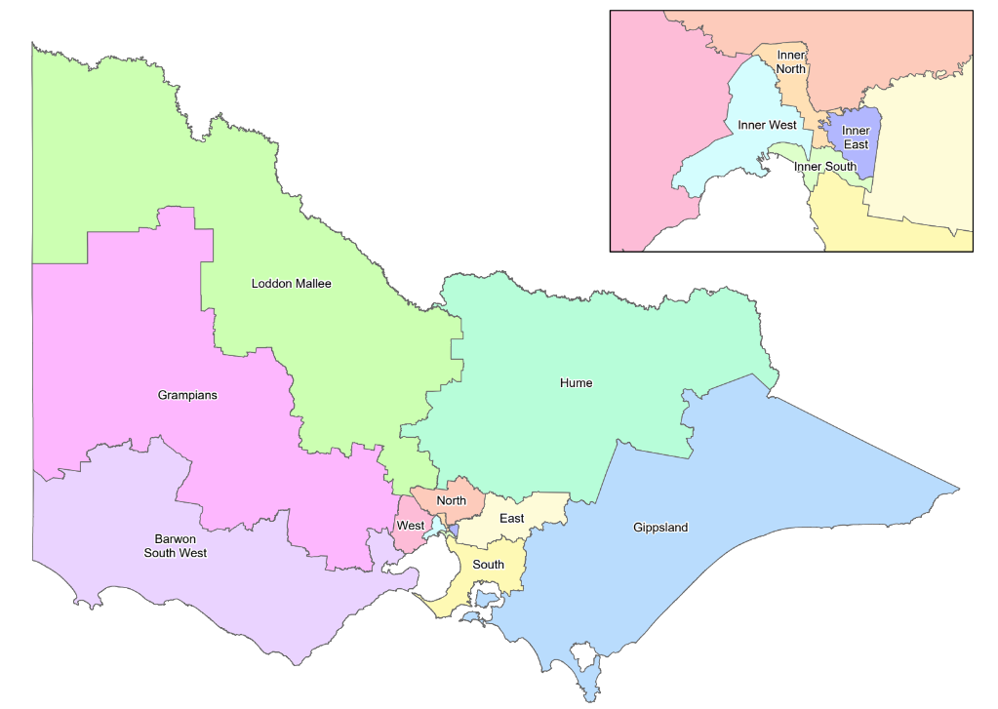

Purpose
The purpose of the Committees is to:
- review maternal and perinatal mortality and selected morbidity cases as a region
- report on findings and recommendations of these reviews
- guide local and regional improvements to the quality and safety of maternity and newborn care
- identify and address common system issues and risks and escalate
- assist in building the capability of individual clinicians and health services to perform robust and timely case reviews
- provide a further layer of maternal and perinatal case review for all public health services in regional and rural Victoria
- advance transparency within and across health services so that communities can be assured that their health services are recognising and responding to opportunities to improve clinical outcomes
- ensure all cases of concern in the region have a case review by the committee in a timely manner
- ensure Chief Executive Officers (CEOs) are advised on actions to reduce preventable harm in relation to maternity and newborn care in the region
- promote appropriate identification and timing of review and reporting of cases by health services such as Root Cause Analysis (RCA) for specified cases in line with the Department of Health, Victorian Health Incident Management Policy, notifications to Coroner, Consultative Council on Obstetric Perinatal Mortality and Morbidity (CCOPMM) or Australian Health Practitioner Regulation Authority (AHPRA)
- monitor trends in maternal and perinatal mortality and morbidity and identify opportunities for regional collaboration to improve maternity and newborn care
- develop and advise clinicians on care based on best practice and management
- support external obstetric and midwifery peer review and reflective practice
- foster and support a culture of continuous improvement and clinical excellence in relation to maternal and newborn care
- ensure reviews are undertaken using Just Culture principles by appropriately considering the impact of systems issues, rather than focusing on individuals. For more information on Just Culture principles please visit <https://www.safercare.vic.gov.au/report-manage-issues/sentinel-events/adverse-event-review-and-response/just-culture-training-and-resources>.

About the Guidelines
These Guidelines seek to support the processes and procedures of the Committees.

Roles

Regional and rural maternity and newborn services
The role of all public health services providing newborn and planned birthing care in regional and rural Victoria is to:
- review all maternal and perinatal morbidity and mortalities locally in line with the Perinatal Society of Australia and New Zealand’s Clinical Practice Guidelines for Care Around Stillbirth and Neonatal Death
- submit cases to the Committee’s Lead service for selection for review at Committee meetings
- attend Committee meetings
- implement recommendations from Committee meetings locally.

Lead service
Dedicated ongoing funding is provided to the Lead service (as per Table 1) to:
- coordinate quarterly Committee meetings
- prepare Committee meeting materials in collaboration with external peers
- maintain accurate Committee records
- disseminate meeting records to the region
- submit quarterly and yearly summary reports to Safer Care Victoria (SCV)
- notify relevant professional colleges of Committee attendance to assist with Continuing Professional Development (CPD) requirements
- Chief Executive Officer (CEO) or appropriate clinical or divisional lead escalates any significant quality and safety clinical concerns to the CEO, Executive Director, Safety or the Chief Nurse Midwifery Officer (CNMO) at SCV to bring to the Complex Issues Management Committee in a timely manner to ensure where possible risk mitigation strategies can be implemented to reduce avoidable harm to mothers and babies
- The CEO or appropriate clinical or divisional lead may seek advice regarding potential to refer a matter to AHPRA based upon mandatory reporting guidelines for AHPRA <https://www.ahpra.gov.au/Notifications/mandatorynotifications.aspx>
- maintain effective partnerships with key stakeholders and relevant professional bodies e.g.; Department of Health, SCV, Consultative Council on Obstetric and Perinatal Mortality and Morbidity (CCOPMM), Australian College of Midwives (ACM), Royal Australian and New Zealand College of Obstetricians and Gynaecologists (RANZCOG), Australian College of Rural and Remote Medicine (ACRRM), Royal Australian College of General Practitioners (RACGP), Paediatric Infant Perinatal Emergency Retrieval (PIPER), Ambulance Victoria (AV) and other teams in attendance including, Neonatologists and the Victorian Perinatal Autopsy Service (VPAS) teams.
Some regions have used the ongoing funding, supported by reciprocal support from other services in the region to employ a midwife, to support this function for the region.

Chair
The role of the Committee Chair is to:
- promote a safe and supportive multidisciplinary learning environment
- ensure the Committee has a no-blame environment within an appropriate legal framework
- collaborate with administrative officer, medical and midwifery service leads to facilitate Committee meetings
- confirm improvement actions from previous meetings have been implemented as part of business as usual for each service
- escalate any clinical concerns raised through the Committee process to the CEO, Executive Director, Safety or the Chief Nurse Midwifery Officer (CNMO) at SCV to take to the Complex Issues Management Committee.

Obstetric Peers
Each regions’ Committee has an Obstetric Peer who is an external Consultant Obstetrician from a Level 6 capability / tertiary maternity service.
The role of the Obstetric Peer is to:
- provide an independent view in the Committee review process
- assist in the triage, case discussion and follow up for the Committee to align with the time allocated for the meeting
- attend Committee meetings
- offer feedback for best practice / evidence-based practice and recommendations for quality improvement
- provide clinical expertise and peer review in collaboration with the Committee Chair and Midwifery Peer
- make recommendations to improve the quality and safety for maternity and newborn care
- identify systems issues to improve clinical care
- escalate any clinical concerns (identified during the case review) to the Committee Chair in a timely manner
- role model the process to promote a safe and supportive multidisciplinary learning environment and ensuring a no-blame environment
- promote leadership and ongoing sustainability for the Committee process.

Midwifery Peer / Midwifery Service Lead
Committees should include an external Midwifery Peer from a Level 5 (or Level 6 / tertiary service if not available) or Midwifery Service Lead role. This role should be undertaken by a practicing midwife in the region or a midwifery service leadership role and can be supported by a Clinical Midwifery Consultant (CMC).
The role of the Midwifery Peer / Midwifery Service Lead is to:
- work in collaboration with the Obstetric Peer and service leads to provide external tertiary clinical midwifery peer review and expertise for cases submitted for Committee meetings
- work collaboratively with the Obstetric Peer, Committee Chair and regional midwifery service lead to support the Committee to process and triage cases for each meeting
- attend Committee meetings
- provide mentorship, clinical leadership and liaison with all maternity service representatives within the region
- provide objective clinically focused midwifery feedback to improve clinical outcomes for mothers and babies
- escalate any clinical concerns (identified during the case review) to the Committee Chair in a timely manner
- contribute to the actions and recommendations generated through case review.

Paediatric Infant Perinatal Emergency Retrieval (PIPER)
The role of PIPER is to:
- provide quarterly maternal and transfer reports to all rural and regional CEOs
- where appropriate and relevant, attend Committee meetings review relevant cases
- a Level 6 Neonatologist has been allocated by PIPER to each Committee for this purpose.

Ambulance Victoria (AV)
The role of AV is to:
- provide quarterly maternal and transfer reports to all rural and regional CEOs
- where appropriate and relevant, attend Committee meetings to review relevant cases.

Consultative Council on Obstetric and Perinatal Mortality and Morbidity (CCOPMM)
The role of CCOPMM is to:
- independently review cases of maternal, perinatal and paediatric mortality and morbidity
- health services must report to CCOPMM:
  - all perinatal, infant, child or adolescent deaths
  - all maternal deaths and serious harm including severe acute maternal morbidity
- the council makes recommendations to help health services and medical practitioners improve clinical practice and systems of care, using its annual report to detail the council’s research and activities
- it also directly advises the Minister for Health and SCV on strategies to improve clinical performance and avoid preventable deaths.

Safer Care Victoria (SCV)
The role of SCV is to:
- receive the quarterly and yearly Committee reports from all six regions
- collate Committee reports and develop a statewide rural and regional report highlighting cross regional system trends and areas of focus for improvements
- liaise with key stakeholders on the outcomes of the statewide rural and regional report to support cross regional learnings and improvement work in areas highlighted in the report (e.g. SCV strategic improvement initiatives, Department of Health or SCV policy development, clinical guideline development, etc.)
- Senior Maternity Advisor (SMA), SCV to attend each Committees’ meetings across all regions to support centralised stewardship and leadership, to provide an escalation point and to liaise with key stakeholders to support key learnings from state-wide trend identification.

Department of Health
The role of the Department of Health is:
- as system steward, the Department of Health is responsible for regular performance monitoring of public health services. Areas of note from regional Committee reports can be discussed as part of routine performance conversations.
- progress policy change to support areas of improvement highlighted in the statewide report from SCV.

Committee Processes

Overview
A summary overview of Committee processes is provided in the below flowchart and outlined in detail thereafter.
Figure 1: Summary of Committee processes
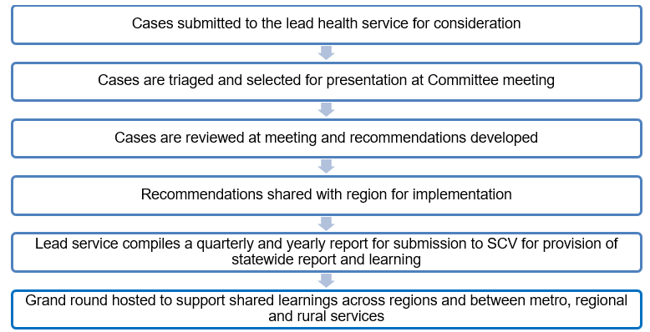

Resources
Committees should have the following resources developed to support their local region’s needs for optimal Committee process:
- an agreed Terms of Reference to provide clear processes and responsibilities
- case review template/s - case review and presentation templates can be developed to support different types of case reviews, for example, developing templates for each topic such as an appearance, pulse, grimace, activity, and respiration (APGAR) template, Fetal Growth Restricted (FGR) template, Severe Acute Maternal ​Morbidity (SAMM), morbidity and mortality templates.

Case submission
All services in the region should:
- review all cases locally as outlined in the Department’s Policy and Funding Guidelines <https://www.health.vic.gov.au/policy-and-funding-guidelines-for-health-services>
- submit cases to the Lead service by the timeline stipulated.

Case triage and selection
Once all cases have been received, they can be triaged to support case selection.
Triaging should:
- be undertaken by a nominated person(s) (i.e. Obstetric / Midwifery Peer or any role nominated in the region specifically allocated for case triage)
- triaging by two nominated people is encouraged to support the shared management of risks and accountability.
Cases can be triaged and selected for review by the Committee based on:
- themes that are of particular interest to the region
- themes that have been highlighted by relevant reports (i.e. The Perinatal Services Performance Indicator (PSPI), COPPMM Mothers and Babies Report)
- cases where the issue has been seen before in the region and so improvements in that area can be further investigated
- cases where improvements in how the region works together can be reviewed
- inclusion of cases that support positive learnings
- cases selected from smaller health services are encouraged
- the number of cases may be limited to ensure there is time for rich discussion and learnings
- cases selected should provide education and learnings for staff and health services and work towards system improvements for the region
- reviewing where birthing has occurred outside of Maternity Capability level
- near miss events.
Further, case selection criteria specific to mortality and morbidity cases is provided below:

Mortality
- all or selected maternal deaths in your region up to one year consistent with World Health Organisation (WHO) and CCOPMM recommendations
- consider cases where women were booked at a service in your region but were transferred elsewhere; including Intensive Care Unit (ICU) / High Dependency Unit (HDU)
- all or selected stillbirths from 20 weeks gestation
- all or selected neonatal deaths from 20 weeks gestation
- if gestation unknown ≥400 grams
- all or selected perinatal deaths where the signs of life at birth were ambiguous
- attention is to be paid to deaths where health service policy, standards or previous recommendations from the committee were not implemented or followed.

Morbidity
- the Committee should agree annually on priority areas for collective review noting that each health service will be doing local reviews on selected mortality and morbidity according to their capability level, local outcomes, trends or risks
- selected morbidity to be referred for review may include (but are not limited to):
  - Severe Acute Maternal Morbidity (SAMM)
  - Women who were pregnant or had given birth in the past 42 days, who were admitted to an adult intensive care unit, or
  - Women who nearly died but survived a complication that occurred during pregnancy, childbirth or within 42 days of birth or termination of pregnancy
  - CCOPMM SAMM categories, criteria and definition (see Table 3, page 34 of the 2021 Victoria’s mothers, babies and children report at <https://www.safercare.vic.gov.au/reports-and-publications/victorias-mothers-babies-and-children-2021-report-and-presentations> or the most recent report at time of viewing these Guidelines), inclusive of:
- severe Primary Post Partum Haemorrhage (≥1500ml blood)
- unplanned ICU admission
- peripartum hysterectomy
  - all or selected transfers out including those involving PIPER or AV, Adult Retrieval Victoria (ARV) – maternal and neonatal
  - any baby delivered, regardless of outcome, which was less than the 3rd centile, FGR (less than 2800g) delivered at 40 weeks or more
  - Apgar at term (< 7 at 5 minutes), or need for substantial or sustained resuscitation for term, healthy infants after birth
  - “other” as requested by the relevant health service in collaboration with the regional Chair & clinical lead.
- Please note that consideration should be made if this case meets sentinel event criteria in line with SCV’s Victorian sentinel events guide found at <https://www.safercare.vic.gov.au/best-practice-improvement/publications/sentinel-events-guide>.

Meetings

Frequency
Meetings should occur quarterly.

Agenda
Committee meetings should include the following:
- an update on status of the implementation of previous Committee recommendations from each service
- case review and discussion
- development and endorsement of recommendations and actions from case reviews, including governance structures to be used to ensure they are progressed.
Consideration for how the agenda is structured should be given to ensure the best use of attendees time (ie. grouping types of cases for review to ensure appropriate members and clinicians are present for relevant sections of the agenda).

Case review
The review of cases at Committee meetings should align with the following principles and can use the following processes to support discussion and recommendation development:
- focus on understanding what happened, why it happened, and identify system improvements to prevent recurrence and minimise harm
- consider previous reviews and recommendations, including their effectiveness, especially for repeated adverse events
- utilise the SCV Systems-Focused Case Review Tool, an adaptation of the London Protocol, to consider sociotechnical system layers and identify contributory factors
- conduct reviews using Just Culture principles, focusing on systems issues rather than individual blame.
For more information, please visit:
- SCV Adverse Patient Safety Event Guideline <https://www.safercare.vic.gov.au/best-practice-improvement/publications/policy-adverse-patient-safety-events>
SCV Systems-focused framework and toolkit <https://safercare.vic.gov.au>
- Just Culture Principles <https://www.safercare.vic.gov.au/report-manage-issues/sentinel-events/adverse-event-review-and-response/just-culture-training-and-resources>.
The ordering of case reviews in Committee meetings can be arranged along the following lines, but should use the structure that works best for each region:
- review cases based on theme together
- begin with smaller services progressing to larger
- begin with mortality cases (allow 10 minutes per case) progressing to morbidity cases (allow 5-10 minutes per case (depending on numbers)), then move to PIPER / AV transfers (allow 5 minutes per site to provide a summary of the transfers and focus on only discussing those triaged by peers or if requested by the local clinical team).

Recommendation development
In developing recommendations, the following should be considered:
- recommendations should be carefully developed and accompanied by an implementation plan and nominated timeframe to be completed within
- recommendations should outline key practice changes to support improvement and prevention of case outcomes
- use Specific, Measurable, Attainable, Relevant, Timely (SMART) principles when developing recommendations.
In developing implementation strategies, the following opportunities could be considered:
- participation in existing, or development of new, improvement projects to address specific recommendations, ensuring the Chief Nursing and Midwifery Office is consulted
- tools and frameworks for improvement from the Institute of Healthcare Improvement https://www.ihi.org/
- speaking to other regions to see if they have implemented similar improvement strategies.

Committee reports
The Lead service should provide a brief quarterly and an extended yearly report from each Committee meeting along the lines of the following:
- to provide the key outcomes and recommendations from the meeting
- be provided to all Committee members in a timely manner (ideally within 2 weeks of the meeting occurring) to ensure implementation of recommendations
- be submitted to SCV through SafetyInsights@safercare.vic.gov.au.

Implementation of recommendations
- a clear timeline and process should be outlined as part of each recommendation for required services to follow
- where a service has not implemented a recommendation as outlined, the Lead service should highlight this in the reports provided to SCV
- discussion with the health service that has not implemented the recommendation will be had at the next Health Service Performance meeting with the Department.

Escalation Process
Figure 2: Escalation Process
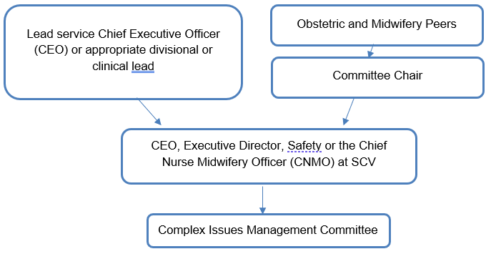
*The CEO or appropriate clinical / divisional lead may seek advice regarding potential to refer the matter to AHPRA based upon mandatory reporting guidelines for AHPRA <https://www.ahpra.gov.au/Notifications/mandatorynotifications.aspx>

Sharing learnings

Grand rounds
To support shared learnings across regions and between metro and regional and rural services the following should occur:
- a grand round hosted by a Level 6 / tertiary service and Level 5 regional in partnership with CCOPMM once to twice per year
- each level 6 / tertiary service and Level 5 regional service should take it in turns to host a grand round with CCOPMM for all metro, rural and regional services to attend and share learnings.

Reports
The lead service compiles a quarterly and yearly report from each Committee meeting for submission to SCV via email to SafetyInsights@safercare.vic.gov.au.
SCV summarises and disseminates a statewide report annually to the sector to be used for ground rounds and shared learnings.

