|  |
| --- |
| Water sampling localities |
| Submitting proposals |
|  |



# Introduction

Victoria’s Safe Drinking Water Act 2003 (the Act) and Safe Drinking Water Regulations 2015 (the Regulations) provide a comprehensive regulatory framework that encompasses a catchment-to-tap risk-based approach to the management of drinking water safety and quality.

This guidance is provided to assist water suppliers in submitting water sampling locality proposals that meet the requirements of the Regulations.

Any new water sampling localities – such as new discrete drinking water distribution systems – or changes to existing water sampling locality boundaries, are required to be specified as such via publication in the Government Gazette under the Regulations by the Secretary to the Department of Health and Human Services (the department).

Water suppliers should discuss their water sampling locality proposals initially with a department Water Unit officer to ensure an understanding of the requirements.

## Water sampling localities

The Regulations require that water suppliers collect drinking water samples from specified water sampling localities. A water sampling locality is a discrete geographical area where water samples collected are representative of the drinking water that is supplied to that area. All locations that are supplied with drinking water must be within a water sampling locality boundary, this provides assurance that water samples collected are representative of the drinking water supplied, enabling water suppliers to identify any issues pertaining to drinking water sources, treatment processes or distribution and to identify customers receiving drinking water in the water sampling locality.

Water sampling localities are applicable to the supply of drinking water only and do not apply to water declared to be regulated water under section 6 of the Act, nor to any water supplied that is not within the scope of the Act and Regulations.

All water sampling localities that were published in the Government Gazette prior to July 2015 remain current under the repealed Safe Drinking Water Regulations 2005. Any new water sampling localities, or changes to existing water sampling locality boundaries, are required to be gazetted under the Regulations. If water agency staff need assistance to access previously gazetted water sampling localities they should contact a Water Unit officer.

New water sampling locality proposals are required for new discrete drinking water distribution systems, including when regulated water supplies are to be upgraded to be drinking water supplies.

Changes to existing water sampling localities may include redefining of boundaries, merging or dividing of current water sampling localities, or changes to supply arrangements.

Regulation 6 states the requirements regarding proposing new, or changing existing, water sampling localities. A water supplier may submit a proposal on its own initiative. In circumstances where the department considers that an area should be specified to ensure that water samples collected are representative, the department may direct a water supplier to submit a proposal under regulation 6(3).

## Proposed water sampling localities

A template has been included to assist water suppliers with collating the required information and checking that required information has been included with the proposal (Appendix 1). Using this template is not mandatory, however it will assist with ensuring all necessary information has been considered and facilitate efficient review of the water supplier’s proposals.

## Determining boundaries

Proposed water sampling locality boundaries should encompass a discrete geographical area in which the water supplied is of a similar quality. Regulation 7(a) requires information to be included with proposals setting out how the boundaries have been determined, with reference to:

* the source or sources of the water that would be supplied as drinking water in the proposed water sampling locality
  + the source/s of water may be a water catchment, groundwater, service reservoir, tank, or a combination of these.
* the treatment processes that would be applied to water that would be supplied as drinking water in the proposed water sampling locality
  + the number of sources and treatment processes must be considered because in isolation or combination they may alter the water quality throughout the water supply system; this includes disinfection, where water quality is changed through an intervention via the addition of chemicals or other processes for the reduction of microbiological, chemical, physical or radiological hazards
  + in a single locality where additional treatment processes are permanently applied within the locality changing the water quality supplied to parts of the locality, there is a need to split the water sampling locality according to the discrete areas of water quality
  + as a rule, passing water through a pump or pressure-reducing valve is not considered to significantly change its quality; therefore one water sampling locality may contain several pressure zones.
* the distribution system that would be used to supply drinking water in the proposed water sampling locality
  + the location of service reservoirs, tanks, trunk or distribution mains and reticulation infrastructure
  + the extensiveness of the water supply distribution system with particular consideration given to significant distances and water travel time
  + pressure zones, where these zones may correlate with areas of discrete or varying water quality.

Boundaries may be determined via supply arrangements from a water source. For smaller supply systems this may be the whole supply network, for larger systems it may entail that part of the reticulated system which is defined via closed valves.

Water entering the proposed area should be supplied from a common source. However, there may be localities that are supplied by two or more varying sources of water at one time, depending upon network arrangements and system hydraulics. For complex arrangements with different sources of supply, the context for the proposed changes could be described as alternating sources of water and varying treatment processes, and must be reflected within the associated water sampling program. Water supply and distribution schematics (preferably via electronic image or picture files) may also be included with proposals to assist the department in determining the rationale for discrete subsets of geographical areas where proposed.

To satisfy the requirements of regulation 7(a) a proposal may state –

* proposed water sampling locality: Locality A showing different sources of supply
* overview of proposed changes: different boundaries
* sources: for 9 months the water supplied originates from East water treatment plant (WTP) which supplies the entire reticulated network within proposed boundary of Locality A, and for 3 months West WTP contributes supply to a subset of Locality A in addition to providing water to Locality B
* treatment processes: East and West WTP’s have the following treatment – solids separation (clarifier), filtration (rapid gravity sand), disinfection (sodium hypochlorite) and fluoridation (fluorosilicic acid).
* distribution systems: the geographical boundaries have been determined via system hydraulics in the reticulated system
* locality A: for 9 months the entire locality receives water from East WTP; for 3 months a subset of locality A receives water from West WTP, this is recorded in the water sampling program
* locality B: continuously receives water from West WTP.

## Map of proposed boundaries

Regulation 7(b) requires a map to be provided showing the proposed water sampling locality boundaries for each proposal. Maps need to contain enough detail to ensure that the geographical locations of the proposed boundaries can be determined. An example of a map containing adequate information is at Appendix 2.

Maps must be provided in grayscale; they will be published in the Government Gazette in black and white. Maps must be provided in one of the following electronic formats:

* PDF format at a resolution of 300 dots per inch (DPI)
* vector format (EPS format ideally) at a resolution of 300 pixels per inch (PPI).

Maps will be printed by the publisher at a maximum of A5 size (148 mm x 210 mm). If map detail at this size is insufficient to adequately discern the boundaries separate enlargements of map areas may be required.

Maps should contain the information provided in Appendix 2 to ensure that the water sampling locality boundaries can be determined geographically. Good mapping practices will need to be followed to ensure they can be interpreted clearly; this will require inclusion of the map scale and directional markings, along with a legend. When published in the Government Gazette the map becomes a legal document; maps should not contain water agency names, reference to private business details or other non-essential markings.

### Other information to identify boundaries

Regulation 7(c) requires that water suppliers include on the map all information reasonably available to them that assists to identify the boundaries of the proposed water sampling locality. This includes, where relevant and available to the water supplier:

geographic coordinates (if coordinates are used each boundary data point should be labelled clearly and accurately along with reference made to the geodetic system utilised)

* a freeway, highway, road, street or other thoroughfare
* a railway line
* a municipal boundary
* a physical feature of the terrain
* a waterway
* a property boundary
* any other information that the water supplier considers relevant, such as suburb or town names.

There may be circumstances where additional information is needed to assess the proposal. Examples include:

* water district boundaries, licence areas and areas of operation, including maps that depict these areas
* historical information and data relating to areas of historically poor water quality
* rationale or justification provided by the water supplier as to why a specific area should be considered a single water sampling locality
* the population of the proposed water sampling locality.

## The department’s response to water sampling locality proposals

Subsequent to the water supplier’s initial discussion with the relevant Water Unit liaison officer, all proposals should be emailed to the relevant liaison officer, which will then be assessed for compliance with the Regulations. It is expected that when all required information has been submitted to the department, depending upon the complexity of the proposal it may take up to 6 weeks to gazette.

If the information required under regulation 7 has been provided, and the water supplied in the proposed water sampling locality is deemed representative of the drinking water supplied in that area, the department may accept the proposed water sampling locality. The department’s decision will be published in the Government Gazette, with the area then considered to be a water sampling locality as per the Regulations. The department will advise the water supplier of this gazettal.

The water supplier must ensure that the water sampling program within its risk management plan aligns with any water sampling locality changes or additions, and the collection of water samples from within water sampling localities meets the requirements of regulation 13.

|  |
| --- |
| To receive this publication in an accessible format phone 1300 761 874 using the National Relay Service 13 36 77 if required, or email [drwu@dhhs.vic.gov.au](mailto:drwu@dhhs.vic.gov.au)  Authorised and published by the Victorian Government, 1 Treasury Place, Melbourne.  © State of Victoria, Department of Health and Human Services, HHSD/18/17452, March 2018. Available at < https://www.health.vic.gov.au/water/guidance-notes > |

# Appendix 1: Information to be submitted with water sampling locality proposals

This table may be used by water suppliers to ensure that all required information associated with water sampling locality proposals is submitted to the department. When completed please email this template along with all required information to the relevant Water Unit liaison officer.

Water supplier:

|  |  |  |  |  |  |  |
| --- | --- | --- | --- | --- | --- | --- |
| Proposed water sampling locality name | Reason for proposal - change or new (i.e. redefining boundaries, merging, dividing, new) | Source/s of the water supplied to proposed water sampling locality | Treatment processes applied to water supplied to proposed water sampling locality (include any assisting information such as  schematics) | Details of the distribution system used to supply drinking water to water sampling locality | Is a map & assisting information to identify proposed boundaries attached? | Is the map in grayscale, in vector EPS or PDF format at a resolution of 300 PPI/DPI and readable at A5 size? |
|  |  |  |  |  |  |  |
|  |  |  |  |  |  |  |
|  |  |  |  |  |  |  |
|  |  |  |  |  |  |  |

This page is intentionally left blank.

# Appendix 2: Example map of proposed water sampling locality

The Regulations require that a map be provided with all water sampling locality proposals to assist in identifying the boundary. The map must include all information reasonably available to the water supplier that assists in identifying the boundary of the proposed locality.

Figure 1 is an example of a map containing adequate information to identify the boundary.

### Figure 1: Maps containing adequate information to identify the boundary

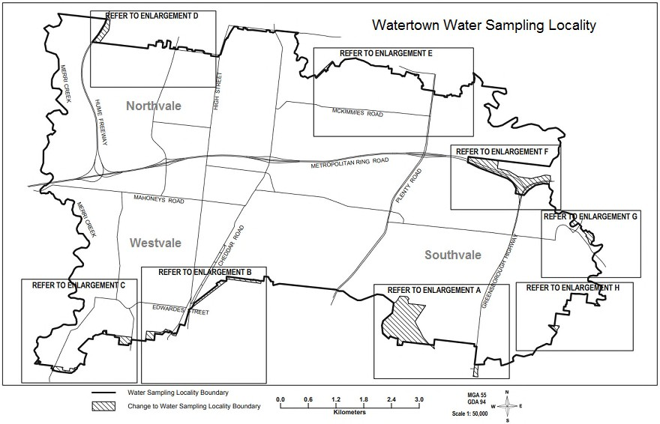

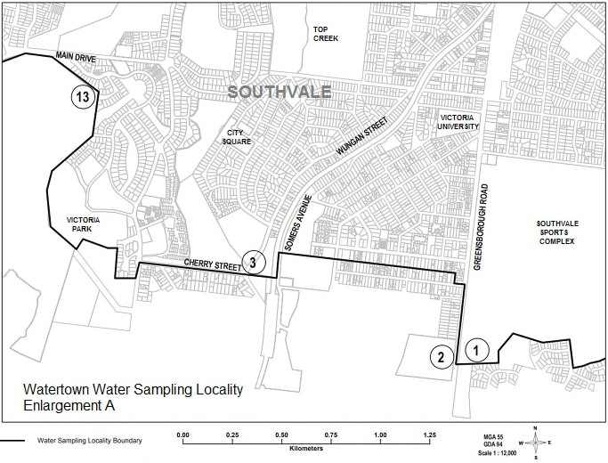

**Meets requirements**

* A5 size (or less)
* grayscale
* name of water sampling locality included
* freeways, highways and major roads are identified
* major landmarks (such as waterways) have been identified to assist in identifying the boundary
* clear and accurate markers associated with geographic coordinates are included to assist in identifying the boundary (associated geographic coordinates are not displayed in this example)
* contains suburb names to assist in identifying the boundary
* contains a legend to assist in identifying boundary
* contains a directional indicator and map scale to assist in identifying the boundary.

### Comments

* where the boundary cannot be adequately identified an enlarged section is provided in a separate map that adequately identifies the boundary.