

|  |
| --- |
| Practice Note - CDIS Client Correspondence and Client Not Present |
| Victorian Maternal and Child Health (MCH) Child Development Information System (CDIS)  July 2024 |
|  |

Contents

Overview 2

Client Not Present Process 3

Service Date & Start time 3

Program 3

Agency 3

Service Type 4

Location 4

Others involved 4

Professionals involved 4

Notes 4

Time 4

Service Type and Process 5

# Overview

This user guide explains how to document client correspondence in CDIS and use the CDIS Client Not Present (CNP) screen, and the purpose of each field.

Client correspondence via SMS, phone calls, emails must be recorded in CDIS to maintain an accurate and complete health record. When documenting the text messages and responses it is important to ensure that the information captured is consistent with established documentation standards and policies. Best Practice is to copy the message in full directly into the record without summarising it. See process below.

Any professional correspondence such as emails or reports also need to be recorded and attached into the relevant client CDIS record to ensure an accurate and complete health record.

The Client Not Present (CNP) function in CDIS is the preferred method of recording any client correspondence and is accessed through an individual client CDIS record, via the Clinical Activity > Client Not Present menu. See image 1.

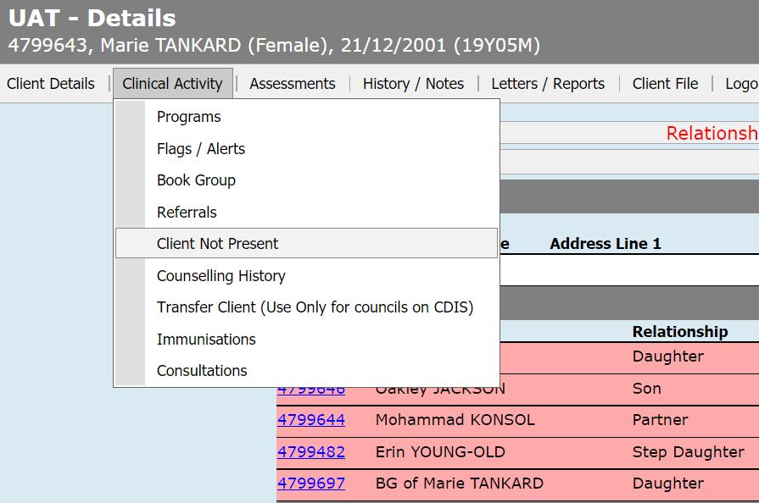

*Image 1 – Selecting the* ***Client not Present Screen*** *in CDIS*

Completed notes will only appear in the CDIS record of the client where the Client Not Present was completed.

If the notes from the Client Not Present need to be included in another client’s notes such as in a family group, then the details can be copied from the first client’s history/notes and pasted into each other relevant history using the add note’s function.

Note: MCH staff need to be aware of the Information Sharing Legislation and the Child Development Information System process guidance for information sharing workaround, which is completed using the Client not present screen.

https://www2.health.vic.gov.au/primary-and-community-health/maternal-child-health/child-development-information-system.

Note: MCH Administration teams can attach any documents to CDIS records and then forward any correspondence to MCH Leadership/clinician.

# Client Not Present Process

## Service Date & Start time

These fields are auto completed with the current date and time. If required, they can be adjusted to reflect the date and time of the action being recorded.

## Program

The Program field (see image 2) allows you to link this CNP to any program that the client is currently enrolled in. This includes non-lead clients of Integrated Programs such as Enhanced MCH or Sleep & settling – Outreach.

Note: for non-Integrated programs this Program field has no effect and data cannot be entered into the field.

If you wish the CNP to be included as part of an Integrated Program case, you must select that Program in this field to ensure that:

* The CNP appears in the Case Summary Screen for the case
* Select program if client is enrolled in the EMCH or Sleep and settling program. (Notes will only appear in the client history a CNP is recorded in)
* The CNP delivery time (Direct, Indirect, Travel) counts towards the overall case time

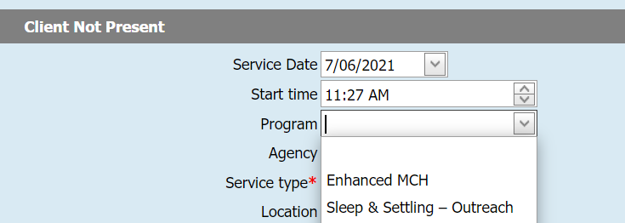

*Image 2 – Select the* ***Program****, within the Client not Present Screen in CDIS*

## 

## Agency

The Agency field should be completed if possible, however although the choices are extensive, there may be occasions where the relevant agency is not listed. Regardless of whether the relevant agency can be selected here, it is important that the name of the Agency and the contact details be included in the Notes section in the CNP screen (see image 3).

##### Screenshot of the CNP screen

*Image 3 –Select the* ***Agency****, within the Client not Present Screen in CDIS*

## Service Type

Service Type is a mandatory field. Select service type as indicated (see image 4). See table 1 on the following page for Service type explanation and process.

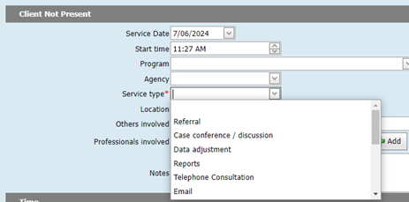

*Image 4 –Select the* ***Service Type****, within the Client not Present Screen in CDIS*

## Location

The location data field lists many of the most likely locations however this is normally not completed as the MCH staff are usually attending to CNP administratively within an office setting. It is not a mandatory field.

## 

## Others involved

This is a free text field which can be completed if relevant. It is not a mandatory field.

## 

## Professionals involved

This is a drop-down field that allows you to add any professionals that are listed in CDIS and have been already linked to the client’s record. It often will have no options for selection. Professionals you are engaged with during the CNP can be added in the ‘Others involved’ free text field. It is not a mandatory field.

# 

# **Notes**

The notes should be comprehensive and enable other staff to ascertain the purpose of the Client Not Present. Make sure to include the name and contact details of who was involved. It is critical that the notes be comprehensive and include enough details that other staff members are able to ascertain necessary information for any follow up.

# **Time**

The time is included in the Client Not Present screen and must be completed. Although both the Direct and Indirect appear mandatory as they both have a red * only one of the fields in those two rows needs to be completed.

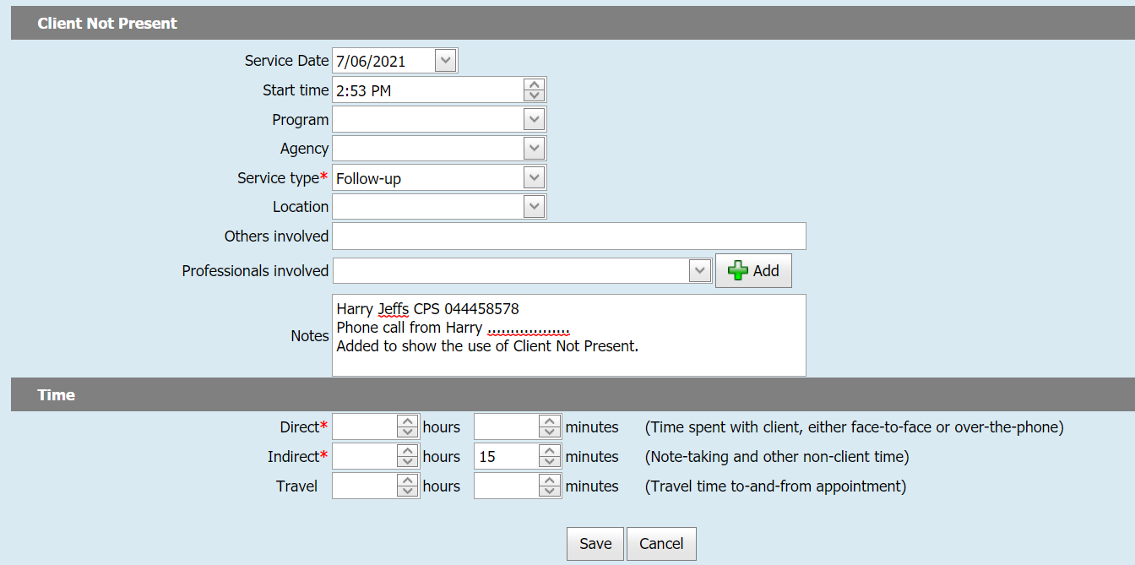

*Image 5 –Enter the* ***Direct or Indirect hours or minutes****, within the Client not Present Screen in CDIS*

Estimate the time taken for completing the activity being recorded in the CNP.

In the Enhanced MCH and/or Sleep & Settling – Outreach programs, the time for the CNP contributes to the delivered hours for that case.

# Service Type and Process

|  |  |
| --- | --- |
| **Service Type** | **Usage** |
| Referral | Used when a referral has been generated |
| Case Conference/discussion | For when the client is not present at a formal /planned professional discussion regarding a specific client or program (including Integrated Programs) |
| Data adjustment | Record time missed in previous consultations especially for integrated programs eg EMCH groups. |
| Reports | For attaching reports received from other agencies (CP, Family services), or when writing a report pertaining to a client or program. |
| Telephone Consultation | For conversations with clients.  If the conversation becomes a consultation, please record as an additional consult – location as telephone consult. |
| Email | For email correspondence pertaining to a client or program. Includes correspondence from the client and to the client.  In the Notes Section copy email **or** write See attached email and report attached.  Save email as an attachment – see your IT dept for process. This ensures a complete health record. |
| SMS | SMS correspondence pertaining to a client or program. Includes correspondence from the client and to the client.  Copy SMS and email to clinicians’ email address.  Copy and paste SMS (emailed) into CDIS Client not present notes.  Best Practice to include the clinicians phone number that sent the message and the clients phone number where the reply originated from.  Save email as an attachment- See your IT dept for process. |
| Follow-up | Sending letters; recording what additional work was done following DNAs; any other follow-up activities related to a client or program.  Can be used for secondary consult with colleague or MCH Leadership.  It can be used for a range of different activities, including when no other service type is suitable. |
| Information Sharing - Making a request | Only to be used when meeting the requirements of the Child Information Sharing Scheme and the Family Violence Information Sharing Scheme  All IS requests and responses to be saved in notes section of client not present and attached if email or document.  Recording of informal information sharing with prescribed ISE to also be recorded as Proactively Sharing |
| Information Sharing - Receipt of requested information |
| Information Sharing - Receiving a request |
| Information Sharing - Responding to a request |
| Information Sharing - Proactively Sharing |
| Information Sharing - Update to Responder Post Sharing |
| Migration - EMCH | No longer in use |

*Table 1 - Service Types and Process Usage*

Please note that the Did Not Attend (DNA) must be completed in the calendar if a client does not attend an appointment. However, you may add additional information by completing a Client Not Present if you have undertaken a more extensive follow-up after the DNA. The follow–up may relate to additional work that the MCH Nurse has done to assist a client and may include advocacy for the client, or the client has multiple DNA’s and additional work is required.

Best Practice with multiple SMS messages is to ensure the SMS trail is complete and enter these in the Notes of the Client Not Present prior to saving. See images 6 and 7 on the following page.

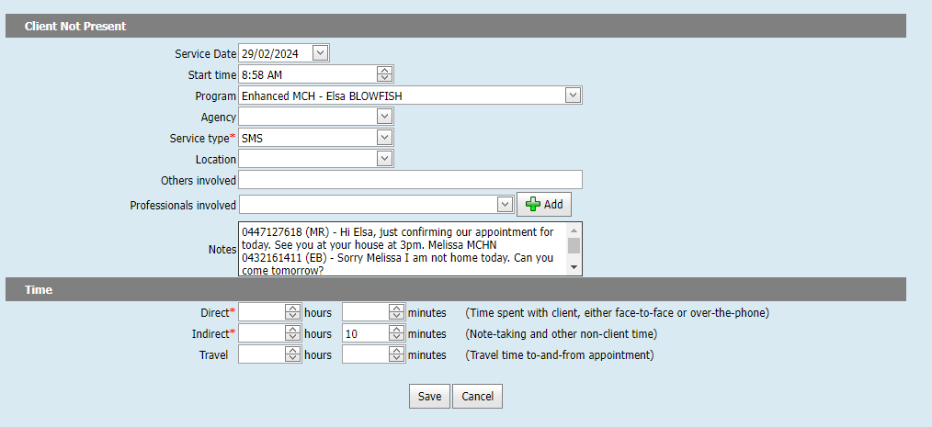

*Image 6 – Enter the* ***complete SMS correspondence****, within the* ***Notes*** *of the Client not Present Screen.*

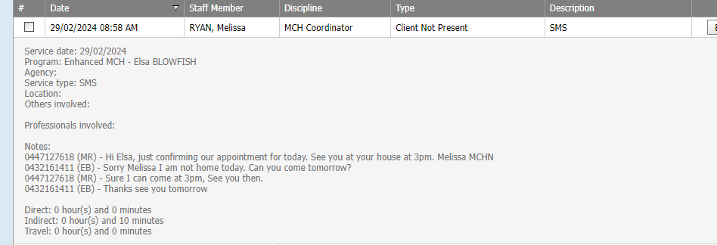

*Image 7 – Client history contains the* ***complete SMS correspondence****.*

|  |
| --- |
| To receive this publication in an accessible format phone 1300 650 172, using the National Relay Service 13 36 77 if required, or email mch@health.vic.gov.au  Authorised and published by the Victorian Government, 1 Treasury Place, Melbourne.  © State of Victoria, Australia, Department of Health July 2024.  Except where otherwise indicated, the images in this publication show models and illustrative settings only, and do not necessarily depict actual services, facilities or recipients of services. This publication may contain images of deceased Aboriginal and Torres Strait Islander peoples.  In this document, ‘Aboriginal’ refers to both Aboriginal and Torres Strait Islander people. ‘Indigenous’ or ‘Koori/Koorie’ is retained when part of the title of a report, program or quotation.  **ISBN** 978-1-76131-637-1 (pdf/online/MS word)  Available at health.vic – Child Development Information System <https://www2.health.vic.gov.au/primary-and-community-health/maternal-child-health/child-development-information-system> |