

|  |
| --- |
| Example consumer information |
| Appendix 1 – Criteria Led Discharge toolkit |
| OFFICIAL |

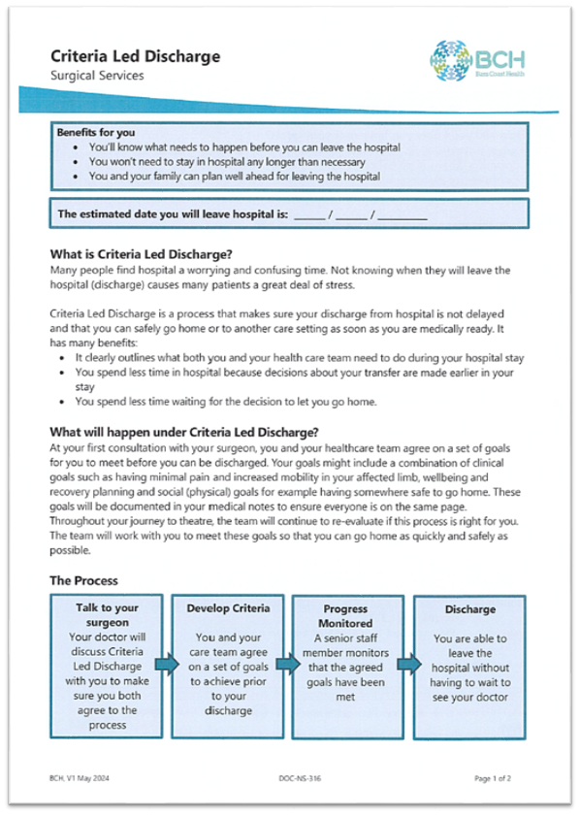

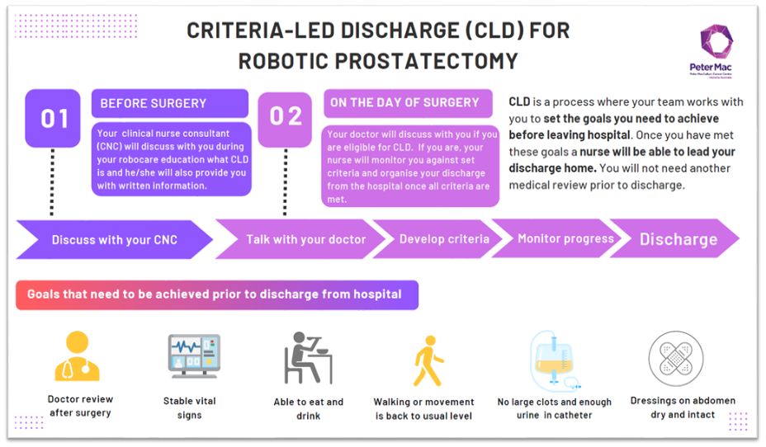

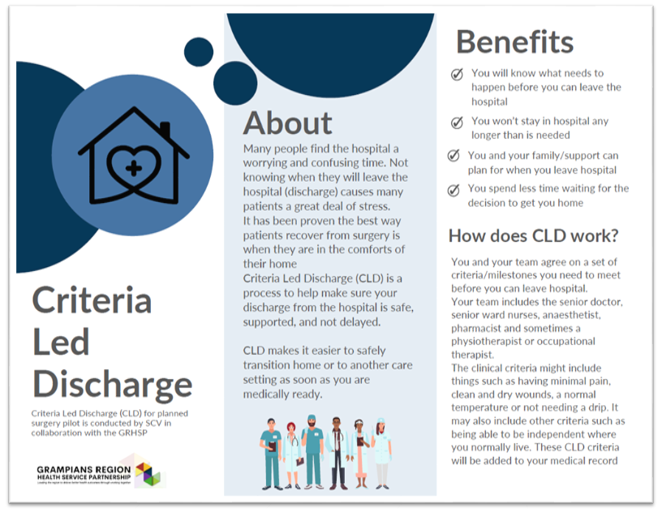

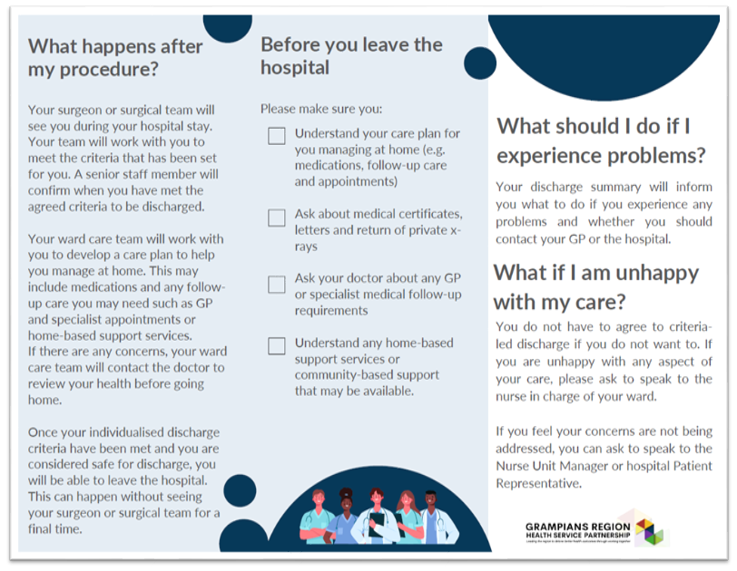

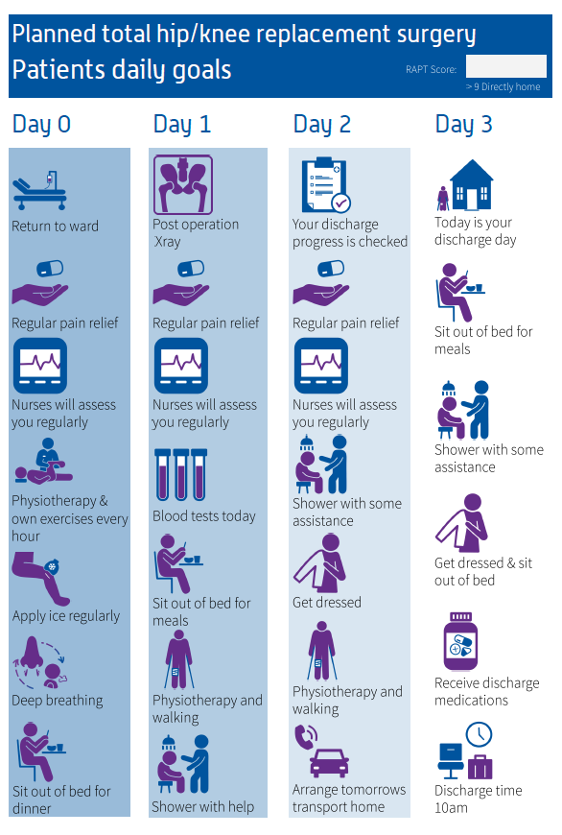

|  |
| --- |
| To receive this document in another format email [info@safercare.vic.gov.au](mailto:info@safercare.vic.gov.au)  Authorised and published by the Victorian Government, 1 Treasury Place, Melbourne.  © State of Victoria, Australia, Department of Health, October 2024  Available [Criteria Led Discharge Toolkit](http://www.health.vic.gov.au/criteria-led-discharge-toolkit) <www.health.vic.gov.au/criteria-led-discharge-toolkit> |