

|  |
| --- |
| Example documentation |
| Appendix 3 – Criteria Led Discharge toolkit |
|  |

# Example CLD form A

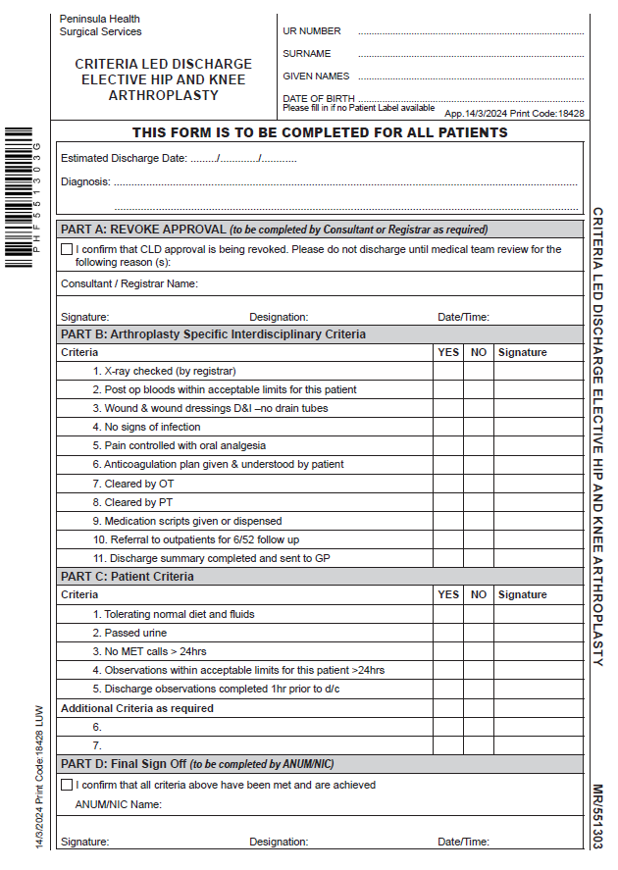

# Example CLD form BExample Criteria for discharge - Orthopaedic. Example criteria for discharge- Orthopaedic.

# Example CLD EMR workflow

Figure 1. Robotic Prostatectomy CLD order entry field in the Epic EMR

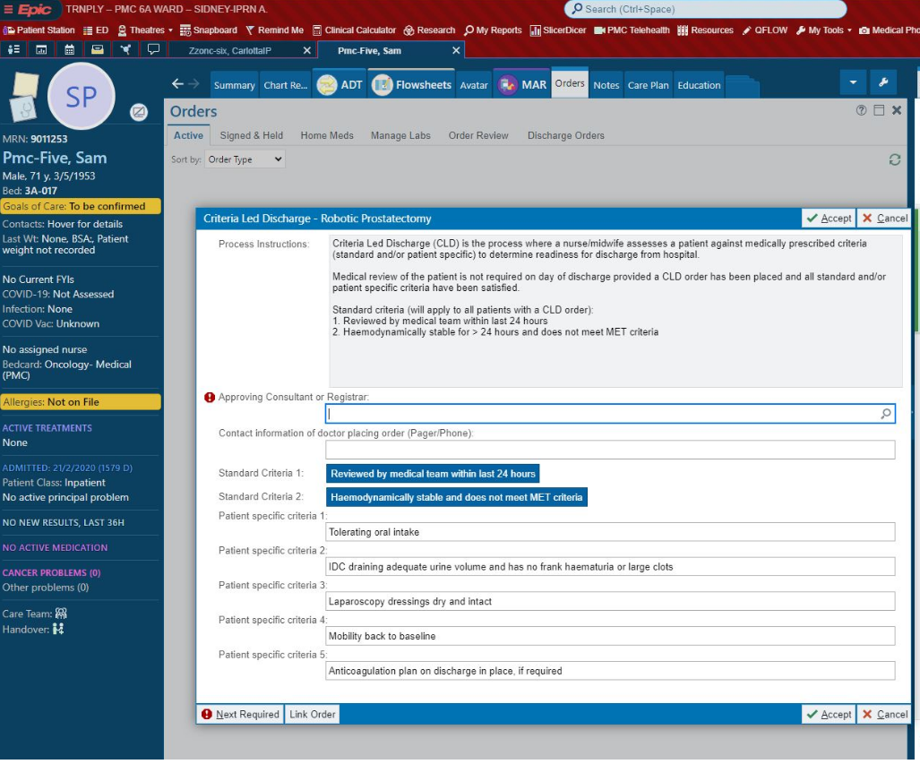  
Figure 2. Robotic Prostatectomy CLD order flagged (clipboard icon) on the Patient Journey board view to alert nurses

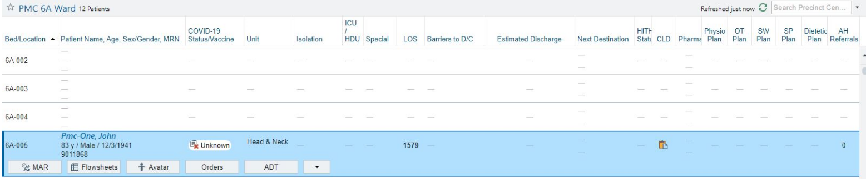

Figure 3: Nursing documentation against Robotic Prostatectomy CLD showing same criteria met

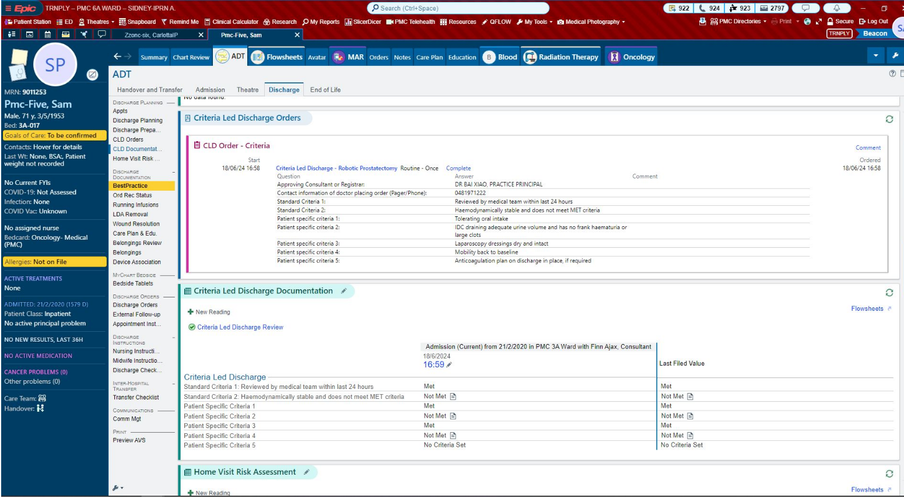

Figure 4. Nursing documentation against Robotic Prostatectomy CLD showing all criteria met

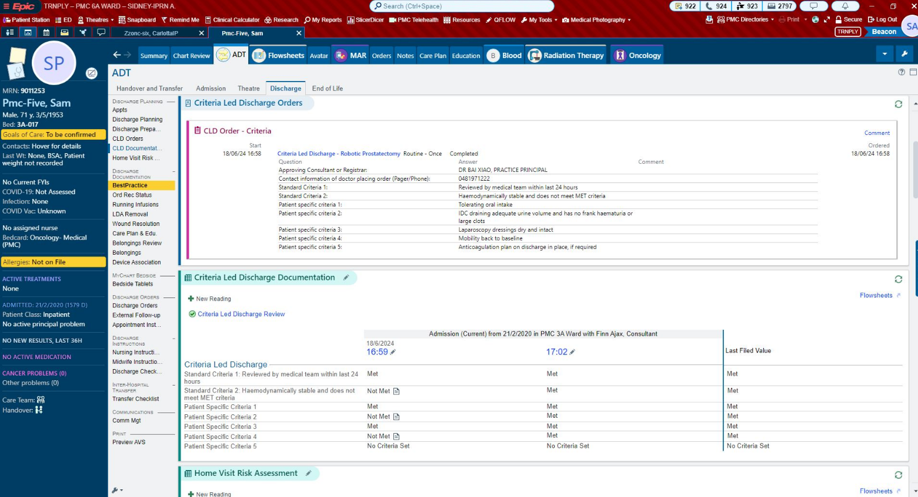

# Example criteria for discharge checklist

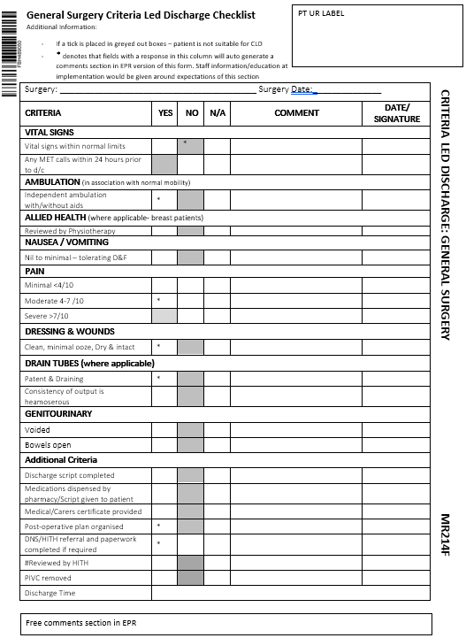

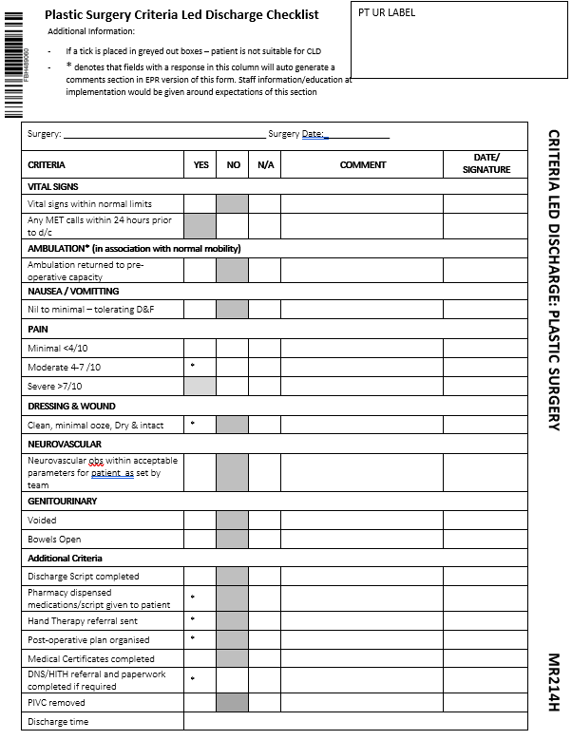

|  |
| --- |
| To receive this document in another format email [info@safercare.vic.gov.au](mailto:info@safercare.vic.gov.au)  Authorised and published by the Victorian Government, 1 Treasury Place, Melbourne.  © State of Victoria, Australia, Department of Health, October 2024  Available [Criteria Led Discharge Toolkit](http://www.health.vic.gov.au/criteria-led-discharge-toolkit) <www.health.vic.gov.au/criteria-led-discharge-toolkit> |