

|  |
| --- |
| Example Patient transition to home plan template |
| Appendix 4 – Criteria Led Discharge toolkit |
| OFFICIAL |

This resource was developed by UHN Open lab as part of Patient Oriented Discharge Summary (PODS), Fore more information on developing patient centred discharge summaries, see [Patient Oriented Discharge Summary](https://pods-toolkit.uhnopenlab.ca/) website <https://pods-toolkit.uhnopenlab.ca/>

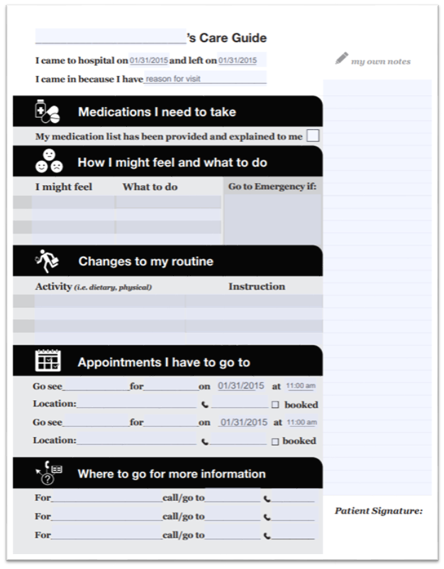

|  |
| --- |
| To receive this document in another format email [info@safercare.vic.gov.au](mailto:info@safercare.vic.gov.au)  Authorised and published by the Victorian Government, 1 Treasury Place, Melbourne.  © State of Victoria, Australia, Department of Health, October 2024  Available [Criteria Led Discharge Toolkit](http://www.health.vic.gov.au/criteria-led-discharge-toolkit) <www.health.vic.gov.au/criteria-led-discharge-toolkit> |