

|  |
| --- |
| Example Tips and Tricks for Building a Case for Change |
| Appendix 8 – Criteria Led Discharge toolkit |
|  |

The following document provides some guidance as to how to build a case for change. This document should act as a supplementary resource when completing your organisation's business case template.

# Key components

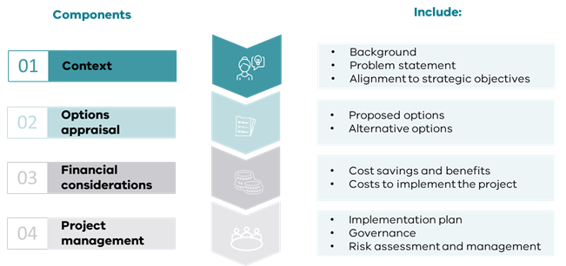

1. **Context**

* The background is concise and should describe project objectives.
* Summarise the problems that the CLD project is aiming to address and current gaps in service.
* Describe how CLD aligns with the current vision, aim, or strategic priorities of the organisation, including other projects being undertaken.

**2**. **Options appraisal table**

|  |  |  |  |
| --- | --- | --- | --- |
|  | **Option 1 (do nothing)** | **Option 2** | **Option 3** |
| **Benefits** Benefits of each option |  |  |  |
| **Disadvantages** Negative consequences of each option |  |  |  |
| **Timescale** Over what period will the costs be incurred and over what period will the benefits occur |  |  |  |
| **Costs** Summarise costs and supporting assumptions associated with each option, including ongoing costs |  |  |  |
| **Major Risks** Provide a summary of the risks, highlighting the major risks that will affect the business objectives and benefits |  |  |  |
| **Stakeholder impact**  Who will be impacted, and how? |  |  |  |

**3. Financial considerations** *This section provides an outline of calculations for savings and benefits for the organisation, and should include:*

**Cost savings and benefits**

* Talk to your finance department for accurate cost estimates and anticipated (or actual) savings for the CLD project
* Include outcome measures such as reduction in length of stay, potential number of patients affected by the CLD project and reduction in readmissions. Consider other value-based benefits the CLD project may have; e.g. patient empowerment to discharge home and stay home, more patients seen as a result of implementation).
* Otherwise, an easy (but crude) way to calculate the cost savings for the project is:



**Costs to implement the project**

Provide a breakdown of investment costs for the CLD project, including staff, training, equipment, running costs and other costs to consider in implementing the project :

**4. Project management** *In this section outline how the CLD project will be managed and implemented. This should include;*

**Implementation plan**

Describe how the CLD project will be delivered, including scope, high-level project phases, deliverables, milestones, target completion dates and organisational areas affected.

**Governance**

Who will be involved in overseeing the CLD project? Can they make/ authorise decisions? Who will the steering committee/working group report to? And how often?

**Risk assessment and management**

Detail the major risks for your proposed option and mitigation plans. Utilising a risk assessment matrix (obtain from your organisation) will help to highlight the likelihood and seriousness of each risk.

**Evaluation**

* How will you monitor the progress of the CLD project (how do you know this project has been beneficial?).
* Consider including outcome, process and balancing measures you will use to evaluate the CLD project, qualitative or quantitative data needed for review and frequency of review.

**Resources**

1. Australian Commission on Safety and Quality in Health. [OSSIE toolkit for implementation of the Australian Infection Control Guidelines](https://www.safetyandquality.gov.au/our-work/communicating-safety/clinical-handover/implementation-toolkit-clinical-handover-improvement) (AICG) 2010.<https://www.safetyandquality.gov.au/our-work/communicating-safety/clinical-handover/implementation-toolkit-clinical-handover-improvement>:

[2](https://www.safetyandquality.gov.au/sites/default/files/migrated/BusinessCaseTemplate.pdf%202). Institute for Healthcare Improvement. Optimising a Business Case for Safe Health Care: [An Integrated Approach to Finance and Safety. Business Case template](https://www.ihi.org/resources/tools/optimizing-business-case-safe-health-care-integrated-approach-safety-and-finance). < https://www.ihi.org/resources/tools/optimizing-business-case-safe-health-care-integrated-approach-safety-and-finance>

|  |
| --- |
| To receive this document in another format email [info@safercare.vic.gov.au](mailto:info@safercare.vic.gov.au)  Authorised and published by the Victorian Government, 1 Treasury Place, Melbourne.  © State of Victoria, Australia, Department of Health, October 2024  Available [Criteria Led Discharge Toolkit](http://www.health.vic.gov.au/criteria-led-discharge-toolkit) <www.health.vic.gov.au/criteria-led-discharge-toolkit> |