|  |
| --- |
| Maternal and Child Health Service Guideline Update |
| **Title: CDIS Training Environment - Guidance and Usage** |
|  |
| OFFICIAL   |  |  | | --- | --- | | **Description** | To communicate the guidance for the use and support of the CDIS Training Environment. Users include staff employed or contracted to deliver Maternal and Child Health services in Victoria, as well as Educators at various Education Institutes. | | **This practice note applies to:** | All MCH Service Providers  All Aboriginal MCH Service Providers  Educators and students at Federation University Australia, RMIT University and La Trobe University, teaching / studying an accredited postgraduate masters / diploma (or equivalent) in Maternal and Child Health Nursing. | | **Status** | Mandatory | | **Authorisation** | Department of Health | | **Implementation date** | 16/10/2024 | |



## Contents

Aim 2

Implementation 2

Relevant legislation and protocols 2

Responsibilities 2

Support, Performance and Terms of use for the CDIS Training Environment 3

Process for Access to the Training Environment 5

1. Commencement – Request for access and use 5

2. Creation & Maintenance – Setup of CDIS accounts and maintenance of same 5

3. Completion – Deactivation of accounts following training completion 7

## Aim

The purpose of this practice note is to define the guidance and processes that are recommended to be used by all Maternal and Child (MCH) service providers and Educational Institutes when using the Child Development Information System (CDIS) Training Environment.

## Implementation

CDIS is the approved client information management system for the MCH Service. The Training Environment was built, using a copy of the Production environment from 7th October 2021. All client history and personal information was removed, and all client and clinician names were deidentified. The environment has been maintained with all software and configuration updates.

## Relevant legislation and protocols

The process outlined in this guideline is consistent with obligations and agreements set out in:

Protocols:

* Child Development Information System (CDIS) Back-To-Back Agreements

## Responsibilities

**Maintaining the CDIS Training Environment**

The Department of Health (The Department) is responsible for maintaining the CDIS Training Environment.

**Administrative support**

The Department and MAV may provide administrative support to MCH Services who may not have resources to manage this internally. This is agreed on an ad hoc basis, following the processes outlined further in this guidance.

**Management of Accounts, Roles and Collaborative Service Delivery**

The Department is responsible, as agreed, for managing the CDIS accounts for the Educational Institutes.

All Local Government Area (LGA) authorised Maternal and Child Heath (MCH) service providers, Aboriginal MCH service providers and Educational Institutes are responsible for:

1. Nominating a Training Leader, who will be responsible for creating the Training accounts in the CDIS Training Environment for all other staff at the Organisation.
2. Ensuring no personal or client information is entered into the CDIS Training Environment.
3. Ensure CDIS accounts only ever contain email addresses licensed by the MCH Service Provider or Education Institute. If they are ever to be created, updated, or changed, this must only be with an organisation email address provided by the MCH service or Education Institute. These must be unique and cannot be shared.
4. The use of a personal email address in the Training environment is not compliant with this directive. This includes Agency staff.
5. Ensuring when accounts are created, they follow the documented naming convention (in the next section) that identifies the accounts for the appropriate CDIS role.
6. There are three permitted roles for use in the CDIS training environment, depending on governance by the service provider. See table 1.
   * Clinician: Access to client records, and service delivery for clients, and other key features, in accordance with training for the Clinical role.
   * Office Admin: Access to add birth notices, schedule client appointments and key admin functions in accordance with training for the Office Admin role.
   * Clinical Coordinator: This role is for the Training Leader of each service provider, and enables account creation, administration and deactivation in accordance with these guidelines. This role has been amended to restrict access to certain system administrative functions, to protect the environment from unintended changes that may inadvertently introduce system issues. This role is not used by Education Institutions, as The Department manages these accounts.

|  |  |  |  |
| --- | --- | --- | --- |
|  | **Permitted users** | | |
| **Roles (role abbreviation)** | MCH Service Providers | Aboriginal MCH Service Providers | Education Institutions |
| Clinician (CL) | ü | ü | ü |
| Office Admin (OA) | Yes - if managed internally | Yes - if managed internally | No |
| Clinical Coordinator (CC) | Yes - if managed internally | Yes - if managed internally | No |

*Table 1 – Permitted roles for Organisations, Service Providers and Education Institutes*

1. Service providers must not ‘transfer in’ clients from Educational Institutes. However, if the Training Leader consents to their contact information being shared with other Service Providers, they can engage in a collaborative training practice that mirrors real world service delivery. Service Providers may then liaise to coordinate ‘transfer in’ of clients for training purposes. ***Without this agreement, the ‘transfer in’ of any clients should not be performed***, as this may disrupt training for other services using the environment. Service providers will never transfer in clients from Education Institutes.
   1. Federation University Australia, RMIT University and La Trobe University may engage between themselves, if wishing to engage in collaborative service delivery training. This will be arranged between them, and not be managed by The Department.

## Support, Performance and Terms of Use for the CDIS Training Environment

1. The Training Environment operates in a cloud storage area with limited resources. This means the environment is less responsive than the production environment, and screens may take longer to load.
2. The Training environment has scheduled software updates at the same time as the Production (Live) environment. This means that both the Live and Training Environments will be unavailable for this period. Communication about these releases is sent from The Department to:
   1. MAV, who then send this to LGA and MCH Services
   2. The Aboriginal MCH Network, and
   3. Education Institutes
3. The Training environment has configuration changes applied at the same time as the Production environment. Communication about these changes may be sent from The Department to:
   1. MAV, who then send this to LGA and MCH Services
   2. The Aboriginal MCH Network, and
   3. Education Institutes
4. There may be times when the Training Environment is required to be re-purposed temporarily for User acceptance Testing. If this occurs, The Department will discuss this with the Training Leader from each Service Provider and Education Institute. A process will be shared, that clearly communicates what is in testing and therefore different to the live environment.
5. The Training environment is not monitored on a day-to-day basis. This means unscheduled outages may occur.
6. SMS is not enabled. If testing of client correspondence is required, this will need to be specified, and training users will need to enter their work email addresses as the contact email for clients. This is not a supported environment and as such the Service provider should accept the risks of this not functioning as expected.
7. Reporting is not something that is supported on the Training Environment. If choosing to run reports on the Training environment, limited system memory may mean that smaller date ranges should be used to avoid errors.
8. Any formal training required by MCH Service Providers will be designed, scheduled and resourced by the Training Leader. If support from MAV or The Department is required, this can be requested and will be assessed on available resources.
9. Password requirements and password re-tries are more relaxed on the Training environment. And detailed later in this guidance. Training Leaders are responsible for unlocking and resetting passwords.
10. Naming conventions are detailed later in this document and should be adhered to. The Training Leader will be the only named user on the training environment.
11. The creation of training materials for training purposes is the responsibility of the Training Leader. They may create their own, or use existing CDIS documentation available at [Child Development Information System | health.vic.gov.au](https://www.health.vic.gov.au/maternal-child-health/child-development-information-system) <<https://www.health.vic.gov.au/maternal-child-health/child-development-information-system>> or [Maternal and Child Health Resources | MAV website](https://www.mav.asn.au/what-we-do/policy-advocacy/social-community/children-youth-family/maternal-and-child-health-children-0-6-years/maternal-and-child-health-resources) <https://www.mav.asn.au/what-we-do/policy-advocacy/social-community/children-youth-family/maternal-and-child-health-children-0-6-years/maternal-and-child-health-resources> web sites (also available via the CDIS Home Page, ‘Help & Support’ Menu, in the production and training environments).
12. CDIS Support is not responsible for answering support questions for the training environment. If there are any issues experienced during training, the Training Leader is responsible for documenting what actually occurred, what was supposed to occur, and detail the steps to be followed to re-create the problem and include relevant screen shots. This should be sent by the Training Leader to [cdis@support.vic.gov.au](mailto:cdis@support.vic.gov.au) and these will be triaged and sent to the CDIS Clinical queue. These will be reviewed and answered as time permits.
13. Requests for access to the CDIS Training Environment, means acceptance of the guidelines in this document. Requests can be sent to CDIS Support, via [cdis@support.vic.gov.au](mailto:cdis@support.vic.gov.au) and these will be triaged and sent to the relevant team in The Department and answered within four weeks. Please note the CDIS support team does not provide support for the CDIS Training Environment.

## Process for Access to the Training Environment

Training Leaders can request access to the CDIS Training Environment. The Department requires a minimum of four-weeks’ notice, for requests to use the Training Environment.

NB: Federation University Australia, RMIT University and La Trobe University have an established liaison, and pre-defined process for requesting additional CDIS accounts. All University accounts have the role of Clinician.

### Commencement – Request for access and use

Clinical Coordinators should clearly identify in their request:

1. The name, phone and email contact of the Training Leader. This will be used by the Department to create their account, a named user account (their name and contact will be visible).
2. The Training Leader is responsible for creating training accounts, in line with the appropriate guidance and naming conventions in this document. The permitted roles are in Table 1. By making the account Names and User names generic, the accounts can be reassigned to others easily, by changing the email addresses as needed.
3. The Training Leader consents to collaborate service delivery. This means that the service provider gives permission for The Department to share the Training Leader’s name and contact with others using the training environment, to support any training of collaborative service delivery across the state, mirroring the MCH state service delivery model. This consent and authority does not mean immediate use and training of ‘transferring in’ of clients from another provider. Following consent and prior to any ‘transferring in’ of clients from another service, Training Leaders are responsible to contact other provider(s) with whom they wish to collaborate with, to gain agreement / acceptance.

**NB:** At no time will any service provider ‘transfer in’ clients from Federation University Australia, RMIT University or La Trobe University.

1. The Training Leader will be responsible to unlock any accounts or reset any passwords. Password retries are set to 10 and require changing every 90-days.
2. If client correspondence via email is to be enabled, this must also be specified, and risks accepted.

### Creation & Maintenance – Setup of CDIS accounts and maintenance of same

The Training Leader will have an account created for them, usually with role Clinical Coordinator, and their full name will be used for this account only. Training Leaders are then responsible for creating training accounts, unless another arrangement has been agreed. This includes adhering to the naming conventions below, and creation of the appropriate CDIS roles based on the level of availability of the service provider to manage their training and delivery.

NB: The accounts used by the Education Institutes have the role of Clinician and have their own naming conventions, due to historical practices.

1. To reduce administrative burden, CDIS Users created by Training Leaders will follow these naming conventions (See Table 1 for roles, and see image 1 on the following page):
2. First name = *Role + number* e.g. Clinician1
3. Last name = ‘*TRAINING’* e.g. TRAINING (the system defaults surname to capitals)

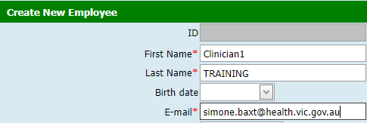

*Image 1 – First name, last name and email*

1. The relevant staff member’s organisation email address will be added to the training account created. These MUST be business accounts, provided by the Service Provider (the same ones used in the CDIS production environment), and never personal email addresses. See image 1.
2. Select Current Site (or update this after completing creation of the account), update Gender. Service Providers will use existing sites/centres/calendars. If there is a specific request this will be managed on an ad-hoc basis dependent on requirements and resources available at the Department. See image 2.

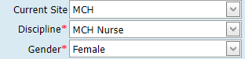

*Image 2 – Select Current Site, Discipline name, and Gender*

1. Choose the appropriate Discipline, select Current Site (or update this after completing creation of the account), update Gender. See image 2.
2. Depending on the role being created (see Table 1):
   1. Tick the Clinician checkbox if creating a clinical user,
   2. Tick Application User for both clinical users and office admin users.
3. If you have scheduled training, that has an end date, you can edit the ‘End Date’ if desired. See image 3.

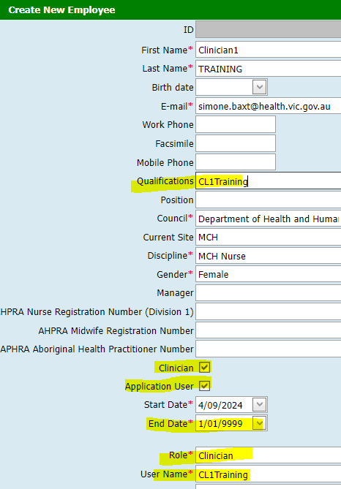

*Image 3 – Tick checkboxes and set end date if desired*

1. The ‘User Name’ will follow the naming conventions of ***Role abbreviation + incremental number + ‘Training’*.** (See Table 1 for role abbreviations, and see Image 4 for an example)
   1. Clinician: *CLxTraining* e.g. CL1Training, CL2Training
   2. Office Admin: *OAxTraining* e.g. OA1Training, OA2Training
   3. Clinical Coordinator: *CCxTraining* e.g. CC1Training, CC2Training

* *x* will commence at 1 and increment in number as accounts are created.
* *Training* is appended to distinguish accounts from other environments, avoiding confusion for staff when working in multiple CDIS environments such as Live (i.e. production) and for those SME’s that may also access the User Acceptance Testing (UAT) environment.

NB: Once the ‘User Name’ has been created, copy this to the ‘Qualifications’ field, so that the username can be re-used when the account is made inactive.

1. **The only roles** that should be selected, are either Clinician, or Office Admin. See image 4.

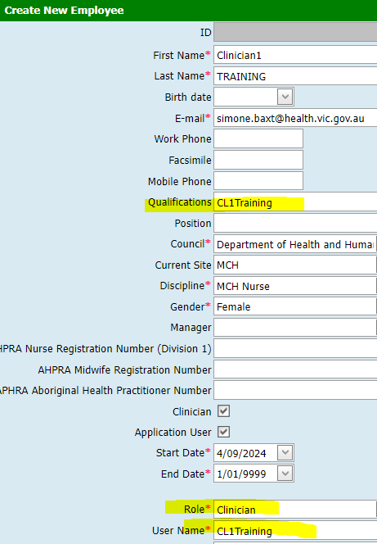

*Image 4 – Example of Role, User Name, and use of Qualifications Field to record User Name*

### Completion – Deactivation of accounts following training completion

1. Training Leaders are responsible for deactivating their own training accounts, at the end of the scheduled training, unless another arrangement is agreed.
2. By making the account Names and User names generic, the accounts can be reassigned to others easily, by changing the email addresses as needed.
3. Federation University Australia, RMIT University and La Trobe University have an established liaison, and pre-defined process for requesting deactivation of CDIS accounts.

*If you require assistance with CDIS regarding any of these items, please email* [*CDIS Helpdesk*](mailto:cdis@support.vic.gov.au) *or call 1300 856 183.*

|  |
| --- |
| To receive this document in another format, phone 1300 650 172, using the National Relay Service 13 36 77 if required, or [email](mailto:email) Maternal and Child Health and Early Parenting Unit <mch@health.vic.gov.au>.  Authorised and published by the Victorian Government, 1 Treasury Place, Melbourne.  © State of Victoria, Australia, Department of Health, April 2024.  Except where otherwise indicated, the images in this document show models and illustrative settings only, and do not necessarily depict actual services, facilities or recipients of services. This document may contain images of deceased Aboriginal and Torres Strait Islander peoples. In this document, ‘Aboriginal’ refers to both Aboriginal and Torres Strait Islander people. ‘Indigenous’ or ‘Koori/Koorie’ is retained when part of the title of a report, program or quotation.  **ISBN 978-1-76131-691-3 (pdf/online/MS word)**  Available at [Child Development Information System | health.vic.gov.au](https://www.health.vic.gov.au/maternal-child-health/child-development-information-system) <<https://www.health.vic.gov.au/maternal-child-health/child-development-information-system>> |

