

|  |
| --- |
| White paper: On the principles of mental health risk assessment |
| Office of the Chief Psychiatrist |
| OFFICIAL |

|  |
| --- |
|  |
| To receive this document in another format, phone 1300 767 299, using the National Relay Service 13 36 77 if required, or [email the Office of the Chief Psychiatrist](mailto:ocp@health.vic.gov.au) <ocp@health.vic.gov.au>.  Authorised and published by the Victorian Government, 1 Treasury Place, Melbourne.  © State of Victoria, Australia, Department of Health, October 2024.  In this document, ‘Aboriginal’ refers to both Aboriginal and Torres Strait Islander people.  ISBN 978-1-76131-701-9 **(pdf/online/MS word)**  Available at [Chief Psychiatrist’s website](https://www.health.vic.gov.au/chief-psychiatrist/chief-psychiatrist-guidelines) <https://www.health.vic.gov.au/chief-psychiatrist/chief-psychiatrist-guidelines> |

Contents

Introduction 4

Mental Health and Wellbeing Act 4

Limitations of risk assessment tools 6

Key principles 7

Practical implications 9

Summary 10

Appendix 1: Risk formulation grid 11

Appendix 2: The Borderline Personality Disorder–Spectrum - Risk Assessment Model 12

Appendix 3: Risk assessment template 13

References and other resources 14

# Introduction

Risk assessment is a foundation skill for all mental health clinical practice. It involves identifying risk factors and synthesising, integrating and formulating risk to adequately understand the person at risk. The purpose of risk assessment and formulation is to address risks and enable people to have fuller, more meaningful lives.

Risks may be of self-harm, suicide, misadventure or risks to other people or the community. Risk factors operate at the population, community and individual levels. They may be relative to population norms (absolute) or the person’s baseline state (relative). Individual risk reflects both the human and the context. It reveals the chronic/static and more immediate/dynamic risks at a point in time and within a timeframe. Risk mitigation occurs in the context of service resources and a broader legislative frame. All decisions about clinical care need to balance:

* different perspectives
* competing human rights needs
* compassion for the person affected and their authentic life values.

There is a range of risk assessment tools.[1] Practitioners commonly assume that these tools can predict risk in terms of severity. But such quantification is imprecise, inconsistently applied and at times misleading (Carroll and McSherry 2018). All risk assessment tools have limitations. This is well articulated in the NICE Guidelines (2022). Therefore current thinking has moved towards risk formulation and risk mitigation of identified risks with an emphasis on the person and what we can do to address their individual needs.

Legislation relevant to assessing and managing risk in mental health and wellbeing settings includes the:

* *Wrongs Act 1958*
* *Occupational Health and Safety Act 2004*
* *Mental Health and Wellbeing Act 2022*.

There is a need to standardise how risk is assessed across and within healthcare settings. In this paper the Office of the Chief Psychiatrist aims to offer guidance to service providers in the context of the tensions that arise as a result.

This paper describes an evidence-based approach to risk to inform thinking in the mental health sector. It describes the key shared principles of risk formulation and mitigation for the sector and explains clinical approaches for non–mental health people who want to understand how decisions about risk are reached.

## Mental Health and Wellbeing Act

The *Mental Health and Wellbeing Act 2022* is the principal Victorian legislation for regulating the treatment and care of people with mental illness or psychological distress. It enshrines key principles to consider and document in making clinical decisions about treatment and care (Department of Health 2024).

The Act supports intervening in cases where a person is at serious risk of harm. It emphasises the following decision-making concepts for treatment and interventions:

* **Dignity of risk:** People receiving mental health care have the right to take reasonable risks to improve their quality of life while balancing the clinician’s duty of care to support safety.
* **Care and transition to less restrictive support:** Aim to transition to less restrictive support when possible.
* **Consequences of interventions:** Consider the traumatic impact and potential drawbacks of compulsory treatment and the risk of restrictive practices. There is no inherent therapeutic benefit to restrictive practices.
* **Balancing of harm:** Weigh the potential harms of restrictive measures against their benefits.
* **Autonomy:** Respect individuals’ rights to make informed decisions, even if those decisions involve some level of risk.
* **Capacity:** The practitioner seeking informed consent must presume the person has the capacity to give it. A person’s decision-making capacity can be temporarily impacted by mental health and physical health factors. Capacity is a key risk factor because it informs the ability to make personal (albeit risky) choices. This needs to be weighed against the principles of the rights to autonomy and dignity of risk.

# Limitations of risk assessment tools

There is little evidence to support relying solely on risk assessment tools that over-simplify risk and do not encourage formulation and individualised planning. One-size-fits-all assessment tools may lack specificity and sensitivity. Such tools may help identify risk and protective factors and therefore contribute to safety planning by guiding risk mitigation as long as they contribute to a risk formulation.

Best practice requires a complex integration of individualised risk and protective factors for each consumer or risk formulation.

The Office of the Chief Psychiatrist supports the National Institute for Health and Care Excellence (NICE) Committee’s conclusions that:

* Risk assessment tools and scales cannot reliably and accurately predict self-harm and suicide.
* Relying on such tools alone to determine access to treatment or hospital care is not warranted.
* Global stratification of risk into low, medium or high should not be used to predict future risk of suicide or repetition of self-harm.
* Global stratification of risk into low, medium or high should not be used to determine who should be offered treatment or who should be discharged.
* Best practice requires integrating individualised risk and protective factors for each consumer: risk formulation (Hawton et al 2022). This is best carried out in a therapeutic setting alongside the person and their social network (often family) to gain a meaningful and authentic understanding of their situation.

A sample risk formulation grid is provided in Appendix 1.

The Office of the Chief Psychiatrist supports incorporating the Mental Health and Wellbeing Act’s treatment and intervention decision-making principles as well as the broader consideration of risk principles below integrated into a risk formulation. We acknowledge that there may be tensions between the principles, the limited predictive capacity of risk assessment tools and the need to support safety and care. Formulation-informed decision making provides the structure for a reasoned approach to risk management in mental health settings.

# Key principles

The following key principles of self-harm and suicide risk assessment may help in formulating risk.

1. **Risk is dynamic**

* Risk is fluid and can change rapidly based on various factors. These include mental state, physical state, environmental changes and personal crises.
* Risk needs to be re-evaluated whenever circumstances change.
* Risk cannot be eliminated but may be mitigated.
* Risk mitigation strategies need to be appropriate to the setting, phase and focus of care.
* Risk needs to be considered for periods of time, considering when the person can next be reviewed.

1. **Risk is impacted by connection and relationship**

* Risk may be exacerbated or reduced through relationships with important others and with clinicians.
* Suicidal actions may be impulsive or may involve long-term planning that may be hidden from key relationships. Actual or perceived loneliness may contribute to hidden planning.
* Reducing the person’s sense of hopelessness and aloneness through therapeutic engagement and connection may have a significant influence to enable collaborative safety planning.
* Bringing in family or friends to the relationship and to awareness about risk can change the trajectory of individual decision making. At times the acuity of the risk may merit breaching privacy or consent to support safety. The extent to which this is done needs to be limited and balanced against the principles of dignity of risk and autonomy.

1. **Risk is impacted by population and context**

* Data on suicide rates and cultural, sociodemographic and population risk may help inform care decisions, but individual risk may vary significantly from general trends.
* Individual contextual factors that consider the person’s history, social environment, beliefs and current life circumstances can influence their risk level.
* Recent life stressors may have a significant impact on risk for a relatively short period. If support is provided during this period, risk significantly reduces thereafter.

1. **Overall risk is a balance between short-term and long-term risks**

* It is important to recognise that short-term risk-reduction measures might compromise long-term recovery goals.
* Strategic planning for long-term safety therefore needs a balanced approach that considers both immediate safety and future recovery needs, adjusting as needed.
* Risk formulation should include both a cross-sectional and a longitudinal component. Historical factors and patterns need to be considered.

1. **Consider undertaking a risk-benefit analysis**

* There needs to be a balance between perceived risks against the likelihood of outcomes alongside the person’s values, needs and context.

1. **Therapeutic risk taking is important to elevating agency and long-term recovery**

* Risk taking is therapeutic when it integrates trust, authentic needs, desires and beliefs and when it empowers the consumer to decide to stay safe.
* Supporting people to make decisions about their safety that may involve some level of short-term risk can be crucial for long-term recovery.
* Reasonable clinical decisions around therapeutic risk taking must always consider the consumer’s level of mental capacity for decision making and their engagement in collaborative safety planning.
* A commitment to therapeutic risk taking does not ensure a positive outcome but does uphold agency. Agency, relationships and trust enhance the potential for longer term safety.
* Families, carers and supporters may struggle to see the potential of therapeutic risk due to concern for the immediate safety of a loved one. Clinicians should strive to involve them in the risk assessment process, hear their concerns, work towards a shared understanding of the risk formulation and, ideally, engage them in a joint approach to therapeutic risk taking to support their loved one’s growth and ultimate recovery.

1. **Identifying strengths, supports and beliefs is protective**

* Having a shared understanding of the consumer’s strengths, supports and beliefs that are protective strengthens the power of these factors.
* Using these by bringing them into proactive co-created safety plans can change the relative risk while engaging with recovery-focused care in a genuine way (including the need to acknowledge and work with risk).

1. **Operational or situational constraints may also impact risk**

* Recognising and documenting operational constraints may be relevant to clinical decisions about risk mitigation.
* Situational constraints may include recent life events, accommodation and supports and the limitations of community support.
* Ideally people do not return to the exact same circumstances that led to risk. This can be mitigated through safety planning and engaging with extra supports such as a friend or family member.

1. **Decision-making about risk should be readily escalated in clinical settings**

* Clinicians should escalate clinical risk when the best balance of these principles is uncertain to ensure a multidisciplinary lens is applied to decide the best management approach.
* Local clinical governance pathways support sharing key decisions that represent a significant risk to the consumer.
* Senior mental health clinicians should be involved in any decision making that prioritises consumer risk choices over clinicians’ choices.
* Consumers and their family/carers should be included as much as possible and be informed of all elements of decisions.

# Practical implications

The following 4 components are part of good risk evaluation and management.

1. **Individual engagement and assessment**

* **Prioritise engagement:** Actively and collaboratively involve the person and their support network in discussions about what is important to them.
* **Instil hope.**
* **Respect autonomy:** Subject to the constraints imposed by impaired capacity, respect the person’s right to make informed choices about their care even when it involves some level of risk.
* **Ensure informed consent:** Ensure consumers fully understand the potential outcomes of their choices. Provide all necessary information for consumers to make informed decisions. If capacity to give consent is lacking, that should be documented.
* **Consider a breadth of risks:** This may be via clinical interview with or without using a risk assessment tool.
* **Risk formulation:** Develop a comprehensive risk formulation that integrates an understanding of the person, their strengths (and possible vulnerabilities), risks, preferences and concerns.

1. **An individualised safety plan**

* Create a safety plan that draws on the risk formulation. Address immediate safety needs as well as long-term psychological and physical wellbeing.Ideally this plan should be co-created with the consumer from the base of a therapeutic relationship.
* Note the practice of contracting for safety has no evidence base and is insufficient to ensure future safety.

Consider:

* **Setting and access to means:** Different levels of risk mitigation may be needed depending on the person’s illness or acuity, specific social context and stage of recovery. Risk may be low in the context of others but high if the person is alone. Points of transition may pose increased risk. Access to lethal means or weapons or environment may be relevant.
* **Therapeutic risk taking and growth:** Facilitate recovery by supporting consumers in making decisions that may involve calculated risks. Do this with the understanding that while these risks may not *immediately* enhance safety, they may be important for long-term recovery.
* **Cultural and contextual sensitivity:** Adapt risk assessment practices to reflect Victoria’s cultural, social and legal context. Consider specific needs or barriers in different communities. All mental health care needs to be culturally informed and responsive to people of all racial, ethnic, faith and cultural backgrounds, especially to Aboriginal people.
* **Support systems:** Identify and engage the person’s support networks, such as family and community resources, to enhance safety planning.

1. **Ongoing review and flexibility**

* **Regular monitoring:** Continuously review and update the person’s risk assessment and safety plan based on new information and changes in their circumstances.
* Be prepared to adjust strategies as new insights emerge or as the person’s situation evolves.
* Respond to communication from the person’s support network (consider their access to pathways to escalate care).

1. **Documenting a clinical rationale or decision-making process**

* To demonstrate a reasoned decision-making process, clinicians must document the options considered including their relative merits, foreseeable consequences and rationale.
* Document any issues relevant to risk on which consumers and clinicians disagree.

**Note:** Mental health risk assessment for the purposes of the criminal justice system (such as predicting future harm for preventive detention schemes) may raise other ethical/human rights issues. These involve a specialist process incorporating many of these features but with added requirements for formal evidence and implications for the extent of collaboration.

# Summary

In following this guidance, practitioners aim to balance serious risks within the bounds of good clinical care. They do this in the context of collaboration and their relationship with the consumer, using the principles of the Mental Health and Wellbeing Act. They use risk formulation and mitigation to engage the person therapeutically in safety planning while meeting broader legal and community expectations.

# Appendix 1: Risk formulation grid

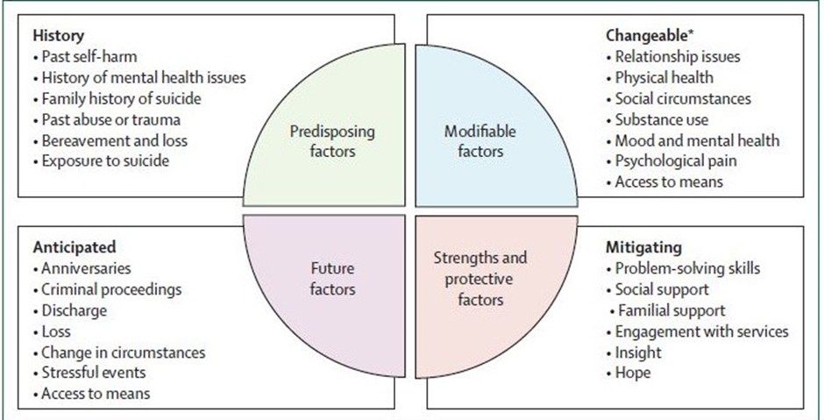

Source: Hawton et al 2022

# Appendix 2: The Borderline Personality Disorder–Spectrum - Risk Assessment Model

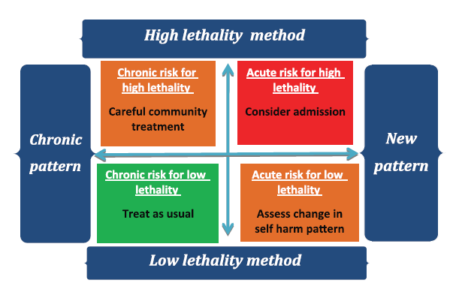

Source: Rao et al 2017

# Appendix 3: Risk assessment template

Clinical services can obtain a copy of the Austin Health Mental Health Risk Assessment tool by contacting the Office of the Chief Psychiatrist at [ocp@health.vic.gov.au](mailto:ocp@health.vic.gov.au). The Austin Health Mental Health Risk Assessment tool is broad risk assessment tool developed in 2023 for local use but incorporating existing Victorian tools, their evidence base, clinical consultation and guidance with a risk identification and risk formulation approach.

**This paper was developed by the Office of the Chief Psychiatrist in consultation with the Victorian Mental Health Authorised Psychiatrists and written by Associate Professor Sophie Adams, Associate Professor Andrew Carroll and Dr Dominika Baetens**

# References and other resources

Carroll A and McSherry B (2018) ‘Making defensible decisions in the era of recovery and rights’, *Australas Psychiatry*, 26(5):474–477.

Carter G and Spittal MJ (2018) ‘Suicide risk assessment: Risk stratification is not accurate enough to be clinically useful and alternative approaches are needed’, *Crisis: The Journal of Crisis Intervention and Suicide Prevention*, 39(4):229–234.

Department of Health (2024) *Mental health and wellbeing principles*, https://www.health.vic.gov.au/mental-health-and-wellbeing-act-handbook/context-of-the-act/mental-health-and-wellbeing-principles

Giddens JM, Sheehan KH and Sheehan DV (2014) ‘The Columbia-Suicide Severity Rating Scale (C-SSRS): Has the “Gold Standard” become a liability?*’ Innovations in Clinical Neuroscience*, 11(9–10):66–80.

Goel D, Dennis B and McKenzie SK (2023) ‘Is suicide a mental health, public health or societal problem?’, *Current Opinion Psychiatry*, 36(5):352–359.

Graney J, Hunt IM, Quinlivan L, Rodway C, Turnbull, P, Gianatsi M, Appleby L and Kapur N (2020) ‘Suicide risk assessment in UK mental health services: a national mixed-methods study’. *The Lancet Psychiatry* 7(12):1046–1053.

Hawton K, Lascelles K, Pitman A, Gilbert S and Silverman M (2022) ‘Assessment of suicide risk in mental health practice: shifting from prediction to therapeutic assessment, formulation and risk management’, *The Lancet*, 9(11):922–928.

Lucey JV and Matti B (2023) ‘Suicide risk assessment: time to think again?’, *Irish Journal of Psychological Medicine,* 40(3):323–325.

NICE Guideline (NG225) (2022) ‘Self harm: assessment, management and preventing recurrence’, https://www.nice.org.uk/guidance/ng225/chapter/Recommendations

Ogloff JRP and Daffern M (2006) ‘The dynamic appraisal of situational aggression: an instrument to assess risk for imminent aggression in psychiatric inpatients’, *Behavioral Sciences & the Law*, 24(6): 799–813.

Perkins R and Repper J (2016) ‘Recovery versus risk? From managing risk to the co-production of safety and opportunity’, *Mental Health and Social Inclusion*, 20(2):101–109.

Rao S, Broadbear JH, Thompson K, Correia A, Preston M, Katz P and Trett R (2017) ‘Evaluation of a novel risk assessment method for self-harm associated with borderline personality disorder’, *Australasian Psychiatry*, 25(5):1–6.

Woods P and Almvik R (2002) ‘The Brøset violence checklist (BVC)’, *Acta Psychiatrica Scandinavica*, 106:103–105.

1. Examples include the Brøset Violence Checklist, Dynamic Appraisal of Situational Aggression, Historical Clinical Risk Management – 20 and the Columbia-Suicide Severity Risk Rating Scale. For an analysis of the Brøset Violence Checklist, refer to Woods and Almvik (2002). For an example of a risk assessment tool used in a Victorian mental health service, refer to the Austin Health Mental Health Risk Assessment tool.