

|  |
| --- |
| Heatwave and heat health warnings |
| Information and guidance for stakeholders |
| OFFICIAL – November 2024 |

# Introduction

Early warning systems can help people and organisations prepare for forecast extreme heat and heatwaves, as identified in the *State Emergency Management Plan – Extreme Heat Sub-Plan[1]*.

The Bureau of Meteorology (Bureau) began issuing heatwave warnings from October 2022. The heatwave warnings are based on the Excess Heat Factor, a nationally agreed metric for measuring heatwaves, and notify of forecast or actual severe or extreme heatwaves.

The Department of Health (department) issues heat health warnings to subscribers such as hospitals, health and community service providers, local and Victorian state government and the department’s program areas. The heat health warnings provide an early notification of forecast or actual extreme heat or heatwave.

# Purpose

This document is designed to inform your heat planning and preparedness activities. The department recommends that you monitor local conditions and act in line with your heat, business continuity, and occupational health and safety plans.

# Bureau of Meteorology

The Bureau developed a nationally consistent approach to defining and warning of forecast and actual heatwaves in collaboration with Australian states and territories.

## Heatwave Service for Australia

[The Bureau’s Heatwave Service for Australia](http://www.bom.gov.au/australia/heatwave/) <http://www.bom.gov.au/australia/heatwave/>, which runs from October through March, provides a comprehensive look at forecast and actual heatwaves in Australia, including:

* heatwave warnings by state and territory (Figure 1)

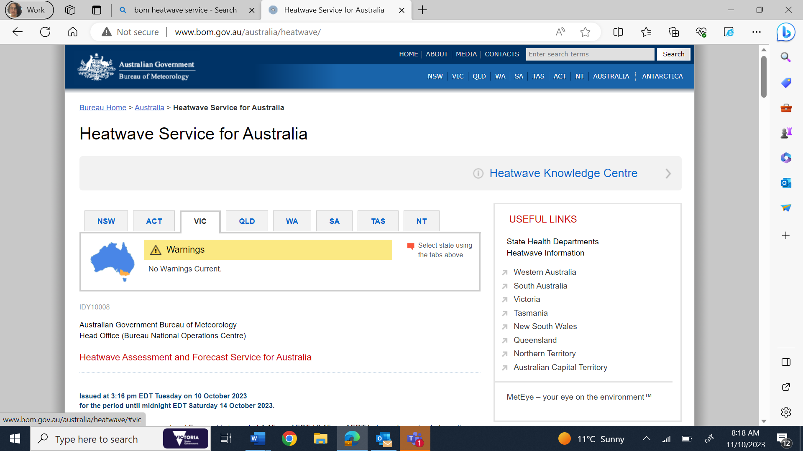

Figure 1. Heatwave warnings by state and territory

* two heatwave assessment maps, which show heatwaves that occurred in the preceding days
* five heatwave forecast maps, which depict heatwaves expected to occur over the next week (Figure 2).

The maps each represent a three-day period which are identified in the bolded map title. Under each map is text that describes what you see in the map.

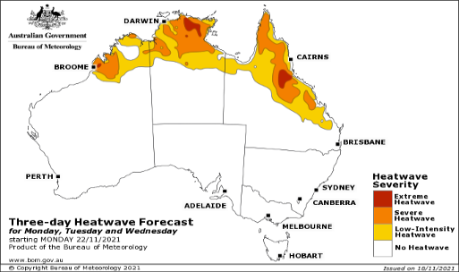

Figure 2. Heatwave Forecast map

The [Heatwave Service for Australia](http://www.bom.gov.au/australia/heatwave/) < http://www.bom.gov.au/australia/heatwave> also contains links to the Bureau’s Heatwave Knowledge Centre and the states’ and territories’ heat-related webpages. The Heatwave Knowledge Centre provides further explanations about how the Bureau defines and warns of heatwaves.

## Excess Heat Factor

The Bureau uses the Excess Heat Factor (EHF) to measure and define heatwaves in Australia. EHF compares the forecast maximum and minimum temperatures for **each three-day period** in the coming week (e.g. Monday-Wednesday, Tuesday-Thursday) to what would be considered hot for that location based on historical data, and also to observed temperatures over the preceding 30 days.

EHF helps to categorise heatwaves into three severity levels: low-intensity, severe and extreme, which are colour coded on the Bureau’s maps. Low-intensity heatwaves (represented by yellow) are more frequent, and most people can cope. Severe heatwaves (represented by orange) are less frequent and likely to be more challenging for people most at risk such as older people, particularly those with medical conditions. Extreme heatwaves (represented by red), although rare, are a problem for people who don't take precautions to keep cool—even for people who are healthy.

## Heatwave warnings

The Bureau issues a **heatwave warning** when the EHF indicates that a severe or extreme heatwave affecting ten per cent or more of one or more weather districts is currently underway or is forecast to begin on the next day.

At approximately 3:00 pm each day, if a warning has been issued, updated or cancelled, it will appear on the Bureau’s public channels, including [The Bureau of Meteorology website](http://www.bom.gov.au) <http://www.bom.gov.au/>, [app](http://www.bom.gov.au/app/) <http://www.bom.gov.au/app/> and through their telephone service. You can sign up for push notifications for heatwave warnings for your location via the Bureau’s app.

The Bureau’s heatwave warnings contain:

* Valid dates (when the heatwave is forecast to occur)
* Affected weather districts by severity level
* Four maps showing where the heat is forecast to occur (Each map represents a three-day period)
* Safety advice on how to stay healthy in the heat
* Weather situation describing in text when the heat will peak or ease and affected locations.

A heatwave warning may be updated or cancelled throughout the event, so it is important to monitor the [Bureau’s warnings](http://www.bom.gov.au/australia/heatwave/) <http://www.bom.gov.au/australia/heatwave/> and your local weather conditions at the [Bureau’s 7-day forecast](http://www.bom.gov.au/vic/forecasts/map7day.shtml) <http://www.bom.gov.au/vic/forecasts/map7day.shtml>.

# Department of Health

## Heat health warning

The department issues heat health warnings from October through March, although this can be extended if required. The warnings are sent via email to heat health warning subscribers in two scenarios:

* to disseminate a link to a new Bureau heatwave warning, or
* when forecast high maximum and minimum temperatures **do not** meet the criteria for a Bureau heatwave warning, but the Chief Health Officer considers that a heat health risk exists.

### Trigger: Bureau heatwave warning

On receipt of a **new** heatwave warning from the Bureau, the department will issue a **heat health warning** to disseminate a link to the Bureau’s website for details. The email also contains heat health messaging and links to more information. These heat health warnings will only be issued once the Bureau’s heatwave warning has been issued at around 3:00pm.

The link to the Bureau’s heatwave warning allows you to access the latest information from the Bureau, including any updates or cancellations. In these instances of the Bureau of updating or cancelling a heatwave warning, it is unlikely the department will issue another heat health warning for updates or cancellations of an existing heatwave warning. Therefore, it is important for you to monitor the Bureau’s heatwave warnings and your local weather conditions.

### Trigger: Heat health risk in the absence of a Bureau heatwave warning

The Chief Health Officer may issue a **heat health** **warning** for forecast high maximum and minimum temperatures of concern that do not meet the criteria for a Bureau heatwave warning, but where the Chief Health Officer considers that a heat heath risk exists. For example, a single day or two-day heat event may trigger a heat health warning.

These heat health warnings*,* which may be issued up to three days in advance, typically contain information about the date of the event, weather district of concern and the rationale for issuing the heat health warning*.* The email also contains heat health messaging and links to more information.

If forecast conditions change, the Chief Health Officer will not issue a cancellation for this type of heat health warning*.* Therefore, it is important for you to monitor local conditions and stay aware of the Bureau’s heatwave warnings for your weather district.

# Subscribe to Heat health warnings

The department’s subscription service is available to anyone with an email address.  You can [subscribe to receive heat health warnings](https://www.health.vic.gov.au/subscribe) <https://www.health.vic.gov.au/subscribe>. Once you submit your email address, you will receive a verification email to complete the process.

# Prepare and respond

Prepare for forecast high maximum and minimum temperatures with these activities:

* bookmark and review the [Bureau of Meteorology website about heatwaves](http://www.bom.gov.au/australia/heatwave/) <http://www.bom.gov.au/australia/heatwave/> and for easy access to the heatwave warnings
* download the Bureau of Meteorology app and set up push notifications for forecast heatwaves for your location
* bookmark the [VicEmergency website](https://emergency.vic.gov.au/respond/) <https://emergency.vic.gov.au/respond/> or download the app for heat preparedness or warning information
* subscribe to the department’s [heat health warnings](https://www.health.vic.gov.au/subscribe) <https://www.health.vic.gov.au/subscribe>
* review and update your heat plan, including incorporating the heatwave and heat health warnings
* promote your organisational heat plan(s) with colleagues and stakeholders so they know how you are preparing for and responding to heatwaves.

Even though the department will be monitoring forecast temperatures across the state, it is important for you to monitor your local weather conditions. It may be necessary for your organisation to activate heat plans in the absence of a heatwave or heat health warning being issued. You are also encouraged to monitor local weather conditions using the [Bureau of Meteorology’s 7-day forecast website](http://www.bom.gov.au/vic/forecasts/map7day.shtml) <http://www.bom.gov.au/vic/forecasts/map7day.shtml>.

All community members are encouraged to prepare for extreme heat to protect themselves and those in their care from the impact of extreme heat, particularly those most at risk.

## More information

* [Bureau of Meteorology Heatwave Service for Australia](http://www.bom.gov.au/australia/heatwave/) <http://www.bom.gov.au/australia/heatwave/>
* [Department of Health - Heat health information about planning, warnings and communications](https://www.health.vic.gov.au/environmental-health/extreme-heat-and-heatwaves) <https://www.health.vic.gov.au/environmental-health/extreme-heat-and-heatwaves>
* [State Emergency Management Plan – Extreme Heat Sub-Plan](https://www.emv.vic.gov.au/responsibilities/state-emergency-management-plan-sub-plans/semp-extreme-heat-sub-plan) <https://www.emv.vic.gov.au/responsibilities/state-emergency-management-plan-sub-plans/semp-extreme-heat-sub-plan>
* [VicEmergency](https://emergency.vic.gov.au/respond/) <https://emergency.vic.gov.au/respond/>
* [Better Health Channel – Extreme heat](https://www.betterhealth.vic.gov.au/extreme-heat) <https://www.betterhealth.vic.gov.au/extreme-heat>

|  |
| --- |
| To receive this document in another format, phone 1300 761 874, using the National Relay Service 13 36 77 if required, or email the Department of Health at [extreme.weather@health.vic.gov.au](mailto:extreme.weather@health.vic.gov.au) <extreme.weather@health.vic.gov.au>.  Authorised and published by the Victorian Government, 1 Treasury Place, Melbourne.  © State of Victoria, Australia, Department of Health, November 2024.  Except where otherwise indicated, the images in this document show models and illustrative settings only, and do not necessarily depict actual services, facilities or recipients of services.  Available on the [Extreme heat and heatwaves](https://www.health.vic.gov.au/environmental-health/extreme-heat-and-heatwaves) <https://www.health.vic.gov.au/environmental-health/extreme-heat-and-heatwaves>. |

1. [*State Emergency Management Plan – Extreme Heat Sub-Plan*](https://www.emv.vic.gov.au/responsibilities/state-emergency-management-plan-sub-plans/semp-extreme-heat-sub-plan) <https://www.emv.vic.gov.au/responsibilities/state-emergency-management-plan-sub-plans/semp-extreme-heat-sub-plan>