

|  |
| --- |
| Downloading a copy of your licence certificate |
| Victorian Radiation Use Licence – Online Licensing Portal. |
|  |

Step 1: Log into the online licensing portal via <https://licensing.health.vic.gov.au/>

Step 2: Click on the three dots on the top right of the licence tile.

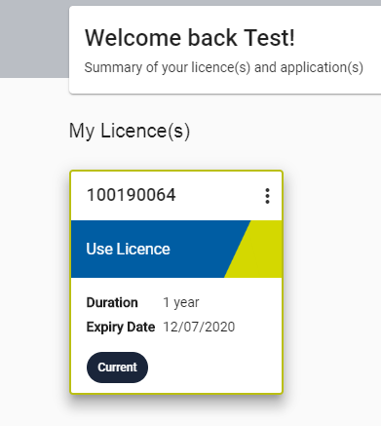

Step 3: Select ‘Download Certificate’

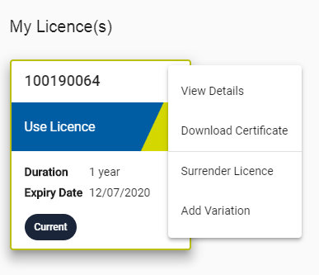

Step 4: A certificate should be downloaded as a .pdf file.

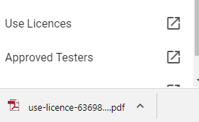

Once the licence certificate is downloaded, the licence certificate can be printed or saved.

|  |
| --- |
| To receive this document in another format, [email Department of Health Radiation Safety](mailto:radiation.safety@health.vic.gov.au), <radiation.safety@health.vic.gov.au>.  Authorised and published by the Victorian Government, 1 Treasury Place, Melbourne.  © State of Victoria, Australia, Department of Health, September 2021. |