

|  |
| --- |
| How to apply for a renewal of your radiation use licence |
| Victorian Radiation Use Licence – Online Licensing Portal. |
|  |

Step 1: Log into the online licensing portal via <https://licensing.health.vic.gov.au/>

Step 2: Click on “Renew/Do Not Renew”

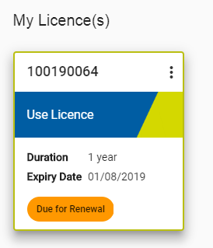

Step 3: Select ‘Yes’, if you are ready to make the renewal payment.

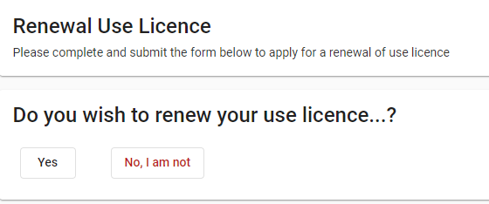

Step 4: Select the licence duration you wish to renew for.

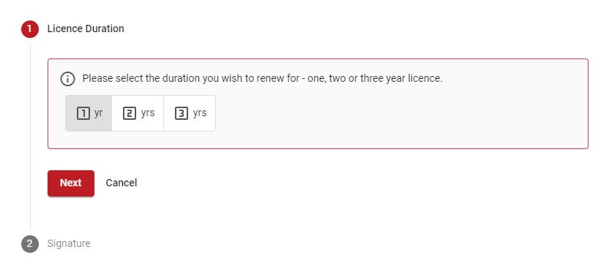

Step 5: Insert your signature and click ‘Calculate Fee

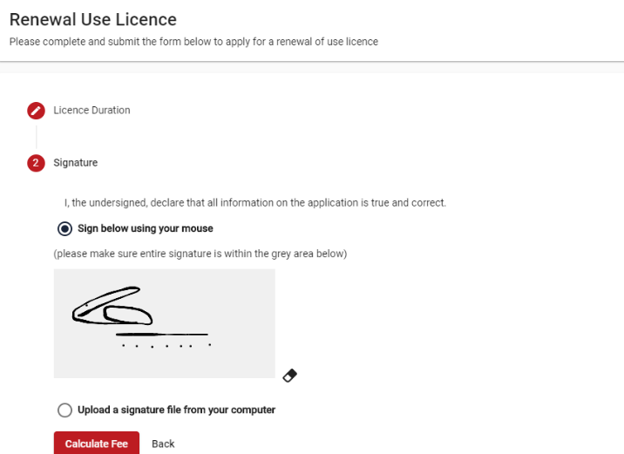

Step 6: Click “Pay’

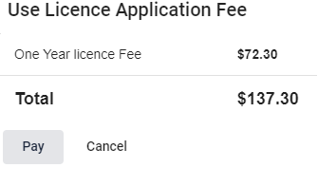

Step 7: Options of making the payment via credit card or BPay will be displayed. Please ensure that payments via BPay are made at least 5 working days prior to the licence expiry.

1. If you choose to make a payment via credit card, enter the card details within the spaces available and click ‘Pay”. A copy of the renewal letter will also be generated and emailed.
2. If you choose to make a payment via BPay, click on “Proceed with BPAY”. A renewal of the licence letter will be generated and emailed.

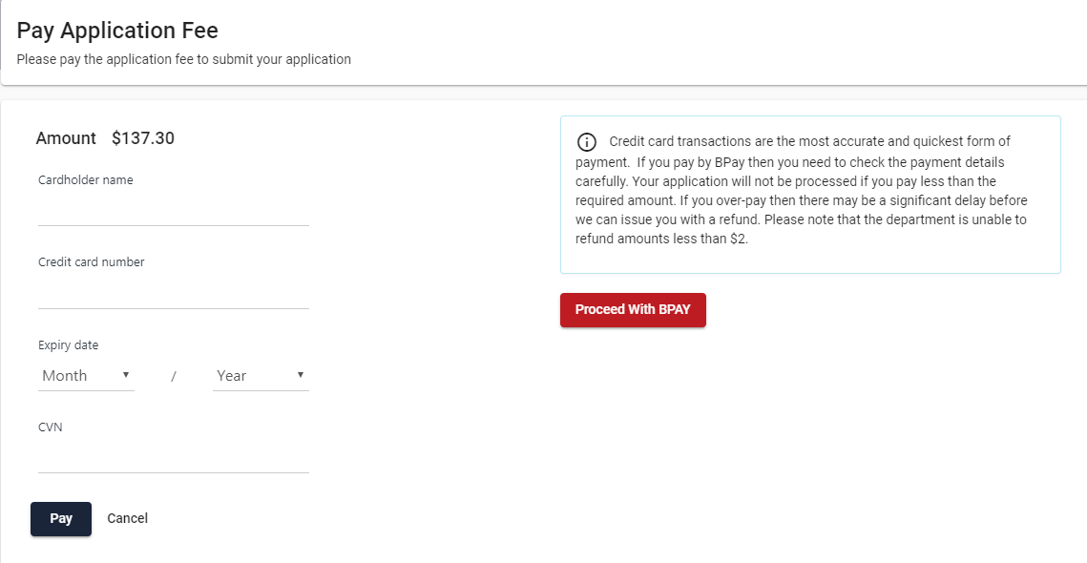

Step 8: Once a payment is received, the licence renewal will require approval by the Delegate within Department of Health Radiation Safety.

|  |
| --- |
| To receive this document in another format [email Department of Health Radiation Safety](mailto:radiation.safety@health.vic.gov.au), <radiation.safety@health.vic.gov.au>.  Authorised and published by the Victorian Government, 1 Treasury Place, Melbourne.  © State of Victoria, Australia, Department of Health, September 2021. |

Step 9: Once the renewal has been approved, a copy of the licence certificate can be downloaded.