

|  |
| --- |
| How to apply for a variation to your radiation use licence |
| Victorian Radiation Use Licence – Online Licensing Portal. |
|  |

Step 1: Log into the online licensing portal via <https://licensing.health.vic.gov.au/>

Step 2: Click on the three dots on the top right of the licence tile.

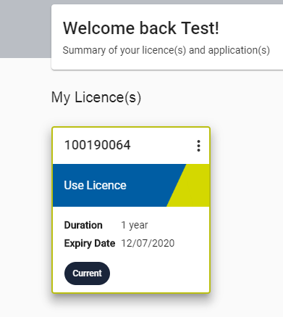

Step 3: Select ‘Add Variation’

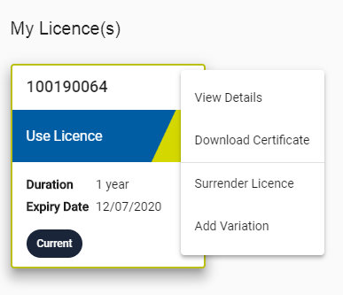

Step 4: Follow the steps within the variation application.

1. Once the variation application variation has been submitted, it will be sent to Department of Health Radiation Safety for assessment and approval.
   1. At any point within the assessment process, you may receive a notification requesting further information. This notification will be sent to you via email as well as displayed on the licence portal.
      1. Once you have collated the requested information, click on ‘Process’

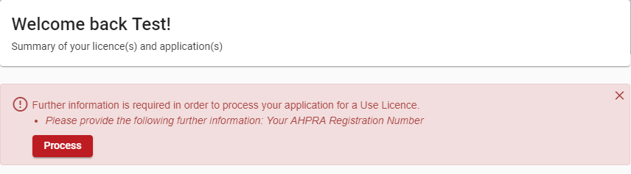

* + 1. Upload the requested information.

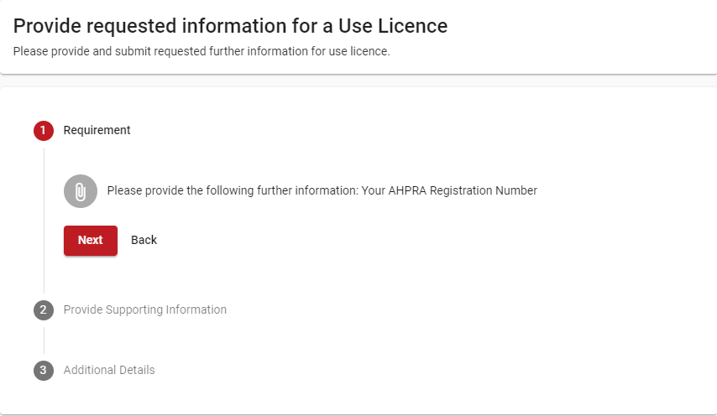

* + 1. Once uploaded, press Submit

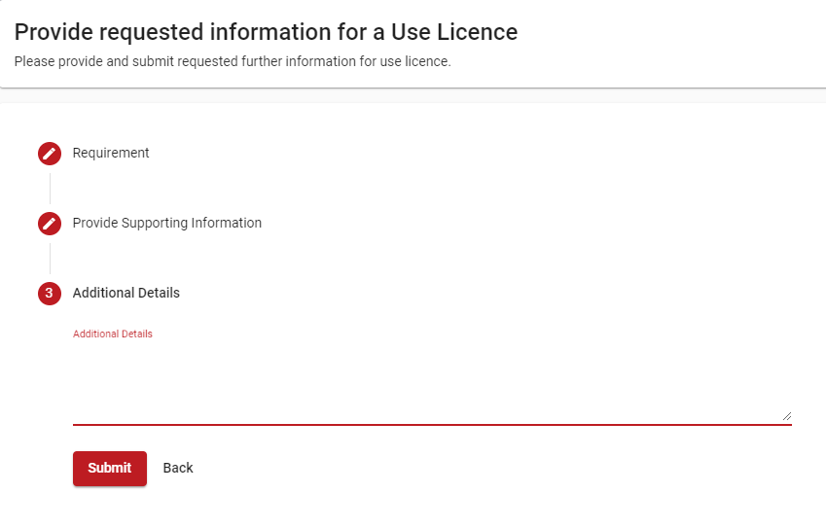

1. The application will be sent to Department of Health Radiation Safety for another assessment.

Once the variation has been approved, a copy of the updated licence certificate can be downloaded.

|  |
| --- |
| To receive this document in another format, [email Department of Health Radiation Safety](mailto:radiation.safety@health.vic.gov.au), <radiation.safety@health.vic.gov.au>.  Authorised and published by the Victorian Government, 1 Treasury Place, Melbourne.  © State of Victoria, Australia, Department of Health, September 2021. |