

|  |
| --- |
| How to change your password |
| Victorian Radiation Use Licence – Online Licensing Portal. |
|  |

Step 1: Log into the online licensing portal via <https://licensing.health.vic.gov.au/>

Step 2: Click on Security

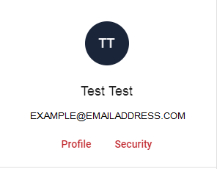

Step 3: Enter current and new password

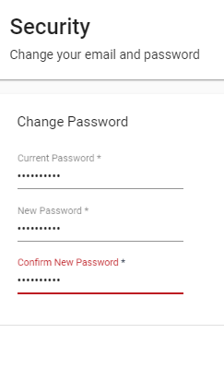

Step 4: Click ‘Change Password’

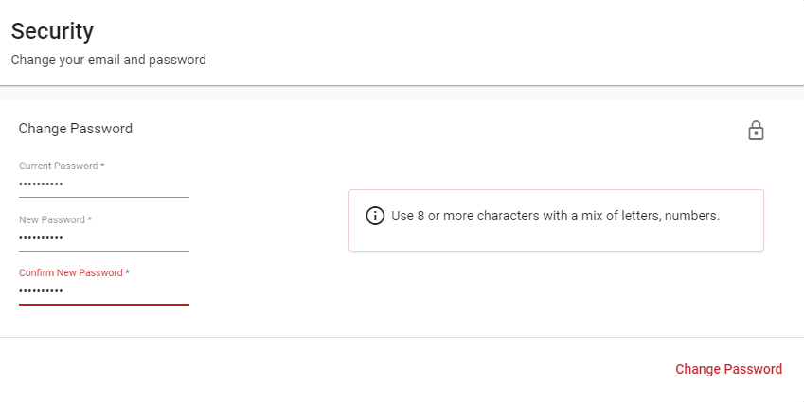

|  |
| --- |
| To receive this document in another format [email Department of Health Radiation Safety](mailto:radiation.safety@health.vic.gov.au), <radiation.safety@health.vic.gov.au>.  Authorised and published by the Victorian Government, 1 Treasury Place, Melbourne.  © State of Victoria, Australia, Department of Health, September 2021. |