

|  |
| --- |
| How to update your contact details. |
| Victorian Radiation Use Licence – Online Licensing Portal. |
|  |

Step 1: Log into the online licensing portal via [https://licensing.dhhs.vic.gov.au](https://licensing.dhhs.vic.gov.au/)

Step 2: Click on ‘Profile’

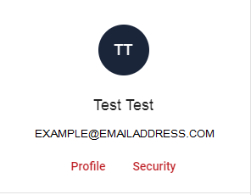

Step 3: Make changes to your profile.

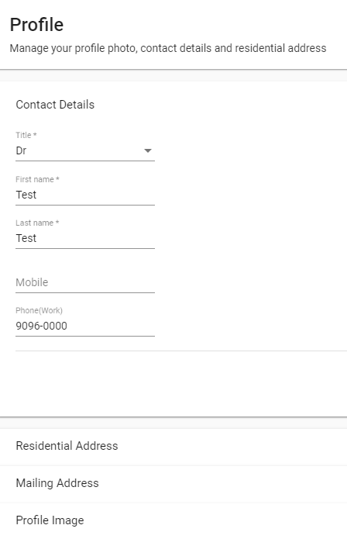

Please note:

* If you are changing the residential address or Mailing address, the edit button will need to be selected prior to making the changes.
* Any changes a title, first name or last name will require a change of name document and initiate an application to change the name on all licences that you currently hold which also requires approval by the Delegate within Department of Health Radiation Safety.

Step 4: Click ‘Save Changes’

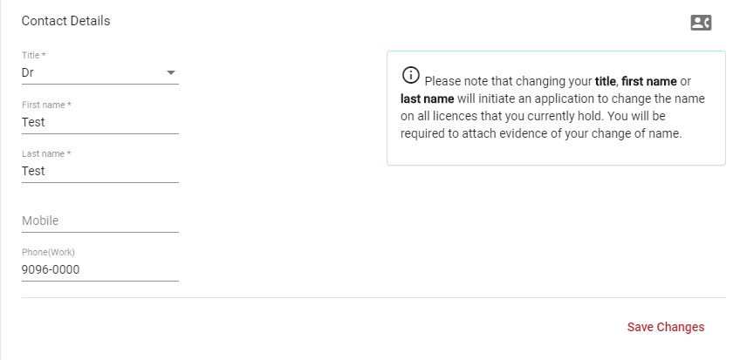

|  |
| --- |
| To receive this document in another format, [email Department of Health Radiation Safety](mailto:radiation.safety@health.vic.gov.au), <radiation.safety@health.vic.gov.au>.  Authorised and published by the Victorian Government, 1 Treasury Place, Melbourne.  © State of Victoria, Australia, Department of Health, September 2021. |

Step 5: Once changes have been saved, a new certificate can be downloaded.