

|  |
| --- |
| Renewal application – Payment Pending. |
| Victorian Radiation Use Licence – Online Licensing Portal. |
|  |

Step 1: Check you bank records to see if the payment has been withdrawn.

Step 2: The following two scenarios can occur –

* If a payment has been deducted -  
  Please provide a copy of the evidence of payment via email to [radiation.safety@health.vic.gov.au](mailto:radiation.safety@health.vic.gov.au)  
  A licensing officer will then submit a request for investigation by the Information Systems Team.
* If **NO** payment has been withdrawn. Log into the portal via <https://licensing.health.vic.gov.au/> -   
  Please locate the heading "Active Application(s)" on the portal and click on the three dots to the right side of the use licence renewal application (as shown below).   
  Please select either the “Make Payment” or "Withdraw" option.  
    
  If the “Make Payment” option is selected, you will be redirected to the payment page where you will be able to enter your credit card details or generate BPay payment details.  
    
  If the “Withdraw” option is selected you will then be able to generate a new renewal application with updated payment details

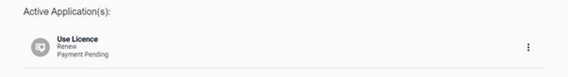

|  |
| --- |
| To receive this document in another format, [email Department of Health Radiation Safety](mailto:radiation.safety@health.vic.gov.au), <radiation.safety@health.vic.gov.au>.  Authorised and published by the Victorian Government, 1 Treasury Place, Melbourne.  © State of Victoria, Australia, Department of Health, September 2021. |