

|  |
| --- |
| Patient blood management information |
| Blood Matters |
|  |

# Patient blood management helps your blood work for you

Patient blood management (PBM) is the standard of care that helps reduce the need for blood transfusions. Standard of care ensures that everyone receives safe, high-quality and evidence-based treatment.

## PBM is research based best practice

*  PBM can reduce the need for a blood transfusion, which reduces the risk of an adverse event
* Research shows that you have fewer complications. This means you can recover faster and spend less time in hospital
* PBM involves you and your carer and your healthcare team to get the best results

## PBM focusses on three main areas

### Finding and treating anaemia

*  Anaemia (low haemoglobin (Hb)) is common, **30% of patients** having surgery are anaemic. Low iron levels are a common cause of anaemia. A blood test is needed to find out if you have anaemia and/or low iron levels.
* 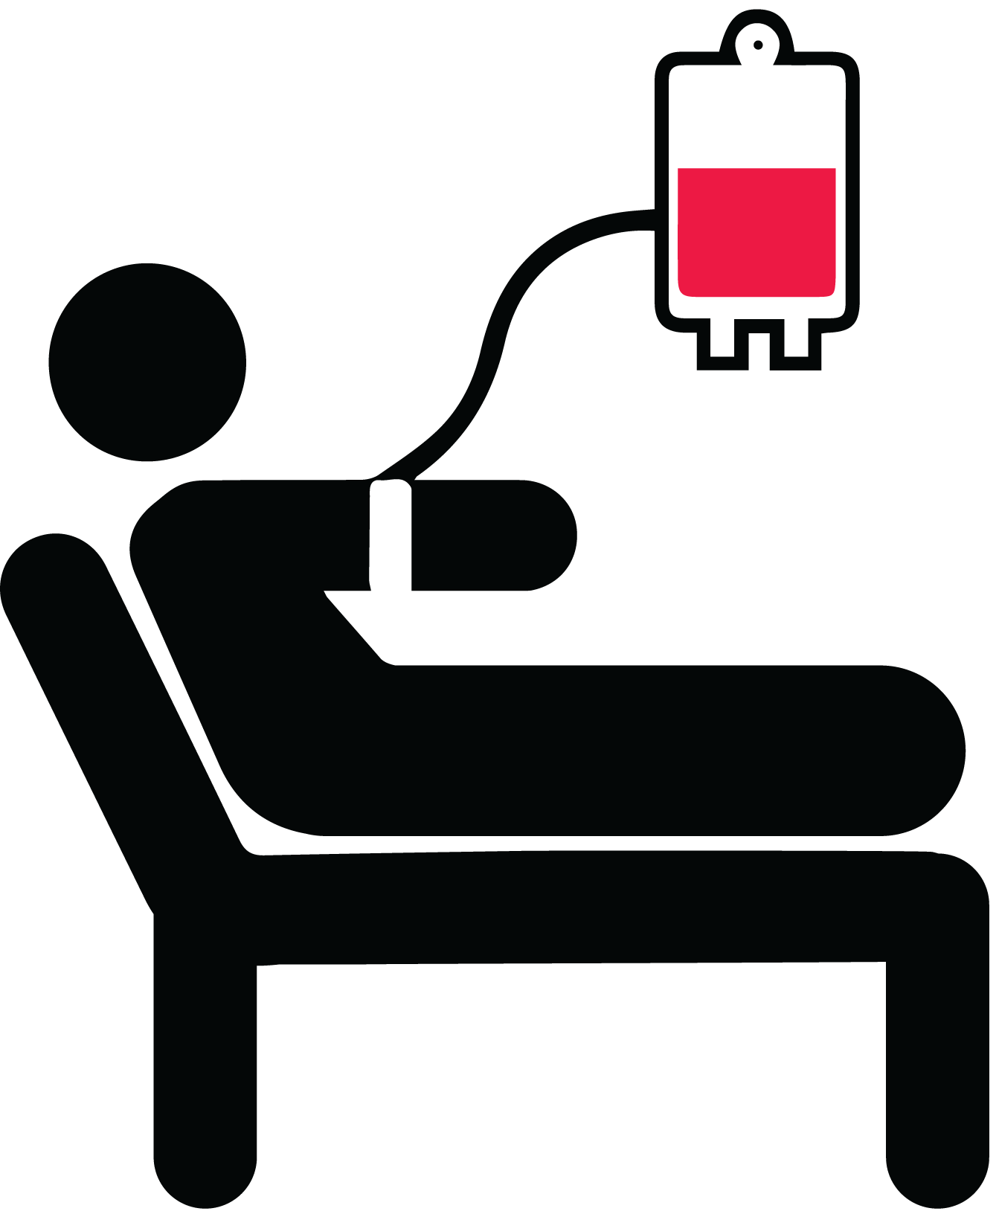 Anaemia and low iron levels can **increase your risk** of complications and needing a blood transfusion
* Oral iron tablets or an iron infusion can be given to increase your iron levels and haemoglobin
*  You may need further tests if there is **no obvious reason** for your anaemia and/or **low iron levels**

Reducing the risk of bleeding

*  Tell the doctor if you are taking any medicines (tablets or other products), prescribed or over the counter. This includes natural and herbal medicines, as some can affect clotting and bleeding
*  **Taking less blood** for tests can **reduce the amount of blood you lose** and can help reduce the need for a blood transfusion. If your doctor wants you to take a blood test, ask if the test is really needed.
*  Your doctor may be able to use **techniques**, such as giving you back the blood you lose in surgery or use some medications to **reduce** bleeding during the procedure. **Ask your doctor if there are any techniques they can use for you.**

Tolerating anaemia

*  After surgery, you will be **carefully monitored** to check for infections and bleeding. You will be given treatment for this if needed.
*  You may still need a blood transfusion if you have signs and symptoms of anaemia or if you have a lot of bleeding. **Before having a blood transfusion, the doctor will assess your condition**. You should only have a blood transfusion if the risk of the transfusion is less than the risk of you becoming unwell due to anaemia.
*  If you need a blood transfusion, the doctor should only order one unit of blood and **assess your condition** again to see if you need any more. This may mean you need **another blood test and an examination by the doctor**.

## Find out more

You can also find out more about PBM practices and transfusion from:

* Your doctor
* The Australian Red Cross Lifeblood’s [Patient portal](https://www.lifeblood.com.au/patients/avoid-a-transfusion) <https://lifeblood.com.au/patients/avoid-a-transfusion>.
* The National Blood Authority (NBA) website has [more information and videos](https://www.blood.gov.au/clinical-guidance/patient-blood-management) <https://www.blood.gov.au/clinical guidance/patient-blood-management>.

## References

Australian Commission on Safety and Quality in Health Care 20190, ‘[What is patient blood management?](https://www.safetyandquality.gov.au/national-priorities/pbm-collaborative/what-is-patient-blood-management#:~:text=PBM%20views%20a%20patient%27s%20own,of%20all%20other%20body%20systems)’, <https://www.safetyandquality.gov.au/national-priorities/pbm-collaborative/what-is-patient-blood-management#:~:text=PBM%20views%20a%20patient%27s%20own,of%20all%20other%20body%20systems>

Australian Red Cross Lifeblood 2019, [‘PBM overview’](https://www.lifeblood.com.au/health-professionals/clinical-practice/patient-blood-management), <https://www.lifeblood.com.au/health-professionals/clinical-practice/patient-blood-management>.

[Patient blood management | National Blood Authority](https://www.blood.gov.au/clinical-guidance/patient-blood-management)

Hands K, Daru J, Evans C,Kotze A, Lewis C, Narayan S, et al. Identification and management of preoperative anaemia in adults: A British Society for Haematology Guideline update. BrJ Haematol. 2024;00:1–12. https://doi.org/10.1111/bjh.19440

|  |
| --- |
| To receive this document in another format, phone 03 9694 0102 , using the National Relay Service 13 36 77 if required, or [Blood Matters](mailto:bloodmatters@redcrossblood.org.au) <bloodmatters@redcrossblood.org.au>.  Authorised and published by the Victorian Government, 1 Treasury Place, Melbourne.  © State of Victoria, Australia, Department of Health, December 2024.  Except where otherwise indicated, the images in this document show models and illustrative settings only, and do not necessarily depict actual services, facilities or recipients of services.  **ISBN** 978-1-76131-714-9 **(pdf/online/MS word)**  Available at [Blood Matters](https://www.health.vic.gov.au/patient-care/blood-matters-program) <https://www.health.vic.gov.au/patient-care/blood-matters-program> |