

|  |
| --- |
| Blood Matters report for blood management (or equivalent) committee |
| August 2024 |
|  |

The Blood Matters Program is a Victorian State Government program run in collaboration with the Australian Red Cross Lifeblood.

**Strategic Plan 2023–24**

**Goal:**

Blood Matters’ goal is to use a collaborative approach to support and promote best practices in quality care and clinical safety in blood management. We aim for sustainable, responsible, safe, and appropriate use of blood and blood products for improved patient outcomes in Victoria.

**Objectives:**

Use innovative and diverse approaches to:

* promote and support the development of strategies that optimise appropriate use of blood, blood products, or alternatives, and person-centred care through national and local governance frameworks and standards
* foster and strengthen partnerships and stakeholder relationships
* analyse data and disseminate findings across the sector to raise awareness, influence practice, promote efficiencies and equity of care, and provide value
* provide and promote expert knowledge sharing and collaboration across the sector, including specific initiatives, tools, and specialised advice.

**Changes in the Blood Matters team**

From July 1 there has been some changes to the Blood Matters team. Chris Akers (Transfusion Nurse), Kaylene Bastin (Patient Blood Management Education Coordinator) and Rae French (Scientist) have all moved to a five-day fortnight and Anne Graham (Blood Matters Nurse Consultant [SCIg]) has moved to a four-day fortnight work pattern. While we have reduced hours, we will maintain our standard of work and provide the services we always have. This means working a little smarter and so there will be some changes to how we provide education e.g. the Five in five series becoming Blood bites, which will change to three sessions of ninety minutes each, over three days.

The most notable change is the retirement of Linley Bielby, Program Manager. Linley’s retirement will be a great loss to the Blood Matters Program and to the blood community.

We are pleased and excited to announce that Clare Hennessy has taken on the role of Program Manager at an eight-day fortnight pattern of work. Many of you will know Clare as one of the Transfusion Nurses at Eastern Health. Clare also worked for a time with Blood Matters in the role of Patient Blood Management Education Coordinator and most recently as a clinical educator with Lifeblood, developing ‘Microcredentials for transfusion practitioners.’ She has extensive blood management experience, transfusion knowledge as well as nursing management skills. We warmly welcome Clare to our team.

We would like to extend our best wishes to Linley in her retirement and while we will be sad to see her go, we know she will be enjoying her retirement with golf, travel and keeping up with family and friends.

Linley has been an active member of many teams that have worked to support and promote the Transfusion Nurse role, working not only with Blood Matters but also chairing the ISBT Transfusion Professionals group, working with ANZSBT Transfusion Professionals network and her many roles on other blood management committees. Her work has been recognised with several awards, including the AABB Presidents’ award in 2019, the Ruth Sanger oration at Blood 2022, most recently the 2024 ISBT award for her significant contribution to transfusion medicine and science, particularly in education and the Dawn Thorpe oration in Adelaide.

**Blood stewardship**

**RBC wastage**

RBC wastage rates in Victoria are consistently at or below national average, your ongoing attentiveness and dedication to blood stewardship is to be applauded.

**2023-24 Festive campaign summary**

The ‘STOP the waste’ festive campaign for 2023-24 was once again very successful. The average Victorian red cell wastage rate over this festive season was 1.3%, a reduction from last year’s average of 1.4%. Despite the increase in RBC issued over this period in recent years, the discard rate remains consistently low.

The diligence and awareness of all has been a major factor in the ongoing success of the ‘STOP the waste’ festive campaign.

It is advisable that stock levels be monitored throughout the year, and inventory adjusted, as necessary. Your continued support of the ‘STOP the waste’ festive campaign is appreciated.

A PDF summary presentation of the festive campaign is attached to this email.

**O RhD negative RBC issue rates**

The number of O RhD negative RBC issued as a proportion of all RBC issued in Victoria has decreased to 15 per cent in June following rates greater than 16 per cent between November 2023 and April 2024. Health services are encouraged to regularly review adherence to emergency use policy and appropriateness. An audit template can be downloaded from the [Blood Matters webpage](https://www.health.vic.gov.au/patient-care/emergency-use-of-group-o-red-blood-cells).<https://www.health.vic.gov.au/patient-care/emergency-use-of-group-o-red-blood-cells>

As O RhD positive RBC for emergency use are implemented across health services, in line with the NBA’s Statement for the Emergency Use of Group O RBC, please review and adjust O RhD negative RBC inventory as appropriate. More information is available on the [Blood Matters Emergency use of group O RBC webpage](https://www.health.vic.gov.au/patient-care/emergency-use-of-group-o-red-blood-cells) <https://www.health.vic.gov.au/patient-care/emergency-use-of-group-o-red-blood-cells>. With the changing demographics and blood group prevalence of the Australian population ([Hirani et al 2022](https://onlinelibrary.wiley.com/doi/10.5694/mja2.51429)), we encourage regular review of inventory to reflect your health service’s patient blood group distribution.

**ISBT 128 labelling requirements**

Australian Red Cross Lifeblood has updated implementation timeframes for the changes to Lifeblood’s blood component label.   
The introduction of ISBT128 2D DataMatrix to the current label **will still occur on** **30 November 2025**,however the removal of the Codabar transition label **will be delayed until 31 March 2029.**

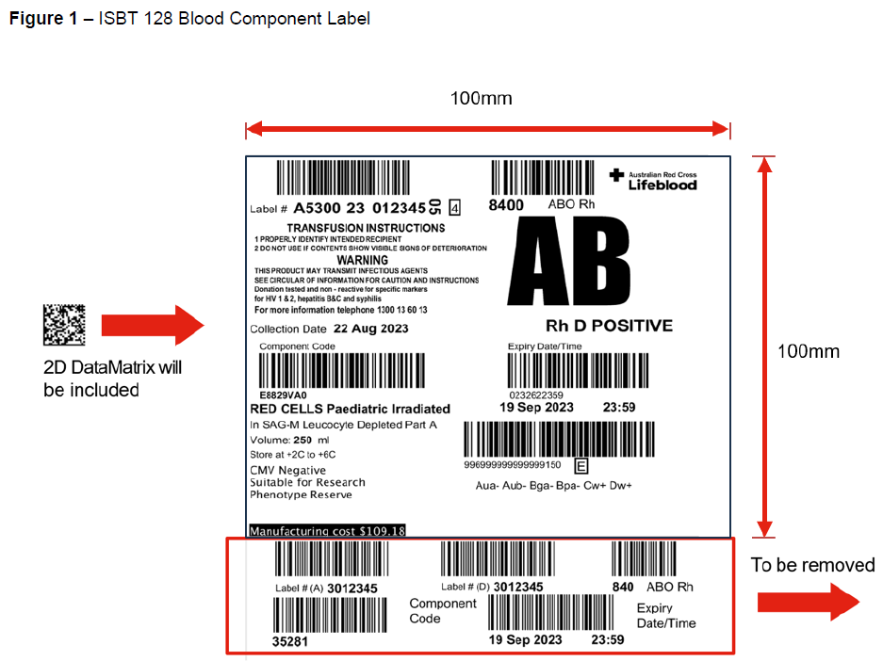

**Auditing**

**Appropriate use of fresh frozen plasma (FFP) audit 2023**

This was the first audit Blood Matters conducted with Australian Red Cross Lifeblood (Lifeblood) and the National Blood Transfusion Committee. Data was collected using the Lifeblood Audit tool. The aim of the audit was to assess appropriate use of FFP in accordance with the National Blood Authority Patient Blood Management Guidelines and indications for use published by [Lifeblood](https://www.lifeblood.com.au/health-professionals/clinical-practice/use-of-blood-components/use-of-fresh-frozen-plasma) <https://www.lifeblood.com.au/health-professionals/clinical-practice/use-of-blood-components/use-of-fresh-frozen-plasma>.

The final report is available at [Blood Matters audit reports](https://www.health.vic.gov.au/patient-care/blood-matters-audit-reports) <https://www.health.vic.gov.au/patient-care/blood-matters-audit-reports>

**The use of group O RhD negative RBC according to guidelines audit 2024**

With demand for group O RhD negative red blood cells (RBC) significantly higher ([Use of group O RhD negative red cells | Lifeblood](https://www.lifeblood.com.au/health-professionals/clinical-practice/use-of-blood-components/use-of-group-o-rhd-negative-red-cells)) than the proportion of the population who are O RhD negative, the 2024 audit is again focusing on the indications for the use of O RhD negative red blood cells. We will compare current data collected to the Blood Matters 2017 audit (report published in 2018). The results will help health services assess compliance with recommended use and identify any gaps in practice or ongoing challenges.

The audit closed on **28 June 2024**. Data is currently being analysed and the report will be available later this year.

**Serious transfusion incident reporting (STIR) system**

We thank, both public and private, health services for continuing to report to the STIR system. These reports form the basis of our annual report, provide information for education and conferences, and provide data for the National Blood Authority Haemovigilance reports.

The 2022-23 annual report will be available soon on the Blood Matters webpage. [Serious Transfusion Incident Reporting system (STIR)](https://www.health.vic.gov.au/patient-care/serious-transfusion-incident-reporting-system-stir) <https://www.health.vic.gov.au/patient-care/serious-transfusion-incident-reporting-system-stir>. Health Services will receive an email indicating when the report is available and providing information on their reported incidents and reactions for that same period.

For reporting criteria for STIR please go to the updated [STIR guide](https://www.health.vic.gov.au/publications/blood-matters-serious-transfusion-incident-reporting-guide) <https://www.health.vic.gov.au/publications/blood-matters-serious-transfusion-incident-reporting-guide>

For any health service in Victoria, Tasmania, Northern Territory or Australian Capital Territory not currently reporting to STIR, please contact Blood Matters at: [Bloodmatters@redcrossblood.org.au](mailto:Bloodmatters@redcrossblood.org.au) if you wish to participate.

**Subcutaneous immunoglobulin (SCIg) access program**

**SCIg** **patient numbers**

The number of patients receiving treatment with SCIg continues to increase.

Currently in Victoria (Q3 2023-2024) there are:

* 20 sites with active programs
* 522 Victorian patients receiving treatment with SCIg
* 2916 Victorian patients eligible for treatment with SCIg by medical diagnosis.

**SCIg Forums**

The July SCIg forum included a presentation and question and answer session, with the Neomedix Clinical Specialist, around the EMED SCIg 60 pump and consumables and an update on the process for travelling with SCIg.

Save the date, 13 November 2024, for the next SCIg forum.

**Travelling with SCIg**

The process for travelling with SCIg was recently reviewed and updated. With the new updated process, the SCIg product will not be packed in an Australian Red Cross Lifeblood shipper box for travel but will now be dispensed to the patient as normal and the patient will pack in their hand luggage. The Blood Matters “Travelling overseas with SCIg” guide will be updated to reflect this new process.

**SCIg funding**

The Independent Health and Aged Care Pricing Authority (IHACPA) released the [*Pricing Framework for Australian Public Hospital Services 2024–25*](https://comms.ihacpa.gov.au/link/id/zzzz65790267b7c31220Pzzzz62c658bb4c443797/page.html) (the Pricing Framework) at the end of 2023.  
In the new pricing framework IHACPA announced the inclusion of a new class to uniquely capture home based SCIg infusion therapy under the Tier 2 non-admitted services classification.

For the time being funding will remain unchanged, and the department will contact health services shortly regarding data collection requirements to support the new tier two codes.

SCIg implementation tools, resources, and health service SCIg contacts are available at: [Subcutaneous Immunoglobulin (SCIg) access program](https://www.health.vic.gov.au/patient-care/subcutaneous-immunoglobulin-scig-access-program) < https://www.health.vic.gov.au/patient-care/subcutaneous-immunoglobulin-scig-access-program>. If you would like further information on SCIg or assistance with commencing or expanding a SCIg program, please contact Anne Graham, Blood Matters Nurse Consultant (SCIg), via email at: [angraham@redcrossblood.org.au](mailto:angraham@redcrossblood.org.au)

**Education**

Education continues to be a focus of our work, with previous events well received by participants. Most events are virtual with a small number being held in person.

Upcoming events for 2024 (June-December)

|  |  |
| --- | --- |
| **Education event** | **Date** |
| Transfusion Nurse / Trainer / Safety Officer Forum | September 16 (face to face)  November 18 (virtual) |
| Scientist Forum | September 18 (face to face) |
| Blood bites: 3 sessions of 90 minutes each over 3 days | October 14-16 (virtual) |
| SCIg Forum | November 13 (virtual) |

Further information will be sent out closer to the dates.

Please contact the Blood Matters team ([Bloodmatters@redcrossblood.org.au](mailto:Bloodmatters@redcrossblood.org.au)) if you would like us to participate in your education program.

**Blood Matters forums**

Blood Matters continues to support blood management/transfusion nurses/trainers and quality officers with the opportunity to get together and discuss current issues that affect all. These sessions are conducted second monthly as a virtual meeting. Content includes Blood Matters activity updates, changes in the blood sector, network questions and discussions, education, and journal club presentations as appropriate. An in-person forum is scheduled for September 2024. Invitations and additional information will be sent out prior to each meeting. The Blood Matters Forums are by invitation only and they should not be forwarded to others without prior agreement.

**CSL Behring prothrombin complex concentrate supply change update**

* Prothrombinex-VF will no longer be available from mid-2024
* Beriplex P/N will be introduced temporarily from mid-2024
* Beriplex AU will replace Beriplex P/N in late 2024/early 2025.

The introduction of Beriplex P/N is an unforeseen necessity. Prothrombinex-VF is no longer being manufactured in Australia and the current stocks will run out in mid-2024, however supply of Beriplex AU, which will ultimately be the prothrombin complex concentrate used in Australia, will not be available until after the Prothrombinex-VF stocks run out. As an interim measure Beriplex P/N (imported product) will be available until the release of Beriplex AU.

Information to assist health services is available on the Blood Matters website: [Prescribing and clinical use of blood and blood products](https://www.health.vic.gov.au/patient-care/prescribing-and-clinical-use-of-blood-and-blood-products) <https://www.health.vic.gov.au/patient-care/prescribing-and-clinical-use-of-blood-and-blood-products>.

**Conferences**

**International Society of Blood Transfusion (ISBT) 2024** - Blood Matters had a poster ‘’Have consent practices for blood transfusion changed in the last 10 years?”, with Linley Bielby representing the Blood Matters team.

[Blood 2024](https://www.blood2024.com/) < https://www.blood2024.com/> is being held in Brisbane from 27-30 October 2024. Blood Matters has had an abstract accepted for a poster presentation, “Review of rural Victorian health services emergency use O RhD negative red blood cell (emergency RBC) holdings.”

**Blood Matters staff**

**Program Manager:** Clare Hennessy email: [clhennessy@redcrossblood.org.au](mailto:clhennessy@redcrossblood.org.au) - phone 03 9694 0102

**Transfusion Nurse:** Christine Akers email: [cakers@redcrossblood.org.au](mailto:cakers@redcrossblood.org.au) - phone 03 9694 3523

**PBM Education Coordinator**: Kaylene Bastin email: [kbastin@redcrossblood.org.au](mailto:kbastin@redcrossblood.org.au) - phone 03 9694 3515

**Data and Information Managers:** Peter Beard/Bridget Glazebrook email: [pbeard@redcrossblood.org.au](mailto:pbeard@redcrossblood.org.au), email: [bglazebrook@redcrossblood.org.au](mailto:bglazebrook@redcrossblood.org.au) - phone 03 9694 0261

**Blood Matters Nurse Consultant (SCIg):** Anne Graham email: [angraham@redcrossblood.org.au](mailto:angraham@redcrossblood.org.au) - phone 03 9694 0126

**Scientist:** Raewyn French email: [rfrench@redcrossblood.org.au](mailto:rfrench@redcrossblood.org.au) - phone 03 9694 3524

**Address:** 100–154 Batman Street, West Melbourne, VIC 3003.

|  |
| --- |
| To receive this document in another format, phone 03 9694 0102 using the National Relay Service 13 36 77 if required, or [email Blood Matters](mailto:Bloodmatters@redcrossblood.org.au) <Bloodmatters@redcrossblood.org.au>.  **ISSN** 2981-8710 **- Online (pdf/word)**  Authorised and published by the Victorian Government, 1 Treasury Place, Melbourne.  © State of Victoria, Australia, Department of Health, February 2024.  Available at [Blood Matters program](https://www.health.vic.gov.au/patient-care/blood-matters-program) <https://www.health.vic.gov.au/patient-care/blood-matters-program> |