Blood Refrigerator Temperature Record Chart –
Copy to Transfusion Laboratory form

Hospital/health service: | Contact:  Phone:
Copy sent to (laboratory name):  Date/time sent: | Address:  Telephone:  Fax/email:
Sent by:  Name:  Title: | Signature:
Place completed blood refrigerator temperature chart in space below and photocopy.
Send copy to your Transfusion Laboratory for checking.
Archive copy with blood refrigerator records.
SAMPLE ONLY DO NOT USE
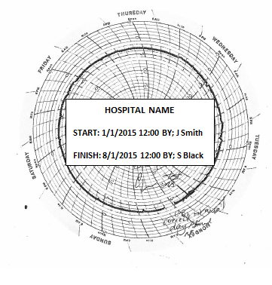
Transfusion Laboratory USE ONLY
Temperature chart check Passed □ Fail □
Store this hospital blood refrigeration temperature chart record sheet appropriately. NATA may require viewing for audit

Checked by……………………………… Signature: ………………………………. Date: …………………. Time: ……….…..

